**Objective:**

A Video Player Application built with technologies HTML5, CSS/CSS3, Javascript.

**Support:**

1. A video on the screen which is auto play.
2. By default first link plays.
3. When any video is played next automatically plays.
4. Local video support.
5. Server video support.
6. You tube video support.
7. Flash fallback support.
8. Link text and video source pulled from an xml.
9. The design is adaptive.
10. A VideoJS library used for videos support and same look and feel on different browsers.

**Diagram**

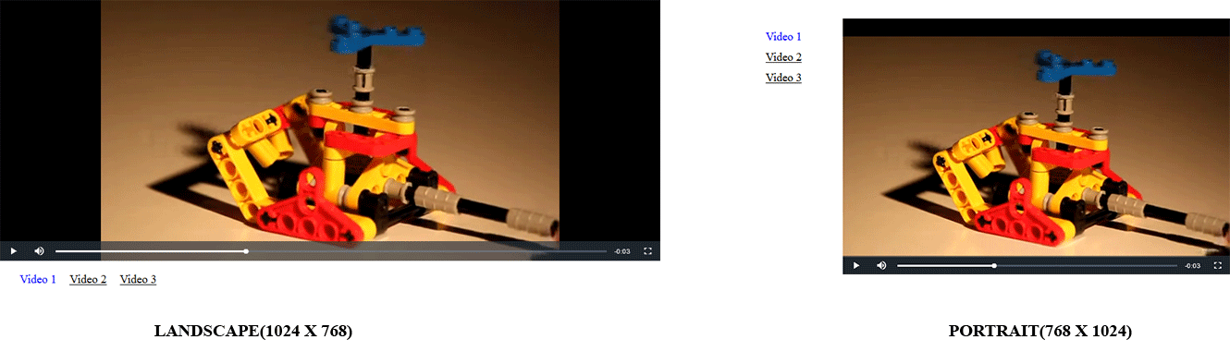

**BROWSERS TESTED**

1. Google Chrome (45 and above)
2. Mozilla Firefox ( 44 only)
3. Internet Explorer( 11 only)
4. Opera (34 only)

**FILE STRUCTURE**

1. Development – This folder is for development process contains files which are not minified and have larger size.

* List of files contains index file, java script files inside js folder, css files inside css folder, xml file inside data folder, local videos inside videos folder and video library inside lib folder.
* Some other files which are used for automation workflow which helps in ease of development process.
* If you want to see the automation process, just open command prompt or git bash and type command gulp. And then go to that link on browser, <http://localhost:8001> . And now, do some editing in xml files or other files and you will see the browser will reload and you get the live.

1. Production – This folder is for production process contains files which are minified and necessary files which are required for application.

**Challenges Faced**

1. Code Structure – Thinking about how to structure the code. What are the things necessary for video player application so that development should be easy and readable for code review and other developers who may work
2. Use video api provided by HTML5 or use video library - What I find that video api has only support for modern browsers which has HTML5 features enabled. So, what about others which does not support. Either I can make it my own or use some kind of library online. So, finally decide to use VIDEOJS library which has supports for my required needs and even has you tube support which is not required right now but we can use it in future.
3. Automate - Then decided to do use some browser workflows like to automate the development process so that files released for production should be minified and browser should have livereload functionality to fast the development process.

**Enhancements**

1. We can provide thumbnails in place of links. Thumbnails should have additional information like title, duration of video, user who uploaded and we can also provide number of views.
2. Video playing on the screen should have information below. Information lilke title and additional information. Even you can provide embedding features and download features related to the video if the site owner wants.
3. Like feature for video.
4. You can also provide comment section so that users who are viewing the video can add comments.
5. Search functionality should not be avoided. Some users knows about they want so If the user wants to search for video, they can easily find.

**Additional Information**

1. Inside the xml file, I have listed three videos in which one of the video is coming from local, other one is coming from server and the last one is youtube video. The youtube video will only play if the owner who has uploaded provided the rights to use the video on other websites.