# Confusion matrix

|  |  |  |  |
| --- | --- | --- | --- |
|  | Predicted Negative (PN) | Predicted Positive (PP) |  |
| Actual Negatives (AN) | True Negative (TN) | False Positive (FP) | FPR |
| Actual Positive (AP) | False Negative (FN) | True Positive (TP) | Recall |
|  |  | Precision | Accuracy |

All = TN + FN + FP + TP

Accuracy – How many samples are predicted correctly?

Accuracy = TN + TP / All

Precision = Out of predicted positives, how many are really positive?

Precision = TP / (FP + TP) = TP / Predicted Positive (PP)

Recall/ Sensitivity / True Positive Rate = Out of actual positives, how many are identified as positive? Also called True Positive Rate. Out of positive cases, how many did we get right?

Recall = TP / (FN + TP) = TP / Actual Positive (AP)

Which metric should be used, depends upon nature of the problem. For example-

* In case of spam filtering, precision is important - minimize False Positive.
* In case of cancer detection, recall is important - minimize False Negative.

In general, if we try to increase one, other suffers. We have to trade one to gain other.

False Positive Rate (FPR) = Out of actual negatives, how many are wrongly identified?

Out of negative cases, how many did we get wrong? (1 - Specificity)

False Positive Rate (FPR) = FP / (FP + TN) = FP / Actual Negatives (AN)

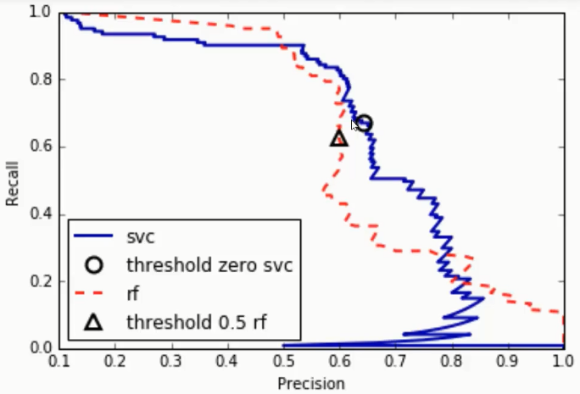

F1-score is combination of Precision and Recall. It is actually harmonic mean of Precision and recall. Maximizing F1-score means balancing Precision and Recall.

F1-score = 2 * Precision * Recall / ( Precision + Recall )

ROC curve (Receiver Operating Characteristics) is a plot of True Positive Rate (TPR/Sensitivity) against False Positive Rate (FPR) where TPR is on y-axis and FPR is on the x-axis.

False Positive Rate (FPR) = FP / (FP + TN) = FP / Actual Negatives (AN)

True Positive Rate (TPR) = TP / (FN + TP) = Recall

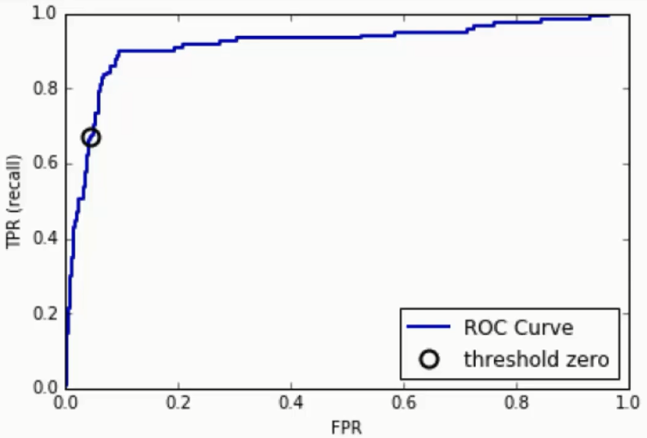

ROC curve can be used to find good trade-off point between precision and recall in certain situations.

AUC of ROC - The Area under the ROC Curve is a measure of classification model’s ability to separate classes. The possible range of area is 0 to 1. The model with higher area under the ROC curve is more capable of distinguishing between classes. When AUC is 0.7, it means there is 70% chance that model will be able to distinguish between positive class and negative class.

AUC is classification-threshold-invariant. It measures the quality of the model's predictions irrespective of what classification threshold is chosen.

In multi-class model, we can plot N number of AUC ROC Curves for N number classes using One vs ALL methodology.

Following diagrams depicts ROC curve and corresponding AOC for various prediction probability distribution. When both the distributions are equiprobable, AOC is 0.5. The more separable the probability distributions are, the more AOC is. AOC is 1 when probability distributions are clearly separable. The AOC is less than 1 when model predicts other way around (means predicts 0 for category 1 and predicts 1 for category 0).

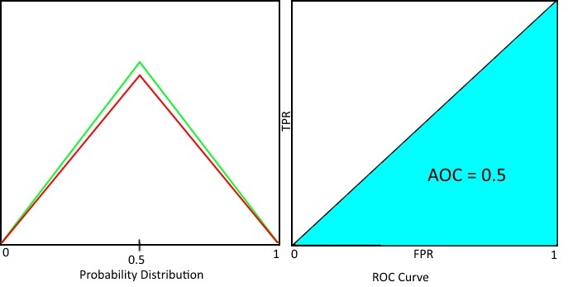

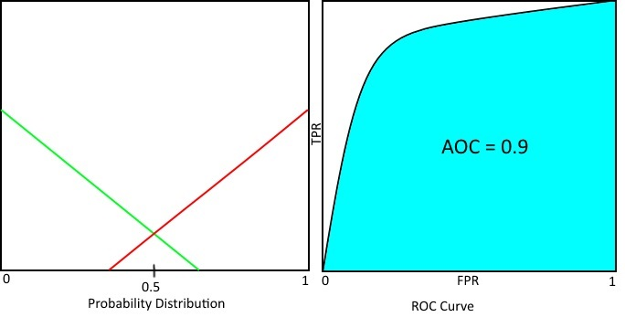

A picture containing screenshot

Description generated with high confidence

A close up of a logo

Description generated with high confidence