Hadoop Basic Commands

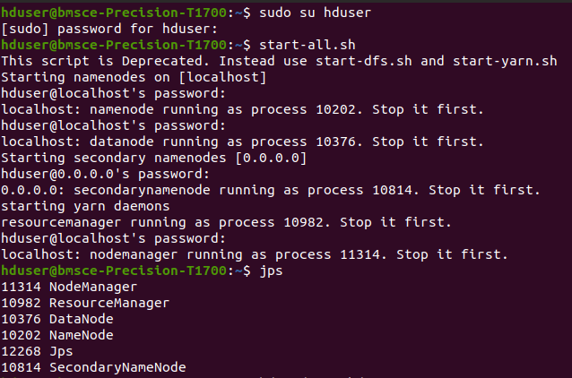
1. mkdir
2. ls

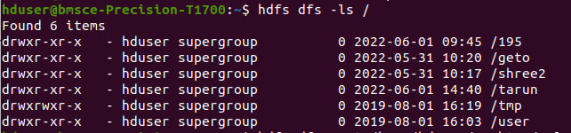
3. put
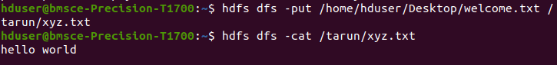
4. copyFromLocal
5. get
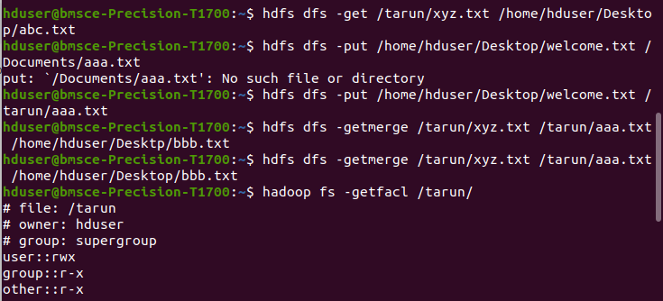
6. copyToLocal

7. cat

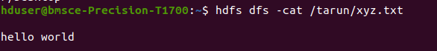
8. mv
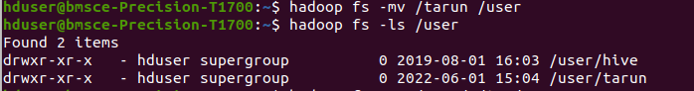
9. cp
