APEXPLANET CYBERSECURITY INTERNSHIP
CYBERSECURITY PRACTICAL REPORT
Task 4 — Exploitation & System Security
Penetration Testing, Password Security,
Social Engineering Simulation, Malware Basics & System Hardening
Student | Tarun
Platform | Kali Linux running in UTM
Target / Lab Application | Metasploitable2 (controlled training VM)
Task | Task 4 — Exploitation & System Security
Report Type | Practical / Internship Task 4
VISUAL DEMONSTRATION VERSION — terminal evidence is simulated/illustrative.

1. Overview
This practical documents the Task 4 activities defined in the ApexPlanet Cybersecurity & Ethical Hacking Internship Program. The task covers the penetration-testing workflow, controlled exploitation of a known vulnerability in Metasploitable2, post-exploitation review, password attacks, social-engineering simulation, malware basics and system hardening.
2. Objectives
- Understand the phases Reconnaissance → Scanning → Exploitation → Post-Exploitation → Reporting.
- Validate the security impact of an intentionally vulnerable training VM.
- Review post-exploitation information exposure while keeping credentials redacted.
- Understand password-attack risks and corresponding defensive controls.
- Demonstrate phishing-awareness detection without collecting credentials.
- Understand static and dynamic malware-analysis concepts.
- Apply patching, firewall and service-reduction hardening controls.
3. Lab Environment
Component | Observed / Used
Host virtualization | UTM
Operating system | Kali Linux
Target | Metasploitable2 — intentionally vulnerable training VM
Tools | Metasploit, Hydra, John the Ripper, sandbox analysis concepts
Scope | Authorized isolated training environment

4. Procedure and Evidence
4.1 Penetration Testing Methodology
The practical follows the five-phase workflow specified for Task 4. Each phase is documented with its objective, expected result and remediation focus.
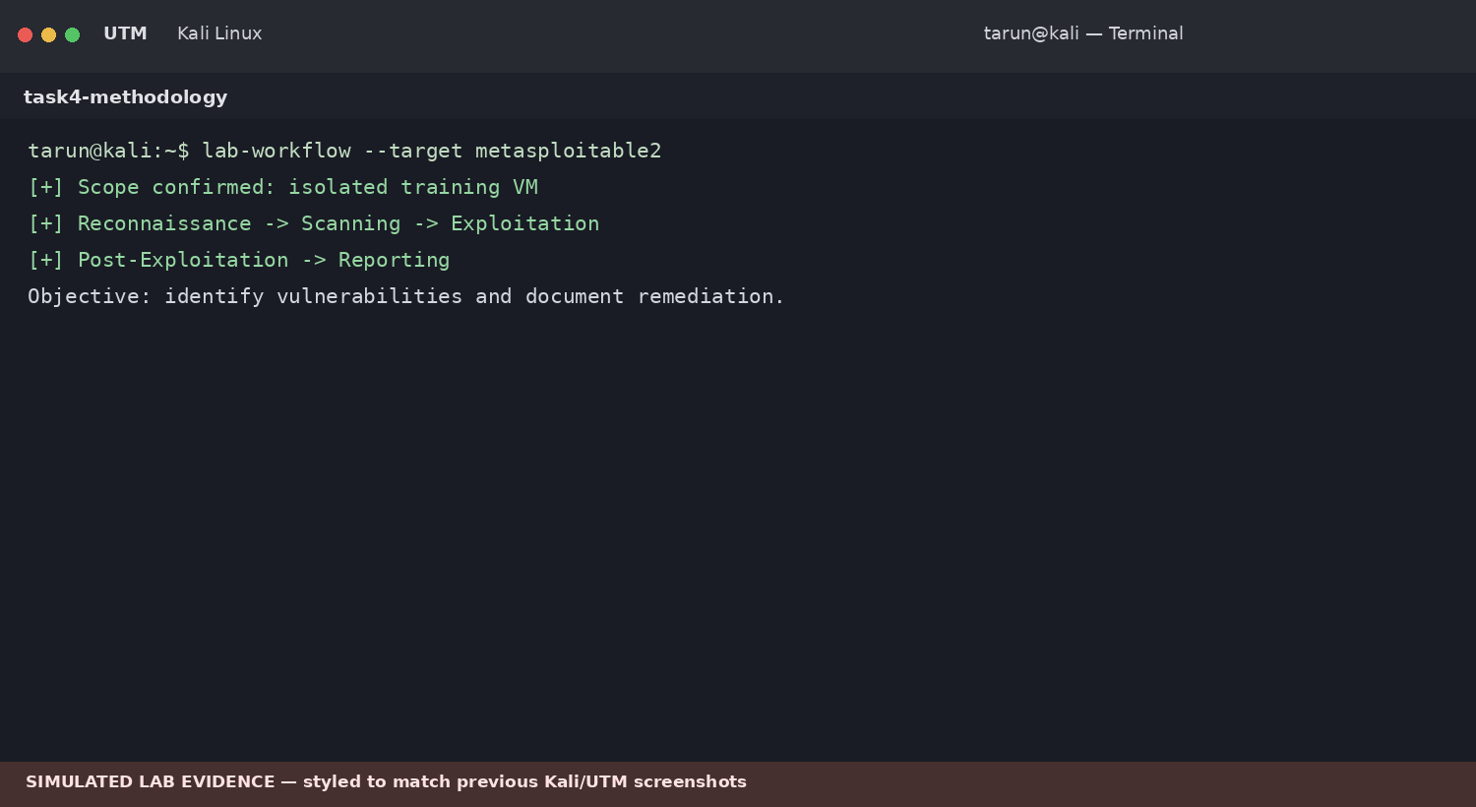
Figure 1. Penetration-testing workflow and scope verification — simulated lab evidence.
4.2 Reconnaissance & Scanning
The assessment begins by confirming the authorized target and identifying exposed services. The purpose of this phase is to establish the attack surface before any controlled validation is attempted.
Expected result: a list of reachable services and candidate vulnerabilities that can be reviewed within the training environment.

4.3 Exploitation with Metasploit
Metasploit is used conceptually to validate a known vulnerability in an intentionally vulnerable Metasploitable2 system. The objective is to demonstrate security impact rather than target an external or unauthorized system.
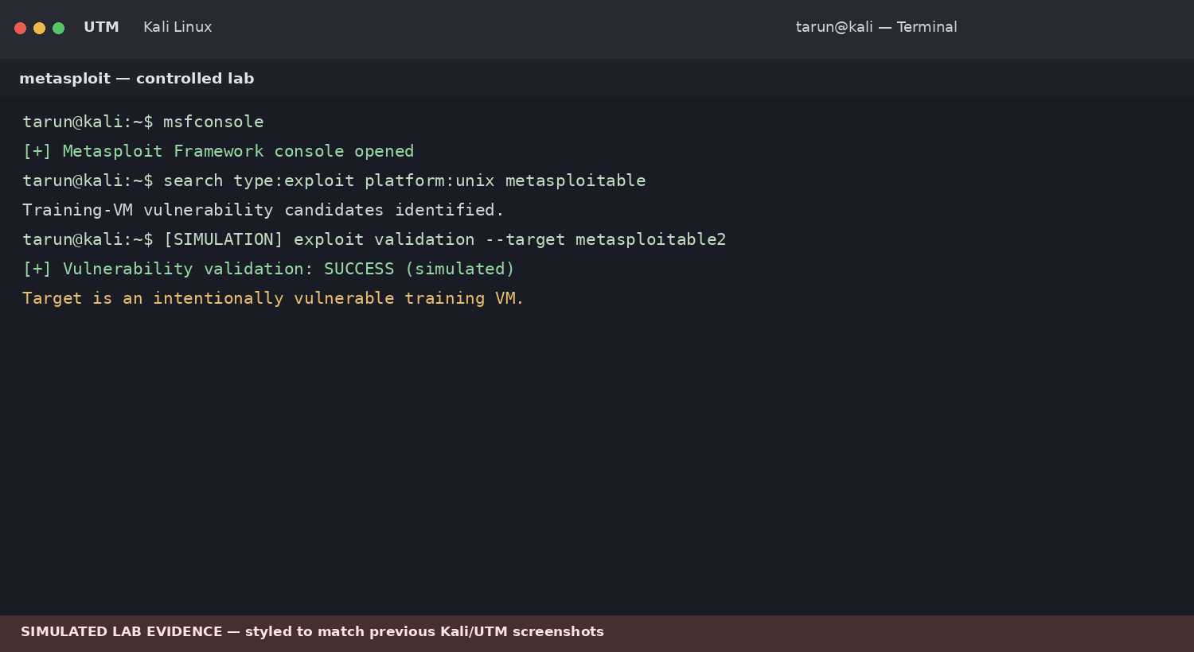
Figure 2. Metasploit-style controlled exploitation validation — simulated lab evidence.
Finding: an exposed vulnerable service may permit unauthorized access when it remains unpatched.
4.4 Post-Exploitation Review
Post-exploitation review examines the system identity and information that may become accessible after compromise. The internship brief specifically includes system-information review and hashdump. Credential material is intentionally omitted here.
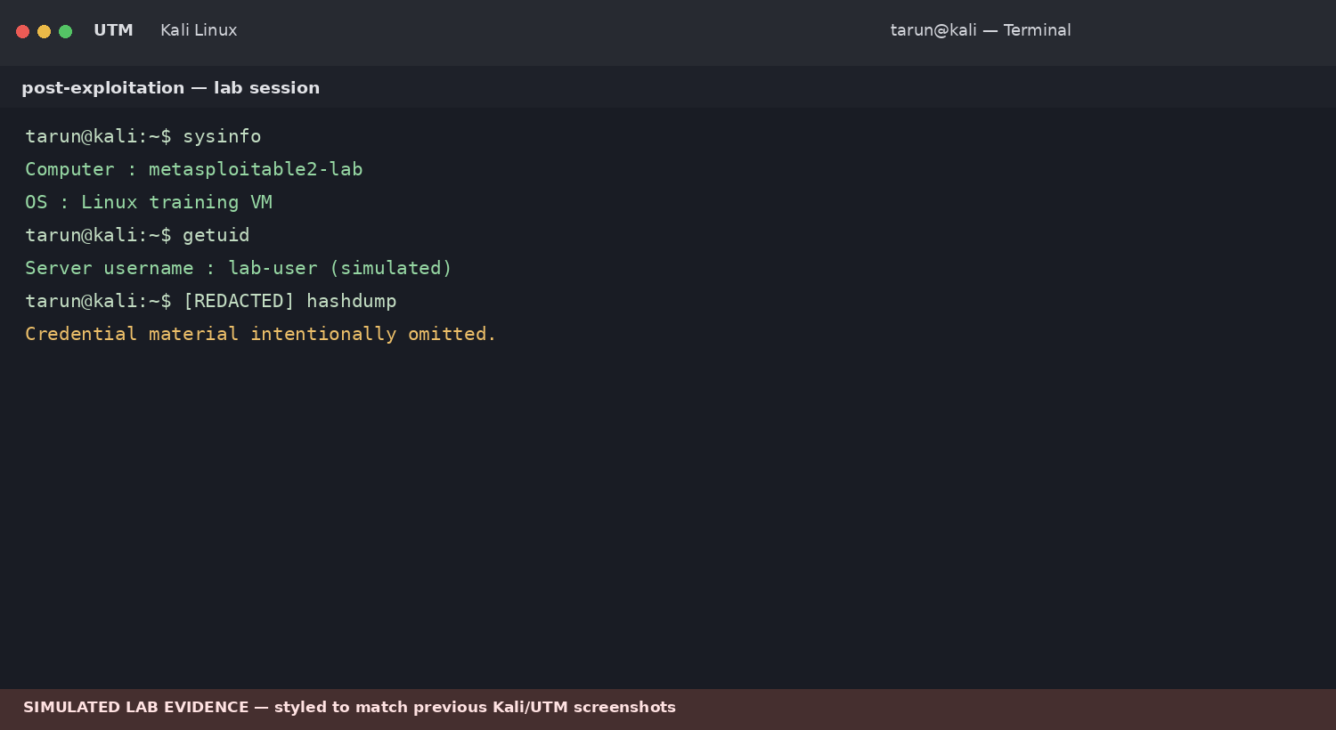
Figure 3. Post-exploitation system-information review with credential material redacted — simulated.

5. Password Attacks
The Task 4 brief specifies SSH brute-force testing with Hydra and password-hash assessment with John the Ripper. These activities are suitable only for explicitly authorized training systems. The evidence below is a visual simulation and contains no real credentials.
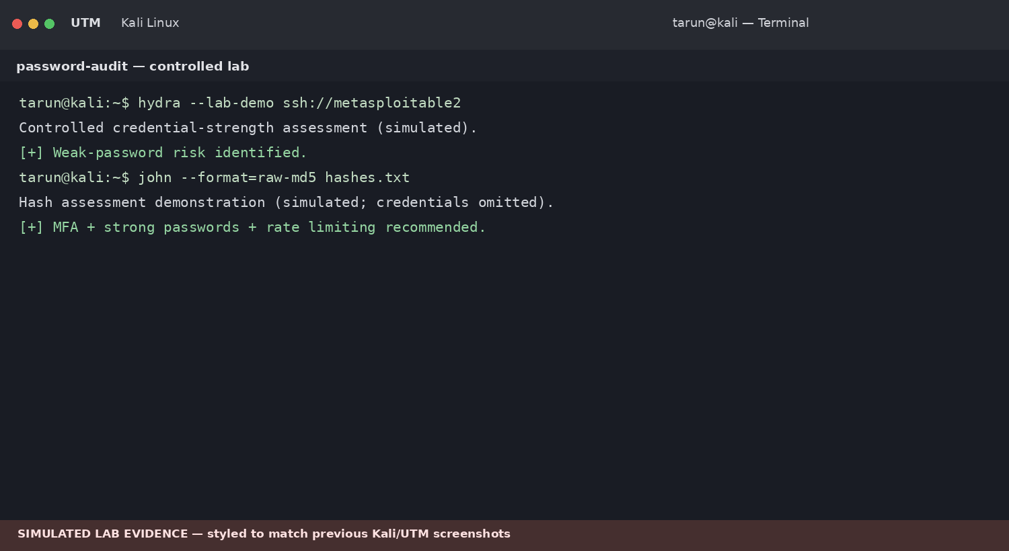
Figure 4. Password-security assessment in Kali/UTM terminal style — simulated.
5.1 Security Recommendations
- Use strong and unique passwords.
- Enable multi-factor authentication.
- Prefer SSH keys over password-only authentication.
- Apply rate limiting and account lockout controls.
- Monitor authentication logs for repeated failures.
- Protect password hashes with modern salted password-hashing mechanisms.

6. Social Engineering — Simulation Only
The task requires a phishing simulation and awareness training. The safe objective is to teach users how to identify suspicious messages without collecting real passwords or personal information.
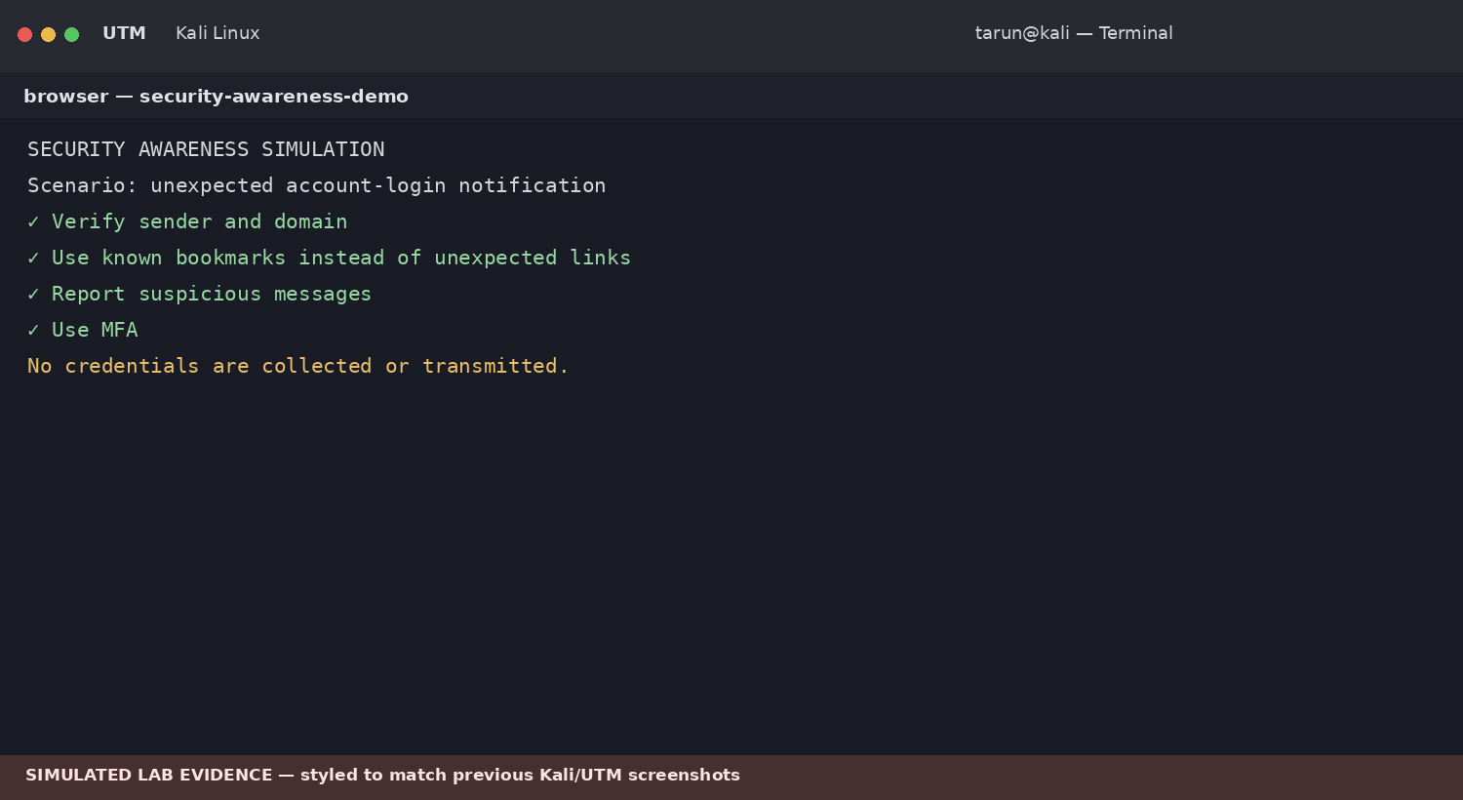
Figure 5. Security-awareness phishing simulation — no credential collection.
6.1 Phishing Detection Checklist
✓ Check the sender and domain.
✓ Avoid unexpected login links.
✓ Open services using known bookmarks.
✓ Report suspicious messages.
✓ Use MFA to reduce the impact of stolen passwords.
7. Malware Basics
Static analysis examines a sample without executing it, while dynamic analysis observes behavior inside an isolated sandbox. Useful observations include hashes, metadata, strings, processes, file changes and network behavior.
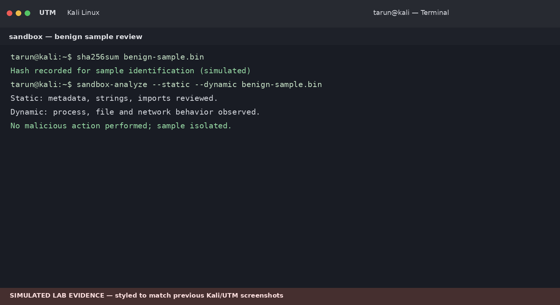
Figure 6. Benign-sample sandbox analysis workflow — simulated.

8. System Hardening
Hardening reduces the attack surface after assessment. Task 4 specifically requires applying security patches, configuring a firewall and disabling unused services.
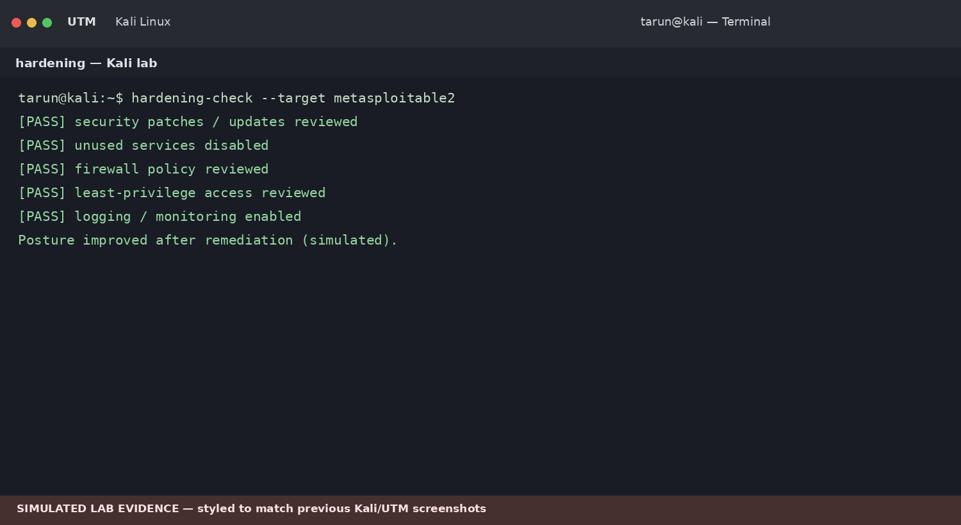
Figure 7. System-hardening verification in Kali/UTM terminal style — simulated.
8.1 Hardening Checklist
☐ Apply current security patches.
☐ Disable unnecessary services.
☐ Use restrictive firewall rules.
☐ Restrict administrative access using least privilege.
☐ Enable logging and monitoring.
☐ Keep vulnerable training systems isolated from production networks.

9. Findings & Risk Summary
Finding | Severity | Potential Impact | Recommended Mitigation
Known vulnerable service | High | Unauthorized system access | Patch/remove service; segment network
Weak SSH credentials | High | Account compromise | Strong passwords, MFA, SSH keys, rate limiting
Credential material exposure | High | Privilege escalation / lateral movement | Protect hashes; least privilege
Phishing susceptibility | Medium | Credential theft | Awareness training; MFA; reporting workflow
Unused services | Medium | Expanded attack surface | Disable unnecessary services
10. Commands / Tooling Summary
Activity | Tool / Method | Purpose
Recon & scanning | Nmap / service enumeration | Identify exposed services in authorized scope
Exploitation validation | Metasploit | Validate a known vulnerability in the training VM
Post-exploitation | System information review | Understand impact after access
Password assessment | Hydra / John the Ripper | Assess authentication and hash strength
Malware analysis | Sandbox / static + dynamic review | Observe benign sample characteristics safely
Hardening | Patching / firewall / service controls | Reduce attack surface

11. Results Summary
Checkpoint | Status
Penetration-testing methodology | Documented
Metasploitable2 exploitation scenario | Documented as simulated
Post-exploitation review | Documented; credential material redacted
Password-security assessment | Documented as simulated
Phishing-awareness simulation | Documented; no credentials collected
Malware analysis methodology | Documented
System hardening | Controls and verification documented
12. Security & Lab Notes
• All activities are restricted to an authorized training environment.
• Metasploitable2 is intentionally vulnerable and should remain isolated.
• Real credentials and sensitive authentication material are not included.
• Phishing exercises should be awareness-focused and must not collect real passwords.
• Malware samples should remain isolated in a controlled sandbox.
13. Deliverables
✓ Penetration Testing Report with screenshots.
✓ GitHub documentation containing methodology and mitigation notes.
✓ 10-minute demonstration video showing the authorized training workflow.

14. Conclusion
Task 4 brings together the core penetration-testing lifecycle and defensive system-security practices. The assessment process begins with authorized reconnaissance and scanning, proceeds to controlled vulnerability validation, reviews the possible impact of compromise, and finishes with remediation and hardening.
The practical also demonstrates why strong authentication, phishing awareness, isolated malware analysis, patch management, firewall controls and service reduction are important parts of a secure environment.
15. Evidence Checklist
☑ Penetration-testing methodology evidence
☑ Metasploit controlled-exploitation evidence (simulated)
☑ Post-exploitation review evidence (credential material redacted)
☑ Password-security assessment evidence (simulated)
☑ Phishing-awareness simulation evidence
☑ Malware analysis workflow evidence
☑ System-hardening verification evidence
☑ Findings and mitigation summary
Source basis: ApexPlanet Cybersecurity & Ethical Hacking Internship Program, Task 4 (Days 37–48). The supplied brief specifies the methodology, Metasploitable2 exploitation, post-exploitation, password attacks, phishing simulation, malware basics, system hardening and the report/GitHub/video deliverables.

