CYBERSECURITY
PRACTICAL REPORT
Task 2 — Metasploitable2 Network & Web Security Assessment
Student Name: Tarun Lochab
Platform: Kali Linux running in UTM
Target / Lab Application: Metasploitable2
Target IP: 192.168.64.3
Task Date: 09 September 2026
Report Type: Practical / Internship Task 2

All activities documented in this report were performed against the intentionally vulnerable Metasploitable2 virtual machine inside the local cybersecurity lab environment.

1. Overview
This practical documents the reconnaissance and security assessment of a controlled Metasploitable2 laboratory host. The work covered HTTP response inspection, network/service discovery, FTP enumeration, SMB/NetBIOS enumeration, web-server assessment with Nikto, and packet-level HTTP observation with Wireshark.

2. Objectives
- Identify exposed network services and versions on the Metasploitable2 host.
- Verify the HTTP service and inspect HTTP response headers and accessible resources.
- Assess the web service for common configuration and information-disclosure issues.
- Enumerate FTP and verify whether anonymous login is permitted.
- Enumerate SMB shares, protocol support and anonymous-access permissions.
- Capture and inspect HTTP request/response traffic using Wireshark.
- Record evidence and results suitable for an internship task submission.

3. Lab Environment
Component | Observed / Used | Purpose
Attacker / Analyst | Kali Linux in UTM | Security testing and enumeration
Target | Metasploitable2 | Intentionally vulnerable lab VM
Target IP | 192.168.64.3 | Lab target address
Web service | Apache 2.2.8 / DAV/2 | HTTP assessment
FTP | vsftpd 2.3.4 | FTP enumeration
SMB | Samba 3.0.20-Debian | SMB enumeration
Tools | Nmap, curl, Nikto, FTP, smbclient, Wireshark | Assessment and evidence

4. Procedure and Evidence

4.1 Verify the Metasploitable2 Web Service
The target HTTP service was checked using curl. The response identified Apache/2.2.8 (Ubuntu) with DAV/2 and PHP/5.2.4-2ubuntu5.10. The root response also displayed the Metasploitable2 landing page and links to training applications.
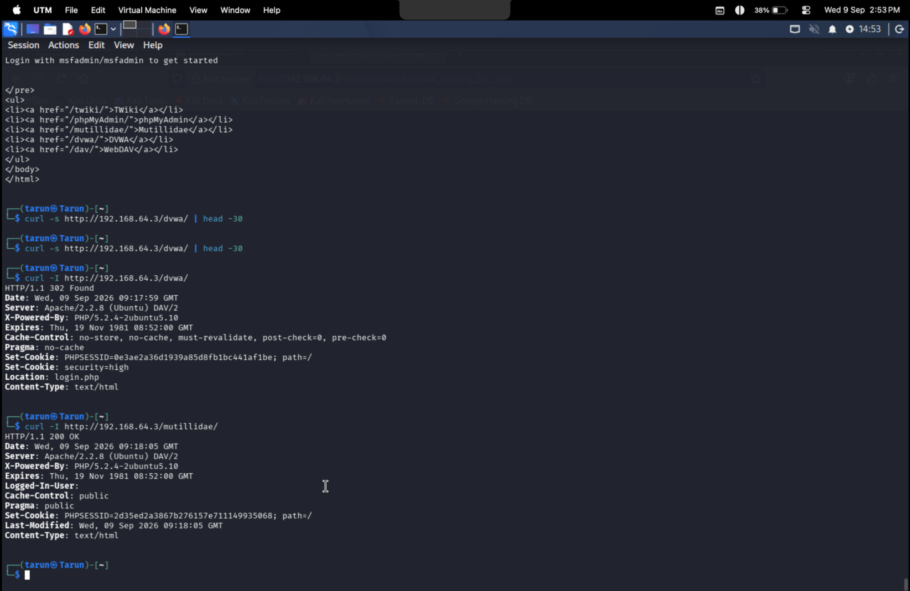
Figure 1. HTTP response from 192.168.64.3 showing Metasploitable2 and server/runtime information.

4.2 Check WebDAV OPTIONS
An HTTP OPTIONS request to /dav/ returned HTTP/1.1 200 OK. The Allow header listed methods including OPTIONS, GET, HEAD, POST, DELETE, TRACE, PROPFIND, PROPPATCH, COPY, MOVE, LOCK and UNLOCK. This confirms a broad WebDAV method surface on the lab endpoint.

4.3 Perform Nmap Service Discovery
Nmap service/version discovery identified TCP services on ports 21, 22, 80, 139 and 445. The scan identified vsftpd 2.3.4, OpenSSH 4.7p1, Apache httpd 2.2.8 (Ubuntu) with DAV/2, and Samba services.
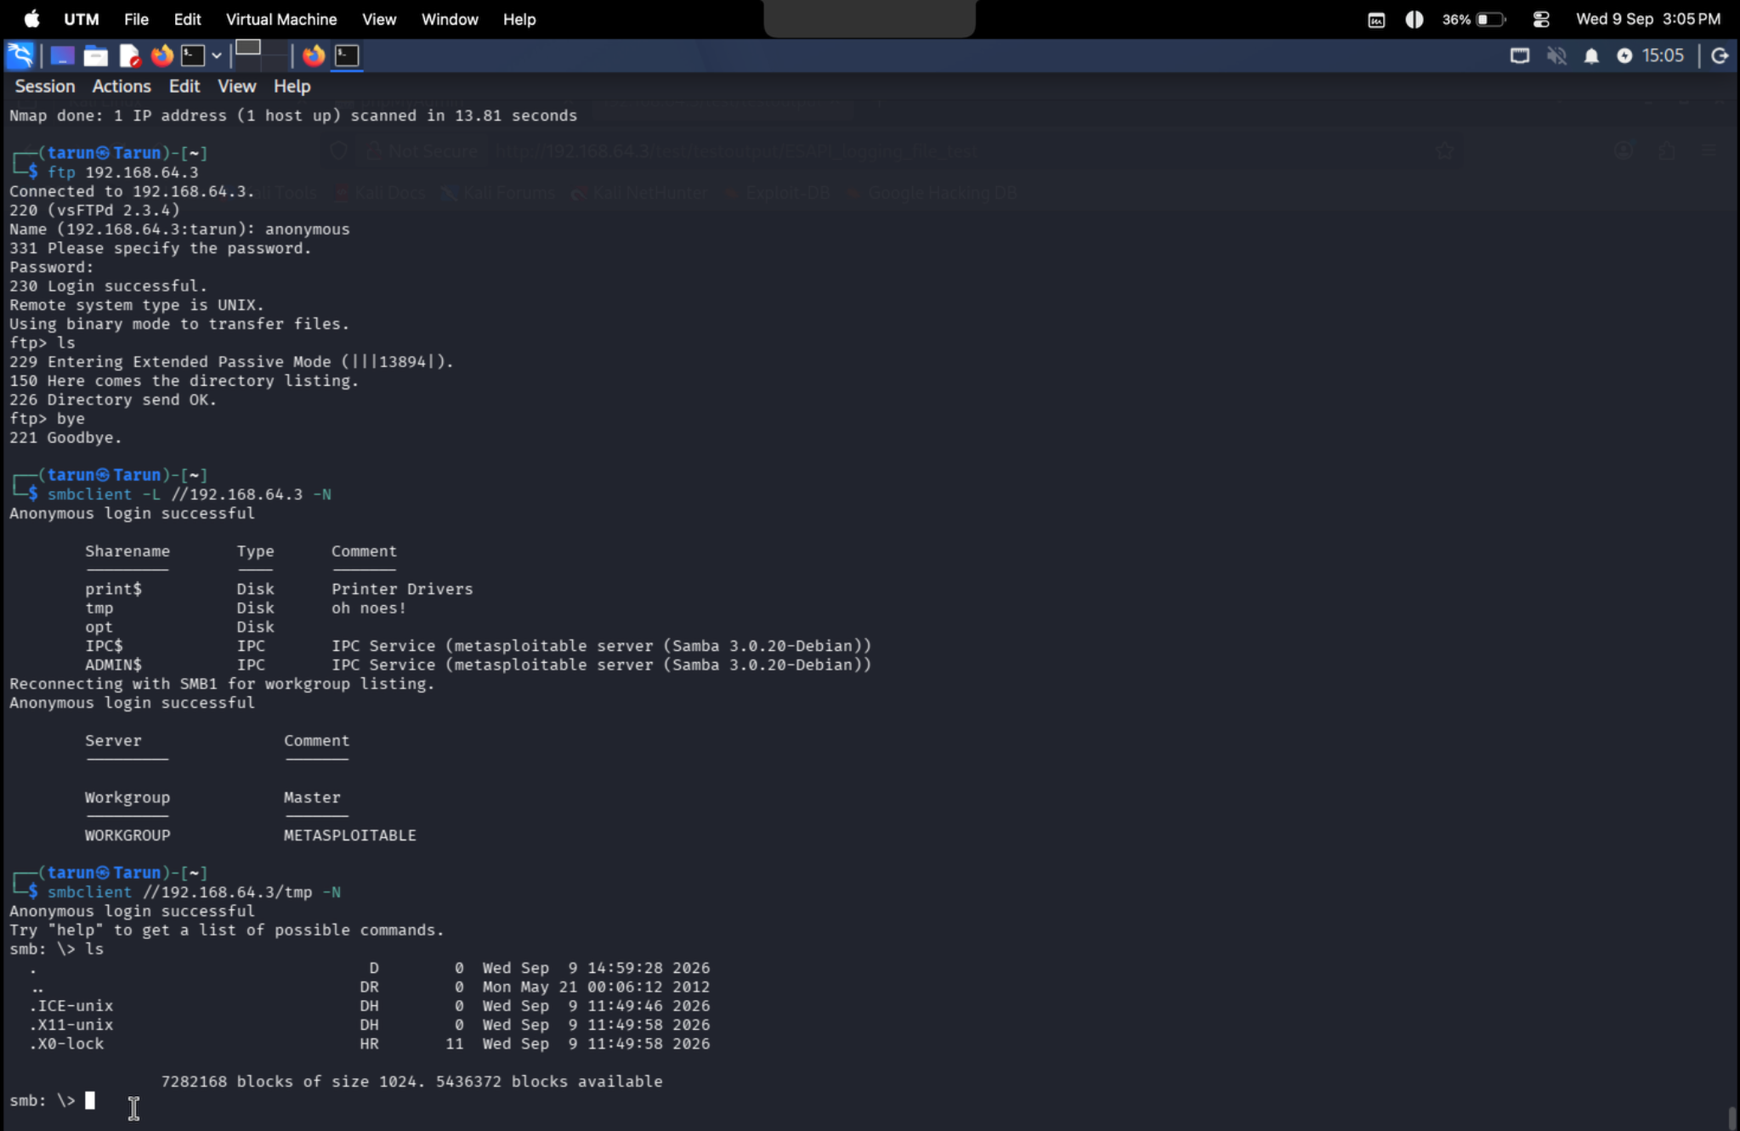
Figure 2. Nmap service/version discovery against 192.168.64.3.

4.4 Service Inventory
Port | State | Service | Version / Observation
21/tcp | open | ftp | vsftpd 2.3.4; anonymous FTP allowed
22/tcp | open | ssh | OpenSSH 4.7p1 Debian 8ubuntu1
80/tcp | open | http | Apache 2.2.8 (Ubuntu) / DAV/2
139/tcp | open | netbios-ssn | Samba/NetBIOS
445/tcp | open | microsoft-ds | Samba 3.0.20-Debian

4.5 Assess the Web Service with Nikto
Nikto reported multiple web-server and application findings. The scan identified outdated PHP and Apache versions, directory indexing, exposed directories/resources, missing recommended security headers, an active HTTP TRACE method, and phpMyAdmin-related information.
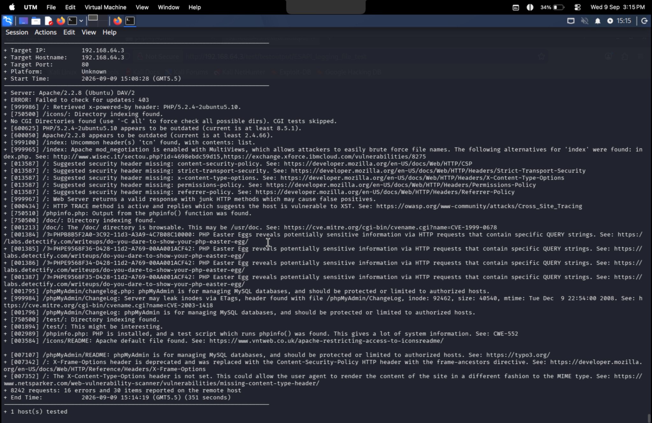
Figure 3. Nikto web assessment results for 192.168.64.3.

4.6 Web Findings Recorded
- PHP/5.2.4-2ubuntu5.10 reported as outdated.
- Apache/2.2.8 reported as outdated.
- Directory indexing found for locations including /icons/, /doc/ and /test/.
- phpMyAdmin and other application resources were identified.
- HTTP TRACE was active and the scanner associated the configuration with XST risk.
- Recommended headers including Content-Security-Policy, Strict-Transport-Security, X-Content-Type-Options, Permissions-Policy and Referrer-Policy were reported missing.
- The scan also reported PHP information-disclosure related findings.

4.7 Capture HTTP Traffic with Wireshark
Wireshark was used to capture HTTP traffic between the Kali system and 192.168.64.3. The capture shows a GET request from 192.168.64.2 to the target followed by an HTTP/1.1 200 OK response.
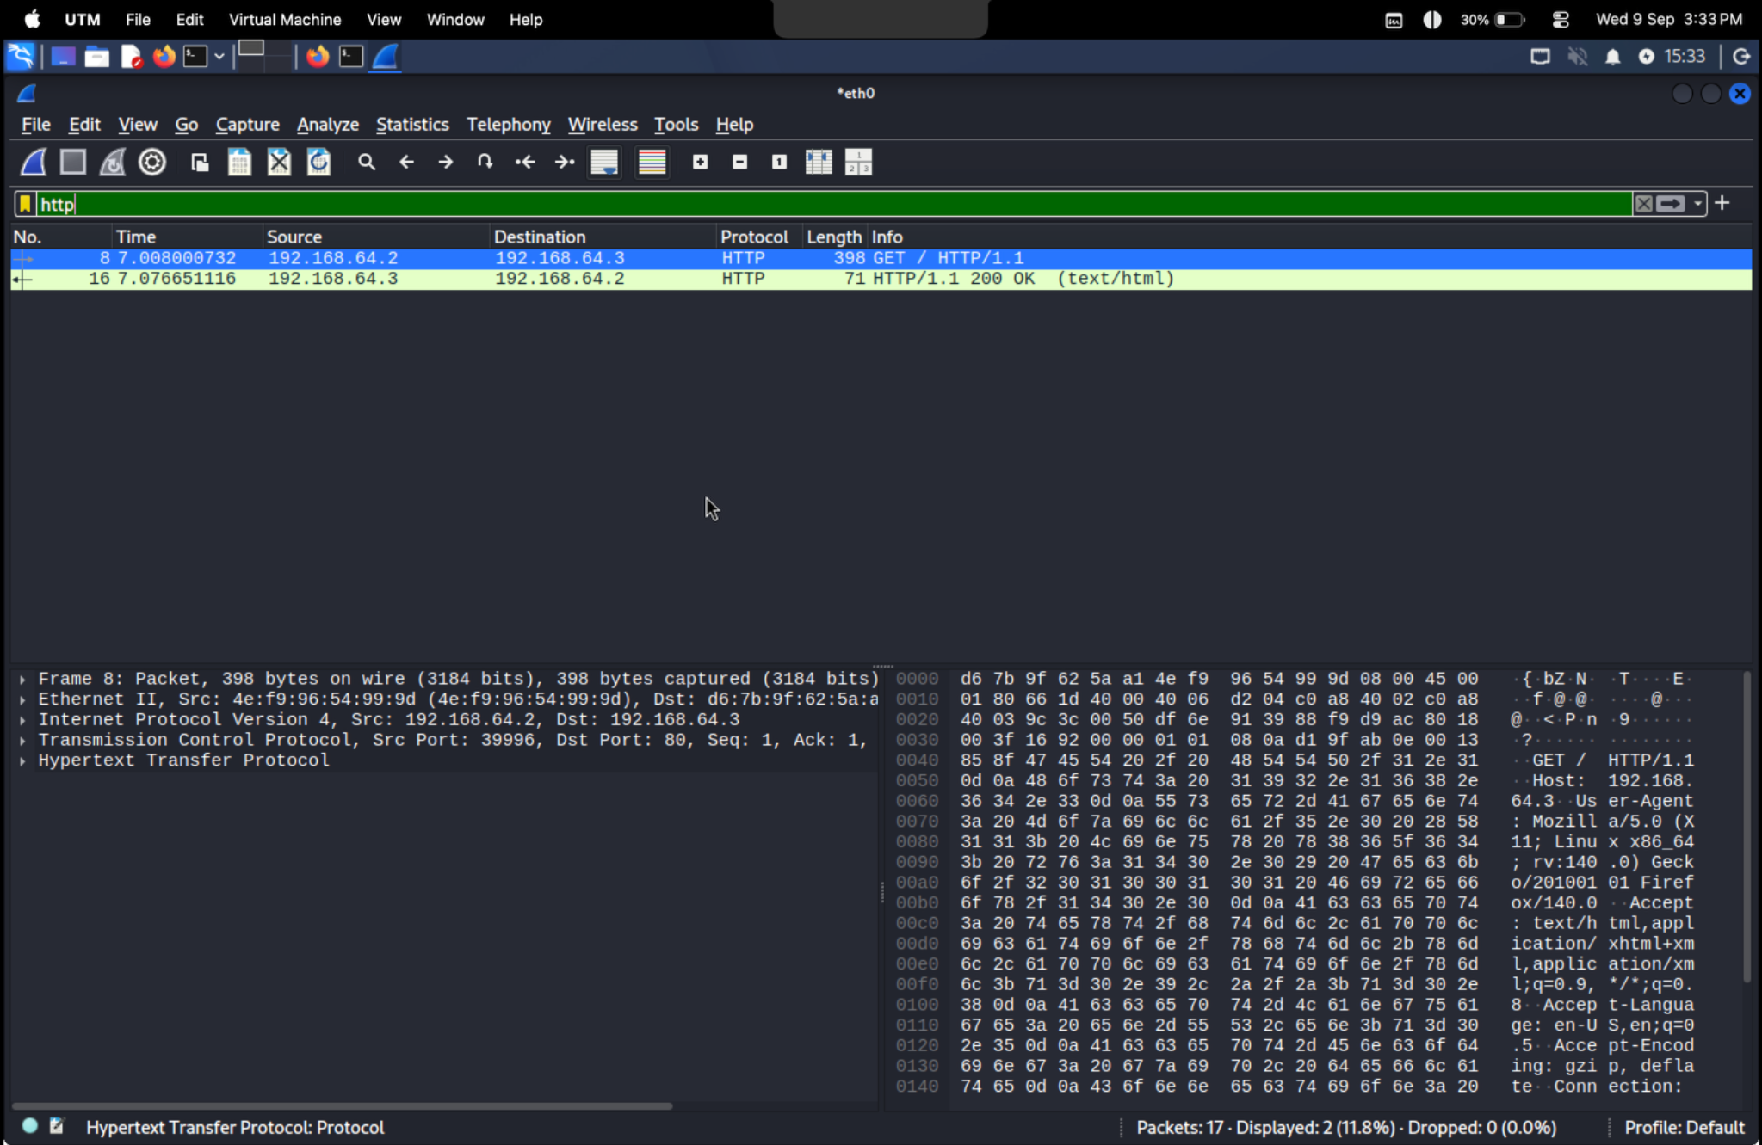
Figure 4. Wireshark HTTP GET request from 192.168.64.2 to 192.168.64.3.
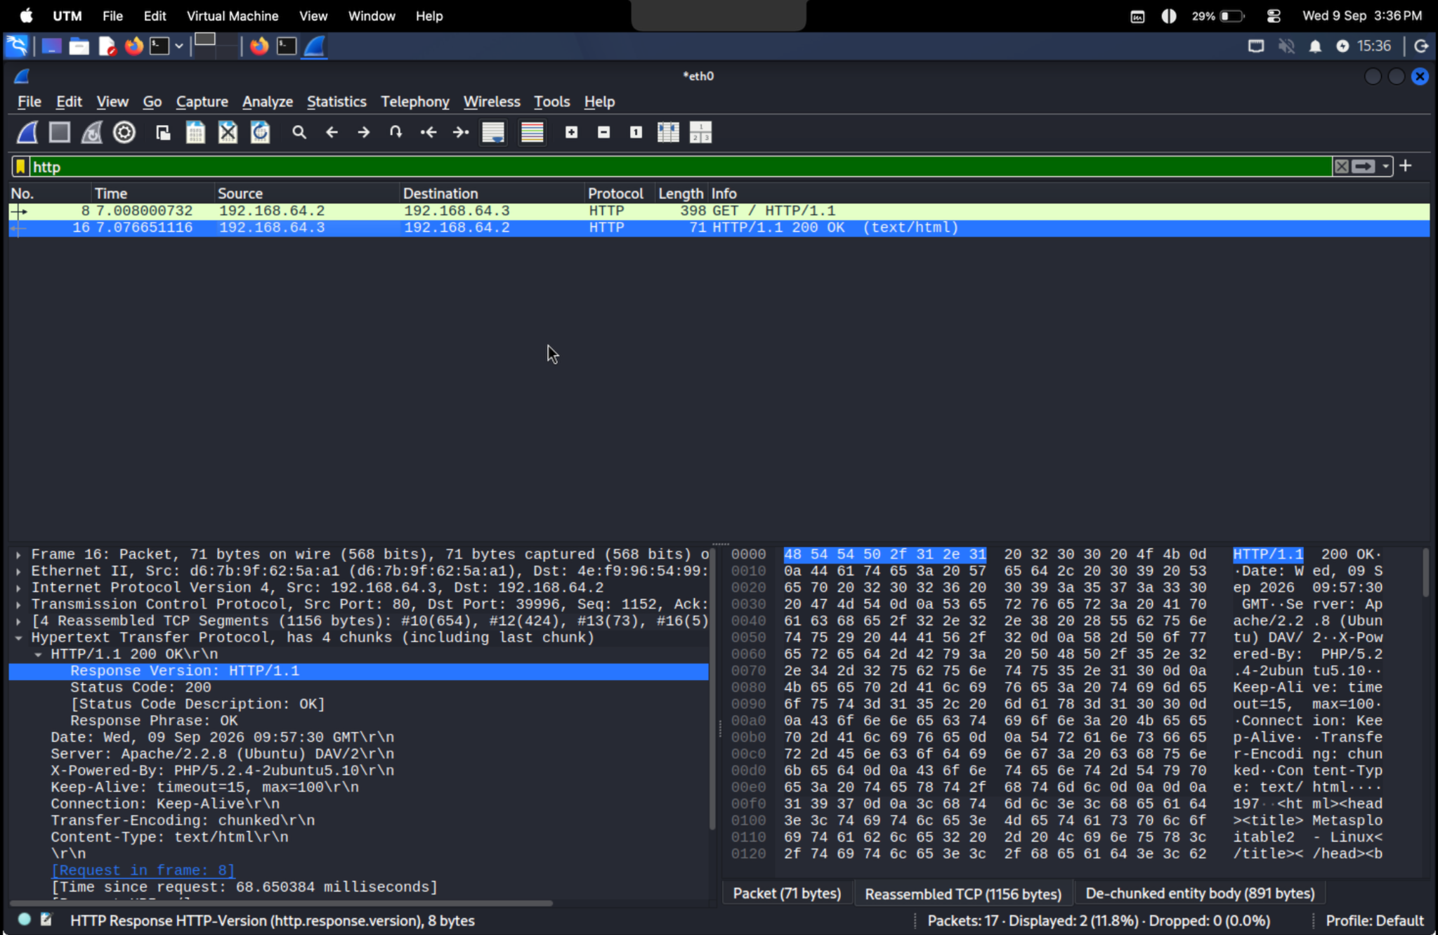
Figure 5. Wireshark HTTP/1.1 200 OK response and visible server/runtime headers.

4.8 Enumerate FTP
Nmap FTP scripts confirmed that the FTP service is vsftpd 2.3.4 and that anonymous FTP login is allowed. A manual FTP connection also returned a successful 230 Login successful response for the anonymous account.
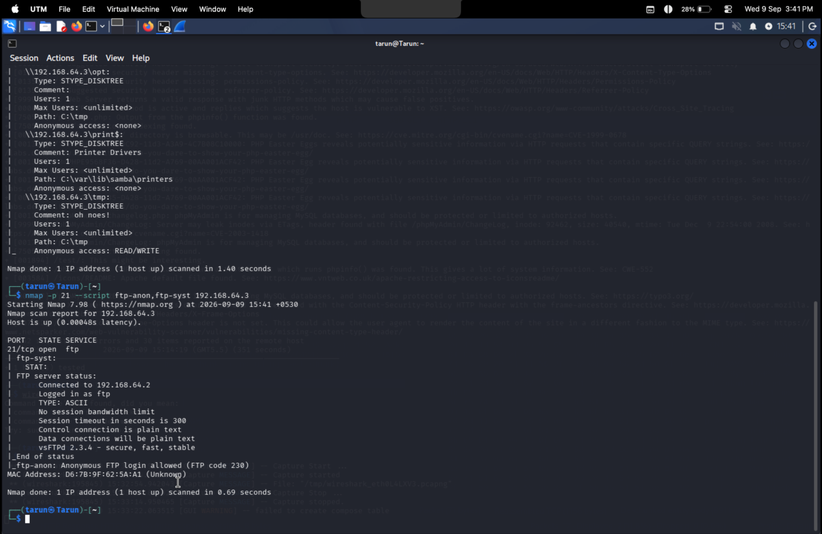
Figure 6. FTP connection showing successful anonymous login and directory listing.

4.9 FTP Security Observation
The scan also recorded that the FTP control and data connections are transmitted in plaintext. Anonymous access and plaintext FTP increase the possibility of unauthorized data exposure in a non-isolated environment.

4.10 Enumerate SMB Shares
SMB enumeration identified the WORKGROUP workgroup and the Metasploitable server. The available shares included print$, tmp, opt, IPC$ and ADMIN$. Anonymous login was successful during share enumeration.
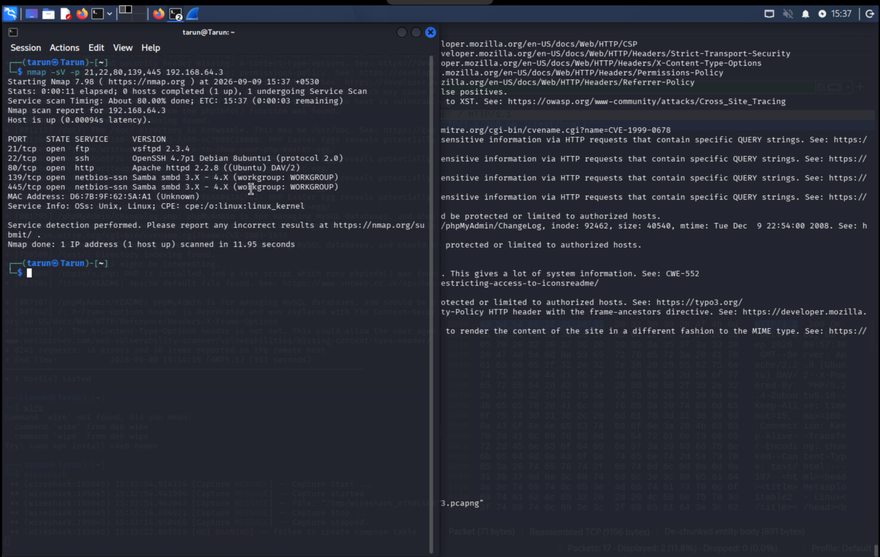
Figure 7. SMB/NetBIOS enumeration showing shares and successful anonymous login.

4.11 SMB Protocol Observation
Nmap SMB protocol enumeration reported NT LM 0.12 (SMBv1) as supported and explicitly described SMBv1 as dangerous/legacy.

4.12 Verify SMB Share Access
The smbclient session against the tmp share showed successful anonymous login and a directory listing. The listing contained entries such as .ICE-unix, X11-unix and X0-lock.
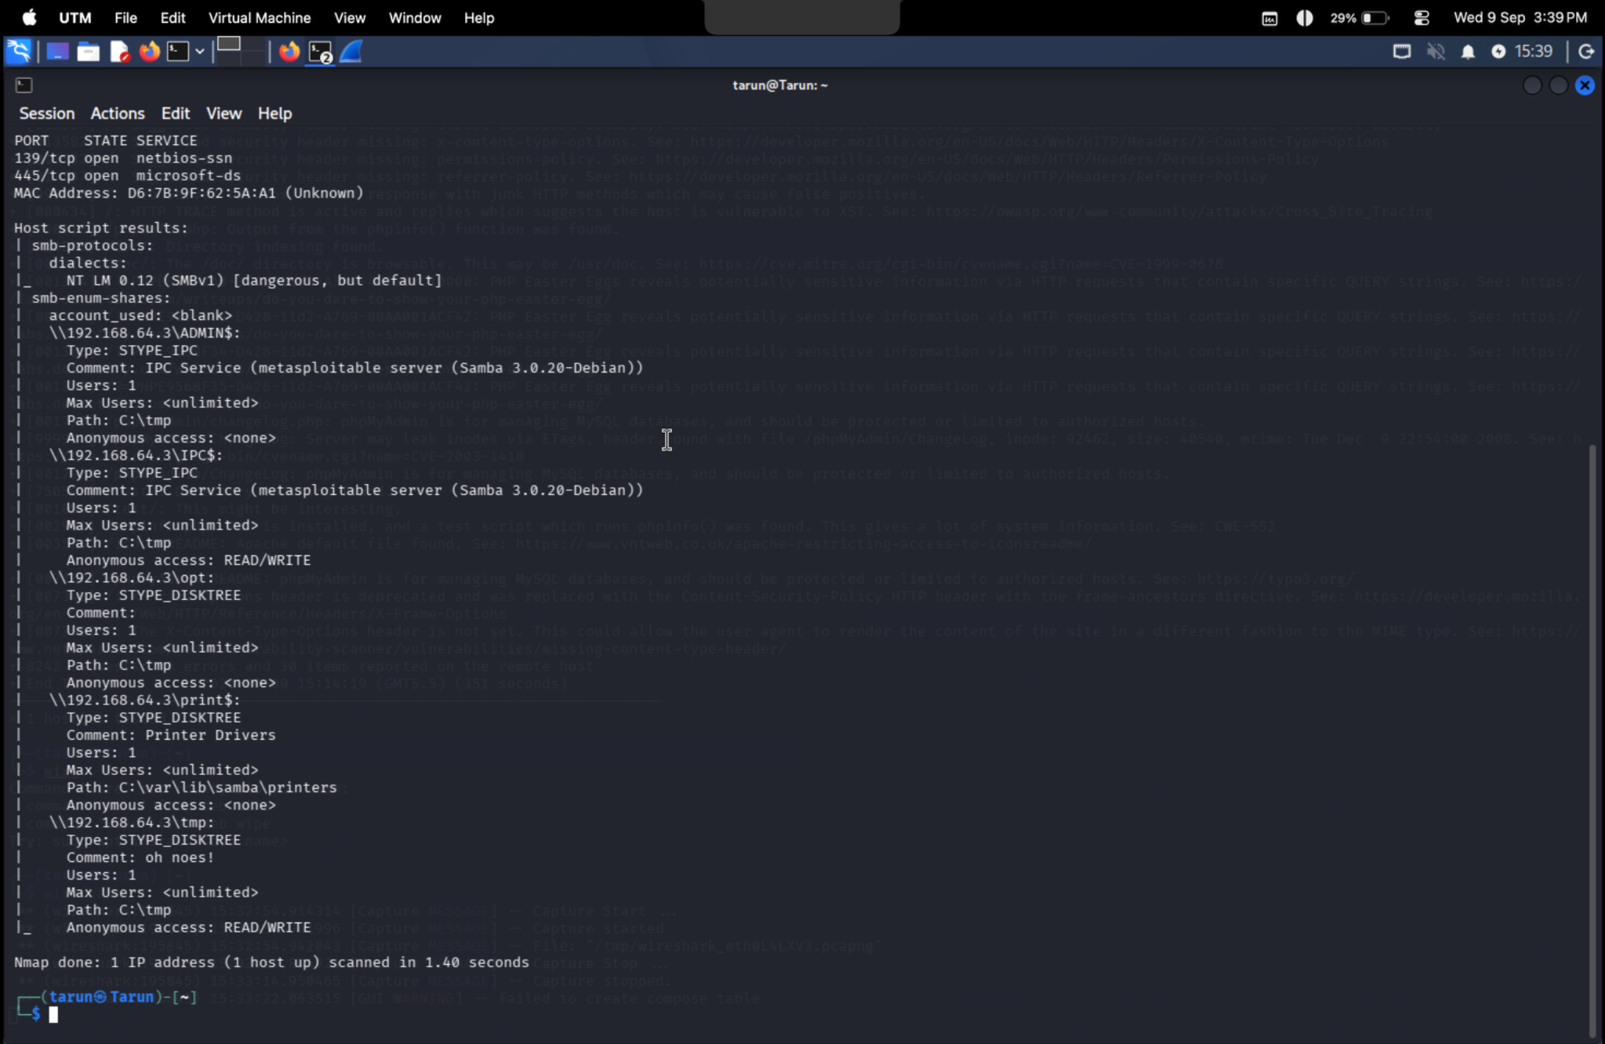
Figure 8. Anonymous smbclient access to the tmp share and directory listing.

4.13 Share Permissions Identified
Share | Anonymous access observed | Assessment
ADMIN$ | None | Restricted in captured enumeration
IPC$ | READ/WRITE | High-risk anonymous access
opt | None | Restricted in captured enumeration
print$ | None | Restricted in captured enumeration
tmp | READ/WRITE | High-risk anonymous access

5. Findings and Risk Assessment
ID | Finding | Severity | Evidence / Impact
F-01 | Anonymous FTP login | Medium | Anonymous account accepted; potential data exposure.
F-02 | SMBv1 supported | High | Legacy SMB dialect exposed on 139/445.
F-03 | Anonymous SMB READ/WRITE | High | IPC$ and tmp reported READ/WRITE access.
F-04 | Outdated Apache/PHP | High | Apache 2.2.8 and PHP 5.2.4 identified as outdated.
F-05 | Directory indexing/exposed resources | Medium | Directory listings and multiple application paths discovered.
F-06 | TRACE + missing security headers | Medium | Web hardening weaknesses reported by Nikto.
F-07 | Version/information disclosure | Low–Medium | Server/runtime details visible in HTTP responses.

6. Recommendations
- Disable anonymous FTP unless there is a documented requirement; prefer secure file-transfer mechanisms.
- Disable SMBv1 and require modern SMB protocols.
- Remove anonymous READ/WRITE permissions from SMB shares and enforce least privilege.
- Replace unsupported Apache/PHP versions with supported releases and maintain regular patching.
- Disable directory indexing where it is not required and remove unnecessary test/administrative applications.
- Disable HTTP TRACE where it is not needed and configure appropriate security headers.
- Minimize server/version disclosure and protect diagnostic and administrative interfaces.

7. Commands and Key Results
Activity | Command / Tool | Observed Result
HTTP header check | curl -i -X OPTIONS http://192.168.64.3/ | HTTP 200; Apache/DAV and PHP information observed.
WebDAV check | curl -i -X OPTIONS http://192.168.64.3/dav/ | HTTP 200; WebDAV methods exposed.
Service discovery | nmap -sV -p 21,22,80,139,445 192.168.64.3 | FTP, SSH, HTTP and SMB services identified.
FTP enumeration | nmap -p 21 --script ftp-anon,ftp-syst 192.168.64.3 | vsftpd 2.3.4; anonymous FTP allowed.
FTP verification | ftp 192.168.64.3 | Anonymous login successful.
SMB share enumeration | smbclient -L //192.168.64.3 -N | Anonymous login; shares enumerated.
SMB access check | smbclient //192.168.64.3/tmp -N | Anonymous login; directory listing accessible.
SMB protocol/share scan | nmap -p 139,445 --script smb-enum-shares,smb-protocols 192.168.64.3 | SMBv1 and share permissions reported.
Web assessment | nikto -h http://192.168.64.3 | Outdated components, indexing, headers and web findings reported.
Traffic analysis | Wireshark | HTTP GET and HTTP 200 response captured.

8. Results Summary
Checkpoint | Status
Target host reachable | Verified during Nmap/service assessment
HTTP service | Apache 2.2.8 / DAV/2 identified
FTP service | vsftpd 2.3.4; anonymous login confirmed
SMB service | Samba 3.0.20-Debian; SMBv1 identified
Anonymous SMB access | READ/WRITE observed for IPC$ and tmp
Web assessment | Nikto completed with multiple findings
Wireshark | HTTP request/response traffic captured

9. Security and Lab Notes
- Metasploitable2 is intentionally vulnerable and should remain inside an isolated/controlled training environment.
- The target used in this practical was the local lab host 192.168.64.3.
- The report documents reconnaissance and configuration findings; it does not claim successful exploitation of the identified issues.
- Anonymous access and legacy services should never be exposed to an untrusted production network.
- Captured traffic should be used only for authorized security analysis.

10. Conclusion
Task 2 was completed successfully in the controlled Kali Linux/UTM laboratory. The assessment identified exposed FTP, SSH, HTTP and SMB services and documented several significant security weaknesses, including anonymous FTP access, SMBv1 support, anonymous SMB READ/WRITE access, outdated web components, directory indexing, and web hardening deficiencies. The included screenshots provide evidence for the major stages of the practical.

11. Evidence Checklist
- ☑ HTTP/WebDAV response evidence
- ☑ Nmap service/version discovery evidence
- ☑ Nikto web assessment evidence
- ☑ Wireshark HTTP request/response evidence
- ☑ FTP anonymous-login evidence
- ☑ SMB share enumeration evidence
- ☑ Anonymous SMB share-access evidence

