CYBERSECURITY
PRACTICAL REPORT
Task 1 — Virtual Lab Setup, Network Verification,
Traffic Capture, Encryption & File Permissions

Student | Tarun
Platform | Kali Linux running in UTM
Target / Lab Application | Damn Vulnerable Web Application (DVWA)
Task Date | 17 August 2026
Report Type | Practical / Internship Task 1

All activities documented in this report were performed inside the local virtual lab environment.

1. Overview
This practical documents the setup and verification of a controlled cybersecurity laboratory using Kali Linux in UTM and the Damn Vulnerable Web Application (DVWA). The work covered environment verification, local web-application access, network configuration checks, connectivity testing, Nmap service discovery, Wireshark traffic capture, OpenSSL-based AES-256-CBC encryption/decryption, and Linux file-permission management.

2. Objectives
- Verify that the Kali Linux virtual machine and its network interface are operational.
- Run and access DVWA in the local lab environment.
- Identify the lab IP address and verify connectivity with ping and traceroute.
- Perform a basic Nmap scan of the local DVWA service.
- Capture and observe local HTTP/TCP traffic using Wireshark.
- Create a text file, encrypt it using OpenSSL AES-256-CBC, and successfully decrypt it.
- Demonstrate Linux file permission management using chmod 644.
- Record evidence and results suitable for an internship task submission.

3. Lab Environment
Component | Observed / Used | Purpose
Host virtualization | UTM | Run the isolated Kali Linux lab
Operating system | Kali Linux | Cybersecurity tools and terminal work
Web application | DVWA | Controlled vulnerable web application
Network interface | eth0 | Lab network connectivity
Observed IP | 192.168.64.2/24 | Lab interface address
Loopback | 127.0.0.1 | Local DVWA/service testing
Tools | Nmap, Wireshark, OpenSSL, Linux utilities | Verification and practical exercises

4. Procedure and Evidence

4.1 Start the Kali Linux Lab
The Kali Linux virtual machine was started using UTM. The desktop and terminal were available for the practical. The environment was then updated with the apt package-list update operation before continuing with the lab.
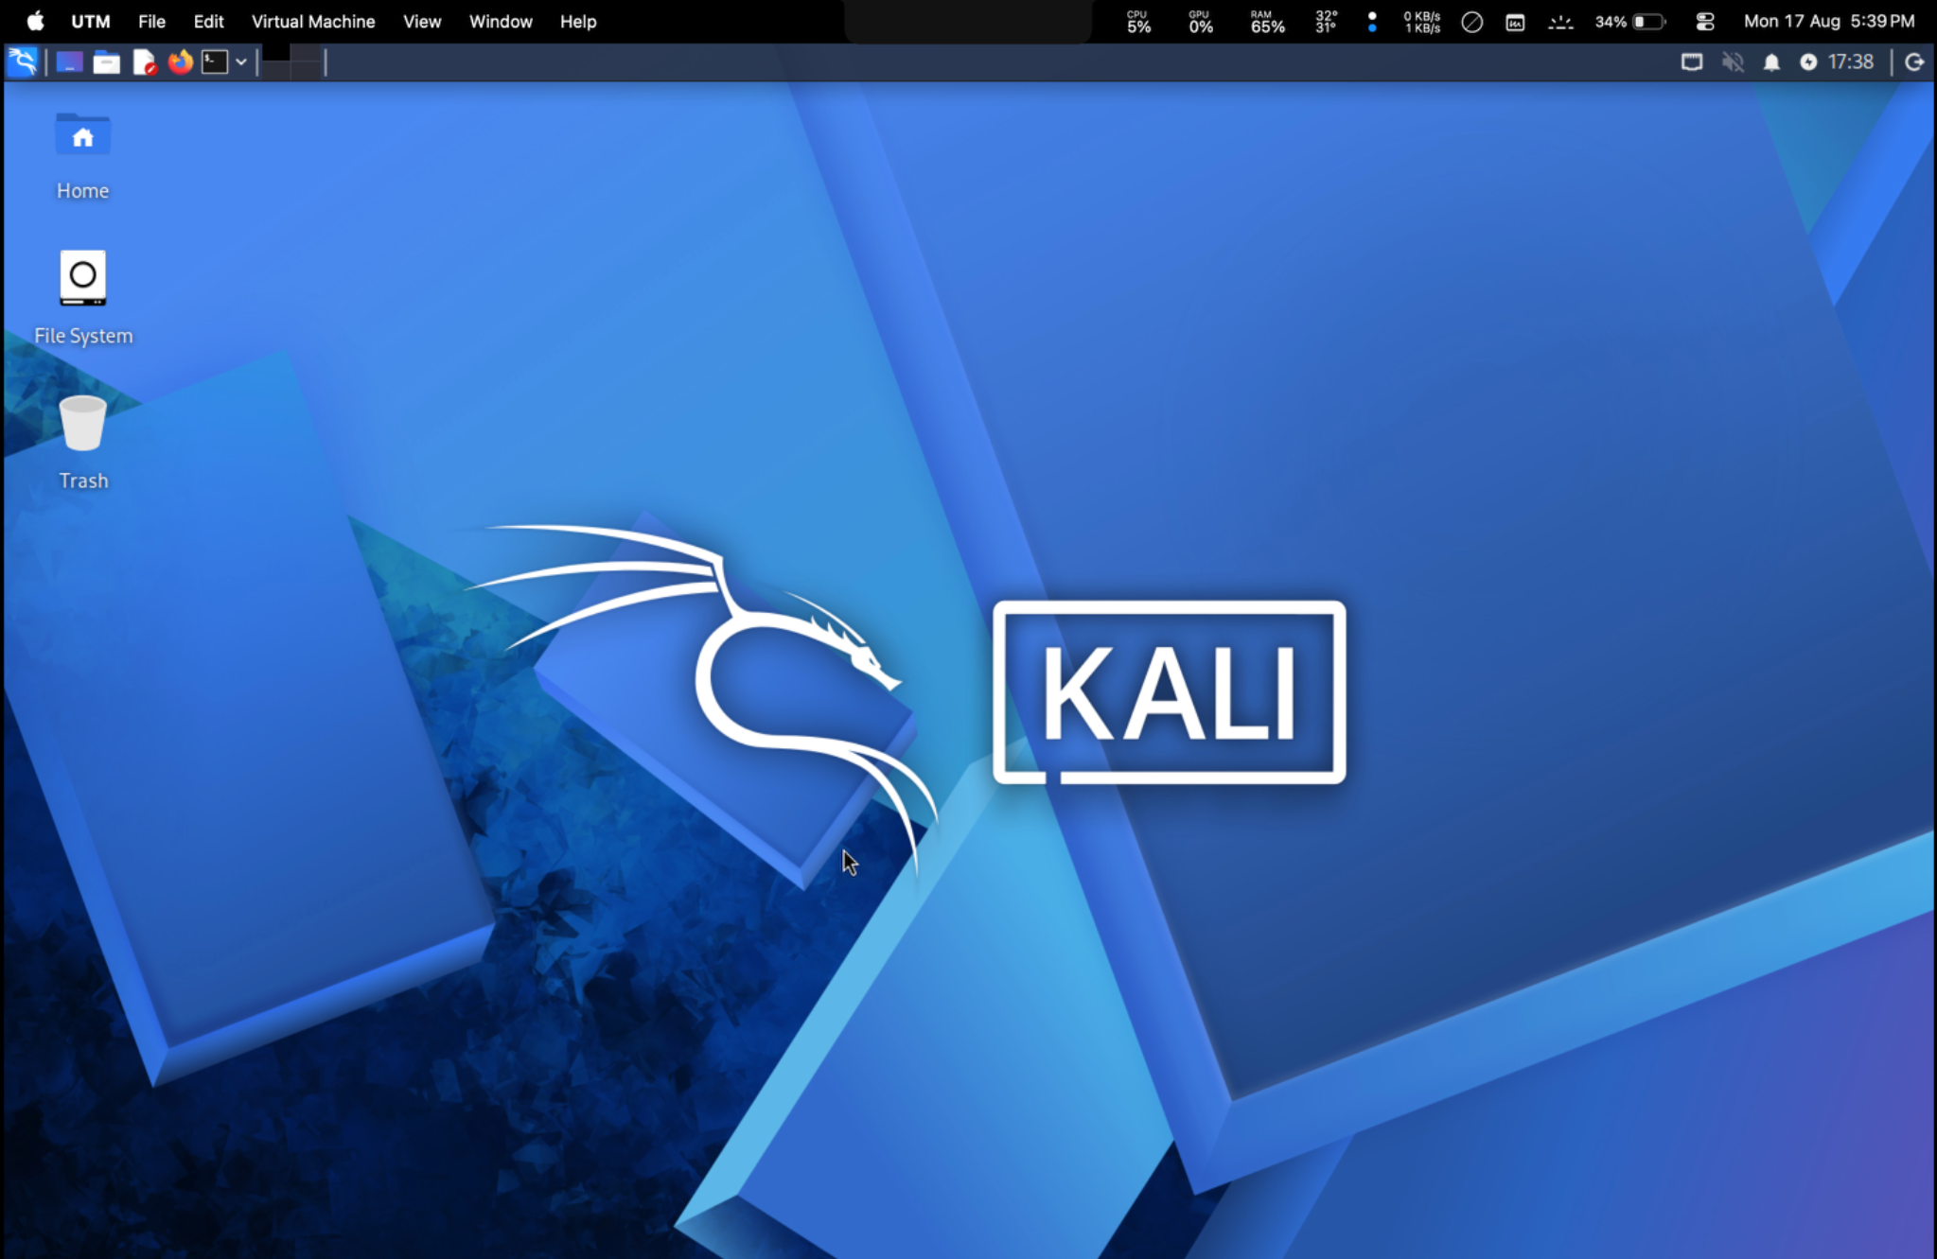
Figure 1. Kali Linux virtual machine running in UTM.
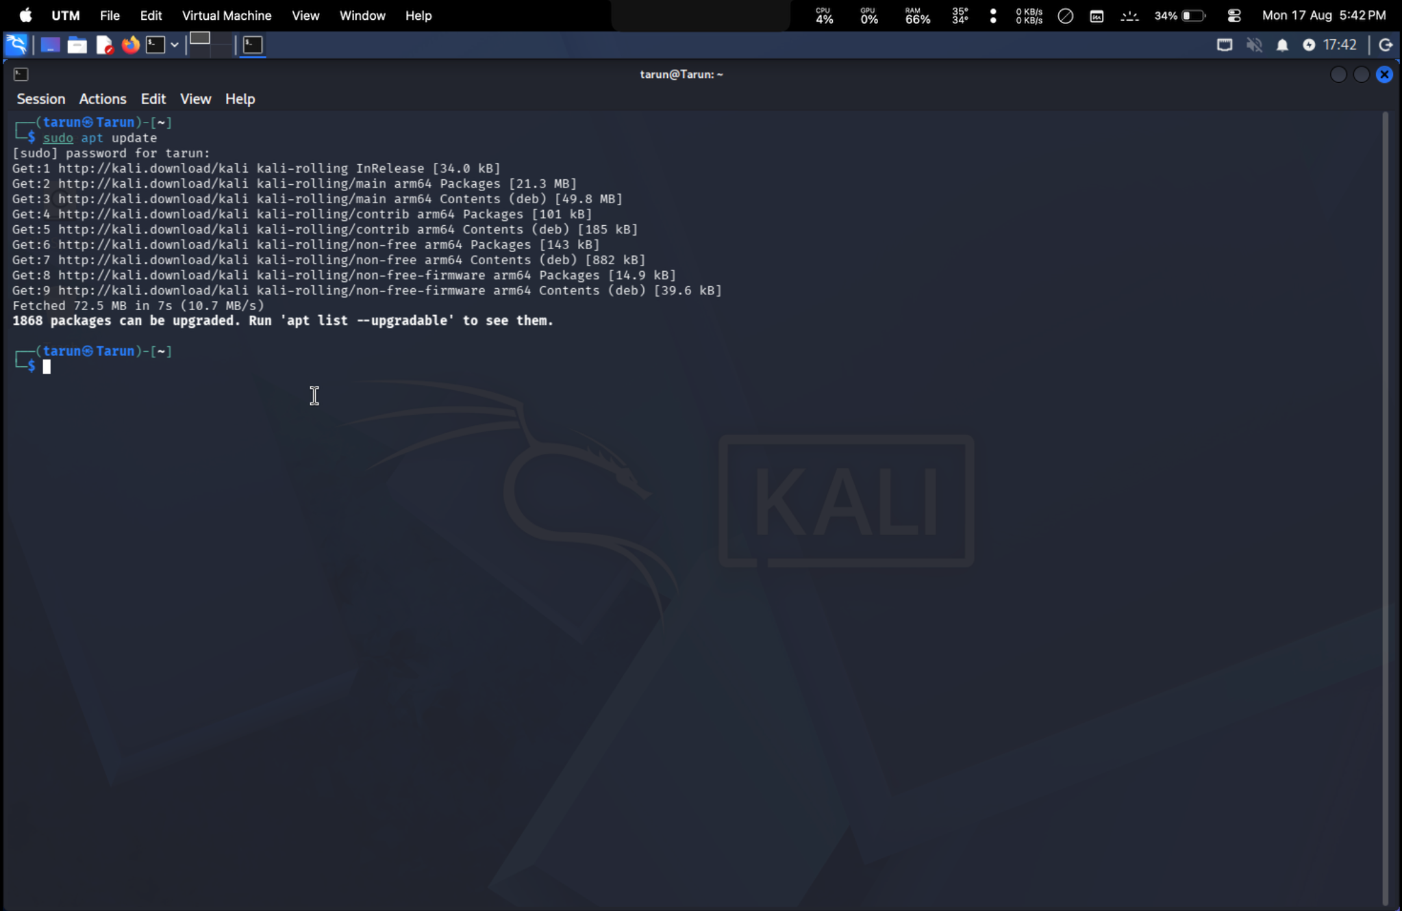
Figure 2. Kali Linux terminal after updating the package lists.

4.2 Launch and Verify DVWA
DVWA was accessed locally through the browser. The application displayed its home page and the available training modules, confirming that the intentionally vulnerable web application was running in the controlled lab.
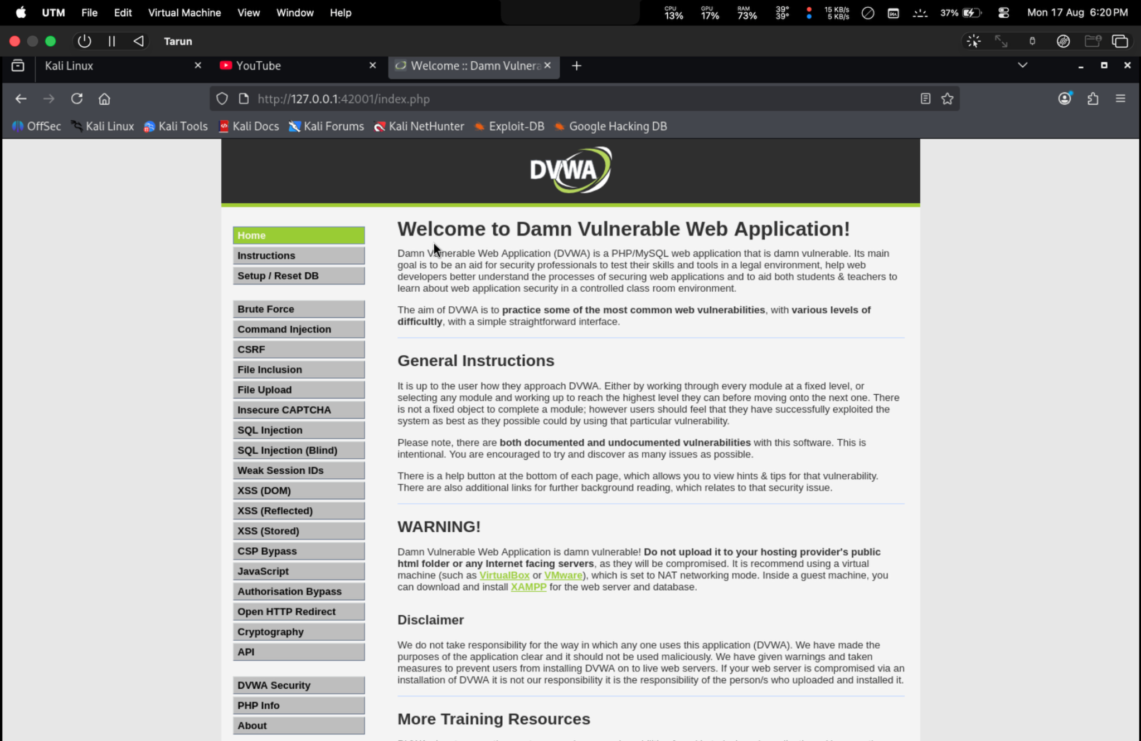
Figure 3. DVWA home page running locally at 127.0.0.1.

4.3 Identify the Network Configuration
The ip addr command was used to inspect the available interfaces. The eth0 interface was shown as UP with IPv4 address 192.168.64.2/24. The loopback interface was also present at 127.0.0.1.
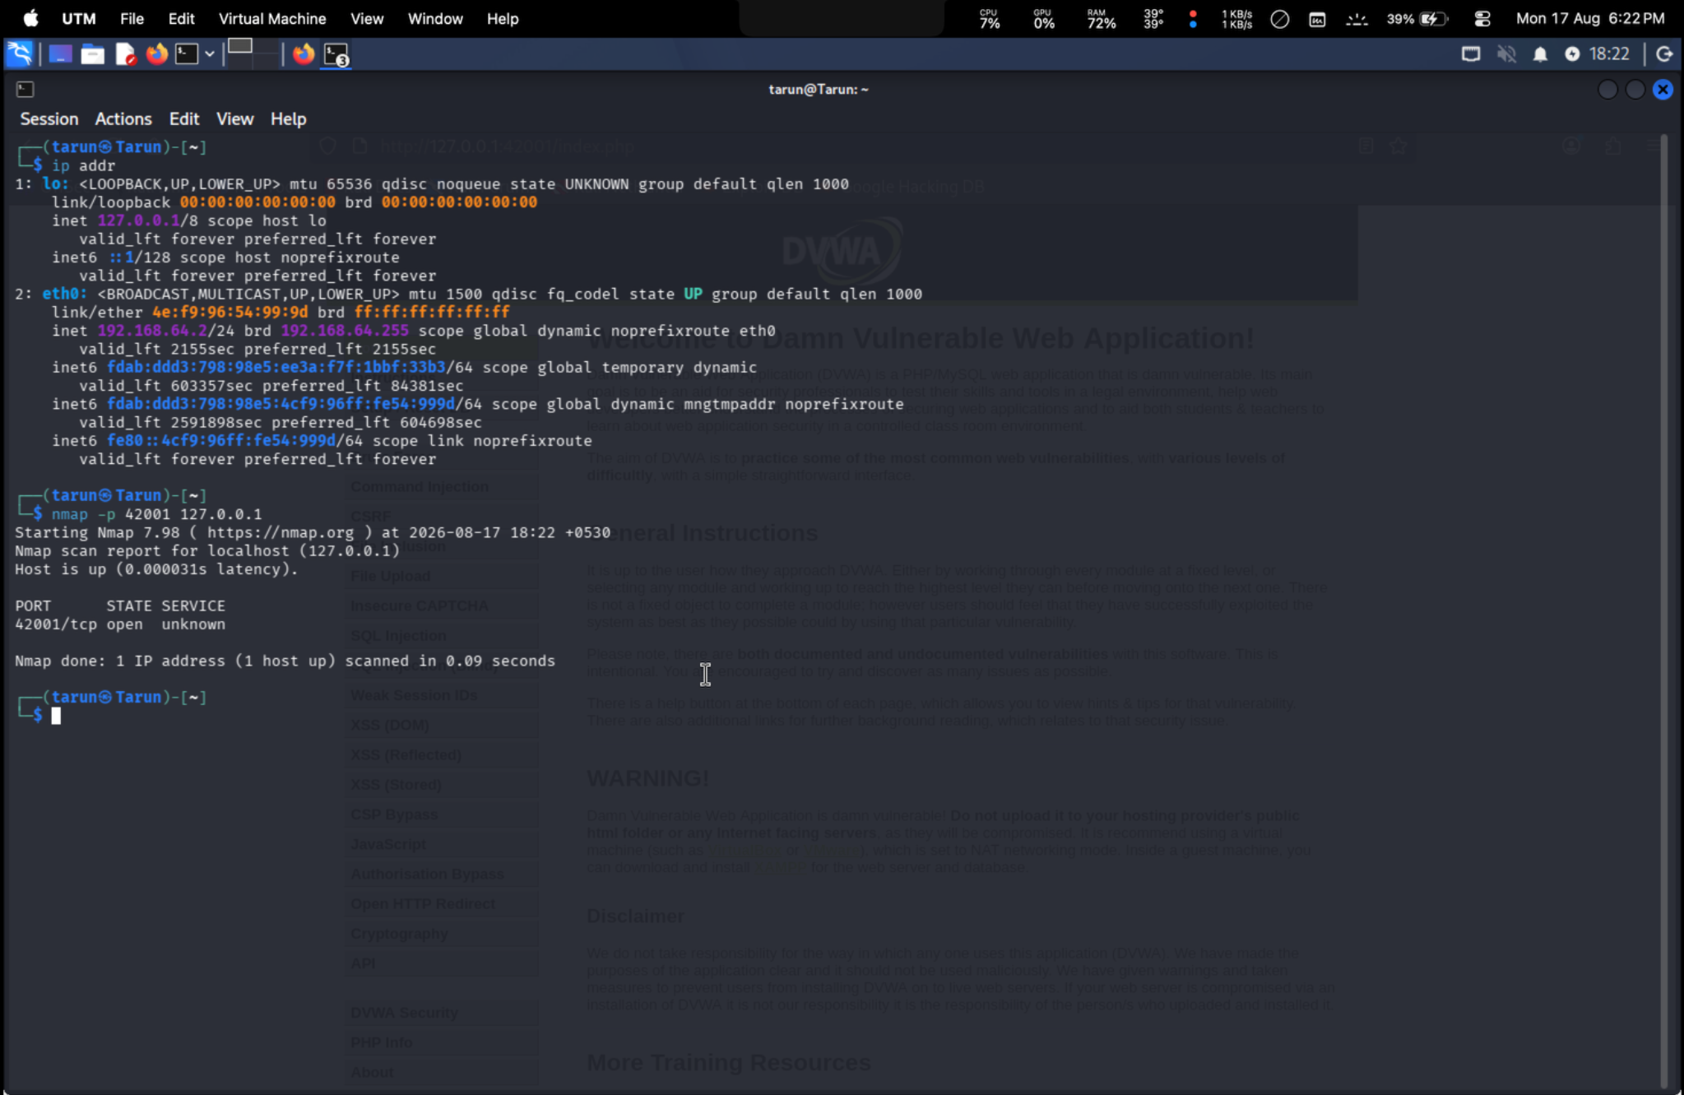
Figure 4. Network configuration showing eth0 address 192.168.64.2/24.

4.4 Verify Connectivity
Connectivity to the lab address 192.168.64.2 was verified using ping. The captured output shows four replies with 0% packet loss. Traceroute to the same address returned a single hop, which is consistent with the target being directly reachable in the local virtual environment.
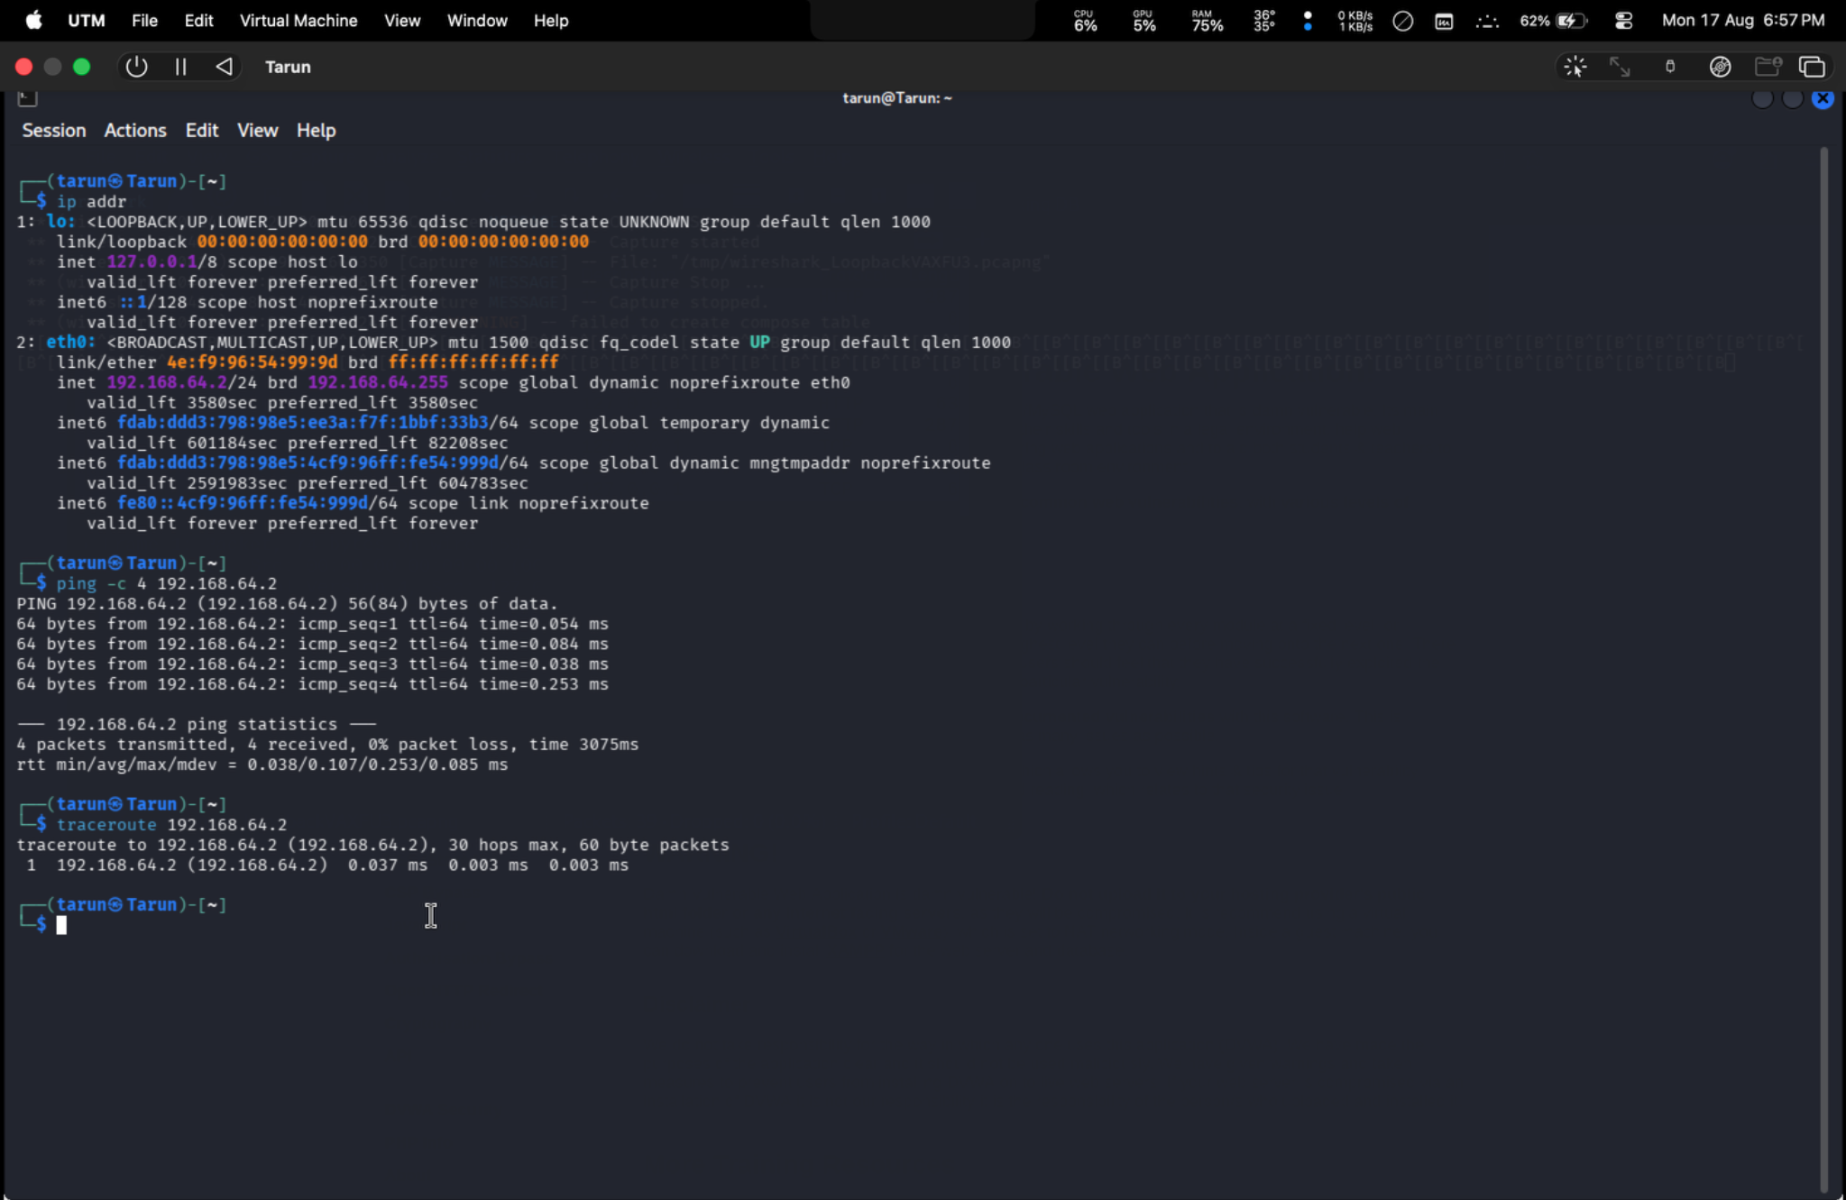
Figure 10. Connectivity verification using ping and traceroute to 192.168.64.2.

4.5 Perform Basic Nmap Service Discovery
A basic Nmap scan was performed against 127.0.0.1. The observed result identified TCP port 42001 as open with the service field reported as unknown. This provides a record of the service exposed on the local lab endpoint at the time of testing.
Figure 3. DVWA home page running locally at 127.0.0.1.
Figure 4. Network configuration showing eth0 address 192.168.64.2/24.

4.6 Capture Local Traffic with Wireshark
Wireshark was opened and the loopback interface (lo) was selected. The capture showed traffic between 127.0.0.1 and 127.0.0.1, including HTTP and TCP packets. This demonstrates how local web-application traffic can be observed at the packet level in a controlled environment.
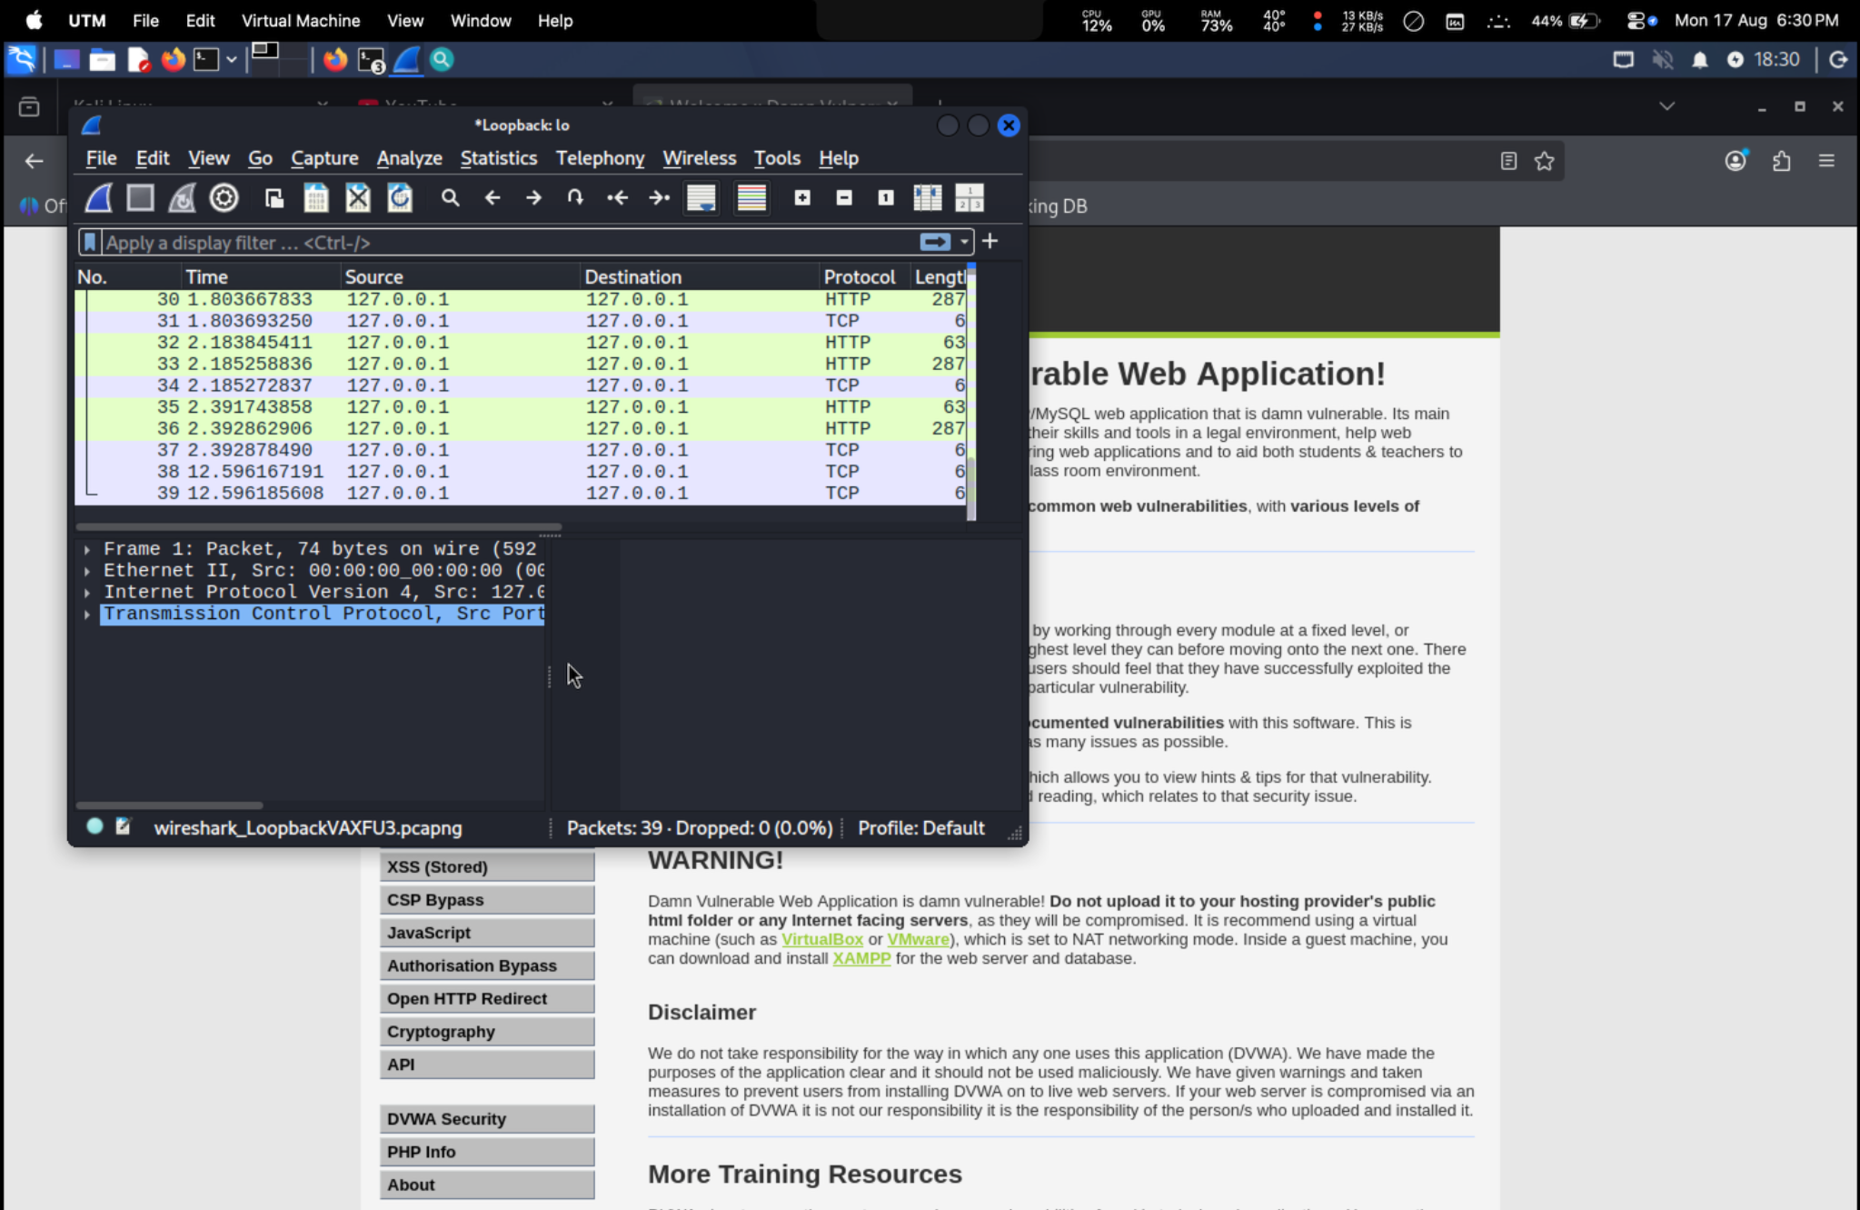
Figure 5. Wireshark capturing loopback HTTP/TCP traffic.

4.7 Verify OpenSSL and Prepare a Message
OpenSSL was checked using openssl version. The terminal reported OpenSSL 3.5.5. A plaintext file named message.txt was then created containing the practical message used for the encryption test.
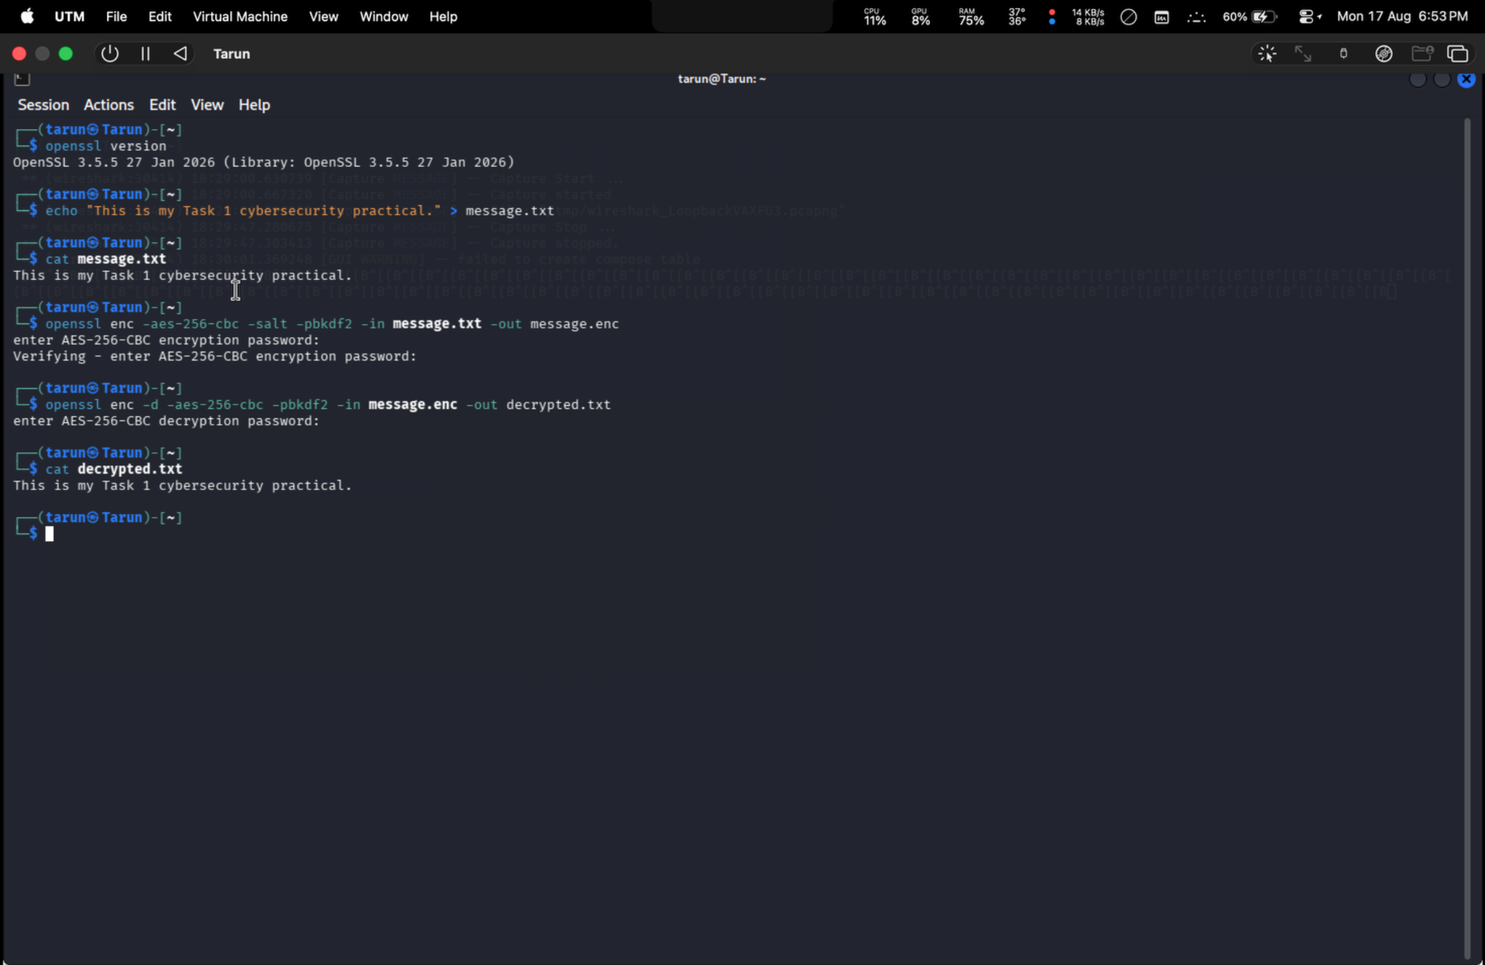
Figure 6. OpenSSL version check and creation of the plaintext message.

4.8 Encrypt and Decrypt the File
The message was encrypted using OpenSSL with AES-256-CBC, PBKDF2-based password derivation, and a salt. The encrypted output was saved as message.enc. The encrypted file was subsequently decrypted into decrypted.txt using the same cipher and password. Displaying decrypted.txt reproduced the original message, confirming successful round-trip encryption/decryption.
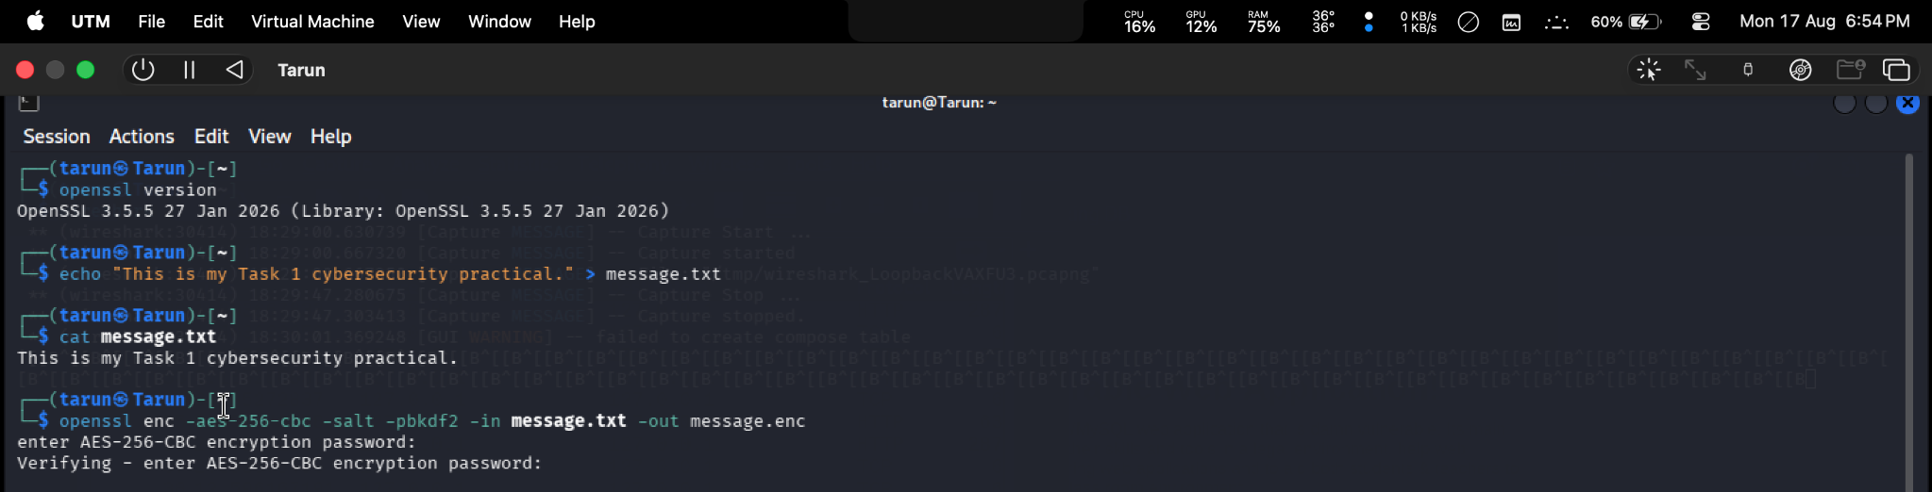
Figure 7. OpenSSL AES-256-CBC encryption and decryption commands.
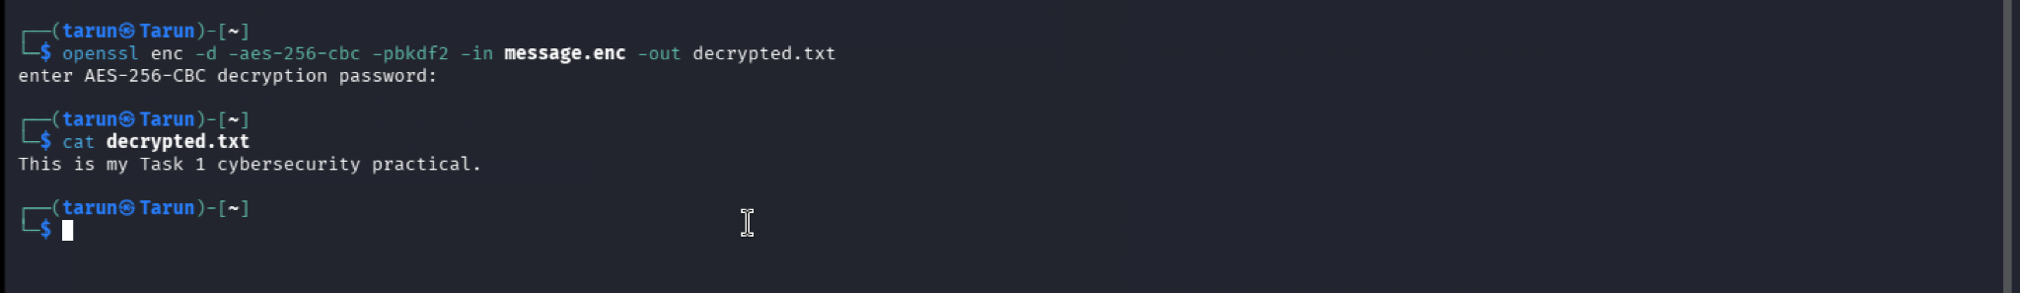
Figure 8. Decrypted file displaying the original message.

4.9 Manage File Permissions
Linux file permissions were demonstrated by applying chmod 644 to message.txt. The subsequent ls -l output showed -rw-r--r--, confirming that the intended permission mode was applied.
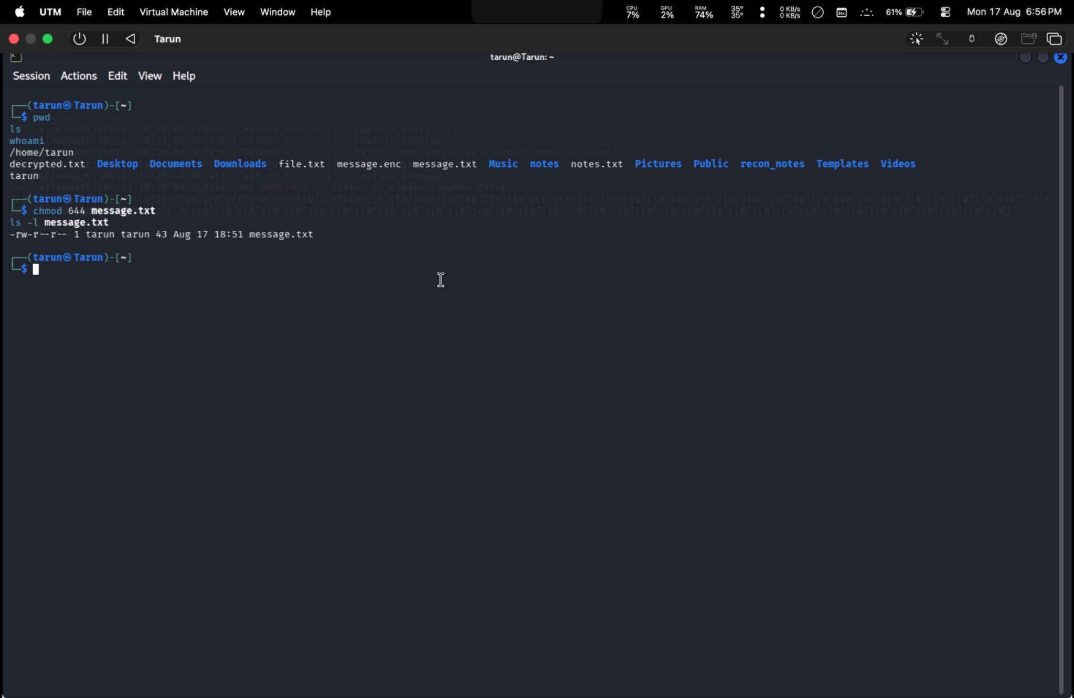
Figure 9. File permissions changed to 644 using chmod.

5. Commands and Key Results
Activity | Command | Observed Result
Environment update | sudo apt update | Package lists were updated successfully.
Network information | ip addr | eth0 observed as 192.168.64.2/24; loopback 127.0.0.1.
Connectivity | ping -c 4 192.168.64.2 | 4 packets received; 0% packet loss.
Route check | traceroute 192.168.64.2 | Single-hop route to the lab address.
Service discovery | nmap -p 42001 127.0.0.1 | TCP/42001 reported open; service shown as unknown.
OpenSSL check | openssl version | OpenSSL 3.5.5 reported.
Encryption | openssl enc -aes-256-cbc -salt -pbkdf2 -in message.txt -out message.enc | Encrypted file message.enc created.
Decryption | openssl enc -d -aes-256-cbc -pbkdf2 -in message.enc -out decrypted.txt | decrypted.txt reproduced the original message.
Permissions | chmod 644 message.txt; ls -l message.txt | Permissions displayed as -rw-r--r--.

6. Results Summary
Checkpoint | Status
Kali Linux VM | Operational
DVWA | Accessible locally
eth0 | UP; 192.168.64.2/24 observed
Ping | Successful; 0% packet loss
Traceroute | Single hop to 192.168.64.2
Nmap | TCP/42001 open on 127.0.0.1
Wireshark | HTTP/TCP loopback traffic captured
OpenSSL | AES-256-CBC encryption/decryption successful
File permissions | message.txt set to 644

7. Security and Lab Notes
- DVWA is intentionally vulnerable and should be kept inside an isolated/controlled training environment.
- The network observations in this report are from the local virtual lab, not from unauthorized external systems.
- Passwords used during the OpenSSL exercise were entered interactively and are not included in this report.
- The Wireshark capture demonstrates packet-level visibility of local traffic and should be used only for authorized analysis.
- File permissions should be selected according to the sensitivity of the data; 644 gives the owner read/write access and other users read access.

8. Conclusion
Task 1 was completed successfully in a controlled Kali Linux/UTM cybersecurity laboratory. The practical established a working DVWA environment, verified the lab network, confirmed connectivity and service exposure, captured local web traffic with Wireshark, and demonstrated practical data protection using OpenSSL encryption and decryption. Linux file permissions were also verified using chmod and ls. The screenshots included in this report provide evidence of the major stages and results of the practical.

9. Evidence Checklist
☑ Kali Linux environment and package update evidence
☑ DVWA local application evidence
☑ Network interface/IP configuration evidence
☑ Wireshark loopback capture evidence
☑ OpenSSL encryption/decryption evidence
☑ File permission evidence
☑ Ping and traceroute connectivity evidence

