TASK – 3
WEB APPLICATION SECURITY
DVWA Security Testing & Vulnerability Assessment Report
Internship Program | Cybersecurity & Ethical Hacking Internship
Task | Task 3 – Web Application Security
Target | Damn Vulnerable Web Application (DVWA)
Environment | Kali Linux / Localhost (127.0.0.1)
Testing Type | Controlled Web Application Security Testing

1. Objective
The objective of Task 3 is to identify and demonstrate common web-application security vulnerabilities in a controlled DVWA laboratory environment. The task covers SQL Injection, Cross-Site Scripting (XSS), Cross-Site Request Forgery (CSRF), File Inclusion, Burp Suite testing, and HTTP security headers.
All testing documented here was performed against the local intentionally vulnerable application at 127.0.0.1.

2. Lab Environment
- Damn Vulnerable Web Application (DVWA)
- Kali Linux virtual machine
- Mozilla Firefox
- Local target: 127.0.0.1
- DVWA security level: Low for vulnerable demonstrations; High was also tested for comparison.
Figure 1 – DVWA Security Level (Low)
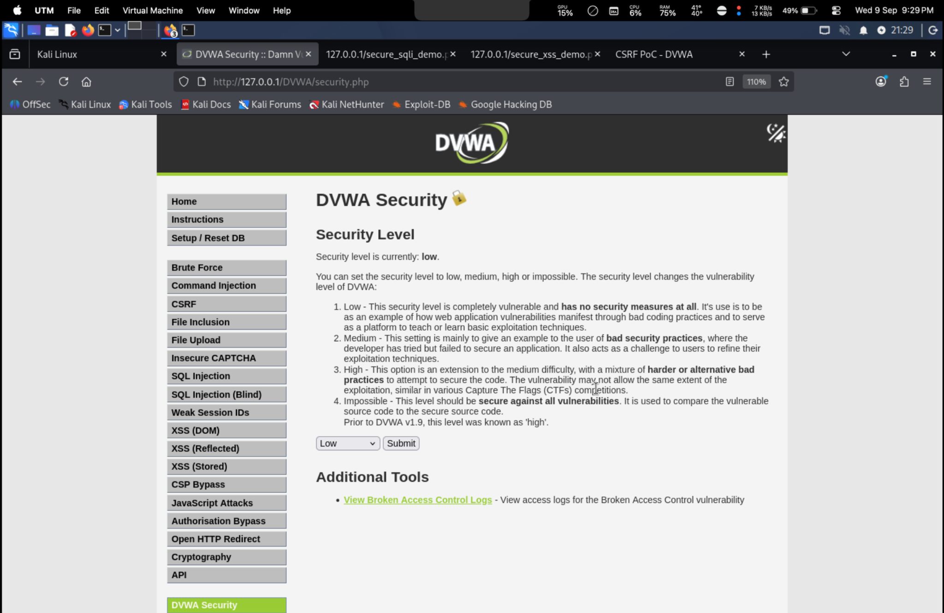
Evidence captured from the local DVWA Security page.

3. SQL Injection

3.1 Demonstration
The DVWA SQL Injection module was tested using controlled input. The application returned multiple database records for a manipulated input, demonstrating that the input influenced the underlying query.
Figure 2 – SQL Injection Result
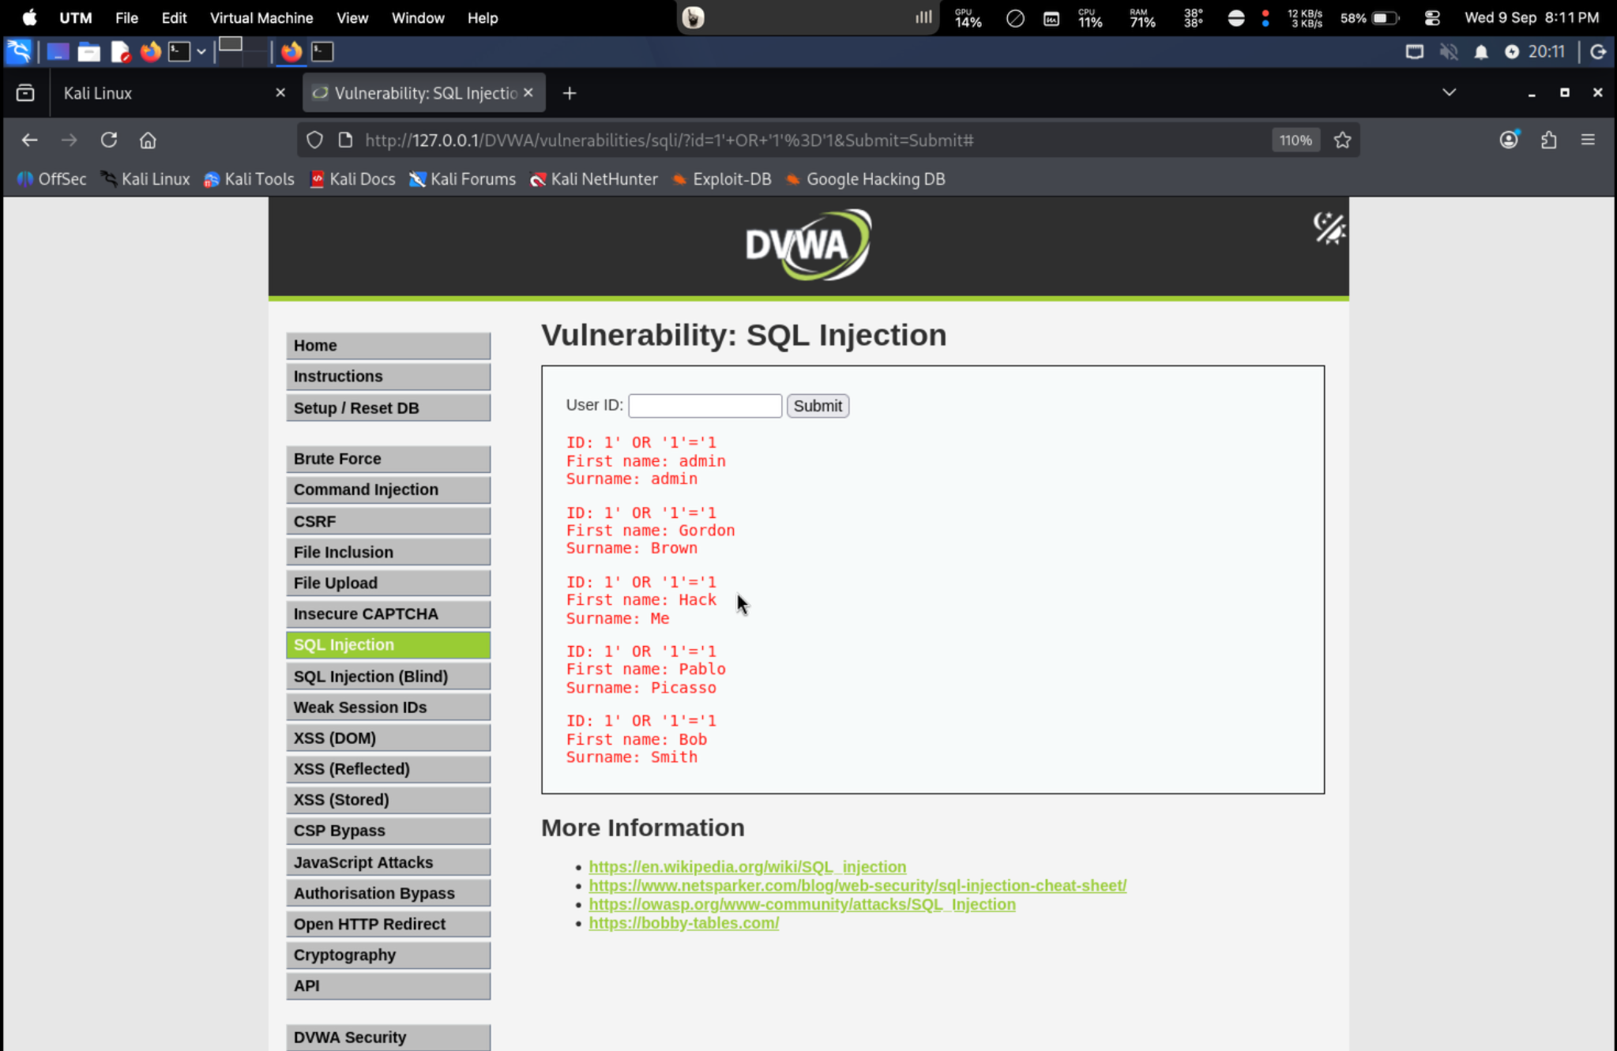
The screenshot shows the manipulated User ID input and multiple returned records.

3.2 Impact and Mitigation
SQL Injection may expose or manipulate database information when untrusted input is incorporated directly into SQL statements. Mitigation includes parameterized/prepared statements, strict input validation, least-privilege database accounts, and avoiding SQL string concatenation.

4. Cross-Site Scripting (XSS)

4.1 Stored XSS
The Stored XSS module was tested by submitting controlled content. The browser displayed an alert after the stored content was rendered, demonstrating client-side script execution from stored application data.
Figure 3 – Stored XSS Triggered
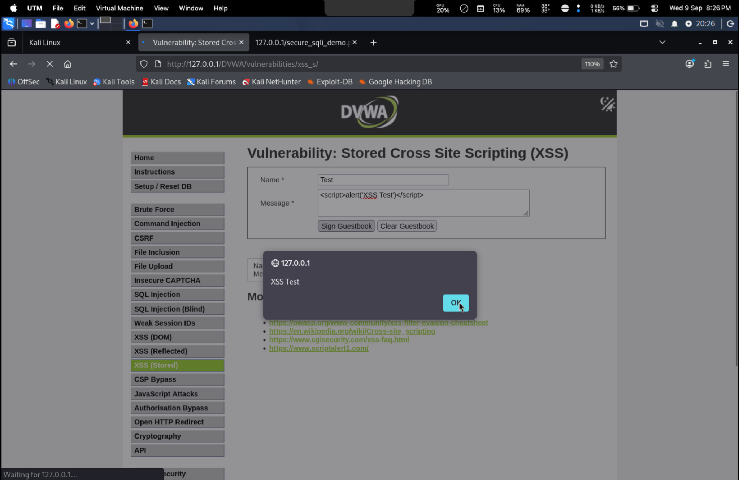
Controlled Stored XSS test result captured in DVWA.

4.2 Reflected XSS
The Reflected XSS module was tested with controlled input. The browser displayed the test alert, demonstrating that request data was reflected into an executable browser context.
Figure 4 – Reflected XSS Triggered
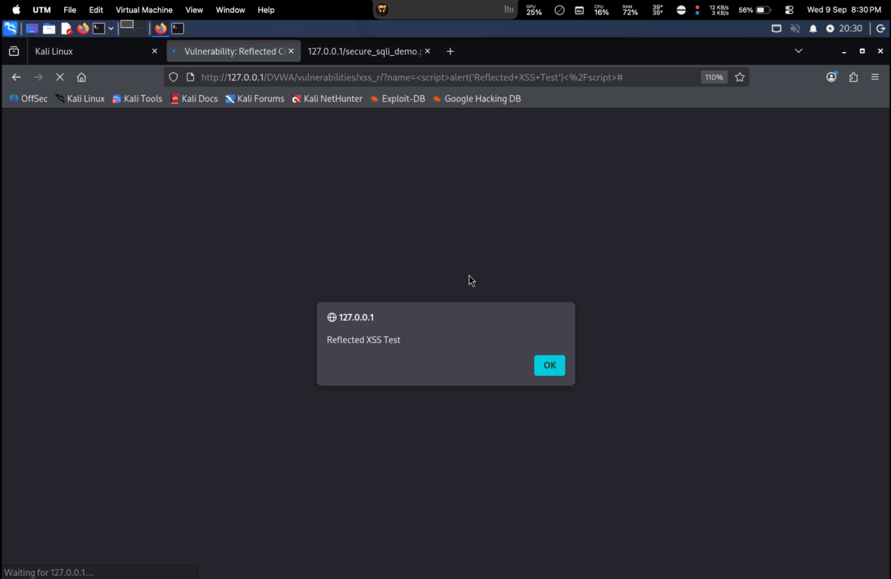
Controlled Reflected XSS test result captured in DVWA.

4.3 Mitigation
Use context-aware output encoding, appropriate input validation, safe DOM APIs, and a restrictive Content Security Policy (CSP).

5. Cross-Site Request Forgery (CSRF)

5.1 Credential Test
The DVWA CSRF credential-testing function was accessed and produced a valid-password response during testing. This confirms that the credential test page and authenticated lab flow were functioning.
Figure 5 – CSRF Credential Test
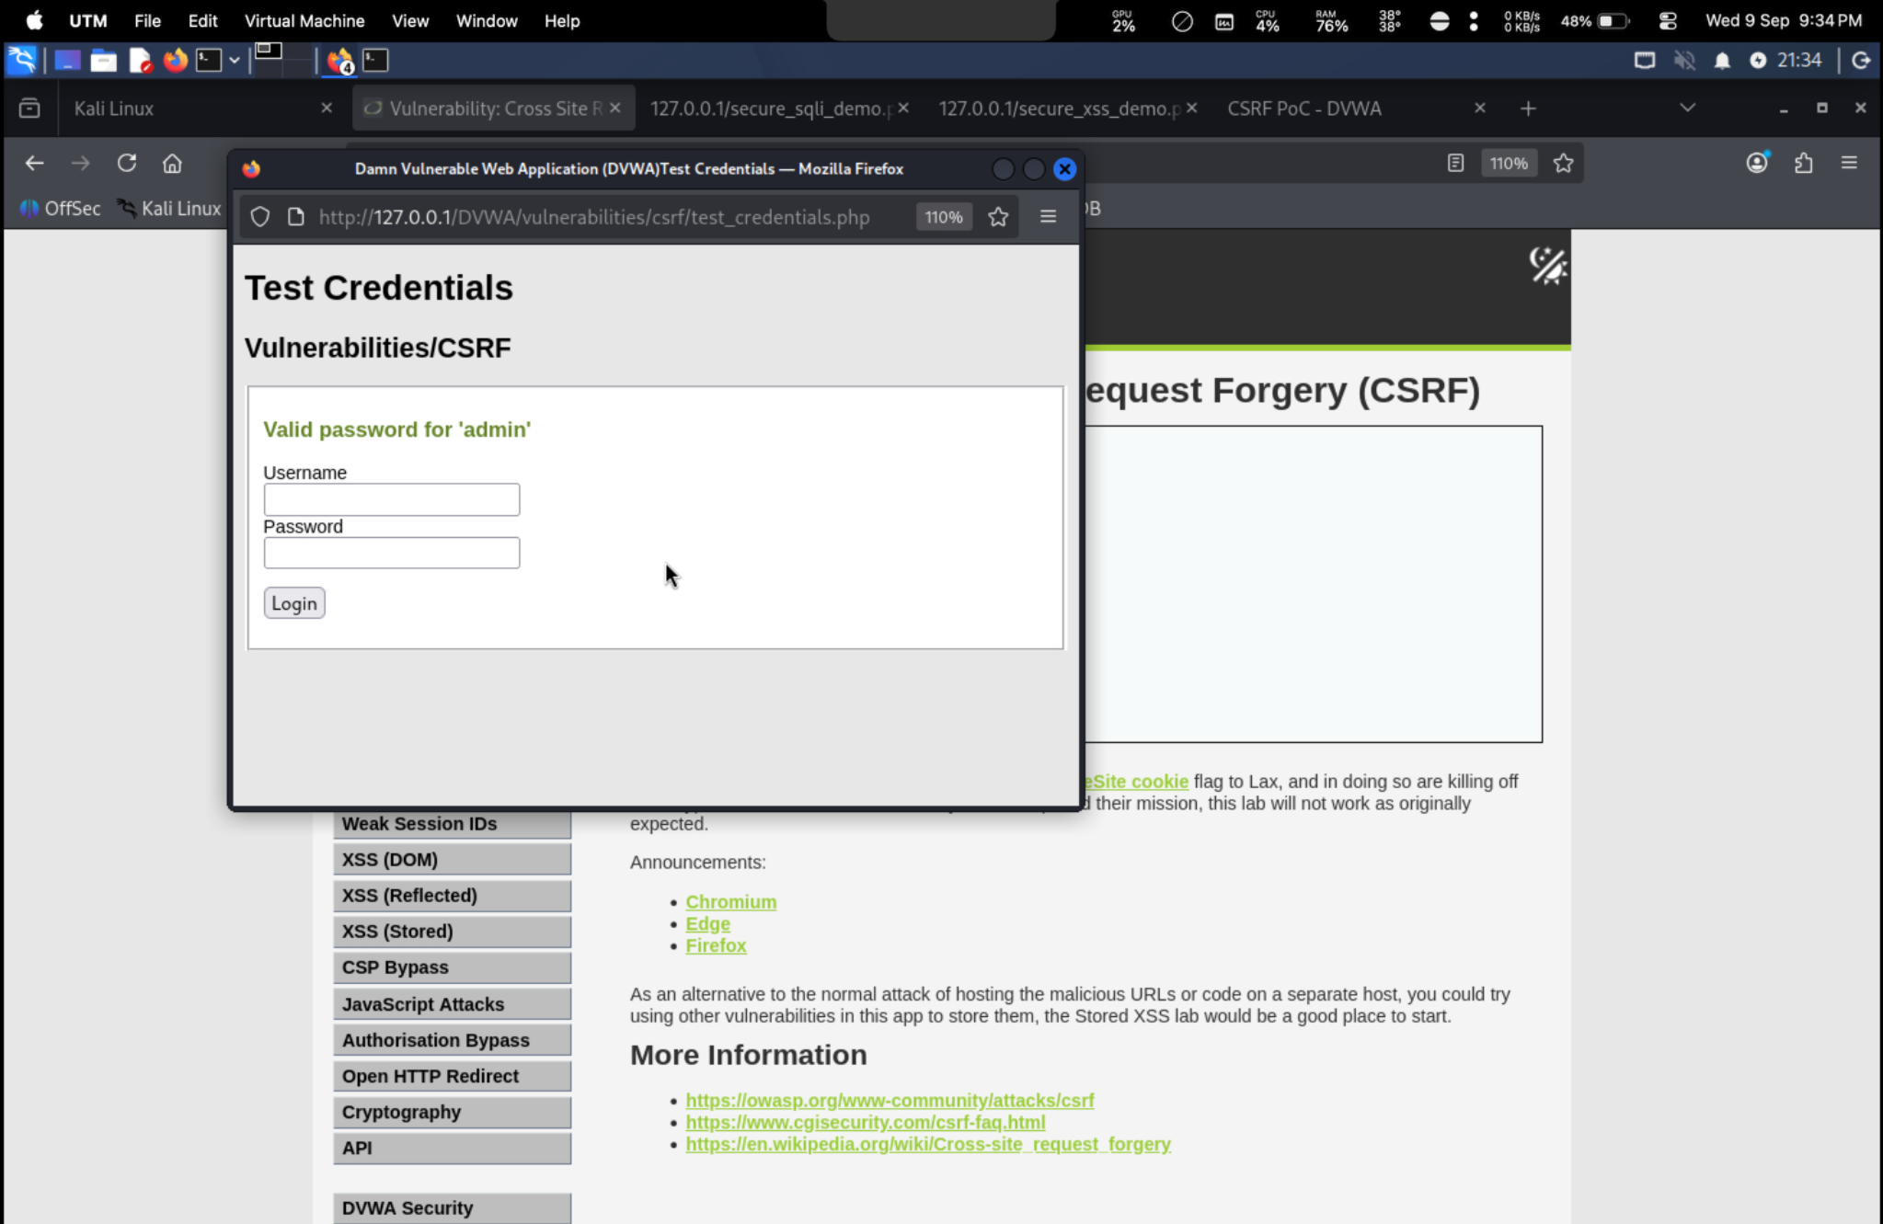
Available CSRF credential-test evidence.

5.2 PoC Observation
A separate local CSRF demonstration page was created. The PoC page itself loaded successfully, but a reliable password-change result could not be reproduced after repeated refresh/testing. Therefore, the report records the PoC as inconclusive rather than claiming an unsupported successful exploit.
Figure 6 – CSRF PoC Page
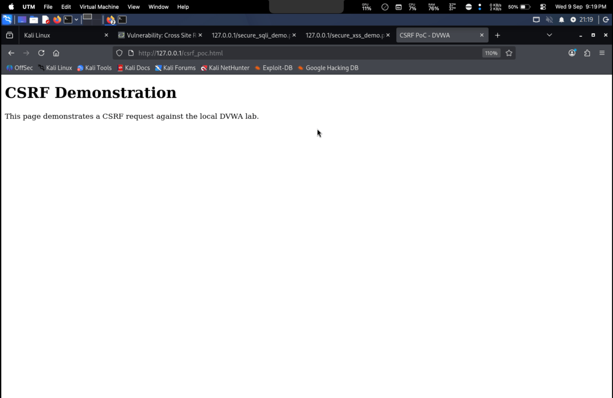
Local CSRF demonstration page used during the controlled lab test.

5.3 Mitigation
Use unpredictable CSRF tokens, validate tokens server-side, configure appropriate SameSite cookie attributes, and require re-authentication for highly sensitive actions.

6. File Inclusion

6.1 Module and Configuration
The File Inclusion module was opened. The page reported PHP 8.4.24 and indicated that allow_url_include was not enabled, which prevented a successful remote-file inclusion demonstration in this environment.
Figure 7 – File Inclusion Configuration
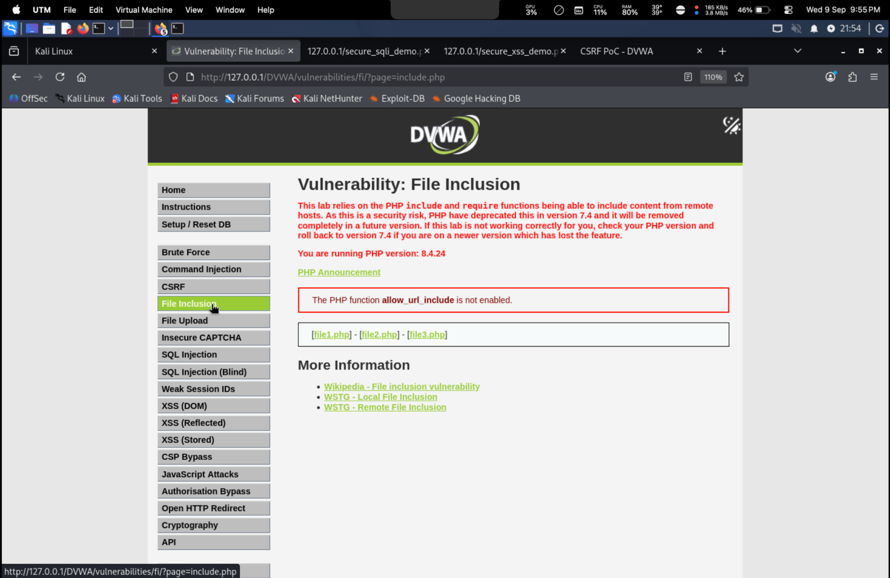
DVWA File Inclusion page showing the PHP configuration warning.

6.2 File 1 – Successful Inclusion
Selecting File 1 successfully loaded its content and displayed 'Hello admin' and the local IP address 127.0.0.1. This provides direct evidence of the application's file-selection/inclusion behavior.
Figure 8 – File Inclusion File 1
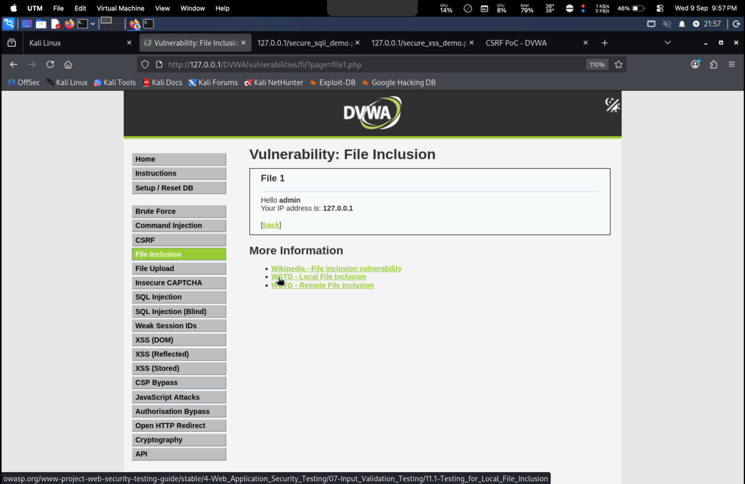
Successful File 1 inclusion in DVWA.

6.3 Controlled Custom-File Test
A local test file containing the marker LFI_TEST_SUCCESS was created. The attempted browser inclusion returned 'ERROR: File not found!', so the custom file was not successfully included. This is documented as a negative test result.
Figure 9 – File Inclusion Negative Result
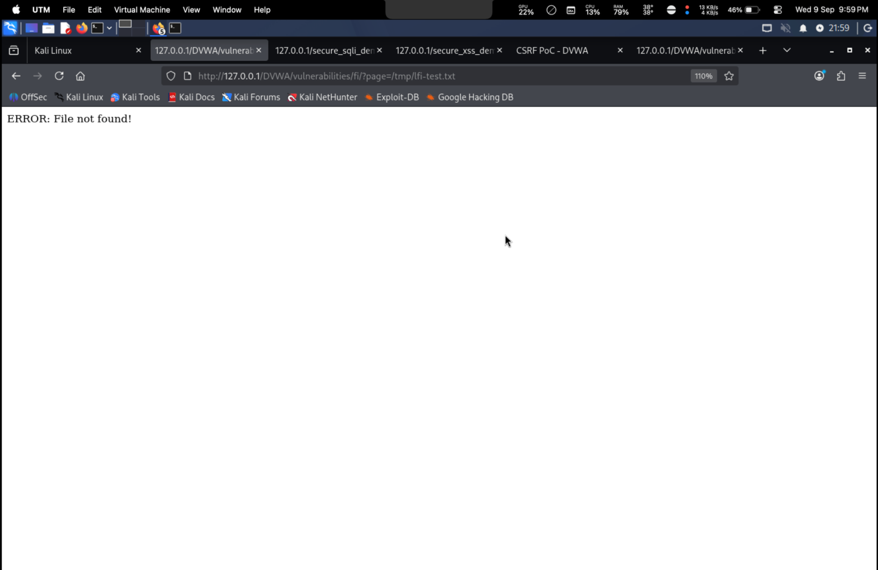
Browser result for the attempted custom test-file inclusion.

6.4 Mitigation
Use an allowlist of permitted resources, map identifiers to fixed server-side files, normalize and validate paths, and never pass arbitrary user-controlled paths directly to inclusion functions.

7. Burp Suite Advanced Testing
Burp Suite is used to intercept, inspect, and modify HTTP requests generated by the DVWA application. The Task 3 workflow includes login-request interception and controlled fuzzing with Intruder.
- Proxy interception evidence should show a captured DVWA request.
- A modified request and server response can demonstrate server-side validation.
- Intruder evidence should show the controlled test configuration and result.
Evidence placeholder: Add the Burp Proxy/Intruder screenshots from the corresponding lab session if required by the evaluator.

8. HTTP Security Headers
Security headers add browser-enforced protections that can reduce the impact of several web attacks. The task requires analyzing a test site with a security-header checking service and applying suitable headers in Apache configuration.
- Content-Security-Policy (CSP)
- X-Content-Type-Options
- Referrer-Policy
- Strict-Transport-Security when HTTPS is used
- Permissions-Policy
- Frame-ancestors through CSP or suitable clickjacking protection
Evidence placeholder: Add the header-analysis and Apache configuration screenshots when captured.

9. Vulnerability Summary
Vulnerability | Evidence | Impact | Mitigation
SQL Injection | Figure 2 | Database disclosure/manipulation | Prepared statements
Stored XSS | Figure 3 | Stored client-side script execution | Output encoding + CSP
Reflected XSS | Figure 4 | Reflected client-side script execution | Validation + output encoding
CSRF | Figures 5–6 | Unintended authenticated actions | CSRF tokens + SameSite
File Inclusion | Figures 7–9 | Unsafe file loading | Allowlist + path validation

10. Conclusion
Task 3 provided practical experience with common web application vulnerabilities in a controlled DVWA environment. The captured evidence demonstrates SQL Injection, Stored XSS, Reflected XSS, and File Inclusion behavior. CSRF credential testing and the local PoC workflow were also documented, with the PoC result explicitly marked inconclusive where a reliable state change could not be reproduced. Mitigations focus on secure input handling, output encoding, request authenticity, safe file handling, server-side validation, and security headers.

11. Evidence Checklist
☑ SQL Injection screenshot
☑ Stored XSS screenshot
☑ Reflected XSS screenshot
☑ CSRF credential-test screenshot
☑ CSRF PoC page screenshot
☑ File Inclusion configuration screenshot
☑ File Inclusion File 1 screenshot
☑ File Inclusion negative-result screenshot
☐ Burp Proxy screenshot
☐ Burp Intruder screenshot
☐ Security Headers analysis screenshot
☐ Apache security-header result screenshot

