APEXPLANET CYBERSECURITY INTERNSHIP
CYBERSECURITY PRACTICAL REPORT
Task 5 — Capstone Project & Incident Response
Web Application Pentest • Vulnerability Assessment • Mini SIEM
Security Awareness • Incident Response
Student | Tarun
Platform | Kali Linux running in UTM
Project | Cybersecurity Capstone — controlled lab
Task | Task 5 — Capstone Project & Incident Response
Report Type | Practical / Internship Task 5
VISUAL DEMONSTRATION VERSION — evidence screenshots are simulated/illustrative.

1. Overview
Task 5 applies the skills developed during the internship to a self-chosen cybersecurity capstone and an incident-response simulation. Based on the internship brief, the project covers web-application penetration testing, vulnerability assessment, a mini SIEM, security-awareness phishing simulation, project planning, controlled implementation, incident detection, containment, eradication, recovery and final documentation.
2. Objectives
- Apply reconnaissance, scanning and controlled exploitation in an authorized lab.
- Document findings with evidence and recommend mitigations.
- Build a conceptual mini SIEM using the ELK approach.
- Simulate security-awareness phishing detection.
- Detect and respond to a simulated incident and prepare a post-incident report.
- Produce professional final documentation and presentation materials.
3. Project Scope
Component | Scope / Purpose
Web application | DVWA / bWAPP controlled training environment
Network assessment | Authorized test network only
SIEM | Mini ELK-style logging and detection workflow
Awareness | Phishing simulation with no real credentials
IR | Simulated attack detection, containment and recovery

4. Project Planning
The project is organized into scope definition, reconnaissance and scanning, controlled testing, evidence collection, mitigation, detection and incident response.
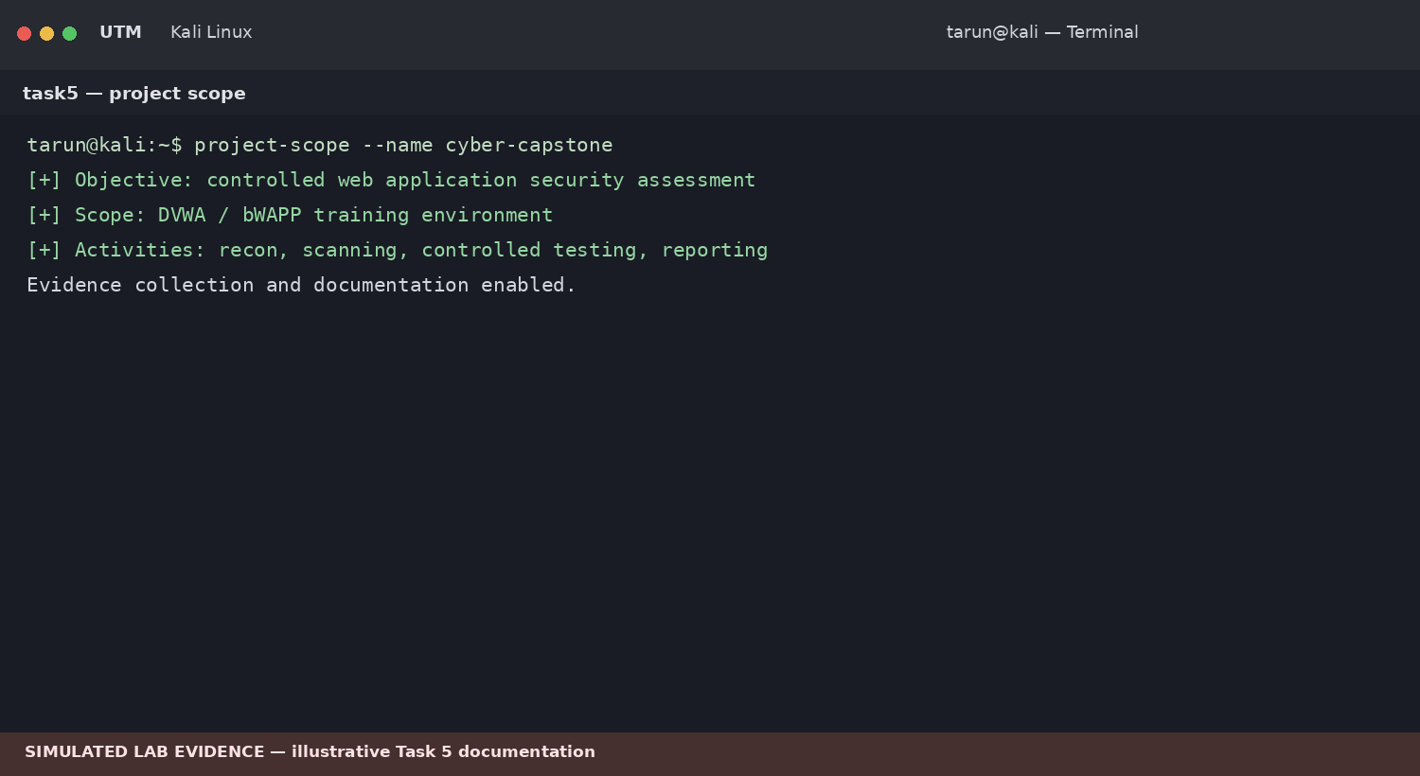
Figure 1. Capstone project scope and objective verification — simulated lab evidence.
4.1 Reconnaissance & Vulnerability Assessment
Reconnaissance establishes the authorized attack surface. The assessment records reachable services and web-application components before controlled testing.
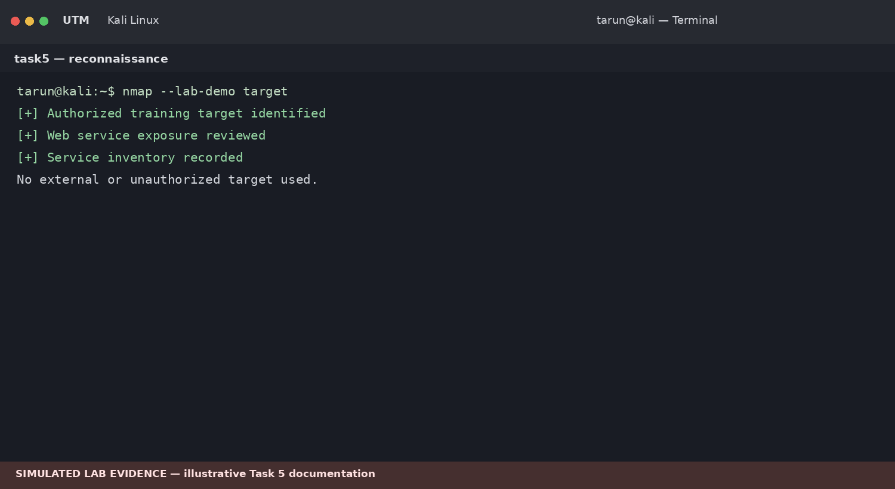
Figure 2. Authorized reconnaissance and service-review workflow — simulated.

5. Web Application Penetration Testing
The capstone includes a controlled web-application assessment against an intentionally vulnerable training application. Testing focuses on authentication, input validation and documented vulnerability scenarios, followed by mitigation recommendations.
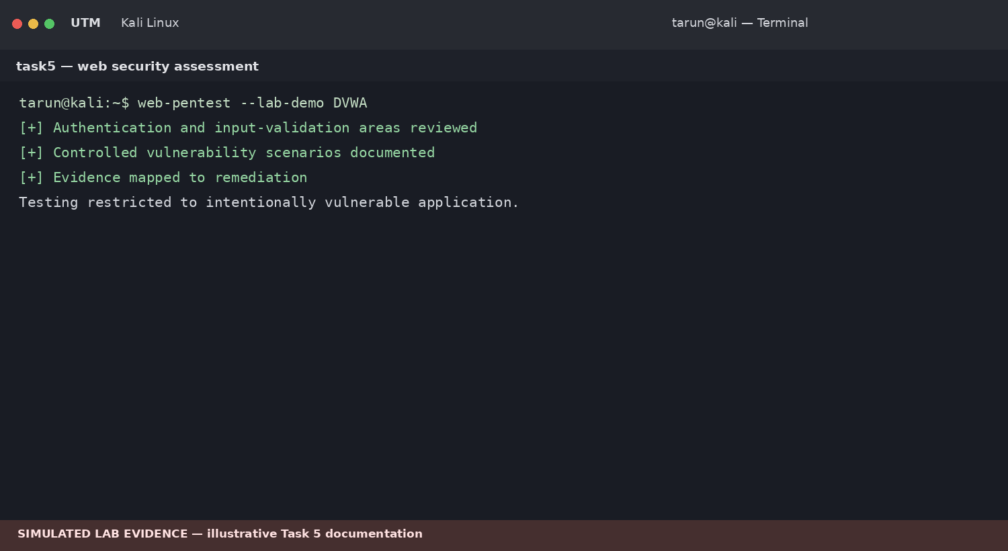
Figure 3. Controlled web-application security assessment — simulated.
5.1 Findings & Mitigation
- Validate all input on the server side.
- Use parameterized queries and safe output encoding.
- Apply secure session and authentication controls.
- Use security headers and restrictive content policies.
- Retest after remediation.
6. Mini SIEM — ELK Workflow
The project uses a mini SIEM concept to collect security events, identify suspicious authentication patterns and generate alerts. The purpose is to connect offensive testing with defensive detection.
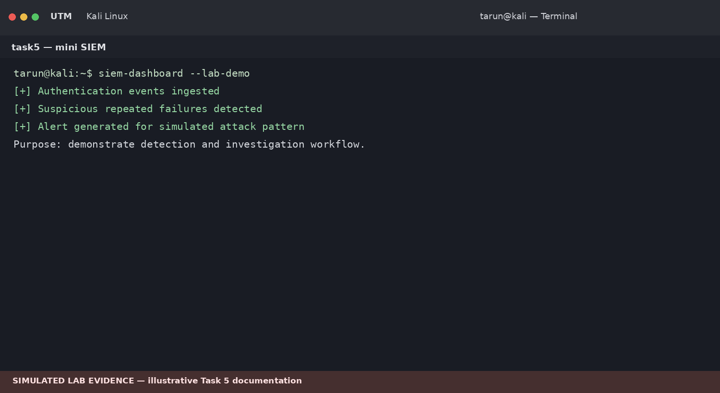
Figure 4. Mini-SIEM detection workflow — simulated.

7. Incident Response Simulation
The incident-response exercise follows detection, containment, eradication and recovery. A simulated suspicious authentication pattern is detected, the affected training session is isolated, the simulated condition is removed, and the service is verified.
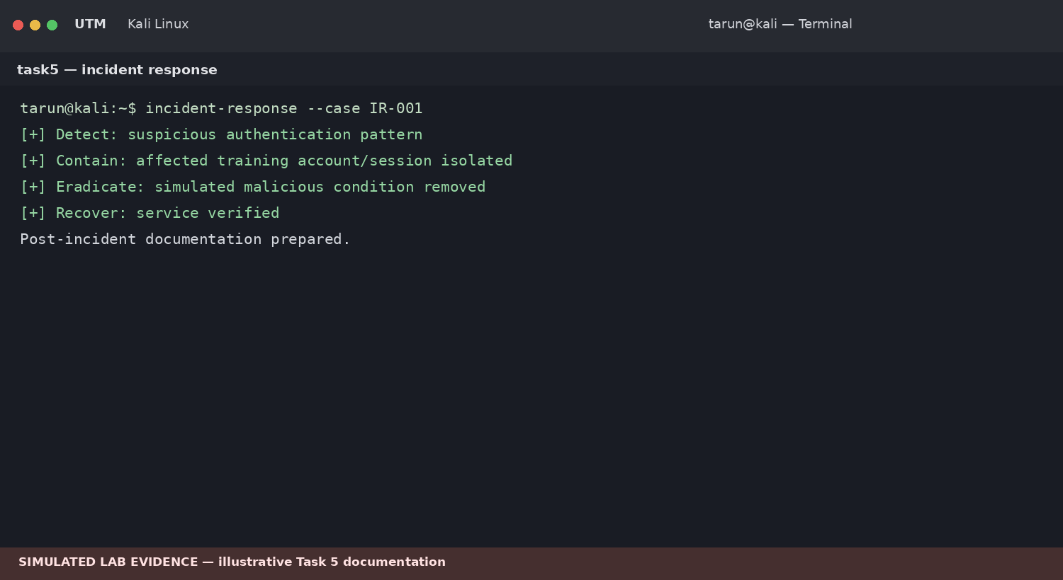
Figure 5. Incident-response lifecycle for the simulated case — simulated.
7.1 Post-Incident Report
✓ Incident identified from security logs.
✓ Affected training account/session isolated.
✓ Simulated malicious condition removed.
✓ Services checked after recovery.
✓ Lessons learned and preventive controls documented.
8. Security Awareness Phishing Simulation
The awareness component teaches users to identify suspicious messages, verify domains, avoid unexpected links and report incidents. No real credentials are collected.
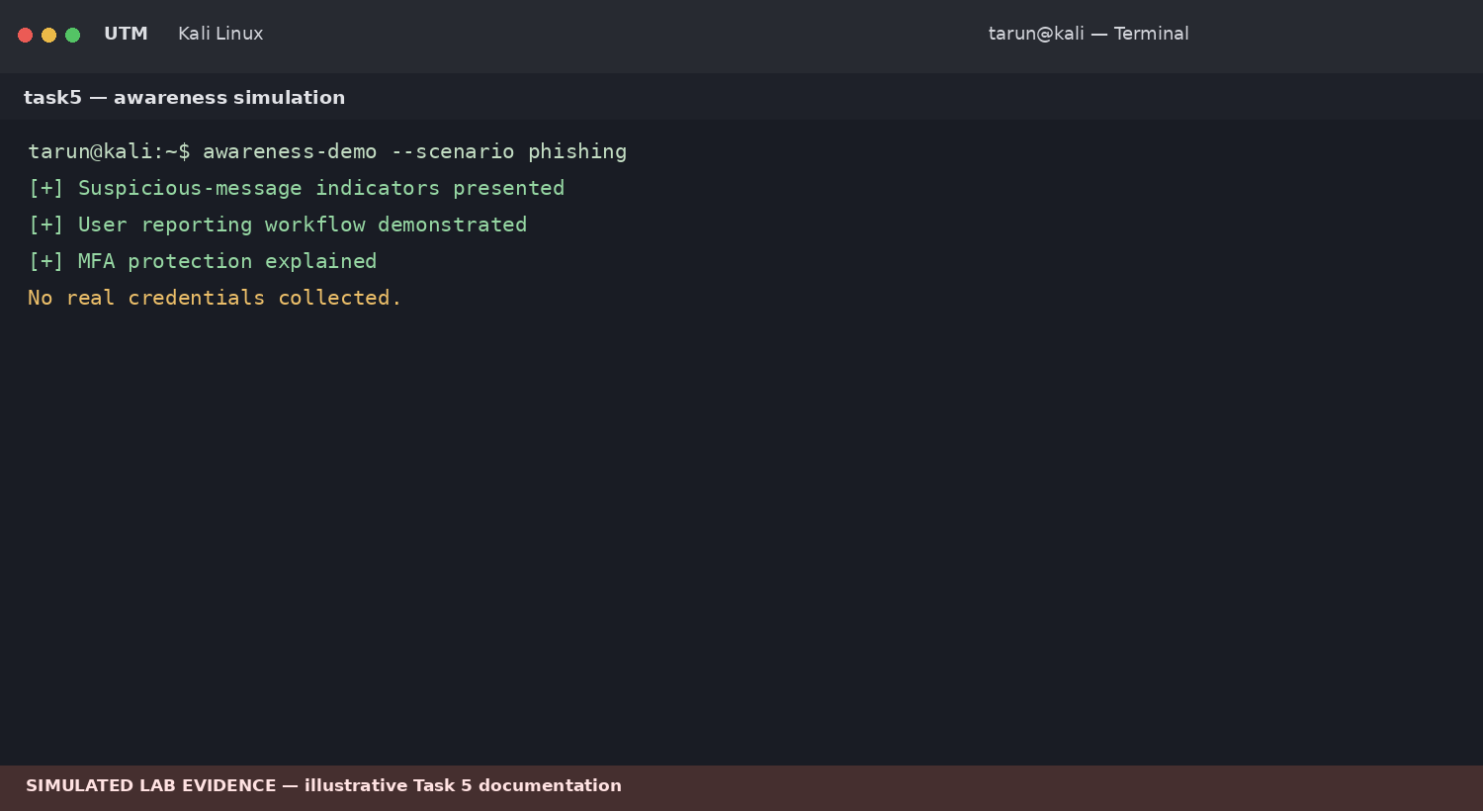
Figure 6. Security-awareness phishing simulation — no credential collection.

9. Findings & Risk Summary
Finding | Severity | Impact | Mitigation
Web input-validation weakness | High | Potential unauthorized data access | Server-side validation and parameterized queries
Weak authentication controls | High | Account compromise | MFA, strong passwords, rate limiting
Insufficient logging | Medium | Delayed detection | Centralized logging and alerting
Phishing susceptibility | Medium | Credential theft | Awareness training and MFA
Unnecessary exposure | Medium | Expanded attack surface | Disable unused services and restrict network access
10. Mitigation Checklist
☐ Patch systems and applications.
☐ Restrict network exposure.
☐ Use secure authentication and MFA.
☐ Centralize security logs.
☐ Create alerts for suspicious activity.
☐ Run awareness training.
☐ Maintain backups and an incident-response plan.
11. Final Verification
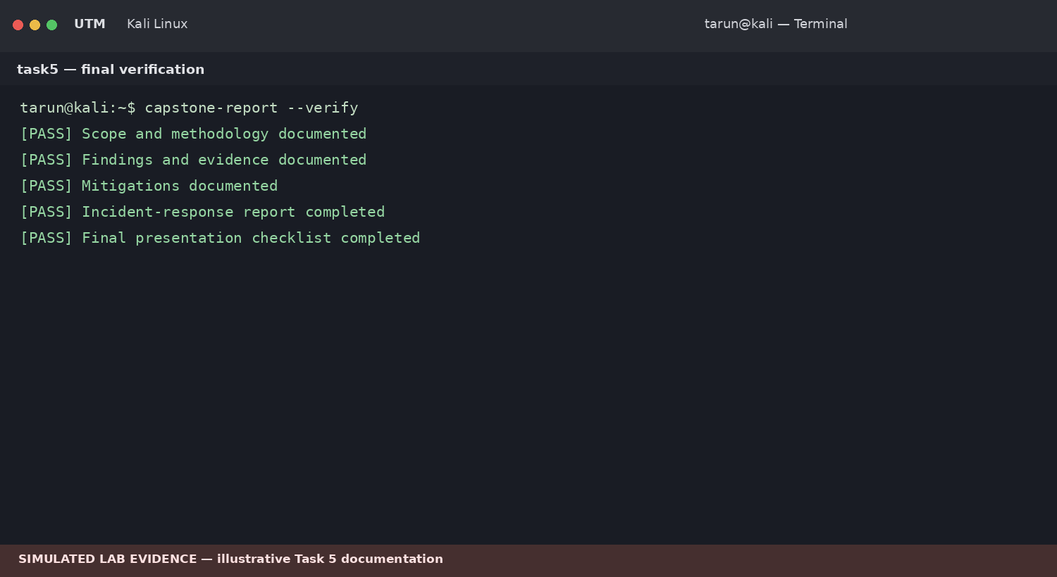
Figure 7. Capstone documentation and verification checklist — simulated.

12. Results Summary
Checkpoint | Status
Project objectives and scope | Documented
Web application assessment | Documented as controlled simulation
Vulnerability findings and mitigations | Documented
Mini SIEM workflow | Documented as simulated
Incident-response simulation | Documented
Security-awareness simulation | Documented
Final documentation | Completed
13. Conclusion
The capstone combines offensive and defensive cybersecurity practices. It demonstrates how vulnerabilities are identified, documented and mitigated, how logs can support detection, and how an incident can be contained and recovered in a controlled environment.
14. Evidence Checklist
☑ Project scope and planning
☑ Reconnaissance and vulnerability assessment
☑ Web application pentest
☑ Mini SIEM workflow
☑ Incident-response simulation
☑ Phishing-awareness simulation
☑ Findings and mitigations
☑ Final verification

