**Topics: Normal distribution, Functions of Random Variables**

1. The time required for servicing transmissions is normally distributed with *μ* = 45 minutes and *σ* = 8 minutes. The service manager plans to have work begin on the transmission of a customer’s car 10 minutes after the car is dropped off and the customer is told that the car will be ready within 1 hour from drop-off. What is the probability that the service manager cannot meet his commitment?
2. 0.3875
3. 0.2676 ans
4. 0.5
5. 0.6987
6. The current age (in years) of 400 clerical employees at an insurance claims processing center is normally distributed with mean *μ* = 38 and Standard deviation *σ* =6. For each statement below, please specify True/False. If false, briefly explain why.
7. More employees at the processing center are older than 44 than between 38 and 44.

FALSE (as we can see below that 68% data in normal distribution comes under first std. deviation and as normal distribution is equally distributed about its mean so 50% of data lies in right side of mean. So from this we can calculate that about 34% data lies in between 38 and 44 . And 16% data is greater than 44.)

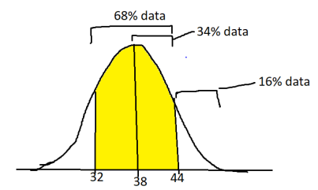

1. A training program for employees under the age of 30 at the center would be expected to attract about 36 employees.  
   False  
   By using   
   stats.norm.cdf(30,loc=38,scale=6) we get 0.15  
   which means 15% data lies under 30   
   15% of 400 = 60  
   so 60 employees are expected to be attracted .
2. If *X1*~ *N*(μ, σ2) and *X*2 ~ *N*(μ, σ2) are *iid*normal random variables, then what is the difference between 2 *X*1 and *X*1 + *X*2? Discuss both their distributions and parameters.

ANS>> 2 *X*1 = *N*(2μ,4 σ2) the mean and variance changes .

*X*1 + *X*2 ~ *N*(2μ, 2σ2) mean and variance doubles.

1. Let X ~ N(100, 202). Find two values, *a* and*b*, symmetric about the mean, such that the probability of the random variable taking a value between them is 0.99.
2. 90.5, 105.9
3. 80.2, 119.8
4. 22, 78
5. 48.5, 151.5 >> **Ans**
6. 90.1, 109.9
7. Consider a company that has two different divisions. The annual profits from the two divisions are independent and have distributions Profit1 ~ N(5, 32) and Profit2 ~ N(7, 42) respectively. Both the profits are in $ Million. Answer the following questions about the total profit of the company in Rupees. Assume that $1 = Rs. 45
8. Specify a Rupee range (centered on the mean) such that it contains 95% probability for the annual profit of the company.

ANS>> As we know that 95% of data lies within two standard deviations of the mean so,  
for Company1 it is (219-231 )Million Rupees

Company2 it is (307-323)Million Rupees

1. Specify the 5th percentile of profit (in Rupees) for the company

ANS>> For company1 = 2.925 million rupees

Company2= 18.9 million rupees

1. Which of the two divisions has a larger probability of making a loss in a given year?  
   ANS>> As company 2 has higher variance so it has higher probability of making a loss in a given year.