# Calculating Cyclomatic Complexity:

Command radon cc directoryname -a

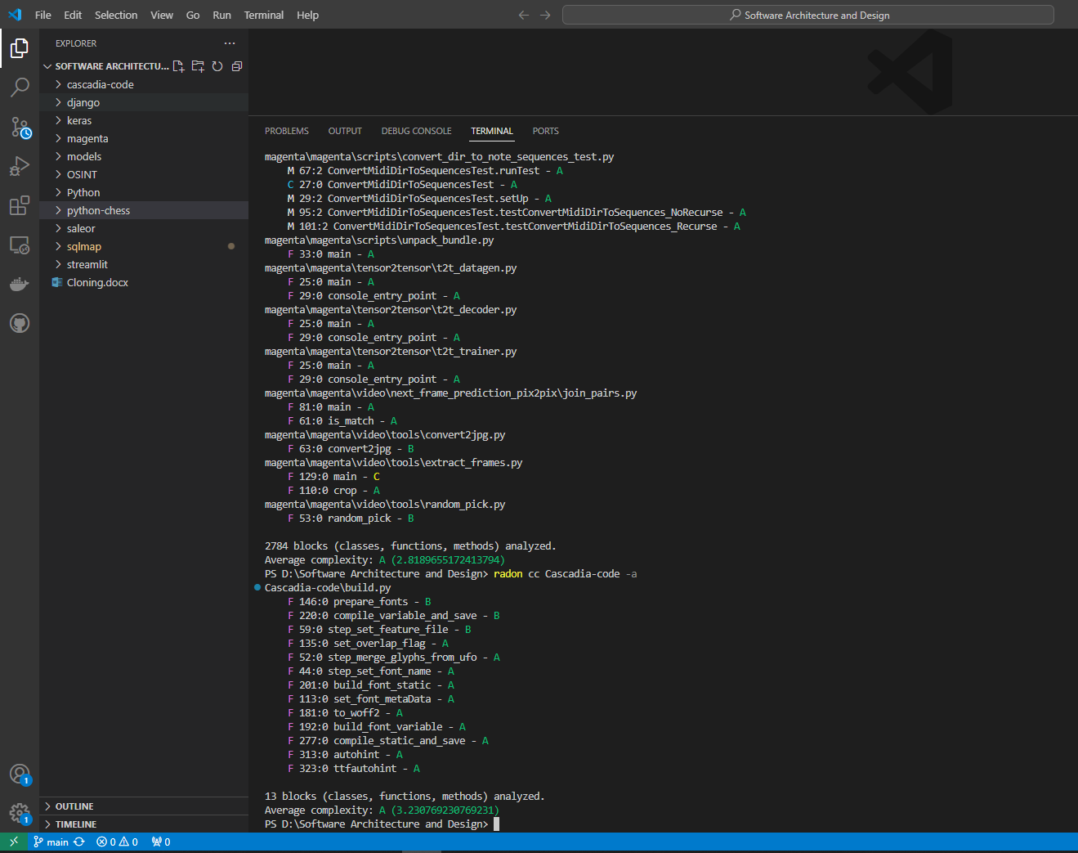

Radon cc sqlmap –a

3271 blocks (classes, functions, methods) analyzed.

Average complexity: B (5.125955365331703)

Radon cc django –a

34450 blocks (classes, functions, methods) analyzed.

Average complexity: A (1.8430478955007257)

Radon cc keras –a

9061 blocks (classes, functions, methods) analyzed.

Average complexity: A (2.316079902880477)

Radon cc OSINT –a

Error in python file

Radon cc python-chess –a

1410 blocks (classes, functions, methods) analyzed.

Average complexity: A (2.801418439716312)

Radon cc saleor –a

20668 blocks (classes, functions, methods) analyzed.

Average complexity: A (3.2475324172634026)

Radon cc streamlit –a

5530 blocks (classes, functions, methods) analyzed.

Average complexity: A (2.021157323688969)

Radon cc Python –a

1800 blocks (classes, functions, methods) analyzed.

Average complexity: A (3.062777777777778)

Radon cc models –a

20252 blocks (classes, functions, methods) analyzed.

Average complexity: A (2.4455362433339918)

Radon cc magenta –a

2784 blocks (classes, functions, methods) analyzed.

Average complexity: A (2.8189655172413794)

Radon cc Cascadia-code –a

13 blocks (classes, functions, methods) analyzed.

Average complexity: A (3.230769230769231)

# Calculating Halstead Metrics

PS D:\Software Architecture and Design\sqlmap> radon hal sqlmap.py

sqlmap.py:

h1: 15

h2: 156

N1: 147

N2: 278

vocabulary: 171

length: 425

calculated_length: 1195.1261050766386

volume: 3152.5873188265073

difficulty: 13.365384615384615

effort: 42135.54204970043

time: 2340.8634472055796

bugs: 1.0508624396088357

PS D:\Software Architecture and Design\django> radon hal setup.py

setup.py:

h1: 2

h2: 6

N1: 3

N2: 6

vocabulary: 8

length: 9

calculated_length: 17.509775004326936

volume: 27.0

difficulty: 1.0

effort: 27.0

time: 1.5

PS D:\Software Architecture and Design\cascadia-code> radon hal build.py

build.py:

h1: 12

h2: 86

N1: 66

N2: 128

vocabulary: 98

length: 194

calculated_length: 595.6783189130342

volume: 1283.2537097583506

difficulty: 8.930232558139535

effort: 11459.754059237364

time: 636.6530032909646

bugs: 0.42775123658611686

PS D:\Software Architecture and Design\saleor> radon hal manage.py

manage.py:

h1: 1

h2: 2

N1: 1

N2: 2

vocabulary: 3

length: 3

calculated_length: 2.0

volume: 4.754887502163469

difficulty: 0.5

effort: 2.3774437510817346

time: 0.1320802083934297

bugs: 0.0015849625007211565

PS D:\Software Architecture and Design\python-chess> radon hal setup.py

setup.py:

h1: 1

h2: 3

N1: 2

N2: 4

vocabulary: 4

length: 6

calculated_length: 4.754887502163469

volume: 12.0

difficulty: 0.6666666666666666

effort: 8.0

time: 0.4444444444444444

bugs: 0.004

PS D:\Software Architecture and Design\magenta> radon hal setup.py

setup.py:

h1: 2

h2: 3

N1: 2

N2: 3

vocabulary: 5

length: 5

calculated_length: 6.754887502163469

volume: 11.60964047443681

difficulty: 1.0

effort: 11.60964047443681

time: 0.6449800263576005

bugs: 0.0038698801581456034

PS D:\Software Architecture and Design\keras> radon hal setup.py

setup.py:

h1: 2

h2: 4

N1: 2

N2: 4

vocabulary: 6

length: 6

calculated_length: 10.0

volume: 15.509775004326936

difficulty: 1.0

effort: 15.509775004326936

time: 0.861654166907052

bugs: 0.005169925001442312

# Calculating Maintainability Index

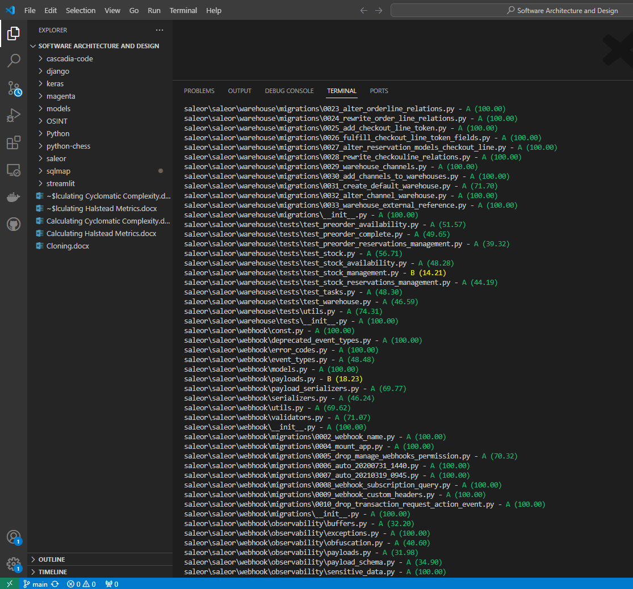

PS D:\Software Architecture and Design> radon mi sqlmap -s

sqlmap\sqlmap.py - B (9.14)

sqlmap\sqlmapapi.py - A (65.07)

sqlmap\extra\__init__.py - A (100.00)

sqlmap\extra\beep\beep.py - A (62.17)

sqlmap\extra\beep\__init__.py - A (100.00)

sqlmap\extra\cloak\cloak.py - A (60.59)

sqlmap\extra\cloak\__init__.py - A (100.00)

sqlmap\extra\dbgtool\dbgtool.py - A (58.32)

sqlmap\extra\dbgtool\__init__.py - A (100.00)

sqlmap\extra\icmpsh\icmpsh_m.py - A (69.33)

sqlmap\extra\icmpsh\__init__.py - A (100.00)

sqlmap\extra\shutils\duplicates.py - A (84.77)

sqlmap\extra\shutils\newlines.py - A (67.99)

sqlmap\extra\vulnserver\vulnserver.py - A (33.14)

sqlmap\extra\vulnserver\__init__.py - A (100.00)

sqlmap\lib\__init__.py - A (100.00)

sqlmap\lib\controller\action.py - A (42.70)

sqlmap\lib\controller\checks.py - C (0.00)

sqlmap\lib\controller\controller.py - C (0.00)

sqlmap\lib\controller\handler.py - A (48.28)

sqlmap\lib\controller\__init__.py - A (100.00)

sqlmap\lib\core\agent.py - C (0.00)

sqlmap\lib\core\bigarray.py - A (48.00)

sqlmap\lib\core\common.py - C (0.00)

sqlmap\lib\core\compat.py - A (52.61)

sqlmap\lib\core\convert.py - A (42.31)

sqlmap\lib\core\data.py - A (100.00)

sqlmap\lib\core\datatype.py - A (56.43)

sqlmap\lib\core\decorators.py - A (81.26)

sqlmap\lib\core\defaults.py - A (100.00)

sqlmap\lib\core\dicts.py - A (57.82)

sqlmap\lib\core\dump.py - C (0.00)

sqlmap\lib\core\enums.py - A (41.75)

sqlmap\lib\core\exception.py - A (100.00)

sqlmap\lib\core\gui.py - A (41.52)

sqlmap\lib\core\log.py - A (53.51)

sqlmap\lib\core\option.py - C (0.00)

sqlmap\lib\core\optiondict.py - A (100.00)

sqlmap\lib\core\patch.py - A (58.24)

sqlmap\lib\core\profiling.py - A (94.77)

sqlmap\lib\core\readlineng.py - A (77.14)

sqlmap\lib\core\replication.py - A (66.80)

sqlmap\lib\core\revision.py - A (73.78)

sqlmap\lib\core\session.py - A (75.95)

sqlmap\lib\core\settings.py - A (47.52)

sqlmap\lib\core\shell.py - A (56.87)

sqlmap\lib\core\subprocessng.py - A (41.99)

sqlmap\lib\core\target.py - C (2.10)

sqlmap\lib\core\testing.py - A (35.89)

sqlmap\lib\core\threads.py - A (42.19)

sqlmap\lib\core\unescaper.py - A (83.92)

sqlmap\lib\core\update.py - A (40.40)

sqlmap\lib\core\wordlist.py - A (63.69)

sqlmap\lib\core\__init__.py - A (100.00)

sqlmap\lib\parse\banner.py - A (60.65)

sqlmap\lib\parse\cmdline.py - B (14.13)

sqlmap\lib\parse\configfile.py - A (64.28)

sqlmap\lib\parse\handler.py - A (65.99)

sqlmap\lib\parse\headers.py - A (94.43)

sqlmap\lib\parse\html.py - A (69.77)

sqlmap\lib\parse\payloads.py - A (62.95)

sqlmap\lib\parse\sitemap.py - A (67.80)

sqlmap\lib\parse\__init__.py - A (100.00)

sqlmap\lib\request\basic.py - A (24.44)

sqlmap\lib\request\basicauthhandler.py - A (89.50)

sqlmap\lib\request\chunkedhandler.py - A (81.37)

sqlmap\lib\request\comparison.py - A (42.52)

sqlmap\lib\request\connect.py - C (0.00)

sqlmap\lib\request\direct.py - A (53.42)

sqlmap\lib\request\dns.py - A (56.77)

sqlmap\lib\request\httpshandler.py - A (57.96)

sqlmap\lib\request\inject.py - B (9.91)

sqlmap\lib\request\methodrequest.py - A (100.00)

sqlmap\lib\request\pkihandler.py - A (90.31)

sqlmap\lib\request\rangehandler.py - A (96.63)

sqlmap\lib\request\redirecthandler.py - A (38.77)

sqlmap\lib\request\templates.py - A (95.63)

sqlmap\lib\request\__init__.py - A (100.00)

sqlmap\lib\takeover\abstraction.py - A (38.21)

sqlmap\lib\takeover\icmpsh.py - A (50.33)

sqlmap\lib\takeover\metasploit.py - B (9.26)

sqlmap\lib\takeover\registry.py - A (56.74)

sqlmap\lib\takeover\udf.py - A (20.65)

sqlmap\lib\takeover\web.py - A (24.79)

sqlmap\lib\takeover\xp_cmdshell.py - A (39.02)

sqlmap\lib\takeover\__init__.py - A (100.00)

sqlmap\lib\techniques\__init__.py - A (100.00)

sqlmap\lib\techniques\blind\inference.py - B (13.96)

sqlmap\lib\techniques\blind\__init__.py - A (100.00)

sqlmap\lib\techniques\dns\test.py - A (81.86)

sqlmap\lib\techniques\dns\use.py - A (53.83)

sqlmap\lib\techniques\dns\__init__.py - A (100.00)

sqlmap\lib\techniques\error\use.py - B (16.25)

sqlmap\lib\techniques\error\__init__.py - A (100.00)

sqlmap\lib\techniques\union\test.py - A (26.62)

sqlmap\lib\techniques\union\use.py - A (22.62)

sqlmap\lib\techniques\union\__init__.py - A (100.00)

sqlmap\lib\utils\api.py - B (11.95)

sqlmap\lib\utils\brute.py - A (21.35)

sqlmap\lib\utils\crawler.py - A (33.67)

sqlmap\lib\utils\deps.py - A (41.74)

sqlmap\lib\utils\getch.py - A (82.81)

sqlmap\lib\utils\har.py - A (44.37)

sqlmap\lib\utils\hash.py - C (0.00)

sqlmap\lib\utils\hashdb.py - A (36.05)

sqlmap\lib\utils\httpd.py - A (47.12)

sqlmap\lib\utils\pivotdumptable.py - A (37.10)

sqlmap\lib\utils\progress.py - A (66.48)

sqlmap\lib\utils\purge.py - A (65.02)

sqlmap\lib\utils\safe2bin.py - A (71.36)

sqlmap\lib\utils\search.py - A (42.75)

sqlmap\lib\utils\sgmllib.py - A (25.00)

sqlmap\lib\utils\sqlalchemy.py - A (48.36)

sqlmap\lib\utils\timeout.py - A (84.24)

sqlmap\lib\utils\versioncheck.py - A (85.32)

sqlmap\lib\utils\xrange.py - A (69.19)

sqlmap\lib\utils\__init__.py - A (100.00)

sqlmap\plugins\__init__.py - A (100.00)

sqlmap\plugins\dbms\__init__.py - A (100.00)

sqlmap\plugins\dbms\access\connector.py - A (75.61)

sqlmap\plugins\dbms\access\enumeration.py - A (100.00)

sqlmap\plugins\dbms\access\filesystem.py - A (100.00)

sqlmap\plugins\dbms\access\fingerprint.py - A (44.35)

sqlmap\plugins\dbms\access\syntax.py - A (96.85)

sqlmap\plugins\dbms\access\takeover.py - A (90.30)

sqlmap\plugins\dbms\access\__init__.py - A (100.00)

sqlmap\plugins\dbms\altibase\connector.py - A (100.00)

sqlmap\plugins\dbms\altibase\enumeration.py - A (100.00)

sqlmap\plugins\dbms\altibase\filesystem.py - A (100.00)

sqlmap\plugins\dbms\altibase\fingerprint.py - A (59.20)

sqlmap\plugins\dbms\altibase\syntax.py - A (96.85)

sqlmap\plugins\dbms\altibase\takeover.py - A (90.30)

sqlmap\plugins\dbms\altibase\__init__.py - A (100.00)

sqlmap\plugins\dbms\cache\connector.py - A (74.39)

sqlmap\plugins\dbms\cache\enumeration.py - A (100.00)

sqlmap\plugins\dbms\cache\filesystem.py - A (100.00)

sqlmap\plugins\dbms\cache\fingerprint.py - A (52.88)

sqlmap\plugins\dbms\cache\syntax.py - A (94.65)

sqlmap\plugins\dbms\cache\takeover.py - A (90.30)

sqlmap\plugins\dbms\cache\__init__.py - A (100.00)

sqlmap\plugins\dbms\clickhouse\connector.py - A (100.00)

sqlmap\plugins\dbms\clickhouse\enumeration.py - A (100.00)

sqlmap\plugins\dbms\clickhouse\filesystem.py - A (100.00)

sqlmap\plugins\dbms\clickhouse\fingerprint.py - A (57.86)

sqlmap\plugins\dbms\clickhouse\syntax.py - A (96.85)

sqlmap\plugins\dbms\clickhouse\takeover.py - A (90.30)

sqlmap\plugins\dbms\clickhouse\__init__.py - A (100.00)

sqlmap\plugins\dbms\cratedb\connector.py - A (84.28)

sqlmap\plugins\dbms\cratedb\enumeration.py - A (100.00)

sqlmap\plugins\dbms\cratedb\filesystem.py - A (100.00)

sqlmap\plugins\dbms\cratedb\fingerprint.py - A (57.86)

sqlmap\plugins\dbms\cratedb\syntax.py - A (100.00)

sqlmap\plugins\dbms\cratedb\takeover.py - A (90.30)

sqlmap\plugins\dbms\cratedb\__init__.py - A (100.00)

sqlmap\plugins\dbms\cubrid\connector.py - A (82.55)

sqlmap\plugins\dbms\cubrid\enumeration.py - A (100.00)

sqlmap\plugins\dbms\cubrid\filesystem.py - A (100.00)

sqlmap\plugins\dbms\cubrid\fingerprint.py - A (57.86)

sqlmap\plugins\dbms\cubrid\syntax.py - A (94.65)

sqlmap\plugins\dbms\cubrid\takeover.py - A (90.30)

sqlmap\plugins\dbms\cubrid\__init__.py - A (100.00)

sqlmap\plugins\dbms\db2\connector.py - A (80.30)

sqlmap\plugins\dbms\db2\enumeration.py - A (100.00)

PS D:\Software Architecture and Design> radon mi saleor -s

saleor\conftest.py - A (77.42)

saleor\manage.py - A (99.90)

saleor\saleor\celeryconf.py - A (100.00)

saleor\saleor\settings.py - A (42.87)

saleor\saleor\urls.py - A (67.78)

saleor\saleor\__init__.py - A (100.00)

saleor\saleor\__main__.py - A (100.00)

saleor\saleor\account\app.py - A (100.00)

saleor\saleor\account\error_codes.py - A (100.00)

saleor\saleor\account\events.py - A (100.00)

saleor\saleor\account\forms.py - A (58.74)

saleor\saleor\account\i18n.py - A (40.47)

saleor\saleor\account\models.py - A (44.15)

saleor\saleor\account\notifications.py - A (60.18)

saleor\saleor\account\search.py - A (59.07)

saleor\saleor\account\signals.py - A (100.00)

saleor\saleor\account\utils.py - A (54.55)

saleor\saleor\account\validators.py - A (68.14)

saleor\saleor\account\widgets.py - A (100.00)

saleor\saleor\account\__init__.py - A (100.00)

saleor\saleor\account\management\__init__.py - A (100.00)

saleor\saleor\account\management\commands\changepassword.py - A (100.00)

saleor\saleor\account\management\commands\createsuperuser.py - A (38.94)

saleor\saleor\account\management\commands\__init__.py - A (100.00)

saleor\saleor\account\migrations\0001_initial.py - A (100.00)

saleor\saleor\account\migrations\0002_auto_20150907_0602.py - A (100.00)

saleor\saleor\account\migrations\0003_auto_20151104_1102.py - A (100.00)

saleor\saleor\account\migrations\0004_auto_20160114_0419.py - A (100.00)

saleor\saleor\account\migrations\0005_auto_20160205_0651.py - A (100.00)

saleor\saleor\account\migrations\0006_auto_20160829_0819.py - A (100.00)

saleor\saleor\account\migrations\0007_auto_20161115_0940.py - A (100.00)

saleor\saleor\account\migrations\0008_auto_20161115_1011.py - A (100.00)

saleor\saleor\account\migrations\0009_auto_20170206_0407.py - A (100.00)

saleor\saleor\account\migrations\0010_auto_20170919_0839.py - A (100.00)

saleor\saleor\account\migrations\0011_auto_20171110_0552.py - A (100.00)

saleor\saleor\account\migrations\0022_auto_20180718_0956.py - A (100.00)

saleor\saleor\account\migrations\0023_auto_20180719_0520.py - A (100.00)

saleor\saleor\account\migrations\0024_auto_20181011_0737.py - A (100.00)

saleor\saleor\account\migrations\0025_auto_20190314_0550.py - A (100.00)

saleor\saleor\account\migrations\0026_user_avatar.py - A (100.00)

saleor\saleor\account\migrations\0027_customerevent.py - A (100.00)

saleor\saleor\account\migrations\0028_user_private_meta.py - A (100.00)

saleor\saleor\account\migrations\0029_user_meta.py - A (100.00)

saleor\saleor\account\migrations\0030_auto_20190719_0733.py - A (100.00)

saleor\saleor\account\migrations\0031_auto_20190719_0745.py - A (100.00)

saleor\saleor\account\migrations\0032_remove_user_token.py - A (100.00)

saleor\saleor\account\migrations\0033_serviceaccount.py - A (100.00)

saleor\saleor\account\migrations\0034_service_account_token.py - A (100.00)

saleor\saleor\account\migrations\0035_staffnotificationrecipient.py - A (100.00)

saleor\saleor\account\migrations\0036_auto_20191209_0407.py - A (100.00)

saleor\saleor\account\migrations\0037_auto_20191219_0944.py - A (100.00)

saleor\saleor\account\migrations\0038_auto_20200123_0034.py - A (100.00)

saleor\saleor\account\migrations\0039_auto_20200221_0257.py - A (100.00)

saleor\saleor\account\migrations\0040_auto_20200225_0237.py - A (100.00)

saleor\saleor\account\migrations\0040_auto_20200415_0443.py - A (67.47)

saleor\saleor\account\migrations\0041_merge_20200421_0529.py - A (100.00)

saleor\saleor\account\migrations\0041_permissions_to_groups.py - A (68.45)

saleor\saleor\account\migrations\0042_merge_20200422_0555.py - A (100.00)

saleor\saleor\account\migrations\0043_rename_service_account_to_app.py - A (100.00)

saleor\saleor\account\migrations\0044_unmount_app_and_app_token.py - A (100.00)

saleor\saleor\account\migrations\0045_auto_20200427_0425.py - A (74.92)

saleor\saleor\account\migrations\0046_user_jwt_token_key.py - A (100.00)

saleor\saleor\account\migrations\0047_auto_20200810_1415.py - A (100.00)

saleor\saleor\account\migrations\0048_auto_20210308_1135.py - A (100.00)

saleor\saleor\account\migrations\0049_user_language_code.py - A (100.00)

saleor\saleor\account\migrations\0050_auto_20210506_1058.py - A (100.00)

saleor\saleor\account\migrations\0051_alter_customerevent_user.py - A (100.00)

saleor\saleor\account\migrations\0052_customerevent_app.py - A (100.00)

saleor\saleor\account\migrations\0053_auto_20210719_1048.py - A (100.00)

saleor\saleor\account\migrations\0054_alter_user_language_code.py - A (100.00)

saleor\saleor\account\migrations\0055_alter_user_language_code.py - A (100.00)

saleor\saleor\account\migrations\0055_alter_user_options.py - A (100.00)

saleor\saleor\graphql\order\tests\mutations\test_draft_order_complete.py - B (10.89)

saleor\saleor\graphql\order\tests\mutations\test_draft_order_create.py - C (0.00)

saleor\saleor\graphql\order\tests\mutations\test_draft_order_delete.py - A (55.29)

saleor\saleor\graphql\order\tests\mutations\test_draft_order_update.py - B (10.30)

saleor\saleor\graphql\order\tests\mutations\test_fulfillment_approve.py - A (24.70)

saleor\saleor\graphql\order\tests\mutations\test_fulfillment_cancel.py - A (34.36)

saleor\saleor\graphql\order\tests\mutations\test_fulfillment_refund_products.py - B (14.56)

saleor\saleor\graphql\order\tests\mutations\test_fulfillment_return_products.py - B (10.43)

saleor\saleor\graphql\order\tests\mutations\test_fulfillment_update_tracking.py - A (59.85)

saleor\saleor\graphql\order\tests\mutations\test_order_bulk_cancel.py - A (52.94)

saleor\saleor\graphql\order\tests\mutations\test_order_bulk_create.py - C (0.00)

saleor\saleor\graphql\order\tests\mutations\test_order_cancel.py - A (58.60)

saleor\saleor\graphql\order\tests\mutations\test_order_capture.py - A (58.00)

saleor\saleor\graphql\order\tests\mutations\test_order_confirm.py - A (40.47)

saleor\saleor\graphql\order\tests\mutations\test_order_discount.py - C (7.31)

saleor\saleor\graphql\order\tests\mutations\test_order_fulfill.py - C (6.69)

saleor\saleor\graphql\order\tests\mutations\test_order_grant_refund_create.py - A (22.33)

saleor\saleor\graphql\order\tests\mutations\test_order_grant_refund_update.py - C (8.78)

saleor\saleor\graphql\order\tests\mutations\test_order_lines_create.py - B (15.98)

PS D:\Software Architecture and Design> radon mi cascadia-code -s

cascadia-code\build.py - A (32.27)

PS D:\Software Architecture and Design> radon mi keras -s

keras\conftest.py - A (93.47)

keras\pip_build.py - A (54.76)

keras\setup.py - A (69.70)

keras\benchmarks\__init__.py - A (100.00)

keras\benchmarks\layer_benchmark\activation_benchmark.py - A (68.23)

keras\benchmarks\layer_benchmark\attention_benchmark.py - A (72.99)

keras\benchmarks\layer_benchmark\base_benchmark.py - A (40.86)

keras\benchmarks\layer_benchmark\conv_benchmark.py - A (58.22)

keras\benchmarks\layer_benchmark\core_benchmark.py - A (71.64)

keras\benchmarks\layer_benchmark\merge_benchmark.py - A (62.33)

keras\benchmarks\layer_benchmark\normalization_benchmark.py - A (70.38)

keras\benchmarks\layer_benchmark\pooling_benchmark.py - A (56.98)

keras\benchmarks\layer_benchmark\regularization_benchmark.py - A (64.69)

keras\benchmarks\layer_benchmark\reshaping_benchmark.py - A (58.70)

keras\benchmarks\layer_benchmark\rnn_benchmark.py - A (60.44)

keras\benchmarks\layer_benchmark\__init__.py - A (100.00)

keras\benchmarks\model_benchmark\benchmark_utils.py - A (74.08)

keras\benchmarks\model_benchmark\bert_benchmark.py - A (70.81)

keras\benchmarks\model_benchmark\image_classification_benchmark.py - A (71.02)

keras\benchmarks\model_benchmark\__init__.py - A (100.00)

keras\benchmarks\torch_ctl_benchmark\benchmark_utils.py - A (72.25)

keras\benchmarks\torch_ctl_benchmark\conv_model_benchmark.py - A (70.72)

keras\benchmarks\torch_ctl_benchmark\dense_model_benchmark.py - A (70.82)

keras\benchmarks\torch_ctl_benchmark\__init__.py - A (100.00)

keras\examples\demo_custom_jax_workflow.py - A (65.02)

keras\examples\demo_custom_layer_backend_agnostic.py - A (70.46)

keras\keras\ops\math_test.py - B (13.03)

keras\keras\ops\nn.py - A (26.60)

keras\keras\ops\nn_test.py - C (0.00)

keras\keras\ops\node.py - A (73.78)

keras\keras\ops\node_test.py - A (100.00)

keras\keras\ops\numpy.py - C (0.00)

keras\keras\ops\numpy_test.py - C (0.00)

keras\keras\ops\operation.py - A (61.21)

PS D:\Software Architecture and Design> radon mi magenta -s

magenta\conftest.py - A (100.00)

magenta\setup.py - A (91.56)

magenta\magenta\version.py - A (100.00)

magenta\magenta\__init__.py - A (100.00)

magenta\magenta\common\beam_search.py - A (65.44)

magenta\magenta\common\beam_search_test.py - A (78.31)

magenta\magenta\common\concurrency.py - A (71.11)

magenta\magenta\common\concurrency_test.py - A (85.83)

magenta\magenta\common\nade.py - A (62.07)

magenta\magenta\common\nade_test.py - A (88.22)

magenta\magenta\common\sequence_example_lib.py - A (73.08)

magenta\magenta\common\state_util.py - A (50.69)

magenta\magenta\common\state_util_test.py - A (90.09)

magenta\magenta\common\testing_lib.py - A (76.81)

magenta\magenta\common\tf_utils.py - A (55.25)

magenta\magenta\common\__init__.py - A (100.00)

magenta\magenta\contrib\cudnn_rnn.py - A (100.00)

magenta\magenta\contrib\rnn.py - A (37.92)

magenta\magenta\contrib\rnn_test.py - A (26.04)

magenta\magenta\contrib\seq2seq.py - A (37.12)

magenta\magenta\contrib\seq2seq_test.py - A (42.65)

magenta\magenta\contrib\training.py - A (38.43)

magenta\magenta\contrib\__init__.py - A (100.00)

magenta\magenta\interfaces\__init__.py - A (100.00)

magenta\magenta\interfaces\midi\magenta_midi.py - A (47.10)

magenta\magenta\interfaces\midi\midi_clock.py - A (85.12)

magenta\magenta\interfaces\midi\midi_hub.py - B (15.77)

magenta\magenta\interfaces\midi\midi_hub_test.py - A (26.53)

magenta\magenta\models\rl_tuner\rl_tuner.py - C (3.11)

# Calculating pylint score

PS D:\Software Architecture and Design\cascadia-code> pylint build.py

************* Module build

build.py:49:0: C0301: Line too long (102/100) (line-too-long)

build.py:61:87: C0303: Trailing whitespace (trailing-whitespace)

build.py:66:26: C0303: Trailing whitespace (trailing-whitespace)

build.py:67:26: C0303: Trailing whitespace (trailing-whitespace)

build.py:69:19: C0303: Trailing whitespace (trailing-whitespace)

build.py:70:19: C0303: Trailing whitespace (trailing-whitespace)

build.py:71:19: C0303: Trailing whitespace (trailing-whitespace)

build.py:75:19: C0303: Trailing whitespace (trailing-whitespace)

build.py:76:19: C0303: Trailing whitespace (trailing-whitespace)

build.py:77:19: C0303: Trailing whitespace (trailing-whitespace)

build.py:78:19: C0303: Trailing whitespace (trailing-whitespace)

build.py:86:19: C0303: Trailing whitespace (trailing-whitespace)

build.py:89:19: C0303: Trailing whitespace (trailing-whitespace)

build.py:90:19: C0303: Trailing whitespace (trailing-whitespace)

build.py:91:19: C0303: Trailing whitespace (trailing-whitespace)

build.py:92:19: C0303: Trailing whitespace (trailing-whitespace)

build.py:93:19: C0303: Trailing whitespace (trailing-whitespace)

build.py:94:19: C0303: Trailing whitespace (trailing-whitespace)

build.py:95:19: C0303: Trailing whitespace (trailing-whitespace)

build.py:107:0: C0301: Line too long (115/100) (line-too-long)

build.py:110:39: C0303: Trailing whitespace (trailing-whitespace)

build.py:224:0: C0303: Trailing whitespace (trailing-whitespace)

build.py:226:0: C0301: Line too long (114/100) (line-too-long)

build.py:227:0: C0303: Trailing whitespace (trailing-whitespace)

build.py:244:0: C0303: Trailing whitespace (trailing-whitespace)

build.py:262:0: C0301: Line too long (103/100) (line-too-long)

build.py:263:0: C0301: Line too long (108/100) (line-too-long)

build.py:1:0: C0114: Missing module docstring (missing-module-docstring)

build.py:8:0: W0402: Uses of a deprecated module 'xml.etree.cElementTree' (deprecated-module)

build.py:11:0: E0401: Unable to import 'cffsubr.__main__' (import-error)

build.py:12:0: E0401: Unable to import 'fontmake.instantiator' (import-error)

build.py:15:0: R0402: Use 'from fontTools.ttLib.tables import _g_l_y_f' instead (consider-using-from-import)

build.py:16:0: E0401: Unable to import 'psautohint.__main__' (import-error)

build.py:17:0: E0401: Unable to import 'gftools.stat' (import-error)

build.py:19:0: E0401: Unable to import 'ufo2ft' (import-error)

build.py:20:0: E0401: Unable to import 'ufoLib2' (import-error)

build.py:21:0: E0401: Unable to import 'vttLib' (import-error)

build.py:22:0: E0401: Unable to import 'vttLib.transfer' (import-error)

build.py:23:0: E0401: Unable to import 'vttmisc' (import-error)

build.py:44:0: C0116: Missing function or method docstring (missing-function-docstring)

build.py:52:0: C0116: Missing function or method docstring (missing-function-docstring)

build.py:59:0: C0116: Missing function or method docstring (missing-function-docstring)

build.py:60:4: C0103: Variable name "featureSet" doesn't conform to snake_case naming style (invalid-name)

build.py:62:8: C0103: Variable name "featureList" doesn't conform to snake_case naming style (invalid-name)

build.py:82:8: C0103: Variable name "featureList" doesn't conform to snake_case naming style (invalid-name)

build.py:105:12: C0103: Variable name "featureSet" doesn't conform to snake_case naming style (invalid-name)

build.py:105:26: W1514: Using open without explicitly specifying an encoding (unspecified-encoding)

build.py:107:12: C0103: Variable name "featureSet" doesn't conform to snake_case naming style (invalid-name)

build.py:107:26: W1514: Using open without explicitly specifying an encoding (unspecified-encoding)

build.py:109:12: C0103: Variable name "featureSet" doesn't conform to snake_case naming style (invalid-name)

build.py:109:26: W1514: Using open without explicitly specifying an encoding (unspecified-encoding)

build.py:113:0: C0103: Function name "set_font_metaData" doesn't conform to snake_case naming style (invalid-name)

build.py:113:0: C0116: Missing function or method docstring (missing-function-docstring)

build.py:113:22: W0621: Redefining name 'font' from outer scope (line 579) (redefined-outer-name)

build.py:135:0: C0116: Missing function or method docstring (missing-function-docstring)

build.py:146:0: C0116: Missing function or method docstring (missing-function-docstring)

build.py:147:4: W0621: Redefining name 'designspace' from outer scope (line 362) (redefined-outer-name)

build.py:181:0: C0116: Missing function or method docstring (missing-function-docstring)

build.py:183:4: W0621: Redefining name 'font' from outer scope (line 579) (redefined-outer-name)

build.py:192:0: C0116: Missing function or method docstring (missing-function-docstring)

build.py:193:4: W0621: Redefining name 'designspace' from outer scope (line 362) (redefined-outer-name)

build.py:201:0: C0116: Missing function or method docstring (missing-function-docstring)

build.py:202:4: W0621: Redefining name 'designspace' from outer scope (line 362) (redefined-outer-name)

build.py:203:4: W0621: Redefining name 'instance_descriptor' from outer scope (line 475) (redefined-outer-name)

build.py:220:0: C0116: Missing function or method docstring (missing-function-docstring)

build.py:221:4: W0621: Redefining name 'designspace' from outer scope (line 362) (redefined-outer-name)

build.py:228:4: C0103: Variable name "familyName" doesn't conform to snake_case naming style (invalid-name)

build.py:229:4: C0103: Variable name "styleName" doesn't conform to snake_case naming style (invalid-name)

build.py:236:4: C0103: Variable name "varFont" doesn't conform to snake_case naming style (invalid-name)

build.py:253:8: W0107: Unnecessary pass statement (unnecessary-pass)

build.py:277:0: C0116: Missing function or method docstring (missing-function-docstring)

build.py:313:0: C0116: Missing function or method docstring (missing-function-docstring)

build.py:323:0: C0116: Missing function or method docstring (missing-function-docstring)

build.py:575:9: W1514: Using open without explicitly specifying an encoding (unspecified-encoding)

build.py:598:15: W0703: Catching too general exception Exception (broad-except)

build.py:586:19: R1732: Consider using 'with' for resource-allocating operations (consider-using-with)

build.py:603:15: R1732: Consider using 'with' for resource-allocating operations (consider-using-with)

build.py:8:0: W0611: Unused xml.etree.cElementTree imported as ET (unused-import)

build.py:9:0: W0611: Unused import tempfile (unused-import)

build.py:23:0: W0611: Unused tsic imported from vttmisc (unused-import)

-----------------------------------

Your code has been rated at 5.52/10

PS D:\Software Architecture and Design\django> pylint setup.py

************* Module setup

setup.py:1:0: C0114: Missing module docstring (missing-module-docstring)

setup.py:4:0: W0402: Uses of a deprecated module 'distutils.sysconfig' (deprecated-module)

setup.py:15:0: C0103: Constant name "overlay_warning" doesn't conform to UPPER_CASE naming style (invalid-name)

setup.py:27:12: C0103: Constant name "overlay_warning" doesn't conform to UPPER_CASE naming style (invalid-name)

setup.py:36:8: C0209: Formatting a regular string which could be a f-string (consider-using-f-string)

------------------------------------------------------------------

Your code has been rated at 7.37/10 (previous run: 8.75/10, -1.38)

PS D:\Software Architecture and Design\keras> pylint setup.py

************* Module setup

setup.py:10:0: C0116: Missing function or method docstring (missing-function-docstring)

setup.py:12:9: W1514: Using open without explicitly specifying an encoding (unspecified-encoding)

setup.py:12:47: C0103: Variable name "fp" doesn't conform to snake_case naming style (invalid-name)

setup.py:16:0: C0116: Missing function or method docstring (missing-function-docstring)

------------------------------------------------------------------

Your code has been rated at 8.00/10 (previous run: 7.37/10, +0.63)

PS D:\Software Architecture and Design\models\tensorflow_models> pylint tensorflow_models_test.py

************* Module tensorflow_models.tensorflow_models_test

tensorflow_models_test.py:23:0: W0311: Bad indentation. Found 2 spaces, expected 4 (bad-indentation)

tensorflow_models_test.py:24:0: W0311: Bad indentation. Found 4 spaces, expected 8 (bad-indentation)

tensorflow_models_test.py:26:0: W0311: Bad indentation. Found 4 spaces, expected 8 (bad-indentation)

tensorflow_models_test.py:28:0: W0311: Bad indentation. Found 2 spaces, expected 4 (bad-indentation)

tensorflow_models_test.py:29:0: W0311: Bad indentation. Found 4 spaces, expected 8 (bad-indentation)

tensorflow_models_test.py:31:0: W0311: Bad indentation. Found 4 spaces, expected 8 (bad-indentation)

tensorflow_models_test.py:33:0: W0311: Bad indentation. Found 2 spaces, expected 4 (bad-indentation)

tensorflow_models_test.py:34:0: W0311: Bad indentation. Found 4 spaces, expected 8 (bad-indentation)

tensorflow_models_test.py:35:0: W0311: Bad indentation. Found 4 spaces, expected 8 (bad-indentation)

tensorflow_models_test.py:40:0: W0311: Bad indentation. Found 2 spaces, expected 4 (bad-indentation)

tensorflow_models_test.py:17:0: C0410: Multiple imports on one line (tensorflow, tf_keras) (multiple-imports)

tensorflow_models_test.py:17:0: E0401: Unable to import 'tensorflow' (import-error)

tensorflow_models_test.py:17:0: E0401: Unable to import 'tf_keras' (import-error)

tensorflow_models_test.py:21:0: C0115: Missing class docstring (missing-class-docstring)

tensorflow_models_test.py:23:2: C0103: Method name "testVisionImport" doesn't conform to snake_case naming style (invalid-name)

tensorflow_models_test.py:23:2: C0116: Missing function or method docstring (missing-function-docstring)

tensorflow_models_test.py:23:2: R0201: Method could be a function (no-self-use)

tensorflow_models_test.py:28:2: C0103: Method name "testNLPImport" doesn't conform to snake_case naming style (invalid-name)

tensorflow_models_test.py:28:2: C0116: Missing function or method docstring (missing-function-docstring)

tensorflow_models_test.py:28:2: R0201: Method could be a function (no-self-use)

tensorflow_models_test.py:33:2: C0103: Method name "testCommonImports" doesn't conform to snake_case naming style (invalid-name)

tensorflow_models_test.py:33:2: C0116: Missing function or method docstring (missing-function-docstring)

tensorflow_models_test.py:33:2: R0201: Method could be a function (no-self-use)

tensorflow_models_test.py:17:0: W0611: Unused import tf_keras (unused-import)

-----------------------------------

Your code has been rated at 0.00/10

PS D:\Software Architecture and Design\python-chess> pylint setup.py

************* Module setup

setup.py:1:0: C0114: Missing module docstring (missing-module-docstring)

setup.py:29:0: C0413: Import "import chess" should be placed at the top of the module (wrong-import-position)

setup.py:37:90: C0103: Variable name "f" doesn't conform to snake_case naming style (invalid-name)

setup.py:43:8: C0209: Formatting a regular string which could be a f-string (consider-using-f-string)

setup.py:48:8: C0209: Formatting a regular string which could be a f-string (consider-using-f-string)

setup.py:5:0: W0611: Unused import platform (unused-import)

------------------------------------------------------------------

Your code has been rated at 6.84/10 (previous run: 8.00/10, -1.16)

PS D:\Software Architecture and Design\saleor> pylint manage.py

************* Module manage

manage.py:1:0: C0114: Missing module docstring (missing-module-docstring)

manage.py:8:4: E0401: Unable to import 'django.core.management' (import-error)

-----------------------------------

Your code has been rated at 0.00/10

PS D:\Software Architecture and Design\sqlmap> pylint sqlmap.py

************* Module sqlmap

sqlmap.py:97: [E0601(used-before-assignment), ] Using variable 'logger' before assignment

-----------------------------------

Your code has been rated at 9.90/10