Project Document
Salesforce CRM Implementation for WhatsNext Vision Motors
Vehicle Sales, Dealer & Test Drive Management on the Salesforce Platform

Abstract
This project report documents the implementation of a Salesforce CRM application for WhatsNext Vision Motors, an automobile sales and dealership business. The solution digitizes vehicle inventory, dealer records, customer records, vehicle orders, test drive scheduling, and service requests inside a single Lightning application.
The core of the implementation is an order-confirmation safeguard: an Apex trigger validates available stock before a vehicle order is allowed to proceed, and automatically reduces stock once an order is confirmed. A Scheduled Batch Apex job re-checks any orders left in a Pending state so that they can be confirmed automatically once stock is replenished, without manual follow-up. On the engagement side, a record-triggered Flow on the Vehicle Test Drive object sends an automated reminder email to the customer ahead of their scheduled test drive.
Together these automations reduce manual data entry, prevent overselling of vehicles that are out of stock, and keep customers informed — demonstrating how a cloud CRM platform can streamline day-to-day operations for an automotive dealership network.

Objectives
The objectives of the Salesforce CRM implementation are as follows:
- Model the dealership's core operations — vehicles, dealers, customers, orders, test drives, and service requests — as related custom objects.
- Prevent a vehicle order from being placed when the selected vehicle has zero stock, using Apex trigger validation.
- Automatically decrement vehicle stock the moment an order's status is set to Confirmed.
- Re-process pending orders on a nightly schedule so that stock replenishment is reflected without manual intervention.
- Automate customer communication by emailing a test drive reminder ahead of the scheduled appointment.
- Present all of the above inside a single, purpose-built Lightning application with dedicated navigation tabs.

Technology Description
The Salesforce CRM implementation uses the following core technologies:
- Salesforce Platform — provides the underlying CRM data model, security, and customization framework.
- Custom Objects — Vehicle, Vehicle Dealer, Vehicle Customer, Vehicle Order, Vehicle Test Drive, and Vehicle Service Request hold the application's data.
- Lightning App Builder — used to assemble the "WhatNext Vision Motors" app and its navigation tabs.
- Flow Builder — a record-triggered flow on Vehicle Test Drive sends an automated reminder email before a scheduled test drive.
- Apex Trigger & Handler Class — VehicleOrderTrigger / VehicleOrderTriggerHandler enforce stock validation and stock updates on Vehicle Order records.
- Batch Apex — VehicleOrderBatch reprocesses Pending orders in bulk once stock is available.
- Scheduled Apex — VehicleOrderBatchScheduler runs the batch job automatically on a daily cron schedule.

Detailed Execution of Project Phases

Phase 1: Developer Account Creation
A Salesforce Developer Edition account was created through the official developer portal so that the application could be built and tested without impacting a production org.
Step 1: Go to https://developer.salesforce.com/signup
Step 2: On the sign-up form, enter First Name, Last Name, Email, Role (Developer), Company (college name), Country, and Postal Code.
Step 3: Choose a Username in the form name@company.com — this does not need to be a real, reachable email address.
Step 4: Submit the form, verify the account through the confirmation email, and set a password and security question.

Phase 2: Object & Relationship Setup
Six custom objects were created to model the dealership: Vehicle, Vehicle Dealer, Vehicle Customer, Vehicle Order, Vehicle Test Drive, and Vehicle Service Request. Lookup relationships tie orders, test drives, and service requests back to the vehicle, customer, and dealer records involved. All six objects have reporting enabled and are deployed.
Object (Singular Label) | API Name | Plural Label | Purpose
Vehicle | Vehicle__c | Vehicles | Inventory, price, and stock
Vehicle Dealer | Vehicle_Dealer__c | Vehicle Dealers | Dealer contact & location
Vehicle Customer | Vehicle_Customer__c | Vehicle_Customers | Customer contact details
Vehicle Order | Vehicle_Order__c | Vehicle_Orders | Order status & stock validation
VehicleTest Drive | Vehicle_Test_Drive__c | Vehicle_Test_Drives | Scheduled test drives & reminders
Vehicle Service Request | Vehicle_Service_Request__c | Vehicle_Service_Requests | Post-sale service tracking

Vehicle (Vehicle__c)
Field Label | API Name | Data Type | Notes
Price | Price__c | Currency(18,0) | -
Status | Status__c | Picklist | -
Stock Quantity | Stock_Quantity__c | Number(18,0) | Checked/updated by Apex
Vehicle Dealer | Vehicle_Dealer__c | Lookup(Vehicle Dealer) | Indexed
Vehicle Model | Vehicle_Model__c | Picklist | -
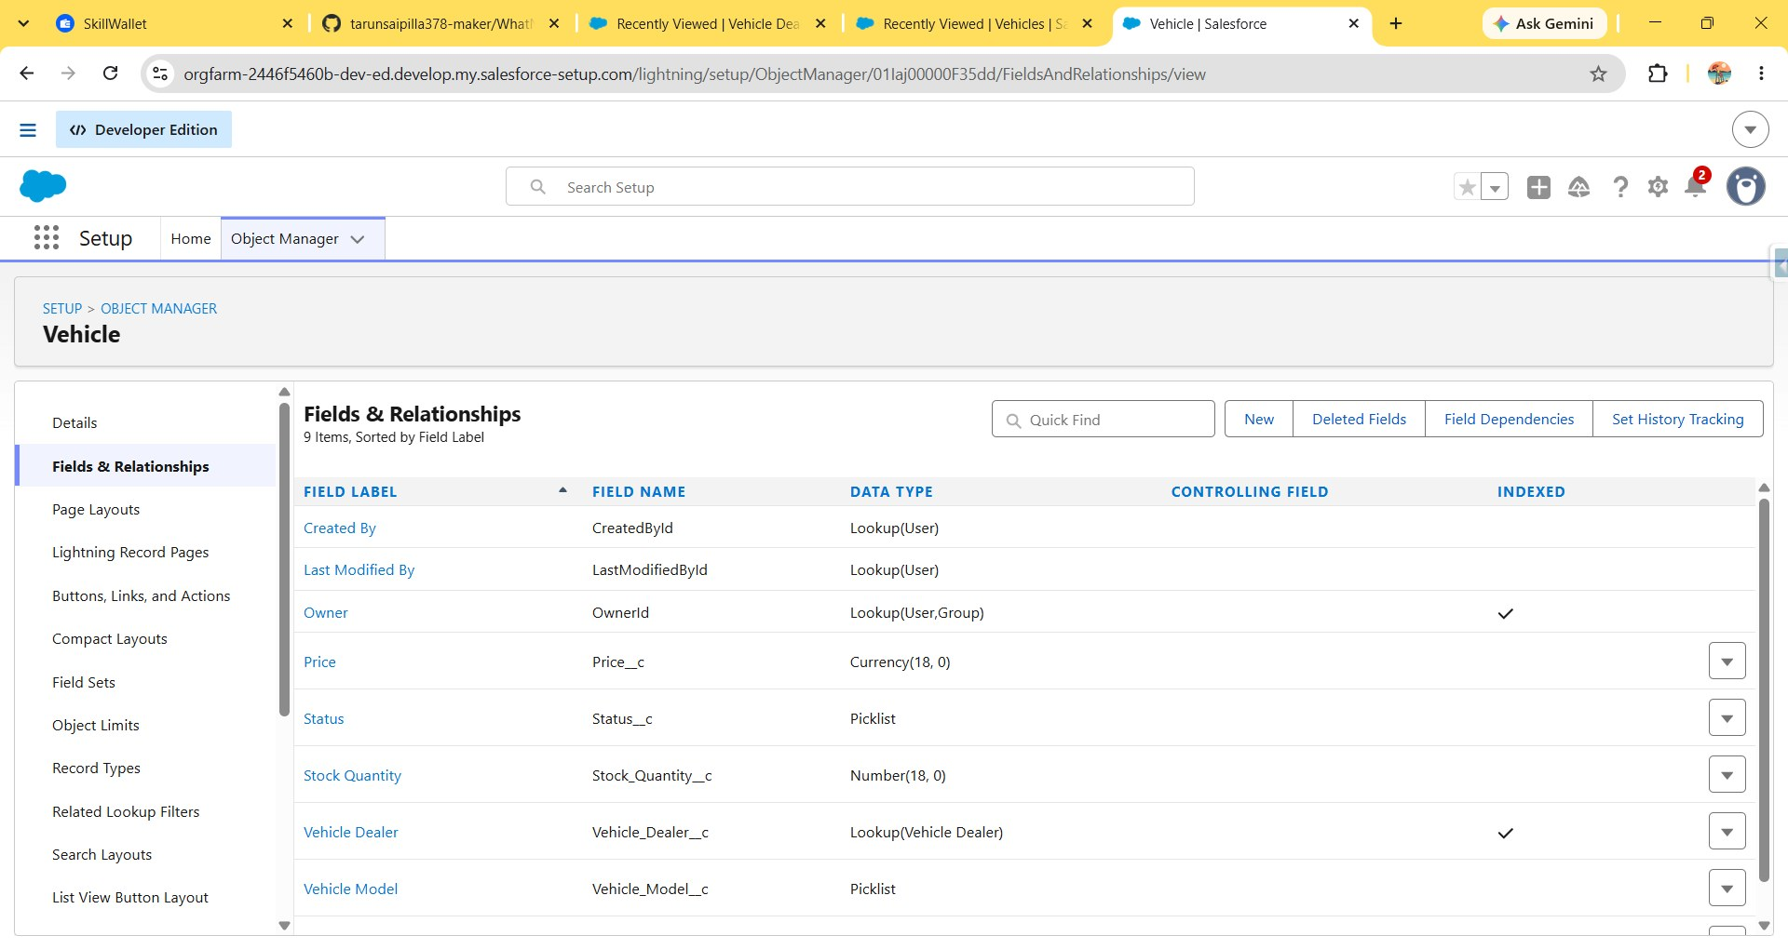
Fig. 1 — Vehicle object: Fields & Relationships

Vehicle Dealer (Vehicle_Dealer__c)
Field Label | API Name | Data Type | Notes
Dealer Code | Dealer_Code__c | Auto Number | -
Dealer Location | Dealer_Location__c | Text(60) | Used to match a customer's address
Email | Email__c | Email | -
Phone | Phone__c | Phone | -
Vehicle Dealer Name | Name | Text(80) | Indexed
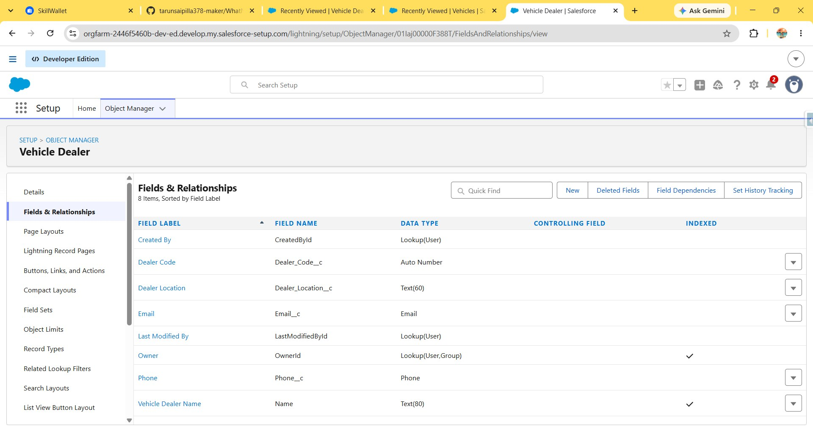
Fig. 2 — Vehicle Dealer object: Fields & Relationships
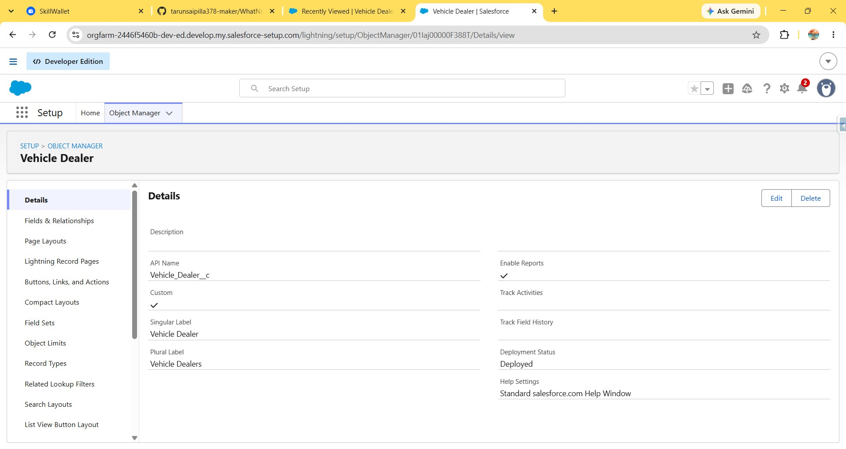
Fig. 3 — Vehicle Dealer object: Details (Singular Label "Vehicle Dealer", Plural "Vehicle Dealers")

Vehicle Customer (Vehicle_Customer__c)
Field Label | API Name | Data Type | Notes
Address | Address__c | Text(60) | -
Email | Email__c | Email | Used by the test drive reminder flow
Phone | Phone__c | Phone | -
Preferred Vehicle Type | Preferred_Vehicle_Type__c | Picklist | -
Vehicle Customer Name | Name | Text(80) | Indexed
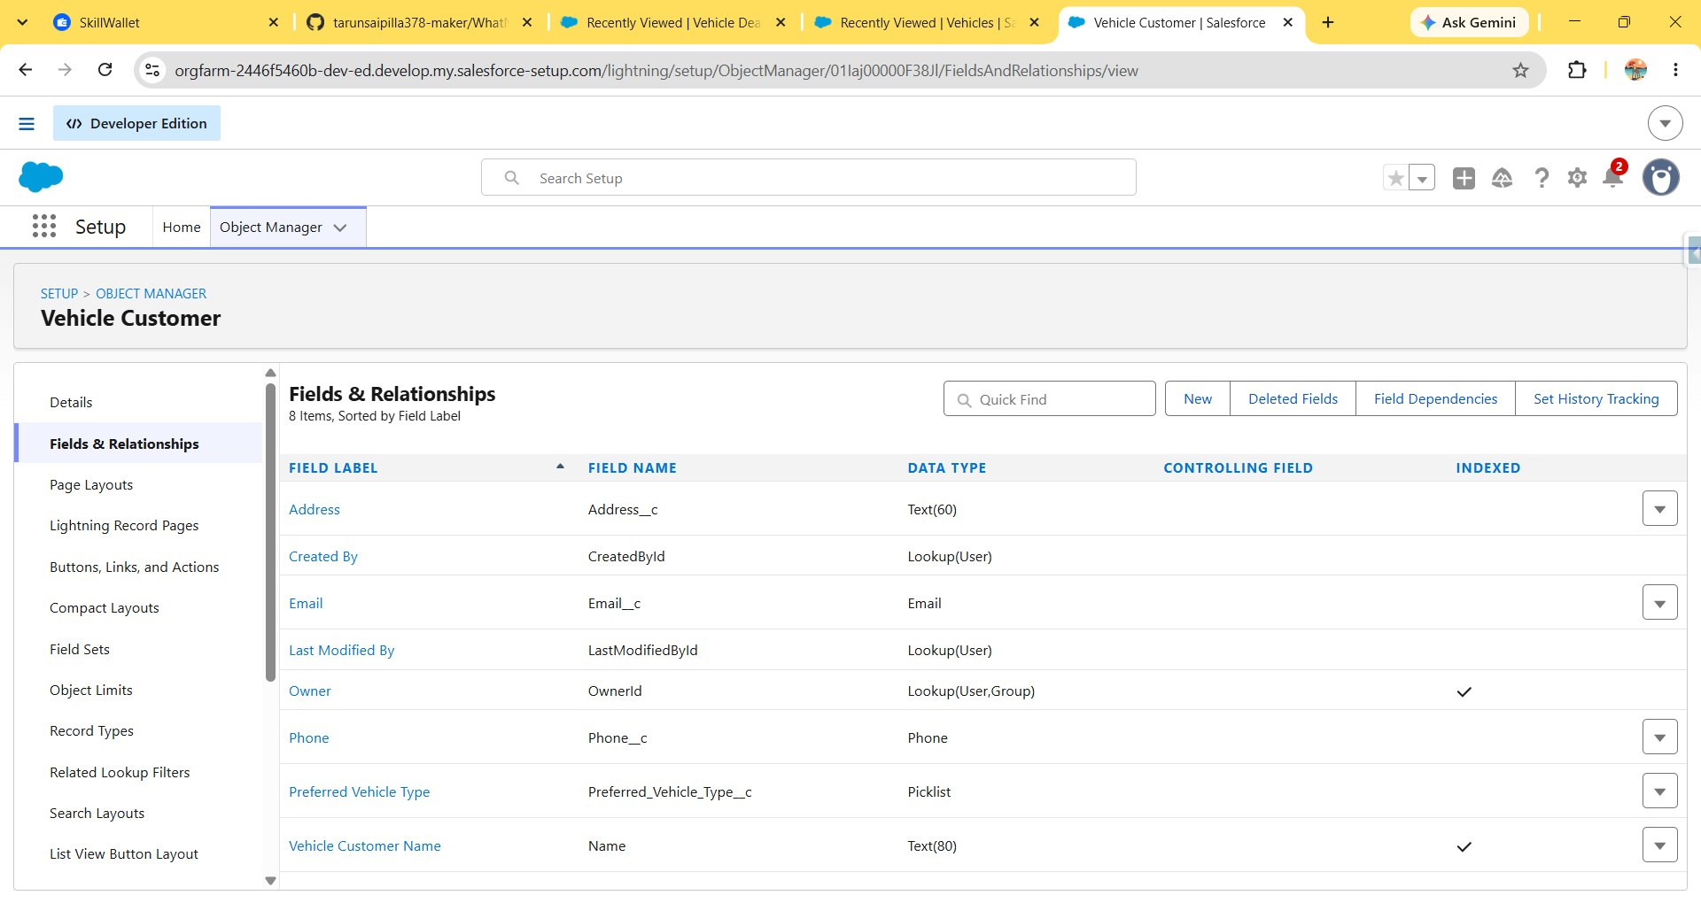
Fig. 4 — Vehicle Customer object: Fields & Relationships

Vehicle Order (Vehicle_Order__c)
Field Label | API Name | Data Type | Notes
Assigned Dealer | Vehicle_Dealer__c | Lookup(Vehicle Dealer) | Indexed
Order Date | Order_Date__c | Date | -
Status | Status__c | Picklist | Pending / Confirmed, drives Apex logic
Vehicle | Vehicle__c | Lookup(Vehicle) | Indexed
Vehicle Customer | Vehicle_Customer__c | Lookup(Vehicle Customer) | Indexed
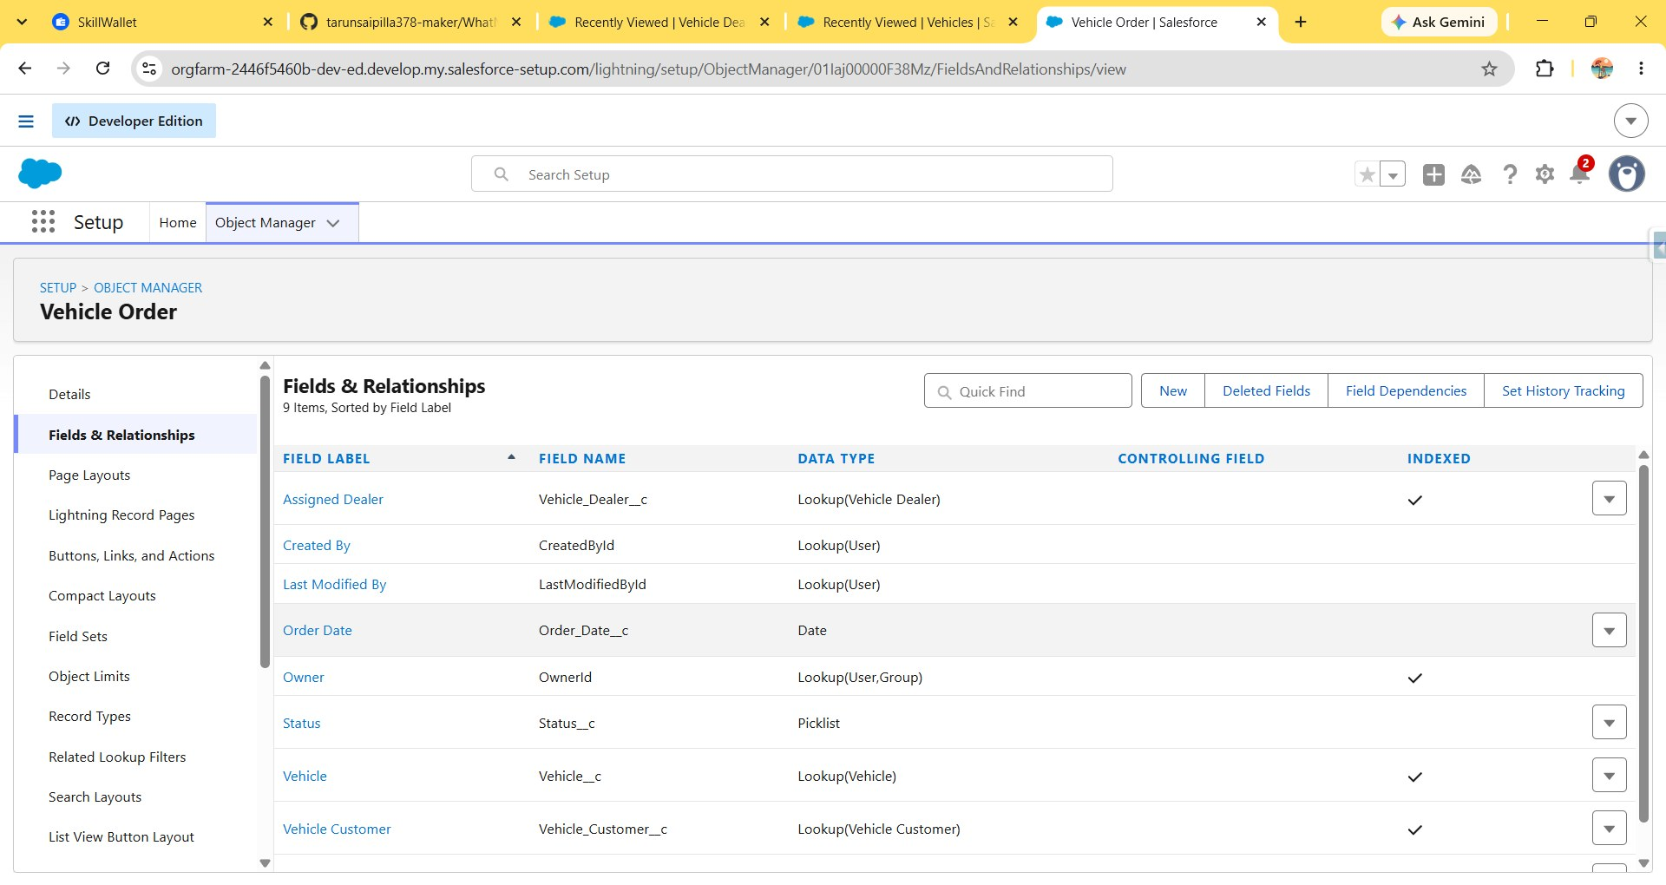
Fig. 5 — Vehicle Order object: Fields & Relationships

Vehicle Test Drive (Vehicle_Test_Drive__c)
Field Label | API Name | Data Type | Notes
Status | Status__c | Picklist | Filtered on "Scheduled" by the reminder flow
Test Drive Date | Test_Drive_Date__c | Date | -
Vehicle | Vehicle__c | Lookup(Vehicle) | Indexed
Vehicle Customer | Vehicle_Customer__c | Lookup(Vehicle Customer) | Indexed — read by the flow
Vehicle Test Drive | Name | Text(80) | Indexed
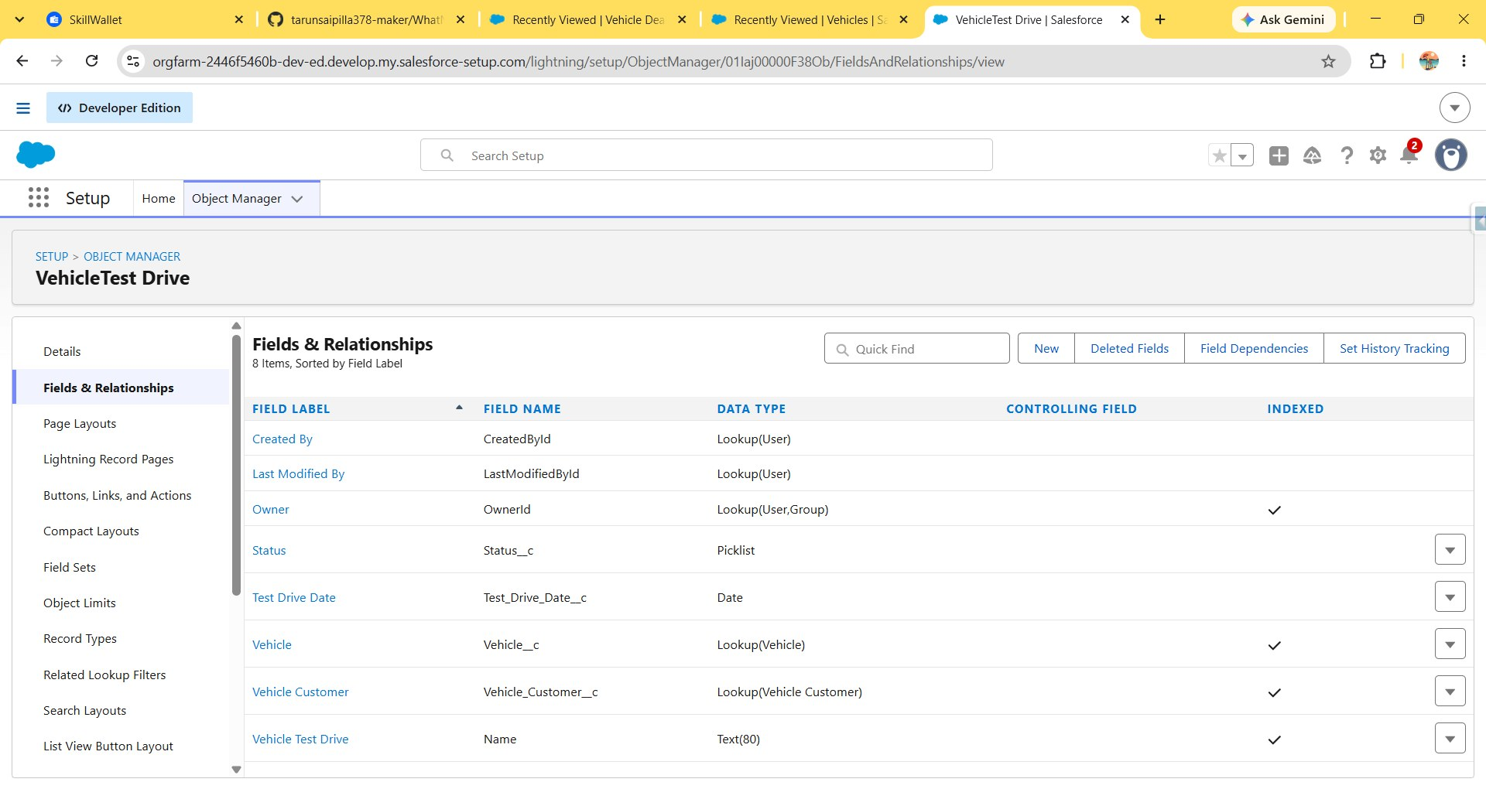
Fig. 6 — Vehicle Test Drive object: Fields & Relationships

Vehicle Service Request (Vehicle_Service_Request__c)
Field Label | API Name | Data Type | Notes
Issue Description | Issue_Description__c | Text(60) | -
Service Date | Service_Date__c | Date | -
Status | Status__c | Picklist | -
Vehicle | Vehicle__c | Lookup(Vehicle) | Indexed
Vehicle Customer | Vehicle_Customer__c | Lookup(Vehicle Customer) | Indexed
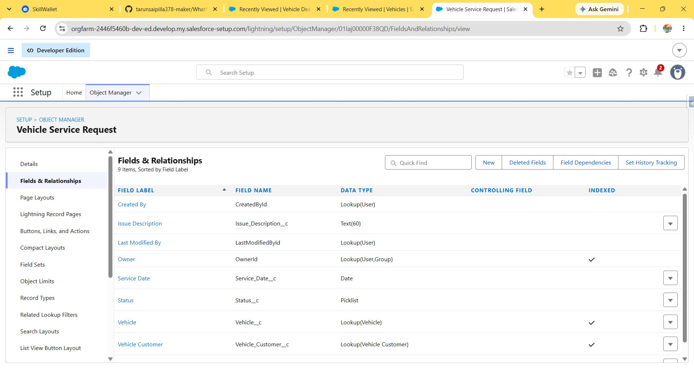
Fig. 7 — Vehicle Service Request object: Fields & Relationships
The Vehicle Order, Vehicle Test Drive, and Vehicle Service Request objects all carry a lookup back to Vehicle Customer, and a lookup to Vehicle. The reminder flow (Phase 4) reads the test drive's Vehicle Customer lookup to find the customer's email address.

Phase 3: Lightning App Creation
A custom Lightning app named "WhatNext Vision Motors" was created with a navigation bar covering every custom object plus Reports and Dashboards.
Step 1: In Setup, search "App Manager" in Quick Find → select App Manager → New Lightning App.
Step 2: Enter the app name (WhatNext Vision Motors), an optional description and icon, and keep the default brand colour.
Step 3: Step through App Options and Utility Items with the defaults, then add Navigation Items.
Step 4: Search for and add each custom tab — Vehicles, Vehicle Dealers, Vehicle_Customers, Vehicle_Orders, Vehicle_Test_Drives, Vehicle_Service_Requests — plus Reports and Dashboards.
Step 5: Assign the app to the System Administrator profile and save.
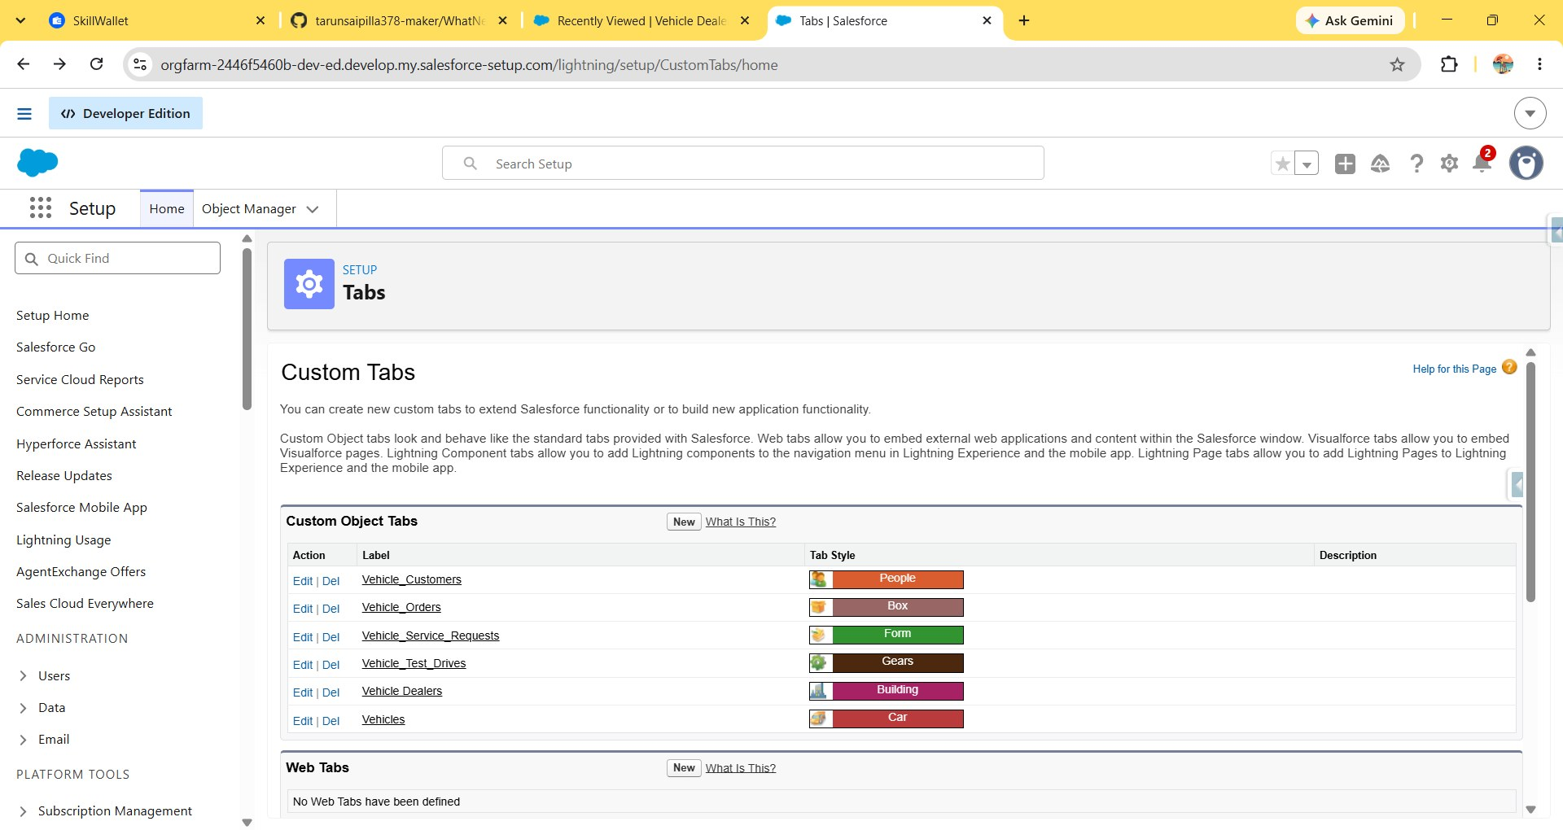
Fig. 8 — Custom Object Tabs created for the app (Vehicle_Customers, Vehicle_Orders, Vehicle_Service_Requests, Vehicle_Test_Drives, Vehicle Dealers, Vehicles)
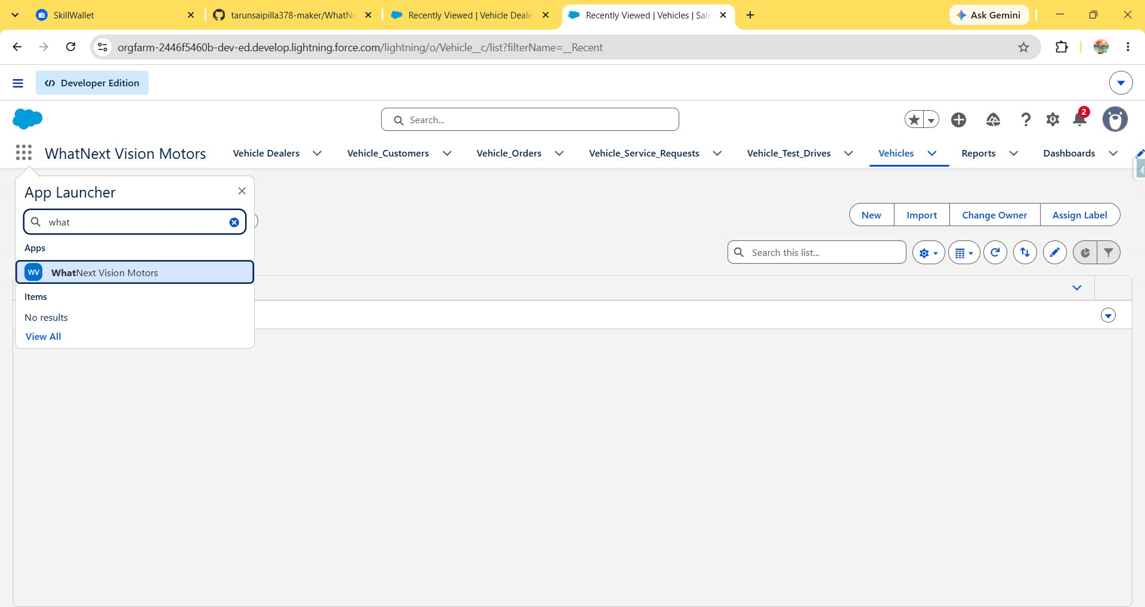
Fig. 9 — "WhatNext Vision Motors" app in the App Launcher, with its navigation bar
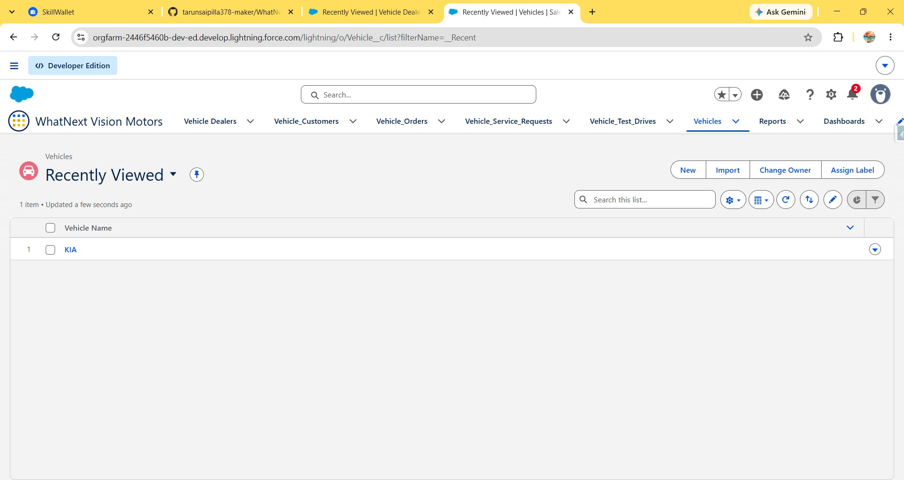
Fig. 10 — Vehicles tab showing a sample record (KIA) once the object was populated

Phase 4: Flow Automation — Test Drive Reminder
A record-triggered flow, Test Drive Reminder, runs whenever a Vehicle Test Drive record is created. It uses two scheduled paths: one that runs immediately and ends without action, and one that fires a configurable interval before the test drive to fetch the customer's details and send them a reminder email.
Step 1: In Quick Find, search Flows → New Flow → Start From Scratch → Record-Triggered Flow → Create.
Step 2: Object: Vehicle Test Drive. Trigger the Flow When: A record is created.
Step 3: Set Entry Conditions — All Conditions Are Met (AND): Field Status, Operator Equals, Value Scheduled.
Step 4: Optimize the flow for Actions and Related Records (since it needs to send an email after the record is saved), and add a second scheduled path, "Reminder Before Test Drive", alongside the default "Run Immediately" path.
Step 5: On the reminder path, add a Get Records element labelled Get Customer Information. Object: Vehicle Customer. Filter: Record ID Equals {!$Record}.Vehicle_Customer__c (the test drive's related customer). Store only the first record, automatically.
Step 6: Add a Send Email action labelled Send Test Drive Reminder. Recipient Addresses: Get_Customer_Information > Email.
Step 7: Compose the email body using a merge field for the customer's name and the record ID, then save and activate the flow.
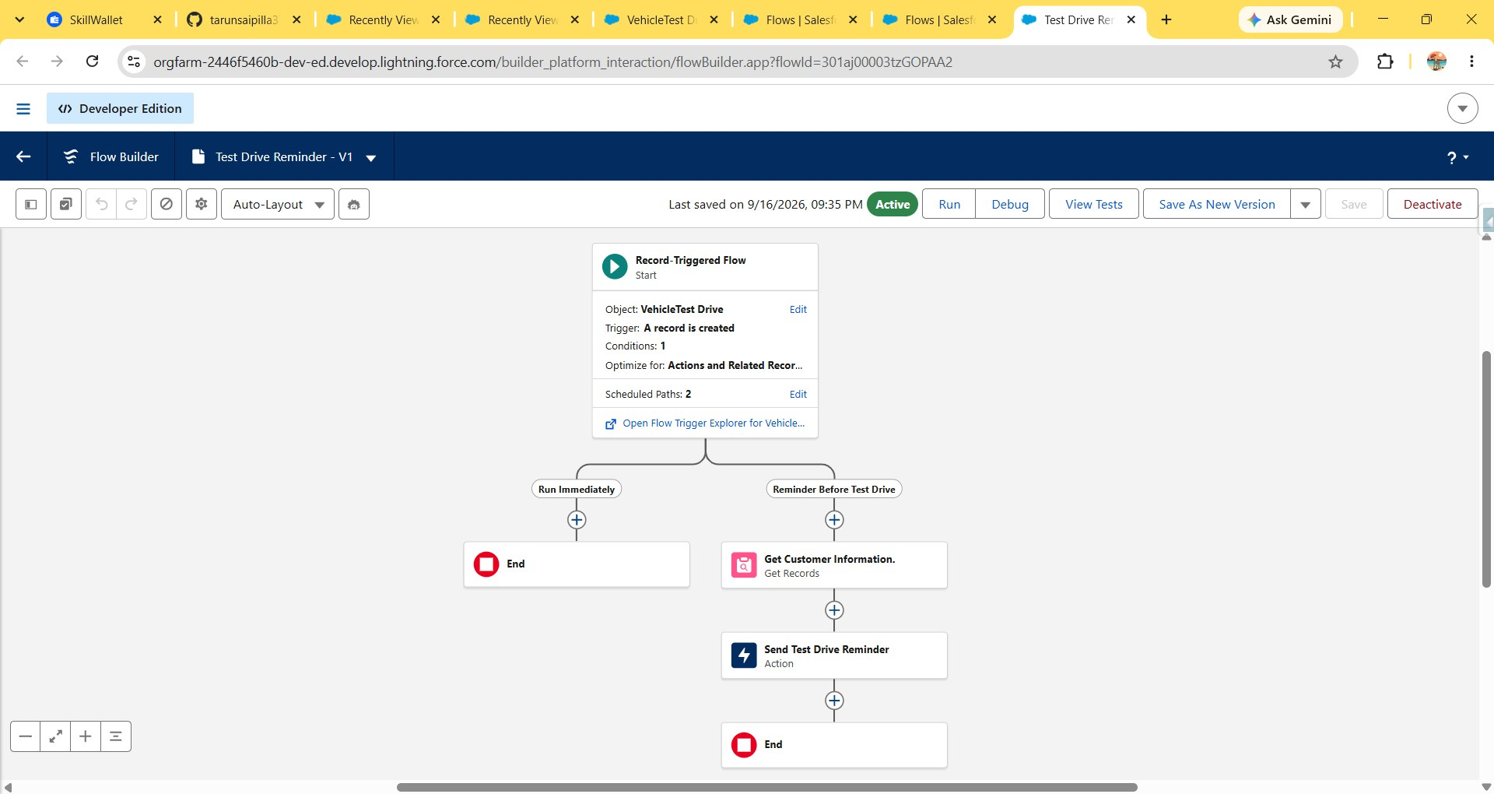
Fig. 11 — Test Drive Reminder flow: two scheduled paths, "Run Immediately" and "Reminder Before Test Drive"
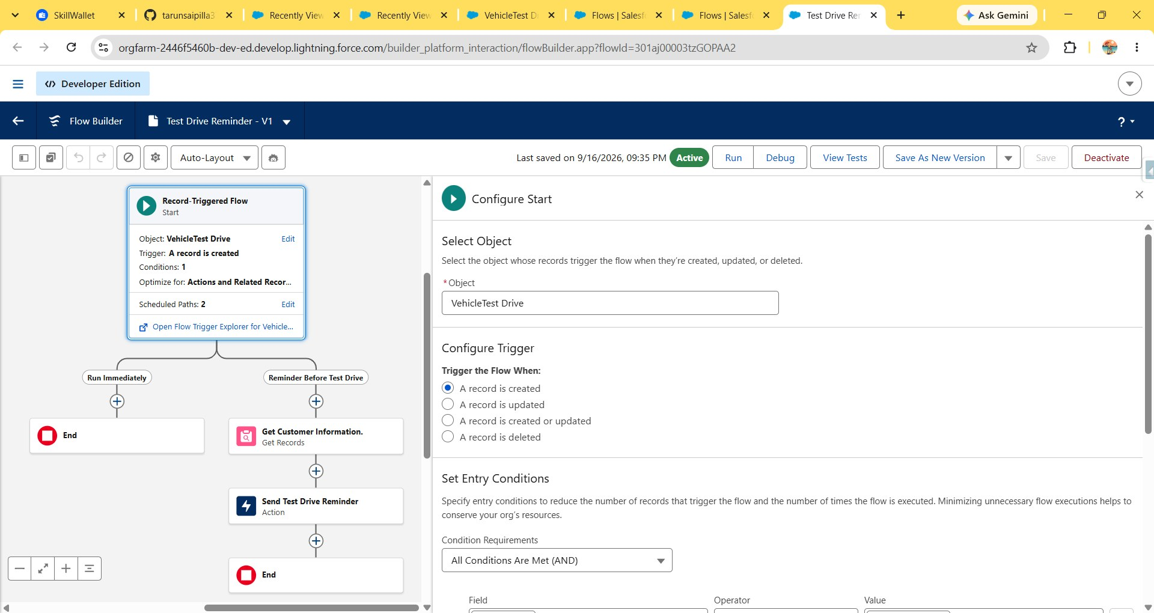
Fig. 12 — Configure Start: object VehicleTest Drive, trigger "A record is created"
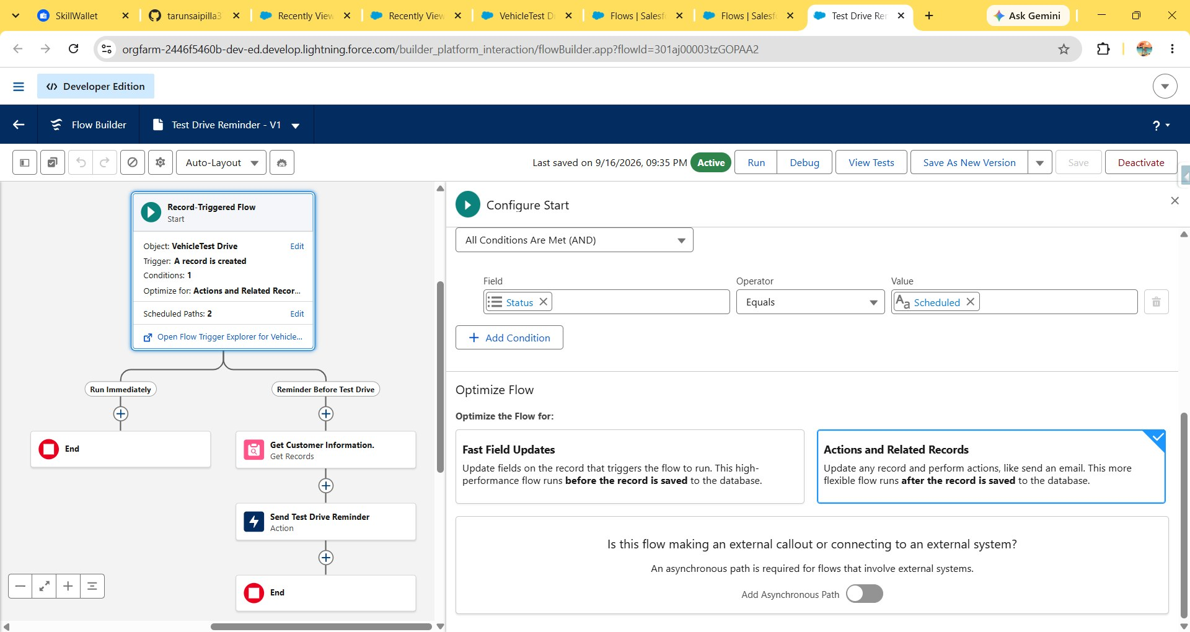
Fig. 13 — Entry condition (Status Equals Scheduled) and "Actions and Related Records" optimization
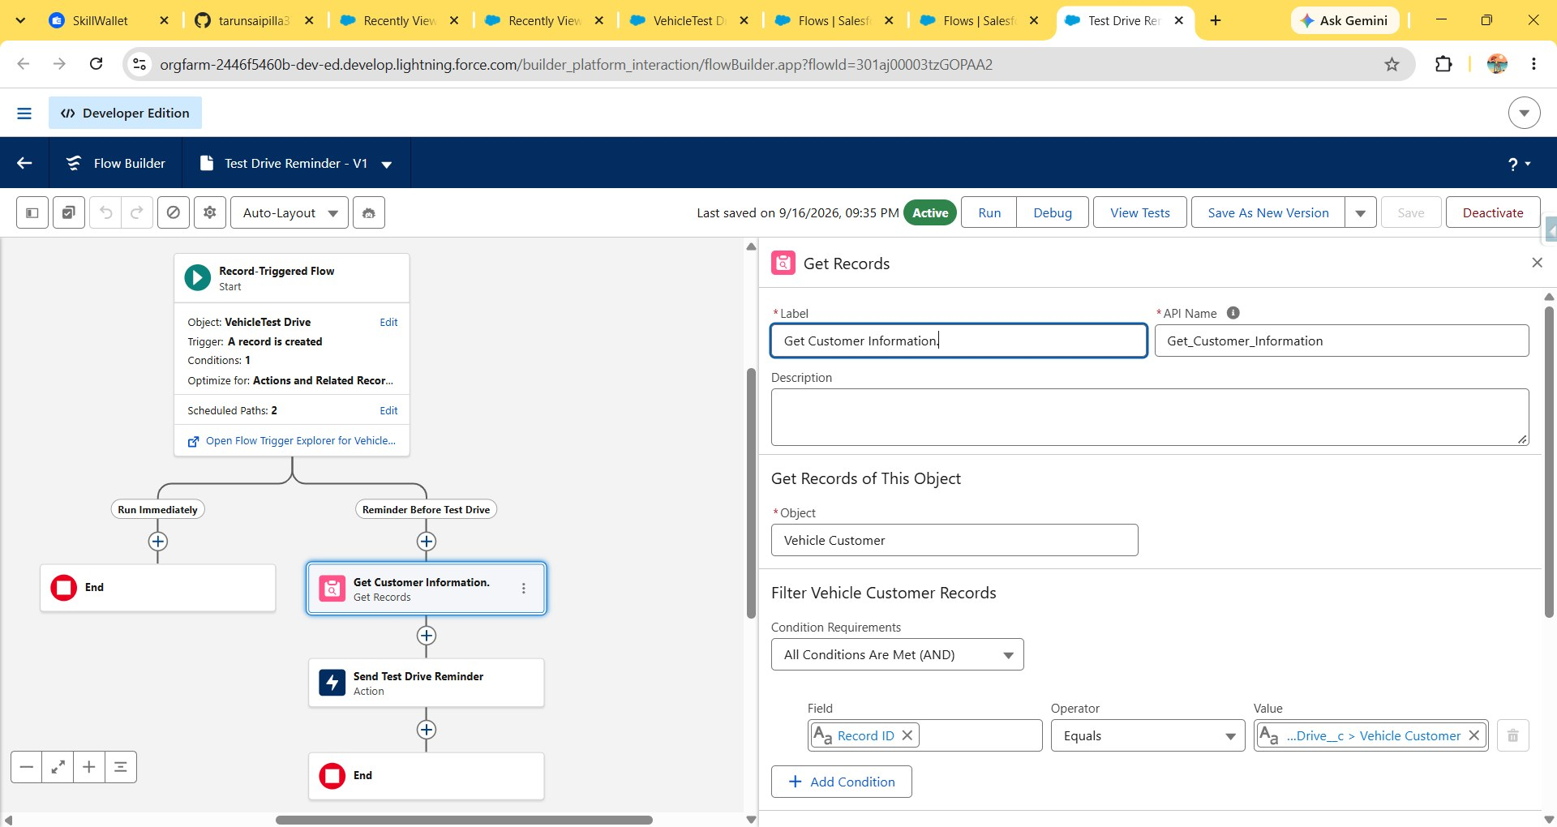
Fig. 14 — Get Customer Information: Get Records from Vehicle Customer, filtered by Record ID
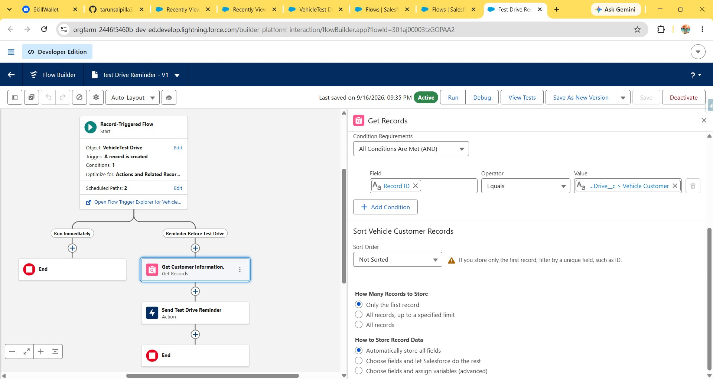
Fig. 15 — Get Records configuration: storing only the first matching record automatically
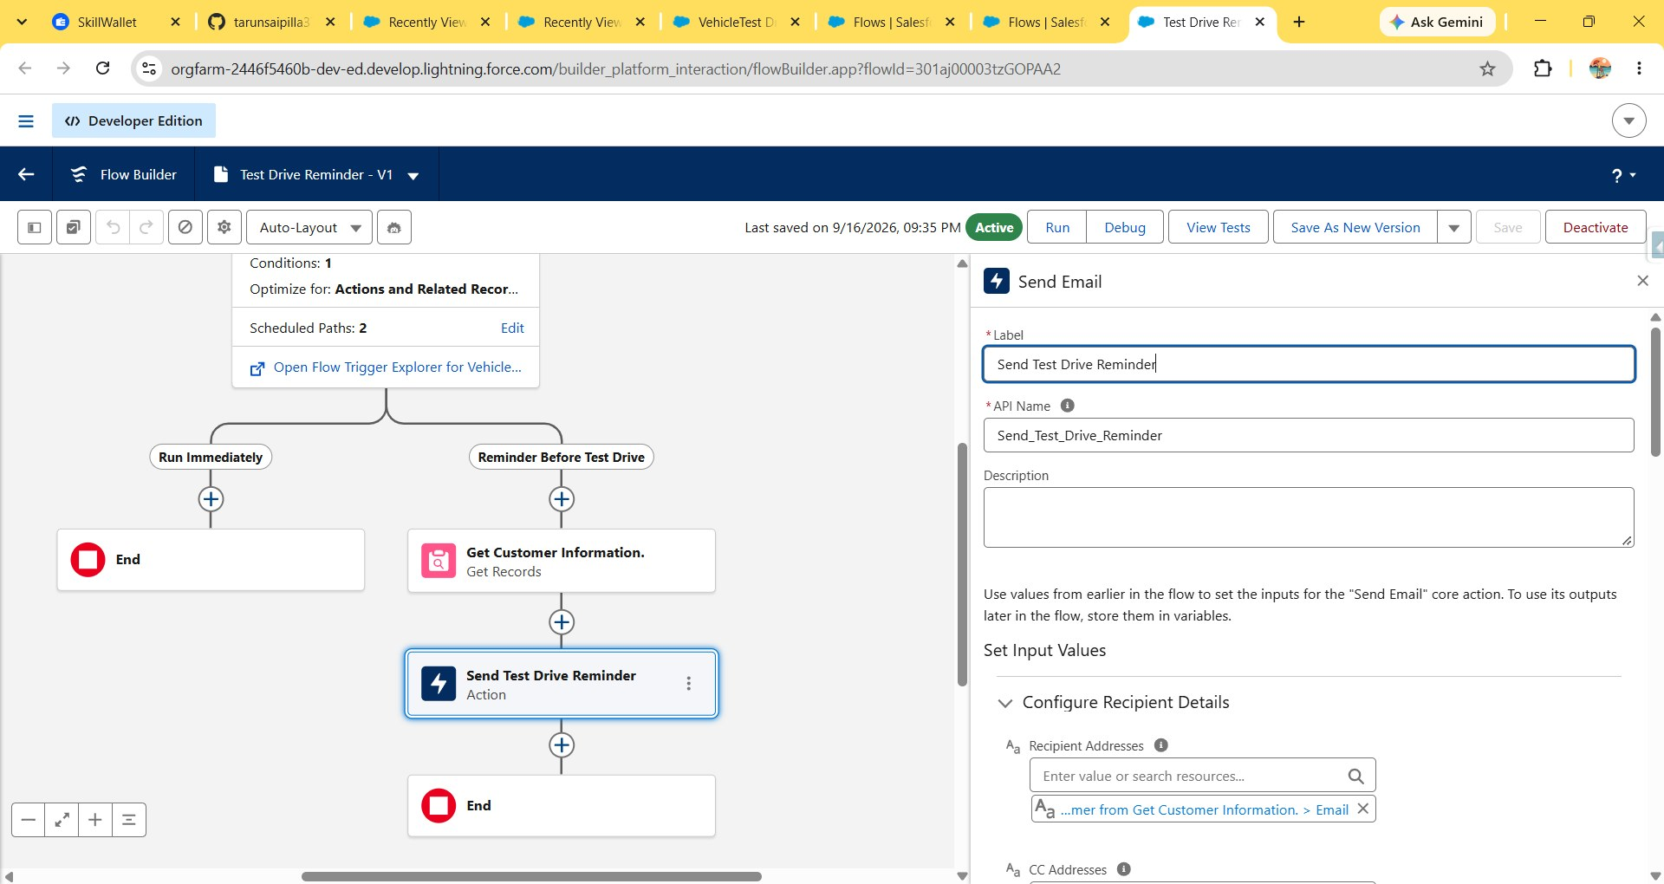
Fig. 16 — Send Test Drive Reminder action: recipient bound to the customer's Email field
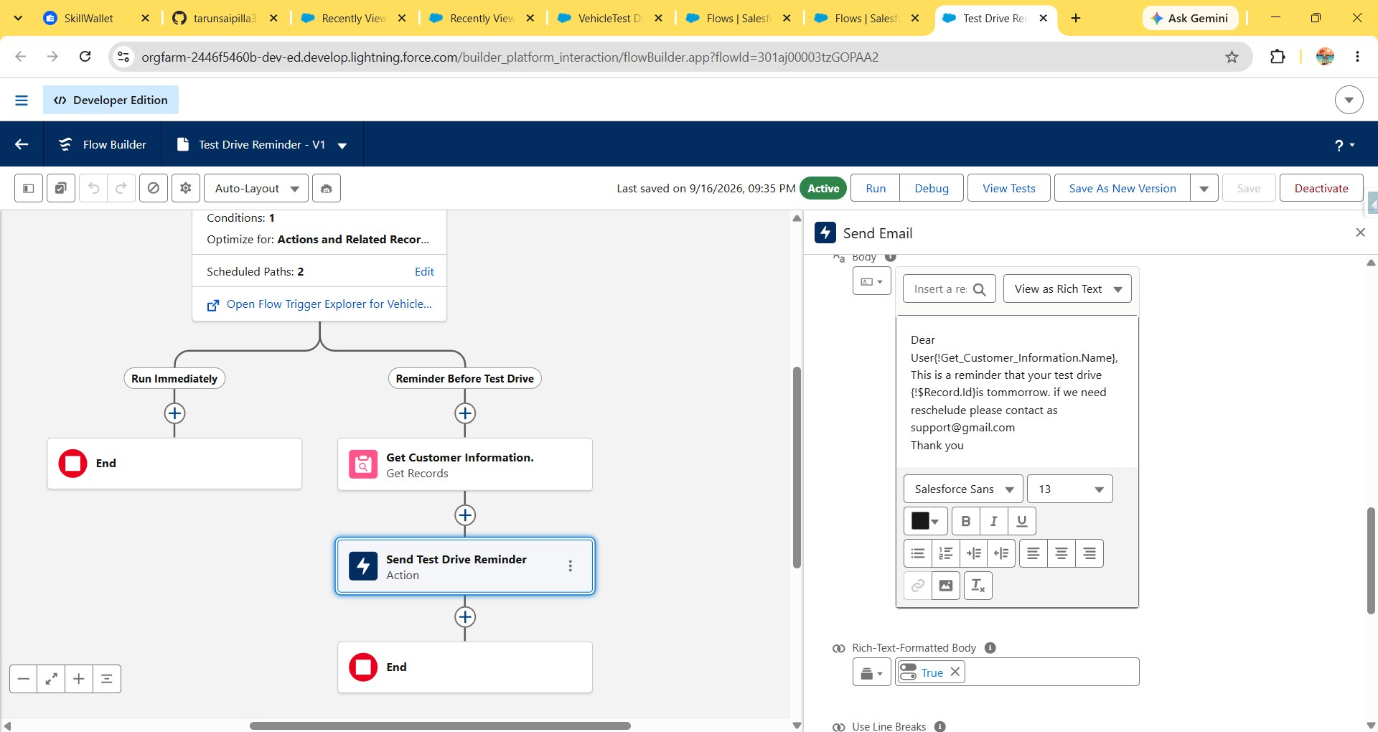
Fig. 17 — Reminder email body, merging the customer's name and the test drive record ID

Phase 5: Apex Implementation
An Apex trigger and handler class were built on Vehicle Order to enforce two rules: reject an order before it saves if the selected vehicle has no stock left, and decrement stock after an order is saved with a Confirmed status.
Step 1: Open Developer Console → File → New → Apex Class → name it VehicleOrderTriggerHandler.
Step 2: Write the handler class:
public class VehicleOrderTriggerHandler {
public static void handleTrigger(List<Vehicle_Order__c> newOrders,
Map<Id, Vehicle_Order__c> oldOrders, Boolean isBefore, Boolean isAfter,
Boolean isInsert, Boolean isUpdate) {
if (isBefore && (isInsert || isUpdate)) {
preventOrderIfOutOfStock(newOrders);
}
if (isAfter && (isInsert || isUpdate)) {
updateStockOnOrderPlacement(newOrders);
}
}
// Prevent placing an order if stock is zero
private static void preventOrderIfOutOfStock(List<Vehicle_Order__c> orders) {
Set<Id> vehicleIds = new Set<Id>();
for (Vehicle_Order__c order : orders) {
if (order.Vehicle__c != null) {
vehicleIds.add(order.Vehicle__c);
}
}
if (!vehicleIds.isEmpty()) {
Map<Id, Vehicle__c> vehicleStockMap = new Map<Id, Vehicle__c>(
[SELECT Id, Stock_Quantity__c FROM Vehicle__c WHERE Id IN :vehicleIds]
);
for (Vehicle_Order__c order : orders) {
Vehicle__c vehicle = vehicleStockMap.get(order.Vehicle__c);
if (vehicle != null && vehicle.Stock_Quantity__c <= 0) {
order.addError('This vehicle is out of stock. Order cannot be placed.');
}
}
}
}
// Decrease stock when an order is confirmed
private static void updateStockOnOrderPlacement(List<Vehicle_Order__c> orders) {
Set<Id> vehicleIds = new Set<Id>();
for (Vehicle_Order__c order : orders) {
if (order.Vehicle__c != null && order.Status__c == 'Confirmed') {
vehicleIds.add(order.Vehicle__c);
}
}
if (!vehicleIds.isEmpty()) {
Map<Id, Vehicle__c> vehicleStockMap = new Map<Id, Vehicle__c>(
[SELECT Id, Stock_Quantity__c FROM Vehicle__c WHERE Id IN :vehicleIds]
);
List<Vehicle__c> vehiclesToUpdate = new List<Vehicle__c>();
for (Vehicle_Order__c order : orders) {
Vehicle__c vehicle = vehicleStockMap.get(order.Vehicle__c);
if (vehicle != null && vehicle.Stock_Quantity__c > 0) {
vehicle.Stock_Quantity__c -= 1;
vehiclesToUpdate.add(vehicle);
}
}
if (!vehiclesToUpdate.isEmpty()) {
update vehiclesToUpdate;
}
}
}
}
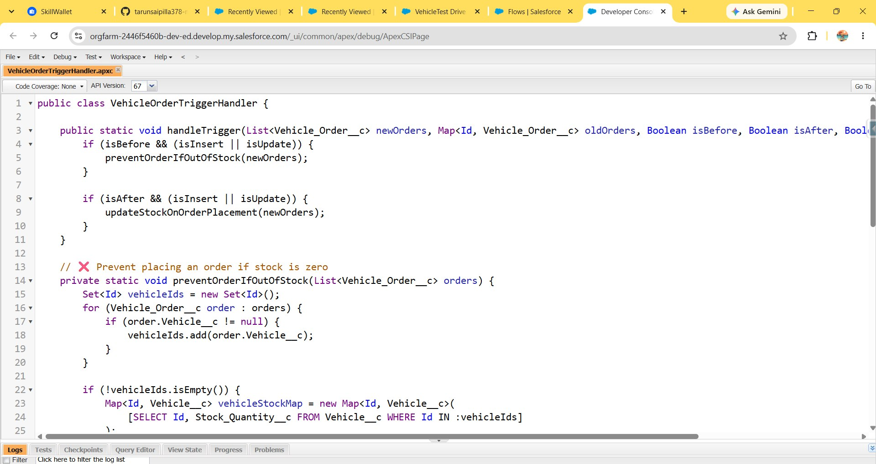
Fig. 18 — VehicleOrderTriggerHandler: handleTrigger and preventOrderIfOutOfStock
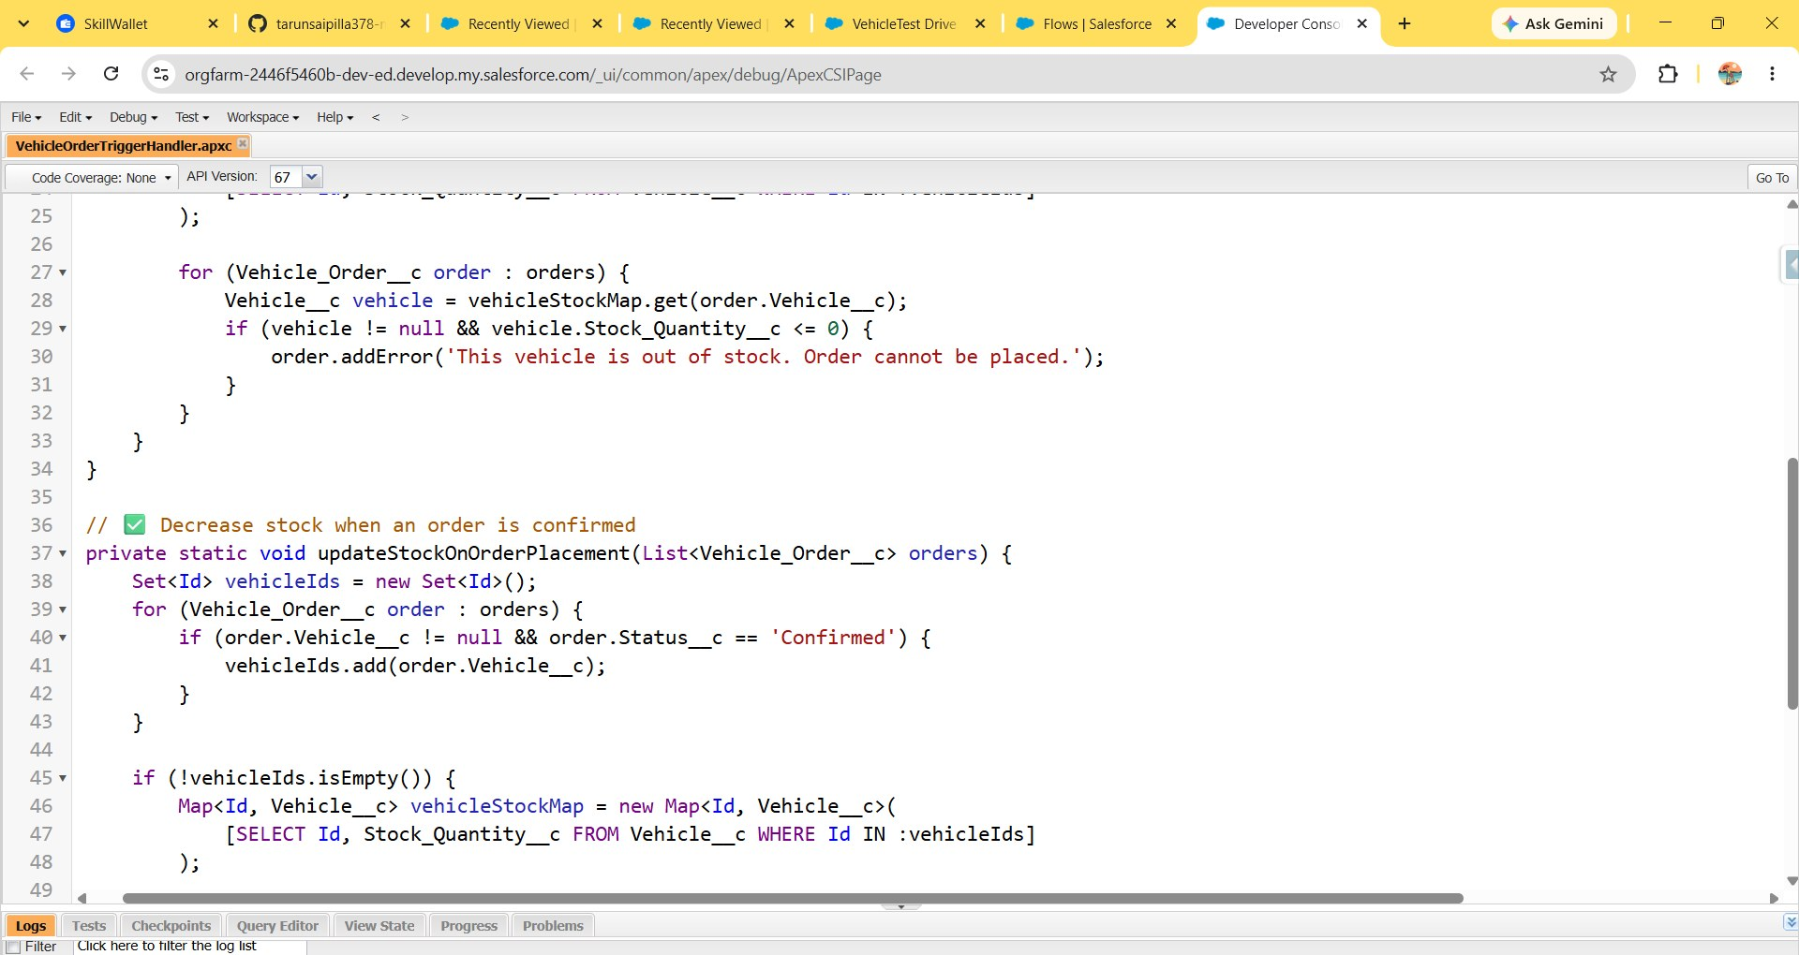
Fig. 19 — preventOrderIfOutOfStock (continued) and updateStockOnOrderPlacement
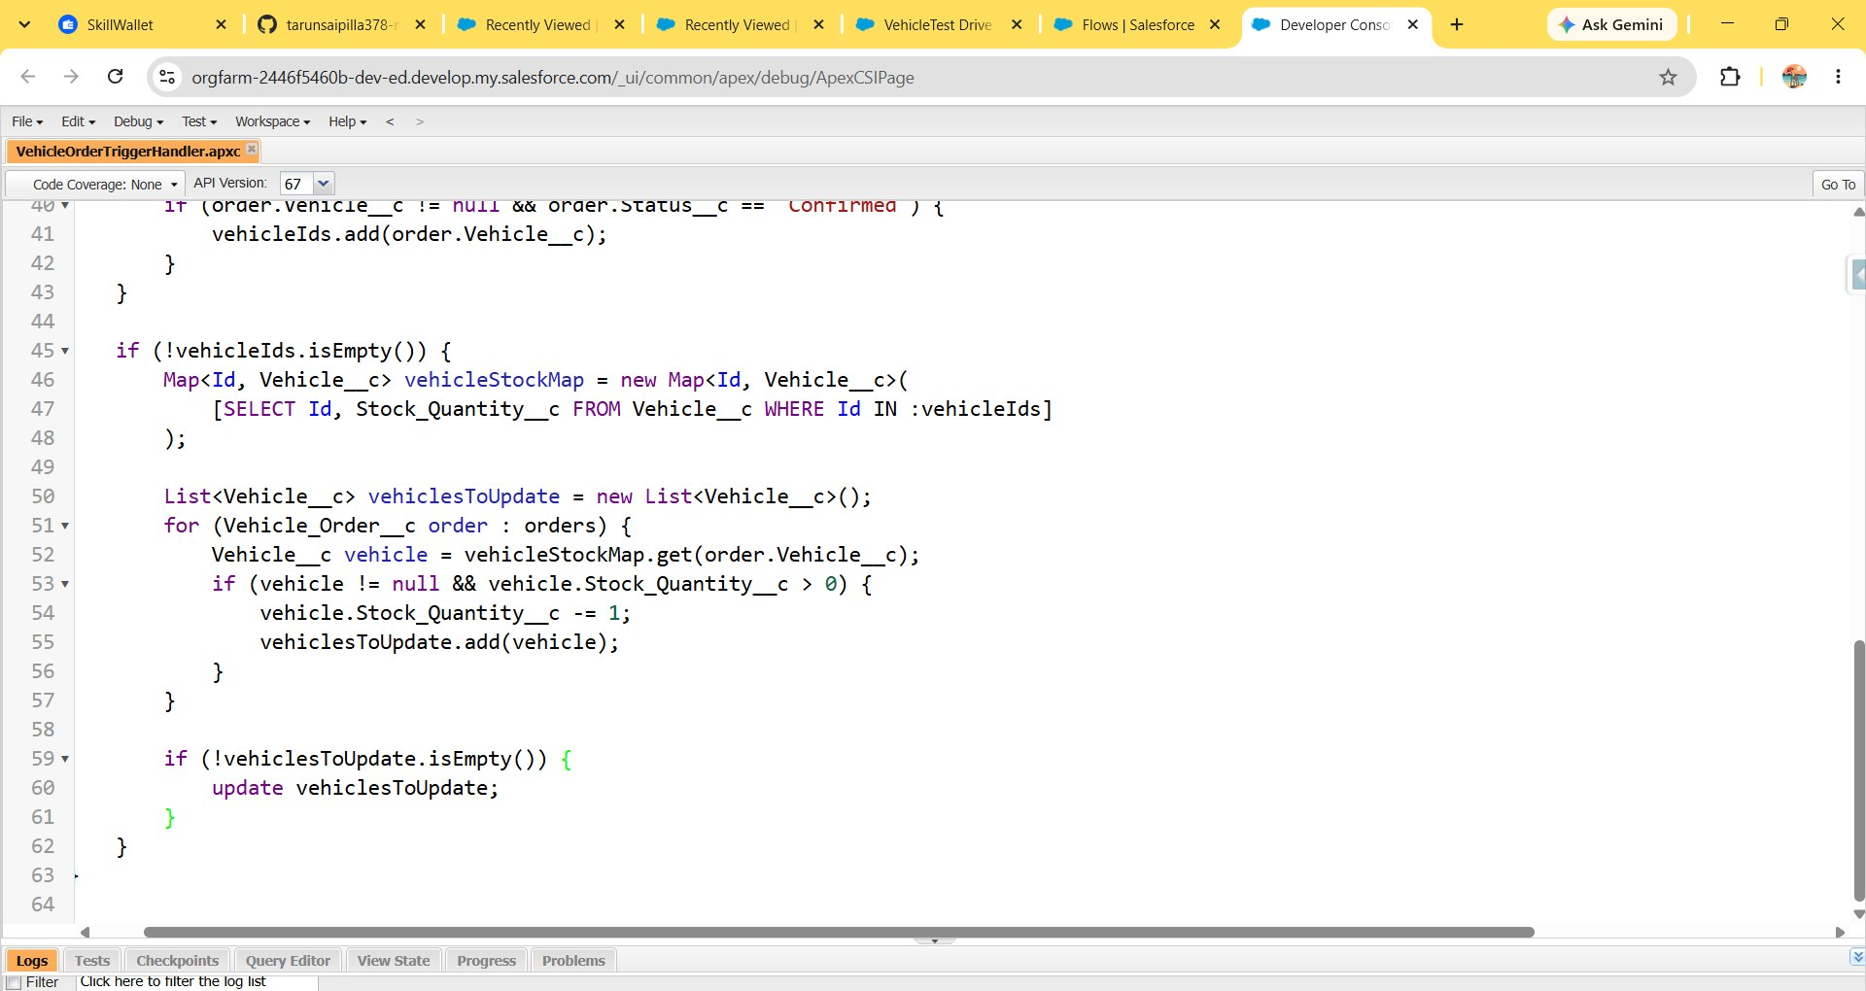
Fig. 20 — updateStockOnOrderPlacement (continued): decrementing and updating stock
Step 3: Create the trigger itself and call the handler:
trigger VehicleOrderTrigger on Vehicle_Order__c
(before insert, before update, after insert, after update) {
VehicleOrderTriggerHandler.handleTrigger(
Trigger.new, Trigger.oldMap, Trigger.isBefore,
Trigger.isAfter, Trigger.isInsert, Trigger.isUpdate
);
}
Step 4: Create a Batch Apex class, VehicleOrderBatch, to re-confirm any order still sitting in Pending status once stock is available:
global class VehicleOrderBatch implements Database.Batchable<sObject> {
global Database.QueryLocator start(Database.BatchableContext bc) {
return Database.getQueryLocator([
SELECT Id, Status__c, Vehicle__c
FROM Vehicle_Order__c
WHERE Status__c = 'Pending'
]);
}
global void execute(Database.BatchableContext bc, List<Vehicle_Order__c> orderList) {
Set<Id> vehicleIds = new Set<Id>();
for (Vehicle_Order__c order : orderList) {
if (order.Vehicle__c != null) {
vehicleIds.add(order.Vehicle__c);
}
}
if (!vehicleIds.isEmpty()) {
Map<Id, Vehicle__c> vehicleStockMap = new Map<Id, Vehicle__c>(
[SELECT Id, Stock_Quantity__c FROM Vehicle__c WHERE Id IN :vehicleIds]
);
List<Vehicle_Order__c> ordersToUpdate = new List<Vehicle_Order__c>();
List<Vehicle__c> vehiclesToUpdate = new List<Vehicle__c>();
for (Vehicle_Order__c order : orderList) {
Vehicle__c vehicle = vehicleStockMap.get(order.Vehicle__c);
if (vehicle != null && vehicle.Stock_Quantity__c > 0) {
order.Status__c = 'Confirmed';
vehicle.Stock_Quantity__c -= 1;
ordersToUpdate.add(order);
vehiclesToUpdate.add(vehicle);
}
}
if (!ordersToUpdate.isEmpty()) {
update ordersToUpdate;
}
if (!vehiclesToUpdate.isEmpty()) {
update vehiclesToUpdate;
}
}
}
global void finish(Database.BatchableContext bc) {
System.debug('Vehicle order batch job completed.');
}
}
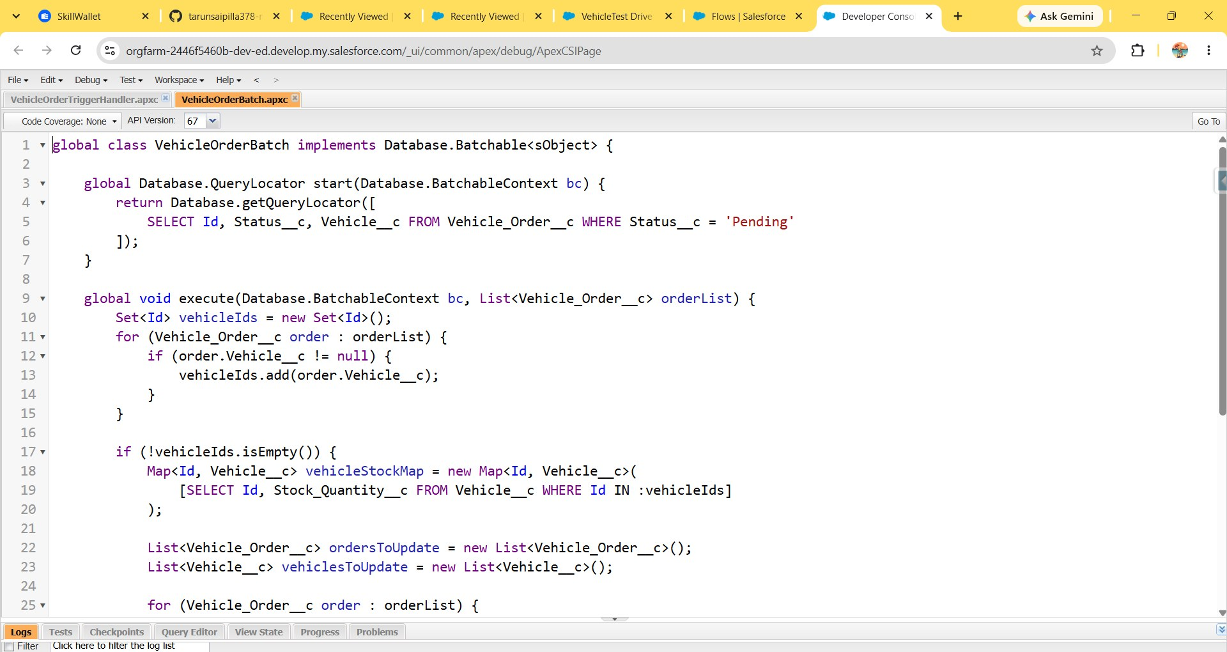
Fig. 21 — VehicleOrderBatch: querying Pending orders and checking vehicle stock
Step 5: Create a Schedulable class and schedule it to run nightly:
global class VehicleOrderBatchScheduler implements Schedulable {
global void execute(SchedulableContext sc) {
VehicleOrderBatch batchJob = new VehicleOrderBatch();
Database.executeBatch(batchJob, 50); // batch size of 50
}
}
String cronExp = '0 0 0 * * ?'; // runs daily at 12:00 AM
System.schedule('Daily Vehicle Order Processing', cronExp,
new VehicleOrderBatchScheduler());
The scheduled job can be verified under Setup → Scheduled Jobs, which lists the next and previous run times for Daily Vehicle Order Processing.

Phase 6: Batch and Scheduled Jobs in Operation
Once activated, VehicleOrderBatchScheduler runs VehicleOrderBatch every night. Any Vehicle Order left in Pending status because its vehicle was out of stock at order time is re-evaluated: if stock has since been replenished, the batch job confirms the order and decrements stock in the same transaction, mirroring the logic already enforced in real time by VehicleOrderTriggerHandler.

Project Explanation with Real-World Example
A customer books a vehicle order through the app. Before the order is saved, VehicleOrderTriggerHandler checks the selected vehicle's stock; if the vehicle has none left, the order is blocked with the message "This vehicle is out of stock. Order cannot be placed." and left in Pending status. If stock exists, the order proceeds — and once its status is moved to Confirmed, the trigger decrements the vehicle's stock by one.
Separately, when new stock is added and a nightly run of VehicleOrderBatch finds Pending orders that can now be fulfilled, it confirms them automatically and reduces stock — no staff follow-up required.
On the scheduling side, when a customer's test drive is created with Status Scheduled, the Test Drive Reminder flow's second scheduled path fires ahead of the appointment: it looks up the customer's record for their email address and sends a reminder that names the test drive and asks the customer to contact the dealership if they need to reschedule. This combination of real-time validation, nightly batch processing, and proactive customer messaging is what keeps the sales pipeline moving without manual chasing.

Conclusion
The Salesforce CRM implementation for WhatsNext Vision Motors brings vehicle inventory, dealer records, customer records, orders, test drives, and service requests together in a single Lightning app. Apex trigger logic protects against overselling out-of-stock vehicles and keeps stock counts accurate as orders are confirmed, a nightly scheduled batch job clears the backlog of pending orders automatically once stock allows, and a record-triggered flow keeps customers informed ahead of their test drives.
Together these automations reduce manual data entry and follow-up while improving the accuracy and responsiveness of the sales process. Future enhancements could extend this foundation with automated dealer assignment based on customer location, predictive stock-replenishment alerts, and SMS-based reminders alongside email.

