**Angular js code Example**

**Name: G.Tarun Roll No: CSE19016**

**Before Output -1:**

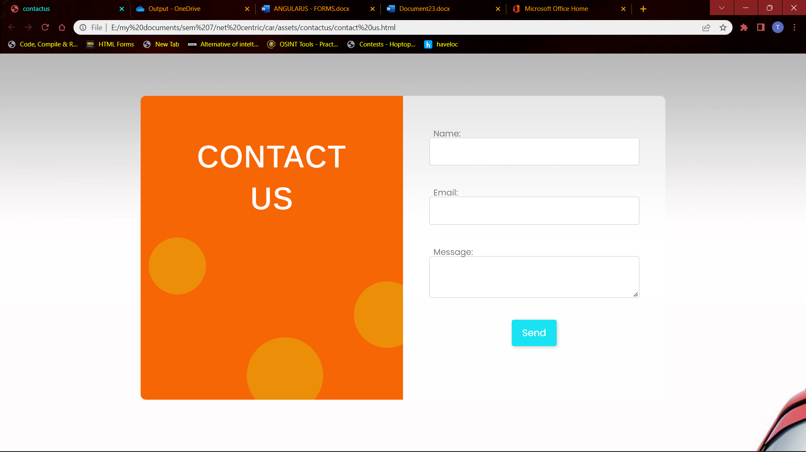

* After clicking send button without filling anything

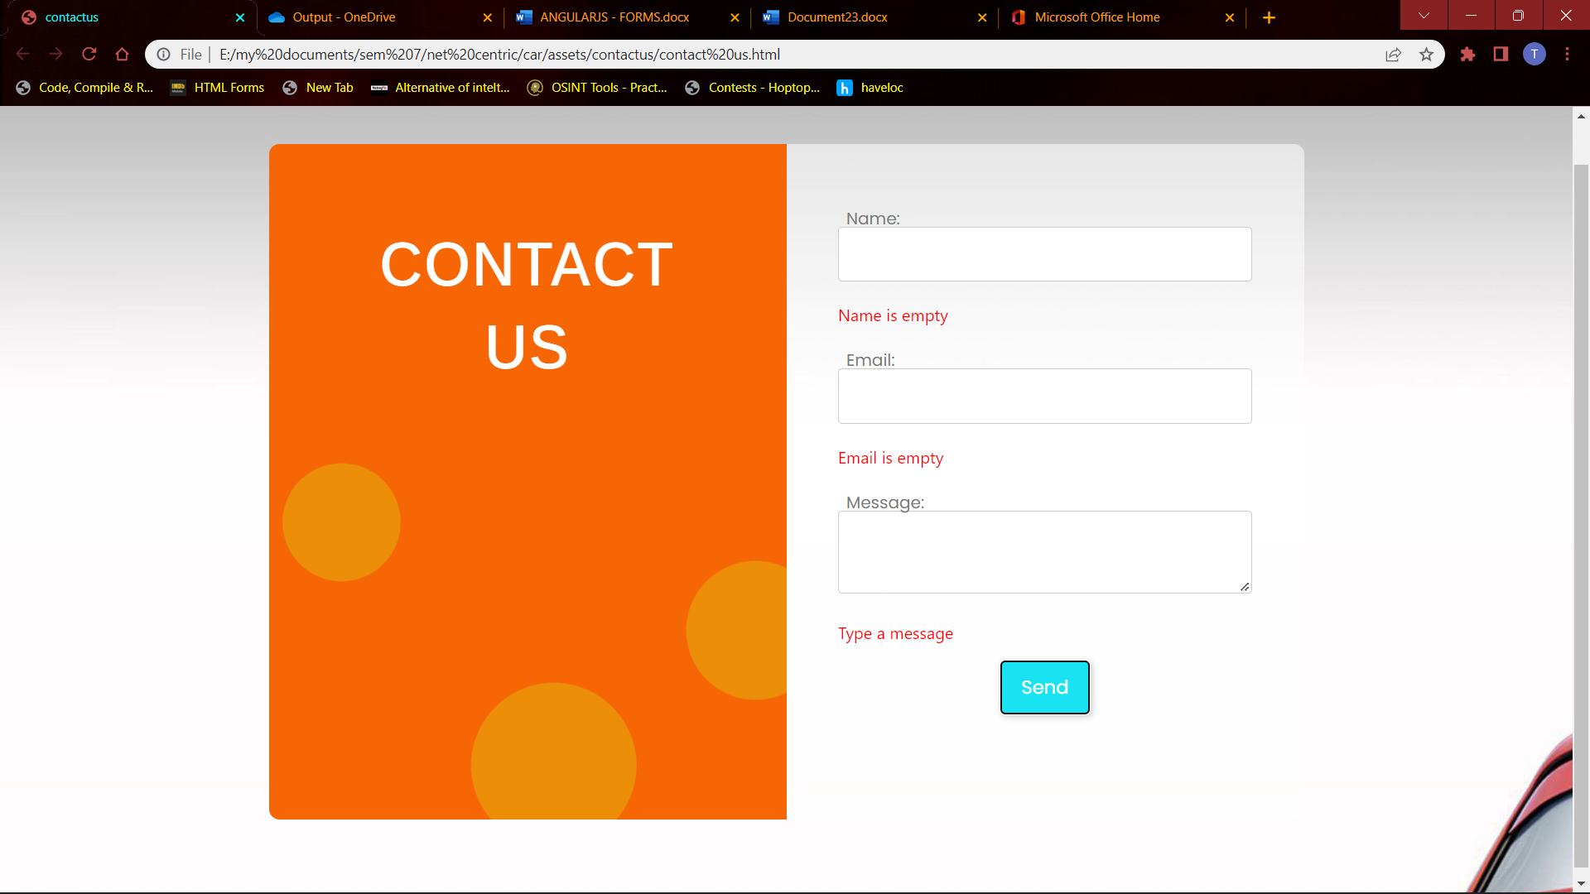

* After giving details and I am giving invalid email id

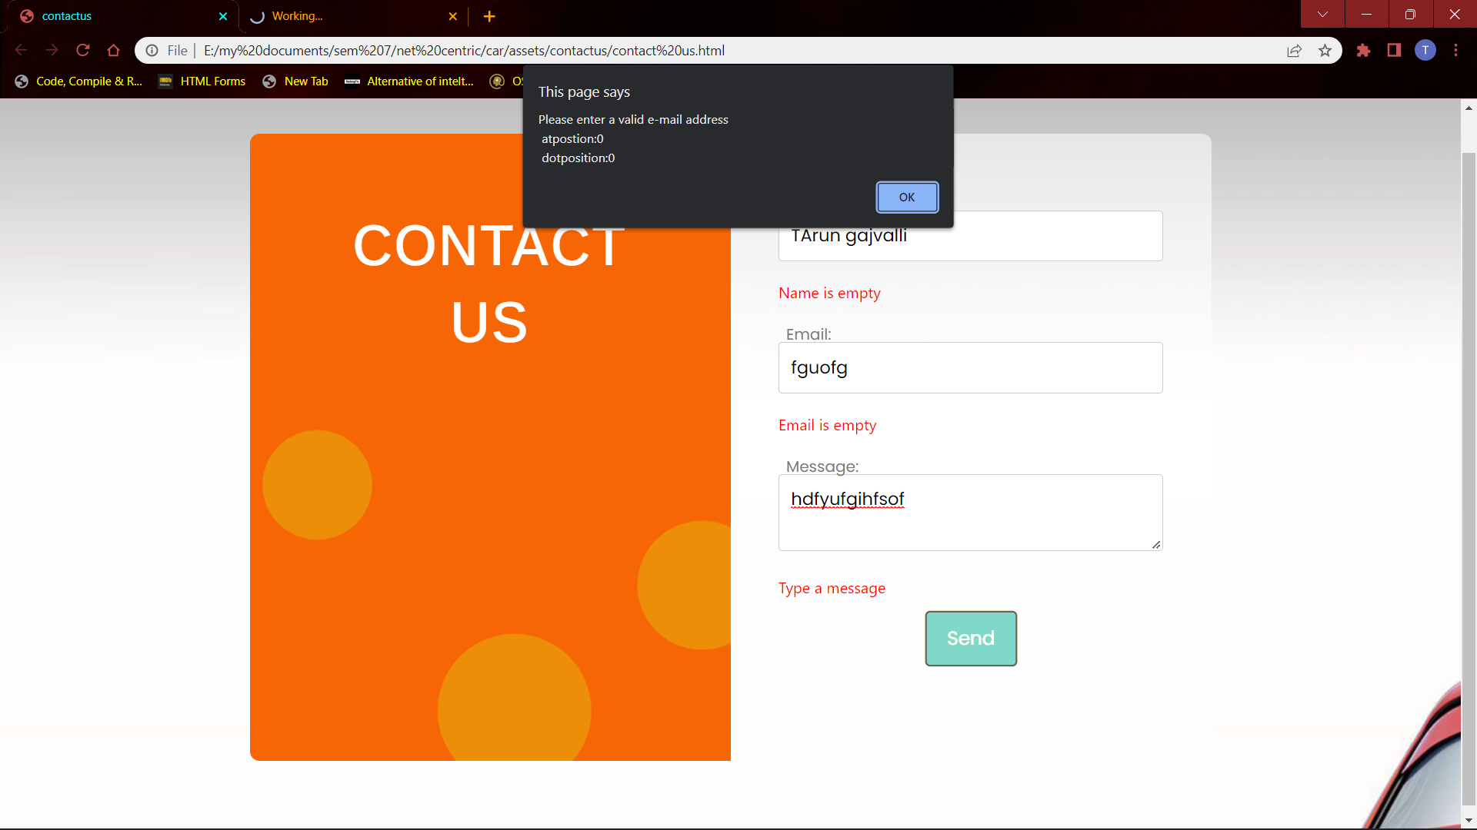

* Where here we used
* Dot position
* At