III SEMESTER | L | T | P | C
III SEMESTER | 3 | - | - | 3
ADVANCED DATA STRUCTURES & ALGORITHMS
ADVANCED DATA STRUCTURES & ALGORITHMS

Course Objectives:
The main objectives of the course is to
- provide knowledge on advance data structures frequently used in Computer Science domain
- Develop skills in algorithm design techniques popularly used
- Understand the use of various data structures in the algorithm design
Course Outcomes: At the end of the course students will be able to

CO1: Discover the performance of an algorithm using asymptotic notation. (K2)

CO2: Use divide and conquer technique to solve problems.(K3)

CO3: Understand greedy and dynamic programming techniques to solve efficient

solutions for optimization problem.(K3)

CO4: Recognize problems suitable for back tracking , branch and bound solutions.(K1)

CO5: Understand the complexity classes NP-Hard and NP-Complete and solve related

decision problems.(K2)

UNIT–I:
Introduction to Algorithm Analysis, Space and Time Complexity analysis, Asymptotic Notations
AVL Trees – Creation, Insertion, Deletion operations and Applications
B-trees – Creation, Insertion, Deletion operations and Applications

UNIT–II:
Heap Trees (Priority Queues)–Min and Max Heaps, Operations and Applications
Graphs–Terminology, Representations, Basic Search and Traversals, Connected Components and Biconnected Components, applications

UNIT–III:
Divide and Conquer: The General Method, Quick Sort, Merge Sort, Heap Sort, Strassen’s matrix multiplication.
Greedy Method: General Method, Job Sequencing with deadlines, Knapsack Problem, Minimum cost spanning trees, Single Source Shortest Paths

UNIT–IV:
Dynamic Programming: General Method, All pairs shortest paths, Single Source Shortest Paths– General Weights (Bellman Ford Algorithm), Optimal Binary Search Trees, 0/1 Knapsack, String Editing.
Backtracking: General Method, 8-Queens Problem, Sum of Subsets problem, Graph Coloring, 0/1 Knapsack Problem

UNIT–V:
Branch and Bound: The General Method, 0/1 Knapsack Problem, Travelling Salesperson problem.
NP Hard and NP Complete Problems: Basic Concepts, Cook’s theorem NP Hard Graph Problems: Clique Decision Problem (CDP), Chromatic Number Decision Problem (CNDP), Traveling Salesperson

Textbooks:
- Fundamentals of Data Structures in C++, Horowitz, Ellis; Sahni, Sartaj; Mehta, Dinesh 2nd Edition Universities Press
- Computer Algorithms/C++ Ellis Horowitz, Sartaj Sahni, Sanguthevar Rajasekaran 2nd Edition University Press

Reference Books:
- Data Structures and program design in C, Robert Kruse, Pearson Education Asia
- An introduction to Data Structures with applications, Trembley & Sorenson, McGraw Hill
- The Art of Computer Programming, Vol.1: Fundamental Algorithms, Donald E Knuth, Addison-Wesley, 1997.
- Data Structures using C & C++: Langsam, Augenstein & Tanenbaum, Pearson, 1995
- Algorithms + Data Structures & Programs:, N.Wirth, PHI
- Fundamentals of Data Structures in C++: Horowitz Sahni & Mehta, Galgottia Pub.
- Data structures in Java:, Thomas Standish, Pearson Education Asia

Online Learning Resources:
  - https://www.tutorialspoint.com/advanced_data_structures/index.asp
  - http://peterindia.net/Algorithms.html
  - Abdul Bari, 1. Introduction to Algorithms (youtube.com)

  - https://www.swarnandhra.ac.in/dsv

UNIT-1

Introduction to Data Structures and Algorithms
Data Structure is a way of collecting and organising data in such a way that we can perform operations on these data in an effective way. Data Structures is about rendering data elements in terms of some relationship, for better organization and storage.
For example, we have some data which has, player's name "Virat" and age 26. Here "Virat" is of String data type and 26 is of integer data type.
We can organize this data as a record like Player record, which will have both player's name and age in it. Now we can collect and store player's records in a file or database as a data structure. For example: "Dhoni" 30, "Gambhir" 31, "Sehwag"
If you are aware of Object Oriented programming concepts, then a class also does the same thing, it collects different type of data under one single entity. The only difference being, data structures provides for techniques to access and manipulate data efficiently.
In simple language, Data Structures are structures programmed to store ordered data, so that various operations can be performed on it easily. It represents the knowledge of data to be organized in memory. It should be designed and implemented in such a way that it reduces the complexity and increases the efficiency.

Basic types of Data Structures
As we have discussed above, anything that can store data can be called as a data structure, hence Integer, Float, Boolean, Char etc, all are data structures. They are known as Primitive Data Structures.
Then we also have some complex Data Structures, which are used to store large and connected data. Some example of Abstract Data Structure are :
- Linked List
- Tree
- Graph
- Stack, Queue etc.
All these data structures allow us to perform different operations on data. We select these data structures based on which type of operation is required.
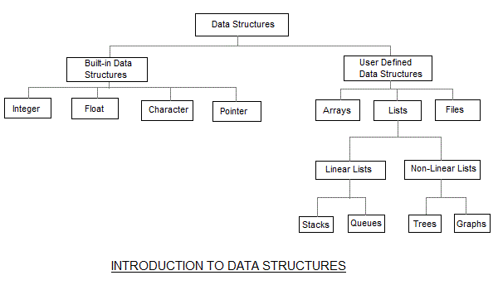

The data structures can also be classified on the basis of the following characteristics:
Characterstic | Description
Linear | In Linear data structures,the data items are arranged in a linear sequence. Example: Array
Non-Linear | In Non-Linear data structures,the data items are not in sequence. Example: Tree, Graph
Homogeneous | In homogeneous data structures,all the elements are of same type. Example: Array
Non-Homogeneous | In Non-Homogeneous data structure, the elements may or may not be of the same type. Example: Structures
Static | Static data structures are those whose sizes and structures associated memory locations are fixed, at compile time. Example: Array
Dynamic | Dynamic structures are those which expands or shrinks depending upon the program need and its execution. Also, their associated memory locations changes. Example: Linked List created using pointers

What is an Algorithm?
An algorithm is a step-by-step set of instructions or rules designed to solve a specific problem or perform a task.
Or
Algorithm is not the complete code or program, it is just the core logic(solution) of a problem, which can be expressed either as an informal high level description as pseudocode or using a flowchart.

Key Characteristics of an Algorithm:
- Input- There should be 0 or more inputs supplied externally to the algorithm.
- Output- There should be atleast 1 output obtained.
- Definiteness- Every step of the algorithm should be clear and well defined.
- Finiteness- The algorithm should have finite number of steps.
- Correctness- Every step of the algorithm must generate a correct output.
1. Input
- An algorithm should have zero or more inputs (data given before the algorithm starts).
- Example: In an addition algorithm, the two numbers to be added are inputs.
2. Output
- An algorithm must produce at least one output, which is the result of the computation.
- Example: In an addition algorithm, the sum of the two numbers is the output.
3. Definiteness (Well-defined steps)
- Each step in the algorithm must be clear and unambiguous.
- There should be no confusion about what to do in each step.
- Example: “Add 1 to the number” is definite, but “Do something with the number” is not.
4. Finiteness
- The algorithm must terminate after a finite number of steps.
- It should not go on forever (no infinite loops).
- Example: A sorting algorithm should finish after sorting all the elements, not keep checking endlessly.
5. Effectiveness
- All operations in the algorithm must be basic and easily understandable, so they can be done using pencil and paper or a simple machine.
- Example: "Multiply two numbers" is effective, but "Guess the number" is not, because it's not precise.
Example in Daily Life:
Algorithm to make a cup of tea:
- Boil water.
- Add tea leaves to a cup.
- Pour hot water into the cup.
- Add sugar and milk if desired.
- Stir and serve.
Example in Programming:
Algorithm to add two numbers:
- Start
- Input number A
- Input number B
- Add A and B → result = A + B
- Output result
- End

🔹Difference between Algorithm and program

Feature | Algorithm | Program
Language | Plain English / Pseudocode | Programming Language (Python, Java)
Execution | Not directly executable | Executable by computer
Usage | Problem-solving logic | Problem-solving implementation
Flexibility | Language-independent | Language-specific

📌 Role of algorithm in Software Development Life Cycle:
The algorithm plays a central and foundational role in the Software Development Life Cycle (SDLC). It helps in designing efficient, logical, and error-free software systems. Here's a breakdown of its role in each phase of SDLC:

1. Requirement Analysis
- Role of Algorithm:
  - Helps understand what needs to be solved and suggests possible logic-based solutions.
  - Designers may draft basic logic flows (algorithms) to explore how the system should behave.
- Example: For a banking app, determining how to calculate interest or validate a transaction.

2. System Design
- Role of Algorithm:
  - Converts requirements into a logical solution (step-by-step process).
  - Algorithms are written to define how features (like sorting, searching, authentication) will work.
- Example: Designing the logic for user login verification.

3. Implementation (Coding)
- Role of Algorithm:
  - Developers translate the algorithm into actual code using programming languages.
  - Clean algorithms make coding faster, more accurate, and maintainable.
- Example: Writing Python/C++ code for the designed algorithm to sort user data.

4. Testing
- Role of Algorithm:
  - Algorithms are tested to ensure they produce correct output for all valid inputs.
  - Testing checks if the logic (algorithm) behaves as expected under different conditions.
- Example: Checking if the search algorithm returns correct results for edge cases.

5. Deployment
- Role of Algorithm:
  - Although no new algorithms are written here, good algorithms ensure the software performs well when released.
  - Efficient algorithms help reduce errors, lags, or failures in real-world usage.
- Example: A fast encryption algorithm ensures secure, responsive data handling.

6. Maintenance
- Role of Algorithm:
  - Algorithms may be updated or optimized if performance issues arise.
  - Bugs in logic (algorithm flaws) may need fixing during maintenance.
- Example: Replacing a slow algorithm with a more efficient one (e.g., from Bubble Sort to Quick Sort).

SDLC Phase | Role of Algorithm
Requirement Analysis | Helps outline logical needs and solution direction
Design | Defines how the software should behave step by step
Implementation | Guides coding with correct logic
Testing | Ensures logic produces expected results
Deployment | Affects real-world performance and user experience
Maintenance | May need updating or optimizing the existing logic

Applications:
Algorithms are central to computer science and are used in many different fields. Here is an example of how the algorithm is used in various applications.
- Search engines: Google and other search engines use complex algorithms to index and rank websites, ensuring that users get the most relevant search results.
- Machine Learning: Machine-learning algorithms are used to train computer programs to learn from data and make predictions or decisions based on that data. It is used in applications such as image recognition, speech recognition, and natural language processing.
- Cryptography: Cryptographic algorithms are used to secure data transmission and protect sensitive information such as credit card numbers and passwords.
- Optimization: Optimization algorithms are used to find the optimal solution to a problem, such as the shortest path between two points or the most efficient resource allocation path.
- Games: Game developers use artificial intelligence and algorithms to navigate, allowing game characters to make intelligent decisions and navigate game environments more efficiently
- Data Analytics: Data analytics applications use algorithms to process large amounts of data and extract meaningful insights, such as trends and patterns.
- Robotics: Robotics algorithms are used to control robots and enable them to perform complex tasks such as recognizing and manipulating objects.

What is meant by Algorithm Analysis?
Algorithm Analysis refers to the process of evaluating an algorithm's performance based on certain criteria like time complexity, space complexity, and efficiency.
It helps us understand how the algorithm behaves as the input size grows, allowing us to choose the most suitable algorithm for a problem.
Example: Sorting Algorithms
Suppose you need to sort a list of numbers. You can choose between:
Algorithm | Time Complexity | Suitable For
Bubble Sort | O(n²) | Small data sets (e.g., ≤ 100 items)
Merge Sort | O(n log n) | Large data sets (e.g., 1,000+ items)
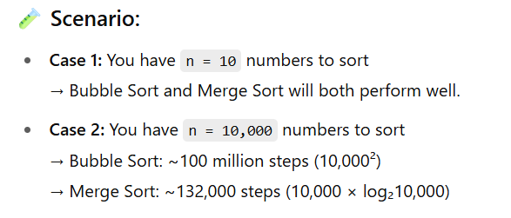
🔍 Result: Merge Sort is clearly much faster for large inputs.
There are many approaches to research the time and space of algorithms, together with big O notation, big Omega notation, and big Theta notation.

Why is Algorithm Analysis important?

Algorithm analysis is crucial in computer science and software development for the following reasons:

1. Predicts Performance

Helps estimate how fast or how much memory an algorithm will use.

You can tell whether the algorithm will work efficiently for large inputs, even before coding.

Example: You can avoid using a slow O(n²) algorithm for a list with millions of

items.

2. Improves Efficiency

Helps identify bottlenecks in your program.

Leads to faster programs and better use of system resources like CPU and RAM.

Example: Choosing Quick Sort over Bubble Sort drastically speeds up sorting

tasks.

3. Aids in Algorithm Selection

When there are multiple algorithms for the same problem, analysis helps pick the most suitable one based on:

Input size

Required speed

Available memory

4. Ensures Scalability (Scalability refers to how well an algorithm or system performs as the size of input data increases.)

As the input size grows, inefficient algorithms can become unusable.

Analysis ensures your program will still perform well as data grows.

Example: A search engine must use efficient algorithms to search through billions

of records.

5. Saves Time and Cost

Efficient algorithms reduce execution time, which means lower server costs, electricity, and better user experience.

"Algorithm analysis helps you write code that is not just correct—but also fast, efficient, and scalable."

Types of Algorithm Analysis:
There are numerous types of algorithm analysis, which can be generally used to measure the performance and efficiency of algorithms:
- Time complexity evaluation: This kind of analysis measures the running time of an algorithm as a characteristic of the input length. It typically entails counting the quantity of primary operations completed by way of the algorithm, such as comparisons, mathematics operations, and reminiscence accesses.
- Space complexity evaluation: This form of evaluation measures the amount of memory required via an algorithm as a characteristic of the enter size. It typically includes counting the variety of variables and information systems utilized by the algorithm, as well as the size of each of these records structures.
- Worst-case evaluation: This type of analysis measures the worst-case running time or space utilization of an algorithm, assuming the maximum toughest viable for the algorithm to deal with.
- Average-case analysis: This kind of evaluation measures the predicted walking time or area usage of an algorithm, assuming a probabilistic distribution of inputs.
- Best-case evaluation: This form of analysis measures the nice case running time or area utilization of an algorithm, assuming the input is the easiest possible for the algorithm to address.
- Asymptotic analysis: This sort of analysis measures the overall performance of an algorithm as the enter size methods infinity. It normally includes the usage of mathematical notation to describe the algorithm's time or area usage, including O(n), Ω(n), or Θ(n).
These sets of algorithm analysis are all useful for information and evaluating the overall performance of various algorithms, and for predicting how properly an algorithm will scale to large problem sizes.

Time Complexity & Space Complexity
What is Time Complexity?
Time Complexity = How much time an algorithm takes as input size increases.
🔁 Think of:
• How many steps does it take to finish?
• Measured in Big-O Notation: O(1), O(n), O(log n), O(n²), etc.

What is Big O Notation?
Big O Notation is a mathematical way to describe the efficiency of an algorithm — how its time or space requirements grow as the size of the input increases.

📌 Why Do We Use It?
• To compare algorithms independently of hardware and language.
• To know how well an algorithm scales as input grows large.
• Helps in choosing the most optimal solution for real-world problems.

🧠 Think of It Like:
If an algorithm is a recipe, Big O tells you how many steps it takes to cook for:
• 1 person 🍽
• 10 people 🍽🍽...🍽

🕒 Time Complexity Examples:
Big O Notation | Description | Example Algorithm
O(1) | Constant Time | Accessing arr[i]
O(log n) | Logarithmic Time | Binary Search
O(n) | Linear Time | Linear Search
O(n log n) | Linearithmic Time | Merge Sort, Quick Sort
O(n²) | Quadratic Time | Bubble Sort, Nested Loops
O(2ⁿ) | Exponential Time | Recursive Fibonacci
O(n!) | Factorial Time | Traveling Salesman

📌 1.1 Constant Time – O(1)
Accessing an array element:

#include <stdio.h>
int main() {
int arr[] = {10, 20, 30, 40};
printf("%d\n", arr[2]); // Direct access
return 0;
}
• 🕒 Time Complexity: O(1)
• 💾 Space Complexity: O(1)

Time Complexity: O(1) – Constant Time
• The line arr[2] directly accesses the 3rd element of the array.
• This access doesn't depend on the size of the array.
• The CPU calculates the memory address using:
address = base_address + (index × size_of_element)
• So whether the array has 4 elements or 4 million,
accessing arr[2] takes the same constant time.
🔁 No loops or recursion involved → Time is constant → O(1)

📌 1.2 Linear Time – O(n)
Linear Time – O(n): Meaning
Linear time means that the time an algorithm takes grows directly in proportion to the size of the input.
🔍 In Simple Words:
If you double the input size, the time it takes will also roughly double.

🧮 In Big-O Notation: O(n)
• n = number of elements in the input (like array size)
• If you loop through the array once, it’s linear time

👨‍💻 Code: Linear Search
#include <stdio.h>
int linear_search(int arr[], int n, int x) {
for (int i = 0; i < n; i++) {
if (arr[i] == x)
return i;
}
return -1;
}
🕒 Time Complexity: O(n) – Linear Time
🔍 What’s happening:
• The function searches for element x in an array of size n.
• It starts at index 0 and checks each element one by one until
it:
1. Finds the element → returns the index.
2. Reaches the end → returns -1 (not found).

🔁 Why O(n)?
• In the worst case, the element might be at the last position, or not present at all.
• That means the loop runs n times.
So, the number of steps grows linearly with the size of the array → O(n).

📊 Example:

Array: {5, 9, 2, 7, 4} Search for 7
• Step 1: 5 ≠ 7
• Step 2: 9 ≠ 7
• Step 3: 2 ≠ 7
• Step 4: 7 = 7 ✅ → Found at index 3
If the array has n elements, it may take up to n comparisons → linear time.

📌 1.3 What is Logarithmic Time in Time Complexity?

Why Is Logarithm Used?
1. ✅ To Reverse Exponentiation
• Just like subtraction undoes addition, logarithms undo exponents.

2. 📉 To Simplify Large Numbers
• Logarithms convert multiplication into addition, which is easier to work with.
• Example: log(ab) = log(a) + log(b)
• This was especially useful before calculators existed!

3. ⏱ In Time Complexity (Computer Science)
• Algorithms like binary search or tree operations run in
O(log n) time.
• Logarithms help measure how fast an algorithm performs
as the input size increases.

Logarithmic time (O(log n)) means that the algorithm's running time increases slowly as the input size increases — specifically, it grows in proportion to the logarithm (usually base 2) of the input size.

💡 In Simple Terms:
If an algorithm cuts the problem in half each time, it’s usually O(log n).

📈 Example:
If n = 16, and you keep halving:
16 → 8 → 4 → 2 → 1
You needed 4 steps → That’s log₂(16) = 4

✅ Most Common Example: Binary Search
int binarySearch(int arr[], int n, int target) {
int low = 0, high = n - 1;
while (low <= high) {
int mid = (low + high) / 2;
if (arr[mid] == target)
return mid;
else if (arr[mid] < target)
low = mid + 1;
else
high = mid - 1;
}
return -1;
}

💡 In this code:
• Each iteration cuts the array in half.
• So for an array of size n, it takes about log₂(n) steps.
• ✅ Time Complexity: O(log n)
• 💾 Space Complexity: O(1) (no extra space used)

📊 Growth Comparison:
Input Size (n) | O(log n) | O(n)
8 | 3 | 8
16 | 4 | 16
1,000,000 | 20 | 1,000,000

💥 O(log n) grows very slowly compared to O(n) — ideal for large
data!

🎯 Real-World Analogy:
• Phone book search: Instead of checking each name one by
one, you open halfway, and discard half the pages — just
like binary search.
• Much faster when data is sorted.

More examples:
1.
Problem:
Write an algorithm to search for an element x in an array arr[] of size n. Return the index if found, otherwise -1.
Determine the time complexity.
✅ Solution:
int linear_search(int arr[], int n, int x) {
for (int i = 0; i < n; i++) {
if (arr[i] == x)
return i;
}
return -1;
}

TimeComplexity:O(n)
Why?
In the worst case, the loop runs n times (element not found or found at the end).

2.Problem:
Given a sorted array arr[] and a target value x, implement binary search tofindx.
What is the time complexity?
✅ Solution:

int binary_search(int arr[], int n, int x) {
int left = 0, right = n - 1;

while (left <= right) {
int mid = left + (right - left) / 2;

if (arr[mid] == x)
return mid;
else if (arr[mid] < x)
left = mid + 1;
else
right = mid - 1;
}

return -1;
}

TimeComplexity:O(logn)
Why?
In each iteration, the search space is reduced by half.

📌 1.4 Linearithmic Time Complexity –
Linearithmic Time Complexity is represented as:
🔹 O(n log n)
It means the algorithm's running time grows faster than linear (O(n)) but slower than quadratic (O(n²)). It's a combination of:
* Linear work (n)
* Logarithmic steps (log n)

📦 Real-World Example: Merge Sort
🔁 How Merge Sort Works:
1. Divide the array into halves recursively – this takes log n steps.
2. Merging each half takes O(n) time.
3. So total time = O(n log n)

// C-code for Merge Sort
void mergeSort(int arr[], int left, int right) {
if (left < right) {
int mid = (left + right)/2;
mergeSort(arr, left, mid);
mergeSort(arr, mid+1, right);
merge(arr, left, mid, right); // Merging step
}
}
✅ Each level of recursion does n work
✅ There are log n levels (dividing in halves)
🔁 Total time = O(n log n)

📊 Other Examples of O(n log n) Algorithms
Algorithm | Description
Merge Sort | Divide and conquer sorting
Heap Sort | Using a heap to sort
Quick Sort (average) | Recursive sorting with partitioning
Efficient Counting | Like counting inversions in an array
Binary Tree Traversal | Building or balancing trees like AVL/Red-Black Trees

🔍 Why Is It Important?
* It's more efficient than O(n²) algorithms like Bubble Sort for large datasets.
* Many optimal algorithms for sorting or divide-and-conquer use this time.

📈 1. Visual Diagram – Merge Sort (O(n log n))
Imagine you're sorting this array:
[8, 3, 2, 7, 5, 4, 1, 6]
🔁 Step-by-step Breakdown (Divide & Merge)
Level 0: [8, 3, 2, 7, 5, 4, 1, 6] → 1 array (n elements)

Level 1: [8, 3, 2, 7] | [5, 4, 1, 6] → 2 halves

Level 2: [8, 3] [2, 7] | [5, 4] [1, 6] → 4 quarters

Level 3: [8] [3] [2] [7] [5] [4] [1] [6] → 8 elements

(Each level does merging work on *n* elements)
🔄 Number of levels = log₂n
🔧 Each level merges n elements → total work: ✅ O(n log n)

🧠 2. Real-Life Analogy – Sorting Papers
Scenario:
You're organizing 100 papers in alphabetical order.

🔹 Naive Method – O(n²)
You compare every paper with every other one:
"Is A before B? B before C? ..."
❌ Takes a lot of time as comparisons grow with size.

🔹 Merge Sort Method – O(n log n)
Step 1: Divide (log n levels)
* Split the pile into smaller and smaller stacks
* Until you have single-paper stacks (which are already sorted)
Step 2: Merge (n work per level)
* Merge two small stacks at a time into sorted stacks
* Repeat until you have one big sorted stack
✅ You do this log n times, and at each level you're handling all n papers.

📌 1.5 Quadratic Time Complexity –
Quadratic Time Complexity is represented as:
🔹 O(n²)
It means the algorithm’s running time grows proportionally to the square of the input size.

So, if n = 10, the operations ≈ 10² = 100.
If n = 1000, it becomes 1,000,000!

📊 Why "Quadratic"?
You're doing something for every pair of inputs, like:
* Comparing every student to every other student
* Checking every item against every other item

✅ Common Examples of O(n²)
1. 🔍 Bubble Sort
void bubbleSort(int arr[], int n) {
for (int i = 0; i < n; i++) {
for (int j = 0; j < n - 1; j++) {
if (arr[j] > arr[j + 1]) {
// Swap
int temp = arr[j];
arr[j] = arr[j + 1];
arr[j + 1] = temp;
}
}
}
}
🟢 Outer loop runs n times
🟢 Inner loop runs n-1 times
⏱ Total operations ≈ n * n = n² → O(n²)

2. 🔁 Nested Loops Example
for (int i = 0; i < n; i++) {
for (int j = 0; j < n; j++) {
printf("Pair (%d, %d)\n", i, j);
}
}
🟢 For every i, loop through all j
⏱ Total operations = n × n → O(n²)

3. ❤ Brute-Force Two-Sum Problem
Find two numbers in an array that add up to a target:
for (int i = 0; i < n; i++) {
for (int j = i + 1; j < n; j++) {
if (arr[i] + arr[j] == target) {
return true;
}
}
}
⏱ Still O(n²) — comparing every pair

🧠 Real-Life Analogy
Imagine a classroom of students (n students):
* Every student must shake hands with every other student once.
👫 Total handshakes = n(n-1)/2 ≈ n²
This is quadratic growth in action!

❗ When is O(n²) Acceptable?
* When n is very small (like ≤ 1000)
* In educational or simple brute-force solutions
* When optimization isn't a priority

📌1.6 Exponential Time Complexity – O(2ⁿ)
Exponential means that the number of operations grows extremely fast, doubling (or multiplying by a constant factor) every time the input size increases by 1.
- The runtime grows exponentially as the input size n increases.
- Growth doubles, triples, etc. as n increases.
- It grows extremely fast, which is why exponential algorithms become infeasible for large inputs.
🔹 Definition:
If the time required is proportional to cⁿ, where c > 1 (commonly 2), the algorithm has exponential time complexity.
T(n) = O(2ⁿ) → If input increases by 1, runtime roughly doubles.

🔹 Examples of Exponential Algorithms:
- Recursive Fibonacci (without memoization)
- Solving the Traveling Salesman Problem (TSP) via brute force
- Generating all subsets of a set (Power Set)
🔹 Example 1: Recursive Fibonacci
int fib(int n) {
if (n <= 1)
return n;
return fib(n-1) + fib(n-2);
}
Time Complexity Analysis:
- Each fib(n) calls 2 more functions → fib(n-1) and fib(n-2)
- The recursion tree doubles in size with each step
- Approximate T(n) = O(2ⁿ)

🔹 Visualization (n = 5)
fib(5)
├─ fib(4)
│ ├─ fib(3)
│ │ ├─ fib(2)
│ │ └─ fib(1)
│ └─ fib(2)
└─ fib(3)
Number of calls grows exponentially with n.

🔹 Growth Comparison:
n | Linear O(n) | Exponential O(2ⁿ)
5 | 5 | 32
10 | 10 | 1,024
20 | 20 | 1,048,576

🔹 Conclusion:
- Exponential algorithms become infeasible for large n.
- Often appear in brute-force problems (subsets, permutations, recursion trees).

📌 1.7 Factorial Time Complexity – O(n!)
Factorial time complexity occurs when the number of operations grows as n! (n factorial) with the input size.
- n! = n × (n-1) × (n-2) × … × 1
- Factorial growth is faster than exponential growth (2ⁿ).
- These algorithms are extremely inefficient for large inputs because the number of operations explodes.

🔹 Definition
If an algorithm takes O(n!) time, then the number of operations increases factorially with n.
Example: For n = 5 → 5! = 120 operations
Example: For n = 10 → 10! = 3,628,800 operations

🔹 Where Does O(n!) Occur?
Factorial complexity appears in problems that generate all permutations or arrangements of n items, such as:

- Generating all permutations of a string or array
- Traveling Salesman Problem (brute force all paths)
- Solving the N-Queens problem using brute-force checking all board configurations

Example: Generating All Permutations
Problem:
Given n elements, generate all possible orderings (permutations).
Example: For n = 3 elements [A, B, C]
- Permutations:
ABC, ACB, BAC, BCA, CAB, CBA
- Total = 3! = 6 permutations
Time Complexity:
- Step 1: Pick 1st element → n ways
- Step 2: Pick 2nd element → (n-1) ways
- Step 3: Pick 3rd element → (n-2) ways
- … until 1 way left

Total Steps = n×(n−1)×(n−2)…1= n!

Time Complexity Analysis:
- For n elements:
  - First position can have n choices
  - Second position can have (n-1) choices
  - Third position can have (n-2) choices
  - … and so on
- Total permutations = n × (n-1) × (n-2) × … × 1 = n!
✅ Time Complexity = O(n!)

🔹 Growth Comparison Table
n | n! | 2ⁿ
5 | 120 | 32
8 | 40,320 | 256
10 | 3,628,800 | 1,024

Factorial time grows much faster than exponential.

🔹 Key Points
- Factorial time algorithms are infeasible for n > 15 in most cases.
- Common in brute force search for permutations and NP-hard problems.
- Often optimized using Dynamic Programming or Backtracking with pruning.

📌 Space Complexity in Algorithms

Space Complexity is the amount of memory an algorithm needs to run to completion.
It measures how much memory is used with respect to the input size n.

🔹 Definition
Space Complexity=Fixed Part + Variable Part
- Fixed Part → Memory that does not change with input size
  - Constants, fixed-size variables, and program instructions
- Variable Part → Memory that depends on input size
  - Memory for dynamically allocated structures (arrays, recursion stack, etc.)

🔹 Components of Space Complexity
- Instruction Space – Memory to store compiled instructions.
- Fixed Memory – For global variables and constants.
- Dynamic Memory – Memory that depends on input size, e.g., arrays.
- Function Call Stack / Recursion – Memory for function calls and local variables.

🔹 Example 1: Iterative Sum
int sumArray(int arr[], int n)
{
int sum = 0; // O(1) space
for (int i = 0; i < n; i++)
{
sum += arr[i]; // O(1) space
}
return sum;
}

Space Complexity:
- Variables: sum, i → O(1)
- No extra data structure used → O(1)
✅ Space Complexity = O(1)

🔹 Example 2: Recursive Factorial
int factorial(int n) {
if (n <= 1) return 1;
return n * factorial(n-1);
}

Space Complexity:
- Each function call stored in stack → O(n) stack space
- No additional arrays → O(n) total
✅ Space Complexity = O(n) (due to recursion)

📌 Different Types of Space Complexity in Algorithms
The total space is made up of different types of memory usage, which can be divided into the following components:

1. Fixed Part (Constant Space)
- Memory required that does not change with input size (n)
- Includes:
  - Program instructions
  - Fixed-size variables (e.g., int x, float y)
  - Constants and literals
Example:
int x = 10;
float y = 20.5;
- These use O(1) memory regardless of n.

2. Variable Part (Dynamic Space)
This part changes with input size and includes:
a) Input Space
- Memory to store the input data
- Example: An array of n integers → O(n) space
b) Auxiliary (Temporary) Space
- Extra memory required by the algorithm for computation
- Example:
  - Temporary arrays in merge sort → O(n)
  - Hash tables for counting frequencies
c) Function Call Stack / Recursion Space
- Memory used for function calls, parameters, return addresses, and local variables
- In recursive algorithms, this is often the dominant space cost
Example:
int factorial(int n) {
if (n <= 1) return 1;
return n * factorial(n-1);
}
- Recursive calls take O(n) space on the call stack.

3. Example of Combined Space Complexity
For an algorithm, total space =
Space Complexity = Fixed + Input + Auxiliary + Recursion Stack

4. Common Types by Complexity
Type of Space Complexity | Example Algorithm
O(1) – Constant | Finding max in array (iterative)
O(log n) | Binary search (recursive stack)
O(n) – Linear | Storing an array of size n
O(n²) | 2D arrays or DP tables (like Floyd-Warshall)

Best Case, Worst Case, and Average Case.

1. Best-Case Analysis

Definition: The scenario where the algorithm performs the minimum possible number of steps.

Meaning: This happens when the input is most favourable.

Purpose: Shows the fastest the algorithm can run.

Example:
Linear Search in an array of n elements

Best Case: The element is found at index 0 (first position).

Time Complexity: O(1)

2. Worst-Case Analysis

Definition: The scenario where the algorithm takes the maximum possible number of steps.

Meaning: This happens when the input is least favorable.

Purpose: Guarantees the upper limit of execution time, which is important for safety-critical systems.

Example:
Linear Search

Worst Case: The element is not found or is at the last position.

Time Complexity: O(n)

3. Average-Case Analysis

Definition: The expected running time of the algorithm over all possible inputs, assuming each is equally likely.

Meaning: Shows how the algorithm behaves most of the time.

Purpose: Gives a realistic expectation of performance.

Example: Linear Search

Problem:

Search for an element x in an array of n elements.

Running Time:

If x is at position 1 → 1 comparison

If x is at position 2 → 2 comparisons

…

If x is at position n → n comparisons

If x is not present → n comparisons

Case 1: Element is present

Probability of being at any position = 1n\frac{1}{n}n1​

Average comparisons:
Average=1+2+3+⋯+n​ / n

= n(n+1)/2 /n ​
= n+1​/2

⏱ Average Time = O(n)

Summary Table
Case | Meaning | Linear Search Example | Complexity
Best | Minimum steps (ideal input) | Found at index 0 | O(1)
Worst | Maximum steps (worst input) | Not found or last | O(n)
Average | Expected steps over random inputs | Found near middle | O(n)

Time Complexity vs. Space Complexity
Now we know the basics of time and space complexity and how it can be calculated for an algorithm or program.
Time Complexity | Space Complexity
Calculates time needed | Calculates memory space needed
Counts time for all statements. | Counts memory space for all variables even inputs and outputs
Depends mostly on input data size | Depends mostly on auxiliary variables size
More important for solution optimization | Less important with modern hardware
Time complexity of merge sort is O(n log n) | Space complexity of merge sort is O(n)

Asymptotic Analysis: Big-O Notation and More
The efficiency of an algorithm depends on the amount of time, storage and other resources required to execute the algorithm. The efficiency is measured with the help of asymptotic notations.
An algorithm may not have the same performance for different types of inputs. With the increase in the input size, the performance will change.
The study of change in performance of the algorithm with the change in the order of the input size is defined as asymptotic analysis.

Asymptotic Notations
Asymptotic notations are the mathematical notations used to describe the running time of an algorithm when the input tends towards a particular value or a limiting value.
For example: In bubble sort, when the input array is already sorted, the time taken by the algorithm is linear i.e. the best case.
But, when the input array is in reverse condition, the algorithm takes the maximum time (quadratic) to sort the elements i.e. the worst case.
When the input array is neither sorted nor in reverse order, then it takes average time. These durations are denoted using asymptotic notations.
There are mainly three asymptotic notations:
- Big-O notation
- Omega notation
- Theta notation

Asymptotic Notations and how to calculate them.

In computing, asymptotic analysis of an algorithm refers to defining the mathematical boundation of its run-time performance based on the input size.

For example, the running time of one operation is computed as f(n), and maybe for another operation, it is computed as g(n2).

This means the first operation running time will increase linearly with the increase in n and the running time of the second operation will increase exponentially when n increases.

Similarly, the running time of both operations will be nearly the same if n is small in value.

Usually, the analysis of an algorithm is done based on three cases:

- Best Case (Omega Notation (Ω))
- Average Case (Theta Notation (Θ))
- Worst Case (O Notation(O))

All of these notations are discussed below in detail:

Omega (Ω) Notation:
Omega (Ω) notation specifies the asymptotic lower bound for a function f(n). For a given function g(n), Ω(g(n)) is denoted by:

Ω (g(n)) = {f(n): there exist positive constants c and n0 such that 0 ≤ c*g(n) ≤ f(n) for all n ≥ n0}.

This means that, f(n) = Ω(g(n)), If there are positive constants n0 and c such that, to the right of n0 the f(n) always lies on or above c*g(n).

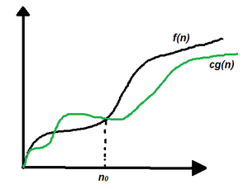

Graphical representation
Follow the steps below to calculate Ω for a program:

- Break the program into smaller segments.
- Find the number of operations performed for each segment (in terms of the input size) assuming the given input is such that the program takes the least amount of time.
- Add up all the operations and simplify it, let’s say it is f(n).
- Remove all the constants and choose the term having the highest order or any other function which is always less than f(n) when n tends to infinity, let say it is g(n) then, Omega (Ω) of f(n) is Ω(g(n)).

For example, consider the below pseudo code.

Sum of large numbers
- Pseudo Code
void fun(n) {
for (i = 0; i < n; i++) {
for (j = 0; j < n; j++) {

// Do some constant work (no loop or
// function call)
}

for (i = 0; i < n; i++) {
// Do some constant work (no loop or
// function call)
}
}

The time taken by the above code can be written as a*n^2 + b*n + c where are a, b and c are some machine specific constants.

In this case, the highest growing term is a*n^2.

So we can say that the time complexity of the code is either Ω(n^2) or Ω(n) or Ω(Log n) or Ω(1)

Omega notation doesn’t really help to analyze an algorithm because it is bogus to evaluate an algorithm for the best cases of inputs.

Theta (Θ) Notation:
Big-Theta(Θ) notation specifies a bound for a function f(n). For a given function g(n), Θ(g(n)) is denoted by:

Θ (g(n)) = {f(n): there exist positive constants c1, c2 and n0 such that 0 ≤ c1*g(n) ≤ f(n) ≤ c2*g(n) for all n ≥ n0}.

This means that, f(n) = Θ(g(n)), If there are positive constants n0 and c such that, to the right of n0 the f(n) always lies on or above c1*g(n) and below c2*g(n).

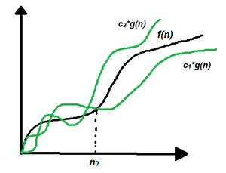
Graphical representation
Follow the steps below to calculate Θ for a program:

- Break the program into smaller segments.
- Find the number of operations performed for each segment(in terms of the input size) assuming the given input is such that the program takes the least amount of time.
- Add up all the operations and simplify it, let’s say it is f(n).
- Remove all the constants and choose the term having the highest order. Let say it is g(n) then, Omega (Θ) of f(n) is Θ(g(n)).

As an example. let us consider the above pseudo code only. In this case, the highest growing term is a*n^2. So the time complexity of the code is Θ(n^2)

Big – O Notation:
Big – O (O) notation specifies the asymptotic upper bound for a function f(n). For a given function g(n), O(g(n)) is denoted by:

O (g(n)) = {f(n): there exist positive constants c and n0 such that f(n) ≤ c*g(n) for all n ≥ n0}.

This means that, f(n) = O(g(n)), If there are positive constants n0 and c such that, to the right of n0 the f(n) always lies on or below c*g(n).

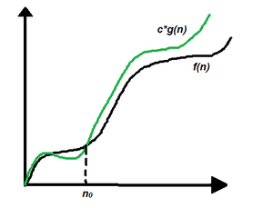
Graphical representation

Follow the steps below to calculate O for a program:
- Break the program into smaller segments.
- Find the number of operations performed for each segment (in terms of the input size) assuming the given input is such that the program takes the maximum time i.e the worst-case scenario.
- Add up all the operations and simplify it, let’s say it is f(n).
- Remove all the constants and choose the term having the highest order because for n tends to infinity the constants and the lower order terms in f(n) will be insignificant, let say the function is g(n) then, big-O notation is O(g(n)) or O(h(n)) where h(n) has higher order of growth than g(n)

As an example.

let us consider the above pseudo code only. In this case, the highest growing term is a*n^2.

So the time complexity of the code is O(n^2) or O(n^3) or O(n Log n) or any other term can be put inside O that has higher growth than n^2.

AVL Trees:
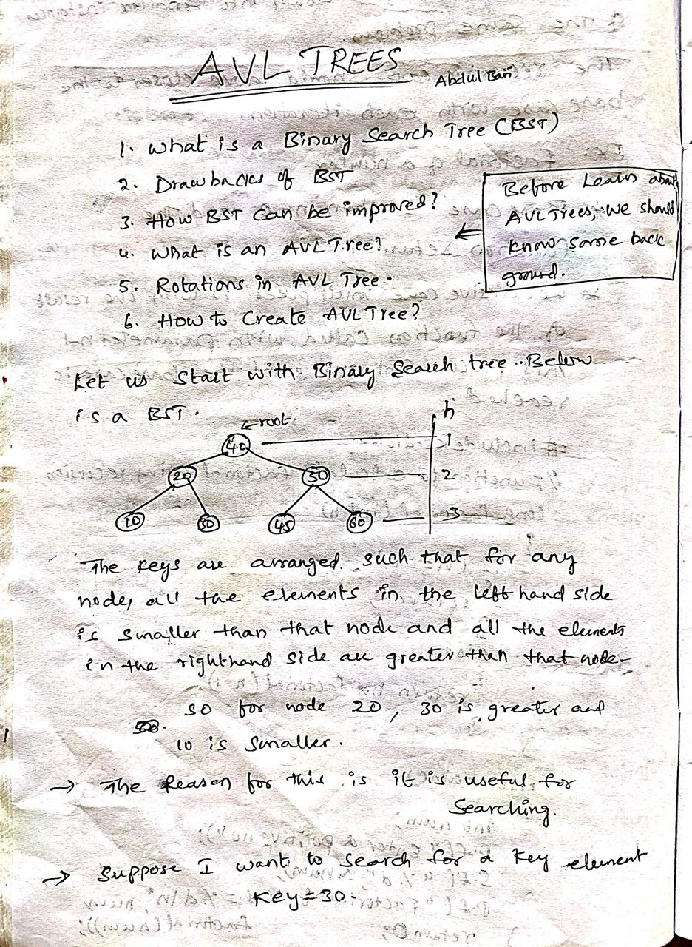
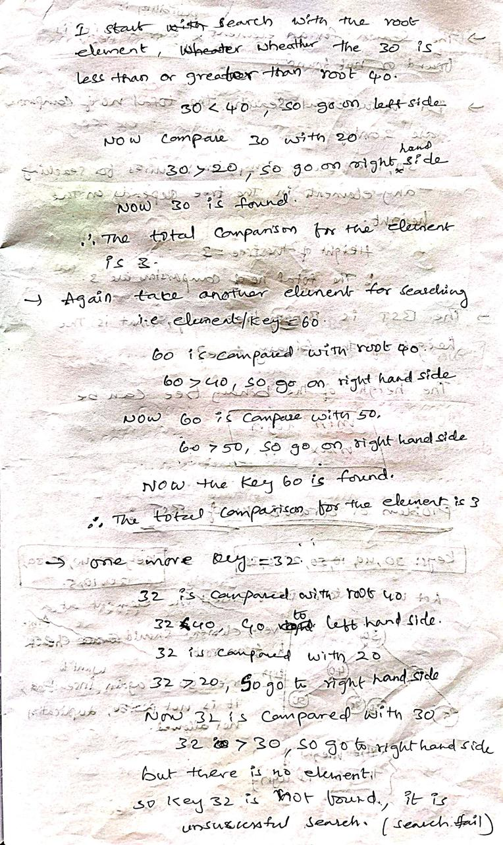
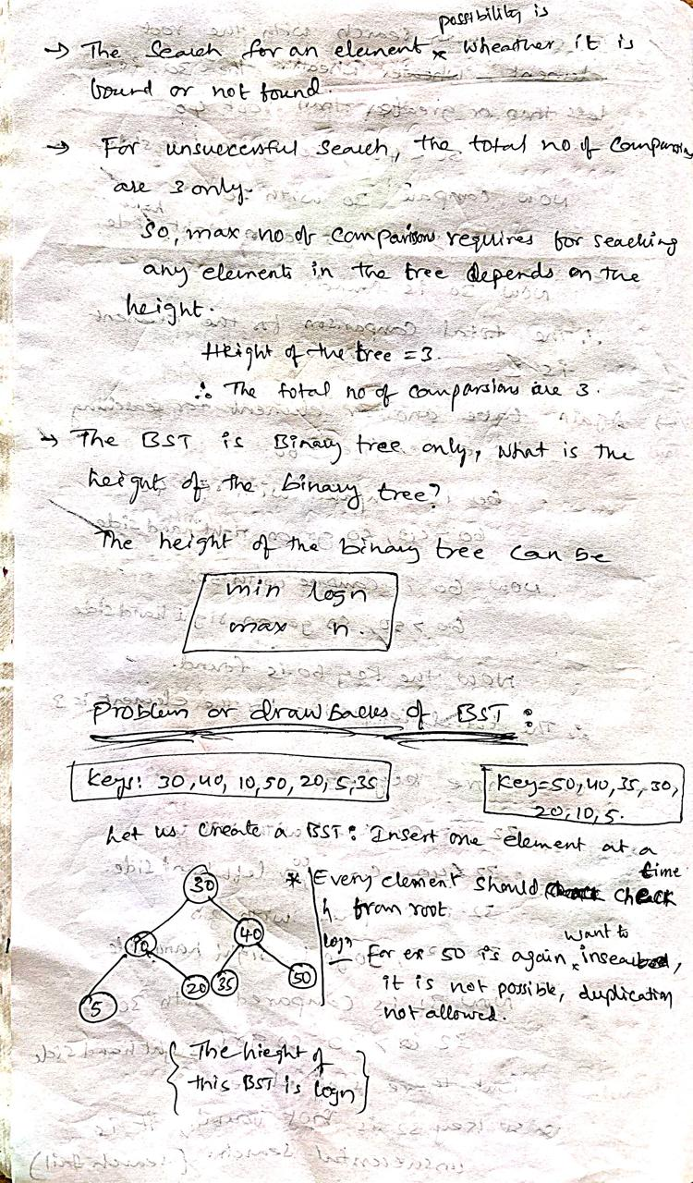
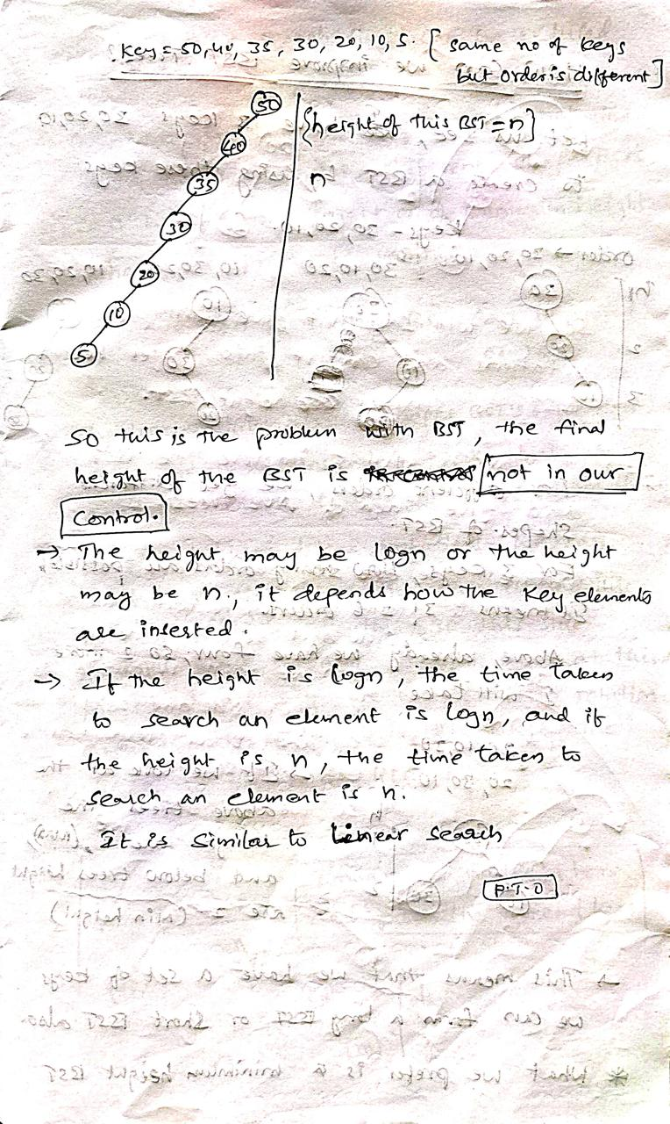
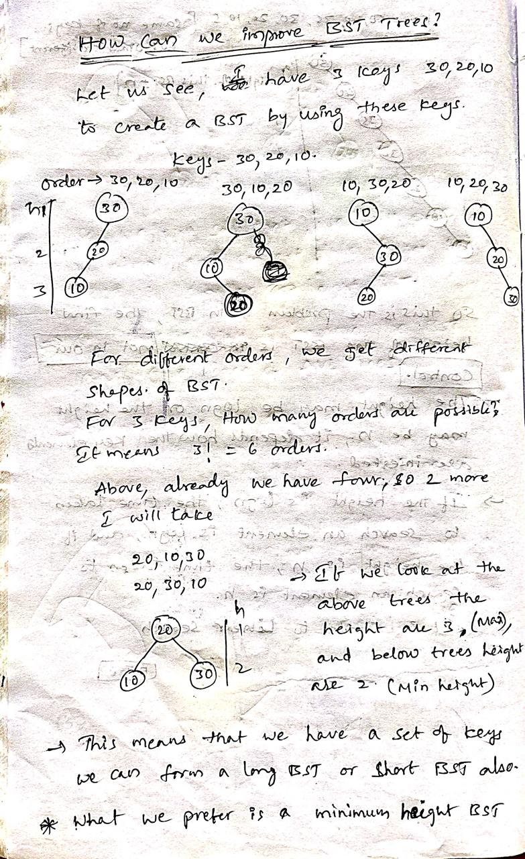
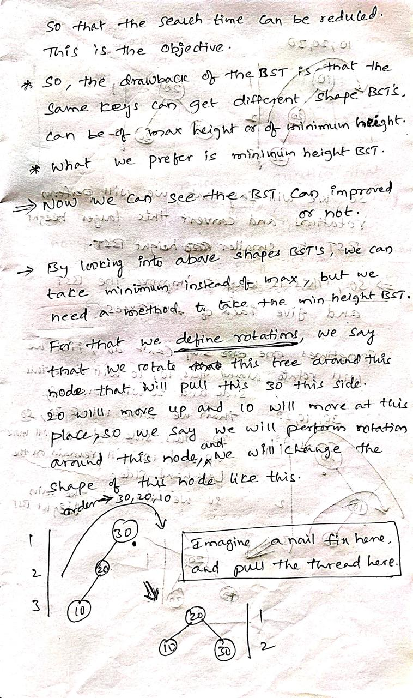
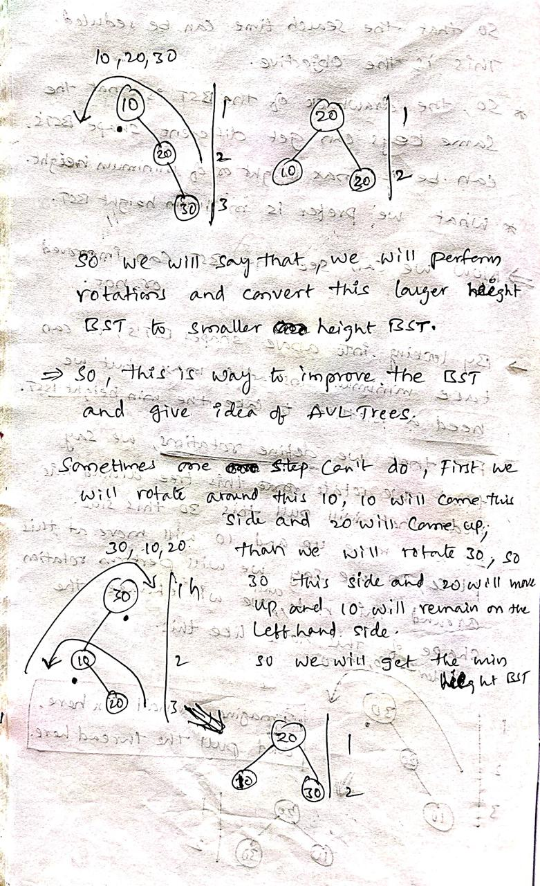
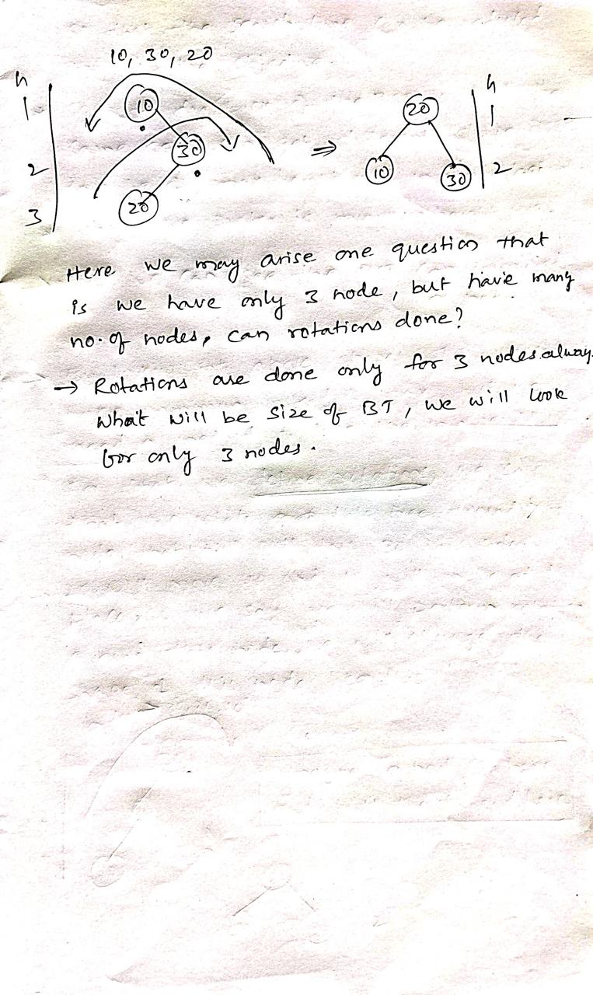

AVL Trees: Rotations, Insertion, Deletion with C Example

What are AVL Trees?
AVL trees are binary search trees in which the difference between the height of the left and right subtree is either -1, 0, or +1.
AVL trees are also called a self-balancing binary search tree. These trees help to maintain the logarithmic search time. It is named after its inventors (AVL) Adelson, Velsky, and Landis.

How does AVL Tree work?
To better understand the need for AVL trees, let us look at some disadvantages of simple binary search trees.
Consider the following keys inserted in the given order in the binary search tree.
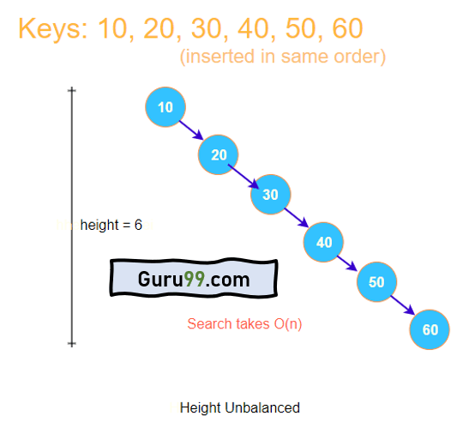

AVL tree visualization

The height of the tree grows linearly in size when we insert the keys in increasing order of their value. Thus, the search operation, at worst, takes O(n).
It takes linear time to search for an element; hence there is no use of using the Binary Search Tree structure. On the other hand, if the height of the tree is balanced, we get better searching time.
Let us now look at the same keys but inserted in a different order.
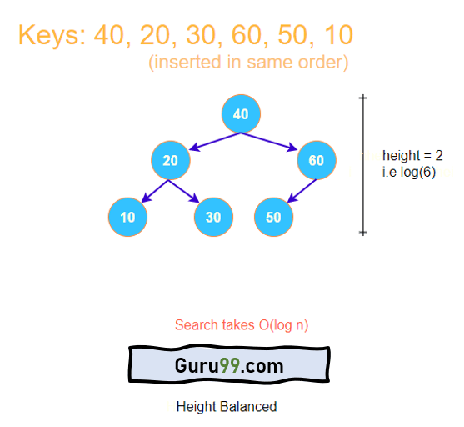
Here, the keys are the same, but since they are inserted in a different order, they take different positions, and the height of the tree remains balanced. Hence search will not take more than O(log n) for any element of the tree. It is now evident that if insertion is done correctly, the tree’s height can be kept balanced.
In AVL trees, we keep a check on the height of the tree during insertion operation. Modifications are made to maintain the balanced height without violating the fundamental properties of Binary Search Tree.

Balance Factor in AVL Trees
Balance factor (BF) is a fundamental attribute of every node in AVL trees that helps to monitor the tree’s height.

Properties of Balance Factor
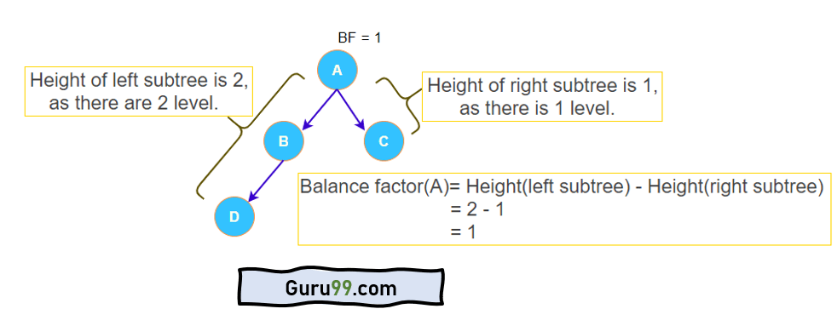
Balance factor AVL tree
- The balance factor is known as the difference between the height of the left subtree and the right subtree.
- Balance factor(node) = height(node->left) – height(node->right)
- Allowed values of BF are –1, 0, and +1.
- The value –1 indicates that the right sub-tree contains one extra, i.e., the tree is right heavy.
- The value +1 indicates that the left sub-tree contains one extra, i.e., the tree is left heavy.
- The value 0 shows that the tree includes equal nodes on each side, i.e., the tree is perfectly balanced.

AVL Rotations
To make the AVL Tree balance itself, when inserting or deleting a node from the tree, rotations are performed.
We perform the following LL rotation, RR rotation, LR rotation, and RL rotation.
- Left – Left Rotation
- Right – Right Rotation
- Right – Left Rotation
- Left – Right Rotation

Left – Left Rotation
This rotation is performed when a new node is inserted at the left child of the left subtree.
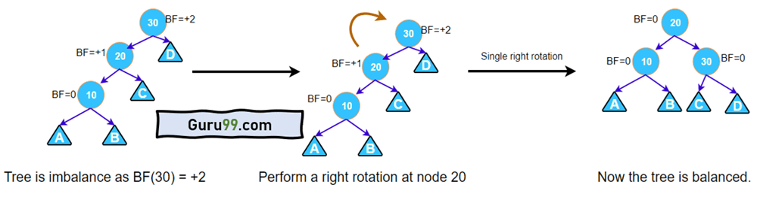
AVL Tree Left – Left Rotation

A single right rotation is performed. This type of rotation is identified when a node has a balanced factor as +2, and its left-child has a balance factor as +1.

Right – Right Rotation
This rotation is performed when a new node is inserted at the right child of the right subtree.
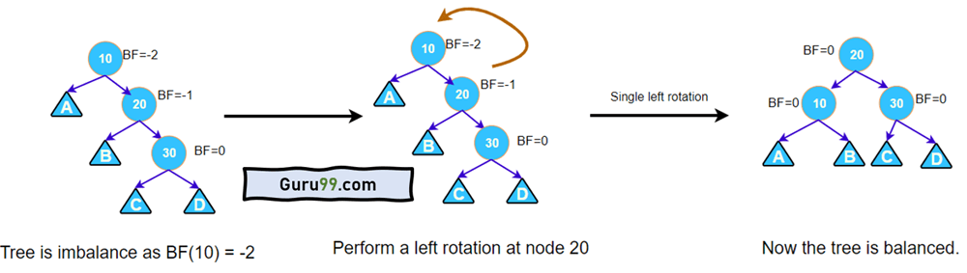

A single left rotation is performed. This type of rotation is identified when a node has a balanced factor as -2, and its right-child has a balance factor as -1.

Right – Left Rotation
This rotation is performed when a new node is inserted at the right child of the left subtree.
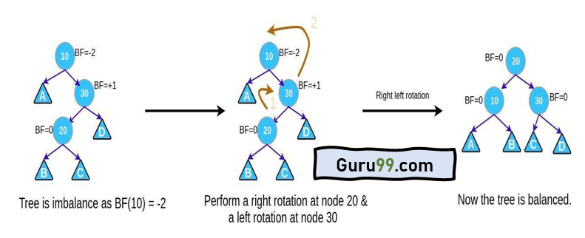

This rotation is performed when a node has a balance factor as –2, and its right-child has a balance factor as +1.

Left – Right Rotation
This rotation is performed when a new node is inserted at the left child of the right subtree.
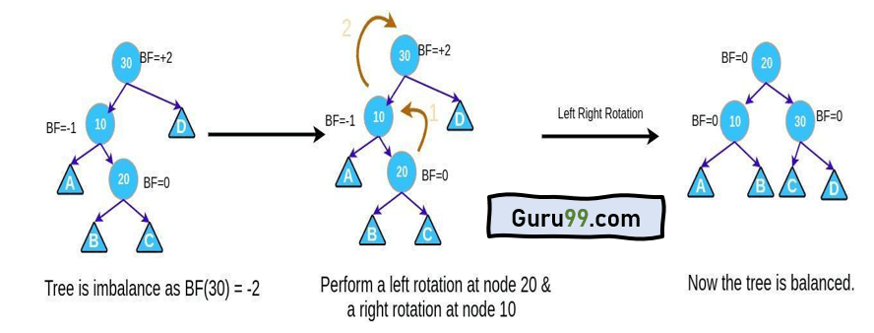
This rotation is performed when a node has a balance factor as +2, and its left-child has a balance factor as -1.

Insertion in AVL Trees
Insert operation is almost the same as in simple binary search trees. After every insertion, we balance the height of the tree. Insert operation takes O(log n) worst time complexity.
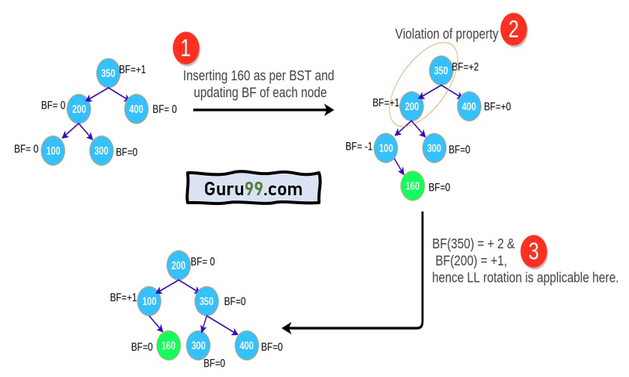
AVL tree insertion implementation
Step 1: Insert the node in the AVL tree using the same insertion algorithm of BST. In the above example, insert 160.
Step 2: Once the node is added, the balance factor of each node is updated. After 160 is inserted, the balance factor of every node is updated.
Step 3: Now check if any node violates the range of the balance factor if the balance factor is violated, then perform rotations using the below case. In the above example, the balance factor of 350 is violated and case 1 becomes applicable there, we perform LL rotation and the tree is balanced again.
- If BF(node) = +2 and BF(node -> left-child) = +1, perform LL rotation.
- If BF(node) = -2 and BF(node -> right-child) = 1, perform RR rotation.
- If BF(node) = -2 and BF(node -> right-child) = +1, perform RL rotation.
- If BF(node) = +2 and BF(node -> left-child) = -1, perform LR rotation.

Deletion in AVL Trees
Deletion is also very straight forward. We delete using the same logic as in simple binary search trees. After deletion, we restructure the tree, if needed, to maintain its balanced height.
Step 1: Find the element in the tree.
Step 2: Delete the node, as per the BST Deletion.
Step 3: Two cases are possible:-
Case 1: Deleting from the right subtree.
- 1A. If BF(node) = +2 and BF(node -> left-child) = +1, perform LL rotation.
- 1B. If BF(node) = +2 and BF(node -> left-child) = -1, perform LR rotation.
- 1C. If BF(node) = +2 and BF(node -> left-child) = 0, perform LL rotation.
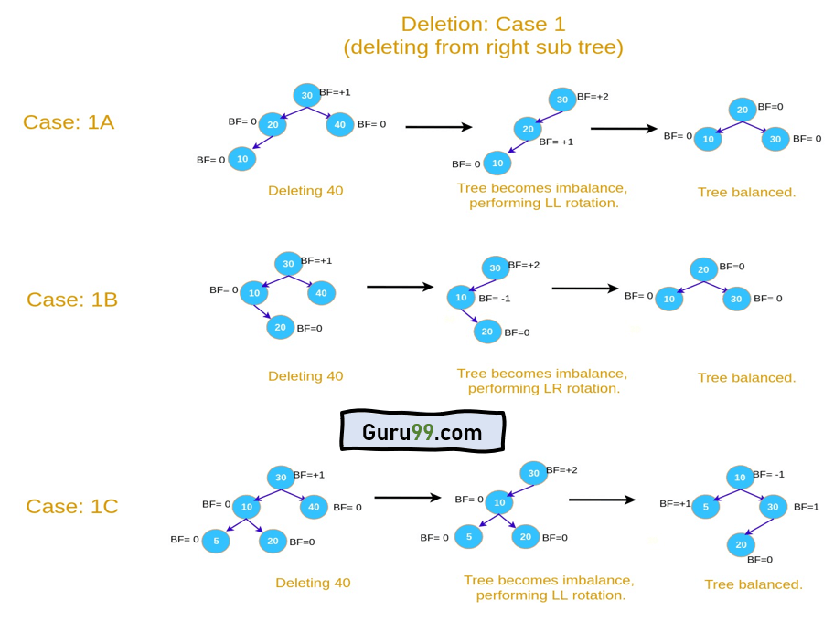

Case 2: Deleting from left subtree.
- 2A. If BF(node) = -2 and BF(node -> right-child) = -1, perform RR rotation.
- 2B. If BF(node) = -2 and BF(node -> right-child) = +1, perform RL rotation.
- 2C. If BF(node) = -2 and BF(node -> right-child) = 0, perform RR rotation.
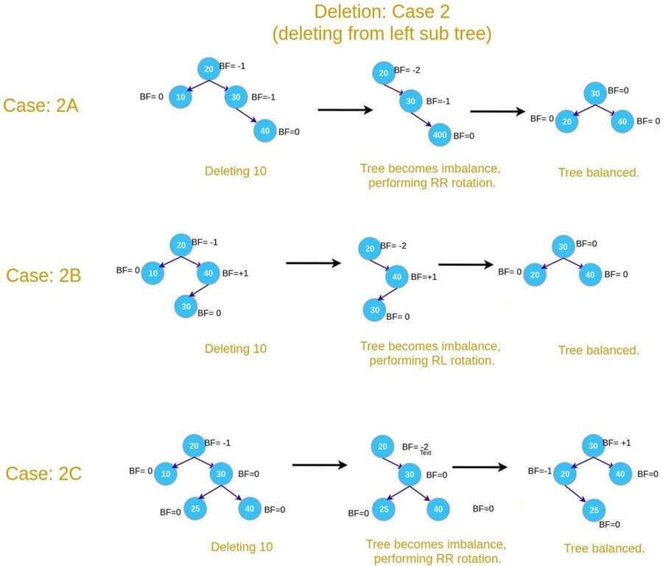

Construct an AVL tree for a given set of elements, which are stored in a file. And implement insert and delete operation on the constructed tree. Write contents of tree into a new file using in-order.

// C program to implement the avl tree
#include <stdio.h>
#include <stdlib.h>

// AVL Tree node
struct Node {
int key;
struct Node* left;
struct Node* right;
int height;
};

// Function to get height of the node
int getHeight(struct Node* n)
{
if (n == NULL)
return 0;
return n->height;
}

// Function to create a new node
struct Node* createNode(int key)
{
struct Node* node
= (struct Node*)malloc(sizeof(struct Node));
node->key = key;
node->left = NULL;
node->right = NULL;
node->height = 1; // New node is initially added at leaf
return node;
}

// Utility function to get the maximum of two integers
int max(int a, int b) { return (a > b) ? a : b; }

// Function to get balance factor of a node
int getBalanceFactor(struct Node* n)
{
if (n == NULL)
return 0;
return getHeight(n->left) - getHeight(n->right);
}

// Right rotation function
struct Node* rightRotate(struct Node* y)
{
struct Node* x = y->left;
struct Node* T2 = x->right;

// Perform rotation
x->right = y;
y->left = T2;

// Update heights
y->height
= max(getHeight(y->left), getHeight(y->right)) + 1;
x->height
= max(getHeight(x->left), getHeight(x->right)) + 1;

return x;
}

// Left rotation function
struct Node* leftRotate(struct Node* x)
{
struct Node* y = x->right;
struct Node* T2 = y->left;

// Perform rotation
y->left = x;
x->right = T2;

// Update heights
x->height
= max(getHeight(x->left), getHeight(x->right)) + 1;
y->height
= max(getHeight(y->left), getHeight(y->right)) + 1;

return y;
}

// Function to insert a key into AVL tree
struct Node* insert(struct Node* node, int key)
{
// 1. Perform standard BST insertion
if (node == NULL)
return createNode(key);

if (key < node->key)
node->left = insert(node->left, key);
else if (key > node->key)
node->right = insert(node->right, key);
else // Equal keys are not allowed in BST
return node;

// 2. Update height of this ancestor node
node->height = 1
+ max(getHeight(node->left),
getHeight(node->right));

// 3. Get the balance factor of this ancestor node to
// check whether this node became unbalanced
int balance = getBalanceFactor(node);

// 4. If the node becomes unbalanced, then there are 4
// cases

// Left Left Case
if (balance > 1 && key < node->left->key)
return rightRotate(node);

// Right Right Case
if (balance < -1 && key > node->right->key)
return leftRotate(node);

// Left Right Case
if (balance > 1 && key > node->left->key) {
node->left = leftRotate(node->left);
return rightRotate(node);
}

// Right Left Case
if (balance < -1 && key < node->right->key) {
node->right = rightRotate(node->right);
return leftRotate(node);
}

// Return the (unchanged) node pointer
return node;
}

// Function to perform preorder traversal of AVL tree
void inOrder(struct Node* root)
{
if (root != NULL) {
inOrder(root->left);
printf("%d ", root->key);
inOrder(root->right);
}
}

// Main function
int main()
{
struct Node* root = NULL;

// Inserting nodes
root = insert(root, 1);
root = insert(root, 2);
root = insert(root, 4);
root = insert(root, 5);
root = insert(root, 6);
root = insert(root, 3);

// Print preorder traversal of the AVL tree
printf("Inorder traversal of AVL tree: ");
inOrder(root);

return 0;
}

Output
Inorder traversal of AVL tree: 1 2 3 4 5 6

Advantages of AVL Trees
- The height of the AVL tree is always balanced. The height never grows beyond log N, where N is the total number of nodes in the tree.
- It gives better search time complexity when compared to simple Binary Search trees.
- AVL trees have self-balancing capabilities.

Summary
- AVL trees are self-balancing binary search trees.
- Balance factor is the fundamental attribute of AVL trees
- The balance factor of a node is defined as the difference between the height of the left and right subtree of that node.
- The valid values of the balance factor are -1, 0, and +1.
- The insert and delete operation require rotations to be performed after violating the balance factor.
- The time complexity of insert, delete, and search operation is O(log N).
- AVL trees follow all properties of Binary Search Trees.
- The left subtree has nodes that are lesser than the root node. The right subtree has nodes that are always greater than the root node.
- AVL trees are used where search operation is more frequent compared to insert and delete operations.

B-TREE: Creation, Insertion, Deletion operations and Applications

Introduction of B-Tree:

- The limitations of traditional binary search trees can be frustrating. Meet the B-Tree, the multi-talented data structure that can handle massive amounts of data with ease.

- When it comes to storing and searching large amounts of data, traditional binary search trees can become impractical due to their poor performance and high memory usage.

- B-Trees, also known as B-Tree or Balanced Tree, are a type of self-balancing tree that was specifically designed to overcome these limitations.

- Unlike traditional binary search trees, B-Trees are characterized by the large number of keys that they can store in a single node, which is why they are also known as “large key” trees.

- Each node in a B-Tree can contain multiple keys, which allows the tree to have a larger branching factor and thus a shallower height.

- This shallow height leads to less disk I/O, which results in faster search and insertion operations.

- B-Trees are particularly well suited for storage systems that have slow, bulky data access such as hard drives, flash memory, and CD-ROMs.

- B-Trees maintains balance by ensuring that each node has a minimum number of keys, so the tree is always balanced.

- This balance guarantees that the time complexity for operations such as insertion, deletion, and searching is always O(log n), regardless of the initial shape of the tree.

Time Complexity of B-Tree:

Sr. No. | Algorithm | Time Complexity
1. | Search | O(log n)
2. | Insert | O(log n)
3. | Delete | O(log n)
Note: “n” is the total number of elements in the B-tree

Why use B-Tree:
Here, are reasons of using B-Tree
- Reduces the number of reads made on the disk
- B Trees can be easily optimized to adjust its size (that is the number of child nodes) according to the disk size
- It is a specially designed technique for handling a bulky amount of data.
- It is a useful algorithm for databases and file systems.
- A good choice to opt when it comes to reading and writing large blocks of data

History of B Tree:
- Data is stored on the disk in blocks, this data, when brought into main memory (or RAM) is called data structure.
- In-case of huge data, searching one record in the disk requires reading the entire disk; this increases time and main memory consumption due to high disk access frequency and data size.
- To overcome this, index tables are created that saves the record reference of the records based on the blocks they reside in. This drastically reduces the time and memory consumption.
- Since we have huge data, we can create multi-level index tables.
- Multi-level index can be designed by using B Tree for keeping the data sorted in a self-balancing fashion.

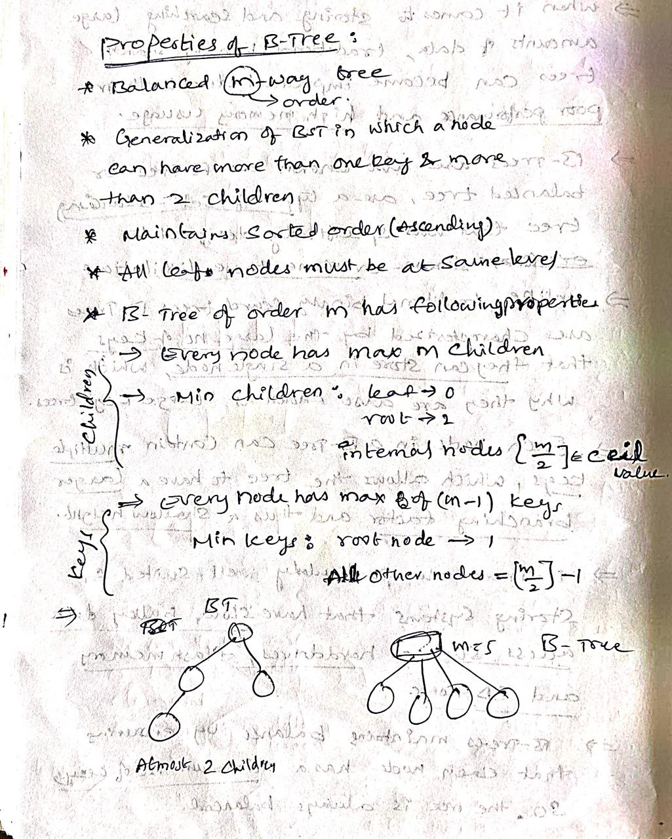

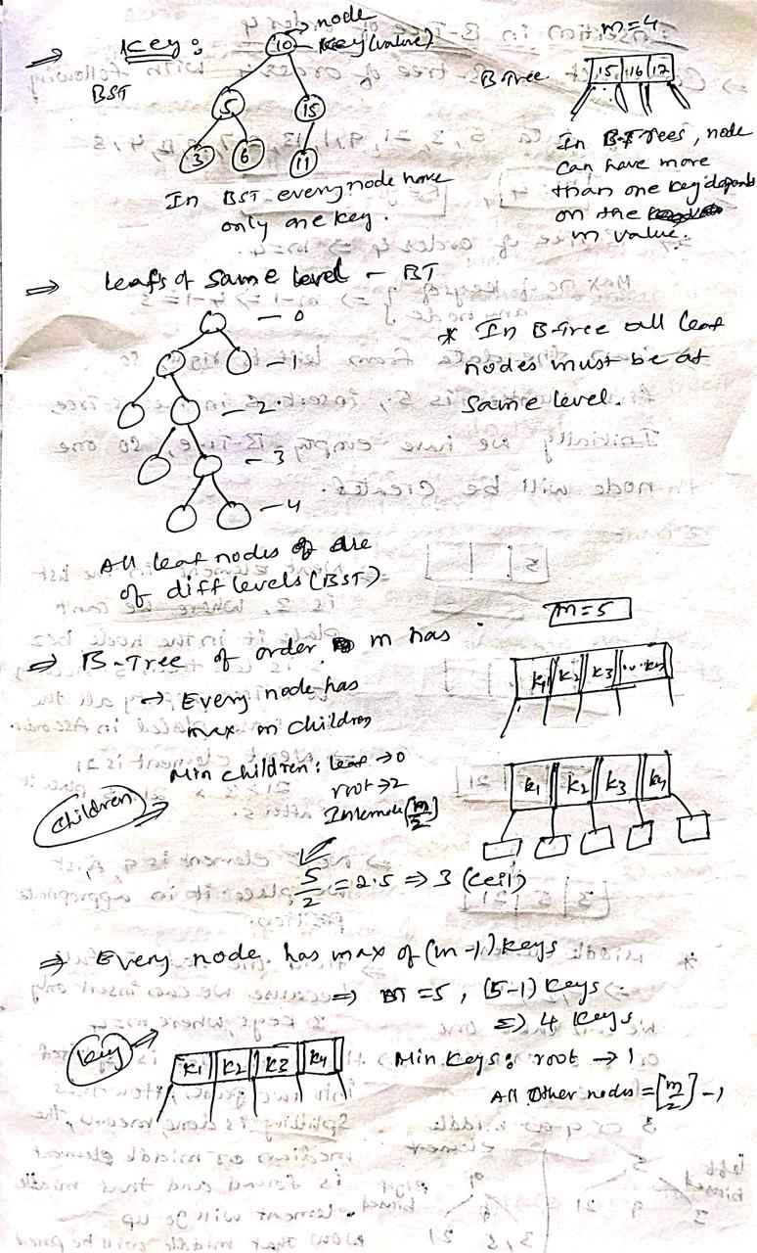
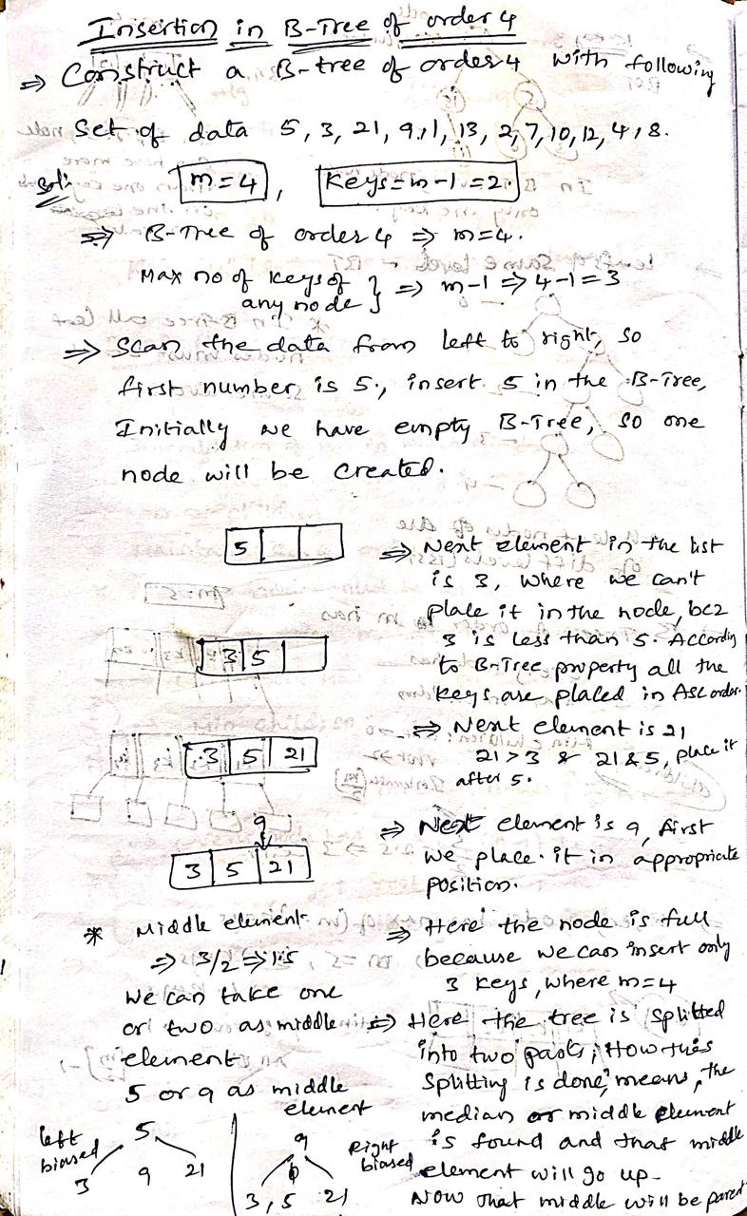
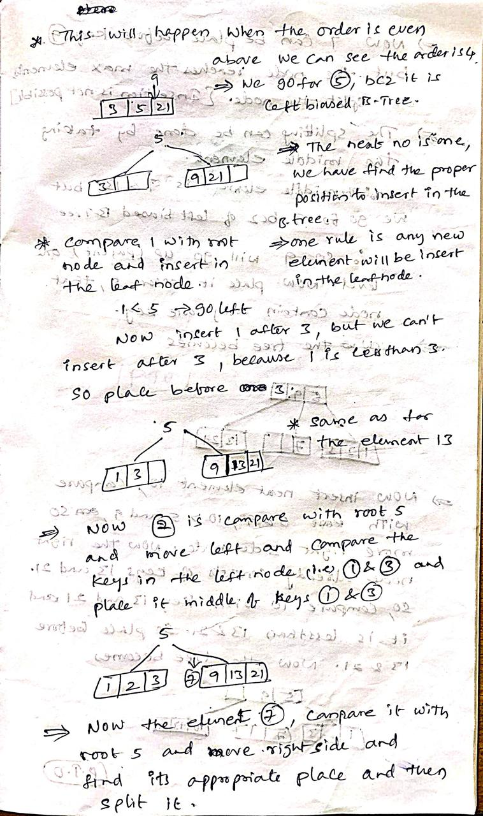
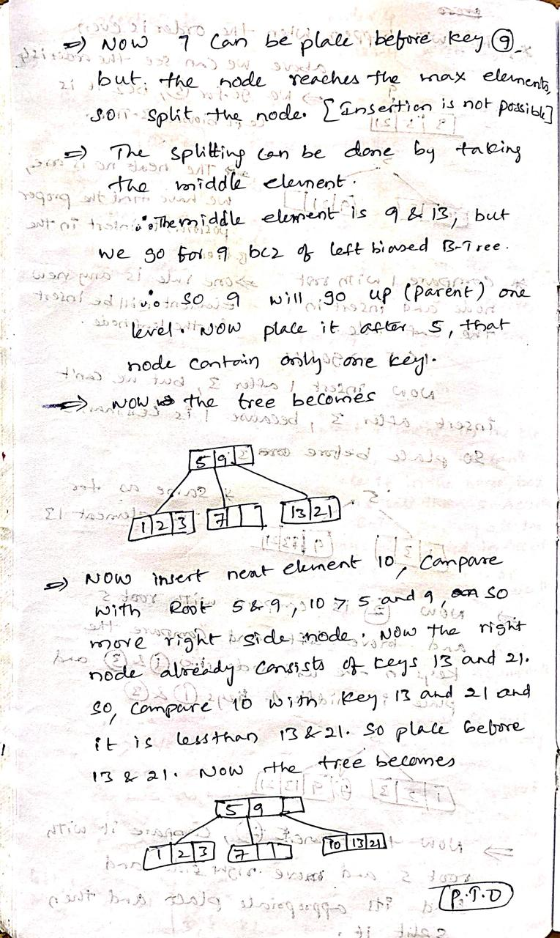
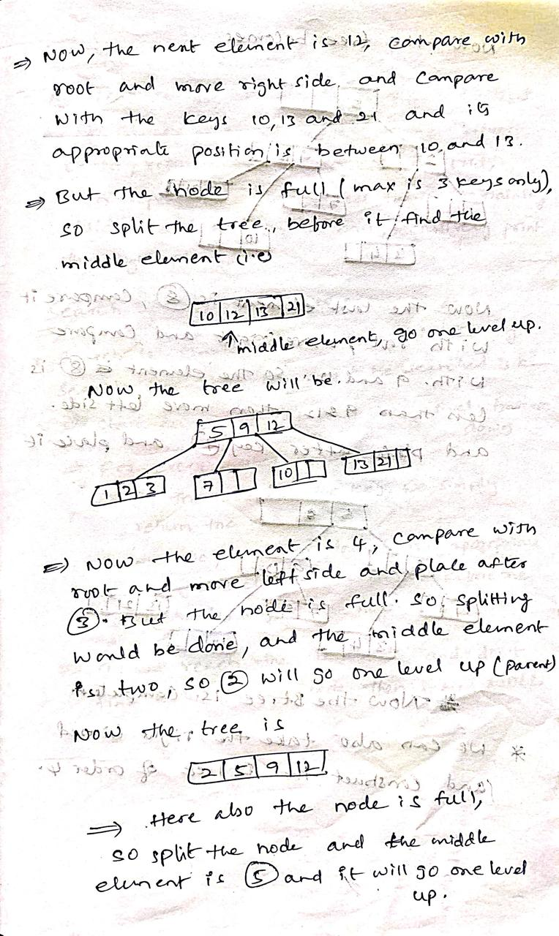
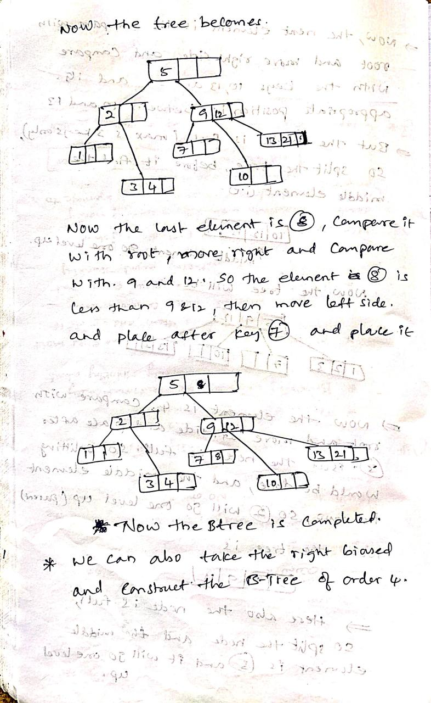
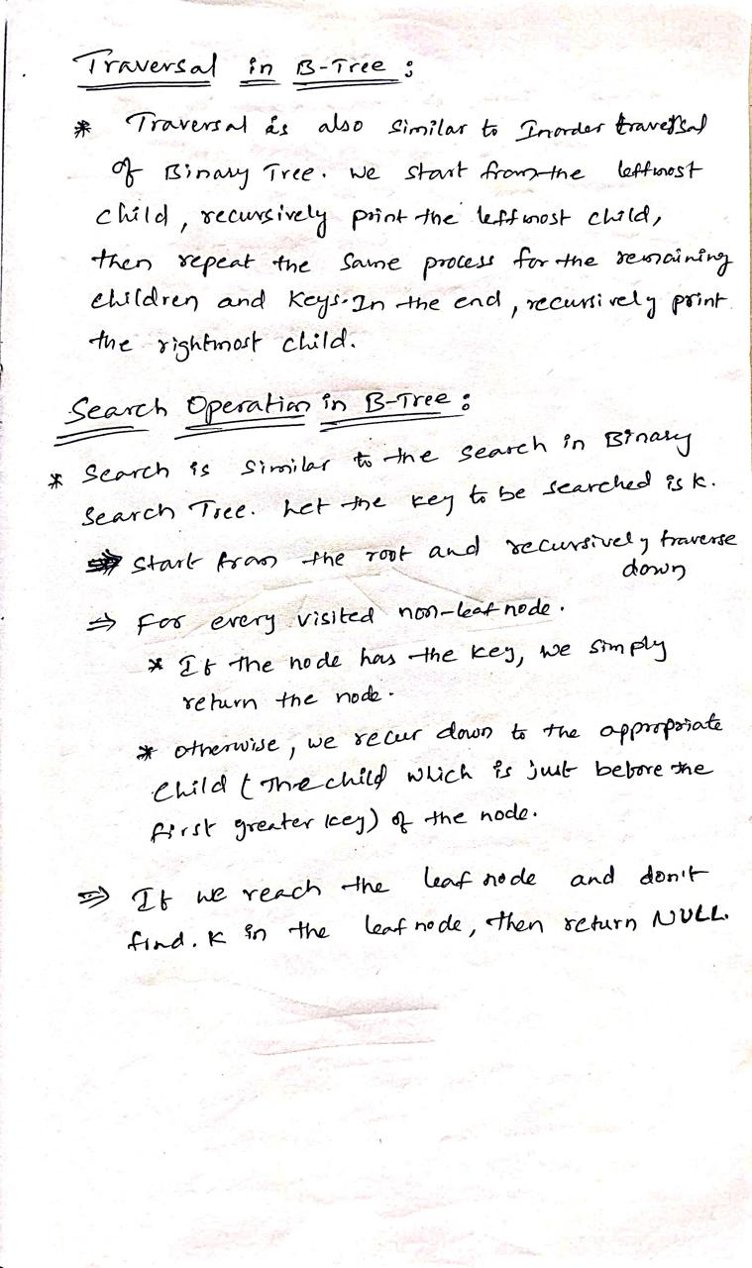

Insert Operation
Since B Tree is a self-balancing tree, you cannot force insert a key into just any node.
The following algorithm applies:
- Run the search operation and find the appropriate place of insertion.
- Insert the new key at the proper location, but if the node has a maximum number of keys already:
- The node, along with a newly inserted key, will split from the middle element.
- The middle element will become the parent for the other two child nodes.
- The nodes must re-arrange keys in ascending order.
The following is not true about the insertion algorithm:
Since the node is full, therefore it will split, and then a new value will be inserted

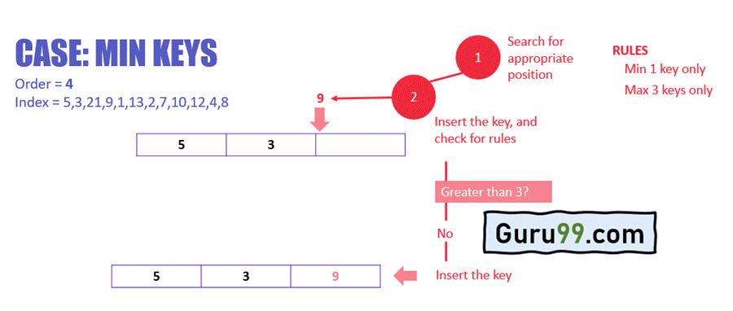
In the above example:
- Search the appropriate position in the node for the key
- Insert the key in the target node, and check for rules
- After insertion, does the node have more than equal to a minimum number of keys, which is 1? In this case, yes, it does. Check the next rule.
- After insertion, does the node have more than a maximum number of keys, which is 3? In this case, no, it does not. This means that the B Tree is not violating any rules, and the insertion is complete.
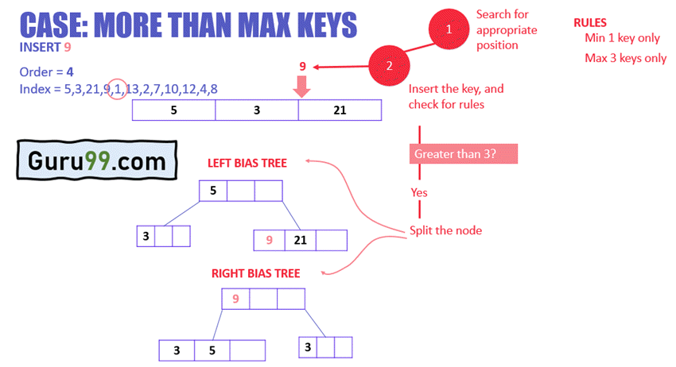
In the above example:
- The node has reached the max number of keys
- The node will split, and the middle key will become the root node of the rest two nodes.
- In case of even number of keys, the middle node will be selected by left bias or right bias.
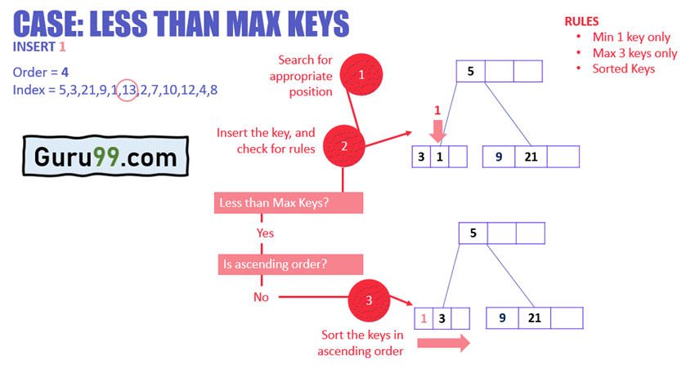
In the above example:
- The node has less than max keys
- 1 is inserted next to 3, but the ascending order rule is violated
- In order to fix this, the keys are sorted
Similarly, 13 and 2 can be inserted easily in the node as they fulfill less than max keys rule for the nodes.
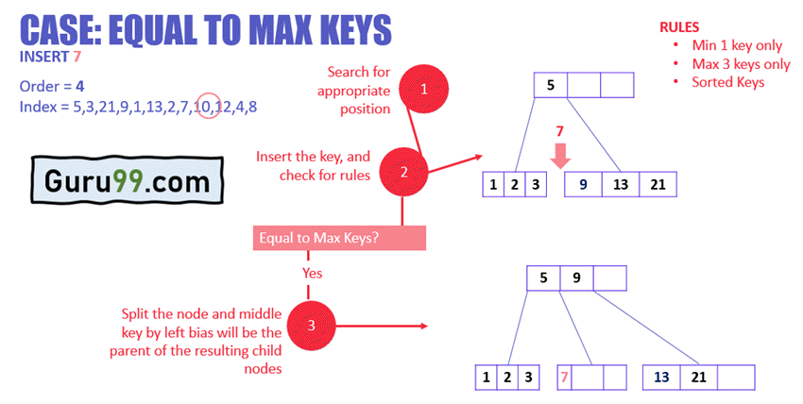
In the above example:
- The node has keys equal to max keys.
- The key is inserted to the target node, but it violates the rule of max keys.
- The target node is split, and the middle key by left bias is now the parent of the new child nodes.
- The new nodes are arranged in ascending order.
Similarly, based on the above rules and cases, the rest of the values can be inserted easily in the B Tree.
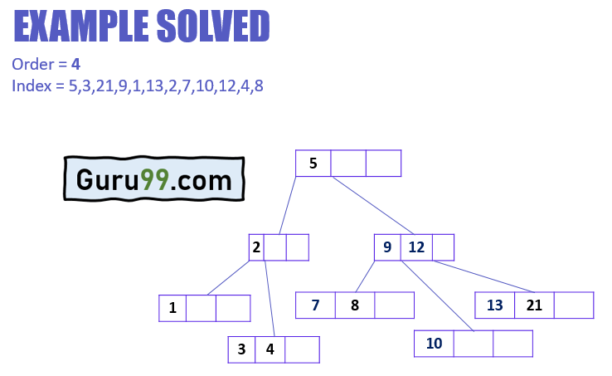

Delete Operation
The delete operation has more rules than insert and search operations.
The following algorithm applies:
- Run the search operation and find the target key in the nodes
- Three conditions applied based on the location of the target key, as explained in the following sections

If the target key is in the leaf node
- Target is in the leaf node, more than min keys.
- Deleting this will not violate the property of B Tree
- Target is in leaf node, it has min key nodes
- Deleting this will violate the property of B Tree
- Target node can borrow key from immediate left node, or immediate right node (sibling)
- The sibling will say yes if it has more than minimum number of keys
- The key will be borrowed from the parent node, the max value will be transferred to a parent, the max value of the parent node will be transferred to the target node, and remove the target value
- Target is in the leaf node, but no siblings have more than min number of keys
- Search for key
- Merge with siblings and the minimum of parent nodes
- Total keys will be now more than min
- The target key will be replaced with the minimum of a parent node

If the target key is in an internal node
- Either choose, in- order predecessor or in-order successor
- In case the of in-order predecessor, the maximum key from its left subtree will be selected
- In case of in-order successor, the minimum key from its right subtree will be selected
- If the target key’s in-order predecessor has more than the min keys, only then it can replace the target key with the max of the in-order predecessor
- If the target key’s in-order predecessor does not have more than min keys, look for in-order successor’s minimum key.
- If the target key’s in-order predecessor and successor both have less than min keys, then merge the predecessor and successor.

If the target key is in a root node
- Replace with the maximum element of the in-order predecessor subtree
- If, after deletion, the target has less than min keys, then the target node will borrow max value from its sibling via sibling’s parent.
- The max value of the parent will be taken by a target, but with the nodes of the max value of the sibling.
Now, let’s understand the delete operation with an example.
Now, let’s understand the delete operation with an example.

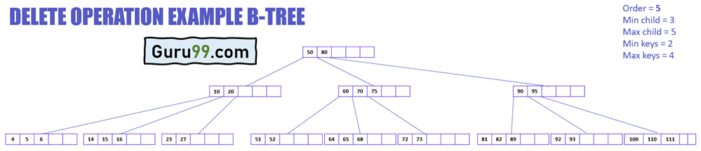

The above diagram displays different cases of delete operation in a B-Tree.
This B-Tree is of order 5, which means that the minimum number of child nodes any node can have is 3, and the maximum number of child nodes any node can have is 5.
Whereas the minimum and a maximum number of keys any node can have are 2 and 4, respectively.
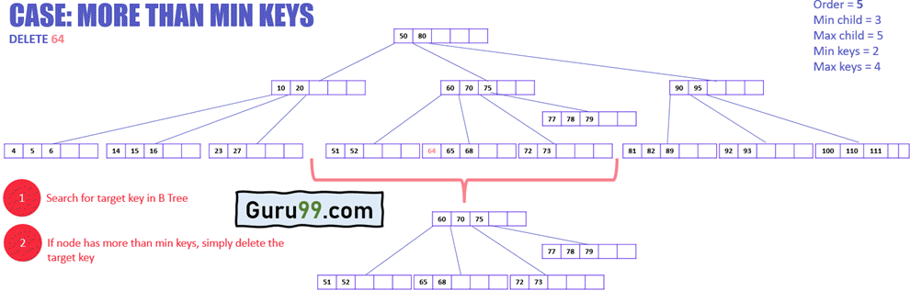

In the above example:
- The target node has the target key to delete
- The target node has keys more than minimum keys
- Simply delete the key

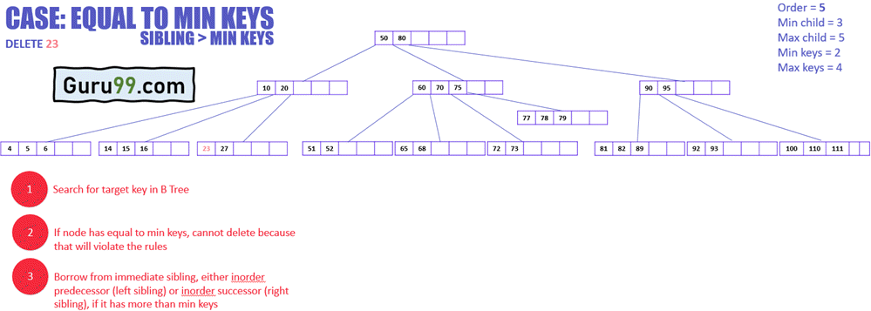

In the above example:
- The target node has keys equal to minimum keys, so cannot delete it directly as it will violate the conditions
Now, the following diagram explains how to delete this key:

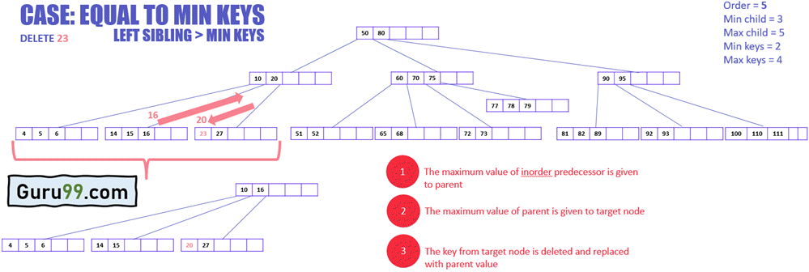

- The target node will borrow a key from immediate sibling, in this case, in-order predecessor (left sibling) because it does not have any in-order successor (right sibling)
- The maximum value of the inorder predecessor will be transferred to the parent, and the parent will transfer the maximum value to the target node (see the diagram below)
The following example illustrates how to delete a key that needs a value from its in-order successor.
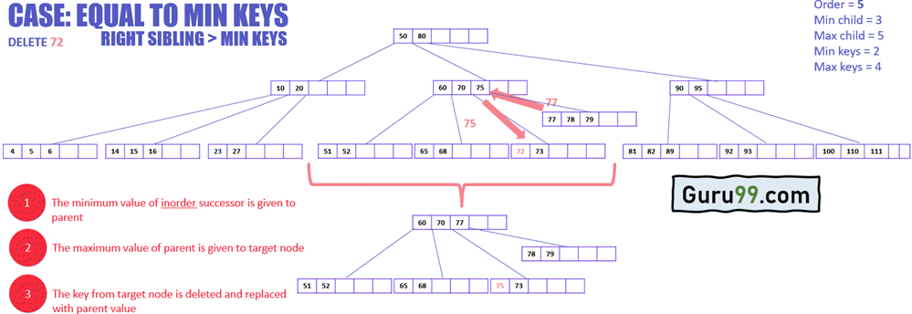

- The target node will borrow a key from immediate sibling, in this case, in-order successor (right sibling) because it’s in-order predecessor (left sibling) has keys equal to minimum keys.
- The minimum value of the in-order successor will be transferred to the parent, and the parent will transfer the maximum value to the target node.
In the example below, the target node does not have any sibling that can give its key to the target node. Therefore, merging is required.

Applications of B-Trees:

- It is used in large databases to access data stored on the disk
- Searching for data in a data set can be achieved in significantly less time using the B-Tree
- With the indexing feature, multilevel indexing can be achieved.
- Most of the servers also use the B-tree approach.
- B-Trees are used in CAD systems to organize and search geometric data.
- B-Trees are also used in other areas such as natural language processing, computer networks, and cryptography.

Advantages of B-Trees:

- B-Trees have a guaranteed time complexity of O(log n) for basic operations like insertion, deletion, and searching, which makes them suitable for large data sets and real-time applications.
- B-Trees are self-balancing.
- High-concurrency and high-throughput.
- Efficient storge utilization.

Disadvantages of B-Trees:

- B-Trees are based on disk-based data structures and can have a high disk usage.
- Not the best for all cases.
- Slow in comparison to other data structures.

