UNIT-2

Priority Queue:

Introduction to Priority Queue:

What is a Priority Queue?
A Priority Queue is a special type of queue where each element has a priority.
- In a normal queue → elements are served in FIFO order (First In, First Out).
- In a priority queue → the highest priority element is served first (not necessarily the first inserted one).

A priority queue is a type of queue that arranges elements based on their priority values.

Elements with higher priority values are typically retrieved before elements with lower priority values.

In a priority queue, each element has a priority value associated with it.
When you add an element to the queue, it is inserted in a position based on its priority value.
For example, if you add an element with a high priority value to a priority queue, it may be inserted near the front of the queue, while an element with a low priority value may be inserted near the back.
Example
Imagine you’re at a hospital:
- Normal queue → patients are seen in the order they arrive.
- Priority queue → patients with more serious conditions are treated first, regardless of when they arrived.

There are several ways to implement a priority queue, including using an array, linked list, heap, or binary search tree.
Each method has its own advantages and disadvantages, and the best choice will depend on the specific needs of your application.
Priority queues are often used in real-time systems, where the order in which elements are processed can have significant consequences.

They are also used in algorithms to improve their efficiencies, such as Dijkstra’s algorithm for finding the shortest path in a graph and the A* search algorithm for pathfinding.
Heap-implemented priority queues are used in popular algorithms like:
- Prim’s algorithm
- Dijkstra’s algorithm
- Heapsort algorithm

Properties of Priority Queue

So, a priority Queue is an extension of the queue with the following properties.

- Every item has a priority associated with it.
- An element with high priority is dequeued before an element with low priority.
- If two elements have the same priority, they are served according to their order in the queue.

In the below priority queue, an element with a maximum ASCII value will have the highest priority. The elements with higher priority are served first.

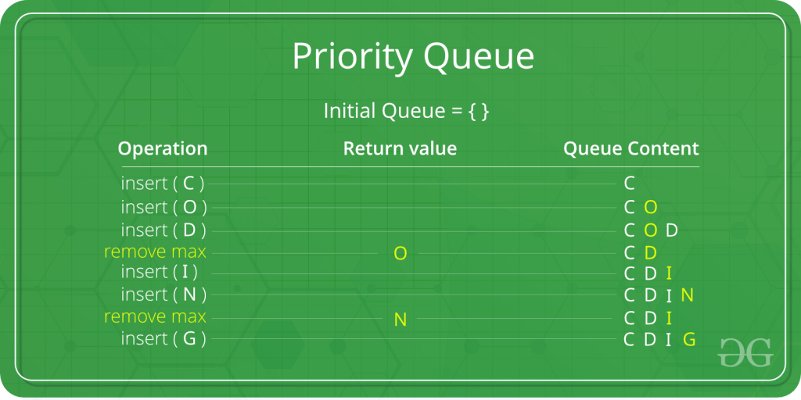

Real-Life Applications:

- CPU scheduling (higher-priority processes run first)
- Dijkstra’s algorithm (finding shortest paths)
- Huffman coding (data compression)
- Job scheduling in operating systems
- Emergency systems (hospital, fire stations, etc.)

Difference between Priority Queue and Normal Queue
Feature | Normal Queue | Priority Queue
Ordering Principle | First In First Out (FIFO) → the element inserted first is removed first. | Elements are served based on priority, not just arrival order.
Insertion | Always at the rear of the queue. | At position according to priority value.
Deletion (Removal) | Always from the front of the queue. | The highest priority element is removed first (not necessarily at the front).
Equal Priority Elements | Not applicable (order fixed by FIFO). | If two elements have the same priority → served in FIFO order.
Use Cases | Printing tasks, ticket booking line, customer service queues. | CPU scheduling, Dijkstra’s shortest path, job scheduling, hospital emergency room.
Implementation | Simple arrays or linked lists. | Often implemented using heaps for efficiency.

Implementation of Priority Queue
Priority queue can be implemented using an array, a linked list, a heap data structure, or a binary search tree.
Among these data structures, heap data structure provides an efficient implementation of priority queues.

Hence, we will be using the heap data structure to implement the priority queue.

A max-heap and min-heap is implemented in the following operations.

Heap Data Structure and Priority Queues

The Heap is one of the most efficient ways to implement a Priority Queue.
1) Why Heap is Efficient?
- A binary heap is a complete binary tree stored in an array.
- It ensures fast insertion and fast extraction of the highest/lowest priority element.
- Both min-heaps and max-heaps satisfy the heap property:
  - Min-Heap: parent ≤ children → root is the smallest.
  - Max-Heap: parent ≥ children → root is the largest.
👉 Since the highest-priority element is always at the root, it can be accessed in O(1) time.

Relationship between Array Indexes and Tree Elements
A complete binary tree has an interesting property that we can use to find the children and parents of any node.
If the index of any element in the array is i, the element in the index 2i+1 will become the left child and element in 2i+2 index will become the right child.

Also, the parent of any element at index i is given by the lower bound of (i-1)/2.
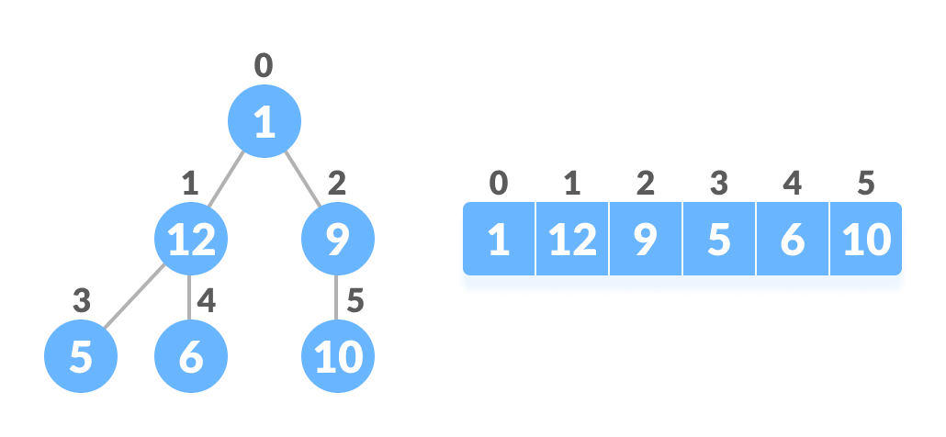
Relationship between array and heap indices
Let's test it out,
Left child of 1 (index 0)
= element in (2*0+1) index
= element in 1 index
= 12

Right child of 1
= element in (2*0+2) index
= element in 2 index
= 9

Similarly,
Left child of 12 (index 1)
= element in (2*1+1) index
= element in 3 index
= 5

Right child of 12
= element in (2*1+2) index
= element in 4 index
= 6
Let us also confirm that the rules hold for finding parent of any node
Parent of 9 (position 2)
= (2-1)/2
= ½
= 0.5
~ 0 index
= 1

Parent of 12 (position 1)
= (1-1)/2
= 0 index
= 1
Understanding this mapping of array indexes to tree positions is critical to understanding how the Heap Data Structure works and how it is used to implement Heap Sort.

What is Heap Data Structure?
Heap is a special tree-based data structure.
A binary tree is said to follow a heap data structure if
- it is a complete binary tree
- All nodes in the tree follow the property that they are greater than their children i.e. the largest element is at the root and both its children and smaller than the root and so on.
- Such a heap is called a max-heap.
- If instead, all nodes are smaller than their children, it is called a min-heap.

How to build a max Heap
Elements in a max heap follow the max heap property. This means that the key at the parent node is always greater than the key at both child nodes. To build a max heap, you:
- Create a new node at the beginning (root) of the heap.
- Assign it a value.
- Compare the value of the child node with the parent node.
- Swap nodes if the value of the parent is less than that of either child (to the left or right).
- Repeat until the largest element is at the root parent nodes (then you can say that the heap property holds).

How to build a min Heap
Intuitively, we can say that elements in a min heap follow the min heap property, as this is opposite to max heaps. The key at the parent node is always less than the key at both child nodes. To build a min heap we:
- Create a new child node at the end of the heap (last level).
- Add the new key to that node (append it to the array).
- Move the child up until you reach the root node and the heap property is satisfied.

The following example diagram shows Max-Heap and Min-Heap.
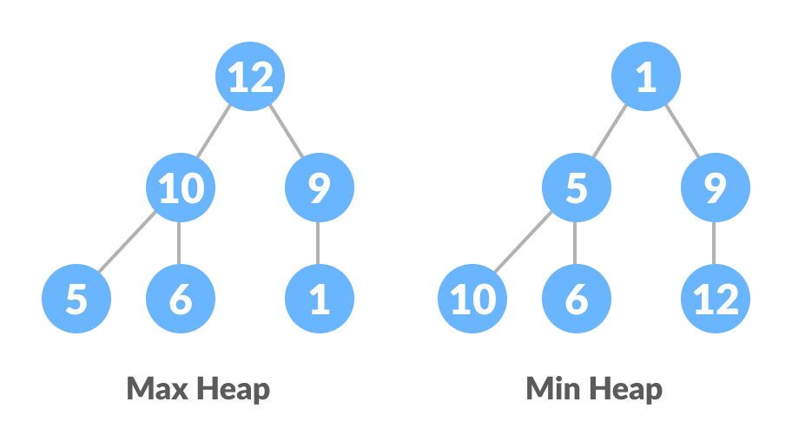
Max Heap and Min Heap

How to "heapify" a tree
Starting from a complete binary tree, we can modify it to become a Max-Heap by running a function called heapify on all the non-leaf elements of the heap.
Since heapify uses recursion, it can be difficult to grasp.
So let's first think about how you would heapify a tree with just three elements.
heapify(array)
Root = array[0]
Largest = largest( array[0] , array [2*0 + 1], array[2*0+2])
if(Root != Largest)
Swap(Root, Largest)

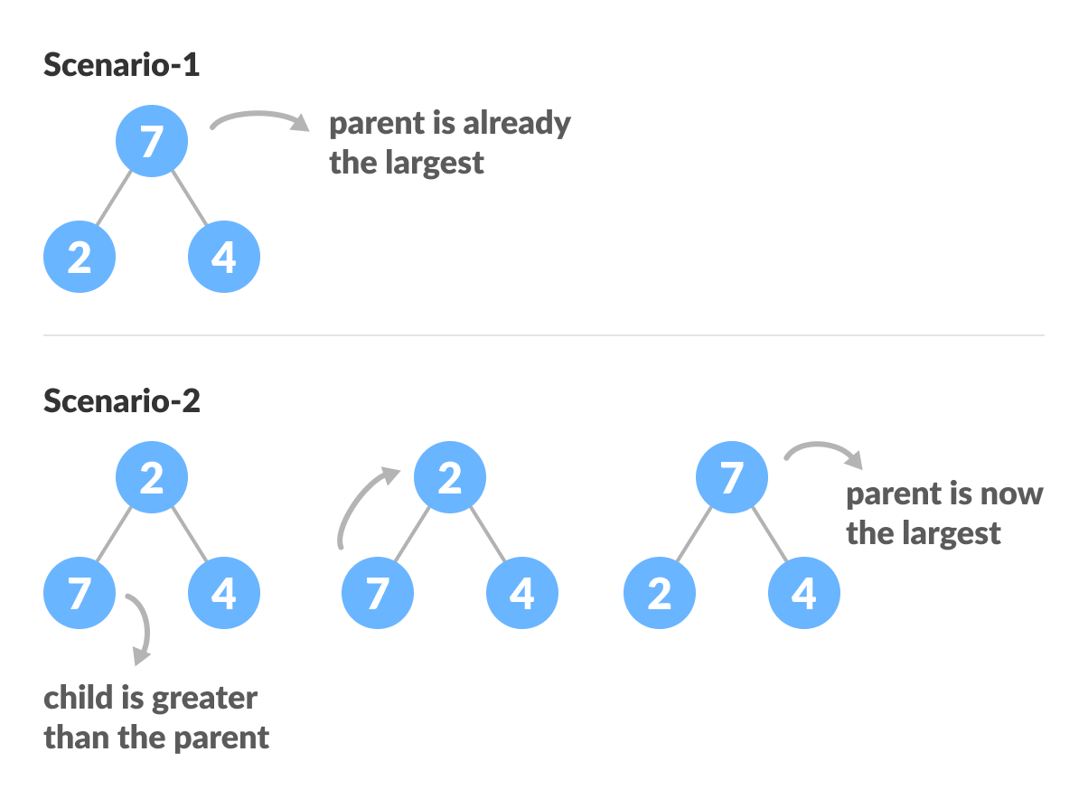Heapify base cases
The example above shows two scenarios - one in which the root is the largest element and we don't need to do anything. And another in which the root had a larger element as a child and we needed to swap to maintain max-heap property.
If you're worked with recursive algorithms before, you've probably identified that this must be the base case.

Now let's think of another scenario in which there is more than one level.
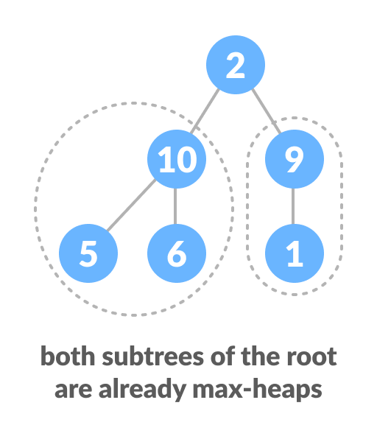
How to heapify root element when its subtrees are already max heaps
The top element isn't a max-heap but all the sub-trees are max-heaps.
To maintain the max-heap property for the entire tree, we will have to keep pushing 2 downwards until it reaches its correct position.
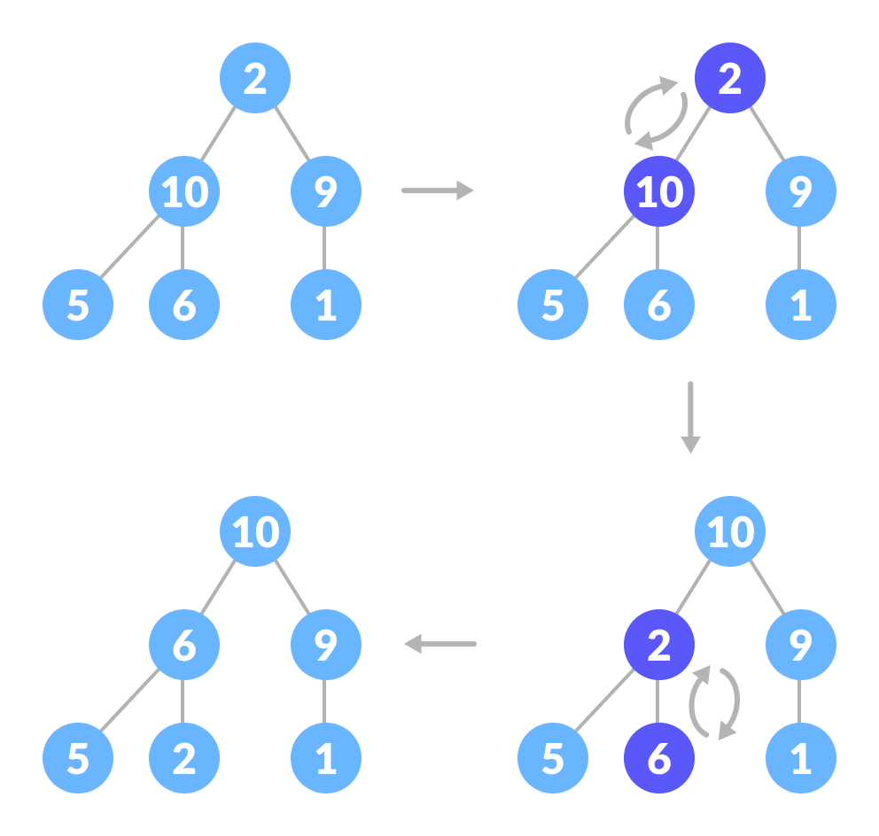
How to heapify root element when its subtrees are max-heaps
Thus, to maintain the max-heap property in a tree where both sub-trees are max-heaps, we need to run heapify on the root element repeatedly until it is larger than its children or it becomes a leaf node.
We can combine both these conditions in one heapify function as
void heapify(int arr[], int n, int i) {
// Find largest among root, left child and right child
int largest = i;
int left = 2 * i + 1;
int right = 2 * i + 2;
if (left < n && arr[left] > arr[largest])
largest = left;
if (right < n && arr[right] > arr[largest])
largest = right;
// Swap and continue heapifying if root is not largest
if (largest != i) {
swap(&arr[i], &arr[largest]);
heapify(arr, n, largest);
}
}

This function works for both the base case and for a tree of any size. We can thus move the root element to the correct position to maintain the max-heap status for any tree size as long as the sub-trees are max-heaps.

Build max-heap
To build a max-heap from any tree, we can thus start heapifying each sub-tree from the bottom up and end up with a max-heap after the function is applied to all the elements including the root element.
In the case of a complete tree, the first index of a non-leaf node is given by n/2 - 1.
All other nodes after that are leaf-nodes and thus don't need to be heapified.
So, we can build a maximum heap as
// Build heap (rearrange array)
for (int i = n / 2 - 1; i >= 0; i--)
heapify(arr, n, i);
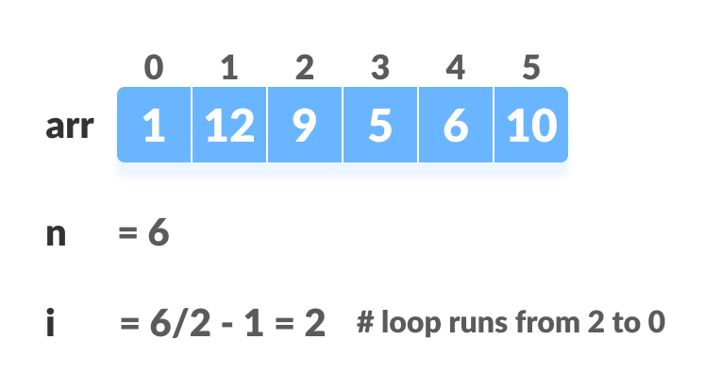
Create array and calculate i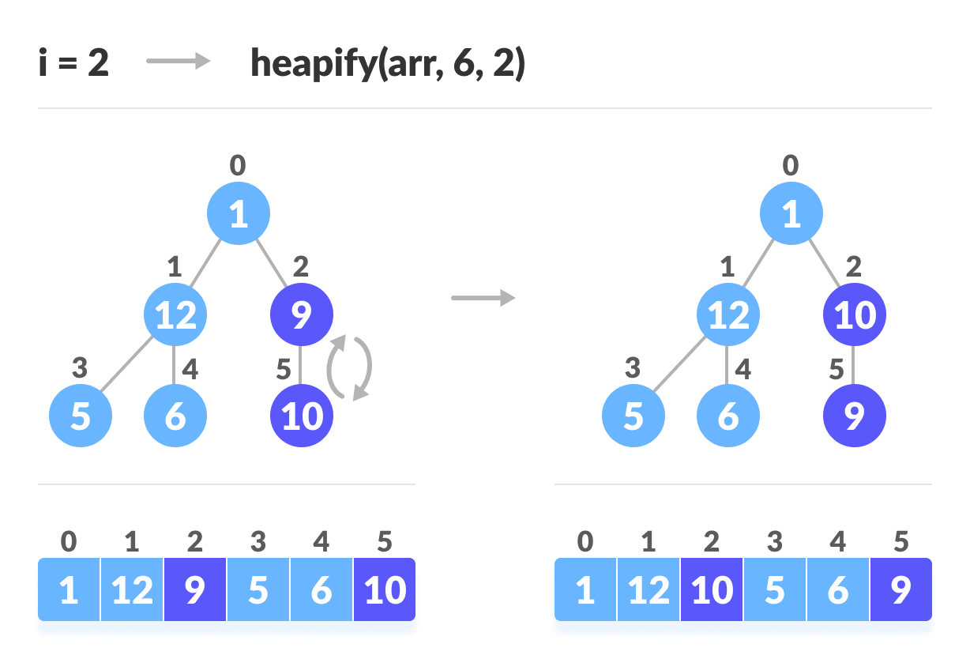
Steps to build max heap for heap sort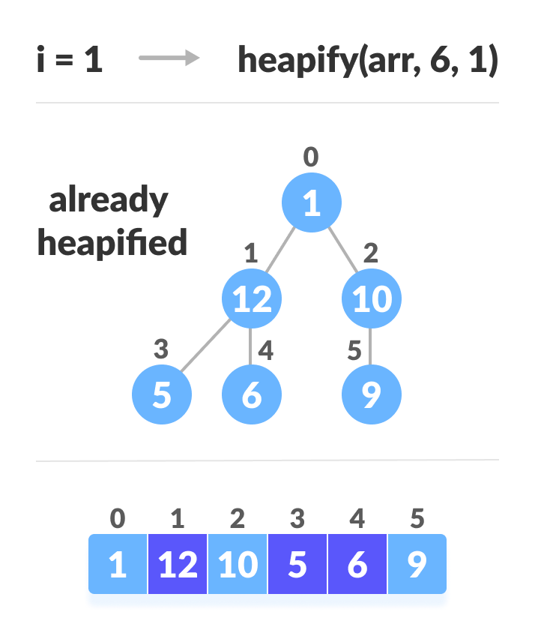 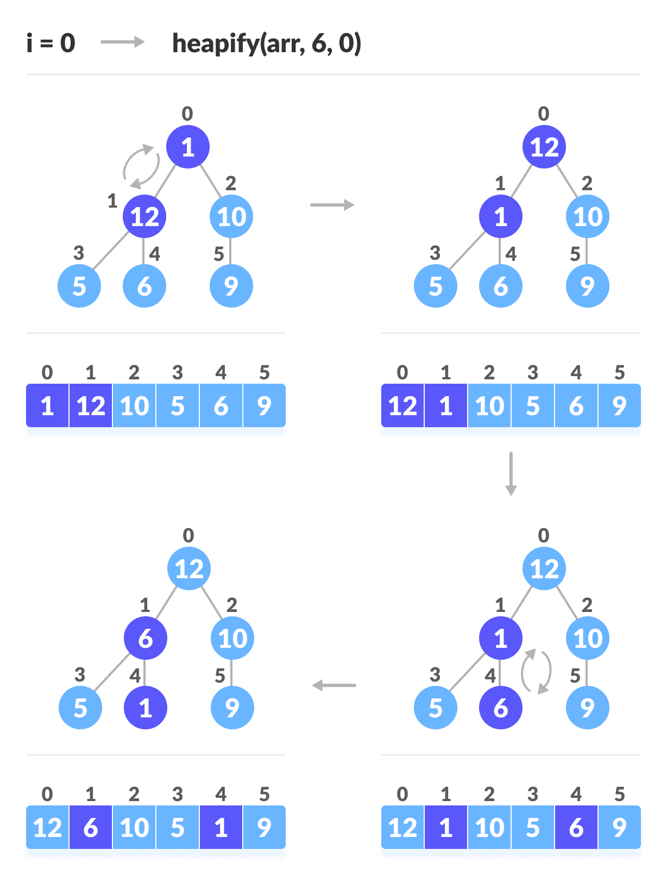 Steps to build max heap for heap sort
As shown in the above diagram, we start by heapifying the lowest smallest trees and gradually move up until we reach the root element.

Working of Heap Sort
- Since the tree satisfies Max-Heap property, then the largest item is stored at the root node.
- Swap: Remove the root element and put at the end of the array (nth position) Put the last item of the tree (heap) at the vacant place.
- Remove: Reduce the size of the heap by 1.
- Heapify: Heapify the root element again so that we have the highest element at root.
- The process is repeated until all the items of the list are sorted.
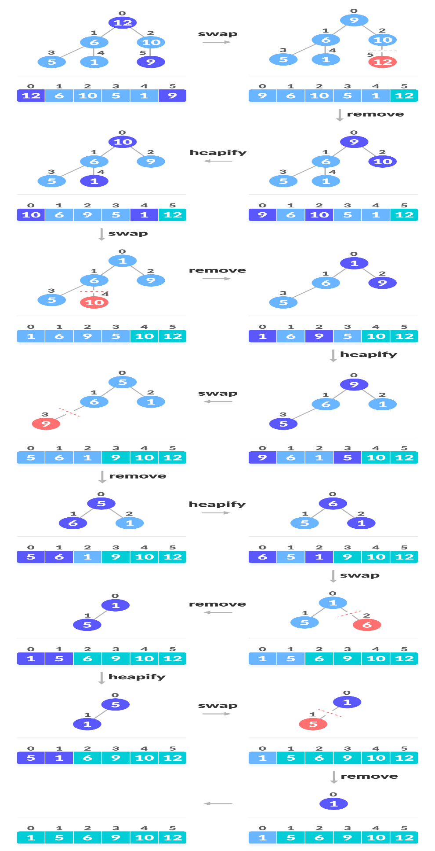
Swap, Remove, and Heapify
The code below shows the operation.
// Heap sort
for (int i = n - 1; i >= 0; i--) {
swap(&arr[0], &arr[i]);

// Heapify root element to get highest element at root again
heapify(arr, i, 0);
}

Heap Sort Complexity
Time Complexity
Best | O(nlog n)
Worst | O(nlog n)
Average | O(nlog n)
Space Complexity | O(1)
Stability | No

Heap Sort Applications
Systems concerned with security and embedded systems such as Linux Kernel use Heap Sort because of the O(n log n) upper bound on Heapsort's running time and constant O(1) upper bound on its auxiliary storage.
Although Heap Sort has O(n log n) time complexity even for the worst case, it doesn't have more applications ( compared to other sorting algorithms like Quick Sort, Merge Sort ).
However, its underlying data structure, heap, can be efficiently used if we want to extract the smallest (or largest) from the list of items without the overhead of keeping the remaining items in the sorted order.
For e.g Priority Queues.

Priority Queue Operations
Basic operations of a priority queue are inserting, removing, and peeking elements.
Before studying the priority queue, please refer to the heap data structure for a better understanding of binary heap as it is used to implement the priority queue.

1. Inserting an Element into the Priority Queue
Inserting an element into a priority queue (max-heap) is done by the following steps.
- Insert the new element at the end of the tree.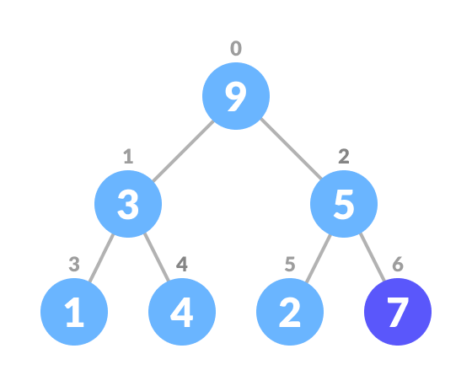Insert an element at the end of the queue
- Heapify the tree.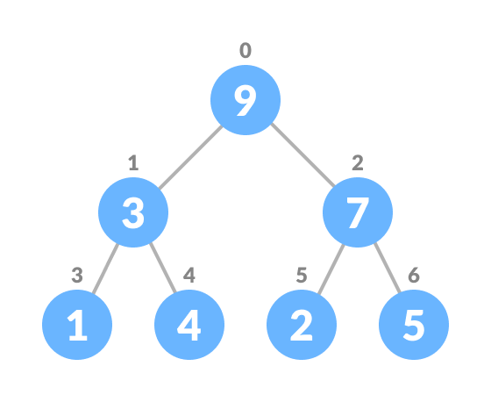Heapify after insertion
Algorithm for insertion of an element into priority queue (max-heap)
If there is no node,
create a newNode.
else (a node is already present)
insert the newNode at the end (last node from left to right.)

heapify the array
For Min Heap, the above algorithm is modified so that parentNode is always smaller than newNode.

2. Deleting an Element from the Priority Queue
Deleting an element from a priority queue (max-heap) is done as follows:
- Select the element to be deleted.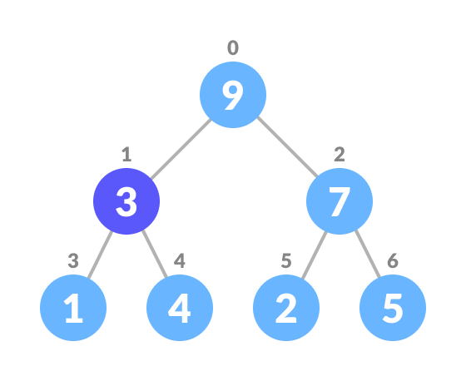
- Swap it with the last element.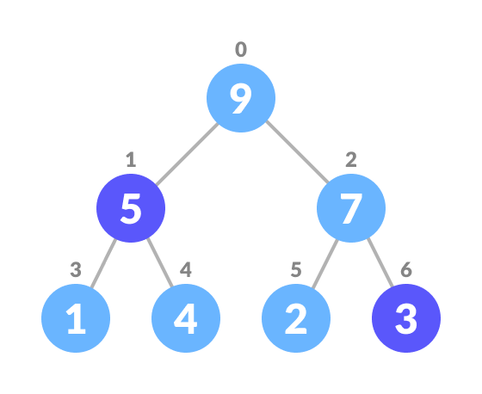 Swap with the last leaf node element
- Remove the last element.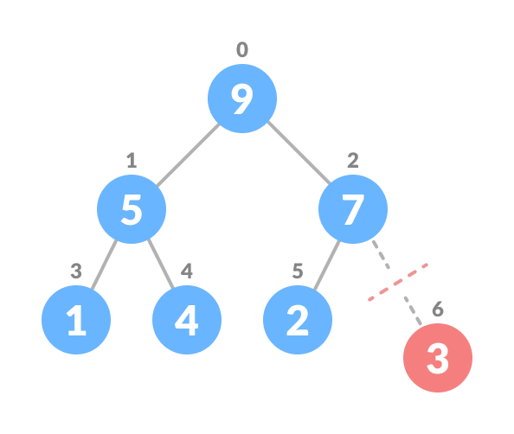 Remove the last element leaf
- Heapify the tree.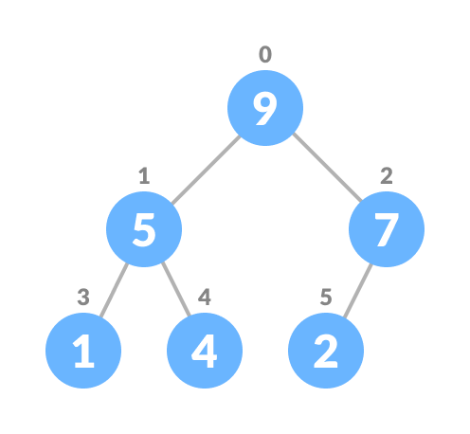 Heapify the priority queue
Algorithm for deletion of an element in the priority queue (max-heap)
If nodeToBeDeleted is the leafNode
remove the node
Else swap nodeToBeDeleted with the lastLeafNode
remove noteToBeDeleted

heapify the array
For Min Heap, the above algorithm is modified so that the both childNodes are smaller than currentNode.

3. Peeking from the Priority Queue (Find max/min)
Peek operation returns the maximum element from Max Heap or minimum element from Min Heap without deleting the node.
For both Max heap and Min Heap
return rootNode

Priority queues applications:

Data compression: Huffman coding uses a priority queue to maintain the codes for data contents.

Algorithms: Priority queues are used in Dijkstra's shortest path algorithm, Prim's algorithm, and heap sort algorithm.

Operating systems: Priority queues are used to select the next process to run.

Load balancing: Priority queues are used to distribute user requests to different available servers.

Bandwidth management: Priority queues are used to prioritize important data packets.

Traffic management: Priority queues can be used to prioritize vehicles based on their emergency status, VIP status, or regular status.
Best-first search: Priority queues are used to efficiently calculate which node to explore next.

Graphs

What is a Graph in Data Structure?
A graph is a non-linear data structure that consists of vertices and edges, where vertices contain the information or data, and the edges work as a link between pair of vertices.
It is used to solve real word problems like finding the best route to the destination location and the route for telecommunications and social networks.
Users are considered a node in the Graph, and the wires are the edges connecting the users.
If edges are represented as E and vertices are represented as V, then the graph G can be written as the set of vertices and edges, such as G (V, E)

Example of Graph in Data Structure
Here’s a simple example of graph data structure:
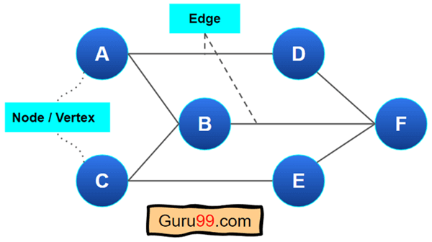
It’s a simple undirected graph (one kind of Graph). Here the set of vertex is: {A, B, C,D,E,F}.
Two vertices create an edge. For example, A and B are linked with an edge. However, A and F are not linked with any edges.

Components of a Graph:
- Vertices: Vertices are the fundamental units of the graph. Sometimes, vertices are also known as vertex or nodes. Every node/vertex can be labeled or unlabeled.

- Edges: Edges are drawn or used to connect two nodes of the graph. It can be ordered pair of nodes in a directed graph. Edges can connect any two nodes in any possible way. There are no rules. Sometimes, edges are also known as arcs. Every edge can be labelled/unlabelled.

Operations on Graphs:

Basic Operations:
- Insertion of Nodes/Edges in the graph – Insert a node into the graph.
- Deletion of Nodes/Edges in the graph – Delete a node from the graph.
- Searching on Graphs – Search an entity in the graph.
- Traversal of Graphs – Traversing all the nodes in the graph.

Applications of Graph:

Following are the real-life applications:

- If we recall all the previous data structures that we have studied like array, linked list, tree, etc. All these had some restrictions on structure (mostly linear and tree hierarchical which means no loops). Graph allows random connections between nodes which is useful in many real world problems where do have restrictions of previous data structures.

- Used heavily in social networks. Everyone on the network is a vertex (or node) of the graph and if connected, then there is an edge. Now imagine all the features that you see, mutual friends, people that follow you, etc can seen as graph problems.

- Neural Networks: Vertices represent neurons and edges represent the synapses between them. Neural networks are used to understand how our brain works and how connections change when we learn. The human brain has about 10^11 neurons and close to 10^15 synapses.

- Compilers: Graph Data Structure is used extensively in compilers. They can be used for type inference, for so-called data flow analysis, register allocation, and many other purposes. They are also used in specialized compilers, such as query optimization in database languages.

- Robot planning: Vertices represent states the robot can be in and the edges the possible transitions between the states. Such graph plans are used, for example, in planning paths for autonomous vehicles.

- In GPS. The problems like finding the closest route, closest petrol pumps, etc are all soled using graph problems.

- For optimizing the cost of connecting all locations of a network. For example, minimizing wire length in a wired network to make sure all devices are connected is a standard Graph problem called Minimum Spanning Tree.

- Can be used to represent the topology of computer networks, such as the connections between routers and switches.

- Graphs are used to represent the connections between different places in a transportation network, such as roads and airports.

- Dependencies in a software project (or any other type of project) can be seen as graph and generating a sequence to solve all tasks before dependents is a standard graph topological sorting algorithm.

Advantages of Graph:

- Representing complex data: Graphs are effective tools for representing complex data, especially when the relationships between the data points are not straightforward. They can help to uncover patterns, trends, and insights that may be difficult to see using other methods.
- Efficient data processing: Graphs can be processed efficiently using graph algorithms, which are specifically designed to work with graph data structures. This makes it possible to perform complex operations on large datasets quickly and effectively.
- Network analysis: Graphs are commonly used in network analysis to study relationships between individuals or organizations, as well as to identify important nodes and edges in a network. This is useful in a variety of fields, including social sciences, business, and marketing.
- Pathfinding: Graphs can be used to find the shortest path between two points, which is a common problem in computer science, logistics, and transportation planning.
- Visualization: Graphs are highly visual, making it easy to communicate complex data and relationships in a clear and concise way. This makes them useful for presentations, reports, and data analysis.
- Machine learning: Graphs can be used in machine learning to model complex relationships between variables, such as in recommendation systems or fraud detection.

Disadvantages of Graph:

- Limited representation: Graphs can only represent relationships between objects, and not their properties or attributes. This means that in order to fully understand the data, it may be necessary to supplement the graph with additional information.
- Difficulty in interpretation: Graphs can be difficult to interpret, especially if they are large or complex. This can make it challenging to extract meaningful insights from the data, and may require advanced analytical techniques or domain expertise.
- Scalability issues: As the number of nodes and edges in a graph increases, the processing time and memory required to analyze it also increases. This can make it difficult to work with large or complex graphs.
- Data quality issues: Graphs are only as good as the data they are based on, and if the data is incomplete, inconsistent, or inaccurate, the graph may not accurately reflect the relationships between objects.
- Lack of standardization: There are many different types of graphs, and each has its own strengths and weaknesses. This can make it difficult to compare graphs from different sources, or to choose the best type of graph for a given analysis.
- Privacy concerns: Graphs can reveal sensitive information about individuals or organizations, which can raise privacy concerns, especially in social network analysis or marketing.

Basic Graph Terminology:

1. Graph
A Graph G is a non-empty set of vertices (or nodes) V and a set of edges E, where each edge connects a pair of vertices. Formally, a graph can be represented as G= (V, E). Graphs can be classified based on various properties, such as directedness of edges and connectivity.

2. Vertex (Node)
A Vertex, often referred to as a Node, is a fundamental unit of a graph. It represents an entity within the graph. In applications like social networks, vertices can represent individuals, while in road networks, they can represent intersections or locations.

3. Edge
An Edge is a connection between two vertices in a graph. It can be either directed or undirected. In a directed graph, edges have a specific direction, indicating a one-way connection between vertices. In contrast, undirected graphs have edges that do not have a direction and represent bidirectional connections.

4. Degree of a Vertex
The Degree of a Vertex in a graph is the number of edges incident to that vertex. In a directed graph, the degree is further categorized into the in-degree (number of incoming edges) and out-degree (number of outgoing edges) of the vertex.
Example:
Consider this simple graph:
A ----- B
\
\
C
- Edges: (A,B), (A,C)
- Vertex A has 2 edges connected to it → so degree(A) = 2
- Vertex B has 1 edge connected to it → so degree(B) = 1
- Vertex C has 1 edge connected to it → so degree(C) = 1
Here, we say:
- Edge (A,B) is incident on vertices A and B.
- Edge (A,C) is incident on vertices A and C.

5. Path
A Path in a graph is a sequence of vertices where each adjacent pair is connected by an edge. Paths can be of varying lengths and may or may not visit the same vertex more than once. The shortest path between two vertices is of particular interest in algorithms such as Dijkstra’s algorithm for finding the shortest path in weighted graphs.

6. Cycle
A Cycle in a graph is a path that starts and ends at the same vertex, with no repetitions of vertices (except the starting and ending vertex, which are the same). Cycles are essential in understanding the connectivity and structure of a graph and play a significant role in cycle detection algorithms.

Types of Graphs:

  - Undirected Graph
A graph with only undirected edges is said to be undirected graph.
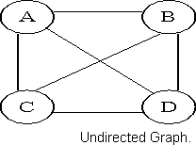

Directed Graph

A graph with only directed edges is said to be directed graph.
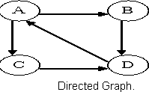

Complete Graph

A graph in which any V node is adjacent to all other nodes present in the graph is known as a complete graph. An undirected graph contains the edges that are equal to edges = n(n-1)/2 where n is the number of vertices present in the graph.

The following figure shows a complete graph.
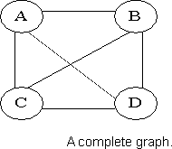

Regular Graph

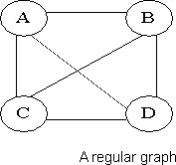
Regular graph is the graph in which nodes are adjacent to each other, i.e., each node is accessible from any other node.

Cycle Graph

A graph having cycle is called cycle graph. In this case the first and last nodes are the same. A closed simple path is a cycle.

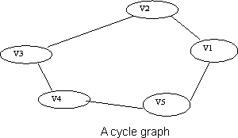
Cycle Graph (Cₙ)
A Cycle Graph is a special type of graph in graph theory.
🔹 Definition:
A cycle graph is a connected graph in which all the vertices are connected in a closed chain (loop).
- Each vertex has degree 2.
- It contains exactly n vertices and n edges.
- It is denoted as Cₙ (where n ≥ 3).

Examples
- C₃ → Triangle (3 vertices, 3 edges)
- C₄ → Square (4 vertices, 4 edges)
- C₅ → Pentagon (5 vertices, 5 edges)

Diagram
C3 (Triangle): C4 (Square): C5 (Pentagon):

A A ----- B A ----- B
/ \ | | | |
C---B D ----- C E ----- C

Properties of Cycle Graph
- Vertices = n
- Edges = n
- Degree of each vertex = 2
- Connected graph (all vertices reachable).
- Eulerian (because all vertices have even degree).
- Bipartite only if n is even (C₄, C₆, …).

Acyclic Graph

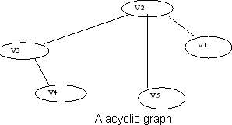
A graph without cycle is called acyclic graphs.

Acyclic Graph
👉 An acyclic graph is a graph that does not contain any cycle.
That means there is no closed path where you can start at a vertex, follow edges, and return back to the same vertex.

Types of Acyclic Graphs
- Undirected Acyclic Graph
  - If the graph is undirected and has no cycles, then it is basically a forest (a collection of trees).
  - Example: A Tree is a connected undirected acyclic graph.
- Directed Acyclic Graph (DAG)
  - A directed graph with no cycles.
  - Widely used in computer science.
  - Example: Scheduling problems, compiler optimization, data flow, Git version control.

Examples
- Undirected Acyclic Graph (Tree)
A
/ \
B C
/ \
D E
No way to form a loop → acyclic.

- Directed Acyclic Graph (DAG)
A → B → C
↓
D → E
- No directed cycle → acyclic.

Key Properties
- No cycles present.
- In a tree (a special acyclic graph):
  - If there are n vertices → there are exactly n-1 edges.
- In a DAG:
  - Useful for Topological Sorting.
  - Used in scheduling, compiler tasks, dependency resolution.

Weighted Graph

A graph is said to be weighted if there are some non negative value assigned to each edges of the graph. The value is equal to the length between two vertices. Weighted graph is also called a network.
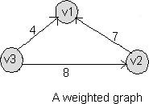

Outgoing Edge

A directed edge is said to be outgoing edge on its origin vertex.

Incoming Edge

A directed edge is said to be incoming edge on its destination vertex.

Degree

Total number of edges connected to a vertex is said to be degree of that vertex.

Indegree

Total number of incoming edges connected to a vertex is said to be indegree of that vertex.

Outdegree

Total number of outgoing edges connected to a vertex is said to be outdegree of that vertex.

Parallel edges or Multiple edges

If there are two undirected edges to have the same end vertices, and for two directed edges to have the same origin and the same destination. Such edges are called parallel edges or multiple edges.

Self-loop

An edge (undirected or directed) is a self-loop if its two endpoints coincide.

Simple Graph

A graph is said to be simple if there are no parallel and self-loop edges.

Adjacent nodes

When there is an edge from one node to another then these nodes are called adjacent nodes.

Incidence

In an undirected graph the edge between v1 and v2 is incident on node v1 and v2.

Walk

A walk is a sequence of vertices and edges in a graph, where each edge connects the vertex before it to the vertex after it.

Formally:
A walk is written as

v₀ – e₁ – v₁ – e₂ – v₂ – … – ek – vk

where each edge ei connects vi-1 and vi.

✅ Key Points

A walk can repeat vertices.

A walk can repeat edges.

Length of a walk = number of edges in it.

Types of Walks

Open Walk

Starting vertex ≠ ending vertex.

Example: A → B → C.

Closed Walk

Starting vertex = ending vertex.

Example: A → B → C → A.

Trail

A walk without repeating edges (but vertices may repeat).

Path (Simple Path)

A walk with no repeating vertices (except maybe start = end in case of cycle).

Cycle

A closed walk with no repeated vertices except the first and last.

Example Graph

A ---- B

\ /

\ /

C

Walk 1: A → B → C → A (Closed Walk, length = 3)

Walk 2: A → C → B (Open Walk, length = 2)

Walk 3: A → B → C → B → A (Walk with repeated vertices and edges).

✅ In short:

Walk = any sequence of connected vertices/edges.

Special cases: Trail, Path, Cycle.

Closed walk

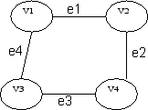
A walk which is to begin and end at the same vertex is called close walk. Otherwise it is an open walk.

If e1,e2,e3,and e4 be the edges of pair of vertices (v1,v2),(v2,v4),(v4,v3) and (v3,v1) respectively ,then v1 e1 v2 e2 v4 e3 v3 e4 v1 be its closed walk or circuit.

Path

A open walk in which no vertex appears more than once is called a path.
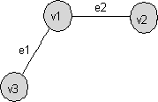

If e1 and e2 be the two edges between the pair of vertices (v1,v3) and (v1,v2) respectively, then v3 e1 v1 e2 v2 be its path.

Length of a path
The number of edges in a path is called the length of that path. In the following, the length of the path is 3.

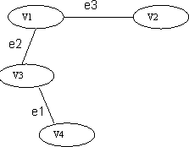

An open walk Graph

Circuit
A closed walk in which no vertex (except the initial and the final vertex) appears more than once is called a circuit.

A circuit having three vertices and three edges.

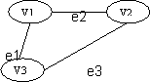

Sub Graph
A graph S is said to be a sub graph of a graph G if all the vertices and all the edges of S are in G, and each edge of S has the same end vertices in S as in G.
A subgraph of G is a graph G’ such that V(G’) ⊆ V(G) and E(G’) ⊆ E(G)

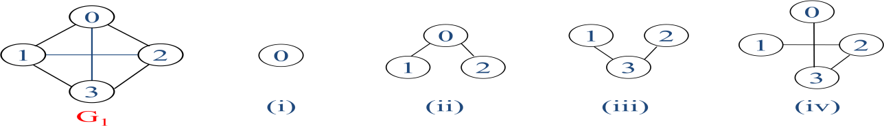

Connected Graph

A graph G is said to be connected if there is at least one path between every pair of vertices in G. Otherwise, G is disconnected.
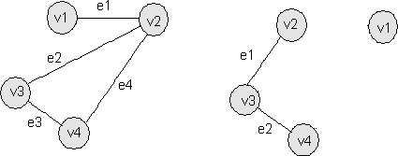
A connected graph G A disconnected graph G

This graph is disconnected because the vertex v1 is not connected with the other vertices of the graph.

Degree
In an undirected graph, the number of edges connected to a node is called the degree of that node or the degree of a node is the number of edges incident on it.
In the above graph, degree of vertex v1 is 1, degree of vertex v2 is 3, degree of v3 and v4 is 2 in a connected graph.

Indegree
The indegree of a node is the number of edges connecting to that node or in other words edges incident to it.
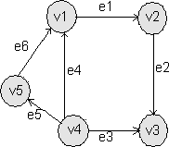

In the above graph, the indegree of vertices v1, v3 is 2, indegree of vertices v2, v5 is 1 and indegree of v4 is zero.

Outdegree
The outdegree of a node (or vertex) is the number of edges going outside from that node or in other words the outdegree of vertices v1, v2, v5 is 1, outdegree of vertices v4 is 2 and outdegree of vertices v3 is 0.

Representations of Graph:

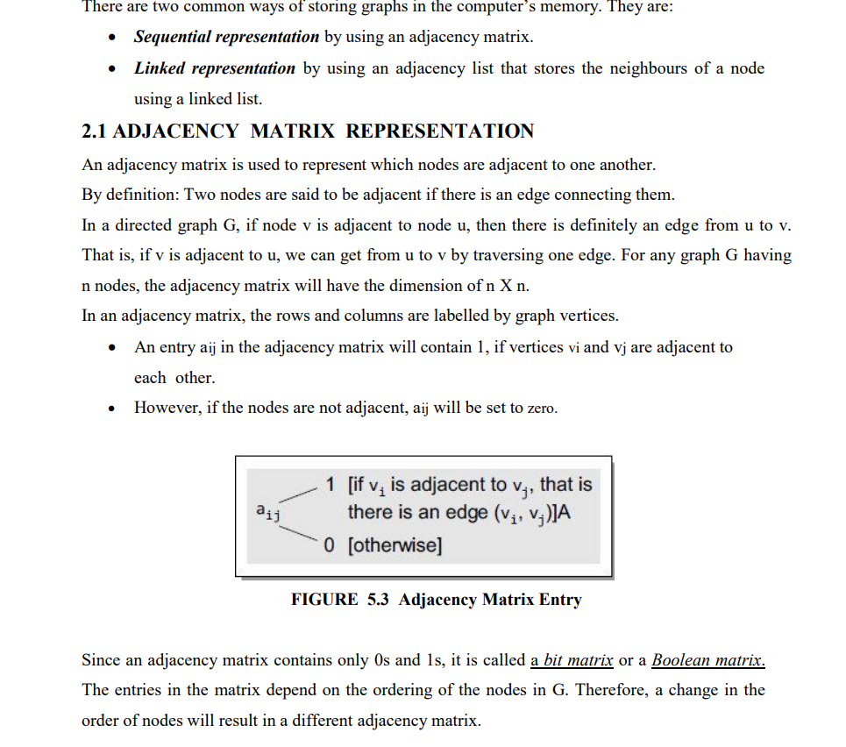
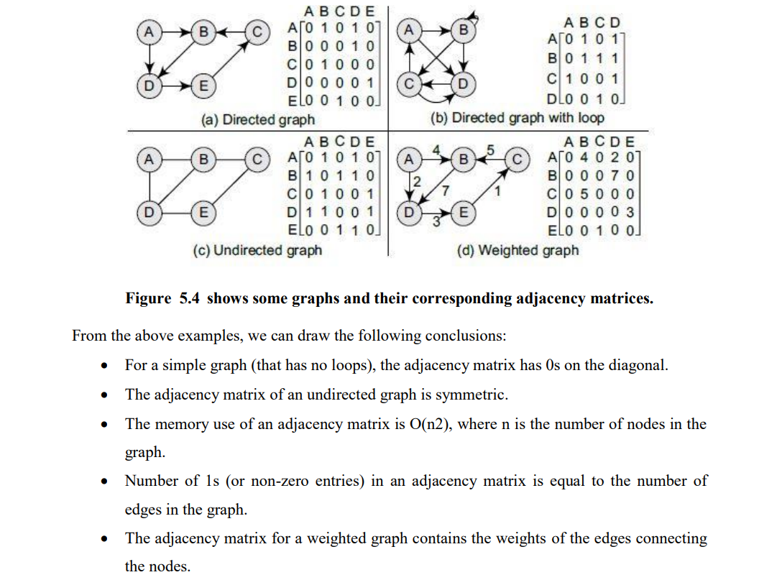

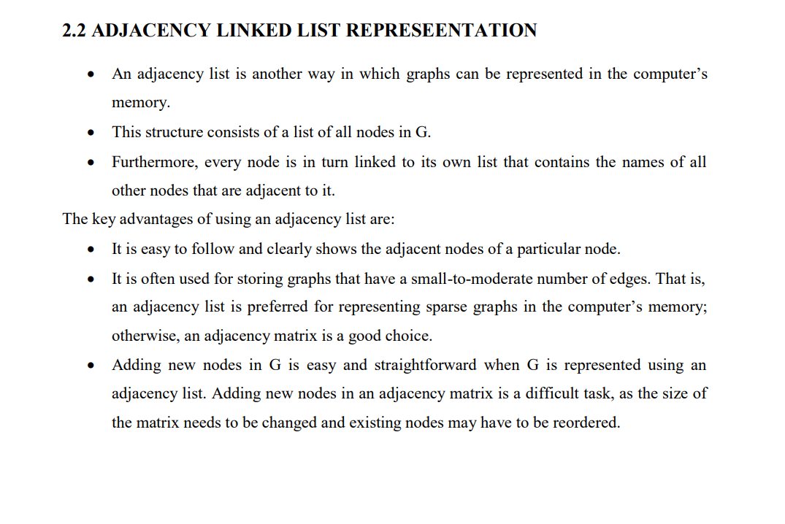

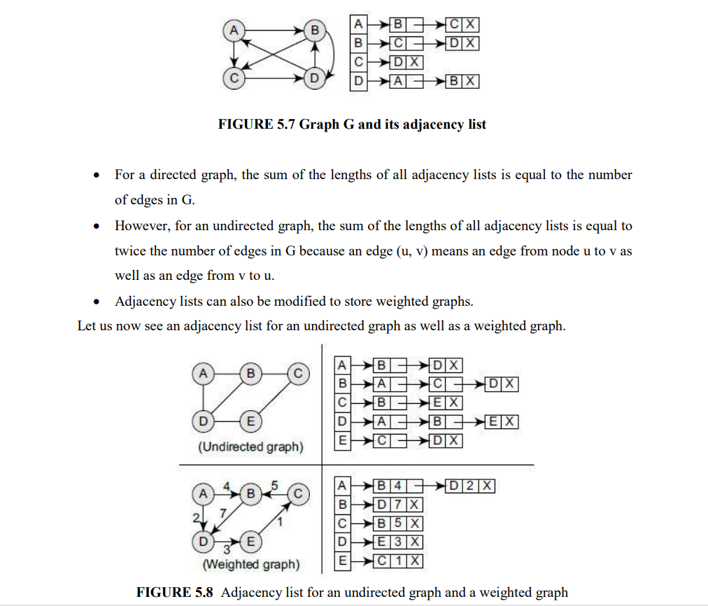
Graph Traversal
A graph, a non-linear data structure represented by vertices (nodes) and edges, is defined as an ordered set (V, E) where V represents the set of vertices and E represents the set of edges connecting these vertices.
Every pair of vertices is connected by one edge. Graph traversal, a fundamental operation in graph theory and computer science, involves systematically visiting all nodes in a graph.
This graph traversal process is crucial in various applications such as network routing, web crawling, and social network analysis.
Methods of Graph Traversal in Data Structure
In simple words, traversal means the process of visiting every node in the graph.
There are two standard methods of graph traversal in data structure
1. Breadth-First Search
2. Depth First Search
1.BFS Graph Traversal
Breadth-First Search (BFS) is a graph traversal algorithm, where we start from a selected(source) node and traverse the graph level by level, by exploring the neighbour nodes at each level.
Algorithm
Breadth-First Search (BFS) is a crucial algorithm for graph traversal, prioritizing the exploration of a node's immediate neighbours before advancing to their next-level neighbours.
This strategy enables efficient searching for the shortest paths in unweighted graphs and ensures all nodes are visited systematically, starting from the closest.
Employing a FIFO queue, BFS initiates from a chosen source node, exploring and marking each node by visiting adjacent unvisited ones, adding them to the queue for subsequent exploration.
This process continues until the queue empties, signifying the completion of traversal.
BFS Algorithm Steps:
- Initialization:
  - Start at a given node, mark it as visited, and enqueue it.
- Exploration:
  - Dequeue a vertex from the queue and examine it.
  - Enqueue all its unvisited neighbors, and mark them as visited.
- Termination:
  - Repeat the process until the queue is empty.
The Steps in Breadth First Search is as follows:
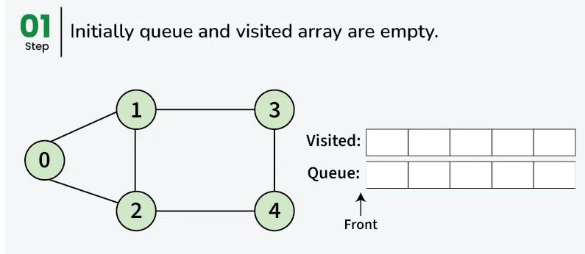
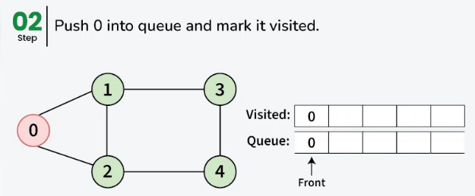
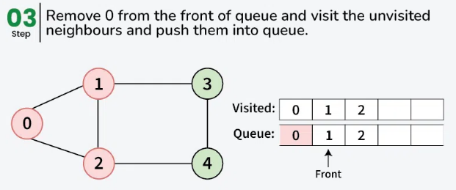

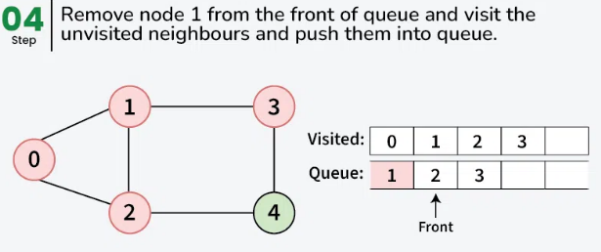

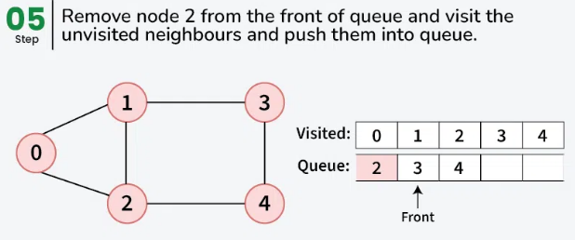

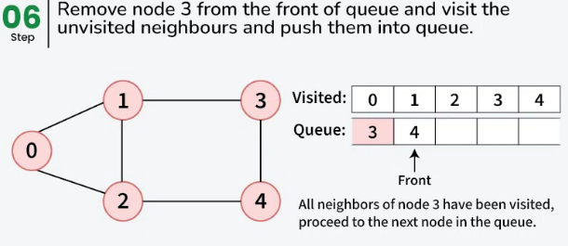

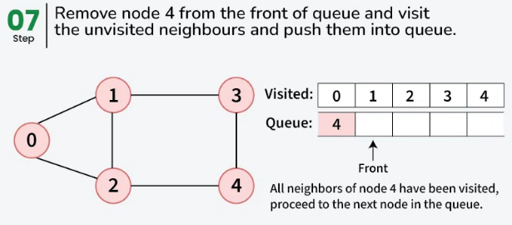

Pseudo code of Breadth-First Search
Create a Queue (say Q)
Mark Vertex V as Visited.
Put V into the Queue

While Q is not empty
Remove the head of Q (Let it be Vertex U)
Iterate all Unvisited Neighbours of U
Mark the neighbour as Visited
Enqueue the Neighbour into Q.

Time Complexity: O(V + E),
where V is the number of vertices (nodes), E is the number of edges in the graph.
In the worst case, BFS needs to visit every node and explore every edge.
Space Complexity:
- O(V) due to the space required for the queue and the visited set.
Applications of BFS
- Shortest Path in Unweighted Graphs: BFS can find the shortest path between two nodes in a graph, particularly in an unweighted graph where all edges have the same cost.
- Web Crawlers: BFS can be used to crawl web pages level by level, exploring all the links from the current page before moving on.
- Social Network Analysis: BFS can explore the shortest "degree of separation" between people in a social network.
- Network Broadcasting: BFS ensures that a message or signal is propagated to all nodes in the minimum number of steps in a network.
DFS Graph Traversal
Depth First Search (DFS) is a graph traversal algorithm, where we start from a selected(source) node and go into the depth of this node by recursively calling the DFS function until no children are encountered.
When the dead-end is reached, this algorithm backtracks and starts visiting the other children of the current node.
DFS Algorithm Steps
- Initialization:
  - Start at a given node, mark it as visited, and recursively visit its unvisited neighbors.
- Exploration:
  - For each node, visit one of its unvisited neighbors, then recursively apply DFS to the neighbor.
  - Once all neighbors of a node have been visited, backtrack to the previous node.
- Termination:
  - Repeat the process until all reachable nodes are visited.
Let's see how we can approach the depth first search algorithm.

Step | Traversal | Description
1 | 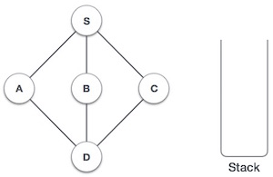 | Initialize the stack.
2 | 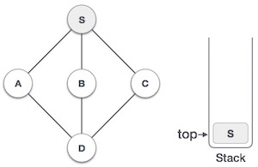 | Mark S as visited and put it onto the stack. Explore any unvisited adjacent node from S. We have three nodes and we can pick any of them. For this example, we shall take the node in an alphabetical order.
3 | 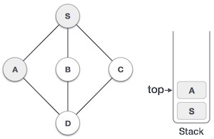 | Mark A as visited and put it onto the stack. Explore any unvisited adjacent node from A. Both S and D are adjacent to A but we are concerned for unvisited nodes only.
4 | 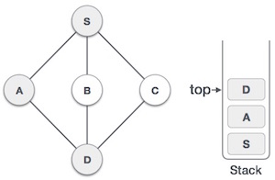 | Visit D and mark it as visited and put onto the stack. Here, we have B and C nodes, which are adjacent to D and both are unvisited. However, we shall again choose in an alphabetical order.
5 | 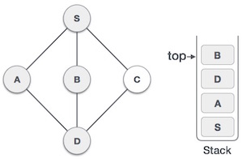 | We choose B, mark it as visited and put onto the stack. Here B does not have any unvisited adjacent node. So, we pop B from the stack.
6 | 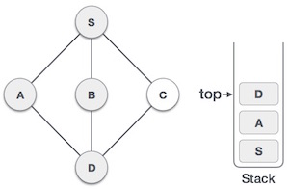 | We check the stack top for return to the previous node and check if it has any unvisited nodes. Here, we find D to be on the top of the stack.
7 | 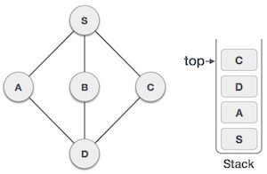 | Only unvisited adjacent node is from D is C now. So we visit C, mark it as visited and put it onto the stack.

Pseudocode of DFS Algorithm
DFS(visited, u):
visited[u]=True
Print u
for each v in adj[u]:
if(visited[v]=False)
DFS(visited,v)

Time Complexity
- O(V + E), where:
  - V is the number of vertices (nodes),
  - E is the number of edges.
In the worst case, DFS needs to explore every vertex and every edge once.
Space Complexity
- O(V) for the recursion stack or explicit stack to store the nodes being visited.
Applications of DFS
- Cycle Detection: DFS can be used to detect cycles in both directed and undirected graphs.
- Topological Sorting: In a directed acyclic graph (DAG), DFS is used to order nodes such that every directed edge points from an earlier node to a later node in the order.
- Solving Puzzles: DFS is often used to explore all possible solutions in puzzles like mazes or the N-Queens problem.
- Finding Strongly Connected Components: DFS-based algorithms like Kosaraju’s algorithm help find strongly connected components in a directed graph.
Connected Components and Bi connected Components
A connected component in a graph is a subset of the graph where there is a path between every pair of vertices in that subset, and no vertex in the subset is connected to any vertex outside the subset.

Types of Connected Components:
- In an Undirected Graph: A connected component is a maximal set of vertices such that there is a path between every pair of vertices in the set.
- In a Directed Graph: There are two types of connected components:
  - Strongly Connected Component: A maximal subset of vertices such that there is a directed path from any vertex to every other vertex in the subset.
  - Weakly Connected Component: A connected component in the underlying undirected graph (ignoring the direction of edges).

Connected component definition
Connected component in an undirected graph refers to a group of vertices that are connected to each other through edges, but not connected to other vertices outside the group.

For example in the graph shown below, {0, 1, 2} form a connected component and {3, 4} form another connected component.
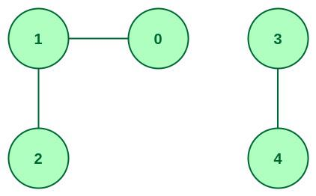
Example of connected components

Characteristics of Connected Component:
- A connected component is a set of vertices in a graph that are connected to each other.
- A graph can have multiple connected components.
- Inside a component, each vertex is reachable from every other vertex in that component.

How to identify Connected Component:
There are several algorithms to identify Connected Components in a graph. The most popular ones are:
- Depth-First Search (DFS)
- Breadth-First Search (BFS)
- Union-Find Algorithm (also known as Disjoint Set Union)

Applications of Connected Component:
- Graph Theory: It is used to find subgraphs or clusters of nodes that are connected to each other.
- Computer Networks: It is used to discover clusters of nodes or devices that are linked and have similar qualities, such as bandwidth.
- Image Processing: Connected components also have usage in image processing.

Strongly Connected Component meaning in DSA

Strongly Connected Component (SCC) is a concept in graph theory, specifically in directed graphs. A subgraph of a directed graph is considered to be an SCC if and only if for every pair of vertices A and B, there exists a path from A to B and a path from B to A.
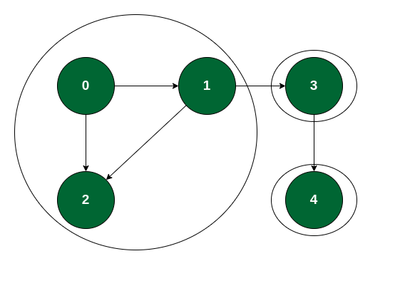
Example of Strongly Connected Component

Properties of Strongly Connected Component:
- An SCC is a maximal strongly connected subgraph.
- An SCC cannot be split into smaller SCCs.
- If two SCCs have an edge between them, then they are part of a larger SCC.
- An SCC contains a cycle.

Applications of Strongly Connected Component:
- Network analysis: SCCs are used to identify strongly connected components in a network. For example, in social network analysis, SCCs can help identify groups of people who are highly connected to each other.
- Detect cycles: SCCs are used to detect cycles in a directed graph. If an SCC is detected, then it is guaranteed that there is at least one cycle in the graph.
- Software Engineering: SCCs can help identify modules or components in a software system that are highly interdependent and may require special attention for maintenance or refactoring.

Count Number of connected components in an undirected graph

Given an undirected graph g, the task is to print the number of connected components in the graph.

Examples:
Input:
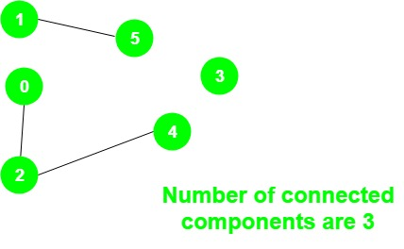
Output: 3
There are three connected components:
1 – 5, 0 – 2 – 4 and 3
Approach:

DFS visit all the connected vertices of the given vertex.
When iterating over all vertices, whenever we see unvisited node, it is because it was not visited by DFS done on vertices so far.

That means it is not connected to any previous nodes visited so far i.e it was not part of previous components.
Hence this node belongs to new component.
This means, before visiting this node, we just finished visiting all nodes previous component and that component is now complete.
So we need to increment component counter as we completed a component.
The idea is to use a variable count to store the number of connected components and do the following steps:
Initialize all vertices as unvisited.
For all the vertices check if a vertex has not been visited, then perform DFS on that vertex and increment the variable count by 1.

Bi connected components:

In graph theory, a bi connected graph is a connected and "nonseparable" graph, meaning that if any one vertex were to be removed, the graph will remain connected. Therefore a biconnected graph has no articulation vertices.

A bi connected undirected graph is a connected graph that is not broken into disconnected pieces by deleting any single vertex (and its incident edges).
A bi connected directed graph is one such that for any two vertices v and w there are two directed paths from v to w , which have no vertices in common other than v and w.

Examples
- 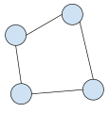
A bi connected graph on four vertices and four edges

- 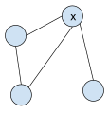
A graph that is not bi connected. The removal of vertex x would disconnect the graph.

- 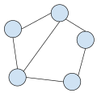
A bi connected graph on five vertices and six edges

- 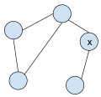
A graph that is not bi connected. The removal of vertex x would disconnect the graph.

In graph theory, a bi connected component or block (sometimes known as a 2-connected component) is a maximal biconnected subgraph.
Any connected graph decomposes into a tree of biconnected components called the block-cut tree of the graph.
The blocks are attached to each other at shared vertices called cut vertices or separating vertices or articulation points. Specifically, a cut vertex is any vertex whose removal increases the number of connected components.
A block containing at most one cut vertex is called a leaf block, it corresponds to a leaf vertex in the block-cut tree.
A biconnected component is a maximal biconnected subgraph.

In above graph, following are the bi connected components:
- 4–2 3–4 3–1 2–3 1–2
- 8–9
- 8–5 7–8 5–7
- 6–0 5–6 1–5 0–1
- 10–11

Idea is to store visited edges in a stack while DFS on a graph and keep looking for Articulation Points.

As soon as an Articulation Point u is found, all edges visited while DFS from node u onwards will form one biconnected component.

When DFS completes for one connected component, all edges present in stack will form a biconnected component.

If there is no Articulation Point in graph, then graph is biconnected and so there will be one biconnected component which is the graph itself.

Articulation Points (or Cut Vertices) in a Graph

A vertex v is an articulation point (also called cut vertex) if removing v increases the number of connected components.

Articulation Point - I
Articulation points represent vulnerabilities in a connected network – single points whose failure would split the network into 2 or more components. They are useful for designing reliable networks.

Examples:

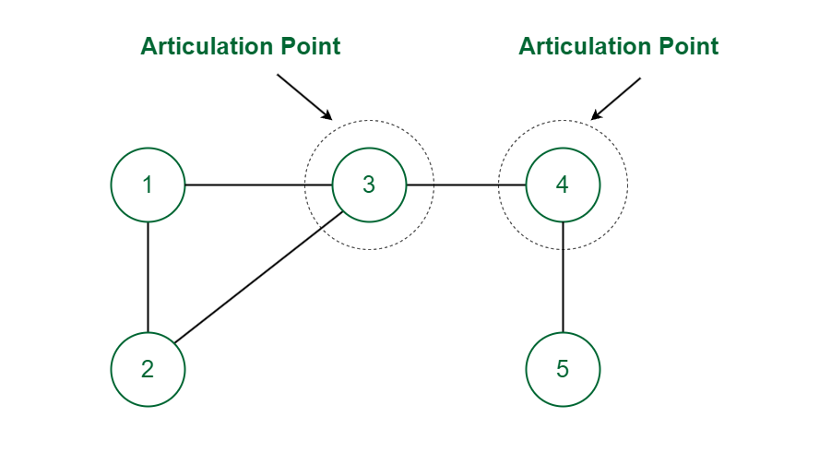
Articulation Point
In the above graph vertex 3 and 4 are Articulation Points since the removal of vertex 3 (or 4) along with its associated edges makes the graph disconnected.

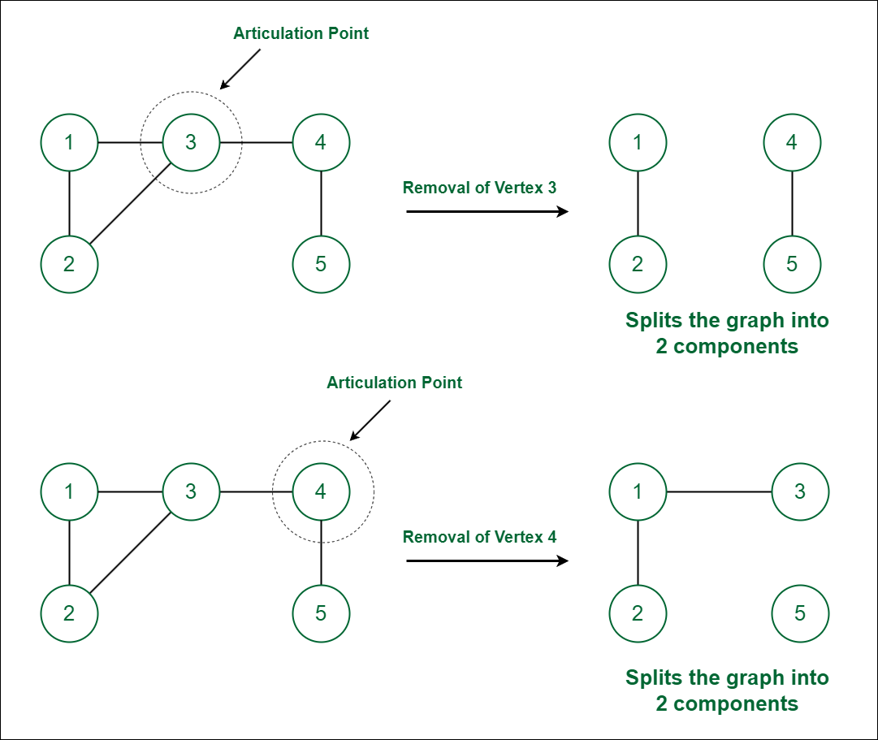

Finding the bi connected components in a given graph.
The bi-connected components of a graph are maximal subgraphs that remain connected even after removing any single vertex.
This concept is important in graph theory for understanding the resilience and structure of networks.
Bi-connected components, also known as biconnected components, contain no articulation points (cut vertices). Removing an articulation point from the graph breaks it into multiple components.

Approach to Find Bi-connected Components
To find the bi-connected components of a graph, we use Depth-First Search (DFS) along with additional arrays to track the discovery time and the lowest point of each node. The core idea is to identify articulation points, which separate the graph into different biconnected components.
Here is a C program that finds the biconnected components using DFS:

#include <stdio.h>
#include <stdlib.h>

#define MAX 100

// Data structure to store a graph edge
struct Edge {
int u, v;
};

// Stack for storing edges
struct Edge stack[MAX];
int top = -1;

// Push edge onto the stack
void push(int u, int v) {
stack[++top].u = u;
stack[top].v = v;
}

// Pop edge from the stack
struct Edge pop() {
return stack[top--];
}

// Array to store adjacency list
int adj[MAX][MAX], visited[MAX], disc[MAX], low[MAX], parent[MAX], timeCounter;

// Function to initialize the graph
void initializeGraph(int V) {
for (int i = 0; i < V; i++) {
visited[i] = 0;
parent[i] = -1;
for (int j = 0; j < V; j++) {
adj[i][j] = 0;
}
}
}

// Function to add edge to the graph
void addEdge(int u, int v) {
adj[u][v] = 1;
adj[v][u] = 1;
}

// DFS function to find bi-connected components
void BCCUtil(int u, int V) {
visited[u] = 1;
disc[u] = low[u] = ++timeCounter;

int children = 0; // To count children of u

for (int v = 0; v < V; v++) {
if (adj[u][v]) { // Check if (u, v) is an edge
if (!visited[v]) {
children++;
parent[v] = u;
push(u, v); // Push the edge to stack

// Recur for DFS
BCCUtil(v, V);

// Update low value of u
low[u] = (low[u] < low[v]) ? low[u] : low[v];

// Articulation point condition
if ((parent[u] == -1 && children > 1) || (parent[u] != -1 && low[v] >= disc[u])) {
printf("Biconnected Component: \n");
struct Edge e;
do {
e = pop();
printf("%d -- %d\n", e.u, e.v);
} while (e.u != u || e.v != v);
printf("\n");
}
}
// Update low value of u if v is already visited and is not parent of u
else if (v != parent[u]) {
low[u] = (low[u] < disc[v]) ? low[u] : disc[v];
push(u, v); // Push the edge onto the stack
}
}
}
}

// Function to find and print biconnected components in graph
void findBCCs(int V) {
timeCounter = 0;
for (int i = 0; i < V; i++) {
if (!visited[i]) {
BCCUtil(i, V);

// After DFS, if stack is not empty, pop all remaining edges
if (top != -1) {
printf("Biconnected Component: \n");
while (top != -1) {
struct Edge e = pop();
printf("%d -- %d\n", e.u, e.v);
}
printf("\n");
}
}
}
}

// Driver program to test above functions
int main() {
int V = 5; // Number of vertices

// Initialize the graph
initializeGraph(V);

// Add edges to the graph
addEdge(0, 1);
addEdge(0, 2);
addEdge(1, 2);
addEdge(1, 3);
addEdge(3, 4);

// Find biconnected components
findBCCs(V);

return 0;
}

Explanation:
- Graph Representation: The graph is represented using an adjacency matrix. adj[u][v] = 1 means there is an edge between vertex u and vertex v.
- Arrays:
  - disc[]: Stores the discovery time of each vertex during DFS.
  - low[]: Stores the lowest vertex that can be reached from the subtree rooted at a particular vertex.
  - parent[]: Stores the parent of each vertex in the DFS tree.
  - visited[]: Marks vertices as visited during DFS.
- DFS Traversal:
  - The BCCUtil() function performs a depth-first search and checks for articulation points using discovery and low values.
  - If a vertex satisfies the articulation point condition, the program pops all edges from the stack up to the articulation point, which forms a biconnected component.
- Stack:
  - A stack is used to keep track of edges that are part of the DFS tree. When an articulation point is found, the program pops edges from the stack to form a biconnected component.
- Biconnected Component:
  - A biconnected component is printed whenever an articulation point is found. If any edges remain in the stack after completing DFS, they also form a biconnected component.

Example:
For the input graph:
0--1
| |
2 3
|
4
The program will output:
Biconnected Component:
0 -- 1
1 -- 2
2 -- 0

Biconnected Component:
1 -- 3

Biconnected Component:
3 -- 4

