Dynamic Programming: General Method, All pairs shortest paths, Single Source Shortest Paths– General Weights (Bellman Ford Algorithm), Optimal Binary Search Trees, 0/1 Knapsack, String Editing, Travelling Salesperson problem
Backtracking: General Method, 8-Queens Problem, Sum of Subsets problem, Graph Coloring, 0/1 Knapsack Problem
Dynamic Programming:
General Method
Dynamic programming is a technique that breaks the problems into sub-problems, and saves the result for future purposes so that we do not need to compute the result again. The main use of dynamic programming is to solve optimization problems. Here, optimization problems mean that when we are trying to find out the minimum or the maximum solution of a problem. The dynamic programming guarantees to find the optimal solution of a problem if the solution exists.
Example:
0, 1, 1, 2, 3, 5, 8, 13, 21, 34, 55, 89, 144, ,…
The numbers in the above series are not randomly calculated. Mathematically, we could write each of the terms using the below formula: F(n) = F(n-1) + F(n-2),
With the base values F(0) = 0, and F(1) = 1. To calculate the other numbers, we follow the above relationship. For example, F(2) is the sum f(0) and f(1), which is equal to 1.
The F(20) term will be calculated using the nth formula of the Fibonacci series. The below figure shows that how F(20) is calculated.
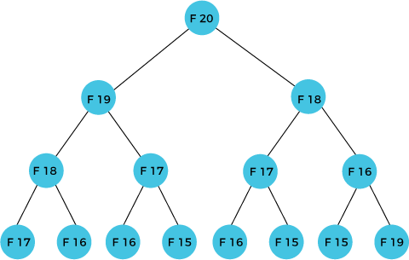

As we can observe in the above figure that F(20) is calculated as the sum of F(19) and F(18). In the dynamic programming approach, we try to divide the problem into the similar sub problems. We are following this approach in the above case where F(20) into the similar sub problems, i.e., F(19) and F(18). If we recap the definition of dynamic programming that it says the similar sub problem should not be computed more than once. Still, in the above case, the sub problem is calculated twice. In the above example, F(18) is calculated two times; similarly, F(17) is also calculated twice. However, this technique is quite useful as it solves the similar sub problems, but we need to be cautious while storing the results because we are not particular about storing the result that we have computed once, then it can lead to a wastage of resources.
Working of Dynamic Programming Method:
The following are the steps that the dynamic programming follows:
- It breaks down the complex problem into simpler sub problems.
- It finds the optimal solution to these sub-problems.
- It stores the results of sub problems (memoization). The process of storing the results of sub problems is known as memorization.
- It reuses them so that same sub-problem is calculated more than once.
- Finally, calculate the result of the complex problem.
Approaches of dynamic programming
There are two approaches to dynamic programming:
- Top-down approach
- Bottom-up approach
Top-down approach
The top-down approach follows the memorization technique, while bottom-up approach follows the tabulation method. Here memorization is equal to the sum of recursion and caching. Recursion means calling the function itself, while caching means storing the intermediate results.
Bottom-Up approach
The bottom-up approach is also one of the techniques which can be used to implement the dynamic programming. It uses the tabulation technique to implement the dynamic programming approach. It solves the same kind of problems but it removes the recursion. If we remove the recursion, there is no stack overflow issue and no overhead of the recursive functions. In this tabulation technique, we solve the problems and store the results in a matrix.
There are following two different ways to store the values so that the values of a problem can be reused. Here, will discuss two patterns of solving Dynamic Programming problem:
- Tabulation: Bottom Up
- Memoization: Top Down
Tabulation Method – Bottom Up Dynamic Programming
As the name itself suggests starting from the bottom and cumulating answers to the top. Let’s describe a state for our DP problem to be dp,x- with dp,0- as base state and dp[n] as our destination state. So, we need to find the value of destination state i.e dp[n]. If we start our transition from our base state i.e dp[0] and follow our state transition relation to reach our destination state dp[n], we call it Bottom Up approach as it is quite clear that we started our transition from the bottom base state and reached the top most desired state.

// Tabulated version to find factorial x. int dp[MAXN];
// base case int dp[0] = 1;
for (int i = 1; i< =n; i++)
{
dp[i] = dp[i-1] * i;
}

The above code clearly follows the bottom-up approach as it starts its transition from the bottom-most base case dp[0] and reaches its destination state dp[n]. Here, we may notice that the dp table is being populated sequentially and we are directly accessing the calculated states from the table itself and hence, we call it tabulation method.
Memoization Method – Top Down Dynamic Programming
If we need to find the value for some state say dp[n] and instead of starting from the base state that i.e dp[0] we ask our answer from the states that can reach the destination state dp[n] following the state transition relation, then it is the top-down fashion of DP. Here, we start our journey from the top most destination state and compute its answer by taking in count the values of states that can reach the destination state, till we reach the bottom most base state.
// Memoized version to find factorial x. int dp[MAXN]
// return fact x! int solve(int x)
{
if (x==0) return 1;
if (dp[x]!=-1) return dp[x];
return (dp[x] = x * solve(x-1));
}
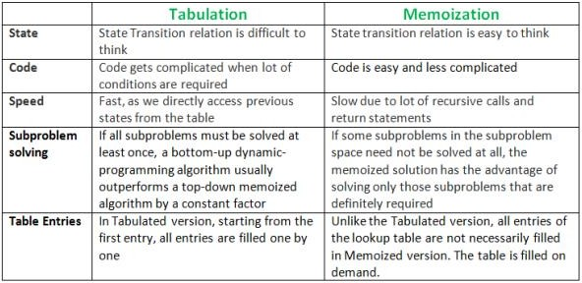

Example sum for Dynamic Programming Program Fibonacci numbers
The Fibonacci numbers are the numbers in the following integer sequence. 0, 1, 1, 2, 3, 5, 8, 13, 21, 34, 55, 89, 144, ……..
In mathematical terms, the sequence Fn of Fibonacci numbers is defined by the recurrence relation
Fn = Fn-1 + Fn-2 with seed values F0 = 0 and F1 = 1.
Find the value of F8?
F0 = 0
F1 = 1
F2 = F2-1 + F2-2 = F1 + F0 = 1 + 0 = 1
F3 = F3-1 + F3-2 = F2 + F1 = 1 + 1 = 2
F4 = F4-1 + F4-2 = F3 + F2 = 2 + 1 = 3
F5 = F5-1 + F5-2 = F4 + F3 = 3 + 2 = 5
F6 = F6-1 + F6-2 = F5 + F4 = 5 + 3 = 8
F7 = F7-1 + F7-2 = F6 + F5 = 6 + 5 = 13
F8 = F8-1 + F8-2 = F7 + F6 = 13 + 8 = 21

Divide and Conquer Method vs Dynamic Programming

Divide and Conquer Method | Dynamic Programming
It deals (involves) three steps at each level of recursion:  Divide the problem into a number of sub problems.  Conquer the sub problems by solving them recursively.  Combine the solution to the sub problems into the solution for original sub problems. | It involves the sequence of four steps: Characterize the structure of optimal solutions.  Recursively defines the values of optimal solutions.  Compute the value of optimal solutions in a Bottom-up minimum.  Construct an Optimal Solution from computed information.
It is Recursive. | It is non Recursive.
It does more work on sub problems and hence has more time consumption. | It solves sub problems only once and then stores in the table.
It is a top-down approach. | It is a Bottom-up approach.
In this sub problems are independent of each other. | In this sub problems are interdependent.
Example: Merge Sort & Binary Search etc. | Example: Matrix Multiplication.

All pairs shortest paths (Floyd Warshall Algorithm)
The Floyd-Warshall algorithm, named after its creators Robert Floyd and Stephen Warshall, is a fundamental algorithm in computer science and graph theory. It is used to find the shortest paths between all pairs of nodes in a weighted graph. This algorithm is highly efficient and can handle graphs with both positive and negative edge weights, making it a versatile tool for solving a wide range of network and connectivity problems.
Each edge has a number, called a weight, that represents the distance or cost to travel between two nodes. The goal of the Floyd-Warshall algorithm is to find the shortest possible path between every pair of nodes in the graph.
The algorithm works by checking every possible path between the nodes and updating the shortest known distance between them. It repeats this process for each node in the graph until it has considered all possible paths, ensuring that the shortest path is found for every pair of nodes.
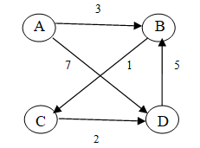
An example using a simple graph with 4 nodes (A, B, C, D) and the following weighted edges:
A to B: 3
A to D: 7
B to C: 1
C to D: 2
D to B: 5
The graph can be represented as an adjacency matrix:
Where "∞" represents that there is no direct path between the nodes.

Step 1: Initialization
Initialize the dist[][] matrix as the adjacency matrix of the graph.

Step 2: Iteration through all nodes (k)
- For each node k, consider it as an intermediate node, and update the shortest paths.
Iteration with k = A:
Update distances considering A as an intermediate node:
- No updates needed as there are no shorter paths through A.
Iteration with k = B:
Update distances considering B as an intermediate node:
- dist[A][C] = min(dist[A][C], dist[A][B] + dist[B][C]) = min(∞, 3 + 1) = 4
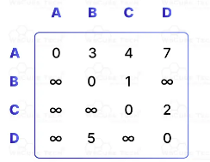
- dist[D][C] remains unchanged as there is no shorter path.
Updated matrix:

Iteration with k = C:
Update distances considering C as an intermediate node:
- dist[A][D] = min(dist[A][D], dist[A][C] + dist[C][D]) = min(7, 4 + 2) = 6
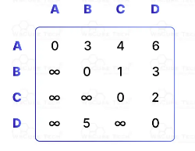
- dist[B][D] = min(dist[B][D], dist[B][C] + dist[C][D]) = min(∞, 1 + 2) = 3
Updated matrix:

Iteration with k = D:
Update distances considering D as an intermediate node:
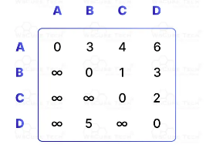
- dist[A][B] and dist[C][B] remain unchanged as there are no shorter paths through D.

Final matrix:

This matrix represents the shortest paths between all pairs of nodes.

Floyd-Warshall Algorithm Time Complexity
The time complexity of Floyd-Warshall algorithm is O(V^3).
Aspect | Complexity | Explanation
Time Complexity | O(V^3) | The algorithm uses three nested loops, each iterating over the vertices (V), leading to O(V^3).
- V represents the number of vertices in the graph.
- The time complexity is O(V^3) because the algorithm checks all pairs of vertices for each possible intermediate vertex.
Single Source Shortest Paths (Bellman Ford Algorithm)
Bellman ford algorithm is a single-source shortest path algorithm. This algorithm is used to find the shortest distance from the single vertex to all the other vertices of a weighted graph. There are various other algorithms used to find the shortest path like Dijkstra algorithm, etc. If the weighted graph contains the negative weight values, then the Dijkstra algorithm does not confirm whether it produces the correct answer or not. In contrast to Dijkstra algorithm, bellman ford algorithm guarantees the correct answer even if the weighted graph contains the negative weight values.
Rule of this algorithm
- We will go on relaxing all the edges (n - 1) times where,
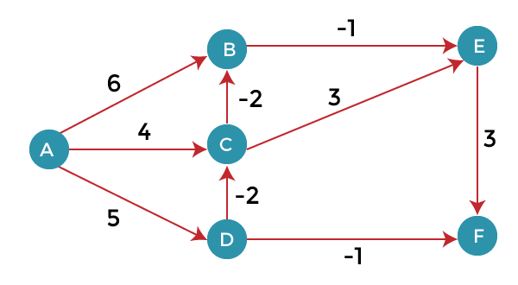
- n = number of vertices
Consider the below graph:

As we can observe in the above graph that some of the weights are negative. The above graph contains 6 vertices so we will go on relaxing till the 5 vertices. Here, we will relax all the edges 5 times. The loop will iterate 5 times to get the correct answer. If the loop is iterated more than 5 times then also the answer will be the same, i.e., there would be no change in the distance between the vertices.
Relaxing means:
- If (d(u) + c(u , v) < d(v))
- d(v) = d(u) + c(u , v)
To find the shortest path of the above graph, the first step is note down all the edges which are given below:
(A, B), (A, C), (A, D), (B, E), (C, E), (D, C), (D, F), (E, F), (C, B)
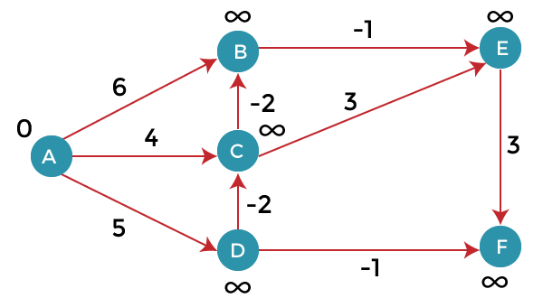
Let's consider the source vertex as 'A'; therefore, the distance value at vertex A is 0 and the distance value at all the other vertices as infinity shown as below:

Since the graph has six vertices so it will have five iterations.
First iteration
- Consider the edge (A, B). Denote vertex 'A' as 'u' and vertex 'B' as 'v'. Now use the relaxing formula:
d(u) = 0 d(v) = ∞ c(u, v) = 6
Since (0 + 6) is less than ∞, so update
d(v) = d(u) + c(u , v)
d(v) = 0 + 6 = 6
Therefore, the distance of vertex B is 6.
- Consider the edge (A, C). Denote vertex 'A' as 'u' and vertex 'C' as 'v'. Now use the relaxing formula:
d(u) = 0 d(v) = ∞ c(u , v) = 4
Since (0 + 4) is less than ∞, so update
d(v) = d(u) + c(u , v)
d(v) = 0 + 4 = 4 Therefore, the distance of vertex C is 4.
- Consider the edge (A, D).
d(u) = 0 d(v) = ∞ c(u , v) = 5
Since (0 + 5) is less than ∞, so update
d(v) = d(u) + c(u , v)
d(v) = 0 + 5 = 5
Therefore, the distance of vertex D is 5.
- Consider the edge (B, E).
d(u) = 6 d(v) = ∞ c(u , v) = -1
Since (6 - 1) is less than ∞, so update
d(v) = d(u) + c(u , v)
d(v) = 6 - 1= 5
Therefore, the distance of vertex E is 5.
- Consider the edge (C, E).
d(u) = 4 d(v) = 5 c(u , v) = 3
Since (4 + 3) is greater than 5, so there will be no updation. The value at vertex E is 5.
- Consider the edge (D, C).
d(u) = 5 d(v) = 4 c(u , v) = -2
Since (5 -2) is less than 4, so update
d(v) = d(u) + c(u , v)
d(v) = 5 - 2 = 3
Therefore, the distance of vertex C is 3.
- Consider the edge (D, F).
d(u) = 5 d(v) = ∞ c(u , v) = -1
Since (5 -1) is less than ∞, so update
d(v) = d(u) + c(u , v)
d(v) = 5 - 1 = 4 Therefore, the distance of vertex F is 4.
- Consider the edge (E, F).
d(u) = 5 d(v) = ∞ c(u , v) = 3
Since (5 + 3) is greater than 4, so there would be no updation on the distance value of vertex F.
- Consider the edge (C, B).
d(u) = 3 d(v) = 6 c(u , v) = -2
Since (3 - 2) is less than 6, so update
d(v) = d(u) + c(u , v)
d(v) = 3 - 2 = 1 Therefore, the distance of vertex B is 1.
Now the first iteration is completed. We move to the second iteration.
Second iteration:
In the second iteration, we again check all the edges. The first edge is (A, B). Since (0 + 6) is greater than 1 so there would be no updation in the vertex B.
The next edge is (A, C). Since (0 + 4) is greater than 3 so there would be no updation in the vertex C.
The next edge is (A, D). Since (0 + 5) equals to 5 so there would be no updation in the vertex D.
The next edge is (B, E). Since (1 - 1) equals to 0 which is less than 5 so update:
d(v) = d(u) + c(u, v)
d(E) = d(B) +c(B , E)
= 1 - 1 = 0
The next edge is (C, E). Since (3 + 3) equals to 6 which is greater than 5 so there would be no updation in the vertex E.
The next edge is (D, C). Since (5 - 2) equals to 3 so there would be no updation in the vertex C.
The next edge is (D, F). Since (5 - 1) equals to 4 so there would be no updation in the vertex F.
The next edge is (E, F). Since (5 + 3) equals to 8 which is greater than 4 so there would be no updation in the vertex F.
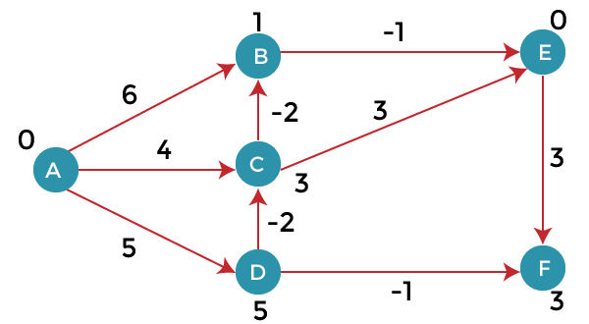
The next edge is (C, B). Since (3 - 2) equals to 1` so there would be no updation in the vertex B.

Third iteration
We will perform the same steps as we did in the previous iterations. We will observe that there will be no updation in the distance of vertices.
The following are the distances of vertices:
A: 0
B: 1
C: 3
D: 5
E: 0
F: 3
Time Complexity
The time complexity of Bellman ford algorithm would be O(E|V| - 1).
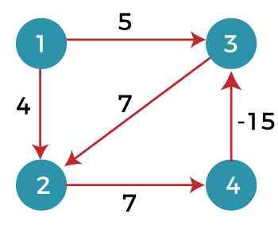
Drawbacks of Bellman ford algorithmThe bellman ford algorithm does not produce a correct answer if the sum of the edges of a cycle is negative. Let's understand this property through an example. Consider the below graph.

- In the above graph, we consider vertex 1 as the source vertex and provides 0 value to it. We provide infinity value to other vertices shown as below:
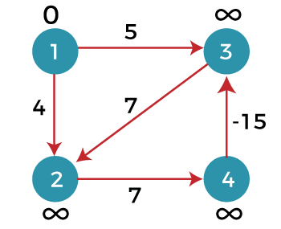
- Edges can be written as: (1, 3), (1, 2), (2, 4), (3, 2), (4, 3)
First iteration
Consider the edge (1, 3). Denote vertex '1' as 'u' and vertex '3' as 'v'. Now use the relaxing formula:
d(u) = 0 d(v) = ∞ c(u , v) = 5
Since (0 + 5) is less than ∞, so update
d(v) = d(u) + c(u , v)
d(v) = 0 + 5 = 5
Therefore, the distance of vertex 3 is 5.
Consider the edge (1, 2). Denote vertex '1' as 'u' and vertex '2' as 'v'. Now use the relaxing formula:
d(u) = 0 d(v) = ∞ c(u , v) = 4
Since (0 + 4) is less than ∞, so update
d(v) = d(u) + c(u , v)
d(v) = 0 + 4 = 4
Therefore, the distance of vertex 2 is 4.
Consider the edge (3, 2). Denote vertex '3' as 'u' and vertex '2' as 'v'. Now use the relaxing formula:
d(u) = 5 d(v) = 4 c(u , v) = 7
Since (5 + 7) is greater than 4, so there would be no updation in the vertex 2.
Consider the edge (2, 4). Denote vertex '2' as 'u' and vertex '4' as 'v'. Now use the relaxing formula:
d(u) = 4 d(v) = ∞ c(u , v) = 7
Since (4 + 7) equals to 11 which is less than ∞, so update
d(v) = d(u) + c(u , v)
d(v) = 4 + 7 = 11
Therefore, the distance of vertex 4 is 11.
Consider the edge (4, 3). Denote vertex '4' as 'u' and vertex '3' as 'v'. Now use the relaxing formula:
d(u) = 11 d(v) = 5 c(u , v) = -15
Since (11 - 15) equals to -4 which is less than 5, so update
d(v) = d(u) + c(u , v)
d(v) = 11 - 15 = -4
Therefore, the distance of vertex 3 is -4.
Now we move to the second iteration.

Second iteration
Now, again we will check all the edges. The first edge is (1, 3). Since (0 + 5) equals to 5 which is greater than -4 so there would be no updation in the vertex 3.
The next edge is (1, 2). Since (0 + 4) equals to 4 so there would be no updation in the vertex 2.
The next edge is (3, 2). Since (-4 + 7) equals to 3 which is less than 4 so update:
d(v) = d(u) + c(u, v)
d(2) = d(3) +c(3, 2)
= -4 + 7 = 3
Therefore, the value at vertex 2 is 3.
The next edge is (2, 4). Since ( 3+7) equals to 10 which is less than 11 so update
d(v) = d(u) + c(u, v)
d(4) = d(2) +c(2, 4)
= 3 + 7 = 10
Therefore, the value at vertex 4 is 10.
The next edge is (4, 3). Since (10 - 15) equals to -5 which is less than -4 so update:
d(v) = d(u) + c(u, v)
d(3) = d(4) +c(4, 3)
= 10 - 15 = -5
Therefore, the value at vertex 3 is -5.
Now we move to the third iteration.
Third iteration
Now again we will check all the edges. The first edge is (1, 3). Since (0 + 5) equals to 5 which is greater than -5 so there would be no updation in the vertex 3.
The next edge is (1, 2). Since (0 + 4) equals to 4 which is greater than 3 so there would be no updation in the vertex 2.
The next edge is (3, 2). Since (-5 + 7) equals to 2 which is less than 3 so update:
d(v) = d(u) + c(u, v)
d(2) = d(3) +c(3, 2)
= -5 + 7 = 2
Therefore, the value at vertex 2 is 2.
The next edge is (2, 4). Since (2 + 7) equals to 9 which is less than 10 so update:
d(v) = d(u) + c(u, v)
d(4) = d(2) +c(2, 4)
= 2 + 7 = 9
Therefore, the value at vertex 4 is 9.
The next edge is (4, 3). Since (9 - 15) equals to -6 which is less than -5 so update:
d(v) = d(u) + c(u, v)
d(3) = d(4) +c(4, 3)
= 9 - 15 = -6
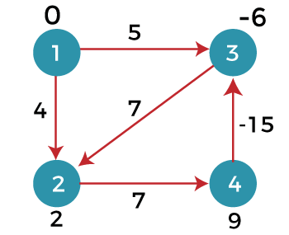
Therefore, the value at vertex 3 is -6.
Since the graph contains 4 vertices, so according to the bellman ford algorithm, there would be only 3 iterations. If we try to perform 4th iteration on the graph, the distance of the vertices from the given vertex should not change. If the distance varies, it means that the bellman ford algorithm is not providing the correct answer.
4th iteration
The first edge is (1, 3). Since (0 +5) equals to 5 which is greater than -6 so there would be no change in the vertex 3.
The next edge is (1, 2). Since (0 + 4) is greater than 2 so there would be no updation.
The next edge is (3, 2). Since (-6 + 7) equals to 1 which is less than 3 so update:
d(v) = d(u) + c(u, v)
d(2) = d(3) +c(3, 2)
= -6 + 7 = 1
In this case, the value of the vertex is updated. So, we conclude that the bellman ford algorithm does not work when the graph contains the negative weight cycle.
Therefore, the value at vertex 2 is 1.

Optimal Binary Search Tree
In a binary search tree, the nodes in the left sub tree have lesser value than the root node and the nodes in the right sub tree have greater value than the root node.
We know the key values of each node in the tree, and we also know the frequencies of each node in terms of searching means how much time is required to search a node. The frequency and key-value determine the overall cost of searching a node. The cost of searching is a very important factor in various applications. The overall cost of searching a node should be less. The time required to search a node in BST is more than the balanced binary search tree as a balanced binary search tree contains a lesser number of levels than the BST. There is one way that can reduce the cost of a binary search tree is known as an optimal binary search tree.
If the keys are 10, 20, 30, 40, 50, 60, 70
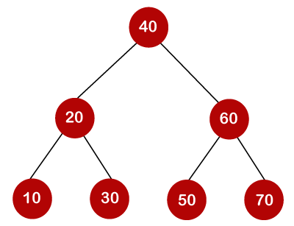
In the above tree, all the nodes on the left sub tree are smaller than the value of the root node, and all the nodes on the right sub tree are larger than the value of the root node. The maximum time required to search a node is equal to the minimum height of the tree, equal to log n.
Now we will see how many binary search trees can be made from the given number of keys.
For example: 10, 20, 30 are the keys, and the following are the binary search trees that can be made out from these keys.
The Formula for calculating the number of trees:
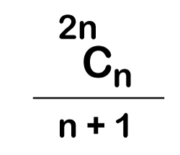
When we use the above formula, then it is found that total 5 number of trees can be created.
The cost required for searching an element depends on the comparisons to be made to search an element. Now, we will calculate the average cost of time of the above binary search trees.
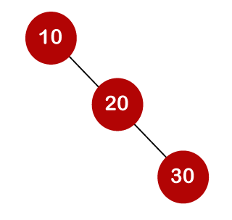
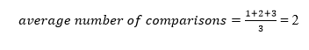
In the above tree, total number of 3 comparisons can be made. The average number of comparisons can be made as:
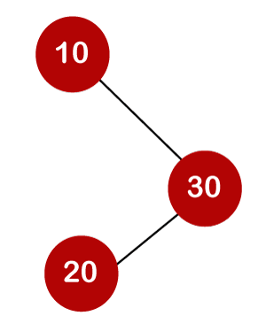
In the above tree, the average number of comparisons that can be made as:
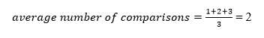
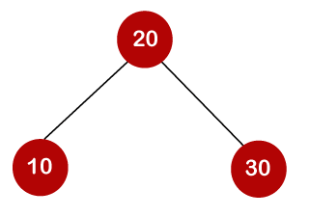
In the above tree, the average number of comparisons that can be made as:
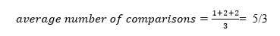
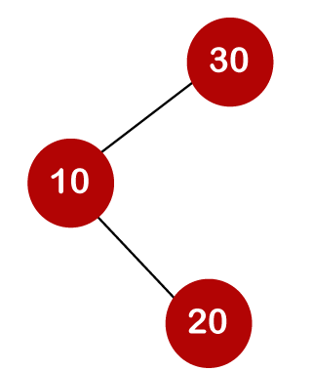
In the above tree, the total number of comparisons can be made as 3. Therefore, the average number of comparisons that can be made as:
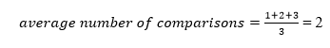
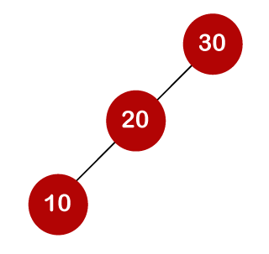
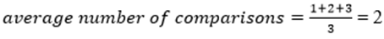
In the above tree, the total number of comparisons can be made as 3. Therefore, the average number of comparisons that can be made as:

In the third case, the number of comparisons is less because the height of the tree is less, so it's a balanced binary search tree.
Till now, we read about the height-balanced binary search tree. To find the optimal binary search tree, we will determine the frequency of searching a key.
Let's assume that frequencies associated with the keys 10, 20, 30 are 3, 2, 5.
The above trees have different frequencies. The tree with the lowest frequency would be considered the optimal binary search tree. The tree with the frequency 17 is the lowest, so it would be considered as the optimal binary search tree.

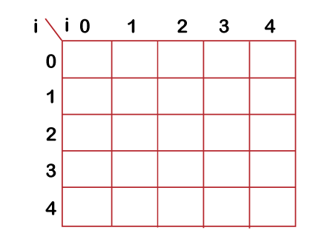
Dynamic Approach
Consider the below table, which contains the keys and frequencies.
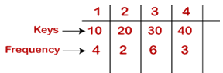
First, we will calculate the values where j-i is equal to zero.
When i=0, j=0, then j-i = 0
When i = 1, j=1, then j-i = 0
When i = 2, j=2, then j-i = 0
When i = 3, j=3, then j-i = 0
When i = 4, j=4, then j-i = 0
Therefore, c[0, 0] = 0, c[1 , 1] = 0, c[2,2] = 0, c[3,3] = 0, c[4,4] = 0
Now we will calculate the values where j-i equal to 1.
When j=1, i=0 then j-i = 1
When j=2, i=1 then j-i = 1
When j=3, i=2 then j-i = 1
When j=4, i=3 then j-i = 1
Now to calculate the cost, we will consider only the jth value.
The cost of c[0,1] is 4 (The key is 10, and the cost corresponding to key 10 is 4).
The cost of c[1,2] is 2 (The key is 20, and the cost corresponding to key 20 is 2).
The cost of c[2,3] is 6 (The key is 30, and the cost corresponding to key 30 is 6)
The cost of c[3,4] is 3 (The key is 40, and the cost corresponding to key 40 is 3)
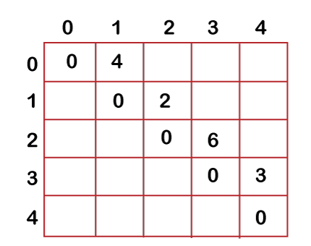
Now we will calculate the values where j-i = 2
When j=2, i=0 then j-i = 2
When j=3, i=1 then j-i = 2
When j=4, i=2 then j-i = 2
In this case, we will consider two keys.
- When i=0 and j=2, then keys 10 and 20. There are two possible trees that can be made out from these two keys shown below:
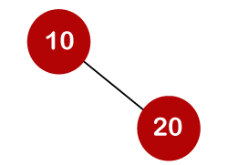
In the first binary tree, cost would be: 4*1 + 2*2 = 8
In the second binary tree, cost would be: 4*2 + 2*1 = 10
The minimum cost is 8; therefore, c[0,2] = 8
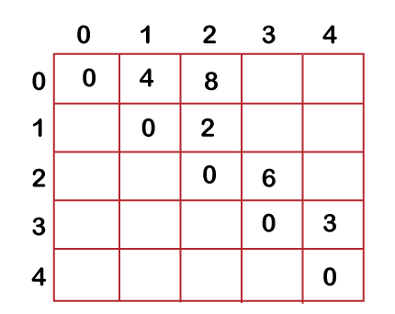
- When i=1 and j=3, then keys 20 and 30. There are two possible trees that can be made out from these two keys shown below:
In the first binary tree, cost would be: 1*2 + 2*6 = 14
In the second binary tree, cost would be: 1*6 + 2*2 = 10
The minimum cost is 10; therefore, c[1,3] = 10
- When i=2 and j=4, we will consider the keys at 3 and 4, i.e., 30 and 40. There are two possible trees that can be made out from these two keys shown as below:
In the first binary tree, cost would be: 1*6 + 2*3 = 12
In the second binary tree, cost would be: 1*3 + 2*6 = 15
The minimum cost is 12, therefore, c[2,4] = 12
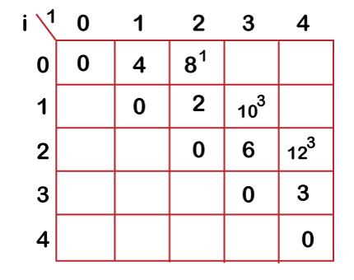
Now we will calculate the values when j-i = 3
When j=3, i=0 then j-i = 3
When j=4, i=1 then j-i = 3
- When i=0, j=3 then we will consider three keys, i.e., 10, 20, and 30.
The following are the trees that can be made if 10 is considered as a root node.
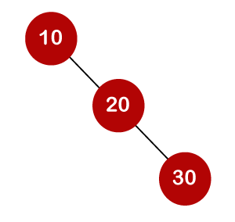
In the above tree, 10 is the root node, 20 is the right child of node 10, and 30 is the right child of node 20.
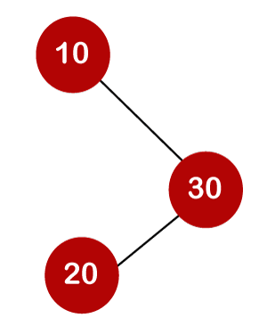
Cost would be: 1*4 + 2*2 + 3*6 = 26

In the above tree, 10 is the root node, 30 is the right child of node 10, and 20 is the left child of node 20.
Cost would be: 1*4 + 2*6 + 3*2 = 22
The following tree can be created if 20 is considered as the root node.
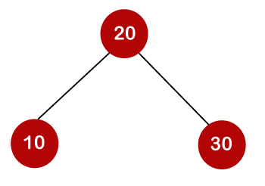
In the above tree, 20 is the root node, 30 is the right child of node 20, and 10 is the left child of node 20.
Cost would be: 1*2 + 4*2 + 6*2 = 22
The following are the trees that can be created if 30 is considered as the root node.
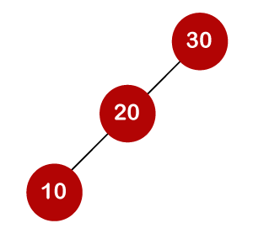
In the above tree, 30 is the root node, 20 is the left child of node 30, and 10 is the left child of node 20.
Cost would be: 1*6 + 2*2 + 3*4 = 22
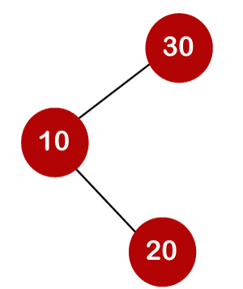
In the above tree, 30 is the root node, 10 is the left child of node 30 and 20 is the right child of node 10.
Cost would be: 1*6 + 2*4 + 3*2 = 20
Therefore, the minimum cost is 20 which is the 3rd root. So, c[0,3] is equal to 20.
- When i=1 and j=4 then we will consider the keys 20, 30, 40
c[1,4] = min{ c[1,1] + c[2,4], c[1,2] + c[3,4], c[1,3] + c[4,4] } + 11
= min{0+12, 2+3, 10+0}+ 11
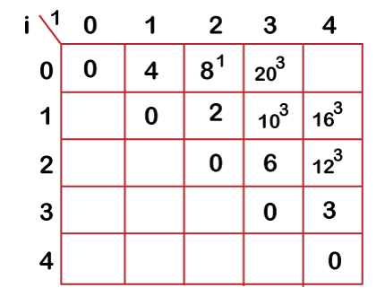
= min{12, 5, 10} + 11
The minimum value is 5; therefore, c[1,4] = 5+11 = 16

- Now we will calculate the values when j-i = 4
When j=4 and i=0 then j-i = 4
In this case, we will consider four keys, i.e., 10, 20, 30 and 40. The frequencies of 10, 20, 30 and 40 are 4, 2, 6 and 3 respectively.
w[0, 4] = 4 + 2 + 6 + 3 = 15
If we consider 10 as the root node then
C[0, 4] = min {c[0,0] + c[1,4]}+ w[0,4]
= min {0 + 16} + 15= 31
If we consider 20 as the root node then
C[0,4] = min{c[0,1] + c[2,4]} + w[0,4]
= min{4 + 12} + 15
= 16 + 15 = 31
If we consider 30 as the root node then,
C[0,4] = min{c[0,2] + c[3,4]} +w[0,4]
= min {8 + 3} + 15
= 26
If we consider 40 as the root node then,
C[0,4] = min{c[0,3] + c[4,4]} + w[0,4]
= min{20 + 0} + 15
= 35
In the above cases, we have observed that 26 is the minimum cost; therefore, c[0,4] is equal to 26.
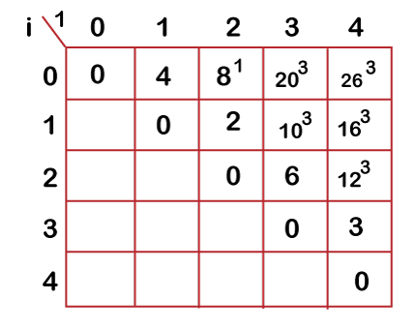
The optimal binary tree can be created as:
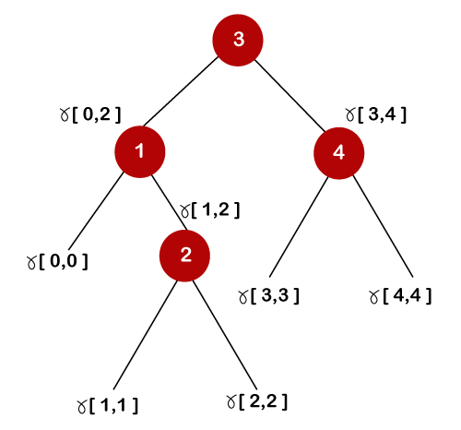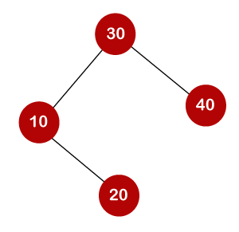
General formula for calculating the minimum cost is:
C[i,j] = min{c[i, k-1] + c[k,j]} + w(i,j)
0/1 knapsack problem using dynamic programming
Knapsack is like a container or a bag. Suppose we have given some items which have some weights or profits. We have to put some items in the knapsack in such a way total value produces a maximum profit.
There are two types of knapsack problems:
- 0/1 knapsack problem
- Fractional knapsack problem
The 0/1 knapsack problem means that the items are either completely or no items are filled in a knapsack. For example, we have two items having weights 2kg and 3kg, respectively. If we pick the 2kg item then we cannot pick 1kg item from the 2kg item (item is not divisible); we have to pick the 2kg item completely. The 0/1 knapsack problem is solved by the dynamic programming.

Example of 0/1 knapsack problem.
Consider the problem having weights and profits are:
Weights: {3, 4, 6, 5}
Profits: {2, 3, 1, 4}
The weight of the knapsack is 8 kg
The number of items is 4
The above problem can be solved by using the following method:
x_{i} = {1, 0, 0, 1}
= {0, 0, 0, 1}
= {0, 1, 0, 1}
The above are the possible combinations. 1 denotes that the item is completely picked and 0 means that no item is picked. Since there are 4 items so possible combinations will be:
2⁴ = 16; So. There are 16 possible combinations that can be made by using the above problem. Once all the combinations are made, we have to select the combination that provides the maximum profit.
Another approach to solve the problem is dynamic programming approach. In dynamic programming approach, the complicated problem is divided into sub-problems, then we find the solution of a sub-problem and the solution of the sub-problem will be used to find the solution of a complex problem.
 | 0 | 1 | 2 | 3 | 4 | 5 | 6 | 7 | 8
0
1
2
3
4
First, we create a matrix shown as below:
In the above matrix, columns represent the weight, i.e., 8. The rows represent the profits and weights of items. Here we have not taken the weight 8 directly, problem is divided into sub-problems, i.e., 0, 1, 2, 3, 4, 5, 6, 7, 8. The solution of the sub-problems would be saved in the cells and answer to the problem would be stored in the final cell. First, we write the weights in the ascending order and profits according to their weights shown as below:
w_{i} = {3, 4, 5, 6} p_{i} = {2, 3, 4, 1}
The first row and the first column would be 0 as there is no item for w=0
 | 0 | 1 | 2 | 3 | 4 | 5 | 6 | 7 | 8
0 | 0 | 0 | 0 | 0 | 0 | 0 | 0 | 0 | 0
1 | 0
2 | 0
3 | 0
4 | 0
When i=1, W=1
w₁ = 3; Since we have only one item in the set having weight 3, but the capacity of the knapsack is 1. We cannot fill the item of 3kg in the knapsack of capacity 1 kg so add 0 at M[1][1] shown as below:
 | 0 | 1 | 2 | 3 | 4 | 5 | 6 | 7 | 8
0 | 0 | 0 | 0 | 0 | 0 | 0 | 0 | 0 | 0
1 | 0 | 0
2 | 0
3 | 0
4 | 0
When i = 1, W = 2
w₁ = 3; Since we have only one item in the set having weight 3, but the capacity of the knapsack is 2. We cannot fill the item of 3kg in the knapsack of capacity 2 kg so add 0 at M[1][2] shown as below:
 | 0 | 1 | 2 | 3 | 4 | 5 | 6 | 7 | 8
0 | 0 | 0 | 0 | 0 | 0 | 0 | 0 | 0 | 0
1 | 0 | 0 | 0
2 | 0
3 | 0
4 | 0
When i=1, W=3
w₁ = 3; Since we have only one item in the set having weight equal to 3, and weight of the knapsack is also 3; therefore, we can fill the knapsack with an item of weight equal to 3. We put profit corresponding to the weight 3, i.e., 2 at M[1][3] shown as below:
 | 0 | 1 | 2 | 3 | 4 | 5 | 6 | 7 | 8
0 | 0 | 0 | 0 | 0 | 0 | 0 | 0 | 0 | 0
1 | 0 | 0 | 0 | 2
2 | 0
3 | 0
4 | 0
When i=1, W = 4
_{W1} = 3; Since we have only one item in the set having weight equal to 3, and weight of the knapsack is 4; therefore, we can fill the knapsack with an item of weight equal to 3. We put profit corresponding to the weight 3, i.e., 2 at M[1][4] shown as below:
 | 0 | 1 | 2 | 3 | 4 | 5 | 6 | 7 | 8
0 | 0 | 0 | 0 | 0 | 0 | 0 | 0 | 0 | 0
1 | 0 | 0 | 0 | 2 | 2
2 | 0
3 | 0
4 | 0
When i=1, W = 5
_{W1} = 3; Since we have only one item in the set having weight equal to 3, and weight of the knapsack is 5; therefore, we can fill the knapsack with an item of weight equal to 3. We put profit corresponding to the weight 3, i.e., 2 at M[1][5] shown as below:
 | 0 | 1 | 2 | 3 | 4 | 5 | 6 | 7 | 8
0 | 0 | 0 | 0 | 0 | 0 | 0 | 0 | 0 | 0
1 | 0 | 0 | 0 | 2 | 2 | 2
2 | 0
3 | 0
4 | 0
When i =1, W=6
_{W1} = 3; Since we have only one item in the set having weight equal to 3, and weight of the knapsack is 6; therefore, we can fill the knapsack with an item of weight equal to 3. We put profit corresponding to the weight 3, i.e., 2 at M[1][6] shown as below:
 | 0 | 1 | 2 | 3 | 4 | 5 | 6 | 7 | 8
0 | 0 | 0 | 0 | 0 | 0 | 0 | 0 | 0 | 0
1 | 0 | 0 | 0 | 2 | 2 | 2 | 2
2 | 0
3 | 0
4 | 0
When i=1, W = 7
_{W1} = 3; Since we have only one item in the set having weight equal to 3, and weight of the knapsack is 7; therefore, we can fill the knapsack with an item of weight equal to 3. We put profit corresponding to the weight 3, i.e., 2 at M[1][7] shown as below:
 | 0 | 1 | 2 | 3 | 4 | 5 | 6 | 7 | 8
0 | 0 | 0 | 0 | 0 | 0 | 0 | 0 | 0 | 0
1 | 0 | 0 | 0 | 2 | 2 | 2 | 2 | 2
2 | 0
3 | 0
4 | 0
When i =1, W =8
_{W1} = 3; Since we have only one item in the set having weight equal to 3, and weight of the knapsack is 8; therefore, we can fill the knapsack with an item of weight equal to 3. We put profit corresponding to the weight 3, i.e., 2 at M[1][8] shown as below:
 | 0 | 1 | 2 | 3 | 4 | 5 | 6 | 7 | 8
0 | 0 | 0 | 0 | 0 | 0 | 0 | 0 | 0 | 0
1 | 0 | 0 | 0 | 2 | 2 | 2 | 2 | 2 | 2
2 | 0
3 | 0
4 | 0
Now the value of 'i' gets incremented, and becomes 2.
When i =2, W = 1
The weight corresponding to the value 2 is 4, i.e., w₂ = 4. Since we have only one item in the set having weight equal to 4, and the weight of the knapsack is 1. We cannot put the item of weight 4 in a knapsack, so we add 0 at M[2][1] shown as below:
 | 0 | 1 | 2 | 3 | 4 | 5 | 6 | 7 | 8
0 | 0 | 0 | 0 | 0 | 0 | 0 | 0 | 0 | 0
1 | 0 | 0 | 0 | 2 | 2 | 2 | 2 | 2 | 2
2 | 0 | 0
3 | 0
4 | 0
When i =2, W = 2
The weight corresponding to the value 2 is 4, i.e., w₂ = 4. Since we have only one item in the set having weight equal to 4, and the weight of the knapsack is 2. We cannot put the item of weight 4 in a knapsack, so we add 0 at M[2][2] shown as below:
 | 0 | 1 | 2 | 3 | 4 | 5 | 6 | 7 | 8
0 | 0 | 0 | 0 | 0 | 0 | 0 | 0 | 0 | 0
1 | 0 | 0 | 0 | 2 | 2 | 2 | 2 | 2 | 2
2 | 0 | 0 | 0
3 | 0
4 | 0
When i =2, W = 3
The weight corresponding to the value 2 is 4, i.e., w₂ = 4. Since we have two items in the set having weights 3 and 4, and the weight of the knapsack is 3. We can put the item of weight 3 in a knapsack, so we add 2 at M[2][3] shown as below:
 | 0 | 1 | 2 | 3 | 4 | 5 | 6 | 7 | 8
0 | 0 | 0 | 0 | 0 | 0 | 0 | 0 | 0 | 0
1 | 0 | 0 | 0 | 2 | 2 | 2 | 2 | 2 | 2
2 | 0 | 0 | 0 | 2
3 | 0
4 | 0
When i =2, W = 4
The weight corresponding to the value 2 is 4, i.e., w₂ = 4. Since we have two items in the set having weights 3 and 4, and the weight of the knapsack is 4. We can put item of weight 4 in a knapsack as the profit corresponding to weight 4 is more than the item having weight 3, so we add 3 at M[2][4] shown as below:

 | 0 | 1 | 2 | 3 | 4 | 5 | 6 | 7 | 8
0 | 0 | 0 | 0 | 0 | 0 | 0 | 0 | 0 | 0
1 | 0 | 0 | 0 | 2 | 2 | 2 | 2 | 2 | 2
2 | 0 | 0 | 0 | 2 | 3
3 | 0
4 | 0
When i = 2, W = 5
The weight corresponding to the value 2 is 4, i.e., w₂ = 4. Since we have two items in the set having weights 3 and 4, and the weight of the knapsack is 5. We can put item of weight 4 in a knapsack and the profit corresponding to weight is 3, so we add 3 at M[2][5] shown as below:
 | 0 | 1 | 2 | 3 | 4 | 5 | 6 | 7 | 8
0 | 0 | 0 | 0 | 0 | 0 | 0 | 0 | 0 | 0
1 | 0 | 0 | 0 | 2 | 2 | 2 | 2 | 2 | 2
2 | 0 | 0 | 0 | 2 | 3 | 3
3 | 0
4 | 0
When i = 2, W = 6
The weight corresponding to the value 2 is 4, i.e., w₂ = 4. Since we have two items in the set having weights 3 and 4, and the weight of the knapsack is 6. We can put item of weight 4 in a knapsack and the profit corresponding to weight is 3, so we add 3 at M[2][6] shown as below:
 | 0 | 1 | 2 | 3 | 4 | 5 | 6 | 7 | 8
0 | 0 | 0 | 0 | 0 | 0 | 0 | 0 | 0 | 0
1 | 0 | 0 | 0 | 2 | 2 | 2 | 2 | 2 | 2
2 | 0 | 0 | 0 | 2 | 3 | 3 | 3
3 | 0
4 | 0
When i = 2, W = 7
The weight corresponding to the value 2 is 4, i.e., w₂ = 4. Since we have two items in the set having weights 3 and 4, and the weight of the knapsack is 7. We can put item of weight 4 and 3 in a knapsack and the profits corresponding to weights are 2 and 3; therefore, the total profit is 5, so we add 5 at M[2][7] shown as below:
 | 0 | 1 | 2 | 3 | 4 | 5 | 6 | 7 | 8
0 | 0 | 0 | 0 | 0 | 0 | 0 | 0 | 0 | 0
1 | 0 | 0 | 0 | 2 | 2 | 2 | 2 | 2 | 2
2 | 0 | 0 | 0 | 0 | 3 | 3 | 3 | 5
3 | 0
4 | 0
When i = 2, W = 8
The weight corresponding to the value 2 is 4, i.e., w₂ = 4. Since we have two items in the set having weights 3 and 4, and the weight of the knapsack is 7. We can put item of weight 4 and 3 in a knapsack and the profits corresponding to weights are 2 and 3; therefore, the total profit is 5, so we add 5 at M[2][7] shown as below:
 | 0 | 1 | 2 | 3 | 4 | 5 | 6 | 7 | 8
0 | 0 | 0 | 0 | 0 | 0 | 0 | 0 | 0 | 0
1 | 0 | 0 | 0 | 2 | 2 | 2 | 2 | 2 | 2
2 | 0 | 0 | 0 | 2 | 3 | 3 | 3 | 5 | 5
3 | 0
4 | 0
Now the value of 'i' gets incremented, and becomes 3.
When i = 3, W = 1
The weight corresponding to the value 3 is 5, i.e., w₃ = 5. Since we have three items in the set having weights 3, 4, and 5, and the weight of the knapsack is 1. We cannot put neither of the items in a knapsack, so we add 0 at M[3][1] shown as below:
 | 0 | 1 | 2 | 3 | 4 | 5 | 6 | 7 | 8
0 | 0 | 0 | 0 | 0 | 0 | 0 | 0 | 0 | 0
1 | 0 | 0 | 0 | 2 | 2 | 2 | 2 | 2 | 2
2 | 0 | 0 | 0 | 2 | 3 | 3 | 3 | 5 | 5
3 | 0 | 0
4 | 0
When i = 3, W = 2
The weight corresponding to the value 3 is 5, i.e., w₃ = 5. Since we have three items in the set having weight 3, 4, and 5, and the weight of the knapsack is 1. We cannot put neither of the items in a knapsack, so we add 0 at M[3][2] shown as below:
 | 0 | 1 | 2 | 3 | 4 | 5 | 6 | 7 | 8
0 | 0 | 0 | 0 | 0 | 0 | 0 | 0 | 0 | 0
1 | 0 | 0 | 0 | 2 | 2 | 2 | 2 | 2 | 2
2 | 0 | 0 | 0 | 2 | 3 | 3 | 3 | 5 | 5
3 | 0 | 0 | 0
4 | 0
When i = 3, W = 3
The weight corresponding to the value 3 is 5, i.e., w₃ = 5. Since we have three items in the set of weight 3, 4, and 5 respectively and weight of the knapsack is 3. The item with a weight 3 can be put in the knapsack and the profit corresponding to the item is 2, so we add 2 at M[3][3] shown as below:
 | 0 | 1 | 2 | 3 | 4 | 5 | 6 | 7 | 8
0 | 0 | 0 | 0 | 0 | 0 | 0 | 0 | 0 | 0
1 | 0 | 0 | 0 | 2 | 2 | 2 | 2 | 2 | 2
2 | 0 | 0 | 0 | 2 | 3 | 3 | 3 | 5 | 5
3 | 0 | 0 | 0 | 2
4 | 0
When i = 3, W = 4
The weight corresponding to the value 3 is 5, i.e., w₃ = 5. Since we have three items in the set of weight 3, 4, and 5 respectively, and weight of the knapsack is 4. We can keep the item of either weight 3 or 4; the profit (3) corresponding to the weight 4 is more than the profit corresponding to the weight 3 so we add 3 at M[3][4] shown as below:
 | 0 | 1 | 2 | 3 | 4 | 5 | 6 | 7 | 8
0 | 0 | 0 | 0 | 0 | 0 | 0 | 0 | 0 | 0
1 | 0 | 0 | 0 | 2 | 2 | 2 | 2 | 2 | 2
2 | 0 | 0 | 0 | 2 | 3 | 3 | 3 | 5 | 5
3 | 0 | 0 | 0 | 1 | 3
4 | 0
When i = 3, W = 5
The weight corresponding to the value 3 is 5, i.e., w₃ = 5. Since we have three items in the set of weight 3, 4, and 5 respectively, and weight of the knapsack is 5. We can keep the item of either weight 3, 4 or 5; the profit (3) corresponding to the weight 4 is more than the profits corresponding to the weight 3 and 5 so we add 3 at M[3][5] shown as below:
 | 0 | 1 | 2 | 3 | 4 | 5 | 6 | 7 | 8
0 | 0 | 0 | 0 | 0 | 0 | 0 | 0 | 0 | 0
1 | 0 | 0 | 0 | 2 | 2 | 2 | 2 | 2 | 2
2 | 0 | 0 | 0 | 2 | 3 | 3 | 3 | 5 | 5
3 | 0 | 0 | 0 | 1 | 3 | 3
4 | 0
When i =3, W = 6
The weight corresponding to the value 3 is 5, i.e., w₃ = 5. Since we have three items in the set of weight 3, 4, and 5 respectively, and weight of the knapsack is 6. We can keep the item of either weight 3, 4 or 5; the profit (3) corresponding to the weight 4 is more than the profits corresponding to the weight 3 and 5 so we add 3 at M[3][6] shown as below:
 | 0 | 1 | 2 | 3 | 4 | 5 | 6 | 7 | 8
0 | 0 | 0 | 0 | 0 | 0 | 0 | 0 | 0 | 0
1 | 0 | 0 | 0 | 2 | 2 | 2 | 2 | 2 | 2
2 | 0 | 0 | 0 | 2 | 3 | 3 | 3 | 5 | 5
3 | 0 | 0 | 0 | 1 | 3 | 3 | 3
4 | 0
When i =3, W = 7
The weight corresponding to the value 3 is 5, i.e., w₃ = 5. Since we have three items in the set of weight 3, 4, and 5 respectively, and weight of the knapsack is 7. In this case, we can keep both the items of weight 3 and 4, the sum of the profit would be equal to (2 + 3), i.e., 5, so we add 5 at M[3][7] shown as below:
 | 0 | 1 | 2 | 3 | 4 | 5 | 6 | 7 | 8
0 | 0 | 0 | 0 | 0 | 0 | 0 | 0 | 0 | 0
1 | 0 | 0 | 0 | 2 | 2 | 2 | 2 | 2 | 2
2 | 0 | 0 | 0 | 2 | 3 | 3 | 3 | 5 | 5
3 | 0 | 0 | 0 | 1 | 3 | 3 | 3 | 5
4 | 0
When i = 3, W = 8
The weight corresponding to the value 3 is 5, i.e., w₃ = 5. Since we have three items in the set of weight 3, 4, and 5 respectively, and the weight of the knapsack is 8. In this case, we can keep both the items of weight 3 and 4, the sum of the profit would be equal to (2 + 3), i.e., 5, so we add 5 at M[3][8] shown as below:
 | 0 | 1 | 2 | 3 | 4 | 5 | 6 | 7 | 8
0 | 0 | 0 | 0 | 0 | 0 | 0 | 0 | 0 | 0
1 | 0 | 0 | 0 | 2 | 2 | 2 | 2 | 2 | 2
2 | 0 | 0 | 0 | 2 | 3 | 3 | 3 | 5 | 5
3 | 0 | 0 | 0 | 1 | 3 | 3 | 3 | 5 | 5
4 | 0
Now the value of 'i' gets incremented and becomes 4.
When i = 4, W = 1
The weight corresponding to the value 4 is 6, i.e., w₄ = 6. Since we have four items in the set of weights 3, 4, 5, and 6 respectively, and the weight of the knapsack is 1. The weight of all the items is more than the weight of the knapsack, so we cannot add any item in the knapsack; Therefore, we add 0 at M[4][1] shown as below:
 | 0 | 1 | 2 | 3 | 4 | 5 | 6 | 7 | 8
0 | 0 | 0 | 0 | 0 | 0 | 0 | 0 | 0 | 0
1 | 0 | 0 | 0 | 2 | 2 | 2 | 2 | 2 | 2
2 | 0 | 0 | 0 | 2 | 3 | 3 | 3 | 5 | 5
3 | 0 | 0 | 0 | 1 | 3 | 3 | 3 | 5 | 5
4 | 0 | 0
When i = 4, W = 2
The weight corresponding to the value 4 is 6, i.e., w₄ = 6. Since we have four items in the set of weights 3, 4, 5, and 6 respectively, and the weight of the knapsack is 2. The weight of all the items is more than the weight of the knapsack, so we cannot add any item in the knapsack; Therefore, we add 0 at M[4][2] shown as below:
 | 0 | 1 | 2 | 3 | 4 | 5 | 6 | 7 | 8
0 | 0 | 0 | 0 | 0 | 0 | 0 | 0 | 0 | 0
1 | 0 | 0 | 0 | 2 | 2 | 2 | 2 | 2 | 2
2 | 0 | 0 | 0 | 2 | 3 | 3 | 3 | 5 | 5
3 | 0 | 0 | 0 | 1 | 3 | 3 | 3 | 5 | 5
4 | 0 | 0 | 0
When i = 4, W = 3
The weight corresponding to the value 4 is 6, i.e., w₄ = 6. Since we have four items in the set of weights 3, 4, 5, and 6 respectively, and the weight of the knapsack is 3. The item with a weight 3 can be put in the knapsack and the profit corresponding to the weight 4 is 2, so we will add 2 at M[4][3] shown as below:
 | 0 | 1 | 2 | 3 | 4 | 5 | 6 | 7 | 8
0 | 0 | 0 | 0 | 0 | 0 | 0 | 0 | 0 | 0
1 | 0 | 0 | 0 | 2 | 2 | 2 | 2 | 2 | 2
2 | 0 | 0 | 0 | 2 | 3 | 3 | 3 | 5 | 5
3 | 0 | 0 | 0 | 1 | 3 | 3 | 3 | 5 | 5
4 | 0 | 0 | 0 | 2
When i = 4, W = 4
The weight corresponding to the value 4 is 6, i.e., w₄ = 6. Since we have four items in the set of weights 3, 4, 5, and 6 respectively, and the weight of the knapsack is 4. The item with a weight 4 can be put in the knapsack and the profit corresponding to the weight 4 is 3, so we will add 3 at M[4][4] shown as below:

 | 0 | 1 | 2 | 3 | 4 | 5 | 6 | 7 | 8
0 | 0 | 0 | 0 | 0 | 0 | 0 | 0 | 0 | 0
1 | 0 | 0 | 0 | 2 | 2 | 2 | 2 | 2 | 2
2 | 0 | 0 | 0 | 2 | 3 | 3 | 3 | 5 | 5
3 | 0 | 0 | 0 | 1 | 3 | 3 | 3 | 5 | 5
4 | 0 | 0 | 0 | 2 | 3
When i = 4, W = 5
The weight corresponding to the value 4 is 6, i.e., w₄ = 6. Since we have four items in the set of weights 3, 4, 5, and 6 respectively, and the weight of the knapsack is 5. The item with a weight 4 can be put in the knapsack and the profit corresponding to the weight 4 is 3, so we will add 3 at M[4][5] shown as below:
 | 0 | 1 | 2 | 3 | 4 | 5 | 6 | 7 | 8
0 | 0 | 0 | 0 | 0 | 0 | 0 | 0 | 0 | 0
1 | 0 | 0 | 0 | 2 | 2 | 2 | 2 | 2 | 2
2 | 0 | 0 | 0 | 2 | 3 | 3 | 3 | 5 | 5
3 | 0 | 0 | 0 | 1 | 3 | 3 | 3 | 5 | 5
4 | 0 | 0 | 0 | 2 | 3 | 3
When i = 4, W = 6
The weight corresponding to the value 4 is 6, i.e., w₄ = 6. Since we have four items in the set of weights 3, 4, 5, and 6 respectively, and the weight of the knapsack is 6. In this case, we can put the items in the knapsack either of weight 3, 4, 5 or 6 but the profit, i.e., 4 corresponding to the weight 6 is highest among all the items; therefore, we add 4 at M[4][6] shown as below:
 | 0 | 1 | 2 | 3 | 4 | 5 | 6 | 7 | 8
0 | 0 | 0 | 0 | 0 | 0 | 0 | 0 | 0 | 0
1 | 0 | 0 | 0 | 2 | 2 | 2 | 2 | 2 | 2
2 | 0 | 0 | 0 | 2 | 3 | 3 | 3 | 5 | 5
3 | 0 | 0 | 0 | 1 | 3 | 3 | 3 | 5 | 5
4 | 0 | 0 | 0 | 2 | 3 | 3 | 4
When i = 4, W = 7
The weight corresponding to the value 4 is 6, i.e., w₄ = 6. Since we have four items in the set of weights 3, 4, 5, and 6 respectively, and the weight of the knapsack is 7. Here, if we add two items of weights 3 and 4 then it will produce the maximum profit, i.e., (2 + 3) equals to 5, so we add 5 at M[4][7] shown as below:

 | 0 | 1 | 2 | 3 | 4 | 5 | 6 | 7 | 8
0 | 0 | 0 | 0 | 0 | 0 | 0 | 0 | 0 | 0
1 | 0 | 0 | 0 | 2 | 2 | 2 | 2 | 2 | 2
2 | 0 | 0 | 0 | 2 | 3 | 3 | 3 | 5 | 5
3 | 0 | 0 | 0 | 2 | 3 | 3 | 3 | 5 | 5
4 | 0 | 0 | 0 | 2 | 3 | 3 | 4 | 5
When i = 4, W = 8
The weight corresponding to the value 4 is 6, i.e., w₄ = 6. Since we have four items in the set of weights 3, 4, 5, and 6 respectively, and the weight of the knapsack is 8. Here, if we add two items of weights 3 and 4 then it will produce the maximum profit, i.e., (2 + 3) equals to 5, so we add 5 at M[4][8] shown as below:
 | 0 | 1 | 2 | 3 | 4 | 5 | 6 | 7 | 8
0 | 0 | 0 | 0 | 0 | 0 | 0 | 0 | 0 | 0
1 | 0 | 0 | 0 | 2 | 2 | 2 | 2 | 2 | 2
2 | 0 | 0 | 0 | 2 | 3 | 3 | 3 | 5 | 5
3 | 0 | 0 | 0 | 2 | 3 | 3 | 3 | 5 | 5
4 | 0 | 0 | 0 | 2 | 3 | 3 | 4 | 5 | 5
As we can observe in the above table that 5 is the maximum profit among all the entries. The pointer points to the last row and the last column having 5 value. Now we will compare 5 value with the previous row; if the previous row, i.e., i = 3 contains the same value 5 then the pointer will shift upwards. Since the previous row contains the value 5 so the pointer will be shifted upwards as shown in the below table:
 | 0 | 1 | 2 | 3 | 4 | 5 | 6 | 7 | 8
0 | 0 | 0 | 0 | 0 | 0 | 0 | 0 | 0 | 0
1 | 0 | 0 | 0 | 2 | 2 | 2 | 2 | 2 | 2
2 | 0 | 0 | 0 | 2 | 3 | 3 | 3 | 5 | 5
3 | 0 | 0 | 0 | 2 | 3 | 3 | 3 | 5 | 5
4 | 0 | 0 | 0 | 2 | 3 | 3 | 4 | 5 | 5
Again, we will compare the value 5 from the above row, i.e., i = 2. Since the above row contains the value 5 so the pointer will again be shifted upwards as shown in the below table:

 | 0 | 1 | 2 | 3 | 4 | 5 | 6 | 7 | 8
0 | 0 | 0 | 0 | 0 | 0 | 0 | 0 | 0 | 0
1 | 0 | 0 | 0 | 2 | 2 | 2 | 2 | 2 | 2
2 | 0 | 0 | 0 | 2 | 3 | 3 | 3 | 5 | 5
3 | 0 | 0 | 0 | 2 | 3 | 3 | 3 | 5 | 5
4 | 0 | 0 | 0 | 2 | 3 | 3 | 4 | 5 | 5
Again, we will compare the value 5 from the above row, i.e., i = 1. Since the above row does not contain the same value so we will consider the row i=1, and the weight corresponding to the row is 4. Therefore, we have selected the weight 4 and we have rejected the weights 5 and 6 shown below:
x = { 1, 0, 0}
The profit corresponding to the weight is 3. Therefore, the remaining profit is (5 - 3) equals to 2. Now we will compare this value 2 with the row i = 2. Since the row (i = 1) contains the value 2; therefore, the pointer shifted upwards shown below:
 | 0 | 1 | 2 | 3 | 4 | 5 | 6 | 7 | 8
0 | 0 | 0 | 0 | 0 | 0 | 0 | 0 | 0 | 0
1 | 0 | 0 | 0 | 2 | 2 | 2 | 2 | 2 | 2
2 | 0 | 0 | 0 | 2 | 3 | 3 | 3 | 5 | 5
3 | 0 | 0 | 0 | 2 | 3 | 3 | 3 | 5 | 5
4 | 0 | 0 | 0 | 2 | 3 | 3 | 4 | 5 | 5
Again we compare the value 2 with a above row, i.e., i = 1. Since the row i =0 does not contain the value 2, so row i = 1 will be selected and the weight corresponding to the i = 1 is 3 shown below:
X = {1, 1, 0, 0}
The profit corresponding to the weight is 2. Therefore, the remaining profit is 0. We compare 0 value with the above row. Since the above row contains a 0 value but the profit corresponding to this row is 0. In this problem, two weights are selected, i.e., 3 and 4 to maximize the profit.
String Editing
The Edit distance (String Editing) is a problem to measure how much two strings are different from one another by counting the minimum number of operations required to convert one string into the other. Edit distance problem can be solved by many different approaches. But the most efficient approach to solve the Edit distance problem is Dynamic programming approach which takes the O(N * M) time complexity, where N and M are sizes of the strings.
Edit distance has different definitions which uses different sets of string operations. Levenshtein distance operations is the basic set of operations which is used in Edit distance Problem. Operation allowed in this method are:
- Delete any character from the string.
- Replace any character with any other
- Add any character into any part of the string.
Given two strings str1 and str2, and the task is to find minimum number operations required to convert string str1 into str2.
Below is the example of Edit Distance Problem with input- output constraint and the solution for the example using the Dynamic programming approach.
Input – Output Data for the Algorithm Str_1 This contains the first string.
Str_2 : This contains the second string.
N : This contains the size of the first string.
M : This contains the size of the second string.
Example:
Given two strings str1 = “Big” and str2 = “Bang” of size of N = 3 and N= 3 respectively, and the task is to find minimum number operations required to convert string str1 into str2.
Given data are
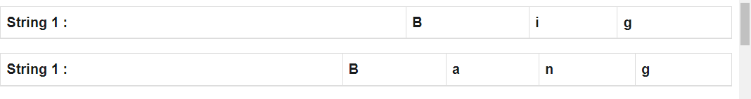
- Create a empty table where First column represents the String 1 and First Row represents the String 2 with additional Value( empty value) in both.
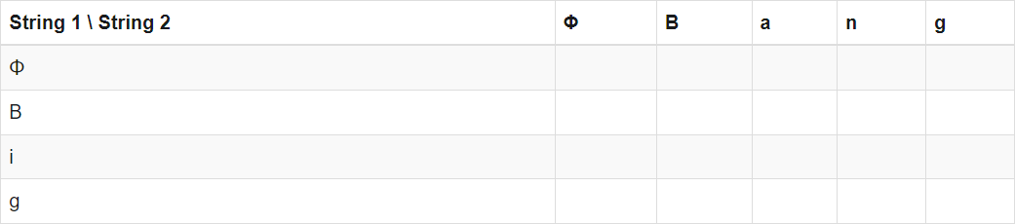
- Let us start filling the table untill one of the string is empty. We will compare
“Big” to Φ and then “Bang” to Φ.
To convert Φ to Φ, we need no operation so value is 0.
To convert B to Φ, we need 1 operation of modify, so value is 1.
To convert i to Φ, we need 2 operation of modify and insert, so value is 2.
for g to Φ, value is 3.
Similarly for Bang, values will be 0, 1, 2, 3, 4. Updated table will be
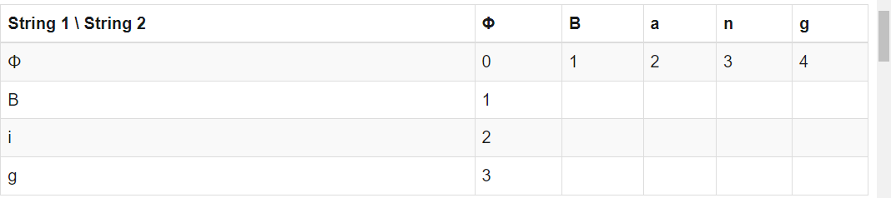
- Now check the each character of String 1 with String 2. And update the table according to approach.
If Str_1[i-1] == Str_2[j-1]: Table[i,j] = Table[i-1,j-1]
else:
Table[i,j] = 1 + min(Table[i-1][j-1], Table[i-1][j], Table[i][j-1])
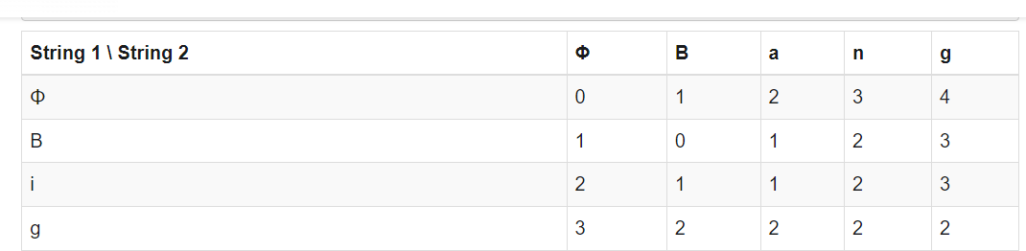
Algorithm for String Editing
Edit_Distance_Problem(Str_1, Str_2):
// length of strings N <- length of Str_1 M <- length of Str_2
//for each r = 0,...,M Initialize Table[0,r] = 0
//for each j = 1,...,N Initialize Table[j,0] = 0
//for every row For j = 1,...,N:
//for every column For r = 0,...,M:
If Str_1[j-1] == Str_2[r-1]: Table[j,r] = Table[j-1,r-1]
else:
Table[j,r] = 1 + min(Table[j-1][r-1], Table[j-1][r],Table[j][r-1]) Return Table[N,M]
Travelling Salesperson problem
Travelling salesman problem is the most notorious computational problem. We can use brute-force approach to evaluate every possible tour and select the best one. For n number of vertices in a graph, there are (n−1)! number of possibilities. Thus, maintaining a higher complexity.
However, instead of using brute-force, using the dynamic programming approach will obtain the solution in lesser time, though there is no polynomial time algorithm.

Travelling Salesman Dynamic Programming Algorithm

Let us consider a graph G = (V,E), where V is a set of cities and E is a set of weighted edges. An edge e(u, v) represents that vertices u and v are connected. Distance between vertex u and v is d(u, v), which should be non-negative.
Suppose we have started at city 1 and after visiting some cities now we are in city j. Hence, this is a partial tour. We certainly need to know j, since this will determine which cities are most convenient to visit next. We also need to know all the cities visited so far, so that we don't repeat any of them. Hence, this is an appropriate sub-problem.

For a subset of cities S ϵ {1,2,3,...,n} that includes 1, and j ϵ S,
let C(S, j) be the length of the shortest path visiting each node in S exactly once, starting at 1 and ending at j.
When |S|> 1 , we define 𝑪C(S,1)= ∝ since the path cannot start and end at 1.

Now, let express C(S, j) in terms of smaller sub-problems.
We need to start at 1 and end at j. We should select the next city in such a way that

C(S,j)=min C(S−{j},i)+d(i,j) where iϵS and i≠j
Algorithm: Traveling-Salesman-Problem
C ({1}, 1) = 0
for s = 2 to n do
for all subsets S є {1, 2, 3, … , n} of size s and containing 1
C (S, 1) = ∞
for all j є S and j ≠ 1
C (S, j) = min {C (S – {j}, i) + d(i, j) for i є S and i ≠ j}
Return minj C ({1, 2, 3, …, n}, j) + d(j, i)

Analysis
There are at the most 2^{n}.n sub-problems and each one takes linear time to solve. Therefore, the total running time is O(2^{n}.n²).

Example
In the following example, we will illustrate the steps to solve the travelling salesman problem.
From the above graph, the following table is prepared.
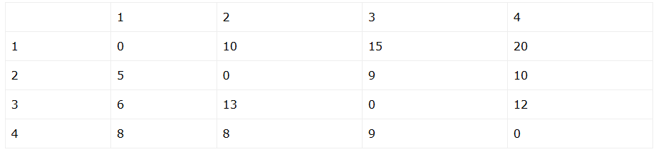
S = ΦΦ
Cost(2,Φ,1)=d(2,1)=5Cost(2,Φ,1)=d(2,1)=5
Cost(3,Φ,1)=d(3,1)=6Cost(3,Φ,1)=d(3,1)=6
Cost(4,Φ,1)=d(4,1)=8Cost(4,Φ,1)=d(4,1)=8
S = 1
Cost(i,s)=min{Cos(j,s−(j))+d[i,j]}
Cost(2,{3},1)=d[2,3]+Cost(3,Φ,1)=9+6=15
Cost(2,{4},1)=d[2,4]+Cost(4,Φ,1)=10+8=18
Cost(3,{2},1)=d[3,2]+Cost(2,Φ,1)=13+5=18
Cost(3,{4},1)=d[3,4]+Cost(4,Φ,1)=12+8=20
Cost(4,{3},1)=d[4,3]+Cost(3,Φ,1)=9+6=15
Cost(4,{2},1)=d[4,2]+Cost(2,Φ,1)=8+5=13
S = 2
Cost(2,{3,4},1)=min{d[2,3]+Cost(3,{4},1)=9+20=29d[2,4]+Cost(4,{3},1)=10+15=25=25
Cost(3,{2,4},1)=min{d[3,2]+Cost(2,{4},1)=13+18=31d[3,4]+Cost(4,{2},1)=12+13=25=25
Cost(4,{2,3},1)=min{d[4,2]+Cost(2,{3},1)=8+15=23d[4,3]+Cost(3,{2},1)=9+18=27=23
S = 3
Cost(1,{2,3,4},1)=min{d[1,2]+Cost(2,{3,4},1)=10+25=35d[1,3]+Cost(3,{2,4},1)=15+25=40d[1,4]+Cost(4,{2,3},1)=20+23=43=35
The minimum cost path is 35.
Start from cost {1, {2, 3, 4}, 1}, we get the minimum value for d [1, 2].
When s = 3, select the path from 1 to 2 (cost is 10) then go backwards.
When s = 2, we get the minimum value for d [4, 2]. Select the path from 2 to 4 (cost is 10) then go backwards.
When s = 1, we get the minimum value for d [4, 2] but 2 and 4 is already selected.
Therefore, we select d [4, 3] (two possible values are 15 for d [2, 3] and d [4, 3], but our last node of the path is 4).
Select path 4 to 3 (cost is 9), then go to s = ϕ step.
We get the minimum value for d [3, 1] (cost is 6).

Backtracking: General Method
The backtracking algorithm is a problem-solving approach that tries out all the possible solutions and chooses the best or desired ones. Generally, it is used to solve problems that have multiple solutions. The term backtracking suggests that for a given problem, if the current solution is not suitable, eliminate it and then backtrack to try other solutions.
Backtracking algorithm can be used for the following problems −
- The problem has multiple solutions or requires finding all possible solutions.
- When the given problem can be broken down into smaller subproblems that are similar to the original problem.
- If the problem has some constraints or rules that must be satisfied by the solution
- The backtracking algorithm explores various paths to find a sequence path that takes us to the solution. Along these paths, it establishes some small checkpoints from where the problem can backtrack if no feasible solution is found. This process continues until the best solution is found.
- 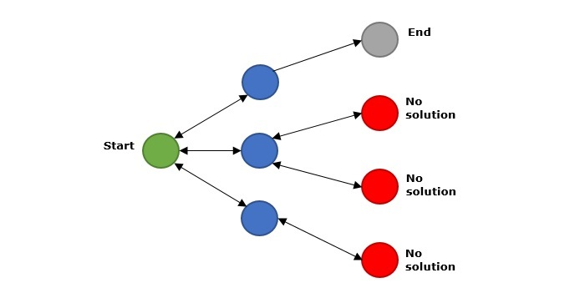
- In the above figure, green is the start point, blue is the intermediate point, red are points with no feasible solution, grey is the end solution.
- When backtracking algorithm reaches the end of the solution, it checks whether this path is a solution or not. If it is the solution path, it returns that otherwise, it backtracks to one step behind in order to find a solution.

Complexity of Backtracking
Generally, the time complexity of backtracking algorithm is exponential (0(k^{n})). In some cases, it is observed that its time complexity is factorial (0(N!)).

Types of Backtracking Problem
The backtracking algorithm is applied to some specific types of problems. They are as follows −
- Decision problem − It is used to find a feasible solution of the problem.
- Optimization problem − It is used to find the best solution that can be applied.
- Enumeration problem− It is used to find the set of all feasible solutions of the problem.

