UNIT–V
Branch and Bound: General Method
Branch and Bound is an algorithmic technique used in various optimization problems, such as solving combinatorial optimization problems, integer programming, and many others. It's particularly useful in scenarios where you want to find the optimal solution but the problem space is too large to explore exhaustively.

Key Concepts in Branch and Bound:
- Branching: This involves dividing the problem into smaller subproblems. For example, if you're solving a problem that involves making a series of decisions, you might split it into multiple branches, each representing a possible decision.
- Bounding: This step is used to calculate the upper or lower bounds of a solution within a sub problem. If a bound on a sub problem indicates that it cannot produce a better solution than the current best that sub problem can be discarded.
- Pruning: By using bounds, you can discard certain sub problems without fully exploring them, reducing the overall search space.

Steps Involved:
- Initialization: Start with the original problem and calculate an initial bound.
- Branching: Split the problem into smaller sub problems.
- Bounding: Calculate the bounds for these sub problems.
- Selection: Choose the next sub problem to explore based on certain criteria (like the lowest bound).
- Pruning: If a sub problem’s bound is worse than the current best solution, discard it.
- Termination: The algorithm terminates when there are no more sub problems to explore or when an optimal solution is found.

Example Use Case:
- Travelling Salesman Problem (TSP): Branch and Bound can be applied to find the shortest possible route that visits each city exactly once and returns to the origin city.

Advantages:
- Efficiency: It can significantly reduce the number of sub problems to explore compared to exhaustive search.
- Optimal Solutions: Capable of finding the optimal solution if executed fully.

Disadvantages:
- Computationally Intensive: For very large problems, the computational cost can still be high.
- Memory Usage: It may require a significant amount of memory to store the sub problems.

Conclusion:
Branch and Bound is a powerful technique in the arsenal of algorithm design and analysis. It strikes a balance between brute-force methods and heuristic methods, aiming to efficiently find optimal solutions without exhaustively searching through all possible solutions.

0/1 Knapsack using Least Cost Branch and Bound

Given N items with weights W[0..n-1], values V[0..n-1] and a knapsack with capacity C, select the items such that:
- The sum of weights taken into the knapsack is less than or equal to C.
- The sum of values of the items in the knapsack is maximum among all the possible combinations.
Examples:
Input: N = 4, C = 15, V[]= {10, 10, 12, 18}, W[]= {2, 4, 6, 9}
Output:
Items taken into the knapsack are
1 1 0 1
Maximum profit is 38
Explanation:
1 in the output indicates that the item is included in the knapsack while 0 indicates that the item is excluded.
Since the maximum possible cost allowed is 15, the ways to select items are:
(1 1 0 1) -> Cost = 2 + 4 + 9 = 15, Profit = 10 + 10 + 18 = 38.
(0 0 1 1) -> Cost = 6 + 9 = 15, Profit = 12 + 18 = 30
(1 1 1 0) -> Cost = 2 + 4 + 6 = 12, Profit = 32
Hence, maximum profit possible within a cost of 15 is 38.
Input: N = 4, C = 21, V[]= {18, 20, 14, 18}, W[]= {6, 3, 5, 9}
Output:
Items taken into the knapsack are
1 1 0 1
Maximum profit is 56
Explanation:
Cost = 6 + 3 + 9 = 18
Profit = 18 + 20 + 18 = 56

Approach:
In this post, the implementation of Branch and Bound method using Least cost(LC) for 0/1 Knapsack Problem is discussed.
Branch and Bound can be solved using FIFO, LIFO and LC strategies. The least cost(LC) is considered the most intelligent as it selects the next node based on a Heuristic Cost Function. It picks the one with the least cost.
As 0/1 Knapsack is about maximizing the total value, we cannot directly use the LC Branch and Bound technique to solve this. Instead, we convert this into a minimization problem by taking negative of the given values.
Follow the steps below to solve the problem:
- Sort the items based on their value/weight(V/W) ratio.
- Insert a dummy node into the priority queue.
- Repeat the following steps until the priority queue is empty:
  - Extract the peek element from the priority queue and assign it to the current node.
  - If the upper bound of the current node is less than minLB, the minimum lower bound of all the nodes explored, then there is no point of exploration. So, continue with the next element. The reason for not considering the nodes whose upper bound is greater than minLB is that, the upper bound stores the best value that might be achieved. If the best value itself is not optimal than minLB, then exploring that path is of no use.
  - Update the path array.
  - If the current node’s level is N, then check whether the lower bound of the current node is less than finalLB, minimum lower bound of all the paths that reached the final level. If it is true, update the finalPath and finalLB. Otherwise, continue with the next element.
  - Calculate the lower and upper bounds of the right child of the current node.
  - If the current item can be inserted into the knapsack, then calculate the lower and upper bound of the left child of the current node.
  - Update the minLB and insert the children if their upper bound is less than minLB.

Illustration:
N = 4, C = 15, V[]= {10 10 12 18}, W[]= {2 4 6 9}
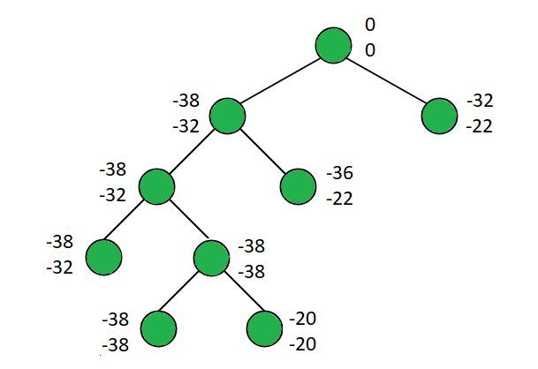
Left branch and right branch at ith level stores the maximum obtained including and excluding the ith element.
Below image shows the state of the priority queue after every step:
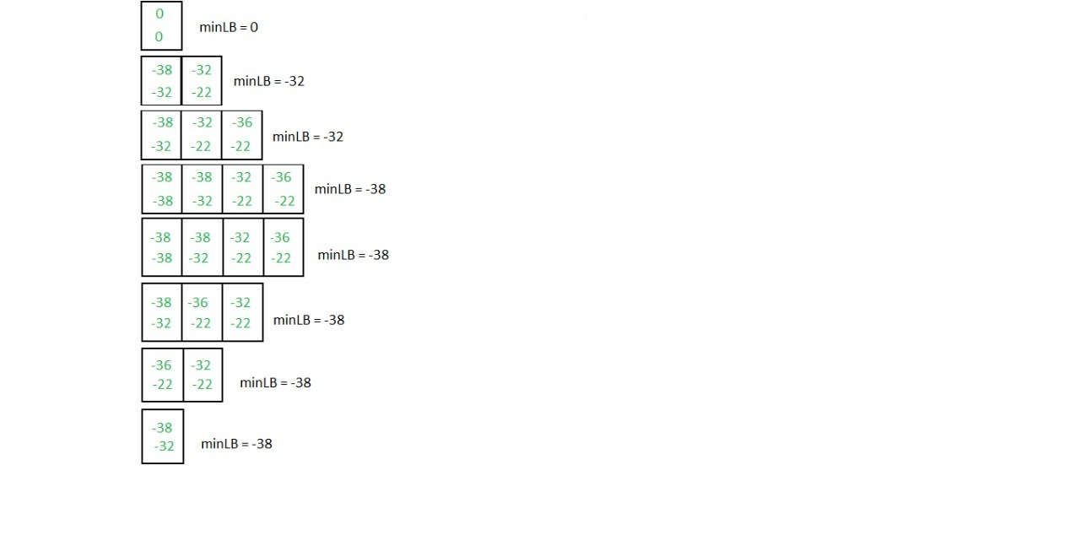

Traveling Salesman Problem using Branch And

Bound

Given a set of cities and distance between every pair of cities, the problem is to find the shortest possible tour that visits every city exactly once and returns to the starting point.
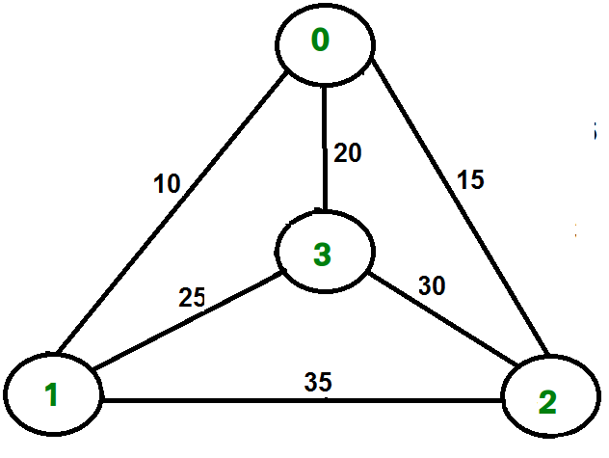
For example, consider the graph shown in figure on right side. A TSP tour in the graph is 0-1-3-2-0. The cost of the tour is 10+25+30+15 which is 80.
We have discussed following solutions
1) Naive and Dynamic Programming
2) Approximate solution using MST
Branch and Bound Solution
As seen in the previous articles, in Branch and Bound method, for current node in tree, we compute a bound on best possible solution that we can get if we down this node. If the bound on best possible solution itself is worse than current best (best computed so far), then we ignore the subtree rooted with the node.
Note that the cost through a node includes two costs.
1) Cost of reaching the node from the root (When we reach a node, we have this cost computed)
2) Cost of reaching an answer from current node to a leaf (We compute a bound on this cost to decide whether to ignore subtree with this node or not).
- In cases of a maximization problem, an upper bound tells us the maximum possible solution if we follow the given node. For example in 0/1 knapsack we used Greedy approach to find an upper bound.
- In cases of a minimization problem, a lower bound tells us the minimum possible solution if we follow the given node. For example, in Job Assignment Problem, we get a lower bound by assigning least cost job to a worker.
In branch and bound, the challenging part is figuring out a way to compute a bound on best possible solution. Below is an idea used to compute bounds for Travelling salesman problem.
Cost of any tour can be written as below.
Cost of a tour T = (1/2) * ? (Sum of cost of two edges
adjacent to u and in the
tour T)
where u ? V
For every vertex u, if we consider two edges through it in T,
and sum their costs. The overall sum for all vertices would
be twice of cost of tour T (We have considered every edge
twice.)

(Sum of two tour edges adjacent to u) >= (sum of minimum weight
two edges adjacent to
u)

Cost of any tour >= 1/2) * ? (Sum of cost of two minimum
weight edges adjacent to u)
where u ? V
For example, consider the above shown graph. Below are minimum cost two edges adjacent to every node.
Node Least cost edges Total cost
0 (0, 1), (0, 2) 25
1 (0, 1), (1, 3) 35
2 (0, 2), (2, 3) 45
3 (0, 3), (1, 3) 45

Thus a lower bound on the cost of any tour =
1/2(25 + 35 + 45 + 45)
= 75
Refer this for one more example.
Now we have an idea about computation of lower bound. Let us see how to how to apply it state space search tree. We start enumerating all possible nodes (preferably in lexicographical order)
1. The Root Node: Without loss of generality, we assume we start at vertex “0” for which the lower bound has been calculated above.
Dealing with Level 2: The next level enumerates all possible vertices we can go to (keeping in mind that in any path a vertex has to occur only once) which are, 1, 2, 3… n (Note that the graph is complete). Consider we are calculating for vertex 1, Since we moved from 0 to 1, our tour has now included the edge 0-1. This allows us to make necessary changes in the lower bound of the root.
Lower Bound for vertex 1 =
Old lower bound - ((minimum edge cost of 0 +
minimum edge cost of 1) / 2)
+ (edge cost 0-1)
How does it work? To include edge 0-1, we add the edge cost of 0-1, and subtract an edge weight such that the lower bound remains as tight as possible which would be the sum of the minimum edges of 0 and 1 divided by 2. Clearly, the edge subtracted can’t be smaller than this.
Dealing with other levels: As we move on to the next level, we again enumerate all possible vertices. For the above case going further after 1, we check out for 2, 3, 4, …n.
Consider lower bound for 2 as we moved from 1 to 1, we include the edge 1-2 to the tour and alter the new lower bound for this node.
Lower bound(2) =
Old lower bound - ((second minimum edge cost of 1 +
minimum edge cost of 2)/2)
+ edge cost 1-2)
Note: The only change in the formula is that this time we have included second minimum edge cost for 1, because the minimum edge cost has already been subtracted in previous level.

# Python3 program to solve
# Traveling Salesman Problem using
# Branch and Bound.
import math
maxsize = float('inf')

# Function to copy temporary solution
# to the final solution
def copyToFinal(curr_path):
final_path[:N + 1] = curr_path[:]
final_path[N] = curr_path[0]

# Function to find the minimum edge cost
# having an end at the vertex i
def firstMin(adj, i):
min = maxsize
for k in range(N):
if adj[i][k] < min and i != k:
min = adj[i][k]

return min

# function to find the second minimum edge
# cost having an end at the vertex i
def secondMin(adj, i):
first, second = maxsize, maxsize
for j in range(N):
if i == j:
continue
if adj[i][j] <= first:
second = first
first = adj[i][j]

elif(adj[i][j] <= second and
adj[i][j] != first):
second = adj[i][j]

return second

# function that takes as arguments:
# curr_bound -> lower bound of the root node
# curr_weight-> stores the weight of the path so far
# level-> current level while moving
# in the search space tree
# curr_path[] -> where the solution is being stored
# which would later be copied to final_path[]
def TSPRec(adj, curr_bound, curr_weight,
level, curr_path, visited):
global final_res

# base case is when we have reached level N
# which means we have covered all the nodes once
if level == N:

# check if there is an edge from
# last vertex in path back to the first vertex
if adj[curr_path[level - 1]][curr_path[0]] != 0:

# curr_res has the total weight
# of the solution we got
curr_res = curr_weight + adj[curr_path[level - 1]]\
[curr_path[0]]
if curr_res < final_res:
copyToFinal(curr_path)
final_res = curr_res
return

# for any other level iterate for all vertices
# to build the search space tree recursively
for i in range(N):

# Consider next vertex if it is not same
# (diagonal entry in adjacency matrix and
# not visited already)
if (adj[curr_path[level-1]][i] != 0 and
visited[i] == False):
temp = curr_bound
curr_weight += adj[curr_path[level - 1]][i]

# different computation of curr_bound
# for level 2 from the other levels
if level == 1:
curr_bound -= ((firstMin(adj, curr_path[level - 1]) +
firstMin(adj, i)) / 2)
else:
curr_bound -= ((secondMin(adj, curr_path[level - 1]) +
firstMin(adj, i)) / 2)

# curr_bound + curr_weight is the actual lower bound
# for the node that we have arrived on.
# If current lower bound < final_res,
# we need to explore the node further
if curr_bound + curr_weight < final_res:
curr_path[level] = i
visited[i] = True

# call TSPRec for the next level
TSPRec(adj, curr_bound, curr_weight,
level + 1, curr_path, visited)

# Else we have to prune the node by resetting
# all changes to curr_weight and curr_bound
curr_weight -= adj[curr_path[level - 1]][i]
curr_bound = temp

# Also reset the visited array
visited = [False] * len(visited)
for j in range(level):
if curr_path[j] != -1:
visited[curr_path[j]] = True

# This function sets up final_path
def TSP(adj):

# Calculate initial lower bound for the root node
# using the formula 1/2 * (sum of first min +
# second min) for all edges. Also initialize the
# curr_path and visited array
curr_bound = 0
curr_path = [-1] * (N + 1)
visited = [False] * N

# Compute initial bound
for i in range(N):
curr_bound += (firstMin(adj, i) +
secondMin(adj, i))

# Rounding off the lower bound to an integer
curr_bound = math.ceil(curr_bound / 2)

# We start at vertex 1 so the first vertex
# in curr_path[] is 0
visited[0] = True
curr_path[0] = 0

# Call to TSPRec for curr_weight
# equal to 0 and level 1
TSPRec(adj, curr_bound, 0, 1, curr_path, visited)

# Driver code

# Adjacency matrix for the given graph
adj = [[0, 10, 15, 20],
[10, 0, 35, 25],
[15, 35, 0, 30],
[20, 25, 30, 0]]
N = 4

# final_path[] stores the final solution
# i.e. the // path of the salesman.
final_path = [None] * (N + 1)

# visited[] keeps track of the already
# visited nodes in a particular path
visited = [False] * N

# Stores the final minimum weight
# of shortest tour.
final_res = maxsize

TSP(adj)

print("Minimum cost :", final_res)
print("Path Taken : ", end = ' ')
for i in range(N + 1):
print(final_path[i], end = ' ')

Output :
Minimum cost : 80
Path Taken : 0 1 3 2 0
The rounding is being done in this line of code:
if (level==1)
curr_bound -= ((firstMin(adj, curr_path[level-1]) +
firstMin(adj, i))/2);
else
curr_bound -= ((secondMin(adj, curr_path[level-1]) +
firstMin(adj, i))/2);
In the Branch and Bound TSP algorithm, we compute a lower bound on the total cost of the optimal solution by adding up the minimum edge costs for each vertex, and then dividing by two. However, this lower bound may not be an integer. To get an integer lower bound, we can use rounding.
In the above code, the curr_bound variable holds the current lower bound on the total cost of the optimal solution. When we visit a new vertex at level level, we compute a new lower bound new_bound by taking the sum of the minimum edge costs for the new vertex and its two closest neighbors. We then update the curr_bound variable by rounding new_bound to the nearest integer.
If level is 1, we round down to the nearest integer. This is because we have only visited one vertex so far, and we want to be conservative in our estimate of the total cost of the optimal solution. If level is greater than 1, we use a more aggressive rounding strategy that takes into account the fact that we have already visited some vertices and can therefore make a more accurate estimate of the total cost of the optimal solution.
Time Complexity: The worst case complexity of Branch and Bound remains same as that of the Brute Force clearly because in worst case, we may never get a chance to prune a node. Whereas, in practice it performs very well depending on the different instance of the TSP. The complexity also depends on the choice of the bounding function as they are the ones deciding how many nodes to be pruned.

NP HARD AND NP COMPLETE:

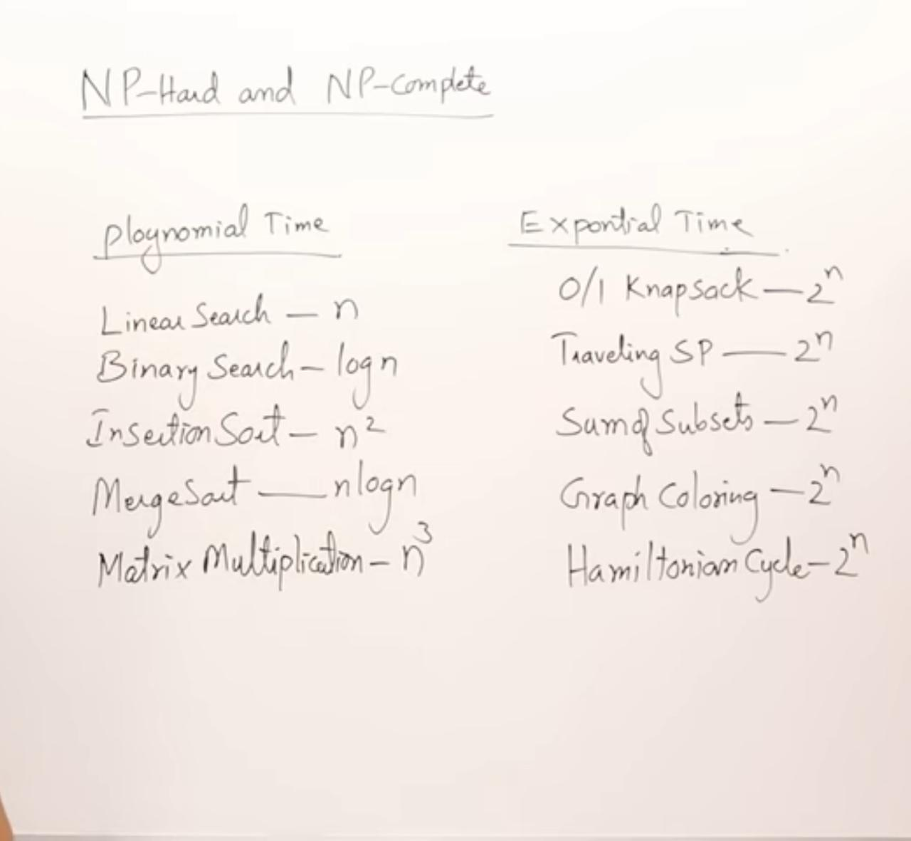

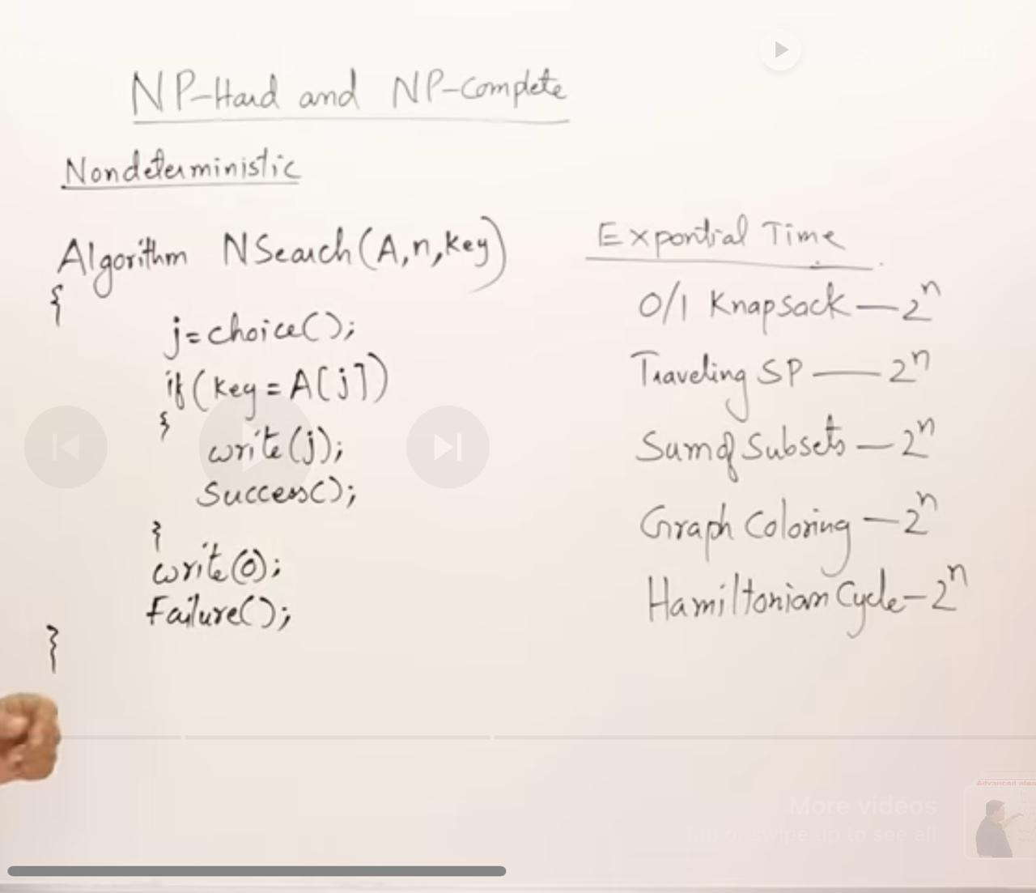

Types of Complexity Classes
This article discusses the following complexity classes:
- P Class
- NP Class
- NP-hard
- NP-complete

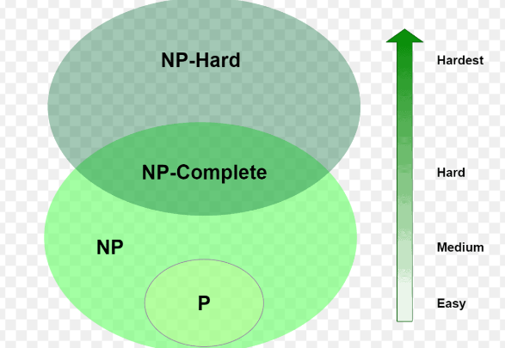

P Class
The P in the P class stands for Polynomial Time. It is the collection of decision problems(problems with a “yes” or “no” answer) that can be solved by a deterministic machine in polynomial time.
Features:
- The solution to P problems is easy to find.
- P is often a class of computational problems that are solvable and tractable. Tractable means that the problems can be solved in theory as well as in practice. But the problems that can be solved in theory but not in practice are known as intractable.

This class contains many problems:
- Calculating the greatest common divisor.
- Finding a maximum matching.
- Merge Sort

NP Class
The NP in NP class stands for Non-deterministic Polynomial Time. It is the collection of decision problems that can be solved by a non-deterministic machine in polynomial time.

Features:
- The solutions of the NP class are hard to find since they are being solved by a non-deterministic machine but the solutions are easy to verify.
- Problems of NP can be verified by a Turing machine in polynomial time.

Example:
Let us consider an example to better understand the NP class. Suppose there is a company having a total of 1000 employees having unique employee IDs. Assume that there are 200 rooms available for them. A selection of 200 employees must be paired together, but the CEO of the company has the data of some employees who can’t work in the same room due to personal reasons.
This is an example of an NP problem. Since it is easy to check if the given choice of 200 employees proposed by a coworker is satisfactory or not i.e. no pair taken from the coworker list appears on the list given by the CEO.

But generating such a list from scratch seems to be so hard as to be completely impractical.

It indicates that if someone can provide us with the solution to the problem, we can find the correct and incorrect pair in polynomial time. Thus for the NP class problem, the answer is possible, which can be calculated in polynomial time.

This class contains many problems that one would like to be able to solve effectively:
- Boolean Satisfiability Problem (SAT).
- Hamiltonian Path Problem.
- Graph coloring.

NP-hard class
An NP-hard problem is at least as hard as the hardest problem in NP and it is a class of problems such that every problem in NP reduces to NP-hard.

Features:
- All NP-hard problems are not in NP.
- It takes a long time to check them. This means if a solution for an NP-hard problem is given then it takes a long time to check whether it is right or not.
- A problem A is in NP-hard if, for every problem L in NP, there exists a polynomial-time reduction from L to A.

Some of the examples of problems in Np-hard are:
- Halting problem.
- Qualified Boolean formulas.
- No Hamiltonian cycle.

NP-complete class
A problem is NP-complete if it is both NP and NP-hard. NP-complete problems are the hard problems in NP.

Features:

- NP-complete problems are special as any problem in NP class can be transformed or reduced into NP-complete problems in polynomial time.
- If one could solve an NP-complete problem in polynomial time, then one could also solve any NP problem in polynomial time.

Some example problems include:
- Hamiltonian Cycle.
- Satisfiability.
- Vertex cover.

Complexity Class | Characteristic feature
P | Easily solvable in polynomial time.
NP | Yes, answers can be checked in polynomial time.
Co-NP | No, answers can be checked in polynomial time.
NP-hard | All NP-hard problems are not in NP and it takes a long time to check them.
NP-complete | A problem that is NP and NP-hard is NP-complete.

The main difference between NP-hard and NP-complete problems lies in two criteria: whether the problem is in the class NP and the type of verification or solution required.

Key Differences:
- Verification in Polynomial Time:
  - NP-complete problems: Are part of the class NP, meaning that given a candidate solution, we can verify its correctness in polynomial time.
  - NP-hard problems: Do not necessarily have to be in NP. For NP-hard problems, a candidate solution may not be verifiable in polynomial time, or it may not even have a "solution" that can be verified (e.g., optimization problems rather than decision problems).
- Problem Type:
  - NP-complete problems: Are decision problems with yes-or-no answers (e.g., "Does a subset of these numbers sum to a specific value?").
  - NP-hard problems: Can include decision problems and more complex problems like optimization problems (e.g., "What is the shortest path covering all cities?"), which are often not in NP.
- Relationship to NP:
  - NP-complete problems: Are the "hardest" problems within NP. If any NP-complete problem can be solved in polynomial time, then every problem in NP can also be solved in polynomial time (which would prove P=NPP = NPP=NP).
  - NP-hard problems: Are at least as hard as NP-complete problems, but they don’t have to belong to NP. Solving an NP-hard problem in polynomial time doesn’t imply all NP problems can be solved in polynomial time.

Examples:
- NP-complete: Subset Sum Problem (decides if there is a subset with a sum equal to a target) or Boolean Satisfiability Problem (SAT).
- NP-hard: Traveling Salesman Problem (TSP) (optimizing the shortest route that visits each city once).

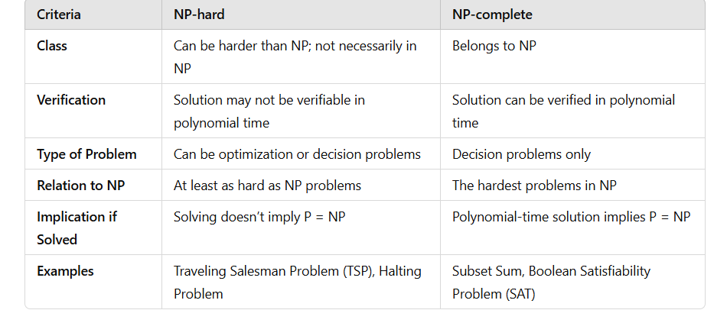

Cook’s Theorem:
Cook’s Theorem is a foundational result in computational complexity theory, proved by Stephen Cook in 1971. It was the first theorem to formally identify an NP-complete problem and established the concept of NP-completeness.

Key Points of Cook’s Theorem:
- The SAT Problem:
  - Cook’s Theorem specifically addresses the Boolean Satisfiability Problem (SAT). In SAT, given a Boolean formula with variables, we are asked if there exists an assignment of truth values (true/false) to these variables that makes the entire formula true.
  - SAT is a decision problem: the answer is either "yes" (a satisfying assignment exists) or "no" (no such assignment exists).
- Statement of the Theorem:
  - Cook's Theorem states that the Boolean Satisfiability Problem (SAT) is NP-complete.
  - This means SAT is both in NP (solutions can be verified in polynomial time) and NP-hard (as hard as any other problem in NP).
- Implications:
  - SAT as a Universal NP Problem: Cook’s Theorem shows that any problem in NP can be transformed (reduced) into an instance of SAT in polynomial time. This reduction implies that SAT is representative of the complexity of all NP problems.
  - Basis for NP-completeness: Cook’s Theorem established the concept of NP-completeness. After this theorem, many other problems were shown to be NP-complete by reducing SAT to them in polynomial time.
- Reductions:
  - Polynomial-Time Reduction: Cook’s Theorem shows that every problem in NP can be reduced to SAT in polynomial time, meaning that if we have a polynomial-time solution for SAT, we can solve every problem in NP in polynomial time.
  - The concept of reductions from SAT to other problems is fundamental to proving that other problems are NP-complete.

Importance of Cook's Theorem:
- Foundation of NP-completeness: Cook's Theorem provided a systematic way to classify hard problems within NP.
- Influence on Computational Theory: It led to the discovery of many other NP-complete problems, advancing understanding of computational complexity and the famous P vs NP problem.
In summary, Cook’s Theorem is significant because it established SAT as the first known NP-complete problem, enabling the classification of other problems in NP-completeness and shaping complexity theory as we know it.

CLIQUE DECISION PROBLEM (CDP):
The Clique Decision Problem is a well-known problem in graph theory and computational complexity. It belongs to the class of NP-complete problems and is closely studied in the field of computer science.

Definition of the Clique Decision Problem:
- Problem Statement:
  - Given an undirected graph G=(V,E) with vertices V and edges E, and a positive integer k,
  - The problem asks: Does the graph G contain a clique of size k?
  - A clique in a graph is a subset of vertices where every pair of vertices is connected by an edge, forming a complete subgraph.
- Decision Problem Format:
  - The Clique Decision Problem is a decision problem because it requires a yes-or-no answer.
  - Example: Given a graph with vertices V={A,B,C,D} and edges that form a complete subgraph between vertices {A,B,C} if k=3, the answer is "yes" (a clique of size 3 exists).
- Example:
  - Consider a graph with vertices {1,2,3,4} and edges between pairs {(1,2),(1,3),(2,3),(3,4)}
  - If k=3, there is a clique of size 3 formed by vertices {1,2,3} (since each pair of these vertices is connected).
  - If k=4, there is no clique of size 4, so the answer is "no."
- Complexity and NP-completeness:
  - The Clique Decision Problem is NP-complete, meaning that it is as hard as the hardest problems in NP.
  - NP: If a subset of vertices forming a clique is given, verifying that it is indeed a clique (i.e., that every pair of vertices is connected) can be done in polynomial time.
  - NP-hardness: Determining if a clique of a certain size exists is computationally intensive; every problem in NP can be reduced to the Clique Decision Problem in polynomial time.
- Applications:
  - The Clique Decision Problem has applications in social network analysis (finding tightly-knit groups of people), bioinformatics (identifying dense subgraphs in protein interaction networks), and optimization.
In summary, the Clique Decision Problem asks if a given graph contains a complete subgraph (clique) of a specified size kkk. It is significant in theoretical computer science as a classic NP-complete problem.

Chromatic Number Decision Problem (CNDP)
The Chromatic Number Decision Problem (CNDP) is a fundamental problem in graph theory and theoretical computer science. It is defined as follows:

Problem Statement:
Given a graph G=(V,E)G = (V, E)G=(V,E) and an integer kkk, decide whether the graph GGG can be colored using at most kkk colors such that no two adjacent vertices share the same color.

Explanation:
- Graph Coloring: Assigning colors to the vertices of a graph so that adjacent vertices (connected by an edge) receive different colors.
- Chromatic Number (χ(G)\chi(G)χ(G)): The smallest number of colors needed to properly color the vertices of GGG.
- Decision Variant: Instead of determining the exact chromatic number, the CNDP asks if χ(G)≤k\chi(G) \leq kχ(G)≤k.

Complexity:
- CNDP is NP-complete.
  - Proving χ(G)≤k\chi(G) \leq kχ(G)≤k involves finding a valid coloring, which is computationally hard as the graph size grows.
  - Verifying a solution (given a coloring) is straightforward and can be done in polynomial time.
- As it is NP-complete, CNDP is as hard as other classic problems like the Traveling Salesman Problem or 3-SAT.

Applications:
- Scheduling Problems: Assigning tasks, meetings, or exams to timeslots without conflicts.
- Frequency Assignment: Allocating radio frequencies to avoid interference.
- Map Coloring: Ensuring neighboring regions on a map get different colors.

Approaches to Solve:
- Exact Algorithms: Use brute force or backtracking. Effective for small graphs.
- Approximation Algorithms: Provide near-optimal solutions for large graphs.
- Heuristics: Greedy coloring and other practical strategies for specific use cases.
- Parameterized Complexity: Focus on fixed parameters like treewidth or graph size.

Traveling Salesperson problem in branch and bound
The Traveling Salesperson Problem (TSP) can be efficiently tackled for small to medium-sized instances using the Branch and Bound (B&B) algorithm. This method systematically explores all possible solutions, but with pruning to avoid unnecessary computation, making it more efficient than brute force.

Problem Definition:
Given a set of cities and the distances between every pair of cities, find the shortest possible route that visits each city exactly once and returns to the starting city.

Branch and Bound Method for TSP

1. Representation of the Problem:
- Represent the problem as a complete graph G=(V,E)G = (V, E)G=(V,E), where:
  - VVV: Set of cities (vertices).
  - EEE: Set of edges with weights representing distances or costs.
- The goal is to find a Hamiltonian cycle with the minimum cost.

2. Steps of the Algorithm:
Step 1: Start with the Root Node.
- At the root, all cities are unvisited except the starting city.
- Compute a lower bound (LB) for the cost of the solution using a heuristic, such as:
  - Minimum spanning tree (MST).
  - Sum of the smallest two edge costs for each vertex.
- Add this bound to the current partial cost (initially 0).
Step 2: Branching.
- Divide the problem into subproblems by choosing the next city to visit.
- Each branch represents a choice of the next city to add to the tour.
Step 3: Calculate the Lower Bound for Each Subproblem.
- Recalculate the lower bound for the current state of the tour, considering:
  - Remaining cities.
  - Remaining edges (using reduced cost matrix or other methods).
Step 4: Pruning.
- If the bound of a subproblem exceeds the cost of the best solution found so far, discard that branch.
Step 5: Search for Optimal Solution.
- Continue branching and pruning until all promising branches are explored.
- The best solution found during the process is the optimal tour.

3. Key Concepts:
- Lower Bound (LB):
  - A heuristic estimate of the minimum possible cost of completing the tour.
  - A common approach is using a reduced cost matrix:
    - Subtract the smallest value in each row and column from all elements to get a reduced matrix.
    - The sum of the reductions gives a lower bound.
- Pruning:
  - Eliminate branches that cannot lead to a better solution than the best known so far.
  - This is based on the LB calculated at each node.
- Priority Queue:
  - Nodes in the B&B tree are stored in a priority queue.
  - Nodes with the smallest LB are explored first (best-first search).

4. Advantages of Branch and Bound:
- Efficient pruning can significantly reduce the number of solutions to evaluate.
- Guarantees an optimal solution.

5. Limitations:
- Computationally expensive for large instances.
- The effectiveness depends heavily on the quality of the lower bound.

Example:
Consider 4 cities with the following cost matrix:
Cost Matrix:[∞10152010∞35251535∞30202530∞]\text{Cost Matrix:} \begin{bmatrix} \infty & 10 & 15 & 20 \\ 10 & \infty & 35 & 25 \\ 15 & 35 & \infty & 30 \\ 20 & 25 & 30 & \infty \end{bmatrix}Cost Matrix:​∞101520​10∞3525​1535∞30​202530∞​​
- Start at City 1.
- Compute the lower bound for the root node using row and column reductions.
- Branch to other cities and compute bounds for subproblems.
- Prune branches where the lower bound exceeds current best cost.
- Continue until an optimal solution (shortest tour) is found.

