PYTHON & BASH
DEVOPS | ASSIGNMENT
Assignment Documentation
Student: Tarun Kumar Vashisth
GitHub: https://github.com/tarunvashist18/Python-and-Bash-Assignment

1. Objective
Practise Python conditionals, dictionaries, file handling, functions, loops, menu-driven programming, and error handling.

2. Grade Checker
Aim: Takes a score and assigns A, B, C, D, or F according to the required score ranges.

Code
score = int(input("Enter your score: "))
if score >= 90:
grade = 'A'
elif score >= 80:
grade = 'B'
elif score >= 70:
grade = 'C'
elif score >= 60:
grade = 'D'
else:
grade = 'F'
print("Your grade is: ", grade)

Execution Command
python grade_checker.py

3. Student Grades
Aim: Uses a dictionary to add a new student or update an existing student's grade and print all grades.

Code
students = {
"Tarun": "A",
"Rahul": "B",
"Aman": "C"
}
print("Current Student Grades:")
for name, grade in students.items():
print(name, ":", grade)
name = input("\nEnter student name: ")
grade = input("Enter grade: ")
if name in students:
students[name] = grade
print("Student grade updated.")
else:
students[name] = grade
print("New student added.")
print("\nUpdated Student Grades:")
for name, grade in students.items():
print(name, ":", grade)

Execution Command
python student_grades.py

4. Write to a File
Aim: Creates sample.txt and writes content using open() and write().

Code
file = open("sample.txt", "w")
file.write("Hello! This is my Python and Bash assignment.\n")
file.write("I am learning file handling in Python.\n")
file.write("Python can create and write text files.")
file.close()
print("Content written to sample.txt successfully.")

Execution Command
python write_file.py

5. Read from a File
Aim: Opens sample.txt in read mode, uses file.read(), and displays the content.

Code
file = open("sample.txt", "r")
content = file.read()
print("File Content:")
print(content)
file.close()

Execution Command
python read_file.py

6. Execution Screenshots

7. Menu-Driven Calculator
The calculator implements the missing requirements: addition, subtraction, multiplication, division, separate functions, a repeating menu loop, and division-by-zero error handling.
- Menu-driven calculator logic for addition, subtraction, multiplication, and division.
- Separate add(), subtract(), multiply(), and divide() functions.
- A while loop repeatedly displays the menu and prompts the user for an operation.
- Division by zero is handled using a zero check and ZeroDivisionError.
- Invalid menu choices and invalid numeric input are also handled.

Calculator Code
def add(a, b):
return a + b
def subtract(a, b):
return a - b
def multiply(a, b):
return a * b
def divide(a, b):
if b == 0:
raise ZeroDivisionError("Cannot divide by zero.")
return a / b
while True:
print("\n===== Simple Calculator =====")
print("1. Addition")
print("2. Subtraction")
print("3. Multiplication")
print("4. Division")
print("5. Exit")
choice = input("Enter your choice: ")
if choice == "5":
print("Exiting calculator.")
break
if choice not in ("1", "2", "3", "4"):
print("Invalid choice. Please select 1-5.")
continue
try:
num1 = float(input("Enter first number: "))
num2 = float(input("Enter second number: "))
if choice == "1":
print("Result:", add(num1, num2))
elif choice == "2":
print("Result:", subtract(num1, num2))
elif choice == "3":
print("Result:", multiply(num1, num2))
elif choice == "4":
try:
print("Result:", divide(num1, num2))
except ZeroDivisionError as error:
print("Error:", error)
except ValueError:
print("Error: Please enter valid numbers.")

Execution Command
python calculator.py

Calculator Operations and Division-by-Zero Evidence
The calculator was executed and verified for addition, subtraction, multiplication, division, repeated menu use, and division by zero.
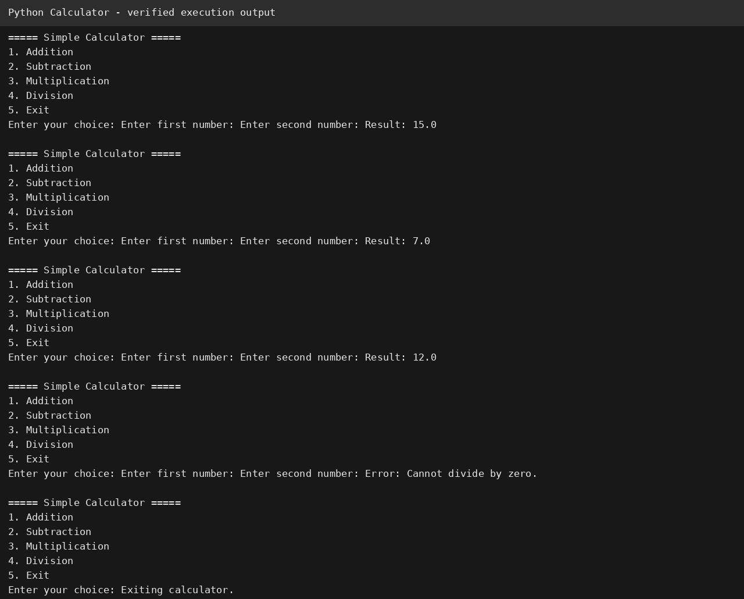

8. GitHub Repository
https://github.com/tarunvashist18/Python-and-Bash-Assignment
Note: the GitHub repository should be updated with calculator.py before submission so the repository matches this final ZIP.

9. Conclusion
All listed Python tasks and the menu-driven calculator requirements have been implemented and tested. Source files, documentation, and execution evidence are included in this ZIP.

