**MILES User MANUAL**

Contents

S-Box to DDT 2

DDT To Truth Table 3

Truth Table Minimization 5

Linear Inequalities Generation 7

Contact Us 8

# S-Box to DDT

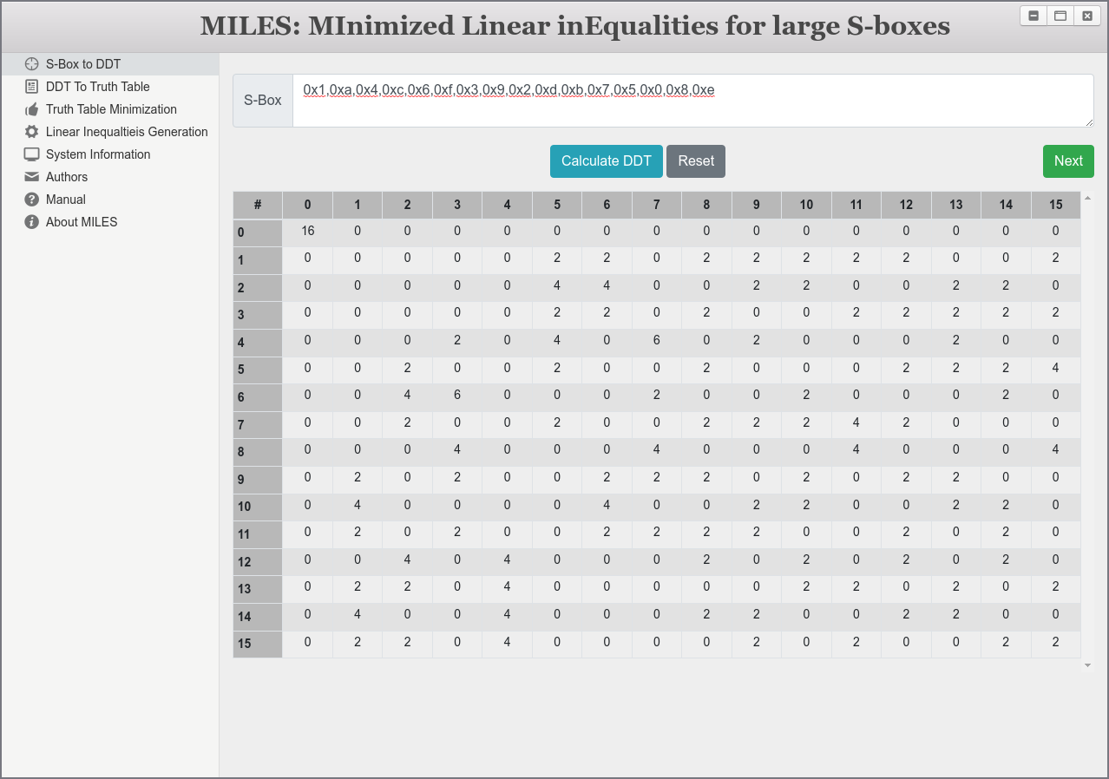

# DDT To Truth Table

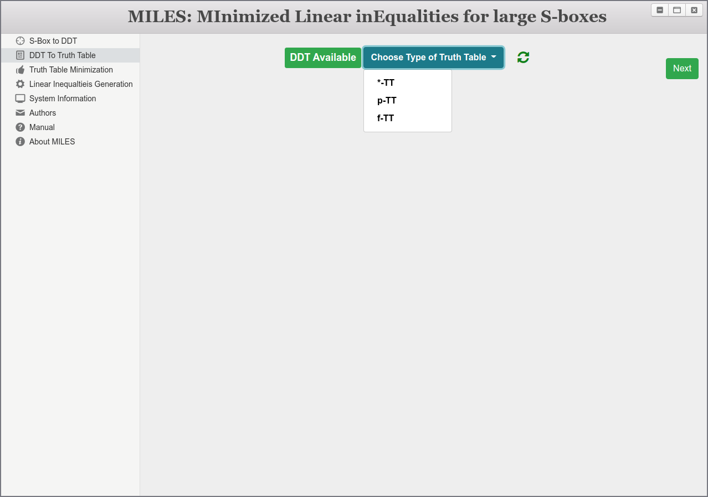

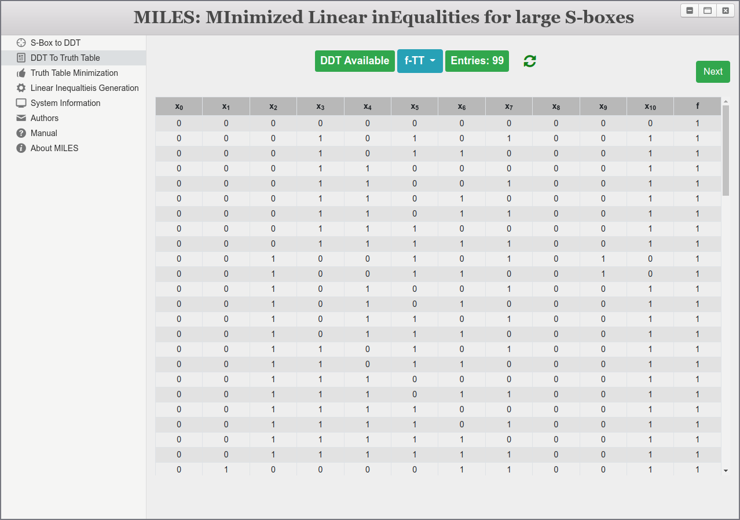

# Truth Table Minimization

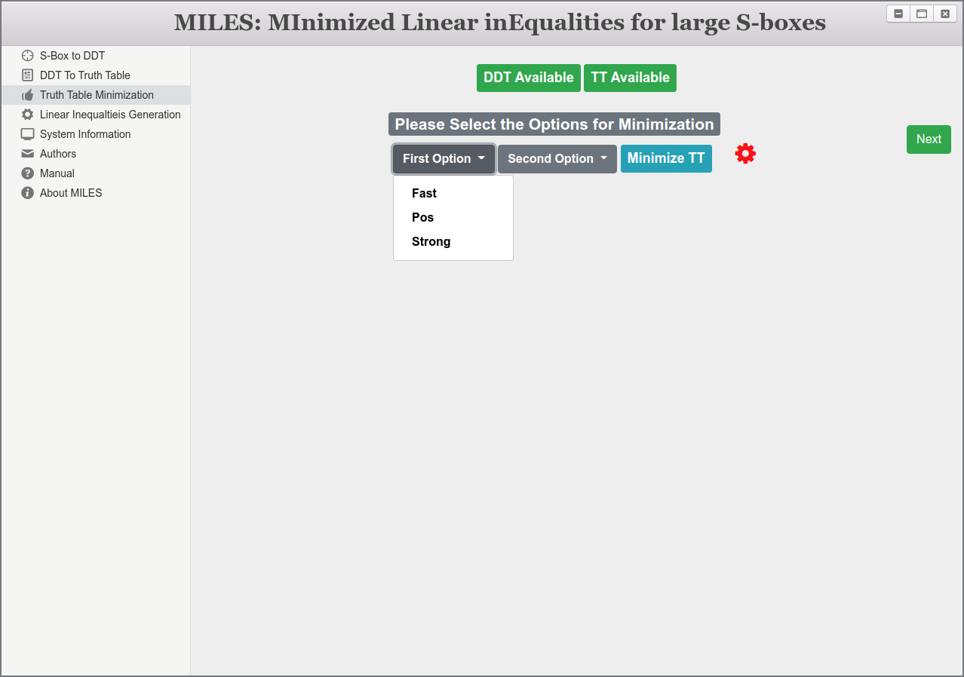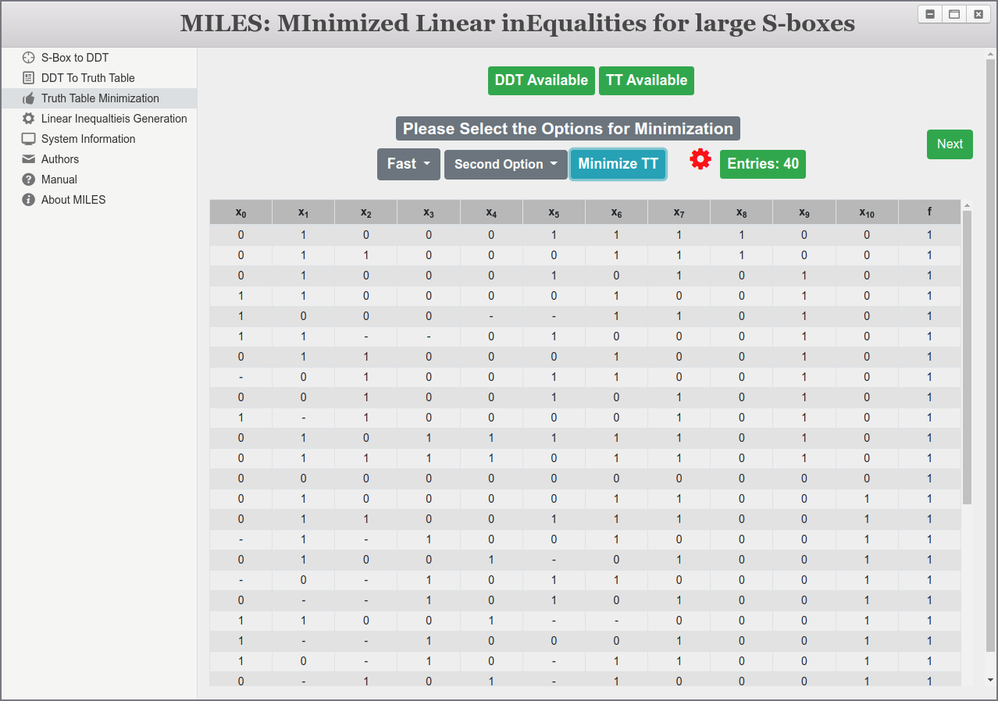

# Linear Inequalities Generation

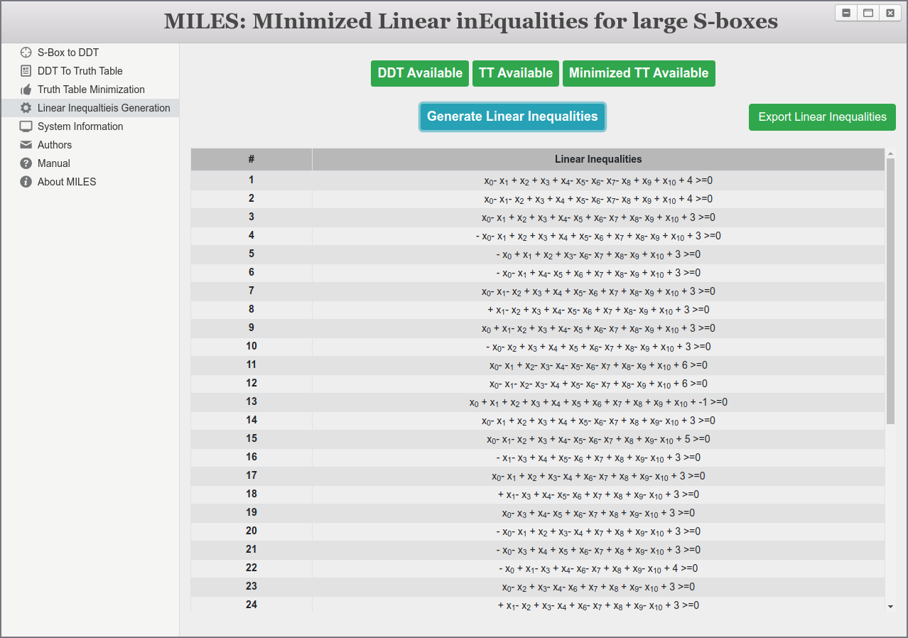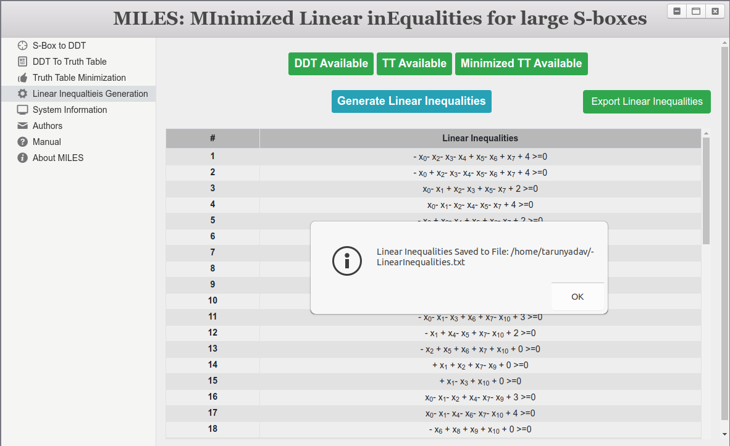

# Contact Us

