The Databento Extension
How the 2025–2026 SPY options dataset was sourced, processed and validated.
353 trading sessions, 2025-01-02 to 2026-06-01, 11,036,871 quote records and 1,880,602 reshaped rows, acquired for $8.11. This document covers that extension only — what was bought and why, what was checked, everything that went wrong, and what the result can and cannot support. It does not cover the pricing methodology; PROJECT_WALKTHROUGH.docx does that.

1. What was pulled, and why
Three schemas, from two Databento datasets. Each was chosen for what it structurally contains, not for price — the alternatives below were rejected because they cannot supply what the pipeline needs, and only the two schemas actually used were priced.
Schema | Dataset | What it gives | Why it was needed
cbbo-1m | OPRA.PILLAR | One consolidated best-bid/offer record per instrument per minute | The pipeline needs a two-sided quote for every listed strike, including illiquid wings — that is the whole smile
definition | OPRA.PILLAR | Strike, expiry and put/call for every instrument_id | Without it a cbbo row is a numeric id with no strike attached. Not optional
ohlcv-1d | EQUS.SUMMARY | One consolidated daily bar for SPY | OPRA carries no underlying price. UNDERLYING_LAST has to come from an equities feed

Alternatives considered and rejected
Alternative | Why not
ohlcv-1m / ohlcv-1d on OPRA | Trade-derived bars. An option that does not trade inside the window produces no bar at all. The far wings — which pin the SABR skew and curvature — trade rarely or never on a given day, so most of the smile would simply be absent
tcbbo | The BBO sampled at trade times. Same defect as OHLCV: it only exists where a trade occurred, so coverage follows liquidity rather than listing
cmbp-1 | Consolidated market-by-price, top of book. It would work, but it is event-level rather than bar-level — far more records for the same information at one-minute granularity, and Databento prices by record volume
Single-venue equity feeds (XNAS.ITCH, XNAS.BASIC, XNYS.PILLAR) | Nasdaq and NYSE are not SPY's listing venue; their last print is not the official close
ARCX.PILLAR (SPY's primary listing venue) | Pulled anyway as a cross-check, on the theory that the primary venue gives the most official close. It does not — see §3.4. Rejected on evidence, not on reasoning
DBEQ.BASIC | Consolidated and would have served, but 8× the price of EQUS.SUMMARY ($0.004418 vs $0.000552) for the same daily close

The three-minute pre-close window
The pipeline consumes one end-of-day snapshot per session, so the pull takes 15:57–16:00 ET and keeps each contract's last bar. The window is DST-resolved per date with zoneinfo rather than a hardcoded UTC hour — 16:00 ET is 20:00 UTC in summer and 21:00 UTC in winter, and getting that wrong silently returns the wrong three minutes.
Cost checks established that a contiguous pull of every hour would cost about 20× more — $168.08 against $8.39 for a comparable year — for data the pipeline discards. The reason the ratio is only 20× and not the ~480× the wall-clock difference implies is that pricing tracks record volume, and the last three minutes before the close are the densest part of the session while the overnight hours are nearly empty. The chosen window is roughly 5% of a full day's cost.

2. The validation step
Before extending to a new period, Databento data was pulled for 2023-12-29 — the original reference date — and run through the project's own unchanged code. If the two vendors disagreed materially on a date where every answer is already known, no later conclusion could be separated from the data feed. Cost: $0.0390.
imply_forward_from_parity and baw.implied_volatility were called with no modification. The instrument_id join was verified independently: the OSI symbol on each quote matched the symbol on its definition for all 312 instruments, and the joined chain came to 156 strikes — exactly the 156 the project already had.
Quantity | Project (OptionsDX) | Databento | Difference
Chain strikes, 2024-02-16 | 156 | 156 | 0
Parity forward | $478.8920 | $478.8495 | −$0.0425 (0.89 bp)
Forward dispersion | $0.203 (22 strikes) | $0.182 (32 strikes) | tighter
Median mid price, 151 strikes | — | — | $0.0000
Median re-implied implied vol | — | — | 0.0000 vol points
95th percentile |IV difference| | — | — | 0.2286 vol points
Strikes differing by >1 vol point | — | — | 1 of 151
The $475 put, bid/ask | 6.51 / 6.54 | 6.58 / 6.61 | mid +$0.0700
Crossed OTM quotes | 2 (K=477, 478) | 0 | —
Re-implied crossover gap, 476→479 | −0.2088 | −0.2164 | 0.007 vol points

The $475 put
Worth naming because it is the contract the headline VaR rests on, and because +$0.07 is the largest single positive mid difference in the sample (the range is −$0.225 to +$0.070), not a typical one. In implied-vol terms it is +0.104 vol points. Both vendors quote a three-cent spread, so the gap is snapshot timing: OptionsDX stamps 16:00, Databento's bar covers 15:59–16:00. The single difference above one vol point is K=260, a deep-wing penny put where a one-cent disagreement is amplified by near-zero vega.

What it settled, and what it did not
Settled: the vendor's kink was the vendor's. OptionsDX implied vols stepped +0.291 vol points upward across a downward-sloping smile — an impossible shape no smooth curve can fit, and the reason Phase 3 re-implies volatilities at all. Databento does not reproduce it. Relatedly, the two crossed put quotes at strikes 477 and 478 that forced those strikes out of the smile are clean and two-sided in Databento, which has zero crossed quotes in the whole out-of-the-money chain.
Not settled: the residual is real. Measuring the gap against a fitted wing slope rather than the project's two-point slope, the residual anomaly is +0.1704 for the project and +0.1697 for Databento on identical strikes — agreement to 0.0007 vol points. The inconsistency Phase 3 documented survives a change of data provider. The check also found that assumption #15's own figure is untrustworthy: its −0.058 prediction comes from a two-point local slope that one seven-cent quote flattens 5.6× and flips in sign.
Conclusion. Every headline quantity agrees within cross-vendor noise; the project's own code runs unmodified on the new source and produces consistent results. That is what licenses treating any later difference between the two reference cases as a market difference rather than a data-feed difference.

3. Every hiccup, and how it was solved
Nine problems, in the order they appeared. Four were mistakes in code written for this extension rather than external obstacles, and are marked as such — a list of only the outside world's failures would misrepresent how the work went.
# | Problem | Origin
3.1 | map_symbols rejected with DBN encoding | Own error
3.2 | Network outage consumed 183 sessions of retries | External, mishandled
3.3 | NYSE early closes invisible to the derived calendar | External blind spot
3.4 | One-off exchange closure invisible to the derived calendar | External blind spot
3.5 | Download skip-check never matched; 137 files re-downloaded | Own error
3.6 | Definition coverage decayed to 89% between quarterly anchors | Design choice, corrected
3.7 | Wrong recommendation on which equity feed to trust | Own error, caught by evidence
3.8 | build_otm_smile returned zero strikes on the new data | Structural, anticipated late
3.9 | Off-by-one stress-window date, and the silent drop it exposed | Own error

3.1 map_symbols rejected with DBN encoding
What happened. The first batch submission failed with 422 data_dbn_encoding_with_map_symbols. DBN is a binary format and cannot carry a symbology mapping.
What was done. Set map_symbols=False. No loss: the instrument_id to strike/expiry/type mapping comes from the definition files, which is exactly the join the validation step had already proven. Cost: one failed submission, nothing billed.

3.2 The network outage
What happened. DNS resolution failed partway through submitting 272 jobs. The submitter caught each failure, logged it, and moved to the next session — so a brief outage consumed 183 sessions in seconds, each marked failed without ever being attempted properly.
What was done. The tracking file did its job: 89 completed jobs were recorded and resume skipped them, so nothing was lost or double-billed. But the retry logic was wrong. It now retries the SAME session with backoff (5s to 300s) and only gives up after six attempts, distinguishing transient network errors from real refusals. The 183 sessions were then submitted normally.
Worth remembering. A resumable tracking file written and fsynced after every single submission is what made a mid-run outage a nuisance rather than a re-spend.

3.3 NYSE early closes
What happened. Three sessions returned 422 data_no_data_found_for_request: 2025-07-03, 2025-11-28 and 2025-12-24. The NYSE closes at 1pm ET on about three days a year — the day before Independence Day, the day after Thanksgiving, and Christmas Eve.
What was done. Those dates are now listed explicitly in EARLY_CLOSE_DAYS and pulled at the 13:00 ET close. All three then returned normal volumes: 26,022, 31,440 and 26,959 rows against a 30,273 median.
Worth remembering. This is more dangerous than a full closure. nyse_trading_days() correctly reports them as trading days, so a 16:00 window looks entirely ordinary while sitting three hours after the bell — it would have returned nothing, or worse, stale quotes, with nothing flagging it. It never surfaced in the 2010–2023 work because OptionsDX stamps one EOD row per day regardless of session length.

3.4 A one-off exchange closure
What happened. 2025-01-09 failed differently: 422 symbology_invalid_request, "none of the symbols could be resolved". No SPY option was active at all. The NYSE was closed for the national day of mourning for President Carter.
What was done. Listed in ONE_OFF_CLOSURES and excluded from the session count, which is factually correct — the exchange did not open. 353 sessions, not 354.
Worth remembering. The two failure modes are distinguishable, and that distinction is now documented in the code: on a short session the symbols resolve and the window is merely empty; on a full closure there is no symbology to resolve. This is exactly the class of defect PROJECT_LOG assumption #6 says should surface for a human rather than be silently absorbed — and it did.

3.5 The download skip-check that never matched
What happened. batch.download nests its output under a job-id subfolder. The skip-check globbed {date}/*.dbn.zst, one level too shallow, so it never matched anything already on disk. Every download pass re-downloaded everything — visible as "already present 0" against 52 existing folders.
What was done. Made the glob recursive. Harmless in cost terms, since downloading a completed batch job is not billed, but it wasted time and the log line that revealed it had been sitting in plain view for two passes.

3.6 The definition coverage gap
What happened. Definitions were first pulled quarterly, on the reasoning that instrument definitions are largely static. They are not static enough: contracts listed between anchors have no definition, so the match rate decayed from 100% near an anchor to 89.3% by 2026-03-17.
What was done. Two options were priced with get_cost before anything was submitted: one contiguous range job at $6.3413, or 353 per-session jobs at an estimated $6.6987. The range job was both cheaper and 353× simpler, and split_duration="day" made it land as one file per session. Match rate went to 100.0000% across all 11,036,871 rows, with zero unmatched instruments on any day.
Worth remembering. The near-identical price of the two options is itself the finding: had the range job returned a deduplicated instrument list it would have cost a fraction of 353 day-pulls. Costing 95% of them is the evidence that it contains a full snapshot per day.

3.7 The wrong recommendation on which equity feed to trust
What happened. OPRA carries no underlying price, so UNDERLYING_LAST was first derived from the options themselves — put-call parity gives a forward per expiry, and regressing log-forward on tenor yields both spot and carry without assuming a dividend yield. That derivation passed three independent checks: it recovered SPY's ~1.31% dividend yield unprompted, reproduced the April 2025 selloff and rebound on the correct dates, and produced no artefacts.
An observed close was still better, so two feeds were priced at $0.000552 each. I recommended ARCX.PILLAR alongside the consolidated EQUS.SUMMARY, reasoning that SPY lists on NYSE Arca and the closing auction runs there, so the primary venue gives the most official close. That reasoning was wrong for this schema. An ohlcv-1d bar from a single venue is the last print inside that venue's bar window, not the closing-auction price.
Comparison | Std dev | Worst | Return correlation
Derived spot vs EQUS.SUMMARY | $0.69 | $4.59 | 0.9954
ARCX.PILLAR vs EQUS.SUMMARY | $2.04 | $19.62 | 0.9102
What was done. EQUS.SUMMARY became UNDERLYING_LAST on all 353 sessions. ARCX is kept on disk, unused, with the reasoning recorded in the module.
Worth remembering. The parity-derived spot tracked the consolidated close better than the "official" venue did — 0.9954 against 0.9102. Had the primary-venue argument been accepted at face value, a good estimate would have been replaced with a worse observation. Pulling both for a tenth of a cent is the only reason it was caught.

3.8 build_otm_smile returned zero strikes
What happened. The reshaped dataset was built without an implied-volatility column, on the reasoning that Phase 3 re-implies its own volatilities anyway. But Phase 0 runs first, and build_otm_smile filters on the vendor IV column between 2% and 200%. NaN >= 0.02 is False, so every strike dropped. Tested rather than assumed: the call returned 0 strikes.
What was done. C_IV and P_IV now hold European Black-76 volatilities inverted from the mid on the parity forward, computed at reshape time. This fills the slot the vendor IV filled, the way a vendor would — genuinely computed, not a placeholder value — and Phase 3 overwrites them exactly as it overwrote the vendor's. The inversion is vectorised bisection rather than Newton: option price is monotone in volatility so a bracketed search cannot diverge, and the penny wings where vega vanishes are precisely where Newton stalls.
Verification. Round-trips to 3.4e-13 in price. The worst sigma error, 1.8e-04, is a deep in-the-money call worth $178.54 with vega exactly zero — pure intrinsic value, where volatility is genuinely undetermined rather than mis-solved, and which build_otm_smile discards anyway as an in-the-money leg.
Consequence to carry. The Phase 3 before/after comparison now means something different in each case. In 2023 it measured vendor error plus the European-to-American correction; in 2026 it measures the correction alone, which is why the difference is smaller and one-signed (−0.0388 vol points across all strikes, against +0.1231 on puts and −0.0911 on calls in 2023).

3.9 The off-by-one, and the silent drop it exposed
What happened. The stress window was configured to end 2025-12-31, reasoning that session 250 anchors a 250-day window. It does not: 250 returns need 251 sessions, because the first session yields no return. The full pipeline run crashed in Phase 5.5.
What was done. Corrected to 2026-01-02, session 251, and the same correction applied to the window-comparison dates. The reasoning is now written into the config so the next person does not repeat it.
The more important finding. generate_scenarios raised loudly on the bad date. rolling_window_statistics dropped the same date silently — five dates configured, four printed in the Phase 4.5 table, no warning. The error was only caught because the crash sent attention back to that table. Had the stress window been valid and only the comparison dates wrong, the run would have completed cleanly with a quietly incomplete diagnostic. That behaviour is unchanged in historical_sim.py and is worth knowing before adding a third reference case.

3.10 Hardcoded 2023 narrative surfacing in the 2026 run
What happened. main.py carried ten references to the original case written as literals. Nine were prose; one corrupted data. var_summary.csv hardcoded "2023 baseline" as its window label, so the 2026 run wrote correct numbers under a label naming the wrong year — and that row is exactly what a cross-case comparison reads to tell the runs apart.
Two of the sentences were false rather than merely stale. Phase 0 printed "no SPY ex-dividend date falls between 2023-12-29 and 2024-02-16" during a run whose whole point was that a dividend does fall inside its window. Phase 3.2 printed "the two strikes nearest the forward (477, 478) both have CROSSED put quotes" against a $760 forward. The numbers underneath both were correctly computed throughout; only the prose lied.
What was done. All ten derived from config or from computed values. The ex-dividend reading now states the implied yield in dollars as well as annualised — on the 2026 case it reports $1.82 on a $758.54 underlying, which is SPY's actual quarterly dividend and corroborates the derivation. The crossover text names the strikes it actually found. The original run was then re-verified to reproduce all 17 of its output tables byte for byte.

4. Assumptions specific to this extension
The project's original 28 assumptions apply to both reference cases and are listed in PROJECT_LOG.md and PROJECT_WALKTHROUGH.docx. These nine apply only to the Databento-sourced case, and are kept separate for that reason.
# | Type | What | Why | Measured impact
29 | approximation | A 3-minute pre-close window (15:57–16:00 ET) stands in for an end-of-day snapshot | OPRA is a quote feed, not an EOD product. The last three minutes are the densest part of the session and the closest analogue to the vendor's 16:00 stamp | Against OptionsDX on a shared date, median mid difference $0.0000; largest single difference $0.07 on the reference put
30 | deviation | Each contract's LAST minute bar is kept, not the final timestamp's rows | A contract quoted only in an earlier bar keeps that quote rather than being dropped | Recovers thinly quoted strikes a timestamp filter would discard
31 | deviation | NYSE early closes listed explicitly and pulled at the 13:00 ET close | About three days a year the exchange shuts at 1pm; the day is still a trading day, so a 16:00 window looks ordinary while sitting after the bell | 3 sessions in range; all returned no data at 16:00 and normal volumes at 13:00
32 | deviation | One-off full closures listed explicitly and excluded from the session count | The derived calendar applies holiday rules and cannot know about state funerals or weather | 1 session: 2025-01-09. Session count is 353, not 354
33 | deviation | UNDERLYING_LAST is SPY's observed consolidated close (EQUS.SUMMARY), not derived and not single-venue | OPRA carries no underlying price. A parity/carry derivation was built first, then replaced by an observation so the return series driving the VaR carries no model | Derived vs observed: median $0.16, return correlation 0.9954. Single-venue (ARCX) diverged up to $19.62, correlation 0.9102
34 | approximation | C_IV and P_IV hold European Black-76 vols computed by this project, not a vendor's | build_otm_smile filters on that column and Phase 0 runs before Phase 3 can replace it; a null column returns zero strikes | Phase 3 overwrites them. Inversion round-trips to 3.4e-13 in price
35 | deviation | Instrument definitions pulled per session rather than quarterly | Quarterly anchors leave contracts listed between anchors unmatched | 89.3% match at worst on quarterly anchors; 100.0000% per-day across 11,036,871 rows. Cost $6.34 against $0.12
36 | assumption | Risk-free rate pinned at 3.66% for 2026-06-01 | Same FRED DGS3MO series and same external-pin methodology as the original's 5.40% | Implied dividend yield comes out +1.90% — $1.82 on a $758.54 underlying, SPY's actual quarterly dividend
37 | limitation | The lookback-window comparison uses in-dataset dates only | The dataset spans 17 months, so only sessions from 2026-01-02 have a full 250-return window behind them | 5 comparison dates against the original's 6 spanning 2011–2023; sharper effect, narrower range

5. Cost
A real dataset has a real acquisition cost, and it belongs in the methodology rather than in a footnote. Every figure below is the amount Databento billed, read back from job details — not a get_cost estimate.
What | Detail | Billed
Phase 9 cross-check | 2023-12-29: one definition day + one 3-minute cbbo-1m window | $0.0390
cbbo-1m, the pull | 353 batch jobs, one per session | $1.6446
Definitions, quarterly | 7 anchor days, superseded by the full-range pull | $0.1245
Definitions, full range | 1 batch job, split per day — closed the coverage gap | $6.3413
SPY daily close | EQUS.SUMMARY + ARCX.PILLAR, ohlcv-1d, one call each | $0.0011
Total |  | $8.1104

Two things this breakdown makes visible
The reference data cost four times the quote data. $6.34 against $1.64. That is the price of taking definition coverage from 89.3% to 100.0000%. Worth knowing for any future period: if a rebuild needs only a handful of reference dates rather than all 353, single-day definition pulls at roughly $0.019 each are far cheaper than buying the whole history.
get_cost over-estimates narrow intraday windows, and prices whole days exactly. The 3-minute cbbo-1m windows were estimated at about $0.033 per session and billed $0.004659 — roughly 7× less. The full-range definition job was estimated at $6.3413 and billed $6.34126178920269, identical to eight decimal places. Both were batch jobs, so this is not a batch-versus-streaming discount. The plausible reading is that get_cost cannot know how sparse a three-minute slice will be and prices it coarsely, while a whole-day definition request is deterministic. Two data points and one hypothesis — a batched whole-day quote job would settle it, and has not been run.

6. What this extension does and does not establish

What it establishes
Claim | Support
The dataset is complete and correct | 353 of 353 sessions have a file; every timestamp on every day falls inside its intended window; no duplicate (ts_recv, instrument_id) rows; 100.0000% of quotes match a definition; 80 crossed quotes in 11,036,871 rows (0.0007%)
It is a genuine drop-in for the existing loader | _read_year_file, load_spy_price_history, load_options_chain, select_expiry, imply_forward_from_parity and build_otm_smile all run unchanged. Only data_dir moves
The methodology transfers to it | All 197 out-of-the-money strikes inverted, none failed, and the SABR fit is better than on the original data: RMSE 0.2080 against 0.2346
Differences between the two cases are the market, not the feed | Measured on a shared date: median mid difference $0.0000, median IV difference 0.0000 vol points, forward apart by 0.89 bp — against 8.3 percentage points of difference in VaR-to-position

What it does not establish
The honest limitation, stated plainly: 2026-06-01 has no independent price benchmark of its own. Only 2023-12-29 was directly cross-checked between two vendors. The second reference case rests on a single source, validated in the sense that the source was verified on a different date — which is a weaker claim than the one the first case can make, and should be read that way.
Limit | Detail
No second source for the 2026 case | The cross-check covers the vendor, not this date. A second feed for 2026-06-01 would cost cents and has not been bought
End-of-day only | One snapshot per session. An end-of-day mark says nothing about the intraday path a real margin model would care about
The stress window cannot reach a 2020-scale event | 17 months of history. Its harshest window contains April 2025, so the 1.27× stress ratio should not be read against the original's 2.01×
The vendor-IV comparison is narrower here | That column is this project's own European inversion, so Phase 3's before/after measures the European-to-American correction alone rather than correction plus vendor error

The reshaped data, seen through the pipeline's own figures
Three figures from the 2026-06-01 run, as evidence the reshaped dataset behaves like option data rather than merely loading without error.
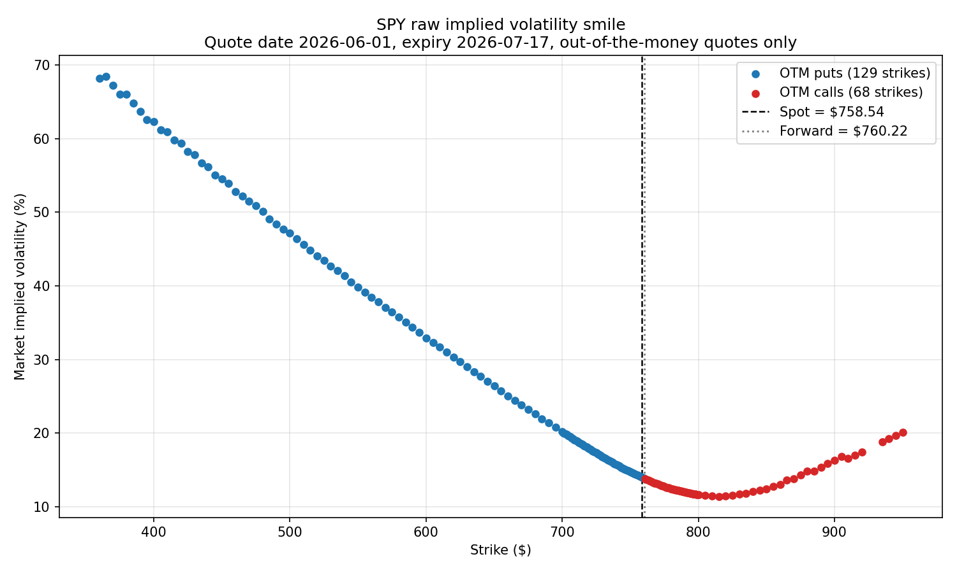
vol_smile_raw.png — 197 out-of-the-money strikes from the reshaped Databento data. A textbook equity index skew, which a broken join or a mis-set forward would not produce
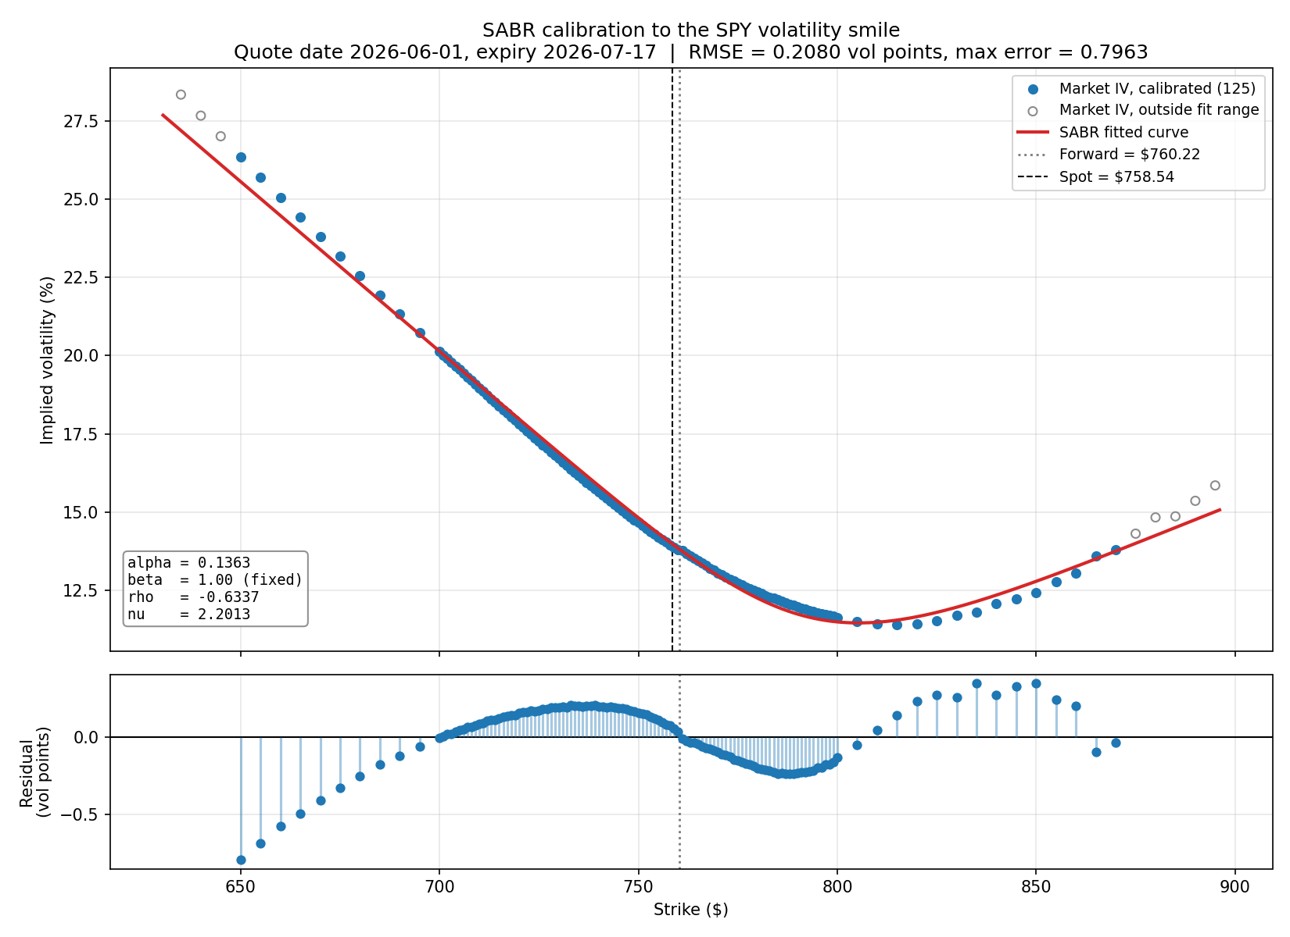
sabr_fit.png — the calibrated SABR curve against those strikes. RMSE 0.2080 vol points, better than the original case's 0.2346
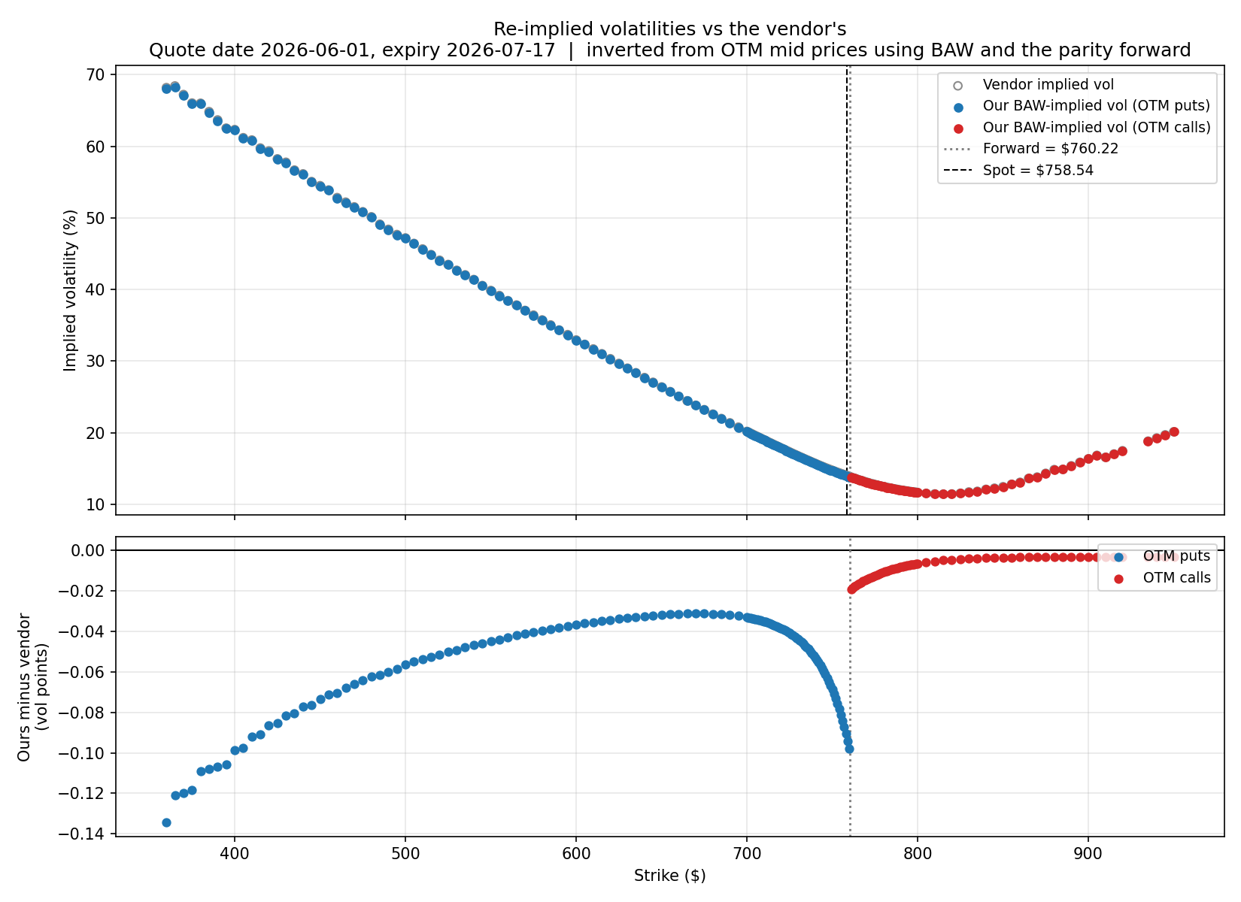
reimplied_vs_vendor_vols.png — read with care. The "vendor" here is this project's own European Black-76 column, so this shows the European-to-American correction alone, not vendor error

