Project Walkthrough
SPY options VaR — code, workflow, and every assumption made along the way.
Seven Python modules, 250 historical scenarios, one option position. This document covers what was built and how it flows; it assumes the reader already knows the goal and the finance.

1. The mental model
Six stages, each handing a concrete artifact to the next. The whole pipeline runs from a single command, python3 main.py, in about nine seconds.
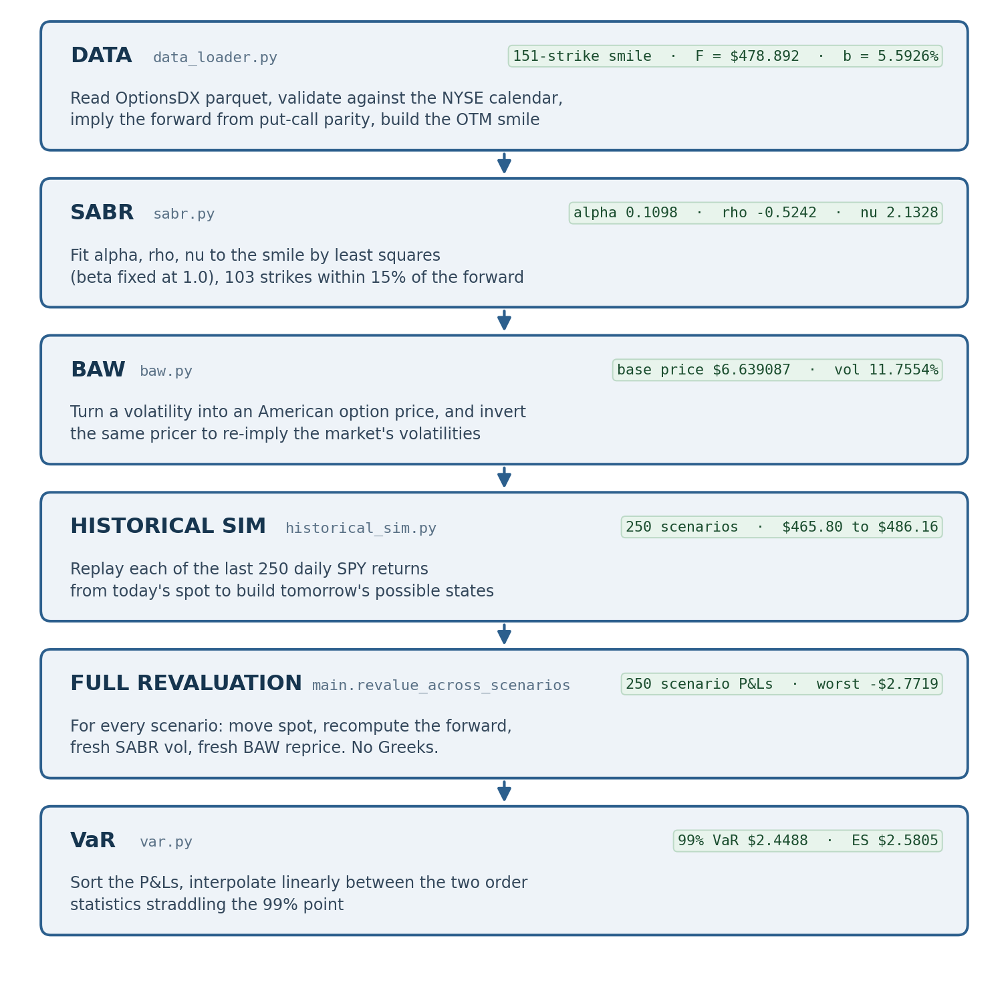
pipeline_flow.png — the six stages, the module implementing each, and the artifact it produces

What each stage does mechanically
Stage | Mechanically | Produces
Data  (data_loader.py) | Reads the OptionsDX parquet files, validates dates against a derived NYSE calendar, implies the forward from put-call parity, and builds the out-of-the-money volatility smile. | 151-strike smile;  F = $478.892;  b = 5.5926%
SABR  (sabr.py) | Least-squares fit of alpha, rho and nu to that smile using Hagan's expansion, with beta held at 1.0, over strikes within 15% of the forward. | alpha 0.109797  rho -0.524225  nu 2.132810
BAW  (baw.py) | Converts a volatility into an American option price. Also runs in reverse: inverting the pricer recovers the market's own implied volatilities. | base price $6.639087  at vol 11.7554%
Historical sim  (historical_sim.py) | Takes the last 250 daily SPY returns and applies each one to today's spot, producing one alternative price for tomorrow per historical day. | 250 scenarios,  $465.80 to $486.16
Full revaluation  (main.py) | Loops over every scenario: shifts spot, recomputes the forward, asks SABR for a fresh volatility, reprices with BAW. No Greeks anywhere. | 250 scenario P&Ls,  worst -$2.7719
VaR  (var.py) | Sorts the P&Ls and interpolates linearly between the two order statistics straddling the 99% point. | 99% VaR $2.4488  ES $2.5805

Three decisions that shape every number downstream
1. Volatilities are re-implied, not taken from the vendor. The vendor's put and call implied vols are mutually inconsistent enough to reverse the local slope of the smile at the crossover, so every volatility used in this project was recovered by inverting the same BAW pricer against the same parity forward.
2. The volatility surface is anchored to the forward and frozen. SABR parameters are held fixed and re-evaluated at each scenario's forward (sticky-moneyness). Scenario P&Ls therefore carry spot risk and the smile's response to spot, but no independent volatility risk.
3. Time to expiry is held fixed at 49 days. Theta is excluded, so the distribution is not shifted down by a constant that would inflate the VaR regardless of market direction.

2. File-by-file breakdown
Seven modules, flat, no packages. Helper functions prefixed with an underscore are omitted below; so are the per-module standalone blocks, which are noted in each subheading instead.

data_loader.py
Loading, validation, and construction of the market state.
Function | What it does | Called by
load_spy_price_history | Builds the daily SPY close series from UNDERLYING_LAST in the option files; caches to CSV and validates the cache covers the request. | run_phase_0, run_phase_4
load_options_chain | Loads the full option chain snapshot for one quote date, all expiries; caches to CSV. | run_phase_0
select_expiry | Filters a snapshot down to a single expiry. | run_phase_0
year_fraction_to_expiry | Time to expiry in years, ACT/365. | run_phase_0
imply_forward_from_parity | Infers the forward from put-call parity across liquid near-the-money strikes, then derives cost of carry and dividend yield from it. | run_phase_0
build_otm_smile | Constructs the volatility smile from out-of-the-money quotes only, split at the forward, filtering crossed and implausible quotes. | run_phase_0
nyse_trading_days | Derives the NYSE calendar (federal holidays, minus Columbus and Veterans Day, plus Good Friday). | validate_price_history, run_phase_4
validate_price_history | Checks for non-positive prices, duplicates, missing trading days and phantom rows on market holidays. | run_phase_0
validate_options_chain | Checks strikes, expiry ordering, single quote time, implied vol range and crossed quotes. | run_phase_0
smile_local_roughness | RMS strike-to-strike jitter in the quoted vols — the noise floor a model fit is judged against. | run_phase_1, run_phase_3
put_call_crossover_step | Measures the discontinuity where the put wing hands over to the call wing; returns a robust adjacent gap and a fragile extrapolated one. | run_phase_1, run_phase_3

sabr.py
Hagan et al. (2002) expansion and calibration. Standalone: python3 sabr.py
Function | What it does | Called by
sabr_implied_vol | The implied volatility expansion for one strike, with an explicit branch to the closed-form limit at the money. | sabr_vol_curve, price_option_with_sabr
sabr_vol_curve | Evaluates the expansion across a list of strikes by plain loop. | calibrate_sabr, plot_sabr_fit
calibrate_sabr | Least-squares fit of alpha, rho, nu from 12 starting points, with bounds that scale correctly with beta. | run_phase_1, run_phase_3
describe_calibration | Prints the parameters with a plain-English reading of each and the fit quality. | run_phase_1, run_phase_3
check_atm_branch_continuity | Confirms the at-the-money branch joins the general formula, after subtracting the genuine smile slope. | run_phase_1

baw.py
American pricing, inversion, and the validation suite. Standalone: python3 baw.py (~30s)
Function | What it does | Called by
black_scholes_price | Generalised Black-Scholes-Merton with cost of carry, so it doubles as Black-76 at b = 0. | baw_price, solve_critical_price
baw_price | The quadratic approximation: European price plus early-exercise premium, or intrinsic value past the exercise boundary. | price_option_with_sabr, implied_volatility
solve_critical_price | Newton-Raphson for the exercise boundary from the BAW seed, with iterates clamped into the economically valid region. | baw_price
implied_volatility | Inverts baw_price by Brent's method; returns NaN rather than a plausible number where no volatility is recoverable. | reimply_smile_volatilities
baw_vega | Finite-difference vega. Diagnostic only — never used to price. | run_phase_3
binomial_american_price | Cox-Ross-Rubinstein lattice. Validation reference only; never called by the pricing pipeline. | validation suite
10 validation checks | check_put_call_parity, check_american_call_equals_european_when_no_dividend, check_american_bounds, check_against_binomial, check_spy_regime_accuracy, check_pnl_error_propagation, check_monotonicity, check_critical_prices, check_spy_reference_case, check_implied_volatility_round_trip. | python3 baw.py

historical_sim.py
Scenario generation. Standalone: python3 historical_sim.py
Function | What it does | Called by
compute_daily_returns | Simple daily returns from the close series. | run_phase_4, run_phase_5
generate_scenarios | Applies each of the last N historical returns to today's spot, carrying the source date through. | run_phase_4, run_phase_5
summarise_returns | Mean, volatility, skewness, excess kurtosis, extremes and their dates. | run_phase_4
largest_moves | The N largest up and down moves, for checking against real market episodes. | run_phase_4
compare_tails_against_normal | Counts observed exceedances at 2/3/4 sigma against a fitted normal. | run_phase_4
rolling_window_statistics | The same window statistics as of several past reference dates, showing how much the answer depends on the window. | run_phase_4

var.py
VaR and expected shortfall. Standalone: python3 var.py
Function | What it does | Called by
compute_var | Sorts the P&Ls and interpolates explicitly between the two order statistics straddling the threshold; returns the full index arithmetic. | run_phase_6
cross_check_against_numpy | Recomputes the same quantile with numpy.percentile as an independent check — never as the answer. | run_phase_6
compare_rank_conventions | Recomputes the VaR under three rank definitions to bound the ambiguity in the filing's wording. | run_phase_6
describe_var | Prints the result with the bracketing scenarios, their dates and the interpolation weight, so it can be rebuilt by hand. | run_phase_6

plots.py
One function per figure, all writing to outputs/figures/ at 150 DPI.
Function | What it does | Called by
plot_raw_vol_smile | The raw market smile, OTM quotes only. | run_phase_0
plot_sabr_fit | Market vols against the fitted curve, with residuals beneath. | run_phase_1, run_phase_3
plot_reimplied_vs_vendor_vols | Our volatilities against the vendor's, and their difference. | run_phase_3
plot_baw_vs_market_prices | Theoretical prices against market, with the bid-ask band and the error in half-spreads. | run_phase_3
plot_spy_price_history | The price path with the lookback window shaded. | run_phase_4
plot_daily_returns_histogram | Return distribution against a fitted normal. | run_phase_4
plot_pnl_distribution | Scenario P&Ls with the VaR threshold marked. | run_phase_8
plot_pnl_timeseries | Scenario P&L against the date that produced it. | run_phase_8
plot_summary_table | The headline numbers rendered as a table image. | run_phase_8
escape_dollars | Escapes currency so matplotlib does not parse it as LaTeX maths. | the plotting functions

main.py
Configuration and the pipeline. Entry point: python3 main.py
Function | What it does | Called by
CONFIG | Every assumption in one dict: paths, reference date and expiry, lookback, risk-free rate, quote filters, the position, SABR settings, confidence level. No magic numbers elsewhere. | all phases
price_option_with_sabr | The junction. SABR supplies a volatility at the forward; BAW turns it into a price from spot. Forward and spot are separate arguments so neither is inferred. | run_phase_3, revalue_across_scenarios
reimply_smile_volatilities | Replaces the vendor's implied vols with ones inverted from OTM mid prices; drops strikes that cannot be inverted. | run_phase_3
revalue_across_scenarios | The full revaluation loop — fresh SABR vol and fresh BAW price for every scenario. | run_phase_5
taylor_approximation_counterfactual | Computes the delta/gamma shortcut the filing forbids, for demonstration only. | run_phase_5
build_summary_rows | Assembles the headline results for the summary table image. | run_phase_8
run_phase_0/1/3/4/5/6/8 | One runner per phase, each printing a labelled section and writing its tables and figures. | main
main | Runs every phase in order and prints the section headers. | python3 main.py

How the modules depend on each other
Module | Imports | Note
data_loader.py | numpy, pandas | No project dependencies.
sabr.py | numpy, scipy | Imports plots only inside its standalone block.
baw.py | numpy, scipy | No SABR dependency — volatility is a plain input, so the pricer stays testable in isolation.
historical_sim.py | numpy, pandas, scipy | No option pricing at all.
var.py | numpy, pandas | Takes P&Ls as an array; knows nothing about options.
plots.py | matplotlib, numpy | Imports sabr lazily inside one function to keep the import graph acyclic.
main.py | all of the above | The only module that knows the pipeline order.

3. Stage-by-stage walkthrough
Execution order, as main.py runs it. Every number below is transcribed from PROJECT_LOG.md.

3.1 Data loading and validation
In | Out
14 OptionsDX parquet files (2010-2023) plus the CONFIG block. | A validated price series, an option chain snapshot, the forward, and a filtered volatility smile.

The price series comes from UNDERLYING_LAST inside the option files rather than a separate equity feed, so spot stays synchronous with the quotes it is paired against. 506 trading days load, 2022-01-03 to 2023-12-29. The chain snapshot for 2023-12-29 is 4,143 rows across 34 expiries; the reference expiry carries 156 strikes from $210 to $575, reduced to a 151-strike smile after the out-of-the-money and quality filters.
Rather than assuming SPY's trailing dividend yield, the rate is pinned externally (5.40%, FRED DGS3MO) and the forward implied from put-call parity across 22 liquid strikes. Those 22 estimates agree to a standard deviation of $0.203 — about 4bp of spot — which is the evidence the method worked. The forward comes out at $478.892 and backs out an implied dividend yield of -0.1926%, essentially zero. That is correct: no SPY ex-dividend date falls between 2023-12-29 and 2024-02-16. Assuming the ~1.4% trailing yield would have mispriced the forward by about $0.90, roughly four strike increments.
Validation found a real vendor defect. The 2022 file's date stamping is broken: 4 real NYSE trading days are absent and 9 rows are stamped on days the market was closed. These damage a return sample in opposite directions — a missing day compresses two sessions into one return, a phantom row injects a spurious near-zero one. Zero of them fall inside the 250-day VaR window, and this is now checked on every run against a derived NYSE calendar.
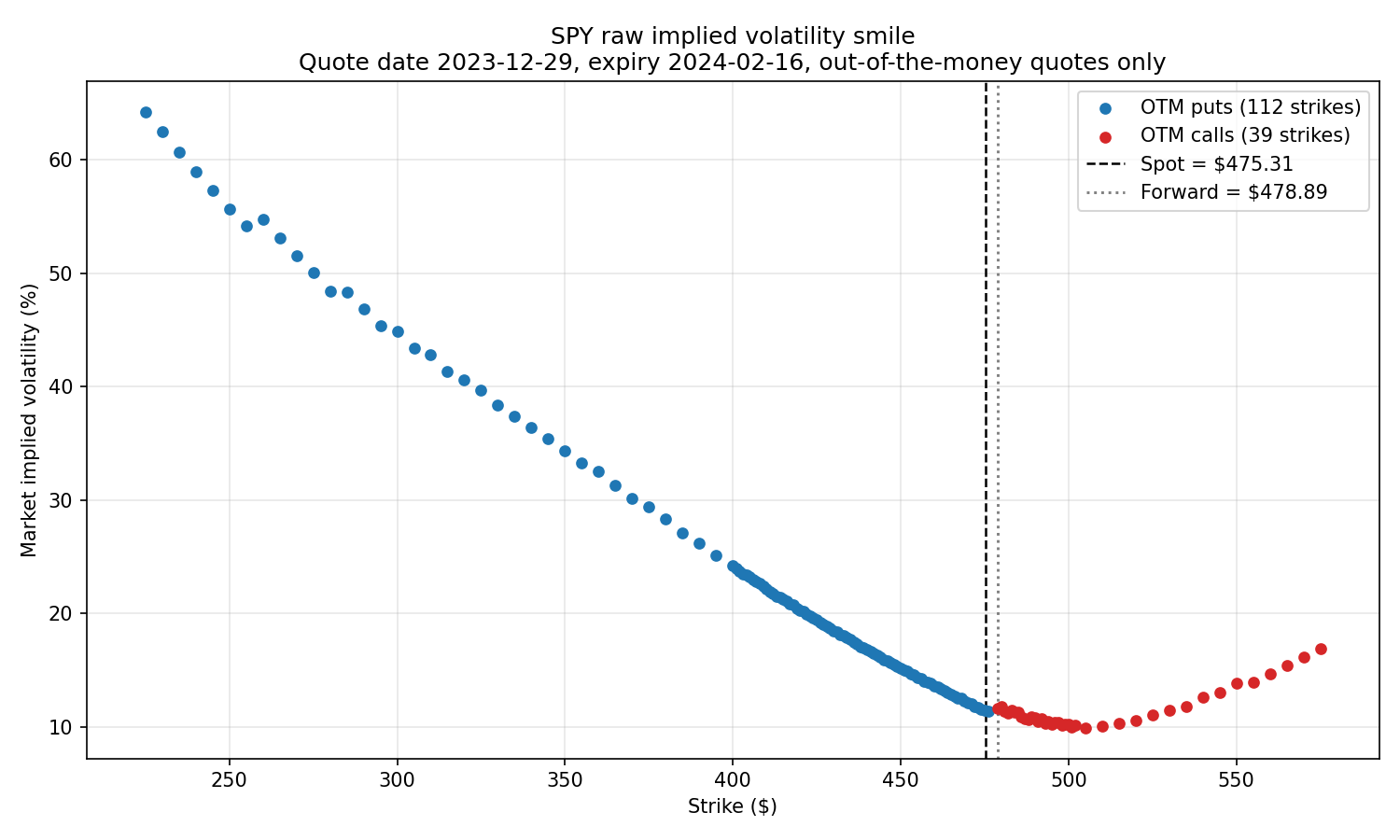
vol_smile_raw.png — the raw market smile, out-of-the-money quotes only, with spot and forward marked

3.2 SABR calibration
In | Out
The 151-strike smile, the forward, and time to expiry. | Four SABR parameters and a fit-quality report.

Fitted to 103 strikes ($408-$550) within 15% of the forward, from 12 starting points. Beta is fixed at 1.0 rather than fitted, and the sensitivity table shows why: across beta from 0.0 to 1.0 the RMSE moves by 0.04 vol points — nothing — while alpha swings by a factor of 476 and rho slides to compensate. The data cannot tell beta and rho apart.
Parameter | Value | Reading
alpha | 0.109922 | Volatility level; at beta=1 close to the ATM vol, ~11.0%
beta | 1.0 | Fixed, not fitted
rho | -0.510842 | Negative, as an equity index should be
nu | 2.103836 | Vol-of-vol; sets smile curvature
RMSE | 0.2946 vol points | Max abs error 0.6378
ATM skew | -0.5461 | Vol points per 1% move in strike
The headline finding of this stage is that the residuals are a data problem, not a model problem. Fitting each wing separately against its own noise floor (the RMS strike-to-strike jitter in the quoted vols) shows each one fits as well as anything could; the combined fit is worse than either because the two wings disagree with each other.
Fit | Strikes | RMSE | Data noise floor | rho
Both wings | 103 | 0.2946 | 0.1140 | -0.5108
Puts only | 69 | 0.0751 | 0.0501 | -0.2578
Calls only | 34 | 0.2036 | 0.1851 | -0.6008
The call wing is 3.7x noisier than the put wing. This is what motivates stage 3.4.
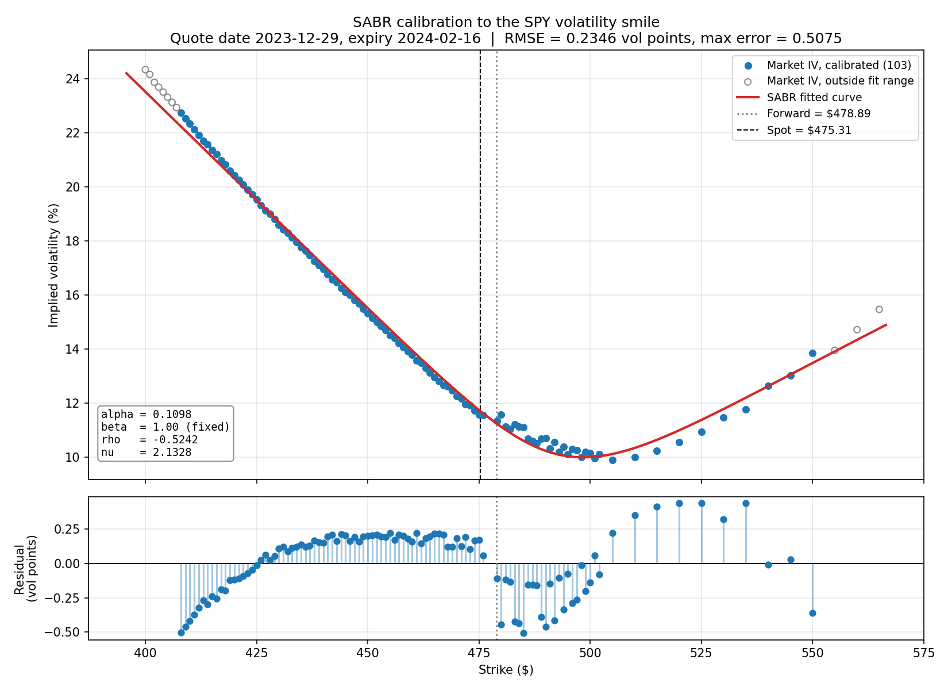
sabr_fit.png — market vols against the calibrated curve, with per-strike residuals beneath; the residual jump at the forward is the wings disagreeing

3.3 BAW pricing engine
In | Out
A volatility, a strike, spot, time, rate and cost of carry. | An American option price — and, run in reverse, an implied volatility.

Built and validated with no SABR involvement: volatility is a plain input argument here. Ten checks run from python3 baw.py and all pass. The sharpest of them is that an American call on a non-dividend-paying underlying (b = r) must equal the European call — it passes to exactly zero, not merely to tolerance.
Check | Result
European put-call parity | Worst error 2.8e-14 across 6 cases
American call = European when b = r | Worst spurious premium exactly 0.0
American >= European and >= intrinsic | 0 violations in 1,350 grid points
BAW vs binomial, stress grid | Worst absolute error $0.0599
BAW vs binomial, SPY regime | Worst absolute error $0.1439
Monotonicity | 10 sequences, all correct
Critical exercise prices | Correct side of strike, move away as vol rises
Implied volatility round trip | 128 cases, worst error 7.893e-06
Tolerances are gated on absolute dollar error, not relative. Tests initially gated on relative error failed; rather than loosening the threshold, the errors were verified against a 40,000-step lattice to be BAW's documented behaviour — smallest at the money, peaking just below the exercise boundary, exactly zero past it. Correctness rests on the exact structural tests above, not on the approximation-quality comparisons.
The measured cost of using BAW. In our regime calls are exact — with b = 5.5926% > r = 5.4000% early exercise is never optimal, so BAW returns the European price and the lattice agrees to 0.02%. Puts carry real error whose sign flips with moneyness: BAW understates the at-the-money premium (recovering ~95%) and overstates it out of the money by more than 2x. Because the sign changes, the error does not cancel when prices are differenced to form scenario P&Ls — it amplifies. The worst P&L error is $0.0852 against a price-level error of $0.0155, 5.5x larger, contributing roughly 1% error to every scenario P&L and therefore to the final VaR.

3.4 Re-implying volatilities and wiring SABR into BAW
In | Out
The 151-strike smile of OTM mid prices, plus the parity forward. | Our own volatilities, a recalibrated SABR, and theoretical prices to compare against the market.

The vendor's put and call implied vols are mutually inconsistent, so every volatility is recomputed here by inverting the same BAW pricer against the same parity forward that the rest of the project uses. All 151 OTM strikes inverted; none failed. The difference from the vendor is a systematic offset that flips sign at the forward — OTM puts +0.1231 vol points, OTM calls -0.0911 — not random noise.
The decisive evidence is the sign of the crossover gap. The smile slopes down through this strike region, so a self-consistent smile must show a negative gap going from the last put to the first call.
 | Last put K=476 | First call K=479 | Adjacent gap
Vendor IV | 11.379% | 11.670% | +0.291 — wrong sign
Our IV | 11.567% | 11.358% | -0.209 — correct sign
Recalibrating on the corrected smile improves the SABR RMSE from 0.2946 to 0.2346 vol points and the put-wing roughness from 0.0501 to 0.0320. The final parameters are alpha 0.109797, rho -0.524225, nu 2.132810.
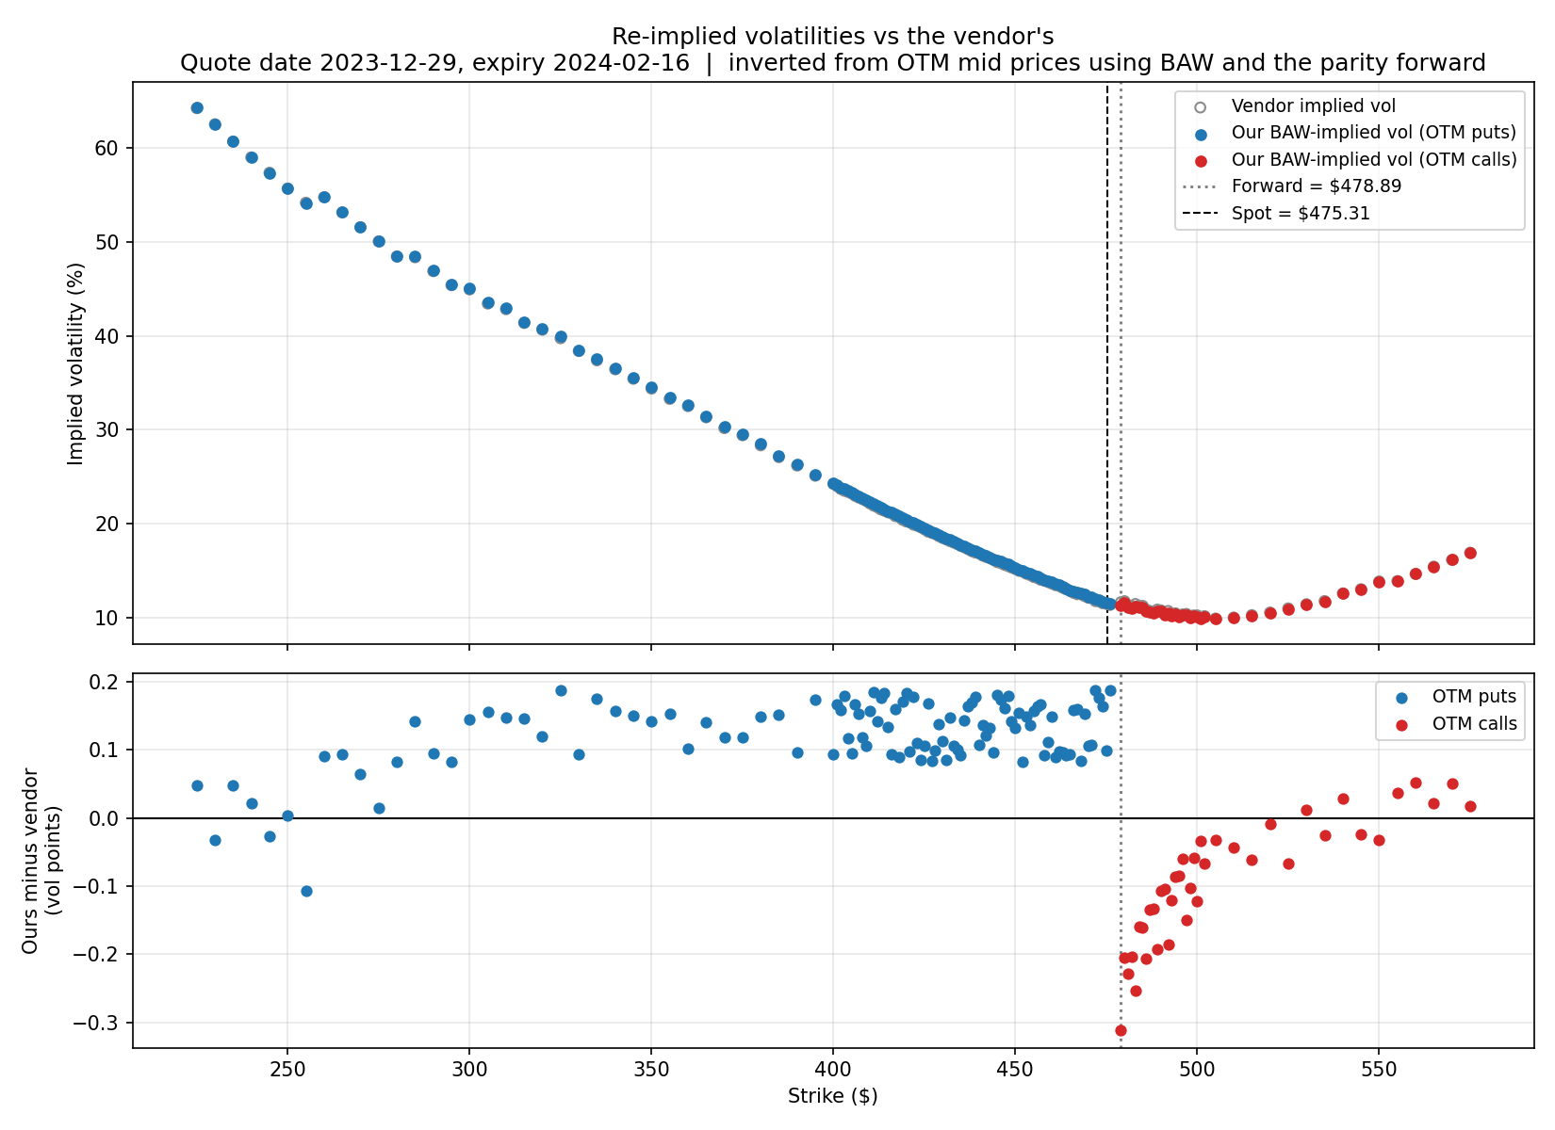
reimplied_vs_vendor_vols.png — our volatilities against the vendor's; the lower panel shows the offset flipping sign at the forward
A residual inconsistency remains and was diagnosed rather than patched. It does not close by moving the forward: the gap would need F around $479.6, some $0.70 above the parity forward and 3.5 standard deviations of that estimate. De-Americanising the parity calculation moves it only +$0.144, about 20% of the gap — real and correctly signed, but not the main cause. The remainder is most likely that the parity forward is computed from both legs, one of which is always the illiquid in-the-money one.
With the volatilities settled, price_option_with_sabr joins the two models: SABR reads the smile at the forward, BAW prices from spot. The two are separate arguments because conflating them is the classic bug at this junction — here they differ by $3.58, more than three strike increments.
Across 103 strikes the mean absolute error is $0.0718 and the mean signed error -$0.0007, so there is scatter but no bias. Only 6 of 103 land inside the bid-ask spread, which looks alarming until you see that SPY spreads here are a single penny (median $0.010, 0.94% of mid) — matching the market to half a cent is not a standard any smile model meets. The meaningful test is attribution: multiplying each strike's volatility error by its vega explains 99.21% of the observed price error, correlation 0.999974, unexplained residual $0.000567. If the forward/spot wiring were wrong the error would be structural and would not track the volatility fit. It does, so the plumbing is correct.
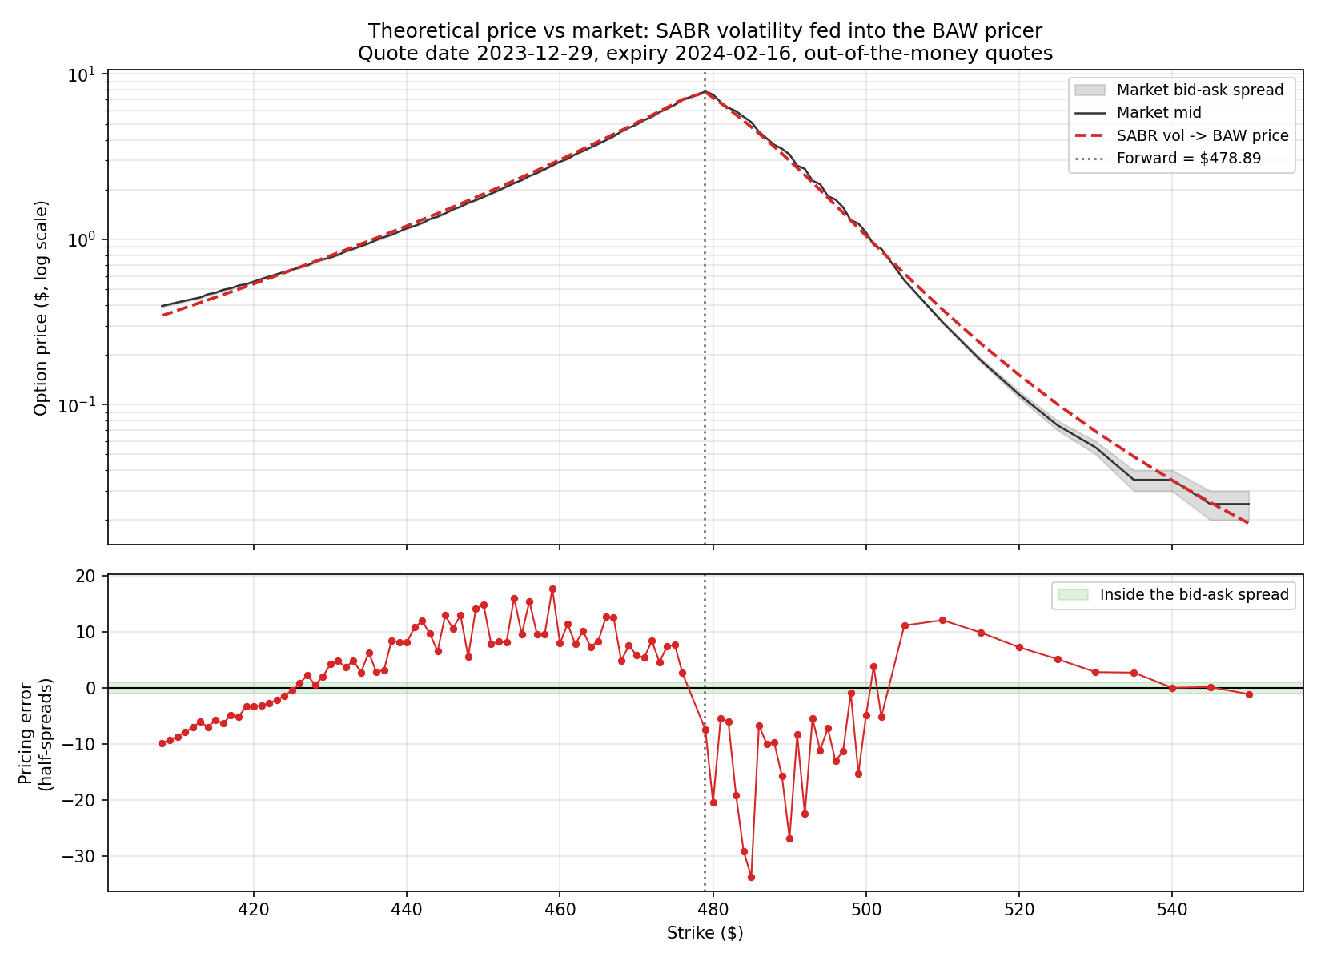
baw_vs_market_prices.png — theoretical against market prices, with the bid-ask band and the error in half-spreads beneath

3.5 Historical scenario generation
In | Out
The SPY close series and today's spot. | 250 alternative prices for tomorrow, each tagged with the date it came from.

No option pricing happens here. Each of the last 250 daily returns is applied to today's $475.31, giving scenario prices from $465.80 to $486.16. The window is 2023-01-03 to 2023-12-29 — exactly calendar 2023, since 250 trading days back lands on the first trading day of the year — and contains zero calendar defects.
Statistic | Value | Statistic | Value
Mean daily return | +0.0904% | Skewness | -0.0278
Daily volatility | 0.8277% | Excess kurtosis | -0.1784
Annualised volatility | 13.14% | Worst day | -2.0012% (2023-02-21)
Scenarios | 250 | Best day | +2.2827% (2023-01-06)
The headline finding is that this window has thin tails, contradicting the textbook expectation. Excess kurtosis of -0.18 means the tails are thinner than a normal, not fatter, and not a single day in 2023 moved beyond 3 sigma (against 0.67 a fitted normal predicts). A normal fitted to a calm year is stretched wide by a handful of moderately large days and ends up with more tail weight than the data itself.
How much the window matters is quantified directly. Same position, same model, same method, standing at each year end instead:
As of | Ann. vol | Skew | Excess kurt | Worst day | 1st percentile
2011-12-30 | 23.08% | -0.433 | +2.581 | -6.51% | -4.34%
2015-12-31 | 15.65% | -0.231 | +2.117 | -4.13% | -2.78%
2018-12-31 | 17.18% | -0.409 | +3.148 | -4.21% | -3.21%
2020-12-31 | 34.14% | -0.598 | +7.631 | -11.51% | -6.76%
2022-12-30 | 24.09% | +0.026 | +0.362 | -4.34% | -3.74%
2023-12-29 (ours) | 13.14% | -0.028 | -0.178 | -2.00% | -1.64%
Ours is the calmest of the six and the only one with negative excess kurtosis. The 1st percentile — essentially what the 99% VaR reads — is -1.64% for us against -6.76% for a 2020 window, 4.1x larger. That factor is not a modelling choice or a market view, only which twelve months precede the reference date.
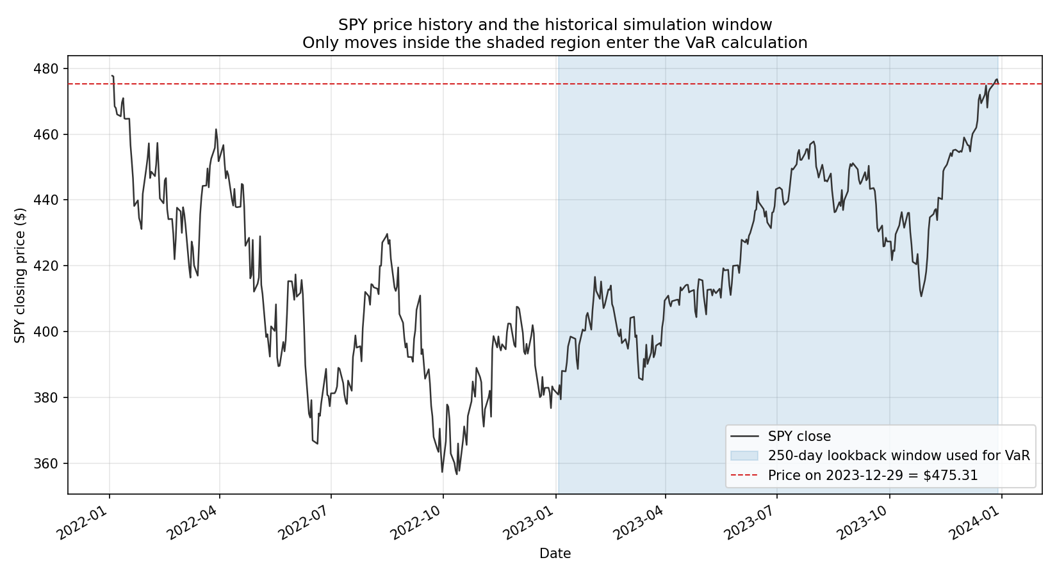
spy_price_history.png — the lookback window shaded; the entire 2022 bear market sits outside it and contributes nothing
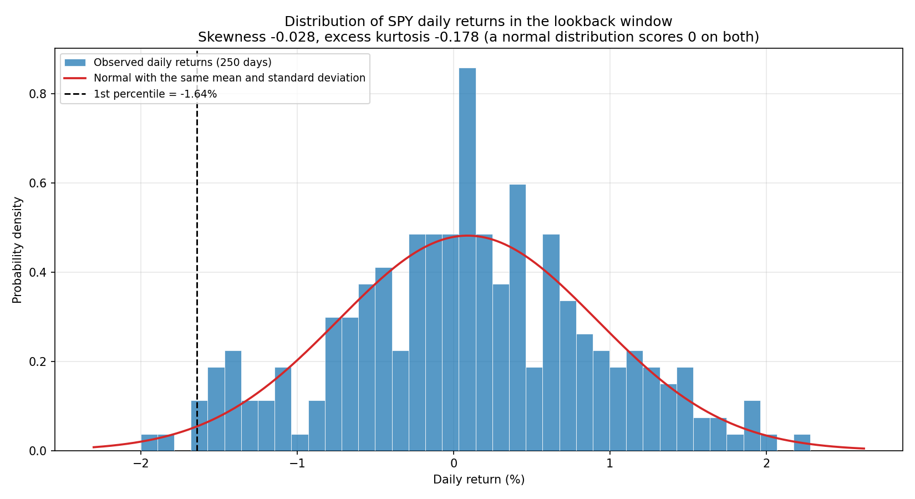
daily_returns_histogram.png — the return distribution against a fitted normal, with skewness and excess kurtosis in the title

3.6 Full revaluation
In | Out
250 scenarios, the calibrated SABR parameters, and the position. | 250 scenario prices and P&Ls.

The position is long 1 x SPY 2024-02-16 $475 put. A put rather than a call deliberately: with b > r, early exercise on a call is never optimal, so BAW would collapse to the European price and the American machinery would do nothing visible. Today's SABR volatility is 11.7554% and the theoretical price $6.639087, against a market mid of $6.5250.
For each scenario the loop shifts spot, recomputes the forward, asks SABR for a fresh volatility at that new forward, and reprices with BAW. It is a plain loop, one scenario per iteration. Three sanity checks pass: the scenario nearest a flat day reprices to exactly the base price (P&L $0.000000); P&L is monotone in the underlying move across all 250; and the P&L is convex, which is the entire reason for full revaluation.
Move | P&L down | P&L up | Sum (positive = convex)
0.5% | +0.894788 | -0.772707 | +0.122080
1.0% | +1.930181 | -1.440300 | +0.489880
2.0% | +4.500072 | -2.518551 | +1.981521
3.0% | +7.851610 | -3.332826 | +4.518784
A linear position sums to exactly zero on every row. What the forbidden delta/gamma shortcut would have cost is measured directly, using Greeks taken from the full chain — deliberately the most favourable version of the shortcut. Delta-only error averages $0.166302 and peaks at $1.166583, which is 17.6% of the whole position value. Delta+gamma averages $0.017813 and peaks at $0.237816; on the single worst scenario it gives -$2.534 against the true -$2.772, understating the worst-case loss by 8.6%.
The volatility response is counterintuitive and worth stating. Under sticky-moneyness the smile is pinned to the forward, so a rally lowers K/F and slides our fixed strike deeper into the steep left wing: our put's volatility rises when the market rises. Against a sticky-strike alternative this dampens the P&L in both directions, and since a long put loses when the market rallies, it is the less conservative convention for this position.
Move | K/F | Our vol | Sticky-moneyness | Sticky-strike | Difference
-3% | 1.0225 | 10.26% | $14.49 | $15.15 | -$0.66
-1% | 1.0019 | 11.16% | $8.57 | $8.97 | -$0.40
+1% | 0.9821 | 12.41% | $5.20 | $4.78 | +$0.42
+3% | 0.9630 | 13.77% | $3.31 | $2.27 | +$1.04

3.7 VaR
In | Out
250 scenario P&Ls. | A 99% VaR, an expected shortfall, and the order statistics behind them.

The 99% point does not land on an observation: 1% of 250 is 2.5, so the threshold falls between the 3rd and 4th worst scenarios. The interpolation is done arithmetically rather than by calling a library.
tail probability alpha : 0.0100
fractional rank : (250 - 1) x 0.0100 = 2.4900
lower order statistic : index 2 = -2.462080 (2023-11-14, +1.940%)
upper order statistic : index 3 = -2.435070 (2023-11-02, +1.912%)
interpolation weight : 2.4900 - 2 = 0.4900
blended quantile : -2.462080 + 0.4900 x 0.027010 = -2.448845

Result | Value | Note
99% one-day VaR | $2.4488 | 36.89% of position value
Expected shortfall | $2.5805 | Mean of the 3 breaching scenarios
Worst scenario | $2.7719 loss | 2023-01-06, a +2.283% move
Stress window (2020) | $4.9321 | 2.0x the baseline
NumPy cross-check | Agrees to 0.000e+00 | Same rank definition, so it confirms the arithmetic
Sign convention, stated once and used everywhere: VaR and expected shortfall are reported as positive loss magnitudes. The underlying quantile keeps its natural sign and is negated once, at the point of reporting.
The filing's wording does not fully pin down the calculation. "Linear interpolation to the 99% threshold" still leaves open where in index space the 99% point sits, and the conventions disagree: (N-1)*alpha gives 2.4488, N*alpha gives 2.4486, and (N+1)*alpha-1 gives 2.4844. The spread is $0.0358 on a $2.4488 VaR, 1.46%, which bounds how precisely the wording can be reproduced at all.
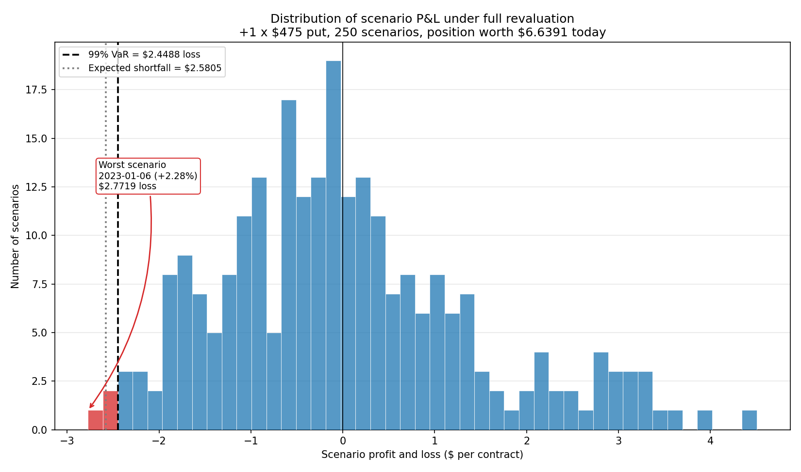
pnl_distribution.png — the 250 scenario P&Ls with the VaR threshold marked; the right-skew is gamma
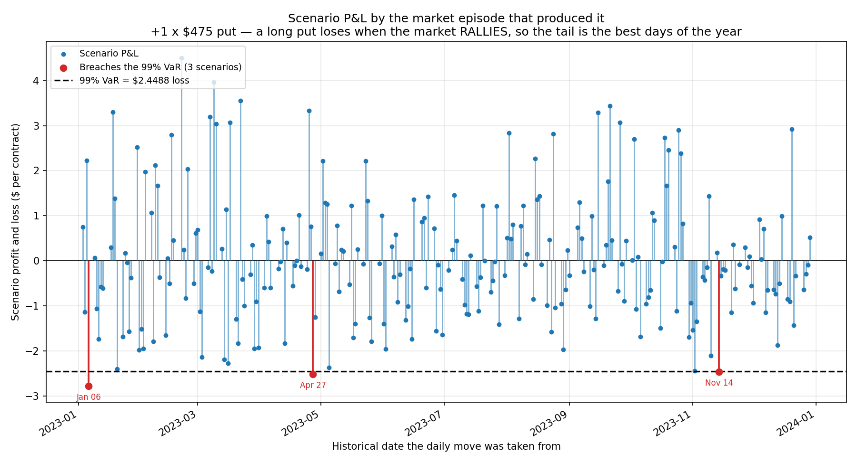
pnl_timeseries.png — each scenario's P&L against the date that produced it; every tail scenario is an up day

3.8 Bugs found and fixed, consolidated
Every defect caught during the build, in the order encountered. Two of them were errors in my own reasoning, corrected after checking against numbers.
# | Stage | Bug | Fix and consequence
1 | SABR calibration | alpha's upper bound did not scale with beta. At beta=0 the model is normal and alpha is an absolute vol in dollars (~52), so a fixed bound of 5.0 made the fit throw. | Bound is now 5.0 * forward(1-beta), seeds clipped inside it.
2 | SABR calibration | The ATM continuity check was measuring the real smile slope, not a discontinuity — it probed 0.1% from the forward where skew genuinely moves vol by 0.055 vol points. | Now probes within a few multiples of the tolerance and subtracts the model's own skew. Unexplained excess 4.5e-08 vol points.
3 | BAW / inversion | The put critical-price seed overflowed to NaN as volatility approached zero: the perpetual boundary collapses onto the strike and h1 blows up. | h1 clamped at zero, which is the correct limit — with no volatility the boundary is the strike.
4 | BAW / inversion | Newton-Raphson diverged to a negative critical price for deep ITM puts at high volatility, after which the log in d1 poisoned every later iterate. | Iterates clamped into the economically valid region: above K for a call, in (0, K) for a put.
5 | Phase 1 reporting | The reported "+0.76 vol point put/call step" was not trustworthy. Crossed quotes at strikes 477 and 478 leave a $3 hole at the crossover; extrapolating across it gives +0.21 to +0.41 depending on the fit. | The diagnostic now reports an extrapolation-free adjacent gap alongside the fragile one. The conclusion held; the magnitude did not.
6 | Data loading | load_spy_price_history returned a cached CSV without checking it covered the requested date range. Harmless with one cache; a second cache with a different range made it a silent-wrong-data bug. | The cache is validated against the request and rebuilt if short.
7 | Full revaluation | My own error: I documented the volatility as rising when spot falls. Backwards — a rally lowers K/F and slides the strike into the steep wing, so our put's vol rises when the market rises. | Corrected, and the sticky-strike comparison is now printed as a table so the direction is visible rather than asserted.
8 | Stress comparison | My own error: I wrote that freezing today's surface understates the stress. Also backwards — a long put is long vega and loses on rallies. | Corrected. Freezing the surface overstates the loss tail; the stress VaR is an upper bound.
9 | Figures | Matplotlib parsed currency as LaTeX maths. A title containing two dollar amounts silently lost both signs and italicised everything between them. | An escape_dollars helper applied to composed money strings.
10 | Summary table | A row labelled "1st pctile return" was quoting the worst daily move (-2.00%) instead of the actual 1st percentile (-1.64%). | Now pulled from the same window-comparison calculation as the stress figure.

4. Complete assumptions and deviations
All 28 entries logged across the project, transcribed from PROJECT_LOG.md. Numbering follows the log. Nothing is omitted or softened; the ones carrying a measured cost are entries 13, 15, 21 and 27.
Grouped as: Data and inputs (9), Model and pricing (8), Numerical and validation (5), Simulation, VaR and interpretation (6).

Data and inputs
# | Type | What | Why | Measured impact
1 | approximation | UNDERLYING_LAST is the unadjusted SPY price, so SPY's four annual ex-dividend dates appear as spurious down-moves. | The option contracts are written on the unadjusted price, so shocking it is internally consistent; synchronicity with the quotes is worth more than removing four dips. | ~0.4% on four days a year; none inside the VaR window.
2 | approximation | ACT/365 day count for time to expiry. | ACT/252 and ACT/365.25 are the alternatives; what matters is using the same T everywhere. | Well under a vol point at 49 days; absorbed by the calibration.
3 | approximation | Put-call parity applied to American options to imply the forward. | Parity holds exactly only for European options; the American put's early-exercise premium biases the forward low. | A cent or two at 49 days, inside the bid-ask noise. De-Americanising moves the forward +$0.144.
4 | deviation | Dividend yield derived from the quotes, not assumed from SPY's trailing yield. | No ex-dividend date falls inside this window, so the trailing yield would be simply wrong here. | Assuming 1.4% would misprice the forward by ~$0.90, about four strike increments.
5 | approximation | Smile built from out-of-the-money quotes only, split at the forward rather than spot. | The in-the-money leg is illiquid and its vendor IV is unreliable. | At the 405 strike the deep-ITM call shows 27.2% against 23.2% for the liquid OTM put.
6 | approximation | The derived NYSE calendar ignores one-off closures (state funerals, Hurricane Sandy). | Those surface as "missing" days for a human to judge, which is the right outcome. | None in the VaR window.
14 | deviation | Implied vols are re-implied by us from OTM mid prices by inverting BAW against the parity forward, replacing the vendor's. | The vendor's put and call IVs are mutually inconsistent — their smile is non-monotone at the crossover. | SABR RMSE 0.2946 to 0.2346; adjacent gap +0.291 to -0.209 (sign corrected).
17 | approximation | The extrapolated crossover-step metric is unreliable on this date. | Crossed quotes at strikes 477 and 478 leave a $3 hole at the forward, in the most curved part of the smile. | Extrapolation gives +0.21 to +0.41 depending on the fit; the robust adjacent gap is used instead.
20 | approximation | The lookback-window comparison years are context only and are not put through the Phase 0 calendar validation. | Vendor data quality varies by year; the comparison is illustrative. | 2022 alone carries 4 missing days and 9 phantom rows. Our 2023 window is clean.

Model and pricing
# | Type | What | Why | Measured impact
7 | approximation | The z/x(z) factor is 0/0 at the money; handled by an explicit branch to the closed-form limit. | Floating point cannot evaluate the ratio near the money — both numerator and denominator are tiny. | Verified continuous to 4.5e-08 vol points across the branch boundary.
8 | deviation | beta fixed at 1.0, not fitted. | beta is close to jointly unidentifiable with rho; the filing specifies SABR but states no beta. | Across beta 0 to 1 the RMSE moves 0.04 vol points while alpha swings 476x.
9 | approximation | Calibration restricted to |moneyness| <= 15%. | The far wings are penny quotes outside the range where Hagan's asymptotic expansion is reliable. | 103 of 151 strikes fitted. At the full smile RMSE is 0.8116 against 0.2946.
10 | deviation | Cost of carry b = r - q rather than the filing's b = 0 (Black-76). | The filing prices interest rate futures options; SPY is a dividend-paying equity ETF. | b derived from the market at 5.5926%, versus r of 5.4000%.
11 | deviation | cost_of_carry is a required argument with no SPY default. | A hardcoded default would conflict with the derived b, and a silently wrong carry produces plausible-looking wrong prices. | None — a safety choice.
22 | deviation | Time to expiry held fixed at 49 days rather than decremented. | Decrementing includes theta, which would shift every scenario down by roughly the same amount regardless of market direction. | Isolates pure market risk; excludes one day of theta from every P&L.
23 | deviation | Sticky-moneyness: SABR parameters held fixed and re-evaluated at the new forward. | The alternative is sticky-strike. Our strike's vol rises when the market rallies, since K/F falls and slides it into the steep left wing. | Dampens P&L both ways; the less conservative convention for a long put. At +3% it prices $3.31 against sticky-strike's $2.27.
24 | deviation | No volatility-surface shock. | Declined; the historical surfaces to build it do exist in the dataset. | Scenario P&Ls carry spot risk and the smile's response to spot, but no independent volatility risk.

Numerical and validation
# | Type | What | Why | Measured impact
12 | deviation | No literature benchmark table transcribed; a convergent CRR binomial lattice is the reference instead. | Reference values from the BAW 1987 paper could not be verified from the build environment, and an unverifiable number would validate the pricer against fiction. | The lattice is the same methodology BAW used, over a whole grid rather than a handful of points.
13 | approximation | BAW's put error changes sign with moneyness: understates the ATM premium (~95% recovered), overstates it OTM by more than 2x. | It is an approximation; the filing specifies it. | Does not cancel in the P&L but amplifies ~5.5x, contributing roughly 1% error to the final VaR.
15 | approximation | A residual put/call inconsistency remains after re-implying. | De-Americanising the parity forward explains only ~20%; the rest is most likely that the parity forward is computed from both legs, one always illiquid. | Adjacent gap -0.209 against -0.058 predicted by the local slope.
16 | deviation | Vega is computed for error attribution only, never to price a scenario. | The filing forbids Greeks-based approximation of scenario prices. | Used to show 99.21% of the pricing error is the volatility fit seen through vega.
25 | deviation | taylor_approximation_counterfactual deliberately computes the shortcut the filing forbids. | For demonstration only, never for a risk number — to show the size of the error being avoided. | Delta+gamma understates the worst-case loss by 8.6%; delta-only peaks at 17.6% of position value.

Simulation, VaR and interpretation
# | Type | What | Why | Measured impact
18 | approximation | Simple returns, not log returns. | They are exactly what S x (1 + r) needs; log returns' advantage is additive aggregation over multi-day horizons, and ours is one day. | 2bp on this sample's worst day.
19 | deviation | The simulation is unweighted, matching the filing. | Every day counts equally despite volatility clustering being real. No exponential weighting, no filtered historical simulation. | Not separately quantified; see entry 21 for the window effect.
21 | limitation | Our 250-day window contains no crisis. | A consequence of the reference date, not a choice. Excess kurtosis -0.18, no day beyond 3 sigma. | 1st percentile -1.64% against -6.76% for a 2020 window — 4.1x smaller. The VaR is benign because of the window, not the position.
26 | approximation | The stress-window run keeps today's volatility surface and changes only the return distribution. | A long put is long vega and loses on rallies, so freezing today's calm surface makes the losing tail deeper than a true joint replay. | Overstates the loss tail: on the worst stress scenario, vol +10 points cuts the loss from $5.59 to $1.90.
27 | approximation | The (N-1)*alpha rank definition is one of several in common use and the filing does not pin one down. | It is R type 7 and NumPy's default, which makes the result directly checkable against a standard library. | Alternatives shift the VaR by up to $0.0358, or 1.46%.
28 | approximation | Expected shortfall averages only the 3 scenarios beyond the threshold. | A limitation of 250 scenarios, not of the estimator. Simple mean of breaching scenarios, not an integrated tail expectation. | One scenario moving in or out changes it visibly.

5. What to trust, and what to caveat

What is solid
The pricer is correct, not merely close. The checks that establish it are exact structural properties, not tolerance comparisons: put-call parity holds to 2.8e-14, the American call equals the European when b = r to exactly zero, and there are no bound violations in 1,350 grid points.
The junction between the two models is verified, not assumed. If spot had been passed where the forward belongs, or the day count mismatched, the pricing error would be structural. Instead 99.21% of it is explained by the volatility fit error seen through vega, correlation 0.999974. What remains is the smile fit, which is limited by the data rather than the plumbing.
The VaR arithmetic is right. The interpolation is implemented explicitly and agrees with numpy.percentile to 0.000e+00 — used as a check, never as the answer. It was also hand-checked against the four worst P&Ls, and the edge cases behave (an all-profitable sample returns a negative VaR unclipped rather than being floored at zero).
It reproduces. A cold run from deleted caches completes in about nine seconds, all five entry points exit clean, and every figure and table regenerates from the raw data.

What to caveat
This VaR is benign because 2023 was a calm year, not because the position is safe. That is the single most important sentence in this document. The window has thinner tails than a normal distribution and contains no day beyond 3 sigma. Its 1st percentile return is -1.64%; a window ending in 2020 gives -6.76%, and the stress VaR is 2.0x the baseline. Nothing about the position changed between those two numbers — only which twelve months preceded the reference date. A crisis counts fully until the day it ages out of the window, then not at all.
There is no volatility risk in this number. The surface is frozen at today's calibration and only the anchor point moves with spot. A genuine full revaluation of a historical day would shock the surface too. The size of that omission is visible in the stress run: in March 2020 the same spot move with the surface where it actually was turns a $5.59 loss into a $3.32 gain.
There is a measured precision floor of about 1%. BAW's approximation error does not cancel when prices are differenced — it amplifies 5.5x — so roughly 1% of every scenario P&L, and therefore of the VaR, is method error rather than market risk. The filing specifies BAW, so this is intended behaviour, but it is a floor.
The smile is still not fully self-consistent. Re-implying the volatilities corrected the sign of the crossover gap and improved the fit, but a residual inconsistency of -0.209 against -0.058 predicted by the local slope remains, diagnosed and documented rather than patched.
The scope is narrow. One position, one day, one underlying, one data source. No portfolio or correlation effects (that phase was scoped and skipped), no multi-day scaling, no liquidity or bid-ask adjustment — positions are marked at theoretical mid — and a single end-of-day vendor whose own implied vols proved inconsistent enough that we recomputed them.

Confidence at a glance
Claim | Confidence | Why
The BAW pricer is correctly implemented | High | Exact structural tests pass to machine precision; 0 violations in 1,350 grid points.
SABR is wired into BAW correctly | High | 99.21% of pricing error attributed to the volatility fit, not to structure.
The VaR arithmetic matches the filing's description | High | Explicit interpolation, cross-checked to 0.000e+00; but see the rank convention caveat below.
The VaR is precise to the cent | Low | ~1% BAW method error, plus 1.46% spread across rank conventions.
The volatility surface is well fitted | Medium | RMSE 0.2346 vol points against a data noise floor of ~0.11; a residual put/call inconsistency remains.
The VaR reflects the position's true risk | Low | No volatility risk, and the window contains no crisis. The 2020-window figure is 2.0x higher.
The results reproduce | High | Cold run from raw data in ~9 seconds; all entry points verified.

