Problem 1:

Student(StdNo, StdName, StdAddress, StdCity, StdState, StdZip, StdEmail)

* Table Name: Student
* Primary Key: StdNo
* Columns: Attributes listed

Loan(LoanNo, ProcDate, DisbMethod, DisbBank, DateAuth, NoteValue, Subsidized, Rate)

* Table Name: Loan
* Primary Key: LoanNo
* Columns: Attributes listed

Institution(InstID, InstName, InstMascot)

* Table Name: Institution
* Primary Key: InstID
* Columns: Attributes listed

Lender(LenderNo, LendName)

* Table Name: Lender
* Primary Key: LenderNo
* Columns: Attributes listed

### Problem 2

Loan(LoanNo, StdNo, LenderNo, InstID, ProcDate, DisbMethod, DisbBank, DateAuth, NoteValue, Subsidized, Rate)

* FOREIGN KEY(StdNo) REFERENCES Student
* FOREIGN KEY(LenderNo) REFERENCES Lender
* FOREIGN KEY(InstID) REFERENCES Institution
* StdNo NOT NULL
* LenderNo NOT NULL
* InstID NOT NULL

### Problem 3

For the ERD in Figure 1, you should indicate applications of the M-N relationship rule. For each M-N relationship rule application, you should list the table name, primary key, and other columns.

There are **NONE.**

### Problem 4

DisburseLine(**DateSent**, **LoanNo**, Amount, OrigFee, GuarFee)

* FOREIGN KEY(LoanNo) REFERENCES Loan
* LoanNo NOT NULL

I altered the weak entity DisburseLine into its own table. Its primary key is a combination of **DateSent** and **LoanNo.**

### Problem 5

[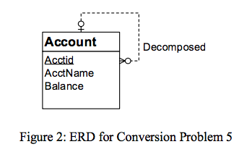](https://github.com/nickzarate/database-management-essentials/blob/master/module10/images/graded_figure2.png)

Account(**Acctid**, AcctName, Balance, Decomposed)

* Primary Key: Acctid
* FOREIGN KEY(Decomposed) REFERENCES Account
* Columns: Attributes listed

### Problem 6

[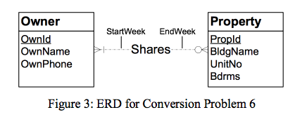](https://github.com/nickzarate/database-management-essentials/blob/master/module10/images/graded_figure3.png)

The following table conversion uses the Entity Type Rule and the M-N Rule.

Owner(OwnId, OwnName, OwnPhone)

* Primary Key: OwnId

Property(PropId, BldgName, UnitNo, Bdrms)

* Primary Key: PropId

Shares(PropId,OwnId, StartWeek, EndWeek)

* Primary Key: PropId and OwnId
* FOREIGN KEY(PropId) REFERENCES Property
* FOREIGN KEY(OwnId) REFERENCES Owner
* Columns: Attributes listed