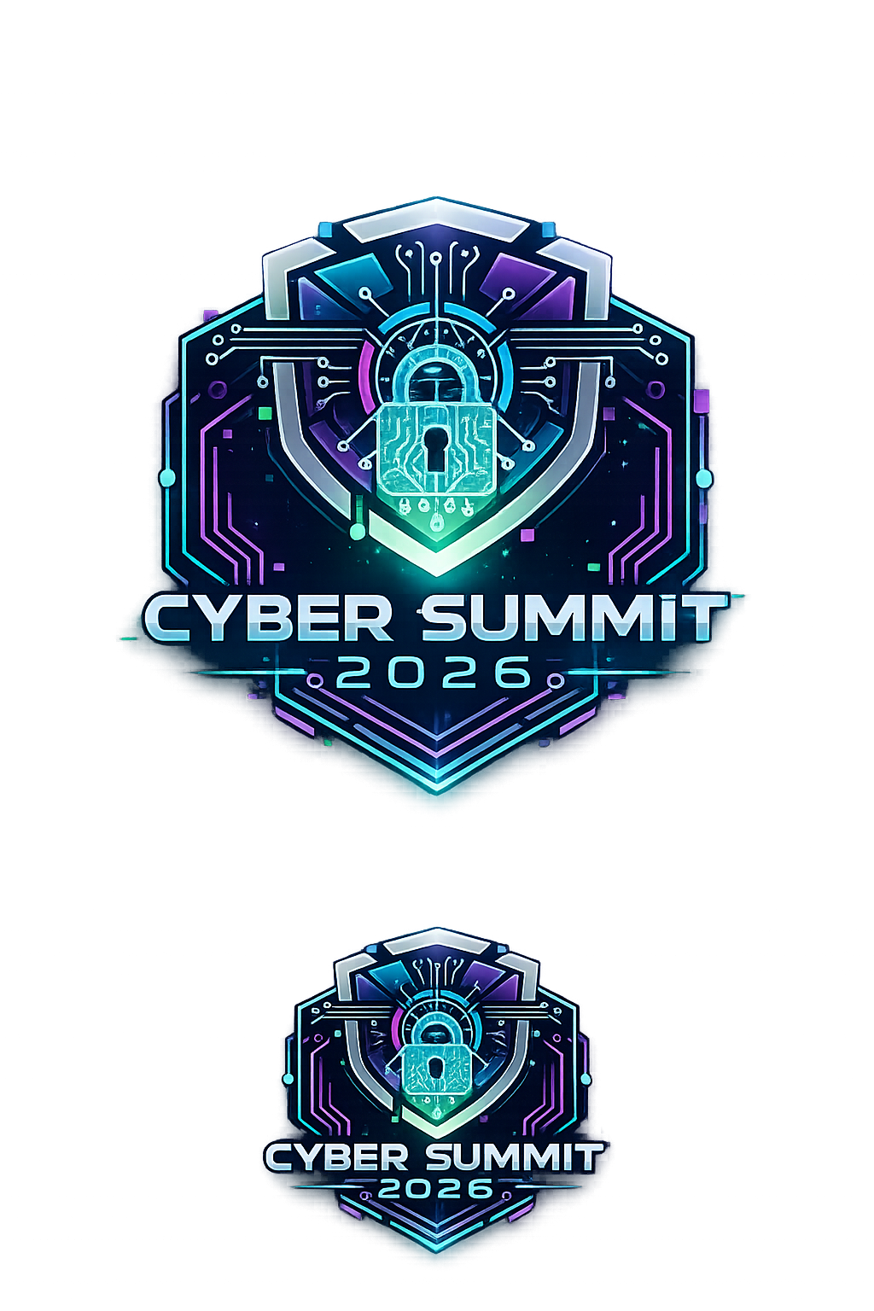
Cyber Summit 2026
Event Information Guide

Overview
Cyber Summit 2026 is a hands-on cybersecurity conference designed for high school students across Loudoun County who are interested in technology, cybersecurity, artificial intelligence, and ethical hacking. The event brings together students, mentors, and industry professionals for a full day of interactive workshops, technical challenges, and collaborative learning.
Our goal is to inspire the next generation of cybersecurity professionals by giving students real-world exposure to tools, techniques, and career paths within the field. Participants will work through challenges similar to those used by professional security teams, gaining practical skills in a fun and engaging environment.

Event Details
Event: Cyber Summit 2026
Date: May 30th, 2026
Time: 9:00 AM – 4:00 PM
Location: Briar Woods High School
22525 Belmont Ridge Rd
Ashburn, VA 20148
Students will spend the day rotating through workshops, competitions, and collaborative cybersecurity challenges.

Who Should Attend
Cyber Summit is designed for:
• High school students interested in cybersecurity, AI, and technology
• Beginners who want to explore cybersecurity for the first time
• Students involved in CyberPatriot, coding clubs, or tech programs
• Anyone curious about ethical hacking and digital defense
No prior cybersecurity experience is required for most activities.

What Students Will Experience
Students will participate in hands-on cybersecurity activities designed to simulate real-world scenarios. These challenges encourage teamwork, critical thinking, and technical exploration.
Participants will gain experience with:
• cybersecurity tools
• digital investigation techniques
• ethical hacking concepts
• artificial intelligence security
• hardware security and IoT devices
Each workshop is guided by mentors and student leaders.

Activities and Workshops

Cyber Escape Room
Students will work in teams to solve cybersecurity puzzles and digital clues in order to “break out” of a simulated cyber incident. Challenges include password cracking, log analysis, cryptography puzzles, and system forensics.
Skills learned:
• problem solving
• teamwork
• digital investigation

AI Capture The Flag (AI CTF)
Students will compete in cybersecurity challenges that involve artificial intelligence systems. Participants will analyze AI models, identify vulnerabilities, and attempt to exploit or defend AI-driven systems.
Topics may include:
• prompt injection attacks
• AI model manipulation
• adversarial AI techniques
• AI security concepts

AI Hardware Lab
This workshop introduces students to building and setting up an Arduino and training a simple AI model that can recognize human emotions. Participants will connect their AI model to physical hardware, creating a system where facial expressions control lights or a small display in real time.
Topics include:
• Emotion‑recognition AI models
• Connecting AI outputs to microcontrollers
• Real‑time hardware reactions (LEDs, displays, servos)
• Fundamentals of AI‑driven embedded systems

IoT Penetration Testing Lab
Students will explore the security of Internet of Things (IoT) devices such as smart cameras, sensors, and embedded systems.
Participants will:
• analyze IoT devices
• identify vulnerabilities
• perform beginner penetration testing
• learn how IoT devices are secured in the real world

What to Bring
Students should bring:
• a laptop (recommended but not required for all activities)
• charger
• curiosity and willingness to learn
All necessary workshop materials will be provided during the event.

Food and Amenities
Lunch and light refreshments will be provided for participants. If you have severe food allergies please plan to bring a packed lunch.

Cyber Summit 2026
Saturday, May 30, 2026
Briar Woods High School

Time | Activity | Location
8:30- 8:55 AM | Check-in | Lobby
9:00 am - 9:05 am | Welcome | Auditorium
9:05 am - 9:55 am | Guest Speaker Panel | Auditorium
9:55 am - 10:00 am | Explain process | Auditorium
10:00 am - 10:10 am | Transition
10:10 am - 11:00 am | Session 1 | L552, L516, L512, L514,
11:00 am - 11:05 am | Transition
11:10 am - 12:00 pm | Session 2 | L552, L516, L512, L514
12:00 pm - 12:10 pm | Transition
12:10 pm - 12:55 pm | Lunch | Cafeteria
1:00 pm - 1:10 pm | Transition
1:10 pm - 2:00 pm | Session 3 | L552, L516, L512, L514
2:00 pm - 2:10 pm | Transition
2:10 pm - 3:00 pm | Session 4 | L552, L516, L512, L514
3:00 pm - 3:30 pm | Ending Ceremony | Auditorium

