Software Requirements Specification

for

SGTravelBud
Version 3.0 approved
Prepared by Huynh Thao Tuong Van, Michelle Low Yuan-Ying, Ong Zhi Jie, Teng Wen Ting, Wan Chenpeng
NTU
29 March 2026
Table of Contents
Table of Contents ii
Revision History ii
1. Introduction 1
1.1 Purpose 1
1.2 Document Conventions 1
1.3 Intended Audience and Reading Suggestions 1
1.4 Product Scope 2
1.5 References 2
2. Overall Description 2
2.1 Product Perspective 2
2.2 Product Functions 2
2.3 User Classes and Characteristics 3
2.4 Operating Environment 32
2.5 Design and Implementation Constraints 32
2.6 User Documentation 32
2.7 Assumptions and Dependencies 32
3. External Interface Requirements 33
3.1 User Interfaces 33
3.2 Hardware Interfaces 40
3.3 Software Interfaces 40
3.4 Communications Interfaces 40
4. System Features 41
4.1 User Input Preference 41
4.2 Trip Request Input 44
4.3 Assess Transport Conditions and Generate Risk Scores 47
4.4 Route Generation and Ranking 49
4.5 Data Freshness, Fallback & Settings 55
5. Other Nonfunctional Requirements 57
5.1 Performance Requirements 57
5.2 Safety Requirements 57
5.3 Security Requirements 57
5.4 Software Quality Attributes 58
5.5 Business Rules 58
6. Other Requirements 59
Appendix A: Glossary 59
6.1 Data Dictionary 59
Appendix B: Analysis Models 62
6.2 Class Diagram 64
6.3 Key Boundary Classes and Control Classes 64
6.4 Dialog Maps 65
Appendix C: To Be Determined List 70

Revision History
Name | Date | Reason For Changes | Version

Introduction

Purpose
Commuters in Singapore face difficulty evaluating and comparing trade-offs among multiple transport modes due to differences in travel time, reliability, crowding levels, and costs, especially under dynamic real-time conditions. This makes it challenging for users to decide which means of transport best aligns with their preferences and situational constraints. This Software Requirements Specification (SRS) document describes the functional and non-functional requirements for SGTravelBud, a software application designed to assist commuters in Singapore in evaluating and selecting transport routes based on their preference for time, cost, reliability, and comfort.

Document Conventions
This document follows the SRS standard conventions based on the IEEE guidelines:

- Section headings are used to organize the requirements of the system

- Functional requirements are written with the term “shall” to indicate mandatory behavior

- Non-functional requirements are described using measurable criteria where applicable

Intended Audience and Reading Suggestions
This SRS is intended for:

- Developers: To understand how the software works and the required features for implementation

- Project Managers: To support planning, scheduling, and allocation of work required for implementation

- Testers: To have a list of test cases to verify that the system meets the specified requirements

- Commuters: To gain a technical understanding of the software system’s capabilities and limitations

- Land Transport Authority (LTA): To understand how data provided by LTA is used and displayed within the software system

Readers, including testers, commuters, and LTA, are recommended to start from the Introduction to understand the general overview and scope of this system, followed by the Overall Description for detailed context. Developers, testers and project managers should focus on Developers, testers, and project managers should focus on External Interface Requirements, System Features, and Other Nonfunctional Requirements to understand the system from a technical perspective.

Product Scope
SGTravelBud is a mobile recommendation application that integrates real-time public transport data to assist Singapore commuters in selecting optimal routes based on personalized preferences. The system computes composite route scores using weighted normalization of travel time, delay risk, crowding risk, and costs. It supports hybrid transport combinations and constraint-based filtering. The objective is to improve commuter decision-making under dynamic transport conditions. This aligns with Singapore’s smart mobility initiatives and supports efforts to enhance transport reliability, efficiency, and commuter experience.

References
We utilize LTA’s official real-time data for taxi availability, MRT crowding, expressway congestion etc., through the LTA DataMall API, as well as finding optimal routes through Google Maps API.

Overall Description

Product Perspective
This product is a standalone mobile application that integrates with external real-time transport data sources such as MRT crowding levels, service delays, taxi availability, and car park availability data. The system consists of the following major components:
- Preference Profile Management Module
- Trip Processing Module
- Risk Assessment Engine
- Route Generation and Ranking Engine
- Data Retrieval Module

Product Functions
The system provides the following major functions:
- Allow users to configure and manage personalized travel preferences, including weighting of travel time, reliability, comfort, and budget
- Accept and validate trip requests, including origin, destination, and departure time
- Retrieve and process real-time transport data, including MRT crowd levels, delay information, taxi availability, and car part availability data
- Compute segment-level and route-level risk indicators for delay and crowding
- Generate feasible route options based on active transport modes and user-defined constraints
- Rank and present route recommendations with explanatory summaries
- Apply fallback mechanisms when real-time data is unavailable
- Allow users to refresh data and modify preferences

User Classes and Characteristics
Use Case ID: | UC-01
Use Case Name: | Detect First-Time User
Created By: | Huynh Thao Tuong Van | Last Updated By: | Huynh Thao Tuong Van
Date Created: | 11/2/2026 | Date Last Updated: | 11/2/2026

Actor: | System
Description: | Checks whether the user has launched the app before. If no saved preference profile exists, the system flags them as a first-time user and redirects them to the preference setup flow before they can request any trip.
Preconditions: | User has opened the application
Postconditions: | System has determined whether the user is new or returning and routed them accordingly
Priority: | High
Frequency of Use: | Once per new user; checked every app launch
Flow of Events: | 1. User opens the application.  2. System checks for an existing saved preference profile.  3. If no profile is found, system flags the user as first-time.  4. System redirects the user to Configure Preference Profile (UC-02).  5. If a profile exists, system proceeds to the main trip request screen.
Alternative Flows: | NIL
Exceptions: | NIL
Includes: | NIL
Special Requirements: | NIL
Assumptions: | NIL
Notes and Issues: | NIL

Use Case ID: | UC-02
Use Case Name: | Configure Preference Profile
Created By: | Huynh Thao Tuong Van | Last Updated By: | Huynh Thao Tuong Van
Date Created: | 11/2/2026 | Date Last Updated: | 11/2/2026

Actor: | User
Description: | Allows the user to set what matters most to them when traveling. They rank their priorities, set walking/transfer limits, and choose their transport modes.
Preconditions: | UC-01 when a new user is detected or when User creates an additional preference profile
Postconditions: | A complete set of user preferences is ready to be saved
Priority: | High
Frequency of Use: | Medium Low
Flow of Events: | 1. User assigns an importance level (Low, Medium, High) to Travel Time, Reliability, Comfort, and Budget.  2. User sets their max walking tolerance (5, 10, 15, or 20 mins) and transfer tolerance (0, 1, 2, or 3).  3. User toggles their transport modes (MRT-only, MRT and Bus, Taxi, Drive). At least one must be active.  4. User optionally configures Hybrid Taxi limits (max duration/budget) and concession fare eligibility.  5. System maps weights internally (Low=1, Med=2, High=3) and normalises them so they equal 1.0.  6. Calls UC-04 to save the preference profile persistently if all validated.
Alternative Flows: | NIL
Exceptions: | NIL
Includes: | NIL
Special Requirements: | NIL
Assumptions: | NIL
Notes and Issues: | NIL

Use Case ID: | UC-03
Use Case Name: | Modify Preference Profile
Created By: | Huynh Thao Tuong Van | Last Updated By: | Huynh Thao Tuong Van
Date Created: | 11/2/2026 | Date Last Updated: | 11/2/2026

Actor: | User
Description: | Lets a returning user update their saved default preferences from the Settings screen. Any changes take effect for all future trips once saved.
Preconditions: | A saved default preference profile already exists (UC-02 was completed previously)
Postconditions: | The modified preferences are ready to be persisted via UC-04
Priority: | Medium
Frequency of Use: | Low
Flow of Events: | 1. User navigates to the Settings screen and opens the saved preference profile.  2. System displays the current preference values (weights, tolerances, mode toggles, budget, etc.).  3. User edits any combination of preference fields.  4. System validates changes (e.g., at least one transport mode stays active, Hybrid Taxi requires a public transport mode).  5. If Hybrid Taxi is enabled but no public transport mode is active, system warns the user and auto-disables Hybrid Taxi.  6. Calls UC-04 to persist the updated profile.
Alternative Flows: | NIL
Exceptions: | If the user tries to disable the last active transport mode, system blocks the action and shows a validation error.
Includes: | NIL
Special Requirements: | NIL
Assumptions: | NIL
Notes and Issues: | NIL

Use Case ID: | UC-04
Use Case Name: | Save Preference Profile
Created By: | Huynh Thao Tuong Van | Last Updated By: | Huynh Thao Tuong Van
Date Created: | 11/2/2026 | Date Last Updated: | 11/2/2026

Actor: | System
Description: | Persists the user's preference profile so it becomes the default for all subsequent trips. Triggered after initial configuration or any modification.
Preconditions: | A complete, validated set of preferences has been configured (UC-02) or modified (UC-03)
Postconditions: | The preference profile is saved and will be applied as the default for future trip requests
Priority: | High
Frequency of Use: | Every time preferences are created or changed
Flow of Events: | 1. System receives the validated preference data from UC-02 or UC-03.  2. System writes the preference profile to persistent storage.  3. System confirms the save was successful.  4. The saved profile becomes the active default for all future trip requests.
Alternative Flows: | NIL
Exceptions: | NIL
Includes: | NIL
Special Requirements: | NIL
Assumptions: | NIL
Notes and Issues: | NIL

Use Case ID: | UC-05
Use Case Name: | Initiate Trip Request
Created By: | Huynh Thao Tuong Van | Last Updated By: | Huynh Thao Tuong Van
Date Created: | 11/2/2026 | Date Last Updated: | 11/2/2026

Actor: | User
Description: | Entry point for planning a new trip. The system loads the user's saved preferences and walks them through entering origin, destination, and departure time.
Preconditions: | User has a saved default preference profile (UC-02 completed)
Postconditions: | All trip inputs (origin, destination, departure time, active preferences) are collected and ready for confirmation
Priority: | High
Frequency of Use: | High
Flow of Events: | 1. User taps to start a new trip request.  2. System fetches the saved default preference profile (UC-07).  3. System displays the active preference summary and asks the user to keep defaults or modify for this trip (UC-06).  4. User enters or selects an origin (UC-08).  5. User enters or selects a destination (UC-09).  6. User selects a departure time; defaults to "Now" if not overridden (UC-10).  7. System displays a trip request summary showing all inputs before confirmation.
Alternative Flows: | NIL
Exceptions: | NIL
Includes: | UC-06 Choose Preference, UC-08 Input Origin, UC-09 Input Destination
Special Requirements: | NIL
Assumptions: | NIL
Notes and Issues: | NIL

Use Case ID: | UC-06
Use Case Name: | Choose Preference
Created By: | Huynh Thao Tuong Van | Last Updated By: | Huynh Thao Tuong Van
Date Created: | 11/2/2026 | Date Last Updated: | 11/2/2026

Actor: | User
Description: | Asks the user whether to go with their saved default preferences or tweak them just for this trip. Trip-level tweaks don't alter the saved profile.
Preconditions: | Trip request has been initiated (UC-05) and default profile has been fetched (UC-07)
Postconditions: | An active preference configuration is set for the current trip request
Priority: | High
Frequency of Use: | High
Flow of Events: | 1. System presents two options: "Use Default Preferences" or "Modify Preferences for This Trip".  2. If the user picks "Use Default Preferences", system applies the saved profile as-is.  3. If the user picks "Modify Preferences for This Trip", system opens an inline editor for trip-level overrides.  4. User adjusts any preferences (weights, tolerances, modes, budget) for this trip only.  5. System applies the trip-level overrides; the saved default profile remains unchanged.  6. If the user dismisses without choosing, system defaults to the saved profile.
Alternative Flows: | NIL
Exceptions: | NIL
Includes: | UC-07 Fetch Preference Profile
Special Requirements: | NIL
Assumptions: | NIL
Notes and Issues: | NIL

Use Case ID: | UC-07
Use Case Name: | Fetch Preference Profile
Created By: | Huynh Thao Tuong Van | Last Updated By: | Huynh Thao Tuong Van
Date Created: | 11/2/2026 | Date Last Updated: | 11/2/2026

Actor: | System
Description: | Retrieves the user's saved default preference profile from storage so it can be displayed and applied during a trip request.
Preconditions: | A saved default preference profile exists
Postconditions: | The preference profile is loaded into memory and available for the current trip request
Priority: | High
Frequency of Use: | High
Flow of Events: | 1. System receives a request to load preferences (triggered by UC-05 or UC-06).  2. System reads the saved preference profile from persistent storage.  3. System returns the full profile (weights, tolerances, mode settings, budget, concession status) to the calling use case.
Alternative Flows: | NIL
Exceptions: | NIL
Includes: | NIL
Special Requirements: | NIL
Assumptions: | NIL
Notes and Issues: | NIL

Use Case ID: | UC-08
Use Case Name: | Input Origin
Created By: | Huynh Thao Tuong Van | Last Updated By: | Huynh Thao Tuong Van
Date Created: | 11/2/2026 | Date Last Updated: | 11/2/2026

Actor: | User
Description: | Lets the user specify where their trip starts, either by using GPS or typing an address manually. The system validates the location is within Singapore.
Preconditions: | Trip request has been initiated (UC-05)
Postconditions: | A validated origin location within Singapore is set for the trip
Priority: | High
Frequency of Use: | High
Flow of Events: | 1. System offers the option to use current GPS location or enter an address manually.  2. If GPS is chosen, system requests location permission (UC-11) and attempts to resolve coordinates.  3. If manual entry is chosen, user types an address and system generates suggestions (UC-12).  4. User selects a suggestion or confirms the typed address.  5. System validates that the origin falls within Singapore.  6. If valid, origin is locked in for the trip.
Alternative Flows: | If GPS fails or times out, system prompts the user to retry or switch to manual input.
Exceptions: | If the origin is outside Singapore or cannot be resolved, system shows an error and asks the user to re-enter.
Includes: | UC-12 Generate Suggestions
Special Requirements: | NIL
Assumptions: | NIL
Notes and Issues: | NIL

Use Case ID: | UC-09
Use Case Name: | Input Destination
Created By: | Huynh Thao Tuong Van | Last Updated By: | Huynh Thao Tuong Van
Date Created: | 11/2/2026 | Date Last Updated: | 11/2/2026

Actor: | User
Description: | Lets the user specify where they want to go, via text entry or by tapping a point on the map. Validated to be within Singapore and different from the origin.
Preconditions: | Trip request has been initiated and origin has been set (UC-08)
Postconditions: | A validated destination location within Singapore is set for the trip
Priority: | High
Frequency of Use: | High
Flow of Events: | 1. User types a destination address and system generates suggestions (UC-12), or user taps a location on the map.  2. User selects a suggestion or confirms the map pin.  3. System validates that the destination is within Singapore.  4. System checks the destination is not identical to the origin.  5. If valid, destination is locked in for the trip.
Alternative Flows: | NIL
Exceptions: | If the destination is outside Singapore, unresolvable, or same as origin, system shows an error and asks for re-entry.
Includes: | UC-12 Generate Suggestions
Special Requirements: | NIL
Assumptions: | NIL
Notes and Issues: | NIL

Use Case ID: | UC-10
Use Case Name: | Input Departure Time
Created By: | Huynh Thao Tuong Van | Last Updated By: | Huynh Thao Tuong Van
Date Created: | 11/2/2026 | Date Last Updated: | 11/2/2026

Actor: | User
Description: | Lets the user pick when they want to leave. Defaults to "Now" but can be scheduled up to 24 hours ahead. The selected time is shown in the trip summary.
Preconditions: | Trip request has been initiated (UC-05)
Postconditions: | A valid departure time is set for the trip request
Priority: | High
Frequency of Use: | High
Flow of Events: | 1. System defaults the departure time to "Now" (current device time).  2. User can accept the default or choose a scheduled departure time.  3. If scheduling, user picks a time within the next 24 hours.  4. System validates the selected time is not in the past.  5. User can edit the departure time before submitting.  6. System displays the selected departure time in the trip request summary.
Alternative Flows: | NIL
Exceptions: | If a past time is selected, system rejects it and prompts re-entry.
Includes: | NIL
Special Requirements: | NIL
Assumptions: | NIL
Notes and Issues: | NIL

Use Case ID: | UC-11
Use Case Name: | Request Location
Created By: | Huynh Thao Tuong Van | Last Updated By: | Huynh Thao Tuong Van
Date Created: | 11/2/2026 | Date Last Updated: | 11/2/2026

Actor: | System
Description: | Handles the GPS location flow: requesting device permission, reading coordinates, and dealing with failures like denied permissions or disabled services.
Preconditions: | User chose to use current location during origin input (UC-08)
Postconditions: | GPS coordinates are returned to the origin input field, or user is redirected to manual input
Priority: | High
Frequency of Use: | High
Flow of Events: | 1. System requests location permission from the device.  2. If permission is granted, system attempts to read GPS coordinates.  3. If coordinates are obtained within the time limit, system returns them to UC-08.  4. If permission is denied, system offers the option to proceed with manual input.  5. If location services are disabled, system prompts the user to enable them or use manual input.  6. If GPS times out, system prompts to retry or fall back to manual input.
Alternative Flows: | NIL
Exceptions: | NIL
Includes: | NIL
Special Requirements: | NIL
Assumptions: | NIL
Notes and Issues: | NIL

Use Case ID: | UC-12
Use Case Name: | Generate Suggestions
Created By: | Huynh Thao Tuong Van | Last Updated By: | Huynh Thao Tuong Van
Date Created: | 11/2/2026 | Date Last Updated: | 11/2/2026

Actor: | System
Description: | Provides live autocomplete suggestions as the user types an origin or destination. The suggestion list updates with every keystroke.
Preconditions: | User is typing in the origin (UC-08) or destination (UC-09) input field
Postconditions: | A list of matching location suggestions is displayed for selection
Priority: | Medium
Frequency of Use: | High
Flow of Events: | 1. User begins typing in the location input field.  2. System queries for matching location suggestions based on the current input text.  3. System displays the suggestion list below the input field.  4. As the user modifies the text, system refreshes the list in real time.  5. User selects a suggestion to populate the field.
Alternative Flows: | NIL
Exceptions: | NIL
Includes: | NIL
Special Requirements: | NIL
Assumptions: | NIL
Notes and Issues: | NIL

Use Case ID: | UC-13
Use Case Name: | Confirm Trip Request
Created By: | Huynh Thao Tuong Van | Last Updated By: | Huynh Thao Tuong Van
Date Created: | 11/2/2026 | Date Last Updated: | 11/2/2026

Actor: | User
Description: | Final step before route generation begins. The user reviews the trip summary (origin, destination, departure time, active preferences) and confirms everything looks right.
Preconditions: | All trip inputs have been entered and validated (UC-05 through UC-10)
Postconditions: | Trip request is confirmed and route generation is triggered
Priority: | High
Frequency of Use: | High
Flow of Events: | 1. System displays the complete trip request summary: origin, destination, departure time, and active preference profile.  2. User reviews the summary.  3. User confirms the trip request.  4. System triggers route generation (UC-23) using the confirmed inputs and active preferences.
Alternative Flows: | User can go back to edit any input before confirming.
Exceptions: | NIL
Includes: | NIL
Special Requirements: | NIL
Assumptions: | NIL
Notes and Issues: | NIL

Use Case ID: | UC-14
Use Case Name: | Refresh Routes
Created By: | Huynh Thao Tuong Van | Last Updated By: | Huynh Thao Tuong Van
Date Created: | 11/2/2026 | Date Last Updated: | 11/2/2026

Actor: | User
Description: | Allows the user to manually re-fetch transport data and regenerate routes before starting their trip, ensuring recommendations reflect the latest conditions.
Preconditions: | Routes have already been generated and displayed for the current trip
Postconditions: | Route recommendations are regenerated using the most recent transport data
Priority: | Medium
Frequency of Use: | Low to Medium
Flow of Events: | 1. User taps the refresh button on the route results screen.  2. System re-initiates transport condition assessment using the latest available data.  3. System regenerates and re-ranks route options (UC-23).  4. Updated routes replace the previous results on screen.
Alternative Flows: | NIL
Exceptions: | NIL
Includes: | UC-23 Generate Routes
Special Requirements: | NIL
Assumptions: | NIL
Notes and Issues: | NIL

Use Case ID: | UC-15
Use Case Name: | Collect Data
Created By: | Huynh Thao Tuong Van | Last Updated By: | Huynh Thao Tuong Van
Date Created: | 11/2/2026 | Date Last Updated: | 11/2/2026

Actor: | System
Description: | Gathers all the real-time transport data needed for risk assessment and route generation. Checks data freshness and triggers fallback handling if anything is stale.
Preconditions: | Trip request has been confirmed (UC-13) or a refresh was requested (UC-14)
Postconditions: | All required transport data is collected, timestamped, and flagged for freshness compliance
Priority: | High
Frequency of Use: | High
Flow of Events: | 1. System identifies which data sources are needed based on the active preference profile (e.g., MRT crowding, delay info, taxi availability, car park data).  2. System calls UC-16 to retrieve real-time data from external APIs.  3. System timestamps each data source upon retrieval.  4. System calls UC-17 to validate freshness of each source.  5. If any source fails freshness checks, system triggers fallback handling (UC-18).  6. System packages the collected data for use in scoring and route generation.
Alternative Flows: | NIL
Exceptions: | NIL
Includes: | UC-16 Retrieve Real-Time Data
Special Requirements: | NIL
Assumptions: | NIL
Notes and Issues: | NIL

Use Case ID: | UC-16
Use Case Name: | Retrieve Real-Time Data
Created By: | Huynh Thao Tuong Van | Last Updated By: | Huynh Thao Tuong Van
Date Created: | 11/2/2026 | Date Last Updated: | 11/2/2026

Actor: | API
Description: | Fetches live transport data from external sources: MRT crowdedness, service/delay status, taxi availability (if enabled), and car park availability (if Drive is enabled).
Preconditions: | Data collection has been initiated (UC-15)
Postconditions: | Raw real-time transport data is returned to the system with retrieval timestamps
Priority: | High
Frequency of Use: | High
Flow of Events: | 1. System sends requests to the relevant external transport data APIs.  2. API returns real-time MRT station crowdedness data.  3. API returns real-time MRT service and delay information.  4. If Taxi or Hybrid Taxi is enabled, API returns real-time taxi availability.  5. If Drive is enabled, API returns real-time car park availability.  6. Each response is timestamped and passed back to UC-15.
Alternative Flows: | NIL
Exceptions: | If an API is unreachable, system proceeds with whatever data is available and flags the gap.
Includes: | NIL
Special Requirements: | NIL
Assumptions: | NIL
Notes and Issues: | NIL

Use Case ID: | UC-17
Use Case Name: | Validate Data Freshness
Created By: | Huynh Thao Tuong Van | Last Updated By: | Huynh Thao Tuong Van
Date Created: | 11/2/2026 | Date Last Updated: | 11/2/2026

Actor: | System
Description: | Checks whether each retrieved data source is fresh enough to use. If a source's timestamp exceeds the allowed threshold, it gets flagged as outdated and routed to fallback handling.
Preconditions: | Real-time data has been retrieved and timestamped (UC-16)
Postconditions: | Each data source is classified as fresh or outdated; outdated sources are sent to fallback
Priority: | High
Frequency of Use: | High
Flow of Events: | 1. System compares each data source's retrieval timestamp against predefined freshness thresholds.  2. Sources within the threshold are marked as fresh and passed through for processing.  3. Sources exceeding the threshold are flagged as outdated.  4. Outdated sources trigger UC-18 (Apply Fallback Handling).
Alternative Flows: | NIL
Exceptions: | NIL
Includes: | NIL
Special Requirements: | NIL
Assumptions: | NIL
Notes and Issues: | NIL

Use Case ID: | UC-18
Use Case Name: | Apply Fallback Handling
Created By: | Huynh Thao Tuong Van | Last Updated By: | Huynh Thao Tuong Van
Date Created: | 11/2/2026 | Date Last Updated: | 11/2/2026

Actor: | System
Description: | Substitutes the most recent cached data when live data is unavailable or stale. Ensures no partial mixing of real-time and outdated data for the same transport mode.
Preconditions: | One or more data sources have been flagged as unavailable or outdated (UC-17)
Postconditions: | Fallback data is in place and affected elements are marked accordingly (UC-19)
Priority: | High
Frequency of Use: | Low to Medium
Flow of Events: | 1. System identifies which data sources need fallback substitution.  2. System retrieves the most recent available cached data for each affected source.  3. System ensures fallback is applied consistently per transport mode (no mixing of real-time and stale data within the same mode).  4. System calls UC-19 to mark all affected data elements as operating in fallback mode.  5. Fallback data is fed into scoring and route generation alongside any fresh data.
Alternative Flows: | NIL
Exceptions: | If no cached data is available at all for a source, the system proceeds without it and flags the gap.
Includes: | UC-19 Mark Fallback Handling
Special Requirements: | NIL
Assumptions: | NIL
Notes and Issues: | NIL

Use Case ID: | UC-19
Use Case Name: | Mark Fallback Handling
Created By: | Huynh Thao Tuong Van | Last Updated By: | Huynh Thao Tuong Van
Date Created: | 11/2/2026 | Date Last Updated: | 11/2/2026

Actor: | System
Description: | Tags data elements and route recommendations that were computed using fallback data, so downstream processes and the user can see which results may be less accurate.
Preconditions: | Fallback data has been applied (UC-18)
Postconditions: | All affected data elements and route outputs carry a fallback indicator
Priority: | Medium
Frequency of Use: | Low to Medium
Flow of Events: | 1. System identifies every data element that was derived from fallback rather than real-time data.  2. System attaches a fallback flag to each affected element.  3. Flags propagate through to route-level risk indicators and scoring outputs.  4. When routes are displayed (UC-26), fallback-affected routes include a reduced-accuracy notation.
Alternative Flows: | NIL
Exceptions: | NIL
Includes: | NIL
Special Requirements: | NIL
Assumptions: | NIL
Notes and Issues: | NIL

Use Case ID: | UC-20
Use Case Name: | Generate Scores
Created By: | Huynh Thao Tuong Van | Last Updated By: | Huynh Thao Tuong Van
Date Created: | 11/2/2026 | Date Last Updated: | 11/2/2026

Actor: | System
Description: | Computes composite scores for each candidate route by combining normalised route attributes with the user's preference weights. Lower score = better route.
Preconditions: | Routes have been generated (UC-23) with assigned attributes, and risk indicators are available from UC-21 and UC-22
Postconditions: | Each candidate route has a composite score ready for ranking
Priority: | High
Frequency of Use: | High
Flow of Events: | 1. System collects route attributes: estimated travel time, route-level delay risk, route-level crowding risk, and estimated cost.  2. System converts risk categories to numeric values (Low=1, Medium=2, High=3, Unknown=2).  3. System applies min-max normalisation across all candidate routes for each attribute.  4. System retrieves the user's normalised preference weights.  5. System computes the composite score: wT*T' + wR*R' + wC*C' + wB*B'.  6. Scores are attached to each route and passed to UC-25 for ranking.
Alternative Flows: | If all routes share the same value for an attribute, the normalised value is set to 0.0 for all.
Exceptions: | NIL
Includes: | UC-21 Assess Crowding Risk, UC-22 Assess Delay Risk
Special Requirements: | NIL
Assumptions: | NIL
Notes and Issues: | NIL

Use Case ID: | UC-21
Use Case Name: | Assess Crowding Risk
Created By: | Huynh Thao Tuong Van | Last Updated By: | Huynh Thao Tuong Van
Date Created: | 11/2/2026 | Date Last Updated: | 11/2/2026

Actor: | System
Description: | Evaluates how crowded each public transport segment is likely to be, based on retrieved data. Each segment gets a Low, Medium, High, or Unknown crowding label.
Preconditions: | Transport data has been collected (UC-15) and routes have been generated (UC-23)
Postconditions: | Segment-level and route-level crowding risk indicators are assigned
Priority: | High
Frequency of Use: | High
Flow of Events: | 1. System identifies all public transport segments across candidate routes.  2. For each segment, system computes a crowding risk indicator from the retrieved transport data.  3. System categorises each segment as Low, Medium, High, or Unknown.  4. If crowding data is missing for a segment, it is marked Unknown.  5. System aggregates segment-level values to a route-level crowding risk using worst-case (max) rule: if any segment is Unknown, the route is Unknown; otherwise, the highest segment risk wins.  6. Route-level crowding risk is passed to UC-20 for scoring.
Alternative Flows: | NIL
Exceptions: | NIL
Includes: | NIL
Special Requirements: | NIL
Assumptions: | NIL
Notes and Issues: | NIL

Use Case ID: | UC-22
Use Case Name: | Assess Delay Risk
Created By: | Huynh Thao Tuong Van | Last Updated By: | Huynh Thao Tuong Van
Date Created: | 11/2/2026 | Date Last Updated: | 11/2/2026

Actor: | System
Description: | Evaluates the likelihood of delays on each public transport segment based on service status data. Each segment gets a Low, Medium, High, or Unknown delay label.
Preconditions: | Transport data has been collected (UC-15) and routes have been generated (UC-23)
Postconditions: | Segment-level and route-level delay risk indicators are assigned
Priority: | High
Frequency of Use: | High
Flow of Events: | 1. System identifies all public transport segments across candidate routes.  2. For each segment, system computes a delay risk indicator from the retrieved service/delay data.  3. System categorises each segment as Low, Medium, High, or Unknown.  4. If delay data is missing for a segment, it is marked Unknown.  5. System aggregates to route-level delay risk using worst-case (max) rule: if any segment is Unknown, the route is Unknown; otherwise, the highest segment risk wins.  6. Route-level delay risk is passed to UC-20 for scoring.
Alternative Flows: | NIL
Exceptions: | NIL
Includes: | NIL
Special Requirements: | NIL
Assumptions: | NIL
Notes and Issues: | NIL

Use Case ID: | UC-23
Use Case Name: | Generate Routes
Created By: | Huynh Thao Tuong Van | Last Updated By: | Huynh Thao Tuong Van
Date Created: | 11/2/2026 | Date Last Updated: | 11/2/2026

Actor: | System
Description: | Produces candidate route options from origin to destination using only the enabled transport modes. Applies all user constraints (walking, transfers, budget) and generates Hybrid Taxi combos if enabled.
Preconditions: | Trip request is confirmed (UC-13) and transport data is collected (UC-15)
Postconditions: | A set of feasible candidate routes is generated, each with assigned attributes
Priority: | High
Frequency of Use: | High
Flow of Events: | 1. System reads the active preference profile to determine which modes are enabled.  2. System generates MRT-only routes if that mode is enabled.  3. System generates MRT and Bus combined routes if that mode is enabled.  4. System generates Taxi-only routes if Taxi mode is enabled.  5. System generates Drive-only routes if Drive mode is enabled.  6. If Hybrid Taxi is enabled, system generates routes combining public transport with a single taxi segment, respecting max duration and budget limits.  7. System filters out routes that violate walking tolerance, transfer tolerance, or budget constraints.  8. If no feasible routes remain, system relaxes constraints in a predefined order and notifies the user.  9. For each feasible route, system assigns: estimated travel time, number of transfers, estimated cost, and route-level risk indicators.  10. Candidate routes are passed to UC-25 for ranking.
Alternative Flows: | If exactly one feasible route exists, it is presented alone with a notice. If zero feasible routes exist, a descriptive message is shown with suggestions to adjust constraints.
Exceptions: | NIL
Includes: | UC-24 Generate Route Explanation, UC-25 Rank Routes
Special Requirements: | NIL
Assumptions: | NIL
Notes and Issues: | NIL

Use Case ID: | UC-24
Use Case Name: | Generate Route Explanation
Created By: | Huynh Thao Tuong Van | Last Updated By: | Huynh Thao Tuong Van
Date Created: | 11/2/2026 | Date Last Updated: | 11/2/2026

Actor: | System
Description: | Creates a short, human-readable one-liner for each route explaining why it was ranked where it is, referencing the user's top priority and the route's risk levels.
Preconditions: | Routes have been scored and ranked (UC-20, UC-25)
Postconditions: | Each route has a brief explanation attached for display
Priority: | Medium
Frequency of Use: | High
Flow of Events: | 1. System identifies the user's highest-weighted preference criterion.  2. For each route, system summarises how it performs on that top criterion.  3. System appends the route-level delay and crowding risk categories.  4. If any risk indicator used fallback data, a reduced-accuracy note is appended.  5. The explanation is attached to the route for display in UC-26.
Alternative Flows: | NIL
Exceptions: | NIL
Includes: | NIL
Special Requirements: | NIL
Assumptions: | NIL
Notes and Issues: | NIL

Use Case ID: | UC-25
Use Case Name: | Rank Routes
Created By: | Huynh Thao Tuong Van | Last Updated By: | Huynh Thao Tuong Van
Date Created: | 11/2/2026 | Date Last Updated: | 11/2/2026

Actor: | System
Description: | Sorts all candidate routes from best to worst based on their composite scores. Uses a multi-level tie-breaker when scores are equal.
Preconditions: | Composite scores have been computed for all candidate routes (UC-20)
Postconditions: | Routes are ordered by rank; top 2–3 are selected for display
Priority: | High
Frequency of Use: | High
Flow of Events: | 1. System sorts all candidate routes in ascending order of composite score (lowest = best).  2. If two or more routes tie on composite score, system breaks ties in order: lower delay risk, lower crowding risk, fewer transfers, shorter travel time, lower cost.  3. System selects the top 2–3 distinct routes for presentation.  4. Each selected route must represent a meaningfully different travel alternative (different modes, paths, or transfer points).  5. Ranked routes are passed to UC-26 for display.
Alternative Flows: | NIL
Exceptions: | NIL
Includes: | UC-26 Display Routes
Special Requirements: | NIL
Assumptions: | NIL
Notes and Issues: | NIL

Use Case ID: | UC-26
Use Case Name: | Display Routes
Created By: | Huynh Thao Tuong Van | Last Updated By: | Huynh Thao Tuong Van
Date Created: | 11/2/2026 | Date Last Updated: | 11/2/2026

Actor: | System
Description: | Presents the final ranked route options to the user, complete with travel times, costs, risk levels, explanations, and any fallback-accuracy warnings.
Preconditions: | Routes have been ranked (UC-25) and explanations generated (UC-24)
Postconditions: | The user can see and compare the recommended route options
Priority: | High
Frequency of Use: | High
Flow of Events: | 1. System displays 2–3 ranked route options (or 1 if only one is feasible).  2. Each route shows: estimated travel time, number of transfers, estimated cost, route-level delay risk, and route-level crowding risk.  3. Each route includes its one-line explanation from UC-24.  4. Routes using fallback data display a reduced-accuracy notation.  5. If no routes were found, system shows a message explaining why and suggests the user adjust constraints or preferences.
Alternative Flows: | NIL
Exceptions: | NIL
Includes: | NIL
Special Requirements: | NIL
Assumptions: | NIL
Notes and Issues: | NIL

Use Case ID: | UC-27
Use Case Name: | Change Settings
Created By: | Huynh Thao Tuong Van | Last Updated By: | Huynh Thao Tuong Van
Date Created: | 11/2/2026 | Date Last Updated: | 11/2/2026

Actor: | User
Description: | Lets the user update app-level settings such as display language, unit format, and their default preference profile. Changes take effect once saved.
Preconditions: | User is logged in and navigates to the Settings screen
Postconditions: | Modified settings are validated and ready to be saved (UC-28)
Priority: | Medium
Frequency of Use: | Low
Flow of Events: | 1. User opens the Settings screen.  2. System displays current settings: language, unit format, and a link to the saved preference profile.  3. User modifies one or more settings.  4. If the user edits the default preference profile, system opens the profile editor (UC-03).  5. System validates all changes.  6. If changes are valid, system triggers UC-28 to save them.
Alternative Flows: | NIL
Exceptions: | NIL
Includes: | NIL
Special Requirements: | NIL
Assumptions: | NIL
Notes and Issues: | User can also reset all settings to default values from this screen.

Use Case ID: | UC-28
Use Case Name: | Save Settings
Created By: | Huynh Thao Tuong Van | Last Updated By: | Huynh Thao Tuong Van
Date Created: | 11/2/2026 | Date Last Updated: | 11/2/2026

Actor: | System
Description: | Persists the user's updated app settings (language, units, preferences) so they carry over to future sessions.
Preconditions: | Settings have been changed and validated (UC-27)
Postconditions: | Updated settings are saved and applied to the current and future sessions
Priority: | Medium
Frequency of Use: | Low
Flow of Events: | 1. System receives validated settings from UC-27.  2. System writes the updated settings to persistent storage.  3. System applies the new settings immediately (e.g., language change refreshes all UI labels).  4. System confirms the save to the user.
Alternative Flows: | NIL
Exceptions: | NIL
Includes: | NIL
Special Requirements: | NIL
Assumptions: | NIL
Notes and Issues: | NIL

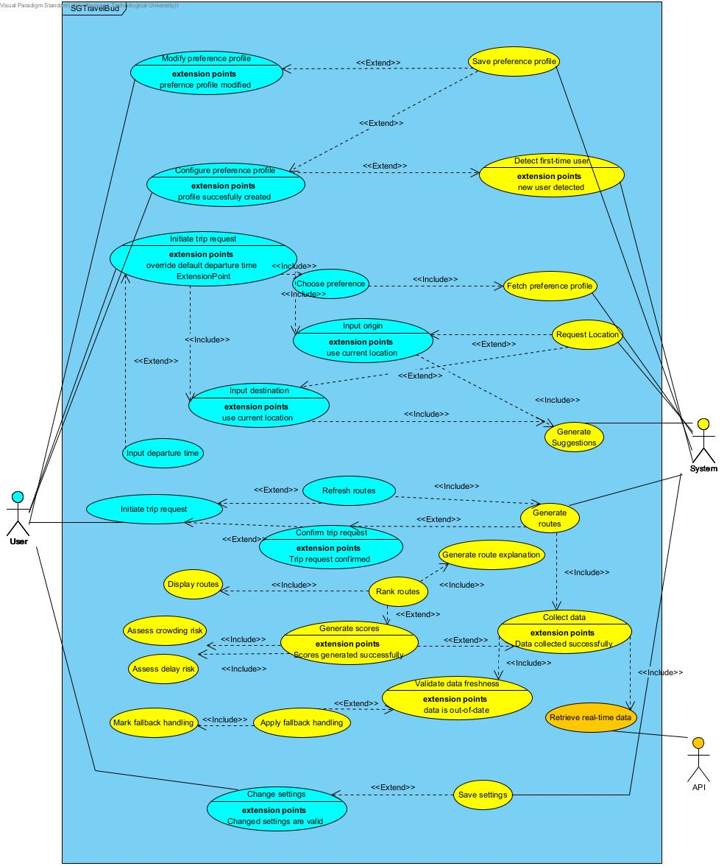

Operating Environment
SGTravelBud is designed to operate as a mobile application.

- Hardware Platform: Mobile devices with GPS capabilities on both Android and iOS

- Software Environment: Frontend application running on the user’s mobile device, and backend services are hosted on a server environment

- External Systems: Transport, traffic data, mapping, and geolocation services for address and route generation

- Network Requirements: An active internet connection is required for real-time data retrieval and route generation

Design and Implementation Constraints
The design and implementation of the system are subject to the following constraints:

- Technology Constraints: The system relies on external APIs for real-time transport data, routing, and geolocation services; hence, rate limit constraints exist

- Platform Constraints: Permission must be given for GPS access on mobile devices

- Design Constraints: The preference weights must always be normalized to ensure consistent scoring

User Documentation
All documentation will be delivered within the application in clear, non-technical language with language translations.

- In-App Help: Tooltips can be accessed in the settings to understand the usability of the application

- Onboarding: First-time users are guided through their personal preference configuration

Assumptions and Dependencies
Assumptions | - Users have access to a GPS-enabled device and grant location permission when asked  - External transport data APIs provide accurate and timely information
Dependencies | - Availability and reliability of third-party transport data APIs  - Availability of mapping services for location validation and routing  - Stable internet connectivity  - Continued support of required APIs and data formats by external providers

External Interface Requirements

User Interfaces
Frame | User Interface | Description
1 | 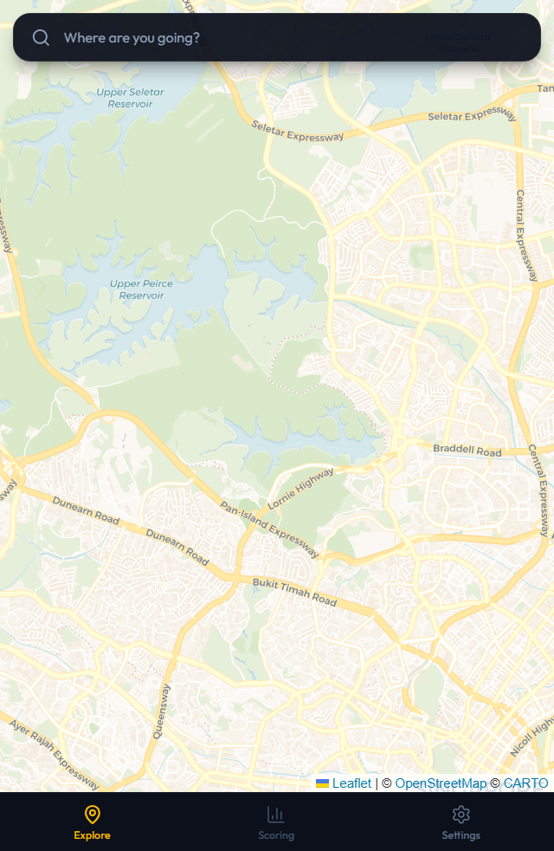 | Once the user enters the application, the map is displayed.
2 | 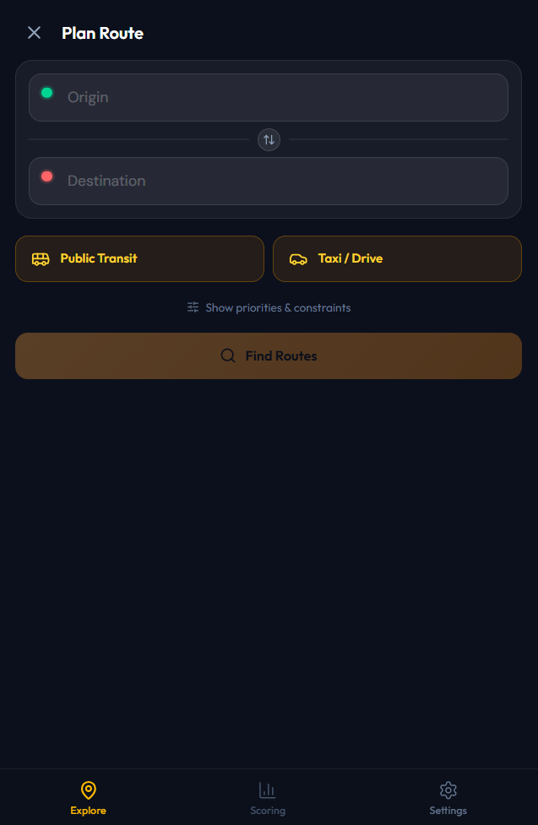 | The application requests the user to input their origin and destination locations.
3 | 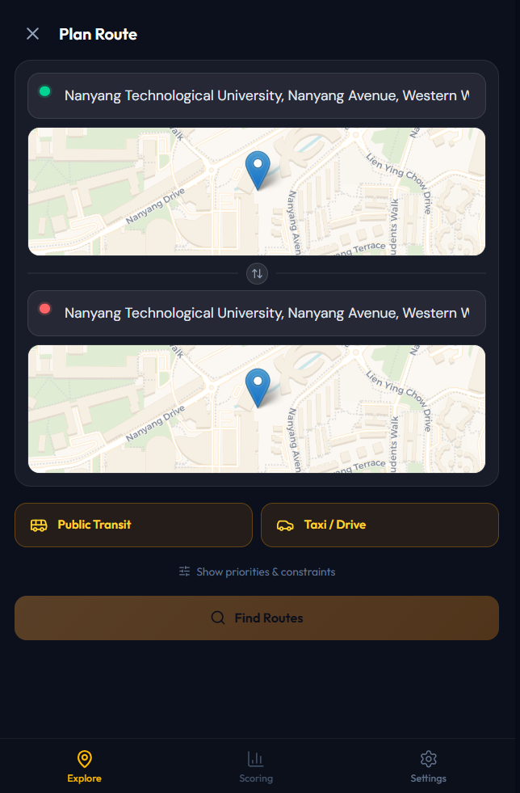 | When the location is chosen, a point would be displayed on the map.  When the locations are similar, users are unable to click ‘Find Routes’ to proceed.
4 | 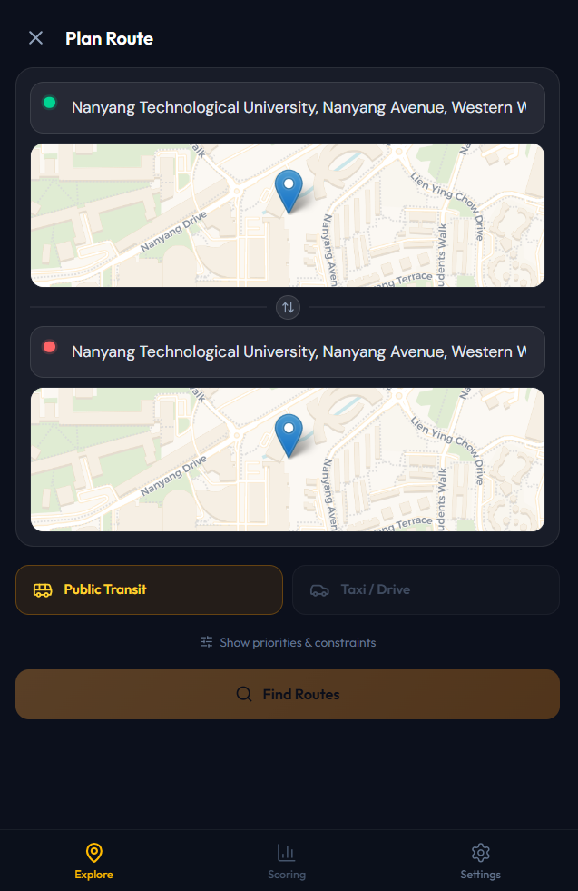 | The user can pick their travel mode of choice:  - Public Transit (MRT & Bus)  - Taxi/Drive  Here, only ‘Public Transit’ is chosen.
5 | 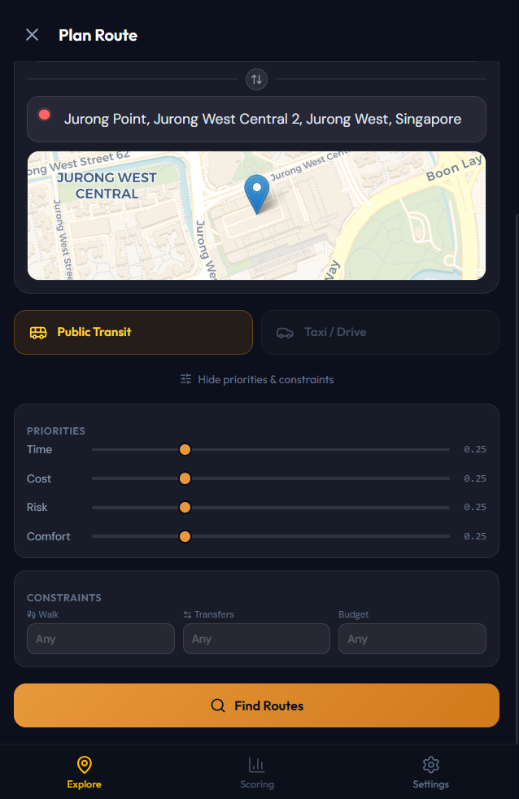 | When ‘Show priorities & constraints’ is clicked on, users can drag the sliding bars to weigh their preferences:  - Time  - Cost  - Risk  - Comfort  The preferences have default weight of 0.25.  Users are also able to enter constraints to:  - Walking time  - Number of transfers  - Budget  When inputs have no errors, the ‘Find Routes’ button would turn orange to prompt users to click to calculate possible routes.
6 | 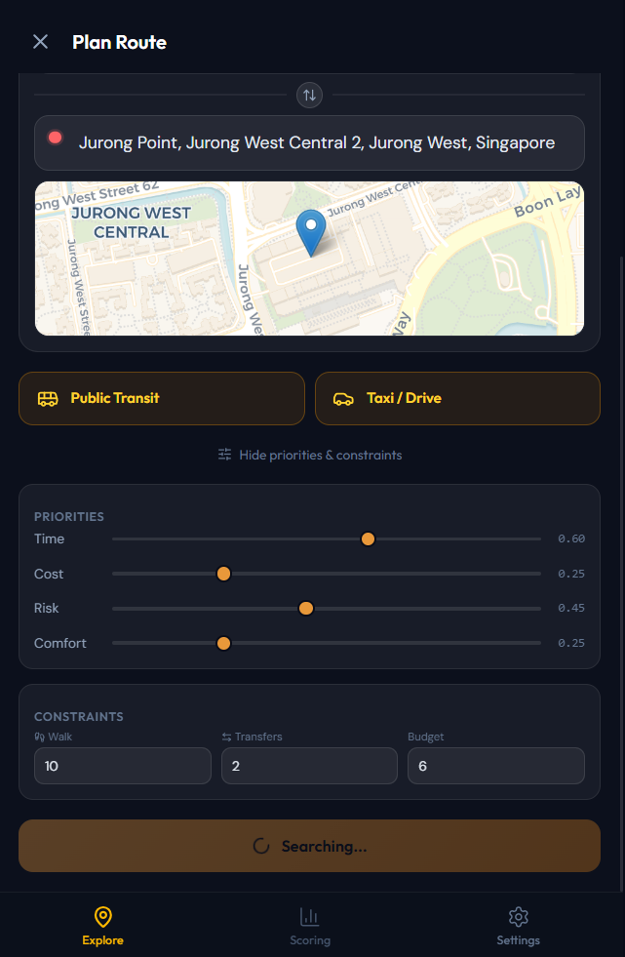 | Loading screen for route calculation.
7 | 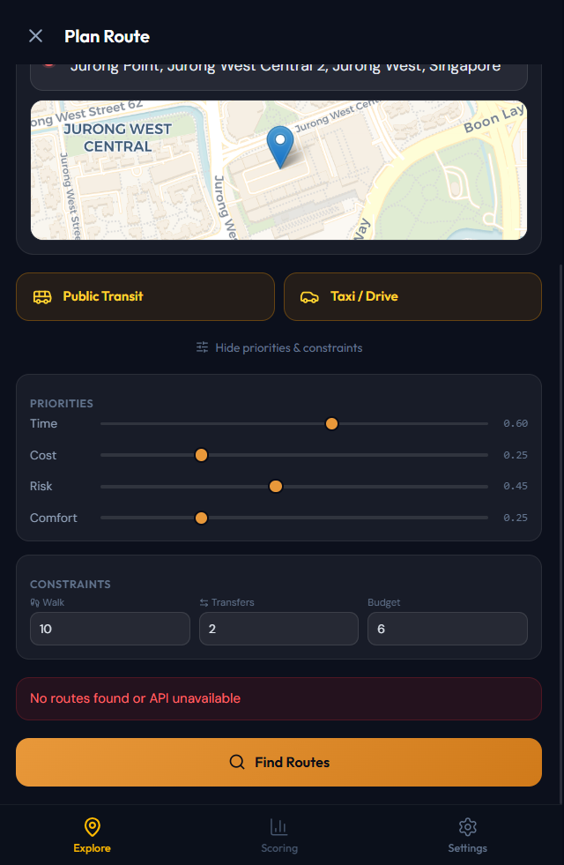 | If there are no possible routes or errors during route calculation, an error message will pop up.  Users can recalibrate their priorities and constraints before clicking ‘Finding Routes’ again.
8 | 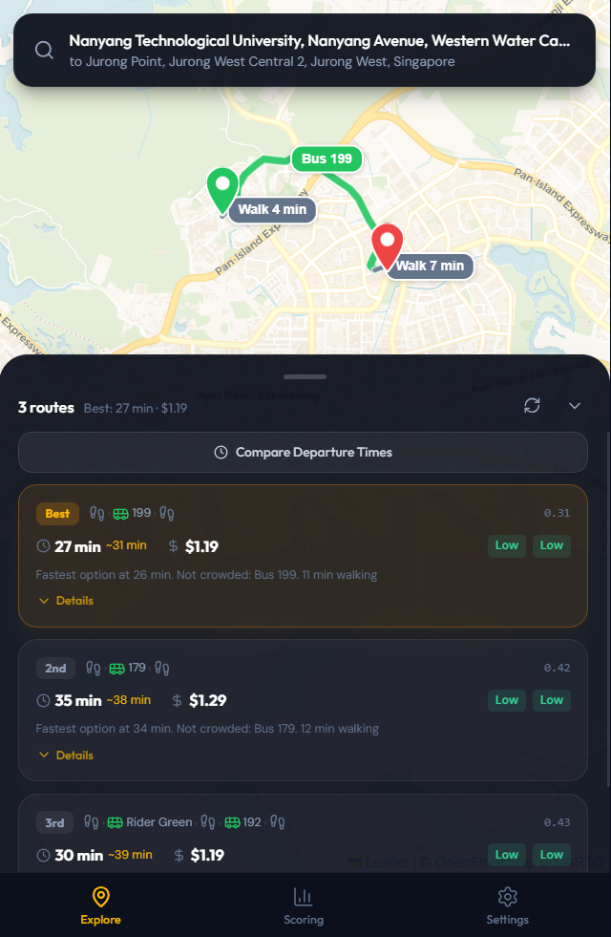 | Once calculation is done, the top 3 best routes would be displayed, along with information about:  - Travel time  - Crowdedness  - Risk score  - Walking time  - Total price of travel  - Composite score
9 | 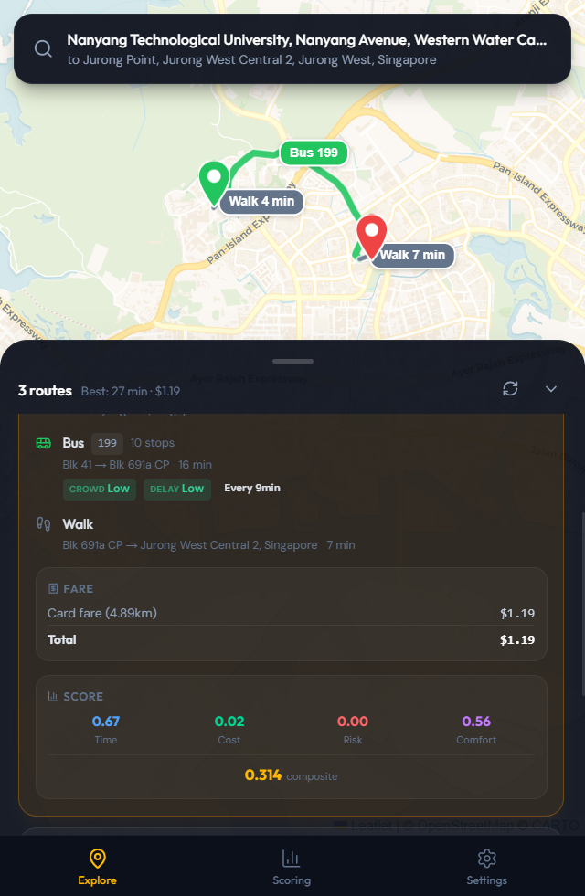 | When ‘Details’ is clicked, application displays:  - Instructions of travel  - Breakdown of travel cost  - Breakdown of preferences score  - Composite score
10 | 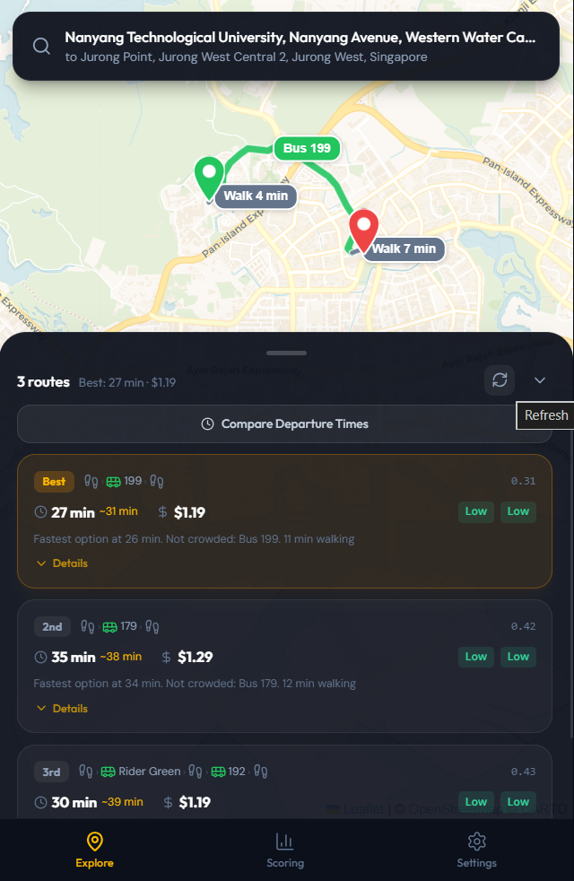 | Users would be able to refresh their routes to the most updated upon clicking the button.
11 | 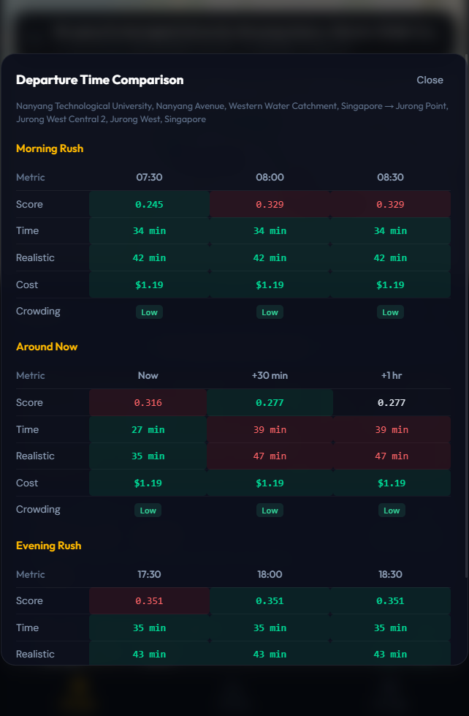 | When ‘Compare Departure Times’ is clicked, breakdown of the top 3 routes based on:  - Composite score  - Time taken for travel  - Cost of travel  - Crowding  during morning rush, the current timing and evening rush are displayed, with a 30-minute and 1-hour comparison.
12 | 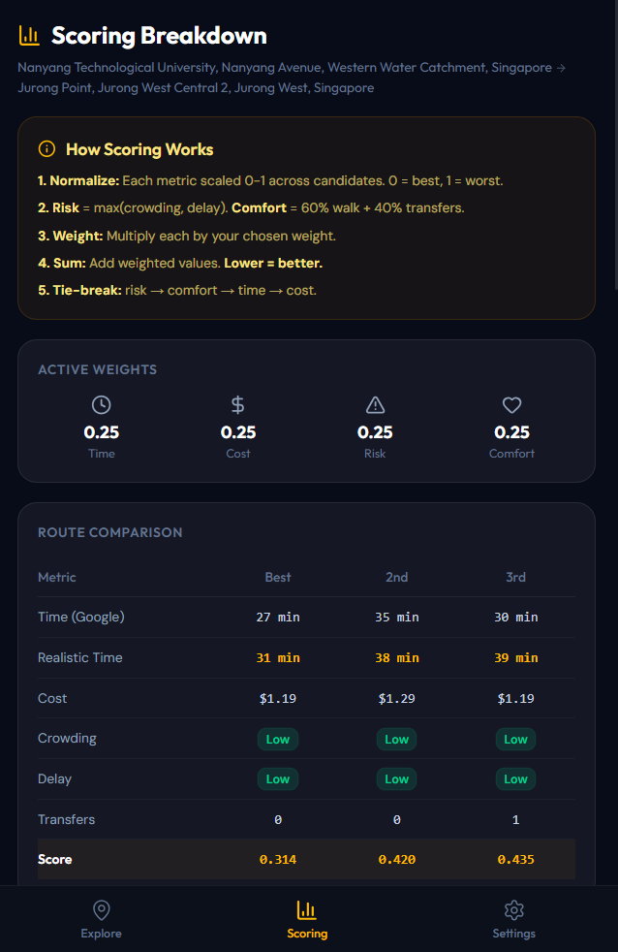 | When ‘Scoring’ is clicked, the app displays how the system calculates route scores, current weights used for scoring and the top 3 routes comparison based on:  - Time taken by Google Maps  - Estimated realistic time taken  - Travel cost  - Crowding level  - Delay level  - Number of transfers  - Overall composite score
13 | 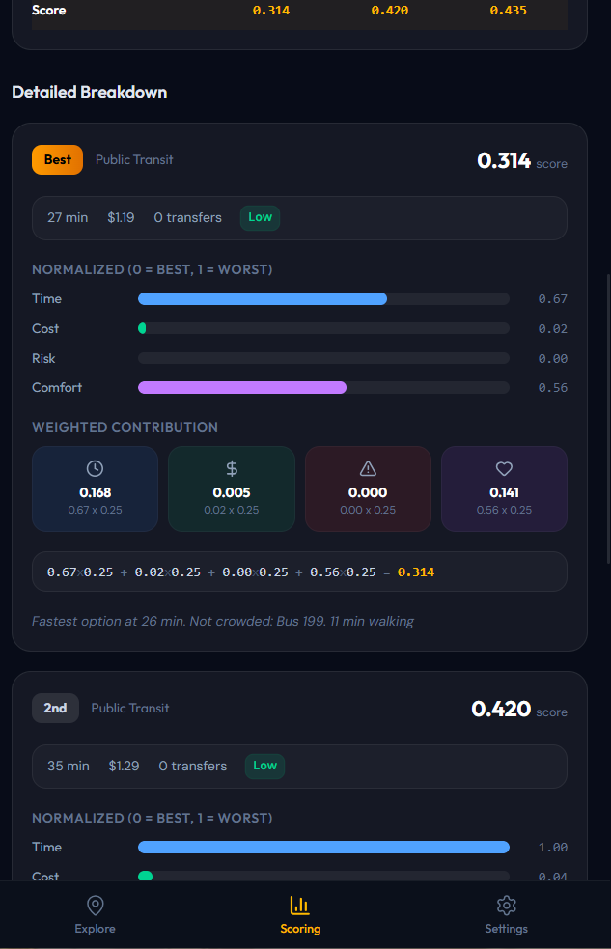 | Users can also see the detailed breakdown of each top 3 routes suggested based on the weights and scores.
14 | 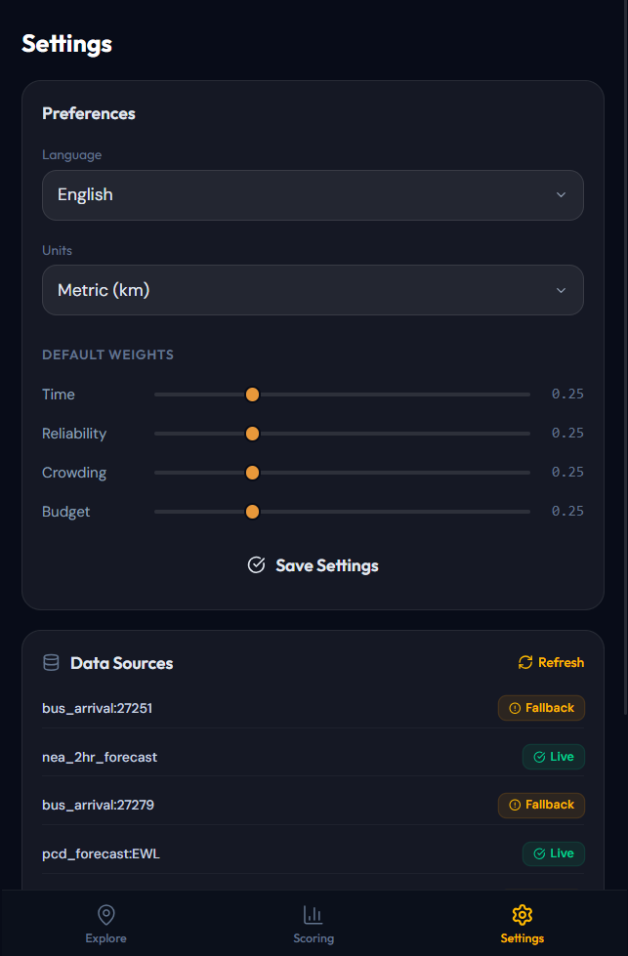 | In the settings page, users are able to:  - Change application language (English, Chinese, Malay, Tamil)  - Change distance units (km, miles)  - Change default weights for scoring
15 | 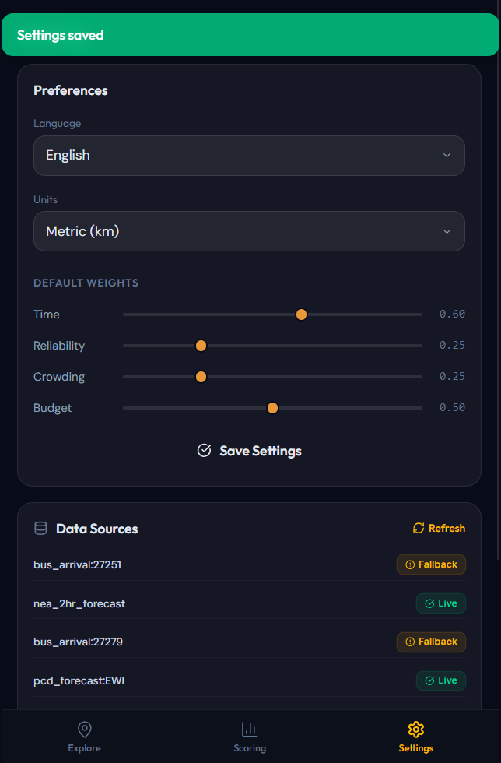 | Application will let the users know after settings has been changed and saved.

Hardware Interfaces
The system is a mobile application designed to run on all mobile devices. The system does not require any specialized or external hardware components, especially device hardware such as cameras, microphones, or sensors. All hardware interactions are handled through the operating system’s APIs without hardware control.

Software Interfaces
The system retrieves transport information from LTA’s real-time database to weigh the best route for users based on their preferences. This is retrieved through Python’s Requests library to establish HTTP communication through web APIs on LTAMall and Google Maps. Subject to the user’s permission, the system can also access the mobile device’s GPS-based location data.

Communications Interfaces
As mentioned above, HTTP communication is used to retrieve information from LTA’s database and Google Maps. As both APIs have limits on the number of calls, the system would only retrieve information when required, such as after users confirm their trip details and when users manually click the refresh button. To ensure that established communication is secure, the API keys for LTA’s database and Google Maps API shall not be revealed or mentioned in any documentation or program.

System Features

User Input Preference

Description and Priority
This feature allows users to configure, modify and store travel preferences that influence route generation and ranking. Preferences include optimization criteria weighting (travel time, delay risk, crowding risk, and budget), transport mode selection, walking and transfer constraints, hybrid taxi configuration, and concession eligibility. These preferences from the active preference profile used in all route scoring and constraint handling operations.
Priority: High

Stimulus/Response Sequences
- User launches the application for the first time
- System detects first-time access
- System prompts the user to configure travel preferences
- User selects importance levels and constraints settings
- System converts importance levels to numerical weights and normalizes them
- User confirms configuration
- System saves the configuration as the default preference profile

Functional Requirements

FR-1.1. First-Time User Detection | 1.1.1. | The system shall detect whether the User is accessing the application for the first time
 | 1.1.2. | If the User is accessing the application for the first time, the system shall prompt the User to configure their travel preferences before any trip request can be submitted
FR-1.2. Preference Weighting Model | 1.2.1. | The system shall allow the User to assign an importance level to each of the following criteria:  - Travel Time  - Reliability (Delay Risk)  - Comfort (Crowding Risk)  - Budget
 | 1.2.2. | The system shall provide the following importance levels for each criterion: Low, Medium, High
 | 1.2.3. | The system shall allow the user to review a brief description of each optimisation preference before selection
 | 1.2.4. | The system shall inform the User that the default preference profile can be modified later in the Settings screen
FR-1.3. Weight Mapping and Scoring Configuration | 1.3.1. | 1.3.1. The system shall internally convert the User's selected importance levels into numerical weights using the following fixed mapping:  - Low = 1  - Medium = 2  - High = 3
 | 1.3.2. | The system shall normalise the mapped numerical weights before applying them to composite scoring formula  1.3.2.1. The normalised weight for criterion k shall be computed as:  1.3.2.2. The sum of all normalised weights shall equal to 1.0
FR-1.4. Initial Preference Constraints | 1.4.1. | The system shall allow the user to specify walking tolerance during initial preference setup  1.4.1.1. The system shall allow the user to select a maximum walking time from the following options: 5, 10, 15 or 20 minutes
 | 1.4.2. | The system shall allow the user to specify transfer tolerance during initial preference setup  1.4.2.1. The system shall allow the user to select a maximum number of transfers from the following options: 0, 1, 2, or 3
FR-1.5. Mode Constraints | 1.5.1. | The system shall allow the User to enable or disable transport mode categories for route generation
 | 1.5.2. | The system shall support at minimum the following transport mode categories:  - Public Transport (MRT + Bus)  - Taxi/Drive
 | 1.5.3. | The system shall allow the user to restrict route recommendations to public transport only by excluding Taxi and Drive modes
 | 1.5.4. | The system shall allow the User to exclude taxi routes while other transport mode categories remain enabled
 | 1.5.5. | The system shall require at least one transport mode category to remain enabled  1.5.5.1. The system shall prevent the User from disabling the last remaining enabled transport mode category  1.5.5.2. If an attempt is made to disable the last enabled mode category, the system shall display a validation error informing the User that at least one mode must remain active
FR-1.6. Hybrid Taxi Preference | 1.6.1. | The system shall allow the user to enable Hybrid Taxi options  1.6.1.1. Hybrid Taxi is a route composition feature that generates routes combining one or more public transport segments with a single taxi segment. It is available only when at least one public transport mode (MRT-only or MRT and Bus) is enabled  1.6.1.2. The system shall allow the user to set a maximum taxi segment duration for Hybrid Taxi routes (e.g., ≤ 10 minutes)  1.6.1.3. The system shall allow the user to set a maximum taxi budget for Hybrid Taxi routes
 | 1.6.2. | If Hybrid Taxi is enabled but no public transport mode is active, the system shall display a warning and disable the Hybrid Taxi option automatically
FR-1.7. Cost Preferences | 1.7.1. | The system shall allow the user to indicate whether concession fares apply (e.g., student or senior fares)
 | 1.7.2. | The system shall allow the User to specify an optimal maximum trip budget
 | 1.7.3. | If a budget is specified, the system shall avoid recommending routes that exceed the budget when feasible
FR-1.8. Saving User Preference | 1.8.1. | Upon completion of the initial preference setup, the system shall save the User’s selected preferences as the default preference profile
 | 1.8.2. | The system shall apply the saved preferences as the default preference profile for subsequent trip requests until modified

Trip Request Input

Description and Priority
This feature allows the User to initiate and configure a trip request by specifying the origin, destination, departure time, and applicable preference profile. The system validates all user inputs and determines the active preference configuration before route generation begins. This feature ensures that only valid and complete trip contexts are passed on to the route generation engine.
Priority: High

Stimulus/Response Sequences
- User selects “New Trip” to initiate a trip request
- System retrieves the saved default preference profile
- System prompts the User to either use the default profile or modify the preferences for the current trip
- User selects preference profile
- System applies the selected preference configuration
- User enters the origin (via GPS, manual input, or map)
- System validates origin input
- User enters destination
- System validates destination
- User selects departure time
- System validates departure time
- User confirms trip request
- System passes validate trip context to the transport condition assessment feature

Functional Requirements
FR- 2.1. Initiate Trip Request | 2.1.1. | The system shall allow the User to initiate a new trip request
 | 2.1.2. | The system shall retrieve the User’s saved default preference profile upon trip request initiation
 | 2.1.3. | The system shall display the active default preference profile to the User prior to origin/destination entry
FR-2.2. Confirm Profile Preference Usage | 2.2.1. | The system asks the User whether to apply the default preference profile or modify it for the current trip
 | 2.2.2. | The system shall provide the following options:  - Use Default Preferences  - Modify Preferences for This Trip
 | 2.2.3. | If the User dismisses the prompt without making a selection, the system shall default to the saved default preference profile
FR-2.3. Apply Preference Configuration | 2.3.1. | If the User selects “Use Default Preferences”, the system applies the saved default preference profile
 | 2.3.2. | If the User selects “Modify Preferences for This Trip", the system shall apply the trip-level overrides to be configured
 | 2.3.3. | Trip-level overrides shall apply only to the current trip request and shall not modify the saved default preference profile
 | 2.3.4. | The system shall apply the active preference configuration, including any trip-level overrides, to all scoring, constraint handling, and route ranking operations for the current trip request
FR-2.4. Origin Input | 2.4.1. | The system shall allow the User to set the origin using the device’s current GPS location  2.4.1.1. The system shall request location permission before accessing the device location  2.4.1.2. If the User denies location permission, the system shall provide an option to proceed with manual origin input  2.4.1.3. If location services are disabled, the system shall prompt the User to enable location services or use manual origin input  2.4.1.4. If the GPS location cannot be obtained within a predefined time limit, the system shall prompt the User to retry or use manual origin input
 | 2.4.2. | The system shall allow the User to manually enter an origin location  2.4.2.1. The system shall display a list of suggested locations while the User is entering the origin  2.4.2.2. The system shall update the suggestion list when the User modifies the input text  2.4.2.3. The system shall allow the User to select a suggested location to populate the origin field
 | 2.4.3. | The system shall validate that the selected or entered origin is within Singapore.  2.4.3.1. If the origin is outside Singapore or unresolvable, the system shall display an error message and require re-entry
FR-2.5. Destination Input and Departure Time | 2.5.1. | The system shall allow the User to manually enter a destination location  2.5.1.1. The system shall display destination suggestions while the User is entering the destination  2.5.1.2. The system shall allow the User to select a destination from the suggestion list  2.5.1.3. The system shall allow the User to select a destination by interacting with a map
 | 2.5.2. | The system shall validate that the destination is within Singapore  2.5.2.1. If the destination is outside Singapore or unresolvable, the system shall display an error message and request re-entry  2.5.2.2. If the origin and destination are the same, the system shall prompt the User to re-enter the destination
 | 2.5.3. | The system shall allow the User to select a departure time  2.5.3.1. The system shall allow the user to select the departure time as “Now”, using the current device time  2.5.3.2. The system shall allow the user to schedule a departure time within the next 24 hours from the current time  2.5.3.3. The system shall reject scheduled departure times earlier than the current time and prompt the User to re-enter  2.5.3.4. The system shall allow the user to edit the selected departure time before submitting the trip request.  2.5.3.5. The system shall display the selected departure time in the trip request summary prior to route generation.

Assess Transport Conditions and Generate Risk Scores

Description and Priority
This feature retrieves real-time transport data relevant to the confirmed trip request and computes segment-level risk indicators for crowding and delay. It evaluates data freshness and applies fallback mechanisms where necessary. The computed risk indicators form the basis for route-level risk aggregation and scoring.
Priority: High

Stimulus/Response Sequences
- Trip request is confirmed
- System retrieves relevant real-time transport data from external sources
- System associates timestamps with retrieved data
- System evaluates whether data meets freshness criteria
- If data is outdated or unavailable, system activates fallback handling
- System computes segment-level crowding risk indicators
- System computes segment-level delay risk indicators
- System packages risk assessment output
- System passes risk assessment output to the route generation and ranking feature

Functional Requirements
FR- 3.1. Initiate Transport Condition Assessment | 3.1.1. | After a trip request is confirmed, the system shall initiate transport condition assessment
 | 3.1.2. | The system uses validated trip inputs (origin, destination, departure time) as the assessment context
 | 3.1.3. | The system applies the active preference profile, including any trip-level overrides during assessment
FR-3.2. Retrieve Real-Time Transport Data | 3.2.1. | The system shall retrieve real-time transport data relevant to the trip context
 | 3.2.2. | The system shall retrieve real-time MRT station crowdedness data
 | 3.2.3. | The system shall retrieve real-time MRT service and delay information
 | 3.2.4. | If Taxi or Hybrid Taxi preference option is enabled, the system retrieves real-time taxi availability
 | 3.2.5. | If Drive option is enabled, the system retrieves real-time car park availability data
FR-3.3 Data Freshness Compliance | 3.3.1. | The system shall associate a retrieval timestamp with each real-time transport data source
 | 3.3.2. | The system shall evaluate whether each data source meets predefined freshness criteria based on its retrieval timestamp
 | 3.3.3. | If a data source does not meet the freshness criteria, the system shall treat it as outdated and apply fallback handling in accordance with Section 5
FR-3.4 Fallback Data Compliance | 3.4.1. | If real-time transport data is unavailable or outdated, the system shall apply fallback handling in accordance with Section 5.2.
 | 3.4.2. | The system shall mark any data elements operating in fallback mode in accordance with Section 5.3
FR-3.5 Assess Crowding Risk |  | 3.5.1. The system shall compute a segment-level crowding risk indicator for relevant public transport segments based on retrieved transport data for segments in the generated routes
 | 3.5.2. | The system shall categorise each segment-level crowding risk indicator as Low, Medium, or High or Unknown
 | 3.5.3. | If crowding data is unavailable for a segment, the system shall mark the segment-level crowding risk indicator as Unknown
FR-3.6 Assess Delay Risk | 3.6.1. | The system shall compute a segment-level delay risk indicator for relevant public transport segments based on retrieved transport data for segments in the generated routes
 | 3.6.2. | The system shall categorise each segment-level delay risk indicator as Low, Medium, or High or Unknown
 | 3.6.3. | If delay data is unavailable for a segment, the system shall mark the segment-level delay risk indicator as Unknown
FR-3.7 Prepare Risk Assessment Output | 3.7.1 | The system shall package the computed segment-level crowding delay risk indicators as a structured risk assessment output
 | 3.7.2. | For each segment-level indicator, the output shall include: the risk category (Low/Medium/High/Unknown) and whether the indicator is derived from real-time or fallback data
 | 3.7.3 | The system shall pass the risk assessment output as input to route generation, route-level aggregation and route scoring in Section 4

Route Generation and Ranking

Description and Priority
This feature generates feasible route options based on validated trip inputs and active preference configurations. It applies user-defined constraints, aggregates segment-level risks into route-level risks, normalizes route attributes, computes composite scores, ranks routes deterministically, and presents ranked recommendations with explanations.
Priority: High

Stimulus/Response Sequences
- Risk assessment output is received
- System generates candidate routes using enabled transport modes
- System applies walking, transfer, and budget constraints
- System applies hybrid taxi constraints when enabled
- System aggregates segment-level risk indicators to route-level risks
- System assigns route attributes (travel time, cost, transfer)
- System converts categorical risks to numeric values
- System normalises route attributes
- System computes composite scores using normalized weights
- System ranks routes in ascending order of composite score
- System applies tie-breaking rules is needed
- System selects top-rank route options
- System generates route explanations
- System presents ranked routes to the User

Functional Requirements
FR-4.1. Initial Route Generation | 4.1.1. | After transport condition assessment is completed, the system shall initiate route generation
 | 4.1.2. | The system shall use the validated trip inputs (origin, destination and departure time) for route generation
 | 4.1.3 | The system shall use the segment-level crowding and delay risk indicators from Section 3 as inputs to route route-level risk aggregation
 | 4.1.4. | The system shall apply the active preference profile, including tip-level overrides, during route generation, scoring and ranking
FR-4.2. Route Generation by Transport Mode | 4.2.1. | The system shall generate route options only using transport modes enabled in the active preference profile
 | 4.2.2. | The system shall generate MRT-only route options when the MRT-only mode is enabled
 | 4.2.3. | The system shall generate combined MRT and bus route when the MRT and Bus mode is enabled
 | 4.2.4. | The system shall generate Taxi-only route options when Taxi mode is enabled
 | 4.2.5. | The system shall generate Drive-only route options when Drive mode is enabled
 | 4.2.6. | If the user has restricted route recommendations to public transport only, the system shall exclude Taxi and Drive route options
FR-4.3. Hybrid Taxi Route Generation | 4.3.1. | If Hybrid Taxi is enabled, the system shall generate route options that combine one or more public transport segments with a taxi segment
 | 4.3.2. | Hybrid Taxi route generation shall comply with all configured hybrid constraints  4.3.2.1. The system shall not generate Hybrid Taxi routes where taxi segment duration exceeds the configured maximum, when a maximum is specified  4.3.2.2. The system shall not generate Hybrid Taxi routes where the taxi segment cost exceeds the configured maximum taxi budget, when a maximum is specified
FR-4.4. Route Feasibility and Constraint Handling | 4.4.1. | The system shall generate only routes that are feasible i.e. routes that allow travel from the specified origin to the destination
 | 4.4.2. | The system shall apply walking tolerance constraints during route generation  4.4.2.1. If a maximum tolerance is specified, the system shall not generate routes exceeding the walking limit when feasible
 | 4.4.3. | The system shall apply the User’s transfer tolerance during route generation  4.4.3.1. If a maximum number of transfers is specified, the system shall not generate routes exceeding the transfer limit when feasible
 | 4.4.4. | If a maximum budget is specified, the system shall not generate routes that exceed the budget when feasible
 | 4.4.5. | If no feasible routes can be generated within all active constraints, the system shall relax restraints in a defined order and notify the User of any constraint relaxation applied
FR-4.5. Route Attribute Assignment | 4.5.1. | For each generated route, the system shall assign an estimated travel time
 | 4.5.2 | For each generated route, the system shall compute a route-level crowding risk level by aggregating segment-level crowding risk values using a worst-case (maximum) rule  4.5.2.1 The system shall compute the route-level crowding risk level by aggregating segment-level crowding risk indicators as follows:  (a) If any segment-level crowding risk indicator is Unknown, the route-level crowding risk level shall be Unknown;  (b) Otherwise, the route-level crowding risk level shall be the maximum segment-level crowding risk level using the precedence High > Medium > Low.
 | 4.5.3 | For each generated route, the system shall compute a route-level delay risk level by aggregating segment-level delay risk values using a worse-case (maximum) rule  4.5.3.1 The system shall compute the route-level delay risk level by aggregating segment-level delay risk indicators as follows:  (a) If any segment-level delay risk indicator is Unknown, the route-level delay risk level shall be Unknown;  (b) Otherwise, the route-level delay risk level shall be the maximum segment-level delay risk level using the precedence High > Medium > Low.
 | 4.5.4. | For each generated route, the system shall determine the number of transfers involved
 | 4.5.5. | For each generated route, the system shall determine the estimated travel cost when applicable
FR-4.6. Risk Quantification for Scoring (Numeric Conversion) |  | 4.6.1. The system shall convert route-level delay risk categories into numerical values for use in the composite scoring formula
 | 4.6.2. | The system shall convert route-level crowding risk categories into numerical values for use in the composite scoring formula
 | 4.6.3. | The system shall use the following numeric mapping for risk categories, where a lower numeric value represents lower risk (better outcome):  Risk Category Numeric Value Rationale  Low 1 Minimal risk – most desirable  Medium 2 Moderate risk – acceptable  High 3 Elevated risk – least desirable  Unknown 2 (default fallback) Conservative mid-point – treated as potentially moderate risk  Note: When route-level risk is Unknown, the system shall display it as Unknown. For scoring purposes only, Unknown may be treated as a neutral value (2).
FR-4.7. Normalisation of Route Attributes | 4.7.1. | The system shall normalise route attributes to a common scale before computing composite scores, enabling fair comparison across routes with different units
 | 4.7.2. | The system shall apply min-max normalisation to the following attributes within each trip request:  - Travel time (T)  - Route-level delay risk numeric value (D)  - Route-level crowding risk numeric value (C)  - Estimated travel cost (B)
 | 4.7.3. | Min-max normlisation shall be applied as follows:  4.7.3.1. Where X is the raw attribute value, Xmin and Xmax are the minimum and maximum values of that attribute across all candidate routes in the current trip request  4.7.3.2. A normalised value of 0.0 represents the best-performing route on that attribute; a normalised value of 1.0 represents the worst-performing route  4.7.3.3. If all candidate routes have identical values for an attribute, the system shall assign a normalised value of 0.0 to all routes for that attribute
 | 4.7.4. | Normalisation shall be computed consistently across all candidate routes within a single trip
FR-4.8. Composite Route Scoring | 4.8.1. | The system shall compute a composite score for each candidate route using the User’s normalised preference weights and normalised route attributes
 | 4.8.2. | The composite score shall be computed using the following weighted scoring formula  Term Definition Remarks  Route Score Lowe score = better route   Normalised preference weights (Section 1.3.2) Sum to 1.0  T' Normalised travel time 0.0 = fastest  R' Normalised delay risk numeric value 0.0 = lowest risk  C' Normalised crowding risk numeric value 0.0 = least crowded  B' Normalised travel cost 0.0 = cheapest
 | 4.8.3. | The system shall rank routes in ascending order of composite score, such that the route with the lowest composite score is ranked first
 | 4.8.4. | A composite score of 0.0 represents that a route that is best on all criteria relative to the candidate set; a score of 1.0 represents a route that is worst on all criteria
FR-4.9. Route Ranking and Tie-Breaker | 4.9.1. | The system shall rank all feasible candidate routes in ascending order of composite score
 | 4.9.2. | If two or more routes have equal composite scores, the system shall apply the following tie breaking sequence in order:  - Lower delay risk numeric value (Section 4.6.3.)  - Lower crowding risk numeric value (Section 4.6.3.)  - Fewer transfers  - Shorter estimated travel time  - Lower estimated travel costs
 | 4.9.3. | Tie-breaking shall use the numeric risk values from Section 4.6.3., not categorical labels to ensure deterministic ordering
FR-4.10. Route Selection Output | 4.10.1. | The system shall generate between two and three ranked route options per trip request
 | 4.10.2. | Each presented route option shall represent a distinct travel alternative (different modes, paths or transfer points)
 | 4.10.3. | If exactly one feasible route can be generated, the system shall present that single route and notify the User that only one option is available
 | 4.10.4. | If no feasible routes can be generated, the system shall notify the User with a descriptive message indicating why no routes were found, and suggest modifying constraints or preferences
FR-4.11. Route Explanation | 4.11.1. | For each generated route option, the system shall provide a brief one-line explanation.
 | 4.11.2. | The explanation shall reference the User’s highest-weighted criterion, summarise how the route performs on that criterion, and display the route-level delay and crowding risk categories
 | 4.11.3. | If fallback data was used in computing any risk indicator for the route, the explanation shall include a notation indicating reduced accuracy, consistent with Section 5.3.

Data Freshness, Fallback & Settings

Description and Priority
This feature manages real-time data freshness evaluation, fallback data handling, user-initiated data refresh, and system settings such as localization and preference updates. It ensures that route recommendations remain consistent, transparent and adaptable to User preferences and data availability conditions.
Priority: Medium

Stimulus/Response Sequences
- Real-time transport data is retrieved
- System evaluates freshness against predefined thresholds
- If data is outdated, system activates fallback mode
- System marks affected route recommendations accordingly
- User selects “Refresh”
- System re-initiates transport condition assessment
- System regenerates and re-rank routes
- User accesses Settings screen
- Use modifies language, units, or default preferences
- System saves updated settings and applies them to subsequent sessions

Functional Requirements
FR-5.1. Data Freshness Management | 5.1.1. | The system shall associate a retrieval timestamp with each retrieved real-time transport data source
 | 5.1.2. | The system shall evaluate whether each data source meets predefined freshness criteria based on elapsed time since retrieval
 | 5.1.3. | If a data source does not meet the freshness criteria, the system shall treat is as outdated
FR-5.2. Fallback Data Handling | 5.2.1. | If real-time transport data is unavailable or outdated, the system shall use the most recent available transport data for processing
 | 5.2.2. | The system shall identify which transport sources are operating in fallback mode
 | 5.2.3. | The system shall ensure that fallback data is used consistently during risk assessment and route generation
 | 5.2.4. | The system shall prevent partial mixing of real-time and outdated data for the same transport mode within a single trip request
FR-5.3. Impact Awareness on Route Recommendations | 5.3.1. | If fallback data is used during risk assessment or route generation, the system shall mark the affected route recommendations accordingly
 | 5.3.2. | The system shall indicate that crowding risk or delay risk scores may be less accurate when fallback data is used
 | 5.3.3. | The system shall allow route generation and ranking to proceed when fallback data is used, unless no relevant data is available
FR-5.4. User-Initiated Data Refresh | 5.4.1. | The system shall allow the User to manually refresh route recommendations before the trip starts
 | 5.4.2. | Upon refresh, the system shall re-initiate transport condition assessment using the most recent available data
 | 5.4.3. | The system shall regenerate and re-rank route options after a successful data refresh
FR-5.5 User Settings & Localisation | 5.5.1 | The system shall allow the User to access the Settings screen.
 | 5.5.2 | The system shall allow the User to select a display language.
 | 5.5.3 | The system shall apply the selected language to all user-facing text, including labels, error messages, and help messages.
 | 5.5.4 | The system shall save the selected language for future sessions.
 | 5.5.5 | The system shall allow the User to reset settings to default values.
 | 5.5.6 | The system shall allow the User to select a preferred unit format (e.g., minutes, km).
 | 5.5.7 | The system shall allow the User to view the saved default preference profile in the Settings screen.
 | 5.5.8 | The system shall allow the User to update the saved default preference profile in the Settings screen.
 | 5.5.9 | Upon saving changes, the system shall apply the updated default preference profile to subsequent trip requests.

Other Nonfunctional Requirements

Performance Requirements
Performance | The system shall return route recommendations within 5 seconds after the user submits a valid origin and destination under normal network conditions.  The system shall refresh real-time transport data at intervals of no more than 5 minutes.
Supportability | The system shall support at least 200 concurrent users during peak commuting hours.  Under the above load, the system shall return route recommendations within 5 seconds after the user submits a valid origin and destination.
Scalability | The system shall allow new transport modes to be added by extending the route-generation module and updating the configuration, without changing existing functional requirements or user workflows.
Availability & Resilience | The system shall remain usable and allow route search even when one or more data sources are unavailable, by falling back to cached data.  The system shall display the timestamp of the latest successfully retrieved data on the results screen.  If cached data is older than 15 minutes, the system shall show a warning that results may be less accurate.

Safety Requirements
- The system shall not provide any route recommendations that include illegal or unsafe transport behavior, such as entering prohibited areas and going against Singapore’s transportation laws

- The system shall have a simple design to prevent distraction-related incidents during the use of the system

Security Requirements
- The system shall not leak any personal information in accordance with Singapore’s Personal Data Protection Act

- The system shall encrypt client applications and backend services using industry-standard protocols

Software Quality Attributes
Reliability | The system shall continue to provide route recommendations using the most recently cached data when one or more real-time data sources are unavailable.
Usability | The system shall provide a route comparison view that displays, for each route, at minimum: estimated travel time, route-level delay risk level, route-level crowding risk level, and estimated travel cost (if applicable).  The system shall display help messages in the user’s selected language.  The system’s design shall prioritize ease of use, where first-time users can obtain route recommendations within three interactions or fewer.

Business Rules
- The system shall generate route recommendations solely based on user-selected preferences, LTA, and Google Maps transport data, without prioritizing any specific transport operators.

- The use of data sources by the system shall only be configured by authorized system administrators

Other Requirements
Appendix A: Glossary

Data Dictionary
Term | Type | Definition | Attributes / Data Elements | Relationships | Constraints / Notes
User | Entity | A commuter who uses SGTravelBud to plan and evaluate travel options. | userId, selectedLanguage, unitFormat | One User owns one default User Preference Profile; one User creates 0..* Trip Requests. | selectedLanguage and unitFormat must be valid supported options.
User Preference Profile | Entity | A set of travel preferences defined by the User that guides route generation, scoring, and ranking. | profileId, importanceLevelTime, importanceLevelReliability, importanceLevelComfort, importanceLevelBudget, walkingTolerance, transferTolerance, enabledModes, hybridTaxiEnabled, maxTaxiDuration, maxTaxiBudget, fareEligibility, tripBudget, numericWeights, normalisedWeights | Belongs to one User; one profile may be applied to 0..* Trip Requests. | At least one transport mode must remain enabled. If hybridTaxiEnabled = true, at least one public transport mode must also be enabled. Numeric mapping: Low = 1, Medium = 2, High = 3. Sum of normalised weights must equal 1.0.
Trip Request | Entity | A request made by the User to plan a journey, including travel inputs and the active preference configuration for that trip. | requestId, origin, destination, departureTime, activeProfileId, tripLevelOverrides (optional), requestStatus (optional) | Belongs to one User; uses one active User Preference Profile; may generate 0..* Route Options. | origin and destination must be within Singapore and must not be identical. departureTime must be “Now” or within the next 24 hours, and not in the past.
Route Option | Entity | A feasible travel route generated by the system from origin to destination using one or more transport modes. | routeId, modeCategory, travelTime, travelCost, transfers, routeLevelDelayRisk, routeLevelCrowdingRisk, routeScore, explanation, isFallbackUsed, dataTimestamp | Belongs to one Trip Request; consists of 1..* Transport Segments; may have aggregated Risk Indicators. | Only feasible routes are retained. Routes are ranked in ascending order of routeScore. The system usually presents the top 1..3 distinct route options.
Transport Segment | Entity | A continuous portion of a route that uses a single transport service or travel method. | segmentId, segmentType, startPoint, endPoint, serviceId (optional), duration, segmentOrder | Belongs to one Route Option; may have 0..1 delay Risk Indicator and 0..1 crowding Risk Indicator. | segmentType must be a valid transport mode segment such as MRT, Bus, Walk, Taxi, or Drive.
Risk Indicator | Entity | A risk assessment attached to either a transport segment or an entire route, representing crowding or delay conditions. | riskType, riskLevel, numericValue, dataSourceType, retrievalTimestamp | Belongs to one Transport Segment (segment-level) or one Route Option (route-level aggregated). | riskType must be either Delay or Crowding. Numeric mapping for scoring: Low = 1, Medium = 2, High = 3, Unknown = 2. If unavailable to the user, the displayed label remains Unknown.
Real-Time Transport Data | External Data | Live transport-related data retrieved from external APIs and used for route generation and risk assessment. | sourceName, sourceCategory, rawPayload, retrievalTimestamp, freshnessStatus | Retrieved from external APIs; used to create Risk Indicators and support Route Option generation. | If data is unavailable or stale, fallback data may be used. The system should not mix real-time and stale data for the same transport mode within a single trip request.
Transport Mode | Enumeration | A supported transport mode category used in preference selection, route generation, and segment classification. | MRT-only, MRT+Bus, Taxi, Drive, Walk, Hybrid Taxi | Referenced by User Preference Profile, Route Option, and Transport Segment. | At least one main transport mode must remain enabled. Hybrid Taxi requires at least one public transport mode to be active.
Importance Level | Enumeration | The user-selected priority assigned to a scoring criterion. | Low, Medium, High | Used by User Preference Profile and converted into Numeric / Normalised Weights. | Fixed mapping: Low = 1, Medium = 2, High = 3.
Risk Level | Enumeration | A categorical representation of risk severity used in the system. | Low, Medium, High, Unknown | Used by Risk Indicator and displayed in Route Option results. | Unknown is shown as Unknown to the user, but may be treated as 2 for scoring purposes.
Data Source Type | Enumeration | Indicates whether a value was derived from live data or fallback data. | real-time, fallback | Used by Risk Indicator and Real-Time Transport Data. | Any fallback-derived result must be clearly marked in system output.
Route Score | Derived Data | A composite score computed for a route from normalised weights and normalised route attributes; lower score indicates a better route. | scoreValue, T', R', C', B', wT, wR, wC, wB | Attached to one Route Option and used for ranking. | Computed after min-max normalisation. Tie-breakers should be applied in order: lower delay risk, lower crowding risk, fewer transfers, shorter travel time, then lower cost.
Normalised Weight | Derived Data | A weight derived from user-selected importance levels and scaled so that all criteria weights sum to 1.0. | wT, wR, wC, wB | Derived from one User Preference Profile; consumed by Route Score calculation. | Sum of all normalised weights must equal 1.0.
Normalised Attribute | Derived Data | A min-max normalised route attribute used to compare candidate routes on a common scale. | T' (travel time), R' (delay risk), C' (crowding risk), B' (travel cost) | Derived from candidate Route Options within one Trip Request; consumed by Route Score. | Value range is 0.0 to 1.0. If all candidate routes share the same raw value for an attribute, the normalised value for all routes is 0.0.

Appendix B: Analysis Models

Use Case Diagrams

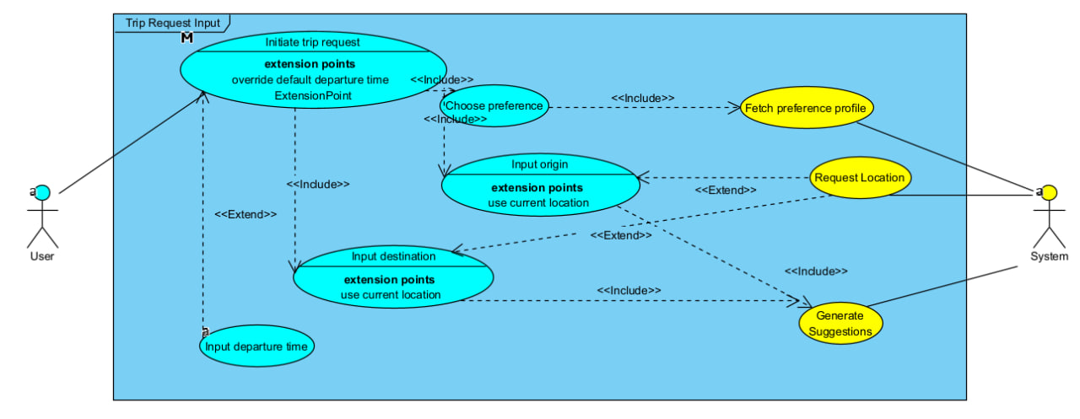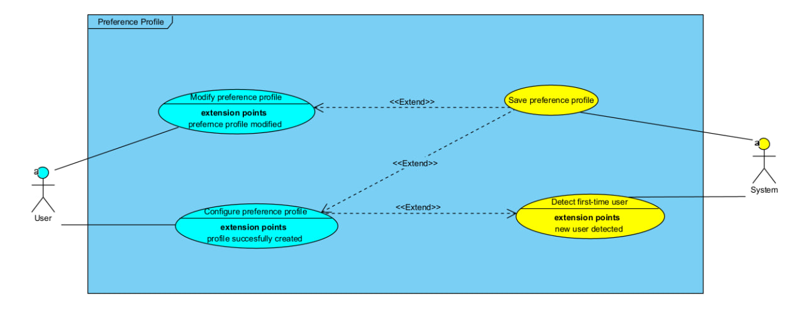User Input Preference

Trip Request Input

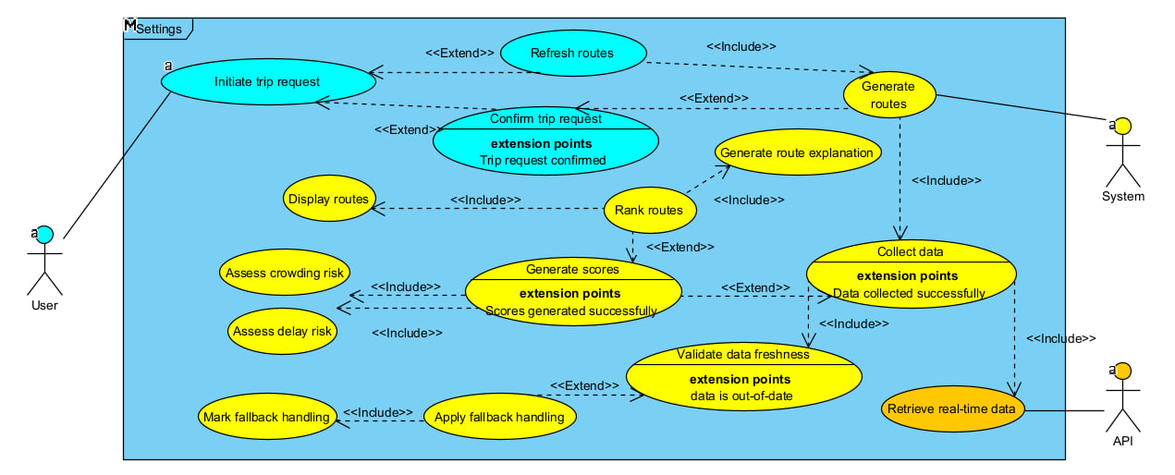Route Generation

Settings Page
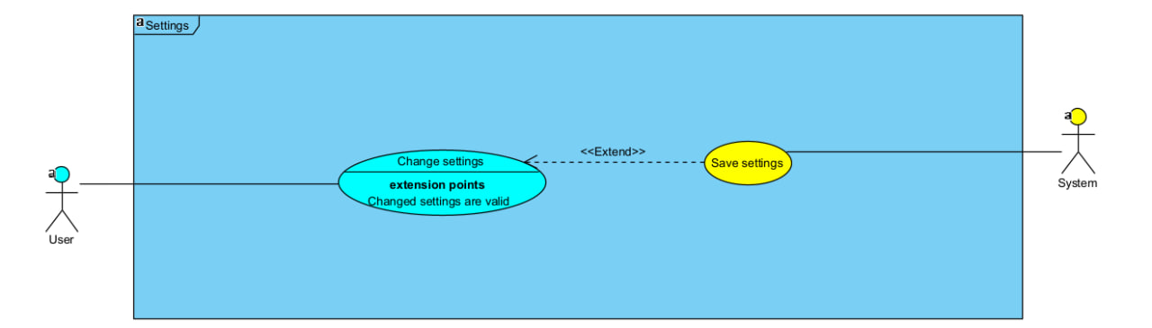

Class Diagram

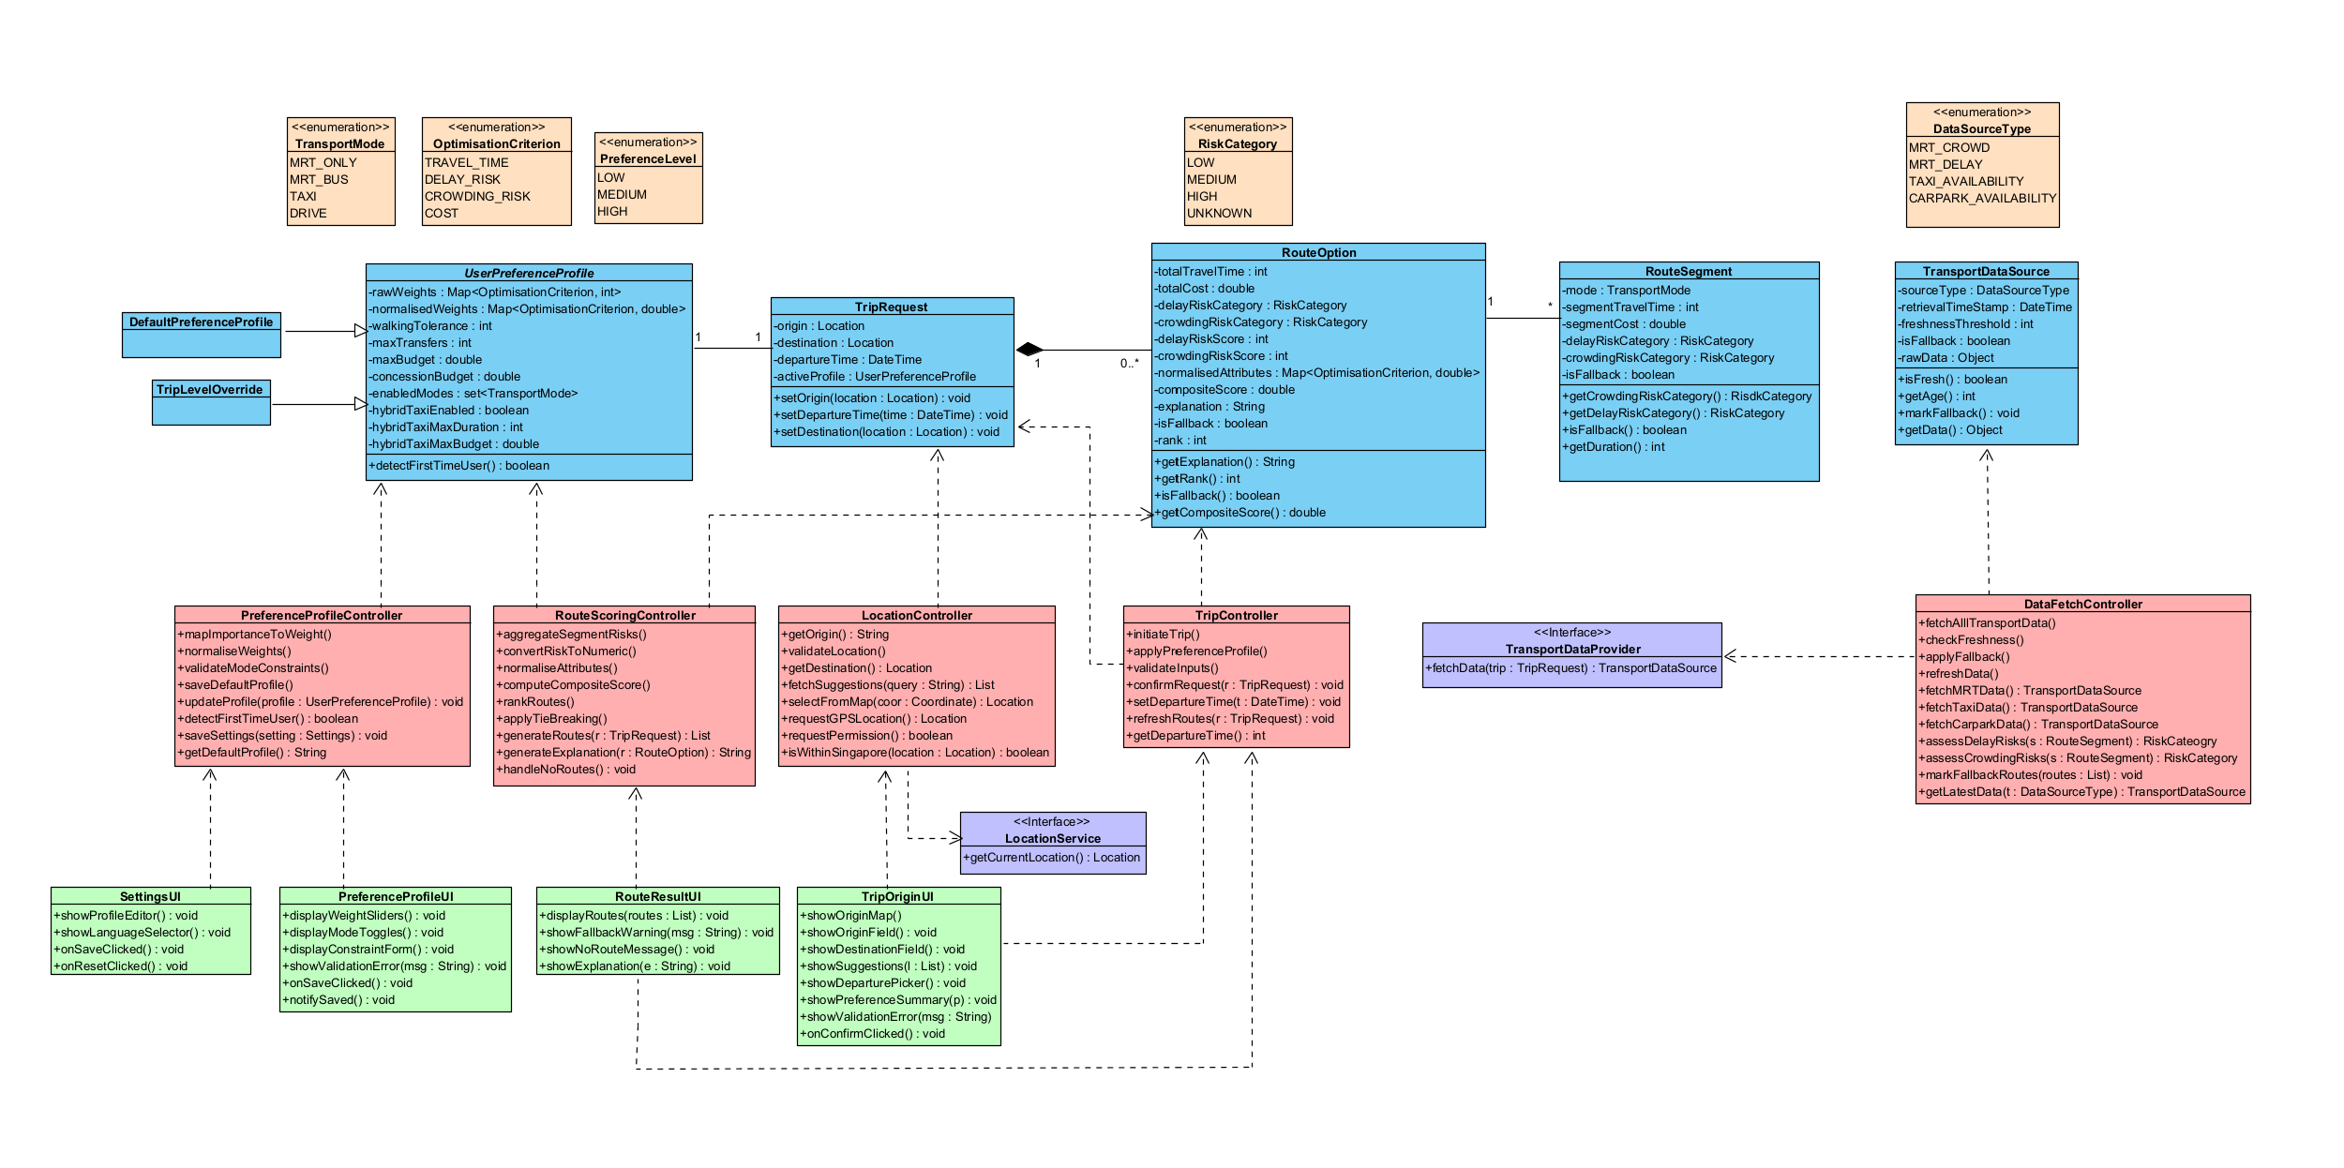

Key Boundary Classes and Control Classes
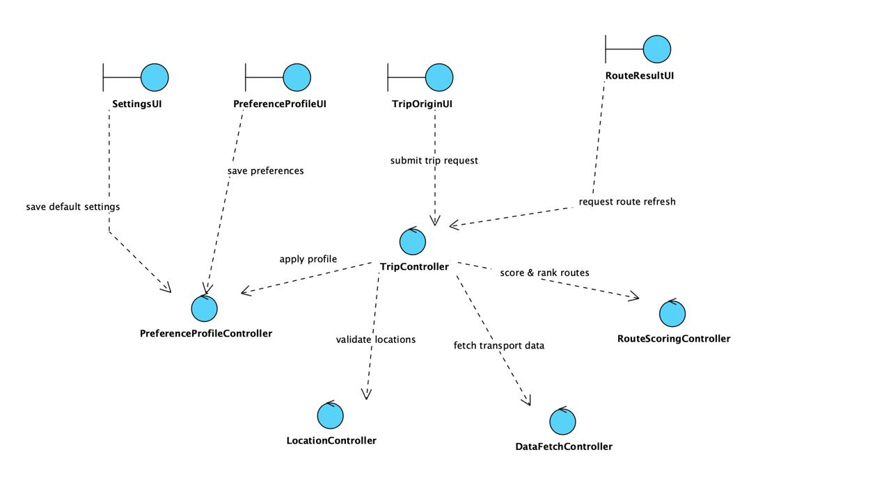

Dialog Maps

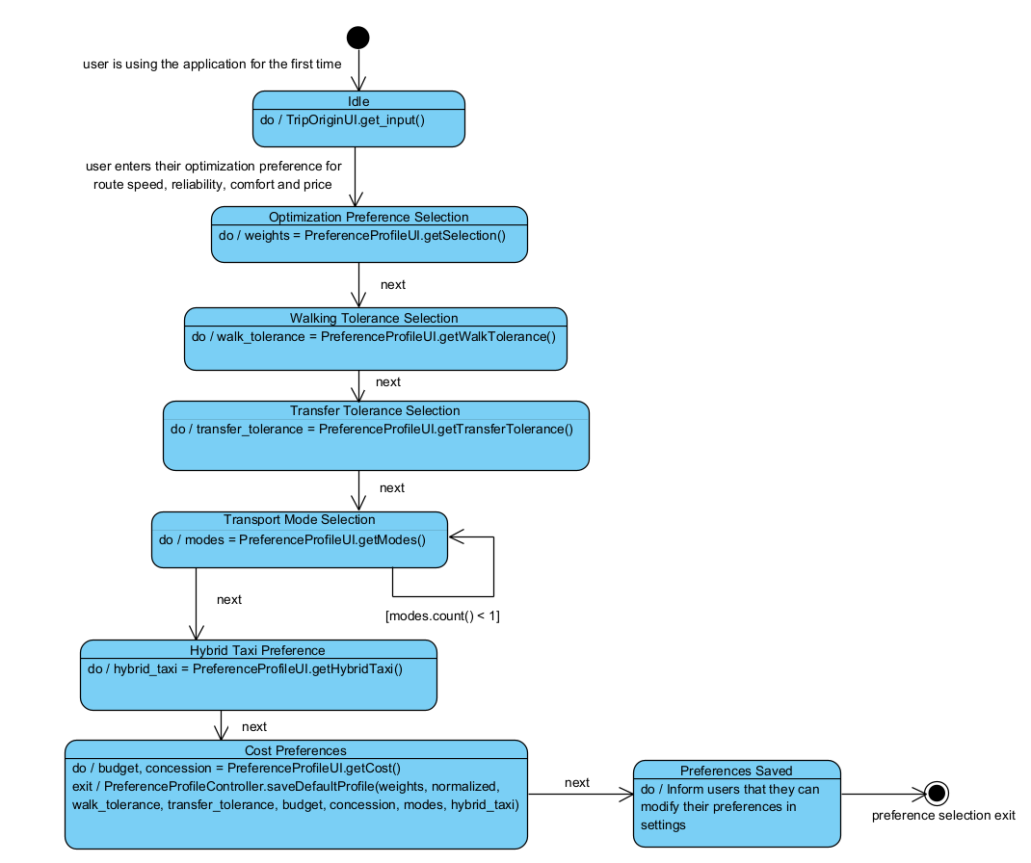User Preference Profile

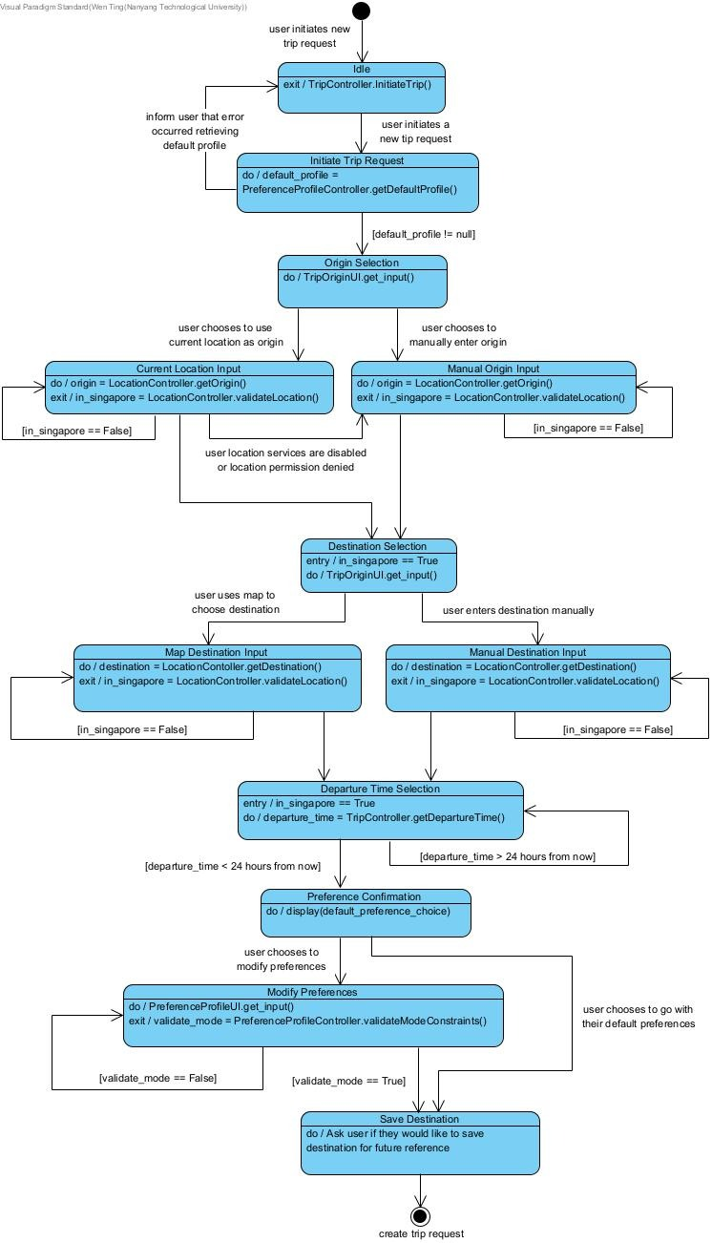Trip Request Input

Assess Transport Conditions and Generate Risk Score
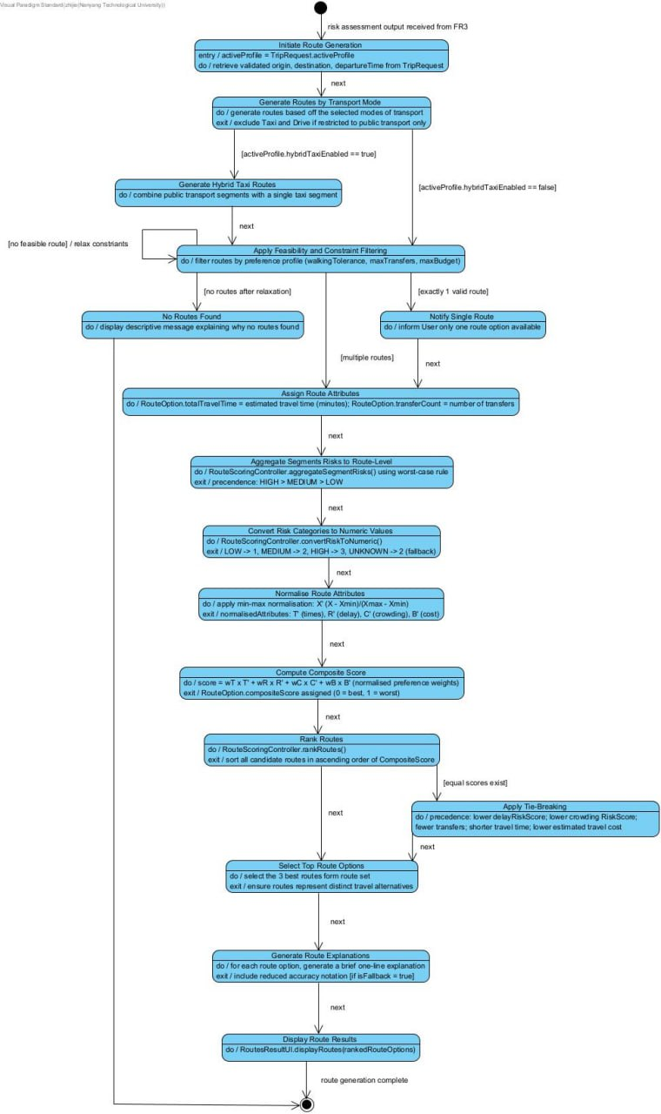

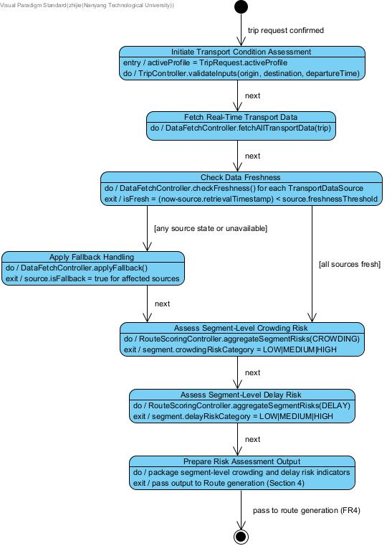Route Generation and Ranking

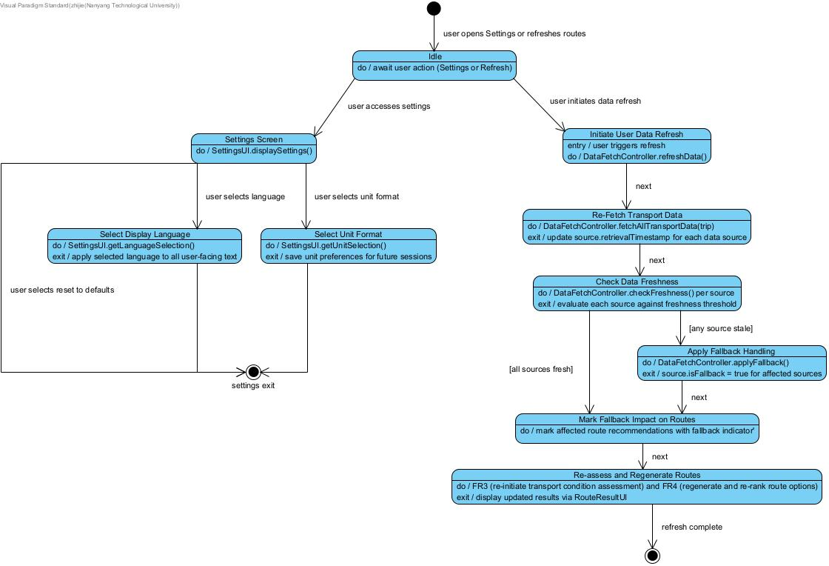Data Freshness, Fallback & Settings

System Architecture
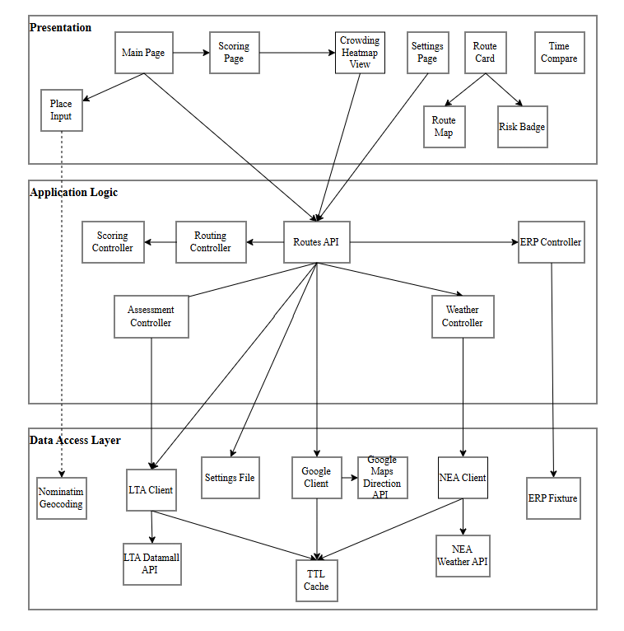

Appendix C: To Be Determined List
<Collect a numbered list of the TBD (to be determined) references that remain in the SRS so they can be tracked to closure.>

Source: http://www.frontiernet.net/~kwiegers/process_assets/srs_template.doc

