Software Requirements Specification

for

SGTravelBud
Version 4.4 approved
Prepared by Huynh Thao Tuong Van, Michelle Low Yuan-Ying, Ong Zhi Jie, Teng Wen Ting, Wan Chenpeng
NTU
10 April 2026
Table of Contents
Table of Contents ii
Revision History ii
1. Introduction 1
1.1 Purpose 1
1.2 Document Conventions 1
1.3 Intended Audience and Reading Suggestions 1
1.4 Product Scope 2
1.5 References 2
2. Overall Description 2
2.1 Product Perspective 2
2.2 Product Functions 2
2.3 User Classes and Characteristics 3
2.4 Operating Environment 25
2.5 Design and Implementation Constraints 25
2.6 User Documentation 25
2.7 Assumptions and Dependencies 25
3. External Interface Requirements 26
3.1 User Interfaces 26
3.2 Hardware Interfaces 33
3.3 Software Interfaces 33
3.4 Communications Interfaces 33
4. System Features 34
4.1 User Input Preference 34
4.2 Trip Request Input 36
4.3 Assess Transport Conditions and Generate Risk Scores 39
4.4 Route Generation and Ranking 42
4.5 Data Freshness, Fallback & Settings 48
5. Other Nonfunctional Requirements 50
5.1 Performance Requirements 50
5.2 Safety Requirements 51
5.3 Security Requirements 51
5.4 Software Quality Attributes 51
5.5 Business Rules 51
6. Other Requirements 52
Appendix A: Glossary 52
6.1 Data Dictionary 52
Appendix B: Analysis Models 55
6.2 Class Diagram 84
6.3 Key Boundary Classes and Control Classes 84
6.4 Dialog Maps 85
Appendix C: To Be Determined List 89

Revision History
Name | Date | Reason For Changes | Version
Teng Wen Ting | 11/2/2026 | Created initial SRS draft with introduction, scope, intended users and UI mockups | 1.0
Huynh Thao Tuong Van | 11/2/2026 | Created use cases for trip request, preference selection, route generation and scoring | 1.1
Ong Zhi Jie | 11/2/2026 | Created use cases for data fallback and updated remaining use cases. Created use case diagrams. | 1.2
Michelle Low Yuan-Ying | 11/2/2026 | Created functional requirements for user preference profile, trip request, assessment of routes, route generation and data fallback | 1.3
Wan Chenpeng | 11/2/2026 | Updated functional requirements and non-functional requirements. Created data dictionary | 1.4
Teng Wen Ting | 25/2/2026 | Created dialog maps | 2.0
Ong Zhi Jie | 25/2/2026 | Created dialog maps | 2.1
Michelle Low Yuan-Ying | 25/2/2026 | Create class diagram | 2.2
Wan Chenpeng | 25/2/2026 | Create BCE diagram and updated data dictionary | 2.3
Huynh Thao Tuong Van | 25/2/2026 | Finalised use case diagrams | 2.4
Teng Wen Ting | 31/3/2026 | Updated and revised UI mockups | 3.0
Michelle Low Yuan-Ying | 31/3/2026 | Create system architecture | 3.1
Wan Chenpeng | 31/3/2026 | Updated data dictionary | 3.2
Ong Zhi Jie | 31/3/2026 | Created test cases | 3.3
Huynh Thao Tuong Van | 31/3/2026 | Updated use cases | 3.4
Teng Wen Ting | 10/4/2026 | Updated use cases | 4.0
Wan Chenpeng | 11/4/2026 | Updated functional requirements | 4.1
Michelle Low Yuan-Ying | 12/4/2026 | Updated class diagram and system architecture | 4.2
Huynh Thao Tuong Van | 12/4/2026 | Updated use case diagrams, dialog maps and testing | 4.3
Ong Zhi Jie | 13/4/2026 | Final review and consolidation of all SRS sections, analysis models, and diagrams into approved submission | 4.4

Introduction

Purpose
Commuters in Singapore face difficulty evaluating and comparing trade-offs among multiple transport modes due to differences in travel time, reliability, crowding levels, and costs, especially under dynamic real-time conditions. This makes it challenging for users to decide which means of transport best aligns with their preferences and situational constraints. This Software Requirements Specification (SRS) document describes the functional and non-functional requirements for SGTravelBud, a software application designed to assist commuters in Singapore in evaluating and selecting transport routes based on their preference for time, cost, reliability, and comfort.

Document Conventions
This document follows the SRS standard conventions based on the IEEE guidelines:

- Section headings are used to organize the requirements of the system

- Functional requirements are written with the term “shall” to indicate mandatory behavior

- Non-functional requirements are described using measurable criteria where applicable

Intended Audience and Reading Suggestions
This SRS is intended for:

- Developers: To understand how the software works and the required features for implementation

- Project Managers: To support planning, scheduling, and allocation of work required for implementation

- Testers: To have a list of test cases to verify that the system meets the specified requirements

- Commuters: To gain a technical understanding of the software system’s capabilities and limitations

- Land Transport Authority (LTA): To understand how data provided by LTA is used and displayed within the software system

Readers, including testers, commuters, and LTA, are recommended to start from the Introduction to understand the general overview and scope of this system, followed by the Overall Description for detailed context. Developers, testers and project managers should focus on Developers, testers, and project managers should focus on External Interface Requirements, System Features, and Other Nonfunctional Requirements to understand the system from a technical perspective.

Product Scope
SGTravelBud is a mobile recommendation application that integrates real-time public transport data to assist Singapore commuters in selecting optimal routes based on personalized preferences. The system computes composite route scores using weighted normalization of travel time, delay risk, comfort, and costs. It supports both drive/taxi and public transport as well as constraint-based filtering. The objective is to improve commuter decision-making under dynamic transport conditions. This aligns with Singapore’s smart mobility initiatives and supports efforts to enhance transport reliability, efficiency, and commuter experience.

References
We utilize LTA’s official real-time data for taxi availability, MRT crowding, expressway congestion etc., through the LTA DataMall API, as well as finding optimal routes through Google Maps API.

Overall Description

Product Perspective
SGTravelBud is a standalone mobile application that helps commuters in Singapore evaluate and compare route options across multiple transport categories using personalized preferences and real-time transport data. The application integrates with external data sources such as MRT crowding levels, service delays, taxi availability, weather forecast, and car park availability data. The system consists of the following major components:
- Preference and Settings Management Module
- Trip Request Processing Module
- Transport Data Retrieval and Freshness Management Module
- Risk Assessment Engine
- Route Generation and Ranking Engine
- Route Display and Explanation Module

Product Functions
The system provides the following major functions:
- Allow users to configure and manage personalized travel preferences, including weighting of travel time, reliability, comfort, and budget, as well as filtering constraints such as walking allowance, transfer limit, and budget
- Accept and validate trip requests, including origin, and destination input, route category selection and active preference configuration
- Generate and update location suggestions for origin and destination entry
- Retrieve and process real-time transport data, including MRT crowd levels, delay information, taxi availability, and car part availability data
- Evaluate data freshness using predefined thresholds and apply fallback handling when real-time data is unavailable or outdated
- Assess segment-level and route-level crowding and delay indicators for candidate routes
- Generate feasible route options based on active transport modes and user-defined constraints
- Rank and present route recommendations with explanatory summaries
- Support comparison of route options across different departure times and conditions
- Allow users to manage setting such as language and default preference values

User Classes and Characteristics
Use Case ID: | UC-05
Use Case Name: | Initiate Trip Request
Created By: | Huynh Thao Tuong Van | Last Updated By: | Huynh Thao Tuong Van
Date Created: | 11/2/2026 | Date Last Updated: | 13/4/2026

Actor: | User
Description: | The user enters an origin and destination on the search page, optionally adjusts preferences (UC-02), and initiates route search. The system validates inputs and passes them to route generation.
Preconditions: | User is on the search page with default preferences initialised (UC-01)
Postconditions: | Validated trip inputs and active preferences are passed to route generation
Priority: | High
Frequency of Use: | High
Flow of Events: | - User enters an origin location (UC-06)  - User enters a destination location (UC-07)  - User optionally adjusts preferences for this search (UC-02)  - System validates that: (a) origin has at least 2 characters, (b) destination has at least 2 characters, (c) origin and destination are not identical (case-insensitive), and (d) at least one route category is enabled.  - System enables the "Find Routes" button when all validations pass  - User taps "Find Routes"  - System passes the validated inputs (origin, destination, weights, modes, constraints) to route generation (UC-23).
Alternative Flows: | User may swap origin and destination using the swap button. After swapping, the system revalidates inputs automatically.
Exceptions: | If origin and destination are identical, system displays "Origin and destination cannot be the same" and disables the Find Routes button.
Includes: | UC-02 Adjust Preferences, UC-06 Input Origin, UC-07 Input Destination
Special Requirements: | NIL
Assumptions: | NIL
Notes and Issues: | NIL

Use Case ID: | UC-06
Use Case Name: | Input Origin
Created By: | Huynh Thao Tuong Van | Last Updated By: | Huynh Thao Tuong Van
Date Created: | 11/2/2026 | Date Last Updated: | 13/4/2026

Actor: | User
Description: | Lets the user specify where their trip starts by typing an address. The system provides autocomplete suggestions from the OneMap API
Preconditions: | User is on the search page
Postconditions: | An origin location is entered in the origin field
Priority: | High
Frequency of Use: | High
Flow of Events: | - User begins typing in the origin input field  - After a 300ms debounce delay and a minimum of 2 characters, the system queries the OneMap API for matching location suggestions (UC-12)  - System displays a dropdown list of up to 5 matching suggestions  - User selects a suggestion to populate the origin field, or continues typing to refine suggestions
Alternative Flows: | NIL
Exceptions: | If the OneMap API returns no results, no suggestions are displayed and the user may type a location manually
Includes: | UC-08 Generate Suggestions
Special Requirements: | NIL
Assumptions: | NIL
Notes and Issues: | NIL

Use Case ID: | UC-07
Use Case Name: | Input Destination
Created By: | Huynh Thao Tuong Van | Last Updated By: | Huynh Thao Tuong Van
Date Created: | 11/2/2026 | Date Last Updated: | 13/4/2026

Actor: | User
Description: | Lets the user specify where they want to go by typing an address. The system provides autocomplete suggestions from the OneMap API
Preconditions: | User is on the search page
Postconditions: | An destination location is entered in the destination field
Priority: | High
Frequency of Use: | High
Flow of Events: | - User begins typing in the origin input field  - After a 300ms debounce delay and a minimum of 2 characters, the system queries the OneMap API for matching location suggestions (UC-12)  - System displays a dropdown list of up to 5 matching suggestions  - User selects a suggestion to populate the origin field, or continues typing to refine suggestions
Alternative Flows: | NIL
Exceptions: | If the destination matches the origin, the system displays "Origin and destination cannot be the same" and disables the Find Routes button.
Includes: | UC-08 Generate Suggestions
Special Requirements: | NIL
Assumptions: | NIL
Notes and Issues: | NIL

Use Case ID: | UC-08
Use Case Name: | Generate Suggestions
Created By: | Huynh Thao Tuong Van | Last Updated By: | Huynh Thao Tuong Van
Date Created: | 11/2/2026 | Date Last Updated: | 13/4/2026

Actor: | System
Description: | Provides live autocomplete suggestions from the OneMap API as the user types an origin or destination
Preconditions: | User is typing in the origin (UC-08) or destination (UC-09) input field with at least 2 characters
Postconditions: | A list of matching location suggestions is displayed in a dropdown
Priority: | Medium
Frequency of Use: | High
Flow of Events: | - User types at least 2 characters in a location input field  - System waits 300ms after the last keystroke (debounce)  - System sends a request to the OneMap API with the input text  - OneMap returns matching Singapore locations with building name, block number, road name, postal code, and coordinates  - System parses results and displays up to 5 suggestions in a dropdown below the input field  - As the user modifies the text, the system re-queries and refreshes the suggestion list  - User selects a suggestion to populate the field.
Alternative Flows: | If the input is fewer than 2 characters, the suggestion dropdown is hidden
Exceptions: | If the OneMap API is unreachable, suggestions fail silently and no dropdown is shown
Includes: | NIL
Special Requirements: | NIL
Assumptions: | NIL
Notes and Issues: | NIL

Use Case ID: | UC-09
Use Case Name: | Refresh Routes
Created By: | Huynh Thao Tuong Van | Last Updated By: | Huynh Thao Tuong Van
Date Created: | 11/2/2026 | Date Last Updated: | 13/4/2026

Actor: | User
Description: | Allows the user to manually re-fetch transport data and regenerate routes before starting their trip, ensuring recommendations reflect the latest conditions.
Preconditions: | Routes have already been generated and displayed for the current trip
Postconditions: | Route recommendations are regenerated using the most recent transport data
Priority: | Medium
Frequency of Use: | Low to Medium
Flow of Events: | - User taps the refresh button on the route results screen  - System re-initiates route generation (UC-XX) using the latest available data  - System fetches fresh data from all external APIs  - Updated routes replace the previous results on screen.
Alternative Flows: | User may also refresh from the Settings screen, which invalidates all cached data without regenerating routes
Exceptions: | NIL
Includes: | UC-XX Generate Routes
Special Requirements: | NIL
Assumptions: | NIL
Notes and Issues: | NIL

Use Case ID: | UC-10
Use Case Name: | Collect Data
Created By: | Huynh Thao Tuong Van | Last Updated By: | Huynh Thao Tuong Van
Date Created: | 11/2/2026 | Date Last Updated: | 13/4/2026

Actor: | System
Description: | Gathers all the real-time transport data needed for risk assessment and route generation. Uses a TTL-based in-memory cache and triggers fallback handling if any data source is stale or unavailable.
Preconditions: | Route generation has been triggered (UC-05 or UC-10)
Postconditions: | All required transport data is collected, timestamped, and flagged for freshness compliance
Priority: | High
Frequency of Use: | High
Flow of Events: | - System identifies which data sources are needed based on the enabled route categories and the route segments returned by Google Directions  - System calls UC-11 to retrieve real-time data from external APIs via the TTL cache  - The cache layer timestamps each data source upon retrieval.  - System calls UC-12 to validate freshness of each cached source against its predefined TTL threshold  - If any source fails freshness checks or is unavailable, system triggers fallback handling (UC-13)  - System packages the collected data for use in segment assessment and route generation.
Alternative Flows: | NIL
Exceptions: | NIL
Includes: | UC-12 Retrieve Real-Time Data, UC-13 Validate Data Freshness
Special Requirements: | NIL
Assumptions: | NIL
Notes and Issues: | NIL

Use Case ID: | UC-11
Use Case Name: | Retrieve Real-Time Data
Created By: | Huynh Thao Tuong Van | Last Updated By: | Huynh Thao Tuong Van
Date Created: | 11/2/2026 | Date Last Updated: | 13/4/2026

Actor: | System
Description: | Fetches live transport data from external APIs. Each response is cached with a retrieval timestamp and TTL
Preconditions: | Data collection has been initiated (UC-10)
Postconditions: | Raw real-time transport data is returned to the system with retrieval timestamps
Priority: | High
Frequency of Use: | High
Flow of Events: | - System sends requests to the relevant external transport data APIs: LTA Bus Arrival API for bus crowding (Load: SEA/SDA/LSD) and next bus arrival times; LTA PCD Forecast for MRT station crowding by time interval; LTA Train Service Alerts for MRT delay/disruption status; LTA Traffic Speed Bands for driving congestion data; LTA Carpark Availability for parking lot counts near the destination (if Taxi/Drive enabled); NEA 2-Hour Weather Forecast for rain prediction along the route  - Each response is stored in the in-memory TTL cache with its retrieval timestamp  - Cached data is passed back to UC-10
Alternative Flows: | NIL
Exceptions: | If an API is unreachable, the system returns an empty data structure with the fallback flag and proceeds with available data
Includes: | NIL
Special Requirements: | NIL
Assumptions: | NIL
Notes and Issues: | NIL

Use Case ID: | UC-12
Use Case Name: | Validate Data Freshness
Created By: | Huynh Thao Tuong Van | Last Updated By: | Huynh Thao Tuong Van
Date Created: | 11/2/2026 | Date Last Updated: | 13/4/2026

Actor: | System
Description: | Checks whether each cached data source is fresh enough to use by comparing elapsed time since retrieval against predefined TTL thresholds
Preconditions: | Real-time data has been retrieved and timestamped (UC-11)
Postconditions: | Each data source is classified as fresh or outdated; outdated sources are sent to fallback
Priority: | High
Frequency of Use: | High
Flow of Events: | - System checks each cached data source against its TTL threshold: Bus Arrival (30s), PCD Forecast (600s), Train Service Alerts (60s), Traffic Speed Bands (300s), Carpark Availability (300s), Taxi Availability (60s)  - If retrieval time shorter than TTL threshold, the source is marked as fresh  - If the TTL is exceeded, the source is flagged as outdated  - Outdated sources trigger UC-13 (Apply Fallback Handling)
Alternative Flows: | NIL
Exceptions: | NIL
Includes: | NIL
Special Requirements: | NIL
Assumptions: | NIL
Notes and Issues: | NIL

Use Case ID: | UC-13
Use Case Name: | Apply Fallback Handling
Created By: | Huynh Thao Tuong Van | Last Updated By: | Huynh Thao Tuong Van
Date Created: | 11/2/2026 | Date Last Updated: | 13/4/2026

Actor: | System
Description: | Substitutes the most recent cached data when live data is unavailable or stale. Different segments within the same route may independently use real-time or fallback data
Preconditions: | One or more data sources have been flagged as unavailable or outdated (UC-12)
Postconditions: | Fallback data is in place and affected elements are marked accordingly (UC-14)
Priority: | High
Frequency of Use: | Low to Medium
Flow of Events: | - System identifies which data sources need fallback substitution  - System retrieves the most recent available cached data for each affected source  - If no cached data exists for a source, system uses an empty data structure  - System calls UC-14 to mark all affected data elements as operating in fallback mode  - Fallback data is fed into assessment and route generation alongside any fresh data.
Alternative Flows: | NIL
Exceptions: | If no cached data is available at all for a source, the system proceeds without it and flags the gap.
Includes: | UC-14 Mark Fallback Handling
Special Requirements: | NIL
Assumptions: | NIL
Notes and Issues: | Different segments within the same route may independently use real-time or fallback data. There is no prevention of partial mixing within a route.

Use Case ID: | UC-14
Use Case Name: | Mark Fallback Handling
Created By: | Huynh Thao Tuong Van | Last Updated By: | Huynh Thao Tuong Van
Date Created: | 11/2/2026 | Date Last Updated: | 13/4/2026

Actor: | System
Description: | Tags data elements and route recommendations that were computed using fallback data, so downstream processes and the user can see which results may be less accurate.
Preconditions: | Fallback data has been applied (UC-18)
Postconditions: | All affected data elements and route outputs carry a fallback indicator
Priority: | Medium
Frequency of Use: | Low to Medium
Flow of Events: | - System flags the fallback on each affected risk indicator.  - At the route level, if any segment uses fallback data, the fallback flag is set to true  - When route explanations are generated (UC-19), fallback-affected routes include the notation "(some data is estimated)"  - The Settings screen displays each data source status as "Live" (green badge) or "Fallback" (amber badge).
Alternative Flows: | NIL
Exceptions: | NIL
Includes: | NIL
Special Requirements: | NIL
Assumptions: | NIL
Notes and Issues: | NIL

Use Case ID: | UC-15
Use Case Name: | Generate Scores
Created By: | Huynh Thao Tuong Van | Last Updated By: | Huynh Thao Tuong Van
Date Created: | 11/2/2026 | Date Last Updated: | 13/4/2026

Actor: | System
Description: | Computes composite scores for each candidate route by combining normalised route attributes with the user's preference weights across four dimensions: Time, Cost, Risk, and Comfort. Lower score = better route.
Preconditions: | Routes have been generated (UC-18) with assigned attributes, and risk indicators are available from UC-16 and UC-17
Postconditions: | Each candidate route has a composite score ready for ranking
Priority: | High
Frequency of Use: | High
Flow of Events: | - System computes a combined Risk score for each route: risk_num = max(crowding_numeric, delay_numeric), producing a value on the 1-3 scale  - System computes a Comfort score for each route: comfort = 0.6 * walk_score + 0.4 * transfer_score, where walk_score is capped at 30 minutes (normalised to 0-10 range) and transfer_score is capped at 5 transfers (normalised to 0-10 range)  - System applies min-max normalisation across all candidate routes for each of the four dimensions (time, cost, risk, comfort). If all routes share the same value for an attribute, the normalised value is set to 0.0 for all  - System retrieves the user's preference weights and normalises them so they sum to 1.0  - System computes the composite score: Score = w_T * T' + w_B * B' + w_R * R' + w_F * F'  - Scores are attached to each route and passed to UC-20 for ranking.
Alternative Flows: | If all routes share the same value for an attribute, the normalised value is set to 0.0 for all.
Exceptions: | NIL
Includes: | UC-16 Assess Crowding Risk, UC-17 Assess Delay Risk
Special Requirements: | NIL
Assumptions: | NIL
Notes and Issues: | NIL

Use Case ID: | UC-16
Use Case Name: | Assess Crowding Risk
Created By: | Huynh Thao Tuong Van | Last Updated By: | Huynh Thao Tuong Van
Date Created: | 11/2/2026 | Date Last Updated: | 13/4/2026

Actor: | System
Description: | Evaluates how crowded each public transport segment is likely to be, based on retrieved data. Each segment gets a Low, Medium, High, or Unknown crowding label.
Preconditions: | Transport data has been collected (UC-10) and routes have been generated (UC-16)
Postconditions: | Segment-level and route-level crowding risk indicators are assigned
Priority: | High
Frequency of Use: | High
Flow of Events: | - For each bus segment, system computes a crowding indicator from the LTA Bus Arrival API: SEA (Seats Available) = Low, SDA (Standing Available) = Medium, LSD (Limited Standing) = High  - For each MRT segment, system computes a crowding indicator from the LTA PCD Forecast CrowdLevel field matched to the closest time interval: "l"/"low" = Low, "m"/"moderate" = Medium, "h"/"high" = High  - If crowding data is unavailable for a segment, it is marked Unknown  - System aggregates segment-level values to a route-level crowding risk using a worst-case (maximum) rule: (a) if all segments are Unknown, the route is Unknown with numeric value 2; (b) if some segments are Unknown and some are known, the route-level value is the maximum of the known values; (c) otherwise, the highest segment risk is used  - Route-level crowding risk is passed to UC- 15 scoring.
Alternative Flows: | NIL
Exceptions: | NIL
Includes: | NIL
Special Requirements: | NIL
Assumptions: | NIL
Notes and Issues: | NIL

Use Case ID: | UC-17
Use Case Name: | Assess Delay Risk
Created By: | Huynh Thao Tuong Van | Last Updated By: | Huynh Thao Tuong Van
Date Created: | 11/2/2026 | Date Last Updated: | 13/4/2026

Actor: | System
Description: | Evaluates the likelihood of delays on each public transport segment based on service status data. Each segment gets a Low, Medium, High, or Unknown delay label.
Preconditions: | Transport data has been collected (UC-10) and routes have been generated (UC-16)
Postconditions: | Segment-level and route-level delay risk indicators are assigned
Priority: | High
Frequency of Use: | High
Flow of Events: | - For each MRT segment, system computes a delay indicator from the LTA Train Service Alerts API: Status=1 (normal) = Low; Status=2 (disruption) on the route's line = High; Status=2 on a different line = Low; Status=2 with no specific line identified = Medium (precautionary)  - For each bus segment, system assigns a default delay indicator of Low  - For each driving/taxi segment, system computes a delay indicator from the LTA Traffic Speed Bands API based on average speed near the route: average speed >= 6 = Low, >= 3 = Medium, < 3 = High  - If delay data is unavailable for a segment, it is marked Unknown  - System aggregates to route-level delay risk using the same worst-case rule as crowding (UC-16 step 4). 6. Route-level delay risk is passed to UC-15 for scoring.
Alternative Flows: | NIL
Exceptions: | NIL
Includes: | NIL
Special Requirements: | NIL
Assumptions: | NIL
Notes and Issues: | NIL

Use Case ID: | UC-18
Use Case Name: | Generate Routes
Created By: | Huynh Thao Tuong Van | Last Updated By: | Huynh Thao Tuong Van
Date Created: | 11/2/2026 | Date Last Updated: | 13/4/2026

Actor: | System
Description: | Produces candidate route options from origin to destination using the Google Directions API for enabled transport modes. Applies user constraints, deduplicates routes, and assigns route attributes including cost estimation.
Preconditions: | Trip request is confirmed (UC-05) and transport data is collected (UC-10)
Postconditions: | A set of feasible candidate routes is generated, each with assigned attributes
Priority: | High
Frequency of Use: | High
Flow of Events: | - System reads the active preference configuration to determine which modes are enabled  - If Public Transit is enabled, system calls the Google Directions API with mode "transit" to generate public transit route options (may include MRT-only or MRT+Bus combinations)  - If Taxi/Drive is enabled, system calls the Google Directions API with mode "driving". For each driving route, system generates two candidates: (a) a Taxi candidate (no parking penalty) and (b) a Drive candidate (with parking time/comfort penalties based on nearby carpark availability)  - System deduplicates candidate routes by fingerprint (category + mode sequence + line names + stops), retaining the faster route when duplicates exist  - System filters out routes that violate the maximum walking allowance, maximum transfers, or maximum budget constraints  - For each feasible route, system assigns: estimated travel time (from Google API), realistic travel time (adding 0.5 * bus miss_penalty_min per bus step), number of transfers (transit segments minus one), estimated cost (transit fare table / CDG 2026 taxi metered fare with surcharges / fuel at $0.12/km + ERP charges), walking time, and route-level risk indicators from UC-16 and UC-17  - For Drive routes, system adds parking search time penalty (+10 min if full, +5 min if limited) and inflates walking time (+5 min if full, +2 min if limited)  - Candidate routes are passed to UC-15 for scoring and UC-20 for ranking.
Alternative Flows: | If no feasible routes remain after constraint filtering, the system returns an empty route list with the message "No routes found or API unavailable"
Exceptions: | NIL
Includes: | UC-19 Generate Route Explanation, UC-20 Rank Routes
Special Requirements: | NIL
Assumptions: | NIL
Notes and Issues: | NIL

Use Case ID: | UC-24
Use Case Name: | Generate Route Explanation
Created By: | Huynh Thao Tuong Van | Last Updated By: | Huynh Thao Tuong Van
Date Created: | 11/2/2026 | Date Last Updated: | 11/2/2026

Actor: | System
Description: | Creates a short, human-readable one-liner for each route explaining why it was ranked where it is, referencing the user's top priority and the route's risk levels.
Preconditions: | Routes have been scored and ranked (UC-20, UC-25)
Postconditions: | Each route has a brief explanation attached for display
Priority: | Medium
Frequency of Use: | High
Flow of Events: | 1. System identifies the user's highest-weighted preference criterion.  2. For each route, system summarises how it performs on that top criterion.  3. System appends the route-level delay and crowding risk categories.  4. If any risk indicator used fallback data, a reduced-accuracy note is appended.  5. The explanation is attached to the route for display in UC-26.
Alternative Flows: | NIL
Exceptions: | NIL
Includes: | NIL
Special Requirements: | NIL
Assumptions: | NIL
Notes and Issues: | NIL

Use Case ID: | UC-25
Use Case Name: | Rank Routes
Created By: | Huynh Thao Tuong Van | Last Updated By: | Huynh Thao Tuong Van
Date Created: | 11/2/2026 | Date Last Updated: | 11/2/2026

Actor: | System
Description: | Sorts all candidate routes from best to worst based on their composite scores. Uses a multi-level tie-breaker when scores are equal.
Preconditions: | Composite scores have been computed for all candidate routes (UC-20)
Postconditions: | Routes are ordered by rank; top 2–3 are selected for display
Priority: | High
Frequency of Use: | High
Flow of Events: | 1. System sorts all candidate routes in ascending order of composite score (lowest = best).  2. If two or more routes tie on composite score, system breaks ties in order: lower delay risk, lower crowding risk, fewer transfers, shorter travel time, lower cost.  3. System selects the top 2–3 distinct routes for presentation.  4. Each selected route must represent a meaningfully different travel alternative (different modes, paths, or transfer points).  5. Ranked routes are passed to UC-26 for display.
Alternative Flows: | NIL
Exceptions: | NIL
Includes: | UC-26 Display Routes
Special Requirements: | NIL
Assumptions: | NIL
Notes and Issues: | NIL

Use Case ID: | UC-26
Use Case Name: | Display Routes
Created By: | Huynh Thao Tuong Van | Last Updated By: | Huynh Thao Tuong Van
Date Created: | 11/2/2026 | Date Last Updated: | 11/2/2026

Actor: | System
Description: | Presents the final ranked route options to the user, complete with travel times, costs, risk levels, explanations, any fallback-accuracy warnings, and a per-station crowding heatmap (6 AM–11 PM) on the Scoring tab for public transit routes.
Preconditions: | Routes have been ranked (UC-25) and explanations generated (UC-24)
Postconditions: | The user can see and compare the recommended route options
Priority: | High
Frequency of Use: | High
Flow of Events: | 1. System displays 2–3 ranked route options (or 1 if only one is feasible).  2. Each route shows: estimated travel time, number of transfers, estimated cost, route-level delay risk, and route-level crowding risk.  3. Each route includes its one-line explanation from UC-24.  4. Routes using fallback data display a reduced-accuracy notation.  5. On the Scoring tab, system renders a per-station MRT crowding heatmap (6 AM–11 PM) sourced from UC-21 step 7, with a marker at the current time.  6. If no routes were found, system shows a message explaining why and suggests the user adjust constraints or preferences.
Alternative Flows: | NIL
Exceptions: | NIL
Includes: | UC-24 Generate Route Explanation
Special Requirements: | NIL
Assumptions: | NIL
Notes and Issues: | NIL
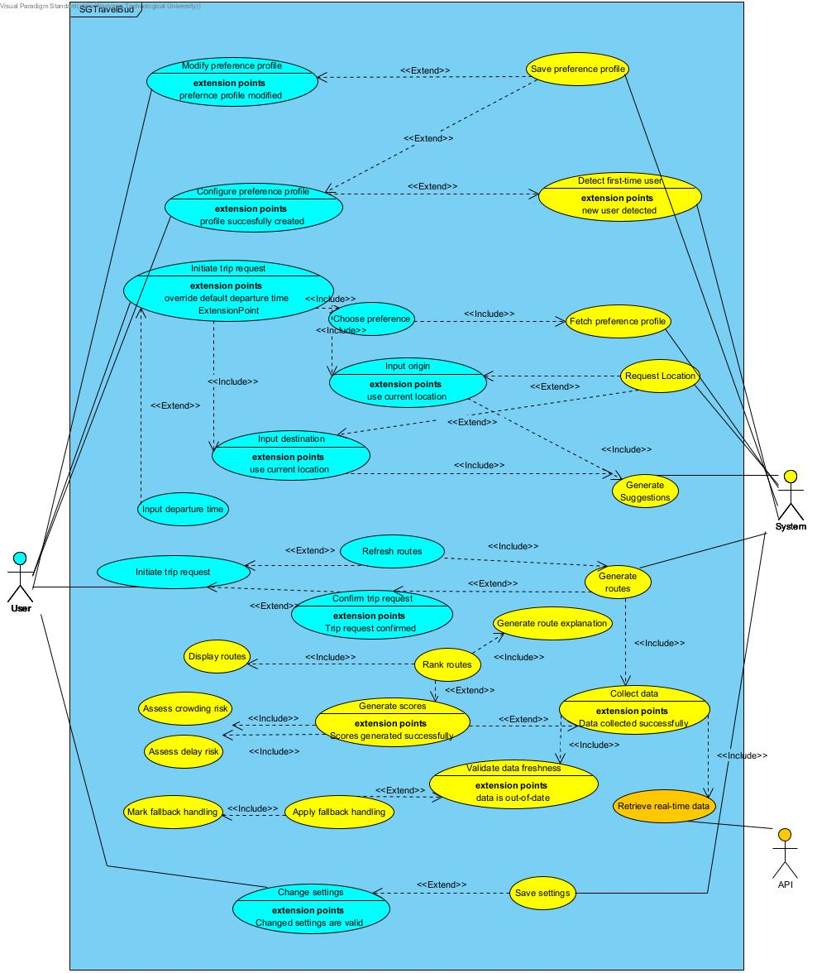

Fig 2.1 Use Case Diagram

Operating Environment
SGTravelBud is designed to operate as a mobile application.

- Hardware Platform: Mobile devices with GPS capabilities on both Android and iOS

- Software Environment: Frontend application running on the user’s mobile device, and backend services are hosted on a server environment

- External Systems: Transport, traffic data, mapping, and geolocation services for address and route generation

- Network Requirements: An active internet connection is required for real-time data retrieval and route generation

Design and Implementation Constraints
The design and implementation of the system are subject to the following constraints:

- Technology Constraints: The system relies on external APIs for real-time transport data, routing, and geolocation services; hence, rate limit constraints exist

- Platform Constraints: Permission must be given for GPS access on mobile devices

- Design Constraints: The preference weights must always be normalized to ensure consistent scoring

User Documentation
All documentation will be delivered within the application in clear, non-technical language with language translations.

- In-App Help: Tooltips can be accessed in the settings to understand the usability of the application

- Onboarding: First-time users are guided through their personal preference configuration

Assumptions and Dependencies
Assumptions | - Users have access to a GPS-enabled device and grant location permission when asked  - External transport data APIs provide accurate and timely information
Dependencies | - Availability and reliability of third-party transport data APIs  - Availability of mapping services for location validation and routing  - Stable internet connectivity  - Continued support of required APIs and data formats by external providers

External Interface Requirements

User Interfaces
Frame | User Interface | Description
1 | 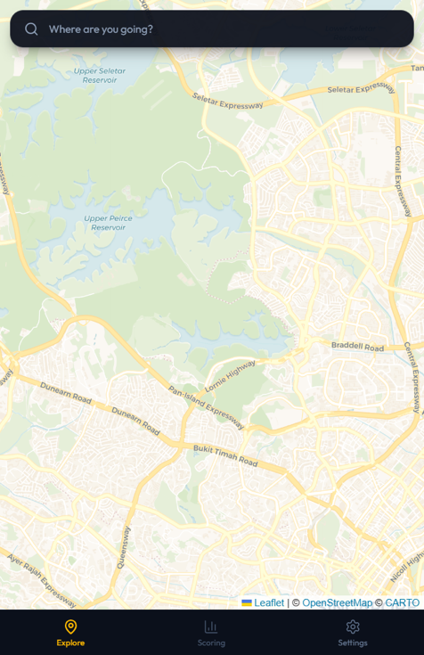Fig 3.1 Search | Once the user enters the application, the map is displayed.
2 | 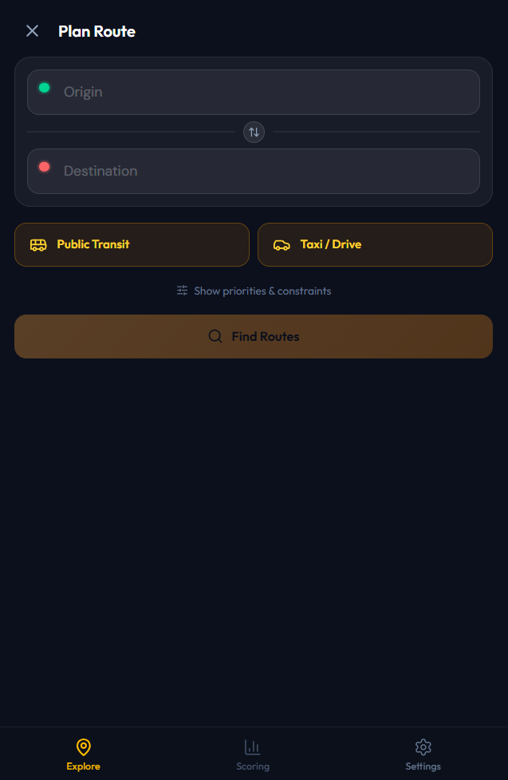Fig 3.2 Origin and Destination Input | The application requests the user to input their origin and destination locations.
3 | Fig 3.3 Origin and Destination 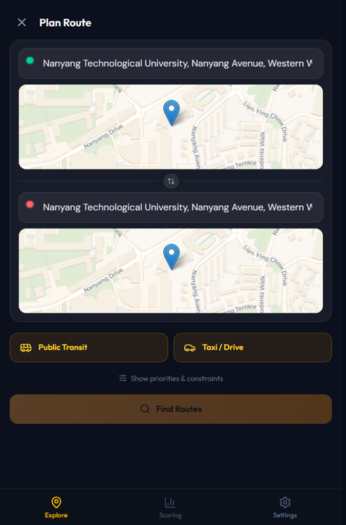 | When the location is chosen, a point would be displayed on the map.  When the locations are similar, users are unable to click ‘Find Routes’ to proceed.
4 | 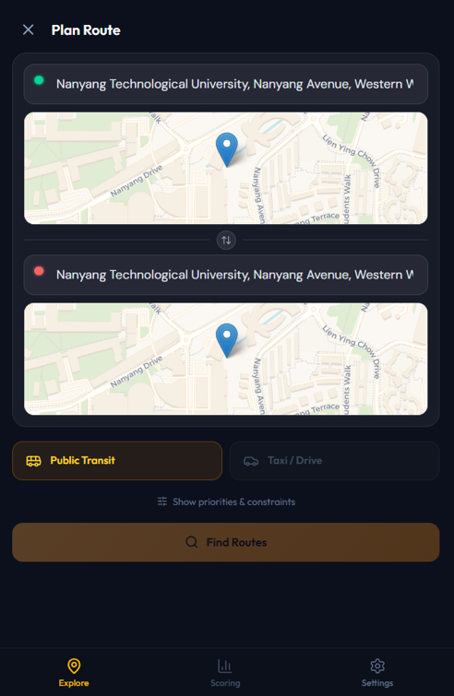Fig 3.4 Select Mode of Travel | The user can pick their travel mode of choice:  - Public Transit (MRT & Bus)  - Taxi/Drive  Here, only ‘Public Transit’ is chosen.
5 | 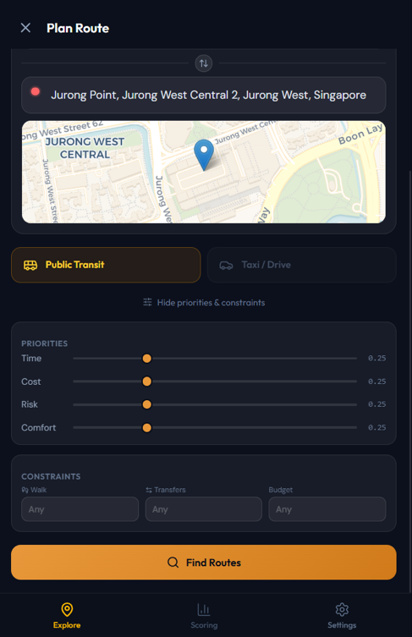Fig 3.5 Priorities & Constraints | When ‘Show priorities & constraints’ is clicked on, users can drag the sliding bars to weigh their preferences:  - Time  - Cost  - Risk  - Comfort  The preferences have default weight of 0.25.  Users are also able to enter constraints to:  - Walking time  - Number of transfers  - Budget  When inputs have no errors, the ‘Find Routes’ button would turn orange to prompt users to click to calculate possible routes.
6 | 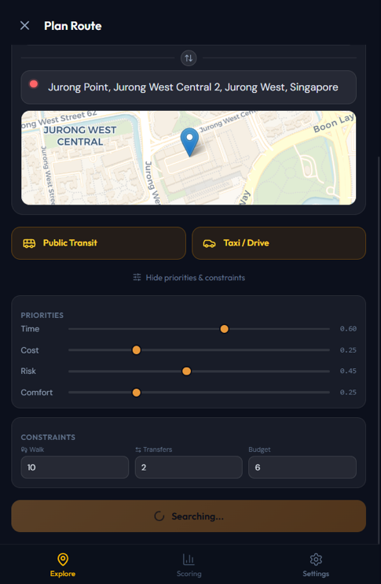Fig 3.6 Loading Screen | Loading screen for route calculation.
7 | 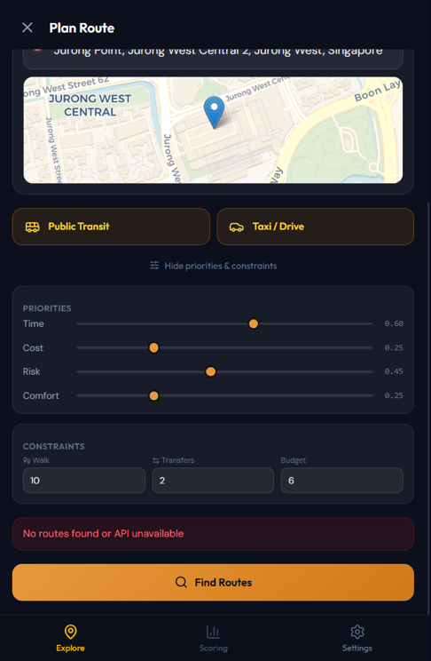Fig 3.7 No Possible Routes | If there are no possible routes or errors during route calculation, an error message will pop up.  Users can recalibrate their priorities and constraints before clicking ‘Finding Routes’ again.
8 | 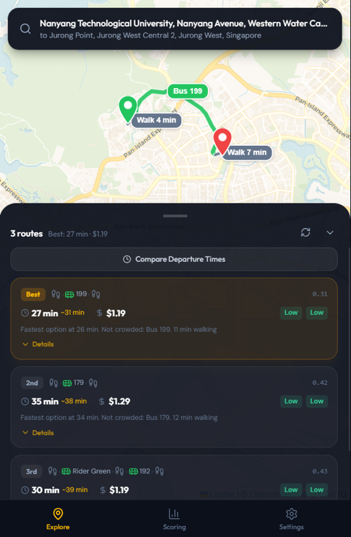Fig 3.8 Route Display | Once calculation is done, the top 3 best routes would be displayed, along with information about:  - Travel time  - Crowdedness  - Risk score  - Walking time  - Total price of travel  - Composite score
9 | 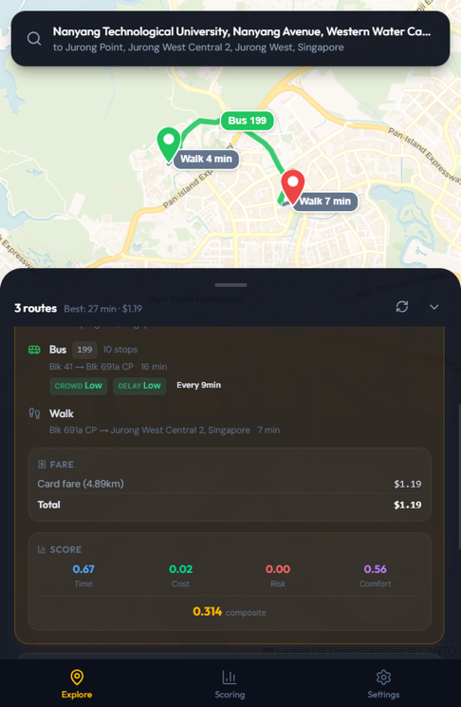Fig 3.9 Route Details | When ‘Details’ is clicked, application displays:  - Instructions of travel  - Breakdown of travel cost  - Breakdown of preferences score  - Composite score
10 | 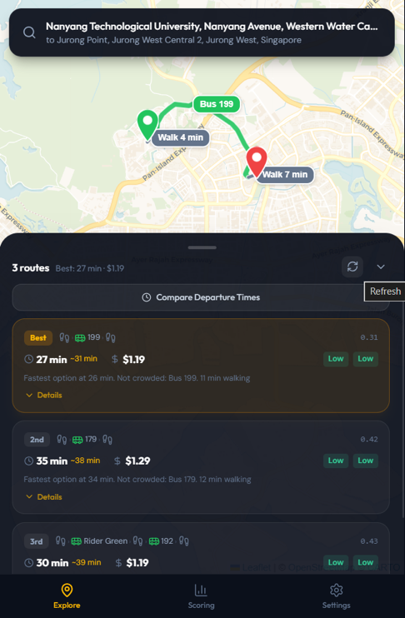Fig 3.10 Refreshed Routes | Users would be able to refresh their routes to the most updated upon clicking the button.
11 | 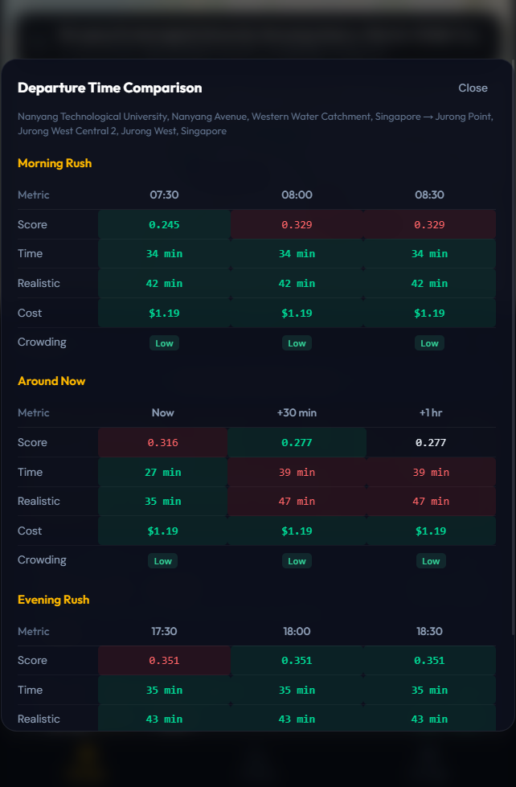Fig 3.11 Compare Departure Times | When ‘Compare Departure Times’ is clicked, breakdown of the top 3 routes based on:  - Composite score  - Time taken for travel  - Cost of travel  - Crowding  during morning rush, the current timing and evening rush are displayed, with a 30-minute and 1-hour comparison.
12 | 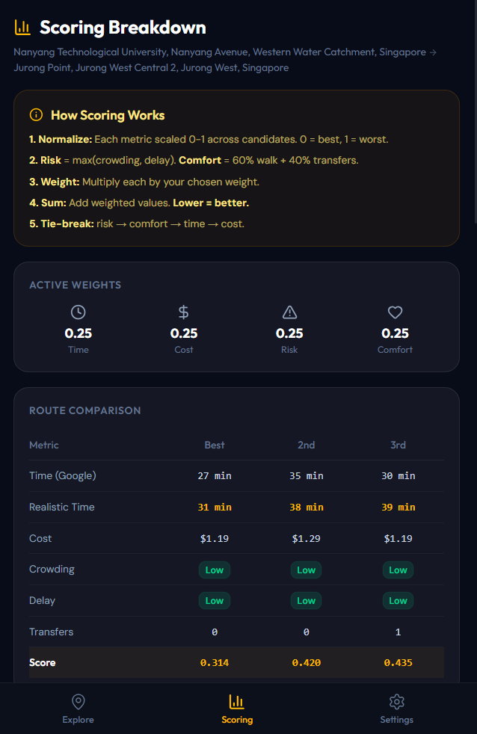Fig 3,12 Scoring Breakdown | When ‘Scoring’ is clicked, the app displays how the system calculates route scores, current weights used for scoring and the top 3 routes comparison based on:  - Time taken by Google Maps  - Estimated realistic time taken  - Travel cost  - Crowding level  - Delay level  - Number of transfers  - Overall composite score
13 | 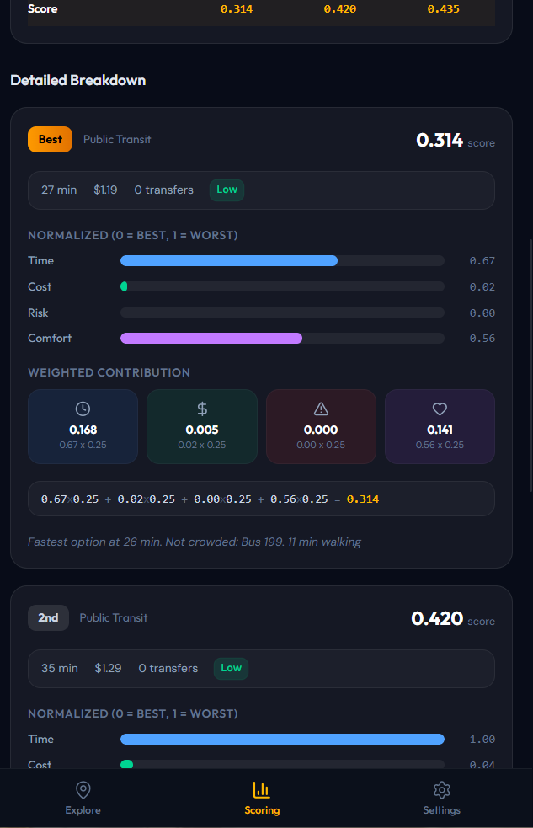Fig 3.13 Detailed Breakdown For Top 3 Routes | Users can also see the detailed breakdown of each top 3 routes suggested based on the weights and scores.
14 | 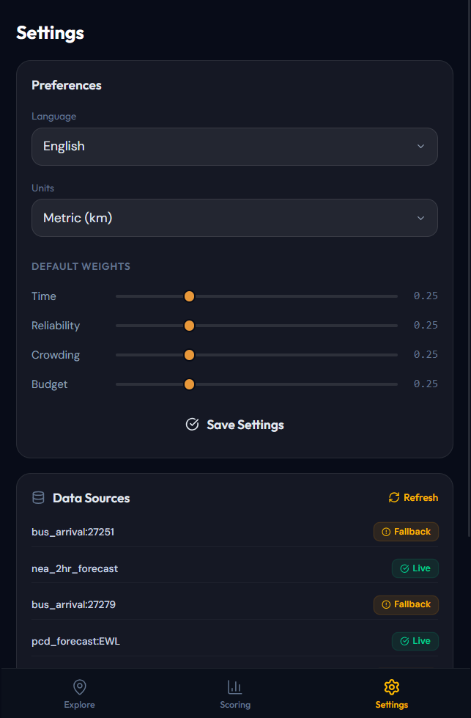Fig 3.14 Settings Page | In the settings page, users are able to:  - Change application language (English, Chinese, Malay, Tamil)  - Change distance units (km, miles)  - Change default weights for scoring
15 | 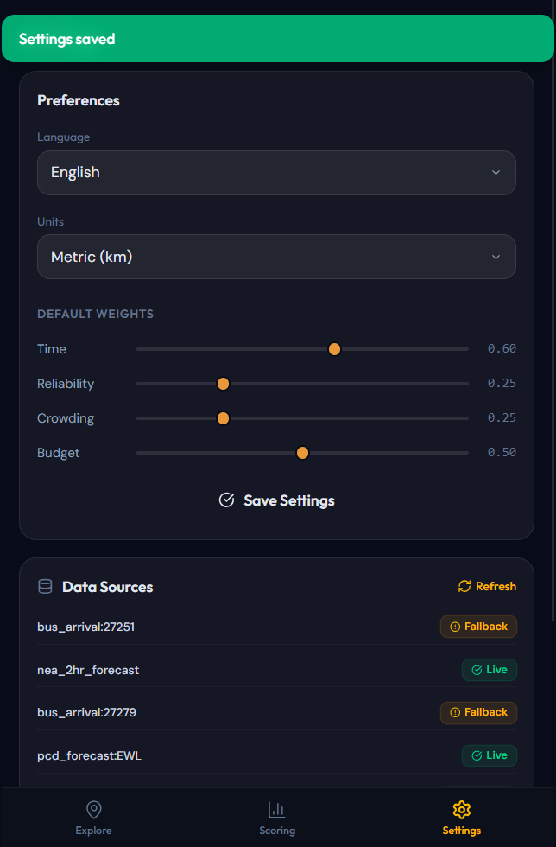Fig 3.15 Settings Change Successful | Application will let the users know after settings has been changed and saved.

Hardware Interfaces
The system is a mobile application designed to run on all mobile devices. The system does not require any specialized or external hardware components, especially device hardware such as cameras, microphones, or sensors. All hardware interactions are handled through the operating system’s APIs without hardware control.

Software Interfaces
The system retrieves transport information from LTA’s real-time database to weigh the best route for users based on their preferences. This is retrieved through Python’s Requests library to establish HTTP communication through web APIs on LTAMall and Google Maps. Subject to the user’s permission, the system can also access the mobile device’s GPS-based location data.

Communications Interfaces
As mentioned above, HTTP communication is used to retrieve information from LTA’s database and Google Maps. As both APIs have limits on the number of calls, the system would only retrieve information when required, such as after users confirm their trip details and when users manually click the refresh button. To ensure that established communication is secure, the API keys for LTA’s database and Google Maps API shall not be revealed or mentioned in any documentation or program.

System Features

User Input Preference

Description and Priority
This feature allows the User to view and adjust travel preferences and route filtering constraints within the route search page. These preferences influence route generation, scoring, and ranking. They include priority weights for Time, Cost, Risk, and Comfort, route category selection, and optional constraints such as maximum walking allowance, maximum number of transfers, and maximum budget. The active preference configuration is applied to the current route search, and default values may be updated through the Settings screen.
Priority: High

Stimulus/Response Sequences
- User accesses the route search page.
- System displays the current active preference values and constraints for the search page, initialised to equal defaults (0.25 each) with no constraints.
- User optionally expands the priorities and constraints section.
- User adjusts one or more priority weights, route categories, or route filtering constraints.
- System updates the active preference configuration for the current search.
- When the User initiates route search, the system applies the active preference configuration during route generation, scoring, and ranking.
- If the User updates default values through the Settings screen, the system saves them for future searches.

Functional Requirements
FR-1.1.  Preference Availability on Search Page | 1.1.1. | The system shall display the current active preference values on the route search page.
 | 1.1.2. | The system shall display the current route filtering constraints on the route search page.
 | 1.1.3. | If no saved default preference values exist, the system shall initialise the preference weights to equal default values (0.25) and zero constraints.
FR-1.2. Preference Weight Adjustment | 1.2.1. | The system shall allow the User to adjust the relative importance of the following criteria within the route search page:  - Time  - Cost  - Risk (combining crowding and delay)  - Comfort (combining walking requirements and transfer burden)
 | 1.2.2. | The system shall provide adjustable slider controls for the above criteria, with a range of 0.0 to 1.0 in steps of 0.05.
 | 1.2.3. | The system shall display the current value of each criterion weight.
 | 1.2.4. | The system shall apply the active criterion weights to the current route search.
FR-1.3. Preference Weight Normalisation | 1.3.1. | The system shall normalise the active preference weights before applying them to route scoring by dividing each weight by the sum of all weights.
 | 1.3.2. | The sum of all normalised preference weights shall equal 1.0.
 | 1.3.3. | The system shall use the normalised preference weights in composite route scoring.
FR-1.4. Comfort Definition | 1.4.1. | The system shall interpret Comfort as a route convenience measure derived from walking requirement and transfer burden, using the formula comfort = 0.6*walking_score + 0.4*transfer_score, where walk_score is capped at 30 minutes and normalised to a 0-10 range, and transfer_score is capped at 5 transfers and normalised to a 0-10 range
 | 1.4.2. | The system shall not treat crowding level as the definition of Comfort. Crowding is part of the Risk dimension.
 | 1.4.3. | The system shall apply the Comfort measure consistently in route scoring.
FR-1.5. Route Filtering Constraints | 1.5.1. | The system shall allow the User to specify a maximum walking allowance (in minutes).
 | 1.5.2. | The system shall allow the User to specify a maximum number of transfers.
 | 1.5.3. | The system shall allow the User to specify a maximum trip budget (in SGD).
 | 1.5.4. | The system shall allow the User to leave any of the above constraints unspecified (empty) to indicate no restriction.
 | 1.5.5. | The system shall apply active constraints to the current route search by filtering out candidate routes that exceed any specified constraint.
FR-1.6. Route Category Selection | 1.6.1. | The system shall allow the User to enable or disable the following route categories on the route search page:  - Public Transit (Bus + MRT)  - Taxi/Drive
 | 1.6.2. | The system shall require at least one route category to remain enabled.
 | 1.6.3. | The system shall prevent the User from disabling the last remaining enabled route category by silently reverting the toggle action (returning to the previous state).
FR-1.7. Expand and Collapse Preferences Section | 1.7.1. | The system shall allow the User to expand or collapse the priorities and constraints section on the route search page via a “Show/Hide priorities & constraints” toggle button.
 | 1.7.2. | When expanded, the section shall display the active priority weights and route filtering constraints.
 | 1.7.3. | When collapsed, the current active preference configuration shall remain in effect for the current search.
FR-1.8. Saving Default Preferences | 1.8.1. | The system shall allow the User to view and update default preference values through the Settings screen.
 | 1.8.2. | Upon saving updated default preference values, the system shall persist them in Local Storage and optionally to the backend for future sessions.

Trip Request Input

Description and Priority
This feature allows the User to initiate and configure a route search by specifying the origin and destination on the route search page. The system validates the search inputs and applies the current active preference configuration before route generation begins. This feature ensures that only valid and complete search inputs are passed to the route generation and assessment functions.
Priority: High

Stimulus/Response Sequences
- User accesses the route search page.
- User enters an origin locatin.
- System displays location suggestions as the User types.
- User selects a suggested origin or continues typing.
- User enters a destination location.
- System displays location suggestions as the User types.
- User selects a suggested destination or continues typing.
- User may swap the origin and destination values.
- System checks whether the search inputs are valid and whether at least one route category is enabled.
- When the required inputs are valid, the system enables the Find Routes action.
- User initiates route search.
- System passes the validated route search inputs and active preference configuration to the route generation and assessment functions.

Functional Requirements
FR- 2.1. Route Search Initiation | 2.1.1. | The system shall allow the User to initiate a route search from the route search page.
 | 2.1.2. | The system shall use the current active preference configuration when route search is initiated.
 | 2.1.3. | The system shall not initiate route search unless the required search inputs are valid.
FR-2.2. Origin Input | 2.2.1. | The system shall allow the User to enter an origin location manually via a text input field.
 | 2.2.2. | The system shall display location suggestions while the User is entering the origin.
 | 2.2.3. | The system shall update the suggestion list when the User modifies the origin input.
 | 2.2.4. | The system shall allow the User to select a suggested location to populate the origin field.
 | 2.2.5. | The system shall implicitly constrain destination locations to Singapore by using the OneMap API, which only returns Singapore-based results.
FR-2.3. Destination Input | 2.3.1. | The system shall allow the User to enter a destination location manually vie a text input field.
 | 2.3.2. | The system shall display location suggestions while the User is entering the destination.
 | 2.3.3. | The system shall update the suggestion list when the User modifies the destination input.
 | 2.3.4. | The system shall allow the User to select a suggested location to populate the destination field.
 | 2.3.5. | The system shall implicitly constrain destination locations to Singapore by using the OneMap API, which only returns Singapore-based results.
FR-2.4. Search Input Validation | 2.4.1. | The system shall validate that the origin and destination are not identical.
 | 2.4.2. | If the origin and destination are identical, the system does not allow the User to enable Find Routes.
 | 2.4.3. | The system shall require at least one enabled route category before route search can proceed.
FR-2.5. Swap Origin and Destination | 2.5.1. | The system shall allow the User to swap the origin and destination values on the route search page via a swap button.
 | 2.5.2. | After swapping, the system shall revalidate the updated search inputs automatically through reactive state binding.
FR-2.6. Find Routes Availability | 2.6.1. | The system shall enable the Find Routes action only when: (a) the origin and destination are not identical, and (b) no search is currently in progress.
 | 2.6.2. | The system shall disable the Find Routes action when any of the above conditions are not met.

Assess Transport Conditions and Generate Risk Scores

Description and Priority
This feature retrieves real-time transport data relevant to the current route search and evaluates transport conditions associated with candidate routes. It assesses data freshness, applies fallback mechanisms where necessary, and computes risk-related indicators for route generation, scoring, ranking, and display. For public transit routes, the system assesses crowding and delay conditions where such data is available. For Taxi/Drive routes, the system retrieves relevant category-specific data where available.
Priority: High

Stimulus/Response Sequences
- User initiates route search from the route search page.
- System determines which transport data sources are relevant based on the validated search inputs, enabled route categories, and active preference configuration.
- System retrieves relevant real-time transport data from external sources.
- System associates timestamps with the retrieved data.
- System evaluates whether each retrieved data source satisfies freshness requirements using TTL-based thresholds.
- If any required data is unavailable or outdated, the system applies fallback handling using the most recent cached data.
- System computes risk-related indicators for relevant route segments and routes.
- System packages the route assessment output.
- System passes the route assessment output to the route generation, scoring, ranking, and display functions.

Functional Requirements
FR- 3.1. Initiate Transport Condition Assessment | 3.1.1. | The system shall initiate transport condition assessment when the User initiates route search.
 | 3.1.2. | The system shall use the validated search inputs as the assessment context.
 | 3.1.3. | The system shall apply the current active preference configuration during transport condition assessment.
FR-3.2. Retrieve Relevant Real-Time Transport Data | 3.2.1. | The system shall retrieve real-time transport data relevant to the current route search from the following sources:  - LTA Bus Arrival API (bus crowding and frequency data)  - LTA Passenger Crowd Data (PCD) Forecast (MRT Crowding Data)  - LTA Train Service Alerts (MRT delay/disruption data)  - LTA Traffic Speed Bands (driving congestion data)  - LTA Carpark Availability (parking data for Drive routes)  - NEA 2-Hour Weather Forecast (weather conditions along route)
 | 3.2.2. | If Public Transit is enabled, the system shall retrieve public-transit-related data where available, including MRT crowdedness data, MRT service alert information and bus arrival data.
 | 3.2.3. | If Taxi/Drive is enabled, the system shall retrieve driving-related data including traffic speed bands, ERP gantry data and carpark availability at the destination.
 | 3.2.4. | The system shall retrieve only the data sources required for the current route search.
FR-3.3 Data Freshness Compliance | 3.3.1. | The system shall associate a retrieval timestamp with each retrieved real-time transport data source via the cache layer.
 | 3.3.2. | The system shall evaluate whether each data source meets predefined TTL-based freshness thresholds:  - Bus Arrival: 30 seconds  - PCD Forecast (MRT crowding): 600 seconds  - Train Service Alerts: 60 seconds  - Traffic Speed Bands: 300 seconds  - Carpark Availability: 300 seconds  - Taxi Availability: 60 seconds
 | 3.3.3. | If a data source does not meet the freshness criteria (TTL expired), the system shall treat it as outdated and apply fallback handling in accordance with Section 4.5.
FR-3.4 Fallback Data Compliance | 3.4.1. | If real-time transport data is unavailable or outdated, the system shall apply fallback handling using the most recent cached data.
 | 3.4.2. | The system shall mark any data elements operating in fallback mode in accordance with Section 4.5.
 | 3.4.3. | The system shall allow route generation and ranking to proceed when fallback data is used, unless no relevant data is available at all.
 | 3.4.4. | Different segments within the same route may independently use real-time or fallback data. If any segment uses fallback data, it will be flagged as “Fallback”.
FR-3.5 Assess Crowding Conditions | 3.5.1. | For bus segments, the system shall compute a crowding indicator from the LTA Bus Arrival API using the following mapping:  - SEA (Seats Available) Low  - SDA (Standing Available) Medium  - LSD (Limited Standing) High
 | 3.5.2. | For MRT segments, the system shall compute a crowding indicator from the LTA PCD Forecast, matched to the closest time interval, using the following mapping:  - “l” / “low” Low  - “m” / “medium” / “moderate” Medium  - “h” / “high” High
 | 3.5.3. | The system shall categorise each crowding indicator as Low, Medium, High or, Unknown.
 | 3.5.4. | If crowding data is unavailable for a relevant segment, the system shall mark the indicator as Unknown.
 | 3.5.5. | The system shall pass crowding-related indicators to downstream route assessment and display functions.
FR-3.6 Assess Delay Conditions | 3.6.1. | For MRT segments, the system shall compute a delay indicator from the LTA Train Service Alerts API:  - Status = 1 (normal service) Low  - Status = 2 (disruption) on a different line Low  - Status = 2 (disruption) with no specific line identified Medium  - Status = 2 (disruption) on the route’s line High
 | 3.6.2. | For bus segments, the system shall assign a default indicator of low.
 | 3.6.3. | For driving/taxi segments, the system shall compute a delay indicator from the LTA Traffic Speed Bands API based on average speed near the route  - Average speed >= 6 Low  - Average speed >= 3 Medium  - Average speed < 3 High
 | 3.6.3. | If system shall categorise each delay indicator as Low, Medium, High or Unknown
 | 3.6.5. | If delay data is unavailable for a relevant segment, the system shall mark the indicator as Unknown.
 | 3.6.6. | The system shall pass delay-related indicators to downstream route assessment and display functions.
FR-3.7 Prepare Route Assessment Output | 3.7.1 | The system shall package the computed transport-condition indicators as a structured route assessment output.
 | 3.7.2. | For each computed indicator, the output shall include the indicator category, numeric value, source type (“realtime” or “fallback”), fallback flag and retrieval timestamp.
 | 3.7.3 | The system shall pass the route assessment output as input to route generation, route scoring, route ranking, and route display functions

Route Generation and Ranking

Description and Priority
This feature generates feasible route options based on validated route search inputs and the current active preference configuration. It applies user-defined route categories and filtering constraints, assigns route attributes, derives route-level risk and comfort-related measures, computes composite scores, ranks routes deterministically, and prepares ranked route options for display with brief explanations.
Priority: High

Stimulus/Response Sequences
- Route assessment output is received after the User initiates route search.
- System generates candidate routes for the enabled route categories.
- System applies active walking, transfer, and budget constraints.
- System assigns route attributes such as travel time, travel cost, walking requirement, transfer count, and risk-related indicators.
- System derives a comfort-related measure and a combined risk measure for each candidate route.
- System normalises route attributes using min-max normalisation.
- System computes composite scores using normalised preference weights and normalised route attributes.
- System ranks routes in ascending order of composite score.
- System applies tie-breaking rules where required.
- System selects up to 5 distinct ranked route options, ensuring category diversity.
- System generates a brief explanation for each selected route.
- System passes the ranked route options to the route display function.

Functional Requirements
FR-4.1. Route Generation Initiation | 4.1.1. | The system shall initiate route generation after transport condition assessment has been completed.
 | 4.1.2. | The system shall use the validated route search inputs for route generation.
 | 4.1.3 | The system shall use the route assessment output from Section 4.3 as input to route generation, scoring, and ranking.
 | 4.1.4. | The system shall apply the current active preference configuration during route generation, scoring, and ranking.
FR-4.2. Route Generation by Route Category | 4.2.1. | The system shall generate route options only using route categories enabled in the active preference configuration.
 | 4.2.2. | If Public Transit is enabled, the system shall generate public transit route options via Google Directions API.
 | 4.2.3. | Public transit route options may include MRT-only or MRT-and-Bus combinations where applicable.
 | 4.2.4. | If Taxi/Drive is enabled, the system shall generate driving route options via Google Directions API, producing both Taxi candidate and a Drive candidate from each driving route.
 | 4.2.5. | The Taxi candidate shall not include parking penalties.
 | 4.2.6. | The Drive candidate shall include parking-related penalties on time, risk, and comfort based on nearby carpark availability.
 | 4.2.7. | If Public Transit is the only enabled route category, the system shall exclude Taxi/Drive route options.
 | 4.2.8. | If Taxi/Drive is the only enabled route category, the system shall exclude Public Transit route options.
FR-4.3. Route Feasibility and Constraint Handling | 4.3.1. | The system shall generate only feasible routes that allow travel from the specified origin to the destination.
 | 4.3.2. | The system shall apply the active maximum walking allowance during route filtering.  4.3.2.1. If a maximum walking allowance is specified, the system shall exclude routes where total walking times exceeds the limit.
 | 4.3.3. | The system shall apply the active maximum number of transfers during route generation.  4.3.3.1. If a maximum number of transfers is specified, the system shall exclude routes where the transfer count exceeds the limit.
 | 4.3.4. | The system shall apply the active maximum trip budget during route generation.  4.3.3.1. If a maximum budget is specified, the system shall exclude routes where the estimated cost exceeds the budget
 | 4.3.5. | If no feasible routes can be generated within the active constraints, the system shall return an empty route list with the message “No routes found or APL unavailable”.
FR-4.4. Route Attribute Assignment | 4.4.1. | For each generated route, the system shall assign an estimated travel time derived from the Google Directions API, converted to minutes.
 | 4.4.2. | For each generated route, the system shall compute a realistic travel time by adding a bus wait buffer of 0.5*miss_penalty_min per bus step (modelling a 50% chance of missing the bus).
 | 4.4.3. | For Drive routes, the system shall add a parking search time penalty to realistic travel time: + 10 minutes if nearby parking is full +5 minutes if parking is limited.
 | 4.4.4. | For each generated route, the system shall compute a route-level crowding risk level by aggregating segment-level crowding risk values using a worst-case (maximum) rule:  - If all segment-level crowding risk indicators are Unknown, the route-level crowding risk level shall be Unknown with numeric value 2.  - If some segment-level crowding risk indicators are Unknown and some are known, the route-level crowding risk shall be maximum of the known segment-level crowding risk values.  - Otherwise, the route-level crowding risk shall be the maximum segment-level crowding risk level.
 | 4.4.5. | For each generated route, the system shall compute a risk-level delay risk by aggregating segment-level delay risk values using the same worst-case rule as crowding (FR-4.4.4).
 | 4.4.6. | For each generated route, the system shall determine the number of transfers as the count of transit segment minus one (minimum 0).
 | 4.4.7. | For each generated route, the system shall determine the estimated travel cost:  - Public Transport: Singapore adult card distance-based fare (TransitLink fare table), ranging from $0.99 (up to 3.2km) to $2.20 (over 40.2km)  - Taxi: ComfortDelGro 2026 metered fare with $4.60 flag-down (first 1km), $0.27 per 400m up to 10km, $0.27 per 350m after 10km, $0.27 per 45 waiting (assuming 20% idle time), plus applicable surchargers (25% peak, 50% late-night, $2.30-$3.30 booking fee, $6-$8 Changi Airport surcharge) plus ERP charges  - Drive: Fuel cost at $0.12km/h plus ERP charges
 | 4.4.8. | For Drive routes, the system shall inflate the walking time when parking is scarce: +5 minutes if parking is full, +2 minutes if limited.
FR-4.5. Risk Quantification for Scoring (Numeric Conversion) | 4.5.1. | The system shall convert route-level crowding and delay risk categories into numerical values for use in the composite scoring formula.
 | 4.5.2 | The system shall use the following numeric mapping for risk categories, where a lower numeric value represents lower risk (better outcome):  Risk Category Numeric Value Rationale  Low 1 Minimal risk – most desirable  Medium 2 Moderate risk – acceptable  High 3 Elevated risk – least desirable  Unknown 2 (default fallback) Conservative mid-point – treated as potentially moderate risk  Note: When route-level risk is Unknown, the system shall display it as Unknown. For scoring purposes only, Unknown may be treated as a neutral value (2).
 | 4.5.3 | The system shall combine route-level crowding delay risk into a single Risk score using the formula: Risk = max(crowding_numeric, delay_numeric), producing a valye on the 1-3 scale.
FR-4.6. Normalisation of Route Attributes | 4.6.1. | The system shall normalise route attributes to a common scale before computing composite scores.
 | 4.6.2. | The system shall apply min-max normalisation within each trip request:  - Travel time (T)  - Estimated travel cost (B)  - Combined risk score (R) derived from max(crowding_numeric, delay_numeric)  - Comfort score (C) derived from 0.6*walk_score + 0.4*transfer_score
 | 4.6.3. | Min-max normalisation shall be applied as follows:  4.6.3.1. X_norm = (X – X_min) / (X_max – X_min), where X_min and X_max are the minimum and maximum values of the attribute across all candidate routes in the current trip request.  4.6.3.2. A normalised value of 0.0 represents the best performing route on that attribute; a normalised value of 1.0 represents the worst-performing route  4.6.3.3. If all candidate routes have identical values for an attribute, the system shall assign a normalised value of 0.0 to all routes for that attribute
 | 4.6.4. | Normalisation shall be computed consistently across all candidate routes within a single trip.
FR-4.7. Composite Route Scoring | 4.7.1. | The system shall compute a composite score for each candidate route using the User’s normalised preference weights and normalised route attributes.
 | 4.7.2. | The composite score shall be computed using the following weighted scoring model:  Route Score = w_T * T’ + w_B * B’ + w_R * R’ + w_C *C’  Where:  - w_T, w_B, w_R, w_C are normalised preference weights sum tp 1.0  - T’ is normalised travel time, 0.0= fastest  - B’ is normalised travel cost, 0.0= cheapest  - R’ is the normalised combined risk score, 0.0 = lowest risk  - C’ is the normalised comfort score, 0.0 = most comfortable
 | 4.7.3. | The system shall rank routes in ascending order of composite score, such that a lower score indicates a more preferred route.
 | 4.7.4. | A composite score of 0.0 represents a route that is best on all included criteria relative to the candidate set, a score of 1.0 represents a route that is worst on all criteria.
FR-4.8. Route Ranking and Tie-Breaker | 4.8.1. | The system shall rank all feasible candidate routes in ascending order of composite score.
 | 4.8.2. | If two or more routes have equal composite scores, the system shall apply the following tie-breaking sequence in order:  - Lower combined risk numeric value (max of crowding and delay)  - Lower comfort numeric value (lower = more comfortable)  - Shorter estimated travel time  - Lower estimated travel cost  - Fewer transfers
 | 4.8.3. | Tie-breaking shall use numeric values rather than displayed labels to ensure deterministic ordering.
FR-4.9. Route Selection Output | 4.9.1. | The system shall display up to 5 ranked route options per trip request.
 | 4.9.2. | The system shall ensure category diversity by first selecting the best route form each category (Public Transport, Taxi, Drive) then filling remaining slots (up to 5) with the next best overall routes.
 | 4.9.3. | Each represented route option shall represent a distinct travel alternative, as determined by different mode sequences, paths or transfer points.
 | 4.9.4. | If no feasible routes can be generated, the system shall notify the User with the message “No routes found or API unavailable” and display a prompt to modify constraints or search again.
FR-4.10 Route Explanation | 4.10.1. | For each generated route option, the system shall provide a brief explanation composed of multiple descriptive pieces joined by periods
 | 4.10.2. | The explanation shall reference the User’s highest-weighted criterion and summarise how the route performs on that criterion:  - Time: Fastest option at X min  - Cost: Cheapest at $ X  - Risk: Lowest risk: Category  - Comfort: Most comfortable: X min walk, Y transfer(s)
 | 4.10.3. | The explanations shall include per-step crowding highlights where available (e.g. Crowded: Bus 143” or “Not crowded: MRT NSL”)
 | 4.10.4. | The explanation shall include the total walking time (e.g. X min walking)
 | 4.10.5. | If fallback data as used in computing any risk indicator for the route, the explanation shall include the notation “(some data is estimated)”

Data Freshness, Fallback & Settings

Description and Priority
This feature manages real-time data freshness evaluation, fallback data handling, user-initiated data refresh, and system settings such as localisation and default preference updates. It ensures that route recommendations remain consistent, transparent, and adaptable to User preferences and data availability conditions.
Priority: Medium

Stimulus/Response Sequences
- System retrieves real-time transport data for the current route search.
- System evaluates the freshness of each retrieved data source against TTL thresholds.
- If any required data source is outdated (TTL expired), system uses the most recent cached data as fallback
- System marks affected route recommendations accordingly via ‘uses_fallback’ flag
- User selects Refresh.
- System invalidates all cached data and re-initiates transport condition assessment.
- System regenerates and re-ranks routes.
- User accesses the Settings screen.
- User modifies language or default preference weights.
- System saves the updated settings and applies them to subsequent sessions or searches as appropriate.

Functional Requirements
FR-5.1. Data Freshness Management | 5.1.1. | The system shall maintain an in-memory TTl cache for all retrieved real-time transport data.
 | 5.1.2. | Each cached item shall record the retrieval timestamp and TTL in seconds.
 | 5.1.3. | The system shall evaluate whether each data source meets its predefined freshness threshold by comparing elapsed time since retrieval against the TTL.
 | 5.1.4. | If a data source does not meet the freshness criteria, the system shall treat it as outdated.
FR-5.2. Fallback Data Handling | 5.2.1. | If real-time transport data is unavailable or outdated, the system shall use the most recent cached data for processing.
 | 5.2.2. | If no cached data exists and the API call fails, the system shall return am empty data structure.
 | 5.2.3. | The system shall identify which transport data sources are operating in fallback mode.
 | 5.2.4. | Different segments within the same route may independently use real-time or fallback data.
FR-5.3. Impact Awareness on Route Recommendations | 5.3.1. | If fallback data is used during transport condition assessment or route generation, the system shall mark the affected route recommendations accordingly.
 | 5.3.2. | The route explanation shall include the notation “(some data is estimated)” when the route uses fallback data.
 | 5.3.3. | The Settings screen shall display the status of each data source as either “Live” (real-time) or “Fallback” (stale/unavailable), w9th colour coded badges (green for Live, amber for Fallback).
 | 5.3.4. | The system shall allow route generation, scoring, and ranking to proceed when fallback data is used, unless no relevant data is available.
FR-5.4. User-Initiated Data Refresh | 5.4.1. | The system shall provide a Refresh button on the results page, the main view and the Settings screen.
 | 5.4.2. | Upon refresh from the results page or main view, the system shall re-fetch routes using the same search parameters with fresh data.
 | 5.4.3. | Upon refresh from the Settings screen, the system shall invalidate all cached data via the ‘refresh’ button, clearing the entire in-memory cache.
 | 5.4.3. | The system shall regenerate and re-rank route options after a successful data refresh.
FR-5.5 User Settings & Localisation | 5.5.1. | The system shall allow the User to access the Settings screen.
 | 5.5.2. | The system shall allow the User to select a display language from the following options:  - English  - Chinese Simplified  - Malay  - Tamil
 | 5.5.3. | The system shall apply the selected language to all user-facing text, including labels, error messages, and help messages.
 | 5.5.4. | The system shall save the selected language for future sessions.
 | 5.5.5. | The system shall allow the User to view and update default preference weights through the Settings screen via slider controls (range 0.0-1.0, step 0.05).
 | 5.5.6. | Upon saving changes, the system shall apply the updated default preference values to subsequent route searches.

Other Nonfunctional Requirements

Performance Requirements
Performance | The system shall return route recommendations within 5 seconds after the user submits a valid origin and destination under normal network conditions.  The system shall refresh real-time transport data at intervals of no more than 5 minutes.
Supportability | The system shall support at least 200 concurrent users during peak commuting hours.  Under the above load, the system shall return route recommendations within 5 seconds after the user submits a valid origin and destination.
Scalability | The system shall allow new transport modes to be added by extending the route-generation module and updating the configuration, without changing existing functional requirements or user workflows.
Availability & Resilience | The system shall remain usable and allow route search even when one or more data sources are unavailable, by falling back to cached data.  The system shall display the timestamp of the latest successfully retrieved data on the results screen.  If cached data is older than 15 minutes, the system shall show a warning that results may be less accurate.

Safety Requirements
- The system shall not provide any route recommendations that include illegal or unsafe transport behavior, such as entering prohibited areas and going against Singapore’s transportation laws

- The system shall have a simple design to prevent distraction-related incidents during the use of the system

Security Requirements
- The system shall not leak any personal information in accordance with Singapore’s Personal Data Protection Act

- The system shall encrypt client applications and backend services using industry-standard protocols

Software Quality Attributes
Reliability | The system shall continue to provide route recommendations using the most recently cached data when one or more real-time data sources are unavailable.
Usability | The system shall provide a route comparison view that displays, for each route, at minimum: estimated travel time, route-level delay risk level, route-level crowding risk level, and estimated travel cost (if applicable).  The system shall display help messages in the user’s selected language.  The system’s design shall prioritize ease of use, where first-time users can obtain route recommendations within three interactions or fewer.

Business Rules
- The system shall generate route recommendations solely based on user-selected preferences, LTA, and Google Maps transport data, without prioritizing any specific transport operators.

- The use of data sources by the system shall only be configured by authorized system administrators

Other Requirements
Appendix A: Glossary

Data Dictionary
Term | Type | Definition | Attributes / Data Elements | Relationships | Constraints / Notes
User | Entity | A commuter who uses SGTravelBud to search for and compare travel routes. | userId, selectedLanguage, unitFormat | One User owns one set of saved default preference values; one User performs 0..* route searches. | selectedLanguage and unitFormat must be valid supported options.
Default Preference Values | Entity | A saved set of default route search preferences and constraints used by the route search page and Settings screen. | defaultWeightTime, defaultWeightCost, defaultWeightRisk, defaultWeightComfort, maxWalk, maxTransfers, maxBudget, enabledCategories, normalisedWeights | Belongs to one User; may be loaded into 0..* route searches. | At least one route category must remain enabled. The sum of normalised weights must equal 1.0.
Trip Request | Entity | A route search request made by the User, containing the selected origin, destination, active preference values, and active route filtering constraints. | requestId, origin, destination, wTime, wCost, wRisk, wComfort, maxWalk, maxTransfers, maxBudget, enabledCategories, validationStatus | Belongs to one User; uses one active set of default or adjusted preference values; may generate 0..* Route Options. | origin and destination must be within Singapore and must not be identical.
Route Option | Entity | A feasible route generated by the system from the specified origin to the destination under the current route search configuration. | routeId, category, timeMin, cost, walkMin, transfers, risk, crowding, delay, comfort, score, scoreBreakdown, explanation, isFallbackUsed | Belongs to one Trip Request; consists of 1..* Route Steps; may reference 0..* Risk Indicators. | Only feasible routes are retained. Routes are ranked in ascending order of score. The system may display up to five distinct route options.
Route Step | Entity | A continuous portion of a route that represents one movement step or transport step. | stepId, mode, fromName, toName, durationMin, distanceKm, riskIndicator, isTransit, isWalk, isTaxi, isDrive | Belongs to one Route Option; may reference 0..1 Risk Indicator. | A Route Step must represent a valid step type such as MRT, Bus, Walk, Taxi, or Drive.
Risk Indicator | Entity | A transport-condition indicator associated with a route step or route, representing crowding-related, delay-related, or derived route-level risk information. | riskType, riskLevel, numericValue, source, isFallback, timeStamp | May belong to one Route Step; may be used to derive one route-level Risk value for a Route Option. | riskType may represent crowding-related or delay-related risk. riskLevel must be one of Low, Medium, High, or Unknown. For scoring, Unknown may be treated as a neutral value.
Real-Time Transport Data | External Data | Live transport-related data retrieved from external APIs and used in route assessment, scoring, ranking, and display. | sourceName, sourceCategory, rawPayload, retrievalTimestamp, freshnessStatus | Retrieved from external APIs; used to derive Risk Indicators and support Route Option generation. | If data is unavailable or stale, fallback data may be used. Real-time and stale data should not be mixed inconsistently within a single route search.
Route Category | Enumeration | A high-level route search category that the User may enable or disable on the route search page. | PublicTransit, TaxiDrive | Referenced by Default Preference Values, Trip Request, and Route Option. | At least one Route Category must remain enabled.
Risk Level | Enumeration | A categorical representation of transport risk severity used in route assessment and display. | Low, Medium, High, Unknown | Used by Risk Indicator and Route Option. | Unknown is displayed as Unknown to the User, but may be treated as a neutral value for scoring.
Data Source Type | Enumeration | Indicates whether a value was derived from live data or fallback data. | real-time, fallback | Used by Risk Indicator and Real-Time Transport Data. | Any fallback-derived output should be clearly marked in the system.
Route Score | Derived Data | A composite score computed for a route using normalised preference weights and normalised route attributes. A lower score indicates a more preferred route. | scoreValue, T', Co', R', F', wTime, wCost, wRisk, wComfort | Attached to one Route Option and used for route ranking. | Computed after min-max normalisation. Tie-breakers may be applied using route-level Risk, Comfort, travel time, travel cost, and transfers.
Normalised Weight | Derived Data | A weight derived from the active preference values and scaled so that all criterion weights sum to 1.0. | wTime, wCost, wRisk, wComfort | Derived from one set of Default Preference Values or active Trip Request values; consumed by Route Score calculation. | The sum of all normalised weights must equal 1.0.
Normalised Attribute | Derived Data | A min-max normalised route attribute used to compare candidate routes on a common scale. | T' (travel time), Co' (travel cost), R' (route-level Risk), F' (comfort-related value) | Derived from candidate Route Options within one Trip Request; consumed by Route Score. | Value range is 0.0 to 1.0. If all candidate routes share the same raw value for an attribute, the normalised value for all routes is 0.0.
Settings | Entity | A set of system-level user settings used to control localisation and saved default preference values. | language, units, defaultWeightTime, defaultWeightCost, defaultWeightRisk, defaultWeightComfort | Belongs to one User; stored in the Settings Repository; used by the route search page and Settings page. | All setting values must be valid supported options.
Data Status | Derived Data | A status object describing the freshness and fallback state of a retrieved transport data source. | lastRetrieved, isFresh, isFallback, source, label | Derived from Real-Time Transport Data; may be displayed to the User and used in fallback handling. | Used to support data freshness and fallback transparency.

Appendix B: Analysis Models

Use Case Diagrams
Use Case ID: | UC-01
Use Case Name: | Detect First-Time User
Created By: | Huynh Thao Tuong Van | Last Updated By: | Huynh Thao Tuong Van
Date Created: | 11/2/2026 | Date Last Updated: | 11/2/2026

Actor: | System
Description: | Checks whether the user has launched the app before. If no saved preference profile exists, the system flags them as a first-time user and loads default preference values and proceeds to the main trip request screen.
Preconditions: | User has opened the application
Postconditions: | System has determined whether the user is new or returning and routed them accordingly
Priority: | High
Frequency of Use: | Once per new user; checked every app launch
Flow of Events: | 1. User opens the application.  2. System checks for an existing saved preference profile.  3. If no profile is found, system loads default preference values.  4. System proceeds to the main trip request screen. A tooltip or notification informs the user they can configure preferences in Settings.  5. If a profile exists, system proceeds to the main trip request screen.
Alternative Flows: | NIL
Exceptions: | NIL
Includes: | NIL
Special Requirements: | NIL
Assumptions: | NIL
Notes and Issues: | NIL

Use Case ID: | UC-02
Use Case Name: | Configure Preference Profile
Created By: | Huynh Thao Tuong Van | Last Updated By: | Huynh Thao Tuong Van
Date Created: | 11/2/2026 | Date Last Updated: | 11/2/2026

Actor: | User
Description: | Allows the user to set what matters most to them when traveling. They rank their priorities, set walking/transfer limits, and choose their transport modes.
Preconditions: | UC-01 when a new user is detected or when User creates an additional preference profile
Postconditions: | A complete set of user preferences is ready to be saved
Priority: | High
Frequency of Use: | Medium Low
Flow of Events: | 1. User assigns an importance level (Low, Medium, High) to Travel Time, Reliability, Comfort, and Budget.  2. User sets their max walking tolerance (5, 10, 15, or 20 mins) and transfer tolerance (0, 1, 2, or 3).  3. User toggles their transport modes (MRT-only, MRT and Bus, Taxi, Drive). At least one must be active.  4. User optionally configures concession fare eligibility.  5. System maps weights internally (Low=1, Med=2, High=3) and normalises them so they equal 1.0.  6. Calls UC-04 to save the preference profile persistently if all validated.
Alternative Flows: | NIL
Exceptions: | NIL
Includes: | NIL
Special Requirements: | NIL
Assumptions: | NIL
Notes and Issues: | NIL

Use Case ID: | UC-03
Use Case Name: | Modify Preference Profile
Created By: | Huynh Thao Tuong Van | Last Updated By: | Huynh Thao Tuong Van
Date Created: | 11/2/2026 | Date Last Updated: | 11/2/2026

Actor: | User
Description: | Lets a returning user update their saved default preferences from the Settings screen. Any changes take effect for all future trips once saved.
Preconditions: | A saved default preference profile already exists (UC-02 was completed previously)
Postconditions: | The modified preferences are ready to be persisted via UC-04
Priority: | Medium
Frequency of Use: | Low
Flow of Events: | 1. User navigates to the Settings screen and opens the saved preference profile.  2. System displays the current preference values (weights, tolerances, mode toggles, budget, etc.).  3. User edits any combination of preference fields.  4. System validates changes (e.g., at least one transport mode stays active).  5. System normalises the updated preference weights so they sum to 1.0.  6. Calls UC-04 to persist the updated profile.
Alternative Flows: | NIL
Exceptions: | If the user tries to disable the last active transport mode, system blocks the action and shows a validation error.
Includes: | NIL
Special Requirements: | NIL
Assumptions: | NIL
Notes and Issues: | NIL

Use Case ID: | UC-04
Use Case Name: | Save Preference Profile
Created By: | Huynh Thao Tuong Van | Last Updated By: | Huynh Thao Tuong Van
Date Created: | 11/2/2026 | Date Last Updated: | 11/2/2026

Actor: | System
Description: | Persists the user's preference profile so it becomes the default for all subsequent trips. Triggered after initial configuration or any modification.
Preconditions: | A complete, validated set of preferences has been configured (UC-02) or modified (UC-03)
Postconditions: | The preference profile is saved and will be applied as the default for future trip requests
Priority: | High
Frequency of Use: | Every time preferences are created or changed
Flow of Events: | 1. System receives the validated preference data from UC-02 or UC-03.  2. System writes the preference profile to persistent storage.  3. System confirms the save was successful.  4. The saved profile becomes the active default for all future trip requests.
Alternative Flows: | NIL
Exceptions: | NIL
Includes: | NIL
Special Requirements: | NIL
Assumptions: | NIL
Notes and Issues: | NIL

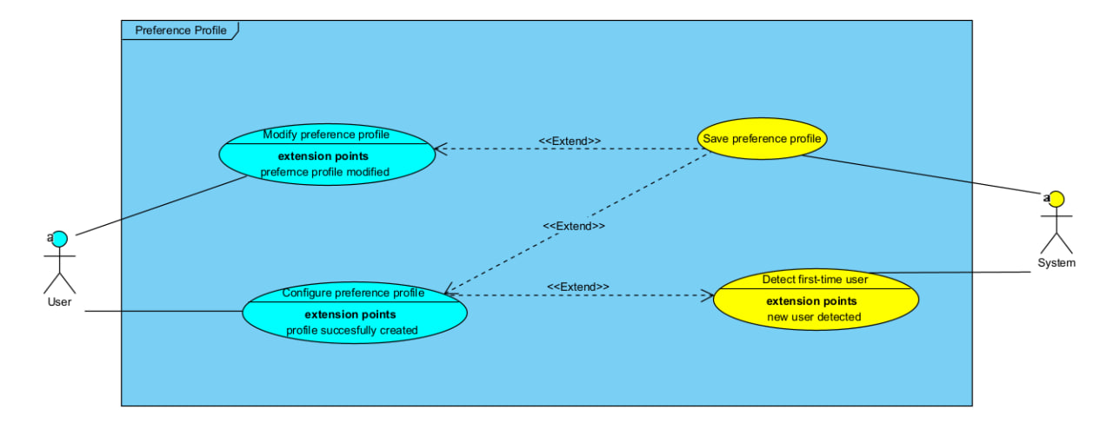User Input Preference

Trip Request Input
Use Case ID: | UC-05
Use Case Name: | Initiate Trip Request
Created By: | Huynh Thao Tuong Van | Last Updated By: | Huynh Thao Tuong Van
Date Created: | 11/2/2026 | Date Last Updated: | 11/2/2026

Actor: | User
Description: | Entry point for planning a new trip. The system loads the user's saved preferences and walks them through entering origin, destination.
Preconditions: | User has opened the application
Postconditions: | All trip inputs (origin, destination, active preferences) are collected and ready for confirmation
Priority: | High
Frequency of Use: | High
Flow of Events: | 1. User taps to start a new trip request.  2. System fetches the saved default preference profile (UC-07).  3. System displays the active preference summary and asks the user to keep defaults or modify for this trip (UC-06).  4. User enters or selects an origin (UC-08).  5. User enters or selects a destination (UC-09).  6. System displays a trip request summary showing all inputs before confirmation.
Alternative Flows: | NIL
Exceptions: | NIL
Includes: | UC-06 Choose Preference, UC-08 Input Origin, UC-09 Input Destination
Special Requirements: | NIL
Assumptions: | NIL
Notes and Issues: | NIL

Use Case ID: | UC-06
Use Case Name: | Choose Preference
Created By: | Huynh Thao Tuong Van | Last Updated By: | Huynh Thao Tuong Van
Date Created: | 11/2/2026 | Date Last Updated: | 11/2/2026

Actor: | User
Description: | Asks the user whether to go with their saved default preferences or tweak them just for this trip. Trip-level tweaks don't alter the saved profile.
Preconditions: | Trip request has been initiated (UC-05) and default profile has been fetched (UC-07)
Postconditions: | An active preference configuration is set for the current trip request
Priority: | High
Frequency of Use: | High
Flow of Events: | 1. System presents two options: "Use Default Preferences" or "Modify Preferences for This Trip".  2. If the user picks "Use Default Preferences", system applies the saved profile as-is.  3. If the user picks "Modify Preferences for This Trip", system opens an inline editor for trip-level overrides.  4. User adjusts any preferences (weights, tolerances, modes, budget) for this trip only.  5. System applies the trip-level overrides; the saved default profile remains unchanged.  6. If the user dismisses without choosing, system defaults to the saved profile.
Alternative Flows: | NIL
Exceptions: | NIL
Includes: | UC-07 Fetch Preference Profile
Special Requirements: | NIL
Assumptions: | NIL
Notes and Issues: | NIL

Use Case ID: | UC-07
Use Case Name: | Fetch Preference Profile
Created By: | Huynh Thao Tuong Van | Last Updated By: | Huynh Thao Tuong Van
Date Created: | 11/2/2026 | Date Last Updated: | 11/2/2026

Actor: | System
Description: | Retrieves the user's saved default preference profile from storage so it can be displayed and applied during a trip request.
Preconditions: | A saved default preference profile exists
Postconditions: | The preference profile is loaded into memory and available for the current trip request
Priority: | High
Frequency of Use: | High
Flow of Events: | 1. System receives a request to load preferences (triggered by UC-05 or UC-06).  2. System reads the saved preference profile from persistent storage.  3. System returns the full profile (weights, tolerances, mode settings, budget, concession status) to the calling use case.
Alternative Flows: | NIL
Exceptions: | NIL
Includes: | NIL
Special Requirements: | NIL
Assumptions: | NIL
Notes and Issues: | NIL

Use Case ID: | UC-08
Use Case Name: | Input Origin
Created By: | Huynh Thao Tuong Van | Last Updated By: | Huynh Thao Tuong Van
Date Created: | 11/2/2026 | Date Last Updated: | 11/2/2026

Actor: | User
Description: | Lets the user specify where their trip starts, either by using GPS or typing an address manually. The system validates the location is within Singapore.
Preconditions: | Trip request has been initiated (UC-05)
Postconditions: | A validated origin location within Singapore is set for the trip
Priority: | High
Frequency of Use: | High
Flow of Events: | 1. System offers the option to use current GPS location or enter an address manually.  2. If GPS is chosen, system requests location permission (UC-11) and attempts to resolve coordinates.  3. If manual entry is chosen, user types an address and system generates suggestions (UC-12).  4. User selects a suggestion or confirms the typed address.  5. System validates that the origin falls within Singapore.  6. If valid, origin is locked in for the trip.
Alternative Flows: | If GPS fails or times out, system prompts the user to retry or switch to manual input.
Exceptions: | If the origin is outside Singapore or cannot be resolved, system shows an error and asks the user to re-enter.
Includes: | UC-12 Generate Suggestions
Special Requirements: | NIL
Assumptions: | NIL
Notes and Issues: | NIL

Use Case ID: | UC-09
Use Case Name: | Input Destination
Created By: | Huynh Thao Tuong Van | Last Updated By: | Huynh Thao Tuong Van
Date Created: | 11/2/2026 | Date Last Updated: | 11/2/2026

Actor: | User
Description: | Lets the user specify where they want to go, via text entry or by tapping a point on the map. Validated to be within Singapore and different from the origin.
Preconditions: | Trip request has been initiated and origin has been set (UC-08)
Postconditions: | A validated destination location within Singapore is set for the trip
Priority: | High
Frequency of Use: | High
Flow of Events: | 1. User types a destination address and system generates suggestions (UC-12), or user taps a location on the map.  2. User selects a suggestion or confirms the map pin.  3. System validates that the destination is within Singapore.  4. System checks the destination is not identical to the origin.  5. If valid, destination is locked in for the trip.
Alternative Flows: | NIL
Exceptions: | If the destination is outside Singapore, unresolvable, or same as origin, system shows an error and asks for re-entry.
Includes: | UC-12 Generate Suggestions
Special Requirements: | NIL
Assumptions: | NIL
Notes and Issues: | NIL

Use Case ID: | UC-11
Use Case Name: | Request Location
Created By: | Huynh Thao Tuong Van | Last Updated By: | Huynh Thao Tuong Van
Date Created: | 11/2/2026 | Date Last Updated: | 11/2/2026

Actor: | System
Description: | Handles the GPS location flow: requesting device permission, reading coordinates, and dealing with failures like denied permissions or disabled services.
Preconditions: | User chose to use current location during origin input (UC-08)
Postconditions: | GPS coordinates are returned to the origin input field, or user is redirected to manual input
Priority: | High
Frequency of Use: | High
Flow of Events: | 1. System requests location permission from the device.  2. If permission is granted, system attempts to read GPS coordinates.  3. If coordinates are obtained within the time limit, system returns them to UC-08.  4. If permission is denied, system offers the option to proceed with manual input.  5. If location services are disabled, system prompts the user to enable them or use manual input.  6. If GPS times out, system prompts to retry or fall back to manual input.
Alternative Flows: | NIL
Exceptions: | NIL
Includes: | NIL
Special Requirements: | NIL
Assumptions: | NIL
Notes and Issues: | NIL

Use Case ID: | UC-12
Use Case Name: | Generate Suggestions
Created By: | Huynh Thao Tuong Van | Last Updated By: | Huynh Thao Tuong Van
Date Created: | 11/2/2026 | Date Last Updated: | 11/2/2026

Actor: | System
Description: | Provides live autocomplete suggestions as the user types an origin or destination. The suggestion list updates with every keystroke.
Preconditions: | User is typing in the origin (UC-08) or destination (UC-09) input field
Postconditions: | A list of matching location suggestions is displayed for selection
Priority: | Medium
Frequency of Use: | High
Flow of Events: | 1. User begins typing in the location input field.  2. System queries for matching location suggestions based on the current input text.  3. System displays the suggestion list below the input field.  4. As the user modifies the text, system refreshes the list in real time.  5. User selects a suggestion to populate the field.
Alternative Flows: | NIL
Exceptions: | NIL
Includes: | NIL
Special Requirements: | NIL
Assumptions: | NIL
Notes and Issues: | NIL

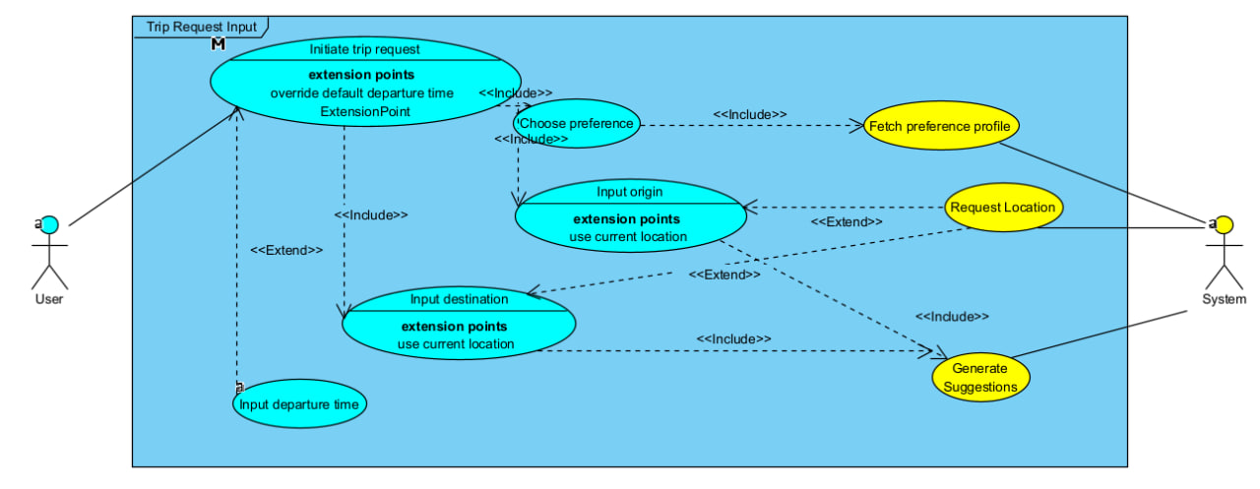
6.2.3 Route Generation
Use Case ID: | UC-13
Use Case Name: | Confirm Trip Request
Created By: | Huynh Thao Tuong Van | Last Updated By: | Huynh Thao Tuong Van
Date Created: | 11/2/2026 | Date Last Updated: | 11/2/2026

Actor: | User
Description: | Final step before route generation begins. The user reviews the trip summary (origin, destination, active preferences) and confirms everything looks right.
Preconditions: | All trip inputs have been entered and validated (UC-05 through UC-9)
Postconditions: | Trip request is confirmed and route generation is triggered
Priority: | High
Frequency of Use: | High
Flow of Events: | 1. System displays the complete trip request summary: origin, destination, and active preference profile.  2. User reviews the summary.  3. User confirms the trip request.  4. System triggers route generation (UC-23) using the confirmed inputs and active preferences.
Alternative Flows: | User can go back to edit any input before confirming.
Exceptions: | NIL
Includes: | NIL
Special Requirements: | NIL
Assumptions: | NIL
Notes and Issues: | NIL

Use Case ID: | UC-14
Use Case Name: | Refresh Routes
Created By: | Huynh Thao Tuong Van | Last Updated By: | Huynh Thao Tuong Van
Date Created: | 11/2/2026 | Date Last Updated: | 11/2/2026

Actor: | User
Description: | Allows the user to manually re-fetch transport data and regenerate routes before starting their trip, ensuring recommendations reflect the latest conditions.
Preconditions: | Routes have already been generated and displayed for the current trip
Postconditions: | Route recommendations are regenerated using the most recent transport data
Priority: | Medium
Frequency of Use: | Low to Medium
Flow of Events: | 1. User taps the refresh button on the route results screen.  2. System re-initiates transport condition assessment using the latest available data.  3. System regenerates and re-ranks route options (UC-23).  4. Updated routes replace the previous results on screen.
Alternative Flows: | NIL
Exceptions: | NIL
Includes: | UC-23 Generate Routes
Special Requirements: | NIL
Assumptions: | NIL
Notes and Issues: | NIL

Use Case ID: | UC-15
Use Case Name: | Collect Data
Created By: | Huynh Thao Tuong Van | Last Updated By: | Huynh Thao Tuong Van
Date Created: | 11/2/2026 | Date Last Updated: | 11/2/2026

Actor: | System
Description: | Gathers all the real-time transport data needed for risk assessment and route generation. Checks data freshness and triggers fallback handling if anything is stale.
Preconditions: | Trip request has been confirmed (UC-13) or a refresh was requested (UC-14)
Postconditions: | All required transport data is collected, timestamped, and flagged for freshness compliance
Priority: | High
Frequency of Use: | High
Flow of Events: | 1. System identifies which data sources are needed based on the active preference profile (e.g., MRT crowding, delay info, taxi availability, car park data).  2. System calls UC-16 to retrieve real-time data from external APIs.  3. System timestamps each data source upon retrieval.  4. System calls UC-17 to validate freshness of each source.  5. If any source fails freshness checks, system triggers fallback handling (UC-18).  6. System packages the collected data for use in scoring and route generation.
Alternative Flows: | NIL
Exceptions: | NIL
Includes: | UC-16 Retrieve Real-Time Data
Special Requirements: | NIL
Assumptions: | NIL
Notes and Issues: | NIL

Use Case ID: | UC-16
Use Case Name: | Retrieve Real-Time Data
Created By: | Huynh Thao Tuong Van | Last Updated By: | Huynh Thao Tuong Van
Date Created: | 11/2/2026 | Date Last Updated: | 11/2/2026

Actor: | API
Description: | Fetches live transport data from external sources: MRT crowdedness, service/delay status, taxi availability (if enabled), and car park availability (if Drive is enabled).
Preconditions: | Data collection has been initiated (UC-15)
Postconditions: | Raw real-time transport data is returned to the system with retrieval timestamps
Priority: | High
Frequency of Use: | High
Flow of Events: | 1. System sends requests to the relevant external transport data APIs.  2. API returns real-time MRT station crowdedness data.  3. API returns real-time MRT service and delay information.  4. If Taxi is enabled, API returns real-time taxi availability.  5. If Drive is enabled, API returns real-time car park availability.  6. Each response is timestamped and passed back to UC-15.
Alternative Flows: | NIL
Exceptions: | If an API is unreachable, system proceeds with whatever data is available and flags the gap.
Includes: | NIL
Special Requirements: | NIL
Assumptions: | NIL
Notes and Issues: | NIL

Use Case ID: | UC-17
Use Case Name: | Validate Data Freshness
Created By: | Huynh Thao Tuong Van | Last Updated By: | Huynh Thao Tuong Van
Date Created: | 11/2/2026 | Date Last Updated: | 11/2/2026

Actor: | System
Description: | Checks whether each retrieved data source is fresh enough to use. If a source's timestamp exceeds the allowed threshold, it gets flagged as outdated and routed to fallback handling.
Preconditions: | Real-time data has been retrieved and timestamped (UC-16)
Postconditions: | Each data source is classified as fresh or outdated; outdated sources are sent to fallback
Priority: | High
Frequency of Use: | High
Flow of Events: | 1. System compares each data source's retrieval timestamp against predefined freshness thresholds.  2. Sources within the threshold are marked as fresh and passed through for processing.  3. Sources exceeding the threshold are flagged as outdated.  4. Outdated sources trigger UC-18 (Apply Fallback Handling).
Alternative Flows: | NIL
Exceptions: | NIL
Includes: | NIL
Special Requirements: | NIL
Assumptions: | NIL
Notes and Issues: | NIL

Use Case ID: | UC-18
Use Case Name: | Apply Fallback Handling
Created By: | Huynh Thao Tuong Van | Last Updated By: | Huynh Thao Tuong Van
Date Created: | 11/2/2026 | Date Last Updated: | 11/2/2026

Actor: | System
Description: | Substitutes the most recent cached data when live data is unavailable or stale. Ensures no partial mixing of real-time and outdated data for the same transport mode.
Preconditions: | One or more data sources have been flagged as unavailable or outdated (UC-17)
Postconditions: | Fallback data is in place and affected elements are marked accordingly (UC-19)
Priority: | High
Frequency of Use: | Low to Medium
Flow of Events: | 1. System identifies which data sources need fallback substitution.  2. System retrieves the most recent available cached data for each affected source.  3. System ensures fallback is applied consistently per transport mode (no mixing of real-time and stale data within the same mode).  4. System calls UC-19 to mark all affected data elements as operating in fallback mode.  5. Fallback data is fed into scoring and route generation alongside any fresh data.
Alternative Flows: | NIL
Exceptions: | If no cached data is available at all for a source, the system proceeds without it and flags the gap.
Includes: | UC-19 Mark Fallback Handling
Special Requirements: | NIL
Assumptions: | NIL
Notes and Issues: | NIL

Use Case ID: | UC-19
Use Case Name: | Mark Fallback Handling
Created By: | Huynh Thao Tuong Van | Last Updated By: | Huynh Thao Tuong Van
Date Created: | 11/2/2026 | Date Last Updated: | 11/2/2026

Actor: | System
Description: | Tags data elements and route recommendations that were computed using fallback data, so downstream processes and the user can see which results may be less accurate.
Preconditions: | Fallback data has been applied (UC-18)
Postconditions: | All affected data elements and route outputs carry a fallback indicator
Priority: | Medium
Frequency of Use: | Low to Medium
Flow of Events: | 1. System identifies every data element that was derived from fallback rather than real-time data.  2. System attaches a fallback flag to each affected element.  3. Flags propagate through to route-level risk indicators and scoring outputs.  4. When routes are displayed (UC-26), fallback-affected routes include a reduced-accuracy notation.
Alternative Flows: | NIL
Exceptions: | NIL
Includes: | NIL
Special Requirements: | NIL
Assumptions: | NIL
Notes and Issues: | NIL

Use Case ID: | UC-20
Use Case Name: | Generate Scores
Created By: | Huynh Thao Tuong Van | Last Updated By: | Huynh Thao Tuong Van
Date Created: | 11/2/2026 | Date Last Updated: | 11/2/2026

Actor: | System
Description: | Computes composite scores for each candidate route by combining normalised route attributes with the user's preference weights. Lower score = better route.
Preconditions: | Routes have been generated (UC-23) with assigned attributes, and risk indicators are available from UC-21 and UC-22
Postconditions: | Each candidate route has a composite score ready for ranking
Priority: | High
Frequency of Use: | High
Flow of Events: | 1. System collects route attributes: estimated travel time, route-level delay risk, route-level crowding risk, and estimated cost, comfort value.  2. System converts risk categories to numeric values (Low=1, Medium=2, High=3, Unknown=2).  3. System applies min-max normalisation across all candidate routes for each attribute.  4. System retrieves the user's normalised preference weights.  5. System computes the composite score:  wT*T' + wRisk*R' + wComfort*F' + wCost*Co  (F' = normalised comfort (walking + transfers),  R' = normalised risk (delay + crowding combined).)  6. Scores are attached to each route and passed to UC-25 for ranking.
Alternative Flows: | If all routes share the same value for an attribute, the normalised value is set to 0.0 for all.
Exceptions: | NIL
Includes: | UC-21 Assess Crowding Risk, UC-22 Assess Delay Risk
Special Requirements: | NIL
Assumptions: | NIL
Notes and Issues: | NIL

Use Case ID: | UC-21
Use Case Name: | Assess Crowding Risk
Created By: | Huynh Thao Tuong Van | Last Updated By: | Huynh Thao Tuong Van
Date Created: | 11/2/2026 | Date Last Updated: | 11/2/2026

Actor: | System
Description: | Evaluates how crowded each public transport segment is likely to be, based on retrieved data. Each segment gets a Low, Medium, High, or Unknown crowding label.
Preconditions: | Transport data has been collected (UC-15) and routes have been generated (UC-23)
Postconditions: | Segment-level and route-level crowding risk indicators are assigned
Priority: | High
Frequency of Use: | High
Flow of Events: | 1. System identifies all public transport segments across candidate routes.  2. For each segment, system computes a crowding risk indicator from the retrieved transport data.  3. System categorises each segment as Low, Medium, High, or Unknown.  4. If crowding data is missing for a segment, it is marked Unknown.  5. System aggregates segment-level values to a route-level crowding risk using worst-case (max) rule: if any segment is Unknown, the route is Unknown; otherwise, the highest segment risk wins.  6. Route-level crowding risk is passed to UC-20 for scoring.  7. System also packages per-station, per-hour crowding data (6 AM–11 PM) as a heatmap dataset and passes it to the Scoring display (UC-26) for user reference.
Alternative Flows: | NIL
Exceptions: | NIL
Includes: | NIL
Special Requirements: | NIL
Assumptions: | NIL
Notes and Issues: | Per-station, per-hour crowding data (6 AM–11 PM) generated in step 7 is passed to the Scoring display (UC-26) for rendering as a crowding heatmap with a current-time marker.

Use Case ID: | UC-22
Use Case Name: | Assess Delay Risk
Created By: | Huynh Thao Tuong Van | Last Updated By: | Huynh Thao Tuong Van
Date Created: | 11/2/2026 | Date Last Updated: | 11/2/2026

Actor: | System
Description: | Evaluates the likelihood of delays on each public transport segment based on service status data. Each segment gets a Low, Medium, High, or Unknown delay label.
Preconditions: | Transport data has been collected (UC-15) and routes have been generated (UC-23)
Postconditions: | Segment-level and route-level delay risk indicators are assigned
Priority: | High
Frequency of Use: | High
Flow of Events: | 1. System identifies all public transport segments across candidate routes.  2. For each segment, system computes a delay risk indicator from the retrieved service/delay data.  3. System categorises each segment as Low, Medium, High, or Unknown.  4. If delay data is missing for a segment, it is marked Unknown.  5. System aggregates to route-level delay risk using worst-case (max) rule: if any segment is Unknown, the route is Unknown; otherwise, the highest segment risk wins.  6. Route-level delay risk is passed to UC-20 for scoring.
Alternative Flows: | NIL
Exceptions: | NIL
Includes: | NIL
Special Requirements: | NIL
Assumptions: | NIL
Notes and Issues: | NIL

Use Case ID: | UC-23
Use Case Name: | Generate Routes
Created By: | Huynh Thao Tuong Van | Last Updated By: | Huynh Thao Tuong Van
Date Created: | 11/2/2026 | Date Last Updated: | 11/2/2026

Actor: | System
Description: | Produces candidate route options from origin to destination using only the enabled transport modes. Applies all user constraints (walking, transfers, budget) and generates Hybrid Taxi combos if enabled.
Preconditions: | Trip request is confirmed (UC-13) and transport data is collected (UC-15)
Postconditions: | A set of feasible candidate routes is generated, each with assigned attributes
Priority: | High
Frequency of Use: | High
Flow of Events: | 1. System reads the active preference profile to determine which modes are enabled.  2. System generates MRT-only routes if that mode is enabled.  3. System generates MRT and Bus combined routes if that mode is enabled.  4. System generates Taxi-only routes if Taxi mode is enabled.  5. System generates Drive-only routes if Drive mode is enabled.  6. System filters out routes that violate walking tolerance, transfer tolerance, or budget constraints.  7. If no feasible routes remain, system relaxes constraints in a predefined order and notifies the user.  8. For each feasible route, system assigns: estimated travel time, number of transfers, estimated cost, and route-level risk indicators.  9. Candidate routes are passed to UC-25 for ranking.
Alternative Flows: | If exactly one feasible route exists, it is presented alone with a notice. If zero feasible routes exist, a descriptive message is shown with suggestions to adjust constraints.
Exceptions: | NIL
Includes: | UC-24 Generate Route Explanation, UC-25 Rank Routes
Special Requirements: | NIL
Assumptions: | NIL
Notes and Issues: | NIL

Use Case ID: | UC-24
Use Case Name: | Generate Route Explanation
Created By: | Huynh Thao Tuong Van | Last Updated By: | Huynh Thao Tuong Van
Date Created: | 11/2/2026 | Date Last Updated: | 11/2/2026

Actor: | System
Description: | Creates a short, human-readable one-liner for each route explaining why it was ranked where it is, referencing the user's top priority and the route's risk levels.
Preconditions: | Routes have been scored and ranked (UC-20, UC-25)
Postconditions: | Each route has a brief explanation attached for display
Priority: | Medium
Frequency of Use: | High
Flow of Events: | 1. System identifies the user's highest-weighted preference criterion.  2. For each route, system summarises how it performs on that top criterion.  3. System appends the route-level delay and crowding risk categories.  4. If any risk indicator used fallback data, a reduced-accuracy note is appended.  5. The explanation is attached to the route for display in UC-26.
Alternative Flows: | NIL
Exceptions: | NIL
Includes: | NIL
Special Requirements: | NIL
Assumptions: | NIL
Notes and Issues: | NIL

Use Case ID: | UC-25
Use Case Name: | Rank Routes
Created By: | Huynh Thao Tuong Van | Last Updated By: | Huynh Thao Tuong Van
Date Created: | 11/2/2026 | Date Last Updated: | 11/2/2026

Actor: | System
Description: | Sorts all candidate routes from best to worst based on their composite scores. Uses a multi-level tie-breaker when scores are equal.
Preconditions: | Composite scores have been computed for all candidate routes (UC-20)
Postconditions: | Routes are ordered by rank; top 2–3 are selected for display
Priority: | High
Frequency of Use: | High
Flow of Events: | 1. System sorts all candidate routes in ascending order of composite score (lowest = best).  2. If two or more routes tie on composite score, system breaks ties in order: lower delay risk, lower crowding risk, fewer transfers, shorter travel time, lower cost.  3. System selects the top 2–3 distinct routes for presentation.  4. Each selected route must represent a meaningfully different travel alternative (different modes, paths, or transfer points).  5. Ranked routes are passed to UC-26 for display.
Alternative Flows: | NIL
Exceptions: | NIL
Includes: | UC-26 Display Routes
Special Requirements: | NIL
Assumptions: | NIL
Notes and Issues: | NIL

Use Case ID: | UC-26
Use Case Name: | Display Routes
Created By: | Huynh Thao Tuong Van | Last Updated By: | Huynh Thao Tuong Van
Date Created: | 11/2/2026 | Date Last Updated: | 11/2/2026

Actor: | System
Description: | Presents the final ranked route options to the user, complete with travel times, costs, risk levels, explanations, any fallback-accuracy warnings, and a per-station crowding heatmap (6 AM–11 PM) on the Scoring tab for public transit routes.
Preconditions: | Routes have been ranked (UC-25) and explanations generated (UC-24)
Postconditions: | The user can see and compare the recommended route options
Priority: | High
Frequency of Use: | High
Flow of Events: | 1. System displays 2–3 ranked route options (or 1 if only one is feasible).  2. Each route shows: estimated travel time, number of transfers, estimated cost, route-level delay risk, and route-level crowding risk.  3. Each route includes its one-line explanation from UC-24.  4. Routes using fallback data display a reduced-accuracy notation.  5. On the Scoring tab, system renders a per-station MRT crowding heatmap (6 AM–11 PM) sourced from UC-21 step 7, with a marker at the current time.  6. If no routes were found, system shows a message explaining why and suggests the user adjust constraints or preferences.
Alternative Flows: | NIL
Exceptions: | NIL
Includes: | UC-24 Generate Route Explanation
Special Requirements: | NIL
Assumptions: | NIL
Notes and Issues: | NIL

Settings Page
Use Case ID: | UC-27
Use Case Name: | Change Settings
Created By: | Huynh Thao Tuong Van | Last Updated By: | Huynh Thao Tuong Van
Date Created: | 11/2/2026 | Date Last Updated: | 11/2/2026

Actor: | User
Description: | Lets the user update app-level settings such as display language, unit format, and their default preference profile. Changes take effect once saved.
Preconditions: | User is logged in and navigates to the Settings screen
Postconditions: | Modified settings are validated and ready to be saved (UC-28)
Priority: | Medium
Frequency of Use: | Low
Flow of Events: | 1. User opens the Settings screen.  2. System displays current settings: language, unit format, and a link to the saved preference profile.  3. User modifies one or more settings.  4. If the user edits the default preference profile, system opens the profile editor (UC-03).  5. System validates all changes.  6. If changes are valid, system triggers UC-28 to save them.
Alternative Flows: | NIL
Exceptions: | NIL
Includes: | NIL
Special Requirements: | NIL
Assumptions: | NIL
Notes and Issues: | User can also reset all settings to default values from this screen.\

Use Case ID: | UC-28
Use Case Name: | Save Settings
Created By: | Huynh Thao Tuong Van | Last Updated By: | Huynh Thao Tuong Van
Date Created: | 11/2/2026 | Date Last Updated: | 11/2/2026

Actor: | System
Description: | Persists the user's updated app settings (language, units, preferences) so they carry over to future sessions.
Preconditions: | Settings have been changed and validated (UC-27)
Postconditions: | Updated settings are saved and applied to the current and future sessions
Priority: | Medium
Frequency of Use: | Low
Flow of Events: | 1. System receives validated settings from UC-27.  2. System writes the updated settings to persistent storage.  3. System applies the new settings immediately (e.g., language change refreshes all UI labels).  4. System confirms the save to the user.
Alternative Flows: | NIL
Exceptions: | NIL
Includes: | NIL
Special Requirements: | NIL
Assumptions: | NIL
Notes and Issues: | NIL

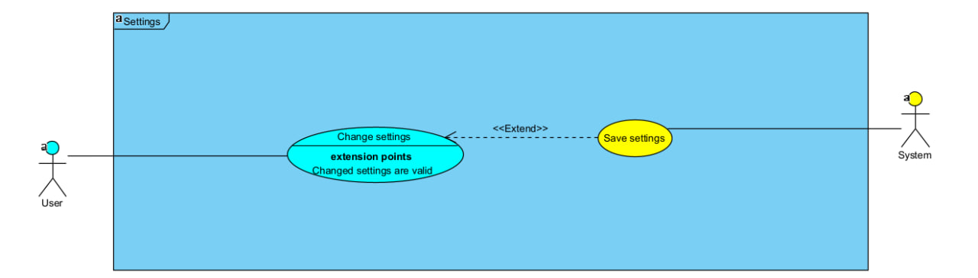

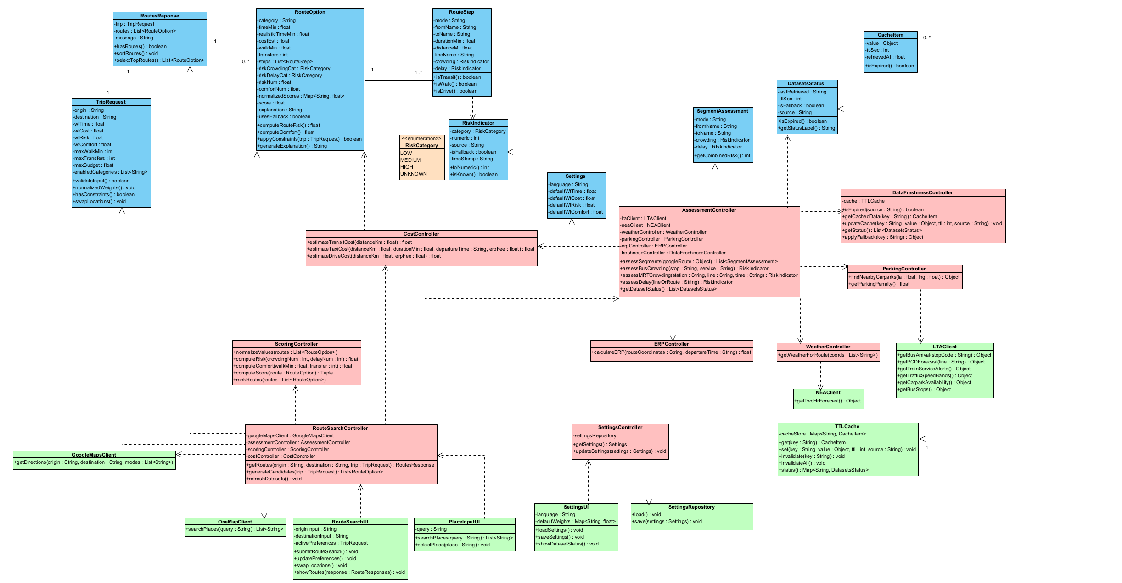Class Diagram

Key Boundary Classes and Control Classes

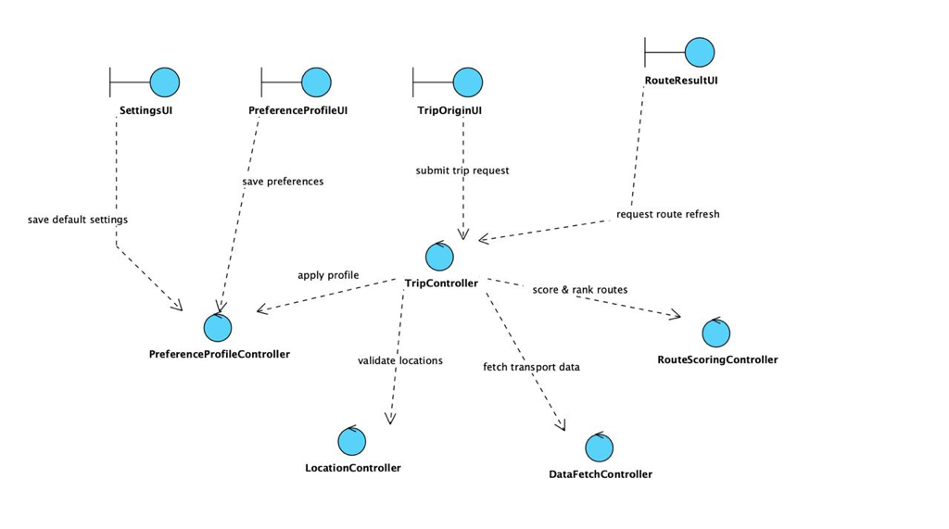

Dialog Maps

User Preference Profile
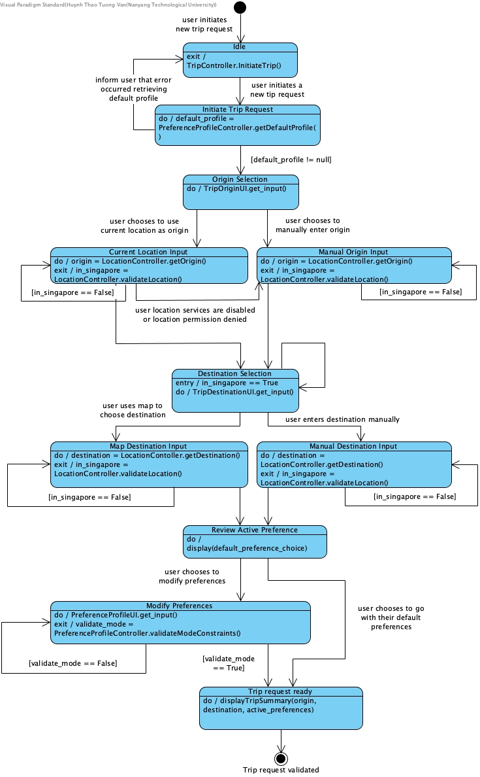

Trip Request Input


Assess Transport Conditions and Generate Risk Score
* in Initiate Route Generation, remove departureTime.
* remove all hybrid taxi logic:
- delete the guard activeProfile.hybridTaxiEnabled == true/false
- delete Generate Hybrid Taxi Routes
- delete any hybrid-taxi-specific branching inside transport mode generation
*in Assing route attribute may include estimated travel cost, walking requirement and route level risk indicator

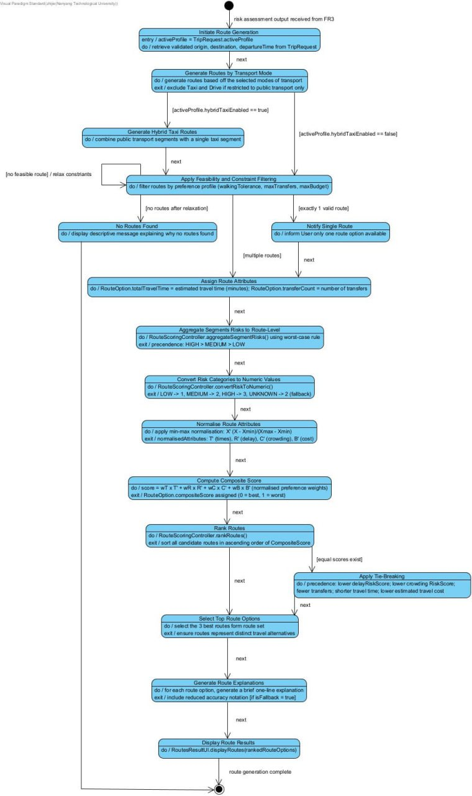

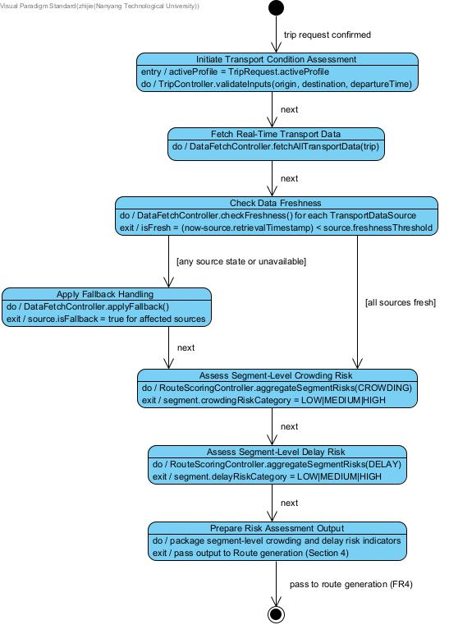Route Generation and Ranking
* In Initiate Transport Condition Assessment: remove departure time
* In assess crowding and delay risk: add Unknown to both risk-category outputs
* typo error under check data fressness: any source state or unavailable (state -> stale)

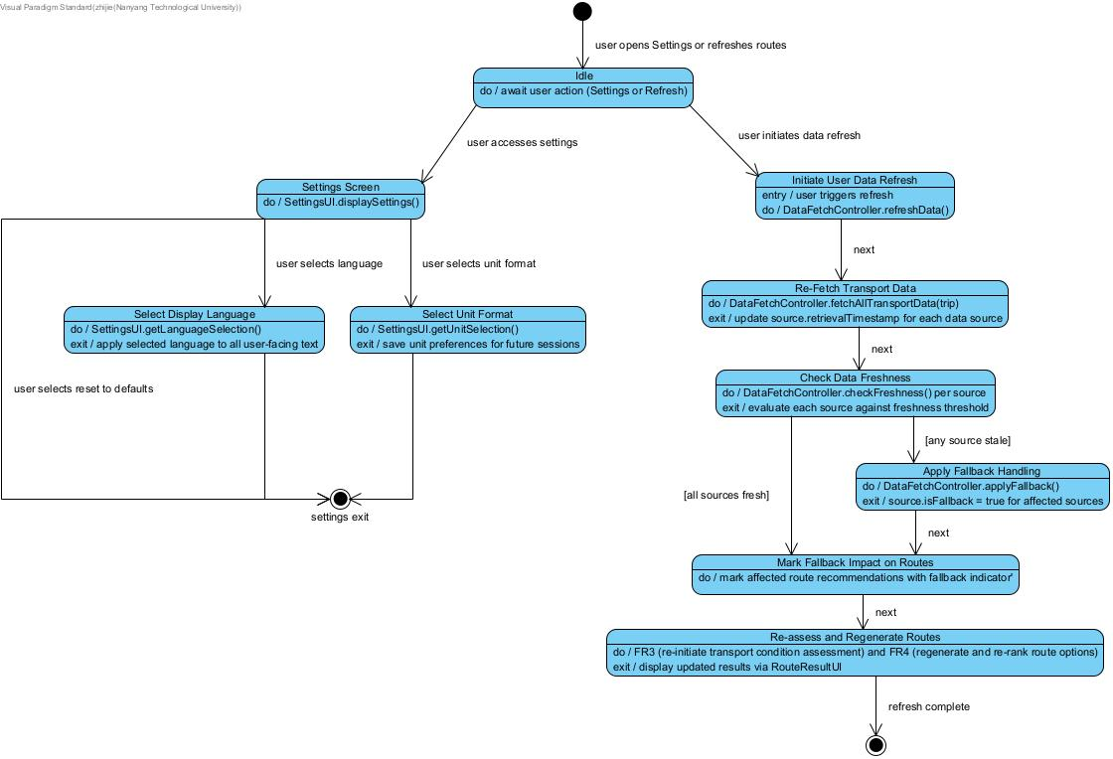Data Freshness, Fallback & Settings

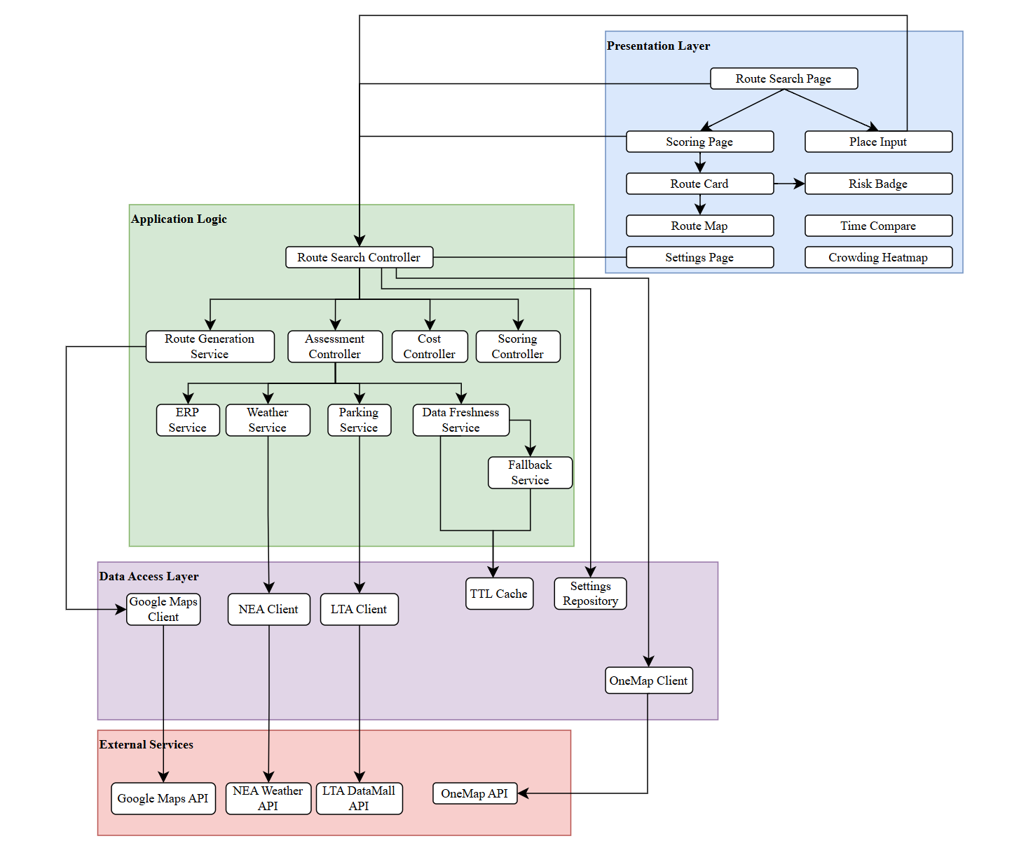System Architecture

Appendix C: Test Cases

Workflow 1: Public Transit Search — Full Journey
Estimated Time | ~3 min
Goal | Demonstrate the core user journey: search for a public transit route, explore results, inspect scoring, compare departure times, and view the route on the map.
Test Cases Covered | TC1, TC4, TC5, TC6, TC7, TC8, TC9, TC10, TC11, TC12, TC13, TC14, TC16, TC18, TC22, TC35, TC36, TC40

Step | Action (What to Do) | Narration (What to Say) | Expected Result / Verify
1 | Open the app. Show the Home screen with the empty search form. | This is SGTravelBud — a smart transport routing app for Singapore. | Map is visible. Search fields are empty. Search button is disabled.
2 | Type "Clem" in the Origin field. Wait for autocomplete dropdown to appear. Select "Clementi MRT Station". | We use Nominatim geocoding for place autocomplete — suggestions appear after 2 characters. | Autocomplete dropdown shows Singapore locations. Selection populates the field with coordinates.
3 | Try to type the same location "Clementi MRT" in Destination. Note the Search button stays disabled. | The app validates that origin and destination are different. | Search button remains disabled. (Covers TC5, TC6 — input validation.)
4 | Clear Destination. Enter "Raffles Place MRT" as the destination. Ensure Public Transit mode is selected. | Now we have a valid transit query — Clementi to Raffles Place. | Both fields filled. Search button becomes enabled.
5 | Tap the Swap button between origin and destination. | Quick swap — useful if you entered them the wrong way around. | Origin and Destination values are reversed. (Covers TC4.)
6 | Swap back. Expand the Advanced Priorities section. Show the 4 weight sliders (Time, Cost, Risk, Comfort) and the 3 constraint fields (Max Walk, Max Transfers, Max Budget). | Users can personalise how routes are ranked. Weights control the scoring formula; constraints hard-filter routes. | Sliders default to 0.25 each. Constraint fields are empty (no constraint).
7 | Set Max Transfers to 0. Tap Search. | Let's first try a strict constraint — zero transfers. | If no direct routes exist: "No routes found" message. (Covers TC10, TC7.) Otherwise, only direct routes shown.
8 | Remove the Max Transfers constraint (clear the field). Tap Search again with default weights. | Now searching with no constraints — we get the full ranked list. | Bottom sheet expands. 1–5 route cards appear with duration, cost, transfers, and crowding risk badges (Low/Medium/High). Map shows route polyline. (Covers TC1, TC22.)
9 | Navigate to the Results tab. Point out the route cards, risk legend, and the Compare Departure Times button. | Each card shows a composite score. Risk badges use real-time LTA crowding and delay data. | Route cards are listed in score order. Risk legend shows Low (green), Medium (amber), High (red).
10 | Tap Compare Departure Times. | This compares routes across 9 time slots — Morning Rush, Around Now, and Evening Rush — so you can see how departure time affects your journey. | Modal opens with 3 groups x 3 time slots. Cells show score, time, realistic time, cost, crowding. Best = green, worst = red. (Covers TC16.)
11 | Close the comparison modal. Select a route card. Tap View on Map. | Let's inspect this route on the map. | MapPage shows the selected route with polyline, start/end markers. Bottom panel: time, distance, cost, risk badges. (Covers TC12.)
12 | Use the Prev/Next arrows to cycle through routes on the map. | You can browse all routes directly on the map. Prev is disabled on route 1, Next on the last. | Map and info panel update for each route. "Route X of Y" counter updates. (Covers TC13.)
13 | Navigate to the Scoring tab. Scroll through the scoring breakdown. | The Scoring page shows how each route was ranked. We normalise metrics to 0–1, multiply by weights, and sum. Realistic time accounts for bus frequency delays. | Active weights displayed. Comparison table (best green, worst red). Per-route breakdown cards with normalised bars, weighted contributions, and formula. Realistic time >= Google time, highlighted amber if different. Crowding heatmaps per MRT station (6AM–11PM, with Now marker). (Covers TC14, TC18, TC35.)
14 | Go back to Home. Expand Advanced Priorities. Set Time = 1.0, Cost = 0.0, Risk = 0.0, Comfort = 0.0. Search again. | Watch how the ranking changes when we only care about speed. | The fastest route is now ranked #1. Order differs from the default-weight search. (Covers TC8.)
15 | Now add constraints: Max Walk = 5 min, Max Transfers = 1, Max Budget = $2.00. Search. | Constraints hard-filter: any route exceeding these limits is removed entirely. | Results only include routes satisfying ALL three constraints. Fewer routes returned. (Covers TC9, TC11, TC40.)

Workflow 2: Driving / Taxi Search — ERP, Parking, Weather
Estimated Time | ~3 min
Goal | Demonstrate driving and taxi mode with differentiation features: ERP toll calculation, carpark availability, and weather integration.
Test Cases Covered | TC2, TC3, TC32, TC33, TC34

Step | Action (What to Do) | Narration (What to Say) | Expected Result / Verify
1 | On the Home screen, enter Origin = "NUS" and Destination = "Changi Airport". | A cross-island trip — good for showing driving features. | Fields populated. Search button enabled.
2 | Toggle mode to Taxi/Drive only (deselect Public Transit). | Now we're searching exclusively for driving and taxi routes. | Only the Taxi/Drive toggle is active.
3 | Tap Search. | The backend calls Google Maps for driving directions, then enriches them with ERP gantry detection, carpark availability, and weather data. | Results show route cards categorised as "Taxi" or "Drive". Cost reflects taxi fare estimate or fuel cost. No transfer count shown. (Covers TC2.)
4 | Select a driving route. Check the route explanation text for ERP mentions. | The app detects ERP gantries along the route polyline and adds toll charges to the cost. This uses the CTE and other expressway gantry data. | If the route passes ERP gantries during peak hours, the cost includes toll charges and the explanation mentions ERP. (Covers TC32.)
5 | Check the route details for carpark availability near the destination. | For driving routes, we query LTA for nearby HDB/URA carparks and show available lot counts. | Carpark availability data appears in the route response with lot counts. (Covers TC34.)
6 | Check the route explanation or assessment for weather information. | We pull the NEA 2-hour weather forecast and factor adverse weather into the risk assessment. | If rain or thunderstorms are forecast, the route explanation or risk reflects this. (Covers TC33.)
7 | Now enable BOTH modes (Public Transit + Taxi/Drive). Search again. | With both modes on, you get a mixed comparison — transit vs driving vs taxi side by side. | Results include a mix of transit, taxi, and drive routes, up to 5 total. Categories labelled correctly. (Covers TC3.)
8 | Navigate to the Scoring tab. Compare transit vs driving route scores. | The scoring system works across all modes — normalised metrics let you compare apples to oranges. | Comparison table shows all route types. Scoring formula applies consistently across modes.

Workflow 3: Settings, Data Freshness, and Fallback
Estimated Time | ~2 min
Goal | Demonstrate user settings management, live data source monitoring, cache refresh, and fallback resilience.
Test Cases Covered | TC19, TC20, TC21, TC28, TC29, TC31, TC37

Step | Action (What to Do) | Narration (What to Say) | Expected Result / Verify
1 | Use the bottom navigation to switch between all 4 tabs: Home, Results, Scoring, Settings. | The bottom nav provides quick access to all sections. State is preserved across tabs. | Each tab loads correctly. Active tab is highlighted. (Covers TC37.)
2 | Navigate to the Settings tab. Show the current settings: language, units, and default weights. | User preferences are persisted on the backend as a JSON file. | Settings page loads with current values. Default weights shown as sliders. (Covers TC19.)
3 | Change Language to "zh" (Chinese). Change Units to "imperial". Adjust the default Time weight to 0.8. Tap Save. | Settings are saved via PUT /settings and persist across sessions. | Green success toast appears. (Covers TC20.)
4 | Navigate away to Home, then back to Settings. | Let's verify persistence. | Settings still show zh, imperial, Time = 0.8. Values persisted. (Covers TC20.)
5 | Reset settings back to defaults (en, metric, all weights 0.25). Save. | Restoring defaults for the rest of the demo. | Success toast. Settings reset.
6 | Scroll down to the Data Sources section. Show the table of data sources with their Live/Fallback status. | This shows the real-time health of every external data source the app depends on — LTA bus arrivals, train crowding, traffic speed bands, carpark availability, and more. Each has a TTL-based cache. | Table lists all data sources. Each shows "Live" (green) or "Fallback" (amber) badge with last-retrieved timestamp. (Covers TC28.)
7 | Tap the Refresh button in the Data Sources section. | This invalidates all caches and re-fetches fresh data from every external API. If an API is down, the app falls back to the last known good data. | Sources reload. Live sources refresh timestamps. Any unavailable API shows "Fallback" badge. (Covers TC21, TC31.)

Appendix D: To Be Determined List
<Collect a numbered list of the TBD (to be determined) references that remain in the SRS so they can be tracked to closure.>

Source: http://www.frontiernet.net/~kwiegers/process_assets/srs_template.doc

