Multiple Sequence Alignment of Hemoglobin Beta
Task 2 : Bioinformatics Internship, CodeAlpha
Six species compared with Clustal Omega

1. Introduction
Multiple Sequence Alignment (MSA) is a method that lines up three or more related sequences on top of one another so that equivalent positions fall into the same column. This makes it easy to see which amino acids are shared across all the sequences (conserved positions) and which ones differ. Conserved positions usually mark parts of a protein that are essential to its structure or function, because they have been preserved through millions of years of evolution.
In this task, the beta subunit of hemoglobin the oxygen-carrying protein of red blood cells was compared across six animal species. Hemoglobin beta is a good example because its oxygen-binding role is critical to survival, so its functionally important regions are expected to be strongly conserved.

2. Objective
The objectives were:
- To collect hemoglobin beta protein sequences from at least five species of the same family.
- To align them using Clustal Omega.
- To identify conserved regions and functional motifs and interpret the results.

3. Materials and Methods
Six hemoglobin beta protein sequences were downloaded in FASTA format from the UniProt database. Their accession numbers were:
- Human (Homo sapiens) — P68871
- Mouse (Mus musculus) — P02088
- Cow (Bos taurus) — P02070
- Rabbit (Oryctolagus cuniculus) — P02057
- Horse (Equus caballus) — P02062
- Chicken (Gallus gallus) — P02112
The six sequences were combined into a single file and submitted to the Clustal Omega multiple sequence alignment tool on the EMBL-EBI web server (https://www.ebi.ac.uk/jdispatcher/msa/clustalo), using the protein setting and default parameters. The resulting alignment, conservation symbols, and percent-identity matrix were examined.

4. Results

4.1 Alignment and conserved regions
Clustal Omega aligned all six sequences over the full ~147-residue length of the protein. Beneath the alignment it marks conservation with symbols: an asterisk (*) means the column is identical in all six species, a colon (:) means strongly similar amino acids, and a period (.) means weakly similar. Long runs of asterisks appear throughout the alignment, showing that hemoglobin beta is highly conserved. The most striking fully conserved block is the stretch SELHCDKLHVDPENFRLL, which contains the histidine residue that holds the heme group in place.
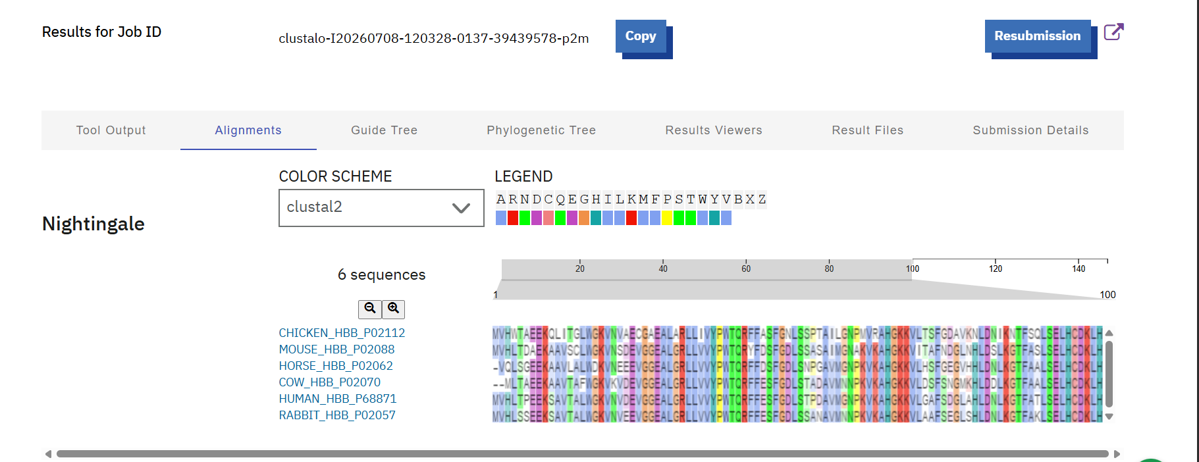

Figure 1. Clustal Omega colored alignment of hemoglobin beta from six species.

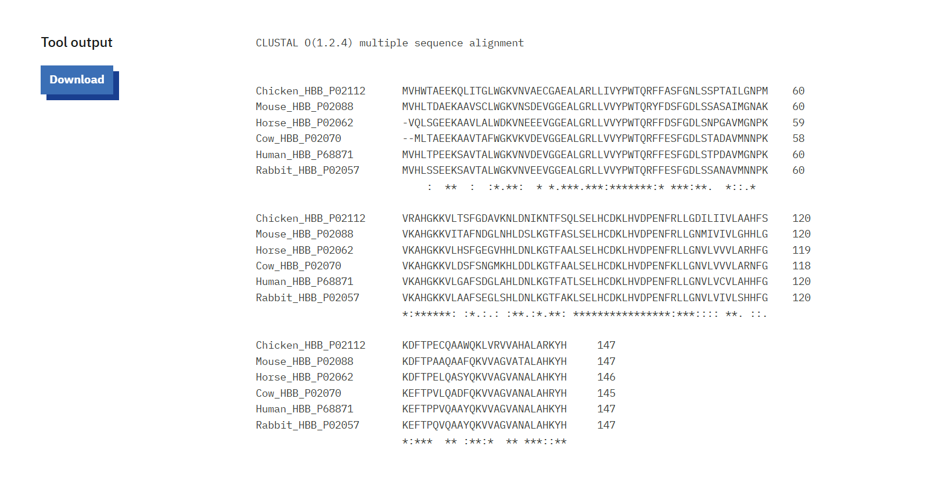

Figure 2. Alignment showing conservation symbols (* identical, : strongly similar, . weakly similar).

4.2 Key conserved motifs
The main fully conserved motifs and their roles are listed in Table 1. They correspond to the parts of the protein that build its structure and bind oxygen.
Conserved motif | Region | Functional role
GGEALGRLL | ~25–33 | Part of the helical scaffold that gives the protein its shape
VVYPWTQR | ~34–41 | Structural region near the heme (oxygen-binding) pocket
KAHGKKV | ~62–68 | Contains the distal histidine that sits over the oxygen-binding site
SELHCDKLHVDPENFRLL | ~90–107 | Most conserved block; contains the proximal histidine (His92) that anchors the heme iron
VAGVANALAHKYH | ~135–146 | Conserved C-terminal tail involved in assembling the hemoglobin tetramer
Table 1. Conserved motifs identified in the alignment and their functional roles.

4.3 Percent identity matrix
Clustal Omega also produced a percent-identity matrix, showing how similar each pair of sequences is. The values (rounded to one decimal) are given in Table 2.
Species | Chick | Mouse | Horse | Cow | Human | Rabbit
Chicken | 100 | 65.3 | 67.8 | 63.5 | 69.4 | 67.4
Mouse | 65.3 | 100 | 76.0 | 73.8 | 80.3 | 79.6
Horse | 67.8 | 76.0 | 100 | 81.4 | 83.6 | 83.6
Cow | 63.5 | 73.8 | 81.4 | 100 | 84.1 | 82.1
Human | 69.4 | 80.3 | 83.6 | 84.1 | 100 | 90.5
Rabbit | 67.4 | 79.6 | 83.6 | 82.1 | 90.5 | 100
Table 2. Percent identity between the six hemoglobin beta sequences.
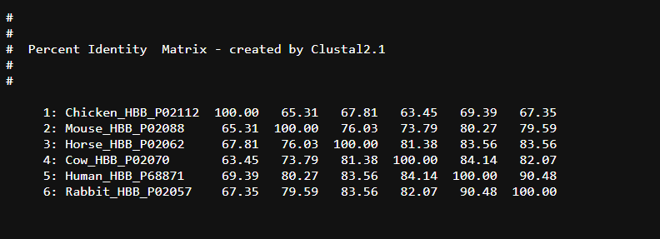

Figure 3. Percent identity matrix produced by Clustal Omega.

5. Interpretation
Two clear patterns emerge. First, the alignment contains many fully conserved columns, especially around the oxygen-binding site. The conserved histidines and the SELHCDKLHVDPENFRLL block are exactly the residues needed to hold the heme group and bind oxygen, so it makes sense that evolution has preserved them unchanged across all six species.
Second, the percent identity matrix reflects evolutionary relationships. The five mammals share high identity with one another (roughly 74–90%), while the chicken the only bird in the set is the most different, sharing only about 63–69% identity with the mammals. This is expected: the chicken diverged from the mammalian lineage much earlier, so more differences have accumulated in the less critical, surface regions of the protein. The highest similarity is between human and rabbit (90.5%), indicating they are the most closely related pair in this group.

6. Conclusion
The multiple sequence alignment of hemoglobin beta from six species showed strong conservation of the functionally important regions, particularly the heme-binding site, while surface positions varied. The percent identity matrix matched known evolutionary relationships, with mammals grouping together and the chicken being the most divergent. The task met its objective of aligning several sequences of the same family, identifying conserved motifs, and interpreting the biological meaning of the results.

7. References
- UniProt Consortium. UniProt: the universal protein knowledgebase. https://www.uniprot.org
- Sievers, F., et al. (2011). Fast, scalable generation of high-quality protein multiple sequence alignments using Clustal Omega. Molecular Systems Biology, 7, 539.
- EMBL-EBI Clustal Omega web server. https://www.ebi.ac.uk/jdispatcher/msa/clustalo

