CIQ-Linked Demand-Driven Multi-Node UAV Logistics Network
GIS Screening and Experimental Protocol — V3.0
Johor Bahru | Causeway (A) and Second Link (B) | October 2026 | Target journal: Sustainability
Research status: evidence-based planning and straight-line network screening; NOT an operating approval, flight-ready 3D route design, verified order-density map, or carbon-emission result.

1 Executive decision and scope
Adopt two Johor Bahru-side networks: A (Causeway) is a dense retail-to-community fixed multi-hub network; B (Second Link) is a regional road-feeder plus approved truck–UAV transfer and village/mixed-use delivery network. Goods cross the national border by ground through CIQ in the S1 base case. Shared D2 local delivery (GrabFood-like orders) is a separate scenario, not evidence that such orders are cross-border freight.
The objective is not to maximize the number of FCD points covered by 4 km circles. It is to maximize feasible parcel service, time reliability and net emissions reductions subject to actual land, aircraft, airspace, weather and logistics constraints. All site coordinates in the current package represent public place centres or study search centroids, not surveyed pads.

2 Audited input data and strict evidence classes
Evidence layer | Currently established | Not yet established
Traffic | 345 formal virtual-FCD positions, G1–G5 labels; hourly May–Sep 2026 summaries | Full directed road edge travel-time calibration, order/vehicle paths
Location | 19 POI/search points with source links; 2 are CIQ context only | Exact buildable parcels/rooftops and owners
Spatial | 64 within-area point pairs, 25 at ≤3 km, 7 at 3–4 km, 32 at >4 km | Approved air corridors, 3D obstacle-clear flight lengths
Demand | Retail, community, transport, logistics place types | Actual household population/occupancy, merchant daily orders
Climate | 2026 May–Sep traffic matches intended climate window | Per-site hourly wind, gust, thunderstorm and calibrated operational thresholds
Data provenance: user-supplied frozen registry (Node_Registry_345_Grouped.csv) and two formal road-group freeze tables; geocoded site centres from public coordinate references listed row-by-row in the Excel Location_Anchors sheet. September speed non-missing completeness is not proof of 100% sensor reliability. No speed interpolation was performed for this site-screening step.

3 Geometry-first 3/4 km multi-node screening
For every within-area pair i,j, calculate WGS84 ellipsoidal geodesic distance d(i,j). Label ≤3 km, 3–4 km or >4 km. Exclude CIQ buildings from the direct-air adjacency inventory; CIQs remain ground-only transport-chain context points. Distances are straight-line lower bounds, not confirmed flight lengths or regulatory service areas.
Network | Anchors (includes CIQ) | All geometric pairs (excl. CIQ) | Distance ≤4 km | Distance >4 km
A: Causeway | 9 | 28 | 24 | 4
B: Second Link | 10 | 36 | 8 | 28
Combined | 19 | 64 | 32 | 32
The 32 geometric candidate edges are not 32 feasible or authorized routes. Official airspace, overflight risk, land access, aircraft weight and energy, recovery strategy, gust/thunderstorm avoidance and recharging must all be cleared before treating a link as usable.

4 Network A — Causeway commercial core and community delivery
Potential commercial source zones: Johor Bahru City Square, KOMTAR JBCC, KSL City and Larkin Sentral surrounding districts. Potential demand/receiving zones: Pelangi Plaza, R&F Princess Cove residential area, Kampung Nong Chik. JB Sentral is a ground interchange reference only. Source and receiver roles are hypotheses for testing, not committed facilities.
Example geometric adjacency: City Square–KOMTAR 0.318 km; KOMTAR–KSL 2.398 km; KSL–Pelangi 0.663 km; KSL–Larkin 2.474 km; KSL–Kampung Nong Chik 3.130 km. These links are not safe route recommendations. The short distances demonstrate why a multi-node strategy merits examination but can also be misleading if CIQ/security/prohibited airspace removes central links.

5 Network B — Second Link truck–UAV feeder and dispersed communities
B-T1 and B-T2 are study search centroids only (not actual land parcels). Local demand anchors include Kampung Ladang, Kampung Tanjung Kupang, Kampung Pendas Baru and Medini. Eco Botanic and Port of Tanjung Pelepas are distant commercial/freight source contexts and may need a conventional road leg or an intermediate authorized facility. Do not position UAV pads inside CIQ or on expressway shoulders.
Example geometric adjacency: B-T1–B-T2 2.458 km; B-T2–Kampung Pendas Baru 2.273 km; Kampung Ladang–Kampung Pendas Baru 2.020 km; B-T1–Medini 3.948 km. Crucially, a >4 km pair is not to be drawn as a one-hop route under the present radius constraint.

6 GIS analysis workflow and equations
Step G1: Register every candidate place with named geometry, site-type and URL, distinguish POI centroid from exact parcel. Step G2: Link traffic-only FCD nodes to relevant roads and calculate observation support around candidates. Step G3: Map actual sales/residential POIs and verifiable demand distribution. Step G4: Apply approved airspace polygons, altitude limits, ground risk, buildings and property authorization as hard constraints. Step G5: Generate flyable edge set E_air(R,u,w) for aircraft u and weather scenario w. Step G6: Generate directed road network E_road(t) with observed traffic at hour t. Step G7: assign orders to ground-only or combined dispatch using an explicit shared-cost objective.
Distance selection: d_ij(geodesic) ≤ R (R=3 or 4 km) is ONLY the first geometry filter. Actual flight service additionally requires flight energy E_mission(i,j, payload, gust, altitude, return/recovery) ≤ usable battery energy and all hard constraints. Required door-to-door time includes pickup/packing, transfer, flight, receiver handoff, customer locker walking, ground fallback and CIQ truck clearance where applicable.
Do not compute a traffic path from one sensor speed. Calculate ground travel T_road(p,t)=Σ_e L_e / v_e(t), where edge lengths, directions and temporal speeds have been validated. Likewise, FCD counts within 3/4 km indicate traffic data support, NOT population coverage or delivered order counts.

7 Demand classes, mode comparison and outcome metrics
Factor | Level(s) | Scientific treatment
Demand | D1: CIQ-related eligible parcels; D2: domestic instant grocery/food | Primary D1-only, then D1+D2 shared-network scenario; no ungrounded real order counts
Geography | A Causeway and B Second Link | Test both modes in both locations to separate place from mode effects
Mode | S0 ground; S1 fixed multi-hub; S2 truck–drone; S3 adaptive | Identical OD and observation hours, with fallback costs included
Radius / aircraft | 3 and 4 km; M2, M3 and FlyCart 30 | Compare matched light loads; separate heterogeneous heavier-order scenarios
Weather | Observed rainfall, wind and thunderstorm; grounded aircraft thresholds | Replay traffic and weather at the SAME hour; no rain speed penalty twice
Outcomes | Time, on-time rate, coverage, walking, vehicle-km, electricity, RM, kg CO2e | Confidence intervals and poor-weather sensitivity plus null-effect cases

8 Regulatory and spatial gating; no presumption of permit
Malaysia CAAM treats carriage of articles and BVLOS projects as Special UAS Project / specific operations subject to approval. The Malaysia AIP (ENR 5.1) contains permanent prohibited areas such as WMP228 Bukit Serene. This V3.0 map does not plot a final WMP228 polygon because exact current legal geometry and relevant chart/NOTAM must be reconciled before use. Regulatory denial or unknown status should block an operational route, not be treated as a soft penalty that the optimizer can pay to ignore.
Authoritative URLs: https://www.caam.gov.my/public/unmanned-aircraft-system-uas/ ; https://aip.caam.gov.my/aip/eAIP/2025-12-02/html/eAIP/WM-ENR-5.1-en-MS.html . Monsoon reference: https://www.met.gov.my/en/pendidikan/fenomena-cuaca/ .

9 Next-stage execution gates and deliverable acceptance
Priority | Work package | Acceptance condition
P0 | Land/airspace site feasibility | A list of exact legal parcels, CAAM checked polygons and written evidence of whether feasible
P0 | Logistics OD sampling and demand survey | Source-to-receiver order types, time windows, weights, observed/simulated labels
P0 | FCD road link matching | Directed OSM roads, mapped FCD representative speeds, sampled route time QA
P1 | Flight/landing operations & energy | Certified/defensible aircraft envelopes, building heights, reserve/return modeling
P1 | Hourly weather merged to traffic | Wind/gust/lightning/rainfall at each dispatch time with provenance
P2 | Optimization and counterfactual | Cross-area S0–S3 matched orders; sensitivity and paired clustered inference
P2 | Carbon accounting | Explicit fuel, electricity and additional handling with net fleet kilometer accounting
Decision rule: proceed to optimization only after P0 is completed. If no physically legal and safe sites or corridors remain in one area, preserve that negative result; do not invent extra facilities merely to force airborne connectivity.

10 Figure and artifacts
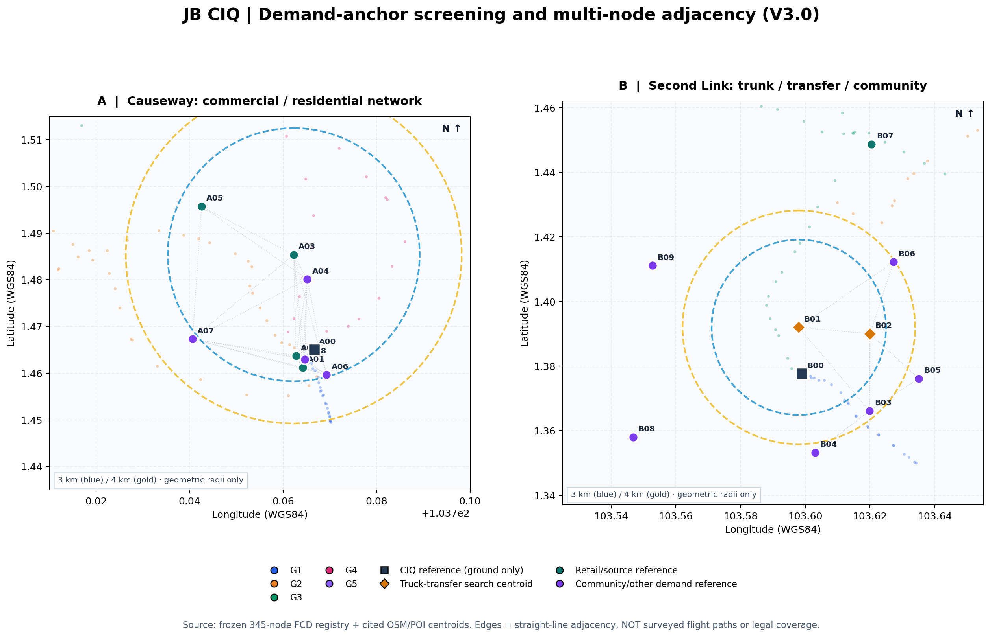
Figure 1. Evidence-graded geographic preliminary screening. Geographic positions and the frozen FCD points are data-linked; dashed 3 km and 4 km rings are theoretical straight-line service distances. Grey graph links are geometry-only candidates, NOT authorized routes. POIs are not exact landing pad coordinates.
Files supplied: editable site database (CSV/XLSX), 64 pairwise adjacency rows, 345 × 19 FCD proximity rows, GeoJSON nodes/geometry-only edges, interactive map, static publication draft image and reproduction script. The primary original 153-day raw FCD archive is intentionally not duplicated here.

