Updates to the proposal design
Our design has been completely changed from our initial proposal because after examining our initial proposal, the proposal was less a design than it was a research project. Our new design is now one of a wearable GPS camera (CMUcam) that logs images throughout the day. The images will be mapped through a software application by their date, time and location. In effect, GPS data will have been incorporated with the video life log idea allowing users to see their pictures both chronologically and geographically.
Since the conception of the idea, there have been numerous changes to our initial design. Most of these changes have occurred in the implementation of the software application as it was difficult to do testing on the hardware design without the camera itself. For our application, we were initially looking into running a Perl script that would create the website’s html. This website would include all the Google maps features and functions we would want implemented.
However, after looking a little more into what resources we had, we found an API for Picasa web albums. Through this, we have implemented many of the features we had first desired through a C# application that interacts directly with a user’s Picasa Web Albums account. The application uploads pictures and retrieves the user’s album information to and from their account. One difficulty presented by using this API is in changing how the map is presented. More work will be done on trying to make this possible and allow the user different ways of viewing their albums and locations.
Some other changes include added configuration settings, features, and different ways of sorting albums and directories. On the hardware side of things, one important change has been made. Initially from the specifications, it seemed as if the GPS chip could be powered directly by the CMUcam’s board. However, once we received the CMUcam, we found the voltage between the pins we needed to connect to the board to be too high (> 3.3 V). Therefore, we will now be using a voltage regulator.
Because our design is completely different, a new budget will be presented below. The design consists of a programmable camera called the CMUcam, a GPS chip, an antenna for the chip, and a SD card for storing the pictures taken by the camera.
New Budget
- Single Unit
  - CMUcam $ 239.00
  - Trimble Copernicus GPS Chip $ 74.95
  - Antenna $ 18.95
  - SD Memory Card ~ $ 15.00
  - Card Reader ~ $ 3.00
  - Enclosure ~ $ 10.00
  - 3.3 Volt Regulator ~ $ 1.00
  - Battery Pack ~ $ 5.00
  - Batteries ~ $ 10.00

- Total for 1 unit ~ $ 376.90
Accounting for extra costs that may come up, the total cost of our product will be around 400 dollars. This is within our goal of keeping the budget under 500 dollars. A large part of this cost comes from the purchase of the CMUcam itself and if bought in bulk, this price would most likely be much lower. For this reason, our product could probably be sold at the price of 400-500 dollars for a reasonable profit.

Preliminary results
Because we just received the CMUcam, we have been unable to test and refine the code written for the hardware aspect of our design. However, this has also caused us to focus much of our efforts toward the development of the software application.
The application’s process is shown below

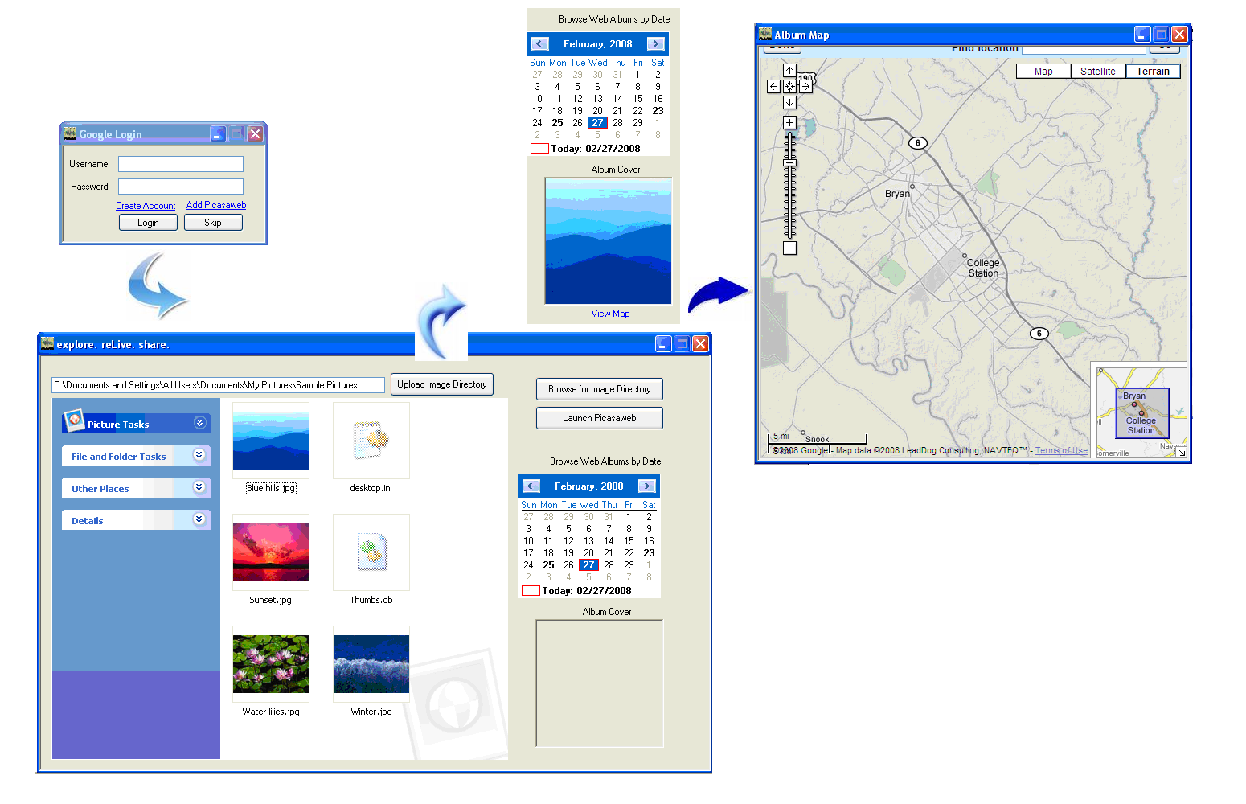
Current Application Process

The first step window that comes up is the Google Login window. This is where the user logs in to his Picasa Web Albums account. There are also options of creating an account, adding Picasaweb, and skipping the login stage. A user skipping the login stage may only desire to change configuration settings on his camera. However, he will not be able to access and browse his albums that have already been uploaded. The other two links merely link to the signup and Picasa web pages.
Once a user logs in, the main page of the application shows up. Currently, only the Picasa album interaction is implemented. The user will select a directory containing the images he wishes to upload. The default for this is the ‘my pictures/reLive’ directory or whatever directory our camera will be uploading into. The user can also browse his past albums by clicking on the bolded dates on the calendar. The album cover of those albums will be shown. Clicking view map will then popup the map of the photos with pictures showing up at their respective positions.

Updated division of labor and responsibilities
Terence Sin will work with Mario to complete the software application. This includes implementing the configuration settings, detecting the SD card/formatting it, and tagging the photos. Meanwhile, he will also be looking into features involving the face-detection capability of the camera and how those could be added to the project.

Updated implementation schedule
The updated schedule targets a completion date of all major features by the first week of April. In order to do this, there is a milestone of finishing major components of the software application by the third week of March, one week after spring break. Hardware components will take a little longer as we have just received the CMUcam. Once the product is completed, we will consider the implementation of additional features such as the Halo feature and different map views. We will also need to test and polish the project, catching all errors that might occur.
The software part of the schedule includes the tagging of the photos, creating a configuration file for the CMUcam, detecting a SD card, and formatting the SD card. During the hardware process, much of the software application will also be tested and refined. The hardware part of the process has just started and a lot of work still needs to be done. This includes opening a serial connection, getting the GPRMC string from the GPS chip, parsing it, capturing images, storing them in the SD card by date, and implementing the facial detection algorithm.
The final part of the schedule is the integration of hardware and software. This will be done through the configuration file and the SD card. The configuration file will be generated by the software, stored on the SD card, and detected by the CMUcam through the SD card. Both software and hardware sides will automatically detect the SD card and read off of it. The configuration file read by the hardware and the directories of images read by the software.
Shown below is the updated Gantt chart for the schedule.

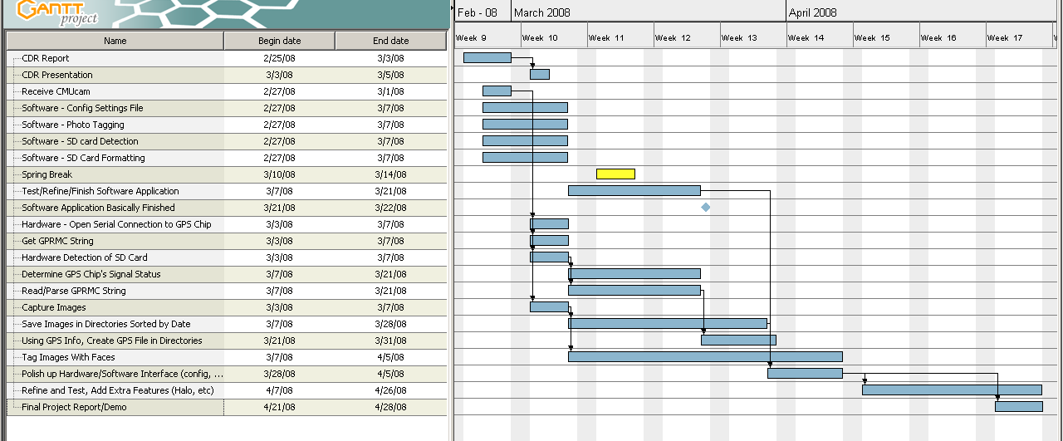
Updated Gantt Chart

