DATA ANALYTICS PROJECT REPORT
Customer Churn Analysis
An End-to-End Analysis of Retail Customer Purchase Patterns | Python • SQL Server • Power BI
3,900  Total Customers | $233,081  Total Revenue | $59.76  Avg. Purchase Value
3.75 / 5  Avg. Review Rating | 27.0%  Subscribed Customers | 2,339  Loyal Customers

1. Executive Summary
This report presents an end-to-end analysis of retail customer shopping behavior, built on a dataset of 3,900 transaction records spanning 18 attributes covering demographics, purchase details, and engagement signals. The project followed a complete analytics pipeline: data cleaning and feature engineering in Python, relational analysis using SQL Server, and interactive visualization through a Power BI dashboard, with the objective of uncovering actionable patterns in customer spending, product performance, loyalty, and channel preference.
Headline Findings
- Male customers generated $157,890 in revenue (67.8%) versus $75,191 (32.2%) from female customers, driven primarily by a larger male customer base (2,652 vs. 1,248).
- 60% of the customer base (2,339 of 3,900) qualifies as "Loyal" with more than 20 previous purchases, indicating a strongly retained core audience.
- Discounts and promo codes are applied together 100% of the time, confirming the two fields are functionally identical in this dataset.
- Express shipping customers spend $2.02 more per order on average than Standard shipping customers ($60.48 vs. $58.46).

2. Project Overview & Objectives
The project simulates a real-world retail analytics workflow, moving raw transactional data through cleaning, structured querying, and executive-level visualization. The guiding objectives were to clean and prepare the raw dataset, engineer new features (age groups, purchase frequency, customer segments), answer ten targeted business questions using SQL, and build an interactive Power BI dashboard for stakeholders.
Stage | Tool | Purpose
Data Cleaning & Feature Engineering | Python (Pandas) | Handle missing values, standardize columns, derive new features
Data Storage & Querying | SQL Server (T-SQL) | Structured querying, aggregation, business-question analysis
Database Connectivity | SQLAlchemy / pyodbc | Load cleaned Pandas DataFrame into SQL Server
Visualization | Power BI | Interactive dashboard for churn and retention insights

3. Dataset & Methodology
The raw dataset (customer_shopping_behavior_dataset.csv) contains 3,900 rows and 18 columns capturing customer demographics (Age, Gender), product details (Item Purchased, Category), purchase value, engagement signals (Review Rating, Subscription Status, Previous Purchases), and fulfillment attributes (Shipping Type, Discount Applied, Payment Method, Frequency of Purchases).
Key processing steps (Python):
- Missing values: 37 missing Review Rating entries imputed using the median rating within each product category.
- Standardization: column headers lower-cased and cleaned for SQL compatibility.
- Redundancy removal: Discount Applied and Promo Code Used were identical across all rows, so the duplicate field was dropped.
- Feature engineering: age_group (four quantile bins) and purchase_frequency_days (numeric mapping of purchase cadence) were derived for deeper analysis.
The cleaned data was loaded into SQL Server via SQLAlchemy, where ten T-SQL queries answered targeted business questions on revenue, discounting, product performance, shipping, and segmentation — summarized in Section 4. Query outputs then fed a Power BI dashboard for interactive, executive-level exploration (Section 5).

4. Key Findings
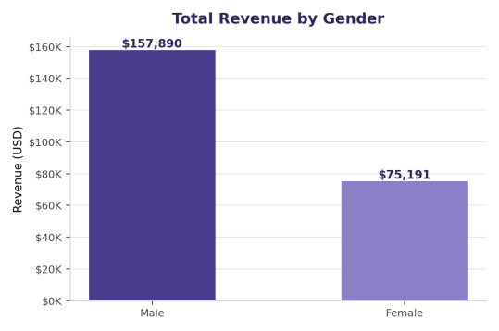  Fig 1. Revenue by gender. | 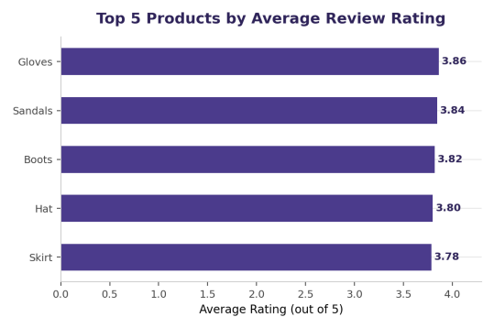  Fig 2. Top 5 products by rating.

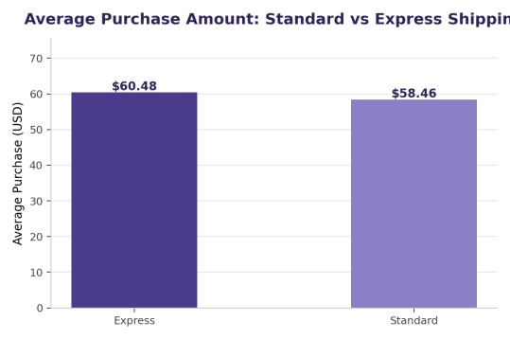  Fig 3. Standard vs. Express shipping spend. | 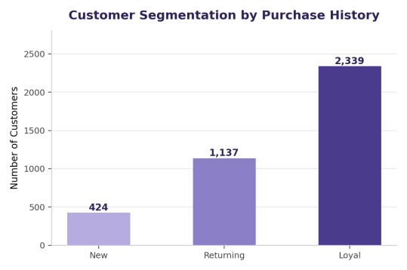  Fig 4. Customers by segment: New, Returning, Loyal.

- High-value discount shoppers: 839 customers used a discount while still spending above the dataset average of $59.76 — discounting doesn't necessarily cap order value.
- Subscription impact: subscribers spend $59.49 on average vs. $59.87 for non-subscribers — subscription status has no material effect on order value; non-subscribers drive more total revenue simply due to their larger share (73%).
- Repeat buyers vs. subscription: only 27.6% of repeat buyers (958 of 3,476) hold a subscription, nearly identical to the 22.4% rate among new/low-activity buyers — purchase history alone doesn't predict subscription uptake.
- Revenue by age group is evenly spread, ranging narrowly from 23.9% (Senior) to 26.7% (Young Adult) — the customer base is not concentrated in any one age bracket.
Top 3 Products per Category
Category | Top Products | Purchases
Accessories | Jewelry | 171
Accessories | Sunglasses / Belt (tied) | 161
Clothing | Blouse / Pants (tied) | 171
Clothing | Shirt | 169
Footwear | Sandals | 160
Footwear | Shoes | 150
Outerwear | Jacket | 163
Outerwear | Coat | 161

5. Power BI Dashboard
SQL query outputs were consolidated into an interactive "Customer Churn Analysis" dashboard, giving stakeholders self-service access to retention and spending patterns via slicers for Subscription Status, Gender, Category, and Shipping Type.
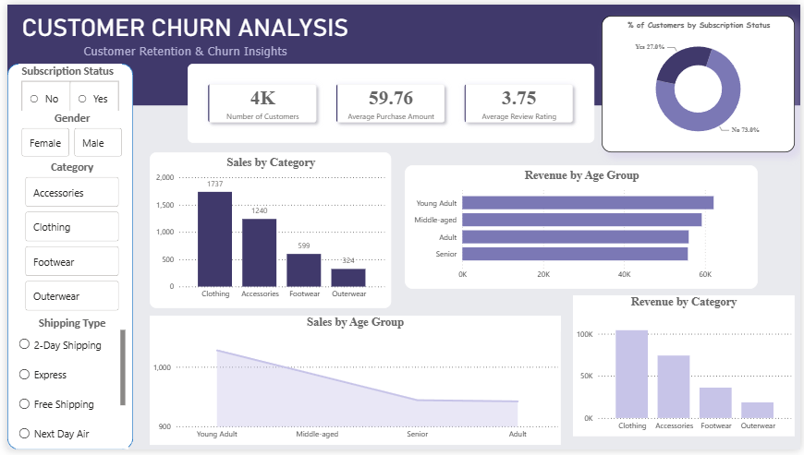
Figure 5. Customer Churn Analysis dashboard — built in Power BI from the SQL query outputs.
- KPI Cards — Number of Customers (4K), Average Purchase Amount ($59.76), Average Review Rating (3.75).
- Subscription Donut — 27.0% of customers are subscribed vs. 73.0% not subscribed.
- Sales by Category — Clothing leads with 1,737 purchases, followed by Accessories (1,240), Footwear (599), and Outerwear (324).
- Revenue by Age Group — horizontal bars confirming the near-even revenue split observed in the SQL analysis.

6. Key Insights & Recommendations
Insight 1 — Male-Skewed Revenue Base
Male customers make up 68% of the base and generate 68% of revenue, suggesting an opportunity to grow the female segment through targeted campaigns rather than relying on further male acquisition.

Insight 2 — Subscriptions Are Underleveraged
Subscribers spend no more per order than non-subscribers, and purchase history does not predict subscription uptake. The program should be repositioned with clearer value (e.g., free shipping, early access) to drive adoption and spend.

Insight 3 — Strong Loyal Base, Thin Acquisition Funnel
60% of customers are already "Loyal" (20+ purchases) but only 11% are "New." Retention is clearly working; the priority should shift toward top-of-funnel acquisition to sustain long-term growth.

Insight 4 — Express Shipping Commands Higher Baskets
Express shipping customers spend ~3.4% more per order. Promoting express shipping thresholds (e.g., free express above a basket value) could lift average order value.

7. Conclusion
This project demonstrates a complete analytics workflow — from raw data cleaning and feature engineering in Python, through structured business-question analysis in SQL Server, to an executive-ready Power BI dashboard. The resulting insights point to a mature, loyalty-driven customer base with an underperforming subscription channel and a revenue mix skewed toward male shoppers, providing a clear, data-backed foundation for retention, acquisition, and subscription-strategy decisions.
Limitations & Future Work
- The dataset is a single-period snapshot; a time-series extension would allow trend and cohort-level churn analysis rather than a point-in-time view.
- Discount Applied and Promo Code Used being fully collinear limits independent analysis of promotional effectiveness — future data collection should decouple the two fields.
- Next steps include a predictive churn model (logistic regression / gradient boosting) built on the engineered features, and A/B testing of the proposed subscription repositioning.
Supporting files: Customer_Shopping_Behavior_Analysis.ipynb (Python EDA & cleaning), customer_shopping_queries.sql (SQL analysis), and the Power BI dashboard file.

