Data for Decision-Making Training
Annotated Instructor Guide

Module 5: Putting it all Together
Total expected time: 3 hours

Student Objectives:
- Review key concepts of data for decision-making and the data life cycle
- Apply visualization techniques in order to “story tell” with data
- Understand the importance of data for decision-making by applying the process to problems in their organization
- Think critically about ways to use data to solve these problems
- Practice data sharing by presenting these findings to other workshop participants

Materials:
- Projector
- Computer
- Blackboard/whiteboard (ideally)
- Paper
- Pencils
- Printout of images used
- Activity packet 5.1
- Activity packet 5.2 (Final Project)

Time | Action | Instructor Notes
10 minutes | Welcome and administrative tasks | Welcome the participants back. Spend a few moments going over any administrative tasks if necessary. Then, outline the structure of today. In the first half of the day, participants will be reviewing the concepts they have learned over the past two days, and will apply these concepts to a data project in order to solve a problem at their own organization using the new skills that they learned. Then, after lunch, the participants will use the remaining time to finish their projects and then present them.  Pause to answer any questions.
15 minutes | Review key concepts | Next, take a few moments to review the following key concepts from yesterday. Project this image on the screen:  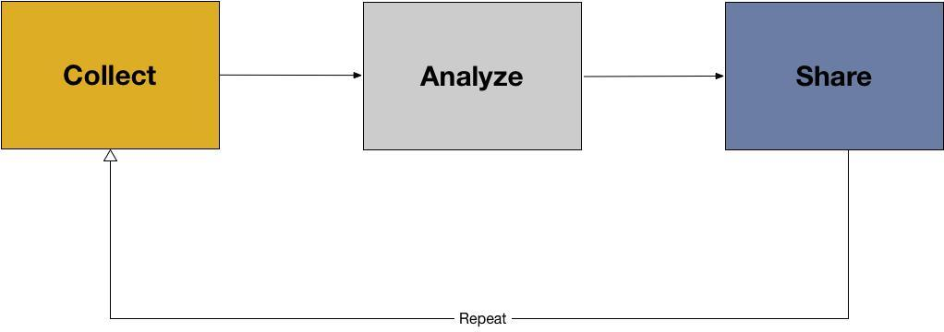  Ask the class about the data lifecycle. How would they describe:  - Collecting data  - Analyzing data  - Sharing data  As they describe the concepts, have them discuss different aspects of each step in the cycle. For instance, with regards to collecting data, what necessary steps are there?  For the collection phase, review  - Primary data  - Secondary data  - Data collection protocols  - Metadata (descriptive, administrative, and rights)  For the analysis phase, review:  - Choosing method of analysis  - Preparing data for analysis  - Data cleaning  - Data coding  - Descriptive statistics  - Visualization  For the sharing phase, review:  - Why is data sharing important?  - Possible digital open formats for sharing (.xls, .csv, .doc, .PDF, .JPEG, etc)  - Data documentation  - Publishing data  - How can participants share data and which methods are best for certain types of data (i.e. excel is good for disaggregated data; pdf is not).  Pause to ask if anyone has questions so far.
35 minutes | Activity 5.1: Developing a Data Story | See Activity 5.1 guide for detailed instructions.
20 minutes | Review key concepts | Review the following key concepts with the participants. This could be done by playing a review game where the class is split into teams and has to answer questions about each concept, or could be done by a simple instructor-led review. For each concept, be sure to spend time with the participants and have them describe each term’s significance in data for decision-making.  Again, as before, try to have the participants provide their own definitions before  - Data  - Data for decision-making  - Stakeholders  - Assessment  - Mission  - Vision  - Data producer  - Data consumer  Ask, what are the key steps to using data for decision-making? Remind the participants:  - Identify a problem or research question  - Assess data available to you and your data needs  - Identify stakeholders  - Plan for how data will be used, analyze, and shared

BREAK: 10 MINUTES

90 minutes | Activity 5.2: Final Project | See Activity 5.2 guide for detailed instructions.

LUNCH: 1 HOUR

