**Activity 1.2: Understanding and Working with Data Visualizations**

*Adapted from Visualization Best Practices, Gengo, 2017 & Visualization, the Medicine for Big Data, East Africa Business Daily 2017)*

**Objectives:**

* Understand the importance of visualized data and why visualization matters.
* Learn how to interpret and use visualized data.
* Learn how to be consumers of data visualizations, who can use the data in the visualization, and how the information found in the data could be applied to answer different questions.

**Total anticipated time: 35 minutes**

**Materials Needed:**

* Data visualization print-outs
* Datasets printed out for participants
* Data visualizations

**Introduction: (Use the following information to introduce and explain the activity to the class)**

Remind the class that data visualization is a way to help people understand the significance of data by placing them in a visual context. Patterns, trends, and correlations that might go undetected in text-based data can be exposed and recognized easier with data visualization.

Pass around this image, or show it on the screen

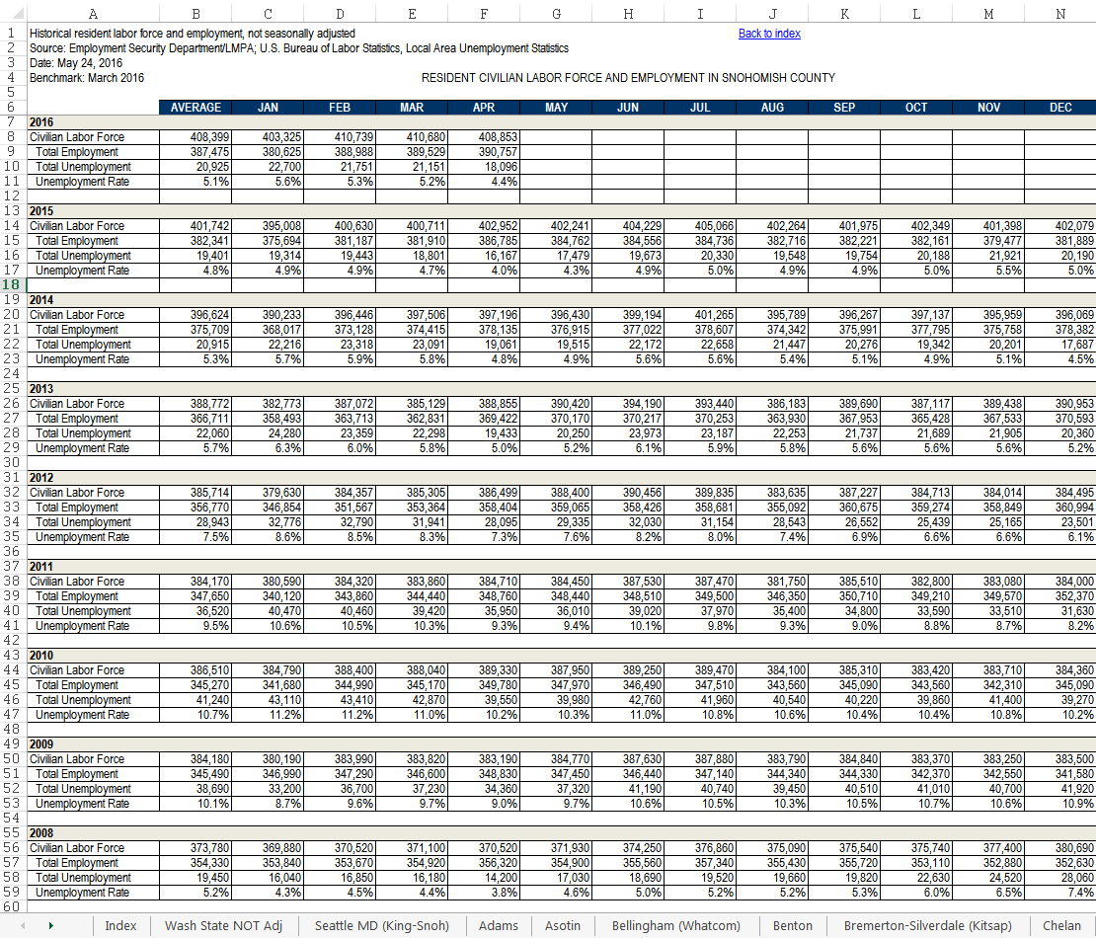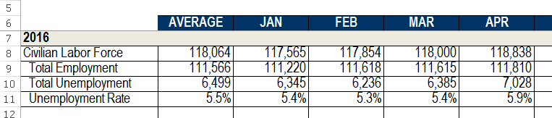

Only allow each person to look at information for 30 seconds. What information is provided? Is it qualitative or quantitative? What does this information show? Who can use it/what is it for? The participants may not have complete answers to this.

Now show the class the same dataset, but visualized:

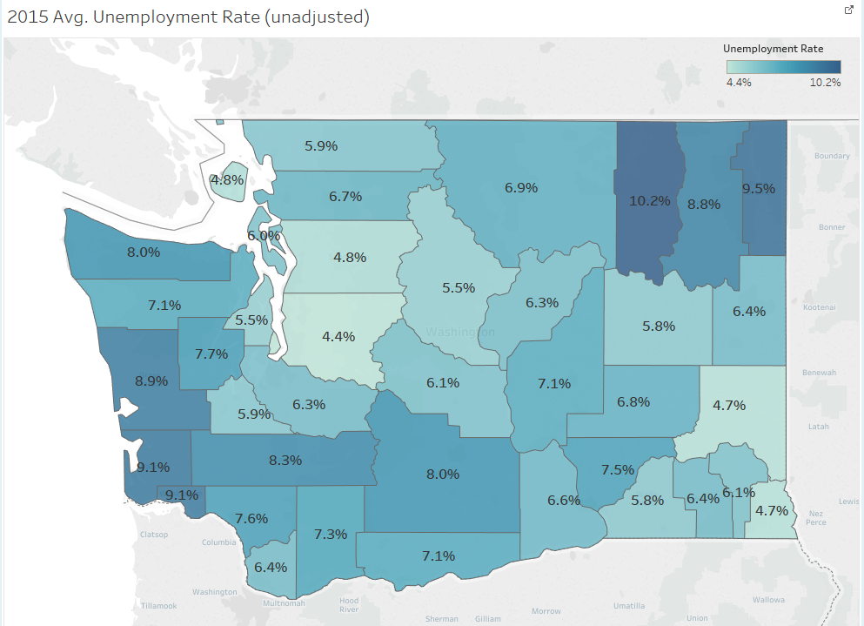

Allow the class 30 seconds once more. Now, have them answer: What information is provided? Is it qualitative or quantitative? What does this information show? Who can use it/what is it for? The participants may not have complete answers to this.

Because of the way the human brain processes information, using charts or graphs to visualize large amounts of complex data are easier than looking at datasets or report. Data visualization is a quick, easy way to convey concepts in a universal manner.

Visualizing data allows us to help you or the person using your data easily understand your results and quick pull out information that is relevant to them.

Now ask the class, how would they visualize these data for different stakeholders. How would they visualize it for those working in the employment bureau? What about that work at an NGO? How would the public want to view these data?

In this activity, the participants will be broken into groups of 2-3. They will each be given a data visualization. Working together, they should answer the following questions:

* What are the data that were used to make this visualization? It is not provided, so think critically about what information was used to make the chart.
* Who is the intended audience, or audiences that could use it?
* How could they frame these data a different stakeholder? For example, if their answer to the above question was the government, how should these data be visualized for the public?
* What problem are these data visualization trying to show?
* What information can you gather from the visualization?
* What conclusions could you make from the visualization?
* Using the conclusions you made, what are additional questions that you could as about the information provided in the data visualization?
* What kinds of decisions could be made from them?

Once the class is finished, have each group present their findings to class. When the presentations are over, debrief with the participants. You might ask the following questions:

* Did you like one visualization more than the other?
* How can you use data visualizations to make insightful conclusions?
* How can you use these conclusions to make decisions?
* How can these decisions improving programming within communities or organizations?
* What should you consider when visualized data for the public, the government, or an NGO?

It’s important to discuss with that class that

* good data visualizations require good *data.* If the data that underlie a visualization are faulty, the result will be misleading and incorrect conclusions from the visualization.
* The processes described in Activity 1.1 of defining a data problem, audience, and goal, are also necessary to take for visualizations. As we move forward throughout this class, we’ll return to these topics. It’s always critically important to remember that for every data project, you need to keep in mind the your audience and what you are trying to accomplish with the data.

NOTE:

For more advanced classes, use the following questions for participants to answer in their presentations:

What other data could be provided to make this more meaningful?

* Different percentages? Total populations? Other...
  + Why do we want to tell this
* Is there anything misleading or easily misinterpreted?
* What other information is necessary for context?
* What assumptions are made about the graph?
  + Date
  + Comparisons provided matter
  + Data quality/completeness
  + Other