Activity 5.2: Final Project

Objectives:
- Review key concepts of data for decision making and the data life cycle
- Apply visualization techniques in order to “story tell” with data
- Understand the importance of data for decision making by applying the process to problem in their organization
- Think critically about ways to use data to solve these problems
- Practice data sharing by presenting these findings to other workshop participants

Total anticipated time: 3 hours (spread out across Modules 5 and 6)

Materials Needed:
- Paper
- Pencils
- Posters or large pieces of paper for presentation
- Activity 5.2 Participant Guide

Instructions

This activity represents the culmination of what the participants have learned over the past few days. In this activity, participants will be put into groups of 3-4. They will be asked to think of a problem that they would like to solve using data, apply this problem to the data lifecycle, and then present their results to their peers. Remind the participants of the steps they should follow:

- Identify a problem or research question
- Assess data available to you and your data needs
- Identify stakeholders
- Plan for how data will be used, analyzed, and shared

The attached worksheet provides a step by step process for the participants to go through each of these pieces as they complete their project.

Activity 5.2 Participant Guide: Final Project

Directions: This project will have you apply what you have learned in the past few days to a real-life scenario at your own organization. In this project, you will 1) identify a problem or research question, 2) assess data availability and your data needs, 3) identify stakeholders, and 4) plan for how data will be used, analyzed, and shared.

You will present your projects, along with a sample visualization of your data, on a poster board to the class. Your poster board should also have the following information:
- the problem you are addressing
- the stakeholders of this problem
- your data collection plan
- how you will analyze your data
- how you will share your data

This worksheet will provide you with helpful steps to complete along the way as you work through your project. To begin, review the process for developing a data collection plan.

- What questions or problems are trying to be addressed?
- What do you need to know?
- When will you collect new data (primary), and when will you use existing data (secondary)?
- What instruments will you need to create?
- Who will be involved in data collection, and for how long?
- What documentation will be needed to use the data again?

Phase One: Defining the Data Problem

Directions: Use this guide to help you think through a key issue you are trying to address, the factors that contribute to that issue, the people it affects, existing data surrounding the issue, potential sources of new data, and how to use those data to make a decision.

- What is the primary question, problem, or issue you want to address? Why it important to others/society? Why is it important for you to address it (e.g. are others looking into it?)?


- What is causing and impacting the problem or issue? What issues surround the problem that keep it from being solved?


- What people and/or communities does the problem impact?

- Who else is currently or has tried to work on this?

- What data do you need to make more informed decisions and programming to address the issue?

- How would you use those data to address the issue?

- What data exist already? What do they focus on and how up-to-date and reliable are they?

- What additional data do you need to address the problem or issue?

Phase Two: Identify Stakeholders

Directions: Recall that a stakeholder is a person with an interest or concern in something. Defining a problem in which to use data to make a decision is a crucial first step in data for decision-making. Another important piece of data for decision-making is understanding who your stakeholders are by performing a stakeholder analysis. Understanding all the actors and their relative influence over the problem will help you frame your plans within the existing government, civil society, academic, and other systems responsible for addressing a problem.

When you think about your stakeholders, you should consider:
- Communities: Individuals or groups who are affected by the problem.
- Change agents: Individuals and groups directly working on the issue. These include community groups, NGOs, and others on-the-ground.
- Support groups: Foundations, governments, NGOs, and others with resources to address the issue.
- Policymakers: the people who can control government responses to the issue.

Find the stakeholders in the problem you have just defined. Think through:

- Who are the stakeholders in the community who are affected by the problem or issue? These can be individuals and groups.

- Who are the change agents? These are individuals and groups directly working on the issue, who include community groups, NGOs, and others on-the-ground.

- Who are the support groups? These are foundations, governments, NGOs, and others with resources to address the issue.

- Who are the policymakers? These are the people who can control government responses to the issue)?

Next, for each stakeholder answer:

- In what ways do they engage with the problem?

- In what ways do their goals align with yours? In what ways are your interests in the issue opposing?

- How much influence and power do they have to make change?

- How do/can they use data to make decisions about the issue?

- Where are the gaps in data that impact their decision-making? What would more/better data allow them to do?

Phase Three: Plan for how Data will be Used and Analyzed

Directions: Remember the data lifecycle:

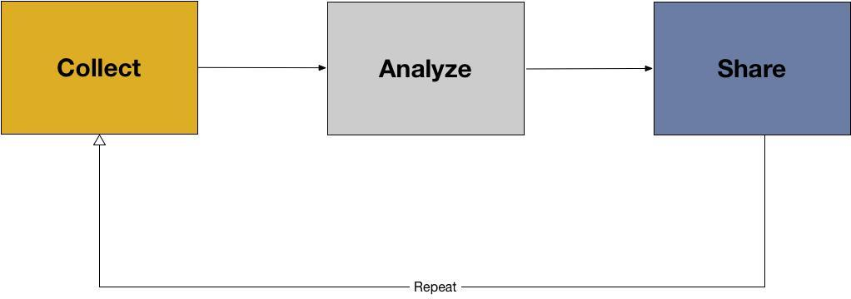

For each phase of the cycle, think through the following:

Data collection
- Where can you get primary data? Of all the possible data you could collect, which are most realistic given your time and resources?

- Where can you get secondary data?

- What resources (new and/or existing) will you need to collect your primary and secondary data?

- What will be your data collection protocols?

- What will be in your metadata (descriptive and administrative)?

Data analysis
- What will be your method(s) of analysis?

- What resources (new and/or existing) will you need to collect your primary and secondary data?

- How will you prepare your data for analysis?

- How will you clean your data?

- How will you code your data?

- How will your normalize your data?

- What descriptive statistics might be interesting?

Data visualization
- Who are your primary audiences for visualization? Why?

- What will be the mediums by which you create visualizations? (e.g. paper reports, digital reports, websites for mobile, websites for computer) Why?

- What stories do you think you might want to tell with your data through visualization? Why?

- What resources (new and/or existing) will you need to visualize your data?

For your project, create a sample visualization on your poster board. Be prepared to answer why you chose this visualization and what main points you hope to communicate about your data.
Remember some key components for data visualizations:
- Visualizations should be created to tell a story
- Discuss any limitations and be aware of how your data may be misleading
- Create legends that tells viewers what data are being used
- Label all axes and create descriptive titles
- Provide links to the original data, or contact information for the data producer

Data sharing

- Why is data sharing important for this project?

- Who are your primary audiences for sharing? Why?

- What formats will you share your data in?

- How will you document your data?

- How will you publish your data?

- What resources (new and/or existing) will you need to share your data?

