Activity 2.2: Learning to Share Resources
Data sources were created for the purpose of this activity

Objectives:
- Learn how to identify when your data alone cannot answer a specific research question or problem
- Learn to identify and collaborate with institutions with relevant data
- Understand why sharing data is important for decision making

Total anticipated time: 25 minutes

Materials Needed:
- Research Questions (printed out)
- Dataset printouts
- Computer
- Projector

Introduction: (Use the following information to introduce and explain the activity to the class)

Government and civil society institutions often collect data within a specific sector. For example, the Department of Education collects data on student demographics, student enrollment, and school facilities, whereas a health NGO might collect data on diseases and disabilities. Often, however, these institutions identify problems or research questions that require additional data from outside of the specific sector. For example, the Department of Labor might want to understand if unemployment is higher and average GDP lower in districts where there are more immigrants. In this instance, the Department of Labor wants to access or request information from the Department of Immigration. Collaboration and cooperation with regards to data between both government institutions and civil society organizations is important in ensuring that the data are available for making evidence-based and credible decisions.

In this activity, participants should gather in six groups. Each group will be given a dataset and the relevant research question or problem. Each group will then identify what information they already have in their data to answer the question and what information they need. Groups then will find the respective organization with the relevant data.

Participants should consider the following questions:

- What data do you need to address the problem/answer the question?
- What data do you have from your organization’s dataset?
- What information are you missing?
- How did you identify which organization had data you could use?
- Which data did you use from the other organization and why?

After the participants have completed the exercise, think about other situations in which you need to share data. Think about the data you organization collects or uses and which organizations you know who collect relevant data that they could collaborate with in the future. Brainstorm out loud as a group.

Instructor: Cut or rip apart the six different data questions below. Give each group one dataset (in this case a spreadsheet table) and the relevant question/problem.

Cell phone company
You have a dataset that shows the number of cell towers four companies have built in each district of the five states. You are a new company and you want to build new cell towers, particularly in rural areas; however, you need to make sure that enough of the population has access to electricity. In the rural districts where there are the fewest cell towers, what percentage of the population has access to electricity?

Health NGO
You want a dataset that shows the number of deaths for each illness or disease in each district of the five states. Does a higher percentage of the district population die from illnesses and diseases where there is limited access to hospitals?

Department of Energy
You have a dataset that shows individuals’ main energy source at home. You want to research how access to electricity or readily available light might affect school completion rates, particularly between primary and middle school. Is the middle school dropout rate higher in districts where the majority of the population relies of kerosene, candles, and solar energy?

Department of Health
You have a dataset that shows the number of hospitals and medical clinics in each district. You want to know which districts are most affected by low access to electricity, which would affect hospital and clinic operations. How many hospitals and how many clinics are located in districts where less than 20% of the population has access to electricity?

Department of Labor
You have a dataset that shows the employment status for individuals over the age of 25 in each district. Often, access to electricity and consistent sources of power can increase productivity and workplace operations. You want to research the relationship between higher unemployment rates and limited access to consistent and modern power sources. Is the percentage of the unemployed district population higher in districts where there is limited access to electricity?

Department of Education
You have a dataset from data collection on education completion in all the districts of the five states. You want to know if higher educational completion of the population relates to lower unemployment rates. What is the average educational attainment of the population in the districts with the highest unemployment rates?

Department of Education

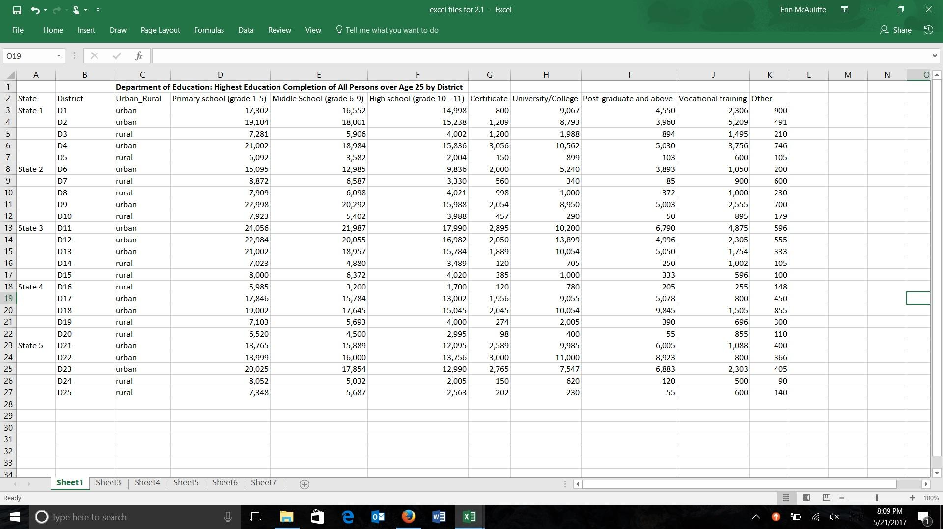
Department of Health

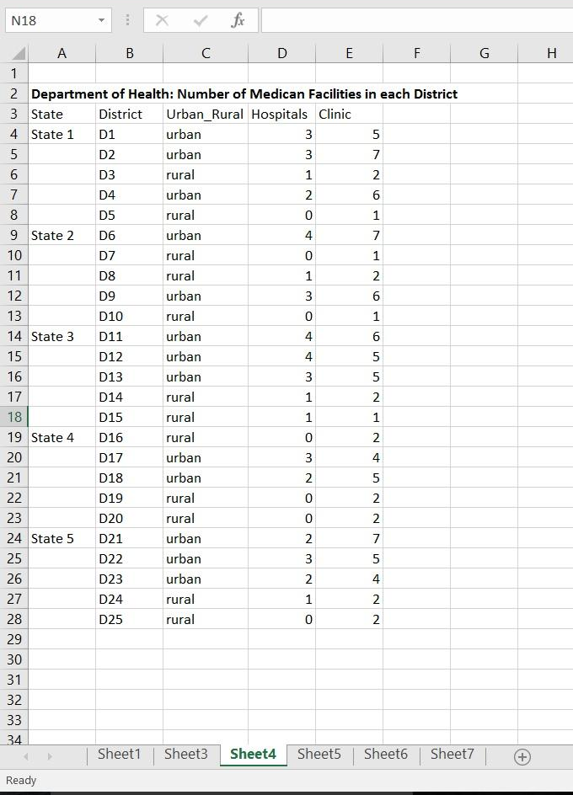

Cell Phone Company

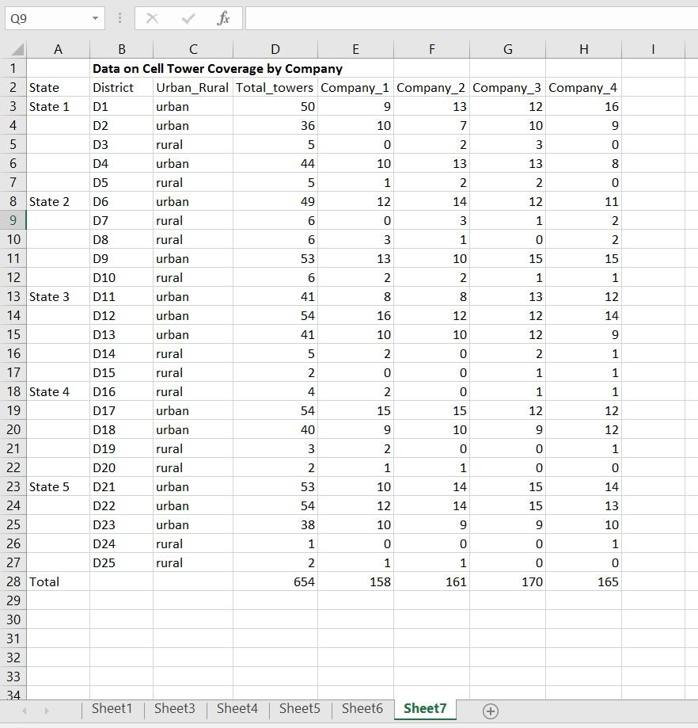

Department of Labor

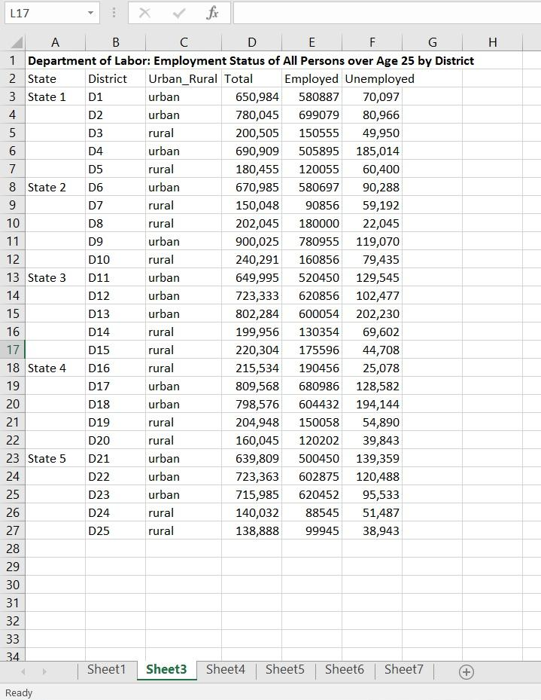

Health NGO

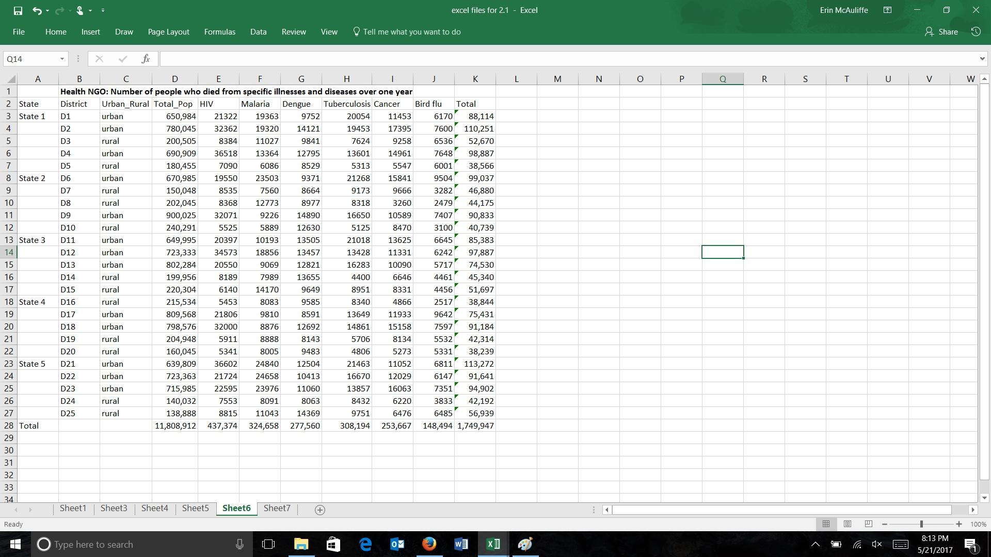

Department of Energy

