
Name: ___________________

Data for Decision-Making Student Handbook
Module 3: Introduction to Data Lifecycle – Collecting Data

Review:
- Data
- Data for decision making
- Stakeholders
- Assessment
- Mission
- Vision
- Data producer
- Data consumer

Key steps to using data for decision-making:
- Identify a problem or research question
- Assess data available to you and your data needs
- Identify stakeholders
- Plan for how data will be used, analyze, and shared

Key Term: Data Lifecycle

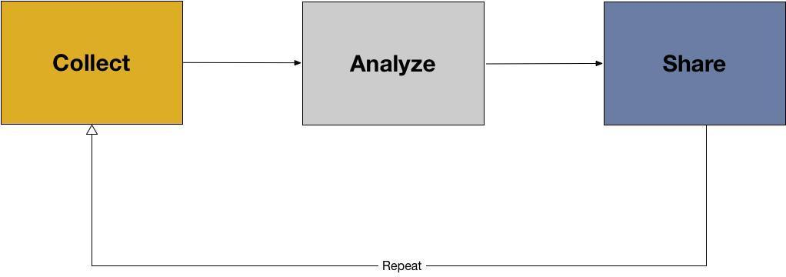

This image represents a data life cycle. There are three stages:

- Collecting data
- Analyzing data
- Sharing data

Key Term: Collecting data

In the box below, write the definition for “data collection” provided by the instructor.

Key Term: Analyzing data

In the box below, write the definition for collecting data provided by the instructor.

Data analysis is made up of many stages:
- Inspecting the data
- Cleaning the data
- Transforming the data
- Visualizing the data (visually)

Key Term: sharing Data

In the box below, write the definition for “sharing data” provided by the instructor.

Applied Example: Data lifecycle (India)

The use of information and communications technology (ICT) in agricultural services is becoming increasingly common. These technologies—radio, SMS, television, video, and Internet services—have the potential to help smallholder farmers increase their incomes by making it easier for them to learn about and adopt new farming methods, grow higher-value crops, or connect with new markets.
Digital Green, an international non-profit organization based in India, uses locally-produced videos and in-person facilitation to share knowledge about improved agricultural and nutrition practices. The program aims to help rural communities across South Asia and Sub-Saharan Africa understand and adopt better agricultural and nutrition practices, and the ultimate goal of the program is to have a positive impact on individual well-being. Digital Green is currently working in nine states in India, and also in Afghanistan, Ethiopia, Ghana, Niger, Tanzania, Malawi, and Papua New Guinea. Since its start in 2008, Digital Green’s program has produced over 4,000 videos reaching more than 800,000 viewers across more than 9,000 villages.
Digital Green is in the process of measuring the program’s impact on farmer livelihoods and health status using evaluations in both India and Ethiopia and its effect on improving nutrition-related behaviors in India. The organization has also invested in an activity monitoring system that reports data on program implementation and tracks the adoption of Digital Green-promoted practices from remote locations. One challenge in the activity monitoring system is its reliance on data from partner organizations, which varies in quality. Recognizing the issue, Digital Green has instituted a series of data quality checks and procedures to improve quality. The Goldilocks Initiative’s recommendations for Digital Green focus on its agricultural activities, and include refining and consolidating the program’s theory of change and conducting a systematic review of data quality. (Innovations for Poverty Action Lab, 2016)

Applied Example (Myanmar)

In 2008, after Cyclone Nargis, the Myanmar Information Management Unit (MIMU) launched their 3W project to track and share humanitarian and development activities undertaken by all agencies across Myanmar.

3W stands for “Who does What, Where.” By keeping an up to date database on which organizations (who) are conducting certain activities (what) in Myanmar (where), other organizations and donors can better target beneficiaries to ensure humanitarian and development needs are met.

The partnered agencies share their information on planned, ongoing, and recently completed activities every six months using standard sector definitions and MIMU compiles these data. They clean and digitize the data, creating quality baseline data sets on humanitarian and development efforts in Myanmar and on responding agencies in the country. They then make the data publically available for other agencies to use. The intended impact is that agencies and donors can use these data to determine which areas, sectors, and populations to target in their future projects. (http://themimu.info/3w-maps-and-reports)

Guiding Discussion Questions:
- What was the problem the organization was trying to solve?
- How did the organization collect data?
- How did they plan to analyze data?
- How will the use data to make a decision?
- How can the organization share their data?
- How does the organization question their data quality?

Review:

- Primary data
- Secondary data

Key Term: Data collection protocols

In the box below, write the definition for “data collection protocols” provided by the instructor.

Key Term: Metadata

In the box below, write the definition for “metadata” provided by the instructor.

Key considerations in developing a data management plan:

What questions or problems are trying to be addressed?
- The first step to collecting data is to clearly understand the problem. Write down a set of questions and potential ways they can be answered with new or existing data.

What do you need to know?
- Often when we list the kinds of data we want it can become a wishlist of things that are all “interesting” but may not all be necessary. Make sure everything in your list of “need-to-know” data are necessary for answering the questions or problem you stated. Go back and forth between the data and problems to make sure both match. You may need to remove some data from your wish list if they do not support the problem statements. You may also need to revise your problem statements if the data you list do not support what is there but you feel those data are vital.

When to collect new data (primary), and when to use existing data (secondary)?
- This can be answered by exploring existing data sources, writing down explicit questions to be asked and trying to answer those with existing data sources, etc.

What instruments will you need to create?
- Collecting new primary data requires significant time developing new instruments, making sure the questions are phrased accurately to get the data you need, and testing them before administering them.

Who will be involved in data collection, and for how long?
- Plan to have people involved that can contribute data collection and analysis stages

What documentation will be needed to use the data again?
- This should tell the history of the data. Who created it? When was it created? Why was it created? What information does it include?

Sample data management resources:

- Data Management Plan tool: https://dmponline.dcc.ac.uk/
- Following best practices in choosing a sample (size, diversity, relevant population, etc.) https://resolutionresearch.com/page/results-calculate/
- Searching for secondary data http://datasupport.researchdata.nl/en/start-de-cursus/iv-gebruiksfase/zoeken-naar-data/
- What are databases? How to design one? www.dartmouth.edu/~bknauff/dwebd/2004-02/DB-intro.pdf

Lying with data
The same data can easily be manipulated and used to tell different, opposing, or inaccurate stories. This can be intentional or unintentional.

Find ways to respectfully talk with your colleagues and even supervisors if you feel data are being used incorrectly or inappropriately.

In the box below, write the definition for “correlation” provided by the instructor.

In the box below, write the definition for “causation” provided by the instructor.

What are ways data can be used in misleading ways?

