Statistic | Command in Sheets | Explanation | Example
Mean (average) | =AVERAGE(value1,value2) (for ONLY two cells)  =AVERAGE(value1:valueN) (for range of cells) | Creates a sum of 2 or more numerical values, and returns the mean. | =AVERAGE(B2,B3)  =AVERAGE(B2:B7) | 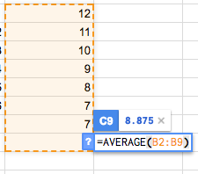
Mode | =MODE(value1,[value2]) | Takes a range of cells, and returns most frequently occurring value | =MODE(B2:B9) | 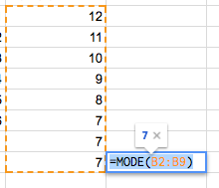
Median | =Median(value1:value2) | Returns median cell from a range, if two cells are median, calculates mean of two numbers) | =MEDIAN(B2:B9) | 