DESIGN DOCUMENT
Pedalwise
Visual design system, view modes, and interaction patterns

Version 1.0
Companion to Pedalwise PRD v1.0
Audience Frontend engineers, product designers, motion design
Status Ready for implementation

Contents
1. Design principles
2. Visual language and tokens
3. The three view modes
4. Wireframe — Anatomical view (default)
5. Wireframe — Realistic view
6. Wireframe — Diagnostic view
7. Wireframe — Optimizer ghost overlay
8. Wireframe — Speed · cadence · gear triangle
9. Render layers and z-order
10. Companion charts
11. Motion and animation
12. Component library
13. Responsive behavior
14. Accessibility
15. Empty, error, and loading states
16. Design-to-code handoff

1. Design principles
Five principles guide every visual and interaction decision in Pedalwise. When in doubt, defer to the principle that comes first.

1.1 Biomechanics first, chrome last
The rider and the simulation are the product. Sliders, panels, and chrome support the simulation; they never compete with it. When a layout decision pits "more controls visible" against "more space for the rider", give the space to the rider.

1.2 Real, then readable
The simulator must look like a sports-engineering instrument, not a children’s diagram. But anatomical clarity always wins over photo-realism. We render limbs as articulated segments with anatomical proportions, not stick figures, and not muscle-by-muscle illustrations.

1.3 One accent color, semantic everything else
A single deep-blue accent (#185FA5) carries the interactive identity — sliders, buttons, focus rings, primary CTA. Everything else is semantic: green for in-range, amber for borderline, red for out-of-range. We never use color decoratively.

1.4 Numbers are the second visual layer
Every screen shows several live numerical readouts. They are typographically distinct (monospace, weight 500, accent color for changes) so the eye can scan them without effort. Numbers that change during animation animate smoothly, never popping.

1.5 Optimization is a dialogue, not a command
When the optimizer suggests changes, it never silently overwrites the user’s configuration. The current state is preserved as a ghost overlay; the optimum is presented as a recommendation; the user explicitly applies it (or doesn’t).
Test your design against the principles
If you can show the screen to a stranger and they cannot immediately identify the rider, the recommendation, and the next thing to do — the design has failed one of these principles. Iterate until they can.

2. Visual language and tokens

2.1 Color tokens
Token | Hex | Use
background.app | #fafaf9 | Page background, behind cards
background.surface | #ffffff | Cards, panels, modal interiors
background.alt | #F6F4EE | Stat cards, subtle hover, code blocks
text.primary | #1c1917 | Body text, headings, numbers
text.secondary | #57534e | Section subtitles, captions
text.tertiary | #a8a29e | Hints, axis labels, ghost overlays
border.default | #e7e5e4 | Card borders, dividers, grid lines
border.strong | #d6d3d1 | Slider tracks, hover state
accent.primary | #185FA5 | Interactive elements, primary CTA, sliders
accent.dark | #0C447C | Accent hover/active states
accent.light | #E6F1FB | Active selection background
status.success | #0F6E56 | In-range values, success badges
status.success.bg | #E1F5EE | Success card backgrounds
status.warn | #854F0B | Borderline values
status.warn.bg | #FAEEDA | Warning callouts
status.danger | #A32D2D | Errors, out-of-range, knee flag in viewport
status.danger.bg | #FCEBEB | Error states, dead-zone indicators
anatomy.fill | #44403c | Limb fill in realistic mode
anatomy.stroke | #1c1917 | Limb outline in anatomical mode

2.2 Typography
Two font families. A refined sans-serif (Inter Display or IBM Plex Sans) for UI and text, and a fixed-width family (JetBrains Mono or Menlo) for numbers and code. No third font.
Role | Family | Size | Weight | Line height
Display | Sans | 32 px | 500 | 1.1
H1 | Sans | 24 px | 500 | 1.2
H2 | Sans | 18 px | 500 | 1.3
Body | Sans | 14 px | 400 | 1.5
Caption | Sans | 12 px | 400 | 1.4
Numeric large | Mono | 24–44 px | 500 | 1.0
Numeric inline | Mono | 13 px | 500 | 1.0
Label / section header | Mono | 10 px UPPERCASE, letter-spacing 0.12 em | 400 | 1.0

2.3 Spacing scale
Use multiples of 4 px. Common values: 4, 8, 12, 16, 24, 32, 48, 64. Card padding is 16 px on small cards, 20 px on large cards. Section spacing between cards is 12 px on dense layouts and 16 px elsewhere.

2.4 Corner radii
Component | Radius
Sliders (track and thumb) | thumb 50% (perfect circle), track 1.5 px
Buttons | 6 px
Stat cards (inner) | 6 px
Cards (outer) | 10 px
Badges and pills | 4 px on small, 9 px on pill-shaped
Modal containers | 12 px

2.5 Iconography
Use a single, consistent outline icon set. Lucide React or Tabler Icons. Outline only — never filled. 16 px in inline contexts, 20 px in buttons, 24 px in empty states. No emoji or pictographs in the UI.

3. The three view modes
Pedalwise has three render modes for the simulator. They share the same kinematic model and the same chrome — only the rider rendering and the diagnostic overlay layer differ. The user toggles between them via a segmented control in the top right.
Mode | Default for | Distinct elements
Anatomical | Bike-fit decisions, learning, slider manipulation | Articulated limbs as outlined segments, visible joint dots, angle labels next to joints, reach envelope visible
Realistic | Marketing screenshots, sharing, presentation | Filled limb forms, torso silhouette with helmet, motion blur trail on pedal arc, minimal chrome, larger HUD numbers
Diagnostic | Bike fitters, coaches, advanced users | Anatomical limbs plus pedal force vectors, polar effectiveness diagram, joint power stacked area, dead-zone markers at TDC/BDC, hip-to-pedal resultant line
Mode is sticky per user
We persist the user’s last mode choice in LocalStorage and restore it on next visit. The default for a first-time user is Anatomical.

4. Wireframe — Anatomical view (default)
The reference layout. Three columns: rider profile and bike fit controls on the left, simulator viewport with three companion charts below it in the center, and the optimizer recommendation panel on the right.
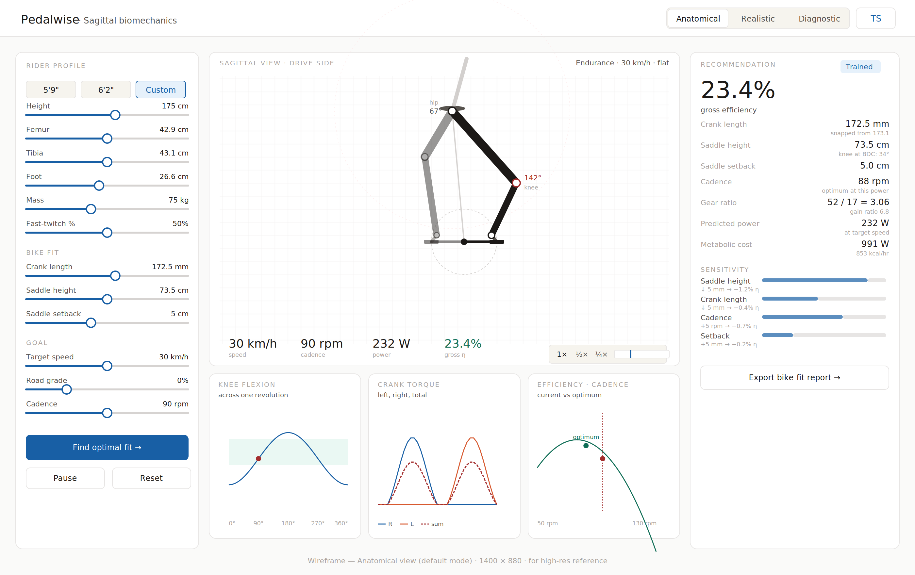
Anatomical view at the target desktop width (1400 × 880). The default first-time experience.

4.1 Anatomy of the layout
- Left rail (280 px) — Three control groups: rider profile (anatomy and physiology), bike fit (the things the optimizer can change), and goal (target speed, grade, cadence). The primary Find optimal fit button sits at the bottom of the rail, distinct in color so it never gets lost.
- Center viewport (720 px) — The simulator. 480 px of pose space at the top, a 28 px-tall HUD strip at the bottom showing speed, cadence, power, and gross efficiency. To the right of the HUD: speed control (1×, ½×, ¼×) and a manual scrubber.
- Charts row (720 px) — Three charts immediately below the viewport: knee flexion curve, crank torque per leg, and efficiency-cadence relationship. Each is in its own card, 252 px tall.
- Right panel (variable, min 280 px) — Recommendation. Large efficiency number at the top, then a list of the recommended bike fit values with notes, then a sensitivity bar chart, then the report export button.

4.2 What the user can do here
- Drag any slider — The rider redraws at 60 fps. All readouts update. The optimizer panel grays out until the user clicks Find optimal fit.
- Click Find optimal fit — The optimizer runs in a Web Worker. The button enters a loading state. After ~250 ms the right panel shows the recommendation and the viewport transitions into ghost-overlay mode.
- Click a preset — 5’4”, 5’9”, or 6’2” pre-fills anatomy values. Custom unlocks the sliders to user-set values.
- Switch view mode — Top-right segmented control. The rider rendering changes; the rest of the layout stays put.
- Export the report — Opens a PDF with the recommendation, methodology, and a sensitivity table. Useful for handoff to a real bike fitter.

5. Wireframe — Realistic view
The Realistic mode replaces the articulated outline rider with a filled silhouette — hunched cycling torso, helmet, arm reaching forward. Chrome shrinks. The HUD becomes three big numbers at the bottom. This mode is for screenshots, marketing, and confidence-building demos.
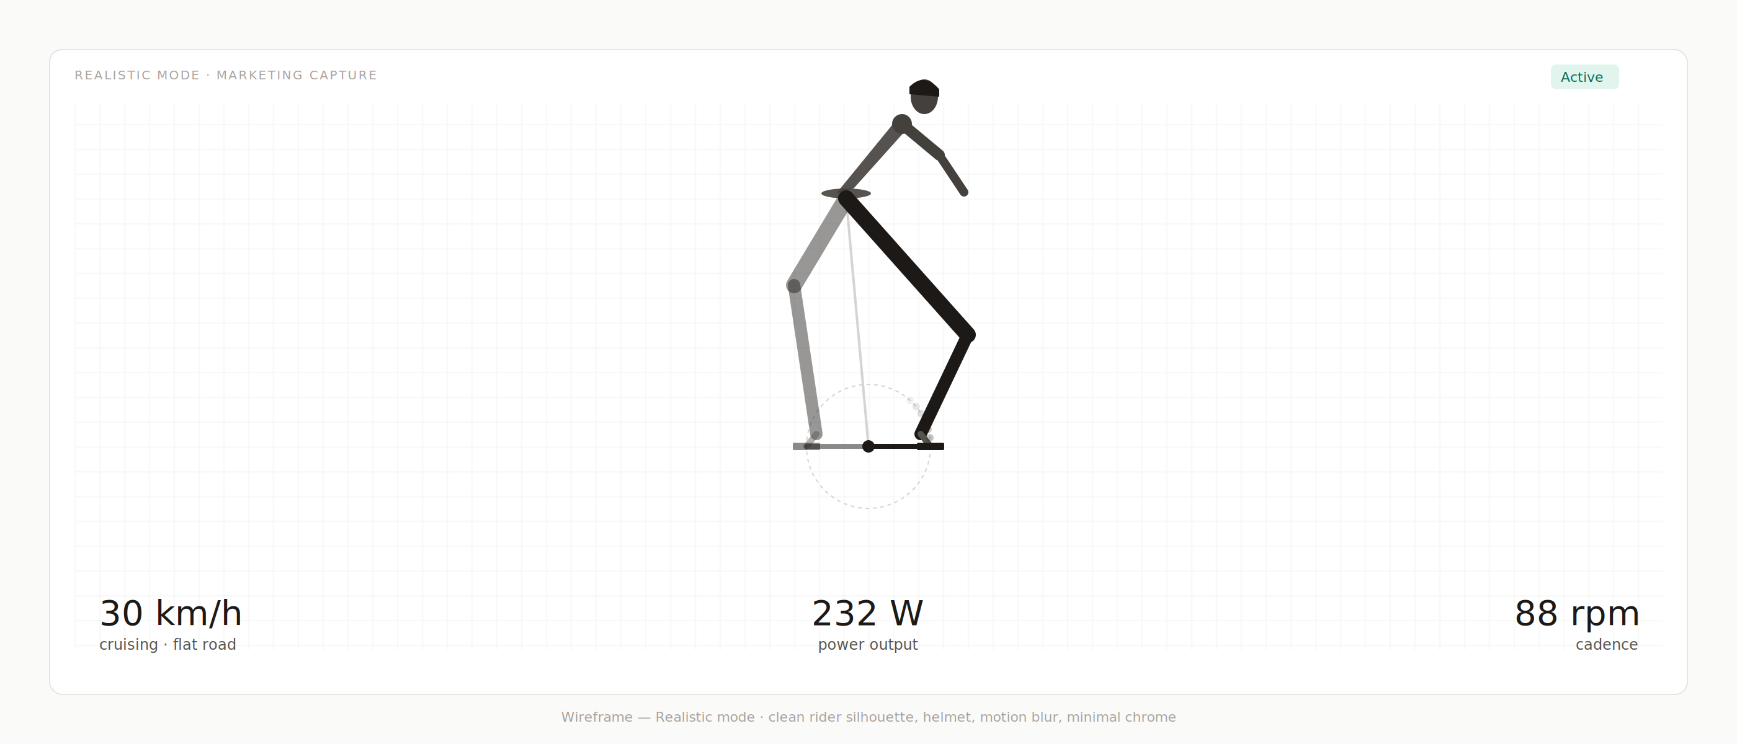
Realistic view. Filled torso, helmet, motion blur trail (faint dots along the pedal arc), large HUD numbers.

5.1 What changes vs Anatomical
- Added — Torso silhouette and helmet (in #44403c at 90% opacity). Forearm reaching to invisible handlebars. Motion-blur trail along the pedal arc (6 faded dots tracking the last 30° of pedal travel).
- Removed — Joint dot rings. Knee angle label. Reach envelope. Charts row. Sensitivity panel. The right column collapses entirely — this mode is full-width.
- Resized — HUD numbers grow to 28 px (vs 18 px in Anatomical). Section labels disappear.
- Preserved — The kinematic model is identical — the leg positions are computed the same way. Only the rendering layer changes.
Why we built this mode
When you show someone a stick-figure simulator, they say "neat physics demo". When you show them a hunched cyclist with motion blur, they say "I want to use this". The data hasn’t changed; the framing has. Use this mode for first impressions and never for actual fit decisions.

6. Wireframe — Diagnostic view
Diagnostic mode is for the user who wants to see why a fit recommendation makes sense. It surfaces pedal force vectors, the polar effectiveness diagram, joint power contribution, and a list of detected issues. The left rail is hidden so the diagnostics get room.
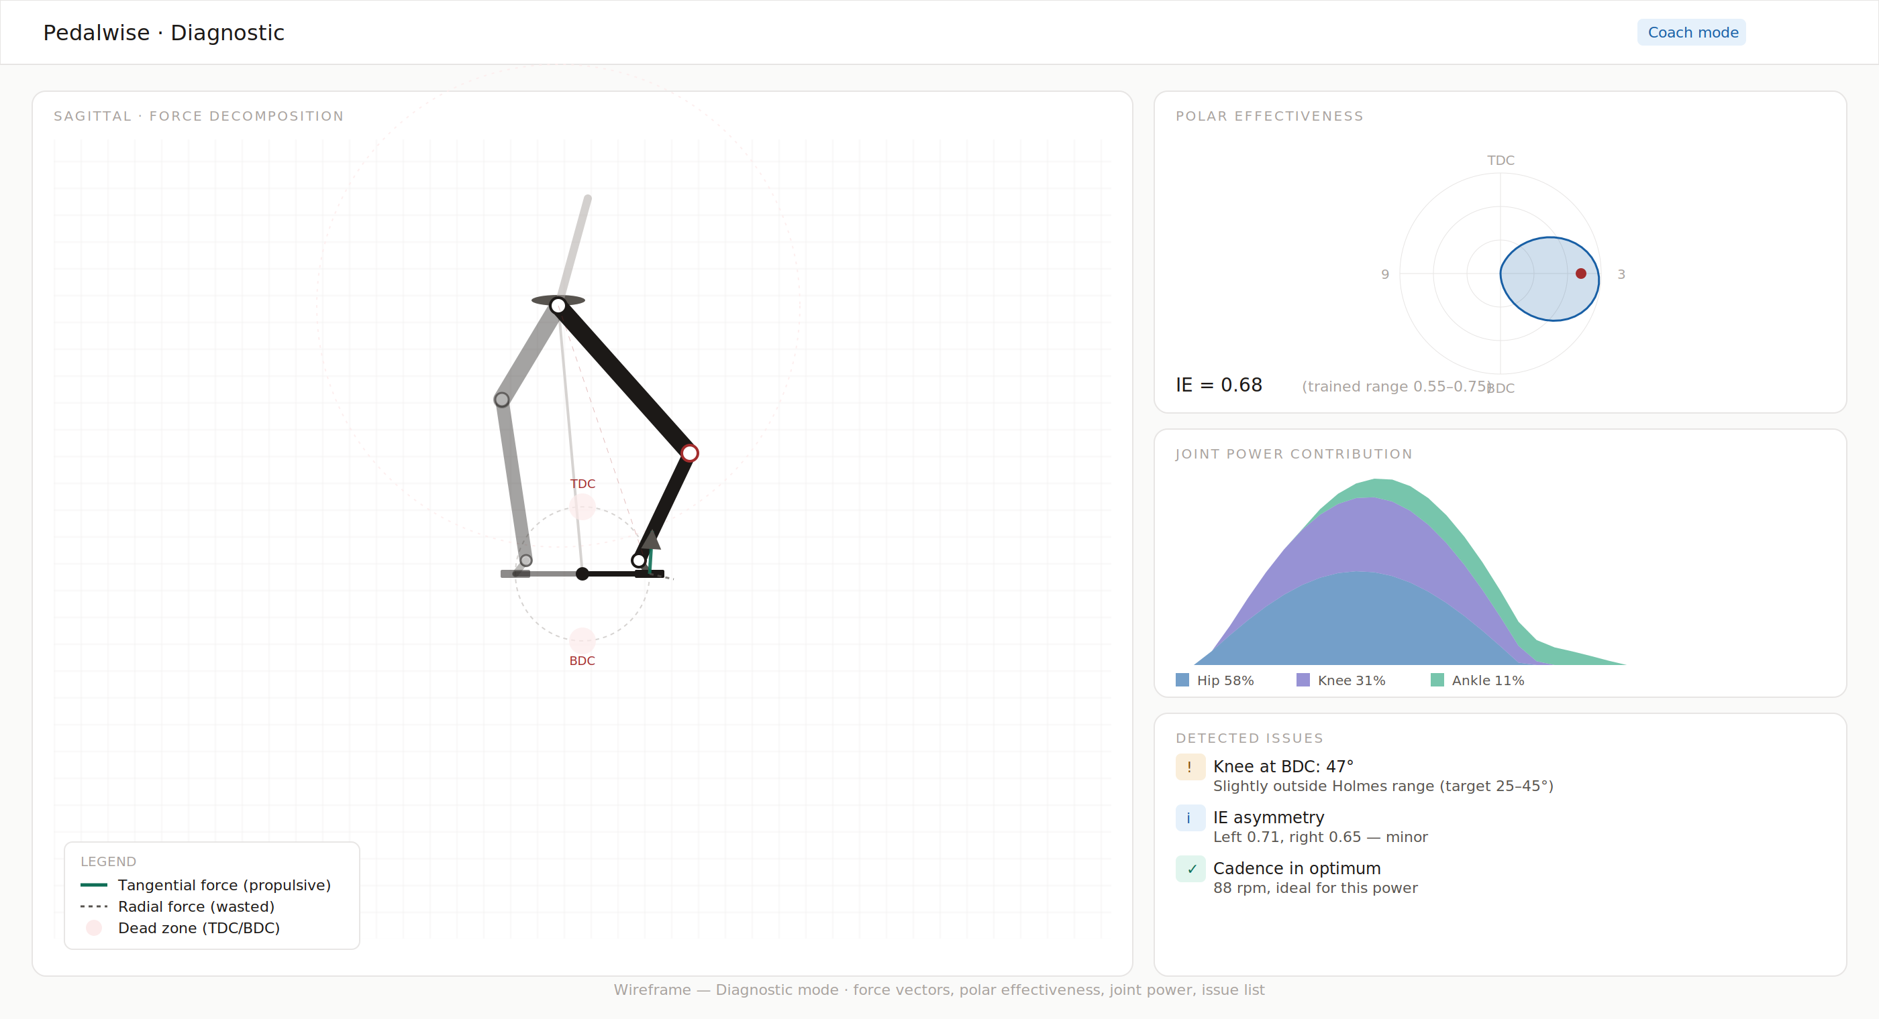
Diagnostic view. Force vectors on the right pedal, dead-zone markers at TDC/BDC, polar effectiveness on top-right, joint power stacked area, detected-issues list.

6.1 Diagnostic-only elements
- Tangential force vector (green) — Drawn from the pedal in the direction of motion, length proportional to force magnitude. Visible only during the propulsive phase (45°–135° of the active leg).
- Radial force vector (gray, dashed) — Drawn along the crank arm. Represents wasted force. Always shorter than the tangential vector for a competent rider.
- Hip-to-pedal resultant line — A faint red dashed line from hip to active pedal. Visualizes the cyclist’s tendency to push "from the hip" along this axis.
- Dead-zone markers — Red filled circles at TDC and BDC, with labels. Highlights the angular regions where vertical pedal force produces zero crank torque.
- Polar effectiveness diagram (top right card) — The classic cycling clock diagram: tangential force magnitude plotted radially around the stroke. Trained cyclists produce an asymmetric blob skewed to the 2–5 o’clock region.
- Joint power contribution (middle right card) — Stacked area: hip, knee, ankle power summed across the revolution. The legend includes the percentage contribution of each joint.
- Detected issues panel (bottom right) — A short list of automatic findings: knee outside Holmes range, IE asymmetry, cadence outside optimum band. Each row has a colored badge (info, warn, success) and a one-line explanation.

7. Wireframe — Optimizer ghost overlay
When the optimizer returns, we don’t silently overwrite the user’s configuration. Instead, the current pose fades to 25% opacity and becomes a "ghost" beneath the recommended pose, which renders at full opacity. A 1.0-second cross-fade announces the change. The right panel shows the diff and gear candidates.
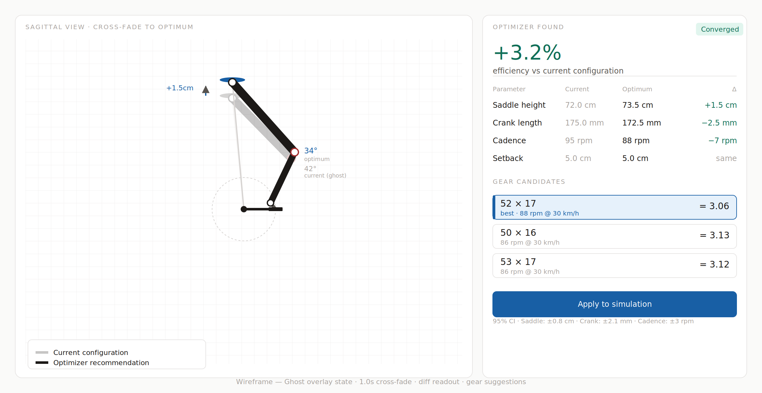
Ghost overlay state. Current configuration (ghost, faded) and optimum (full opacity) shown together. The +1.5 cm annotation calls out the saddle change.

7.1 The cross-fade choreography
- t = 0 ms — User clicks Find optimal fit. Button enters loading state. Right panel scrolls into a "Solving…" skeleton.
- t = 0–250 ms — Optimizer runs in the Web Worker. The simulator continues to animate at the user’s current configuration.
- t = 250 ms — Optimizer returns. The current pose immediately starts fading to 25% opacity (ease-out, 1000 ms). Simultaneously, the recommended pose draws in at 0% opacity and fades up.
- t = 750 ms — The annotated callouts (“+1.5 cm”, “34° optimum”) draw in with a delay.
- t = 1250 ms — Cross-fade complete. Both rider configurations are now stable. The right panel reveals the diff table and gear candidates.
- User action — Click Apply to simulation to commit. The ghost is removed and the recommended pose becomes the current pose. Click anywhere else, or change any slider, to dismiss the recommendation and restore the original.

7.2 The diff readout
Four rows: saddle height, crank length, cadence, setback. Each shows current, optimum, and delta. Deltas are colored green when they represent an improvement, gray when unchanged. The big number at the top is the predicted efficiency gain in percentage points.

7.3 Gear candidates
Three cards. The first is the optimum, marked with a left-edge accent stripe and the "best" badge. The other two are the next-closest commercial gears, presented for context. Each card shows the chainring × cog combo, the resulting ratio, and the actual cadence at the target speed. The user can click any card to apply that gear instead of the optimum.

8. Wireframe — Speed · cadence · gear triangle
Three quantities are linked by one equation: v = (n / 60) · G · π · D. Given any two, the third is determined. The triangle widget makes this constraint visible — pinning two nodes solves the third.
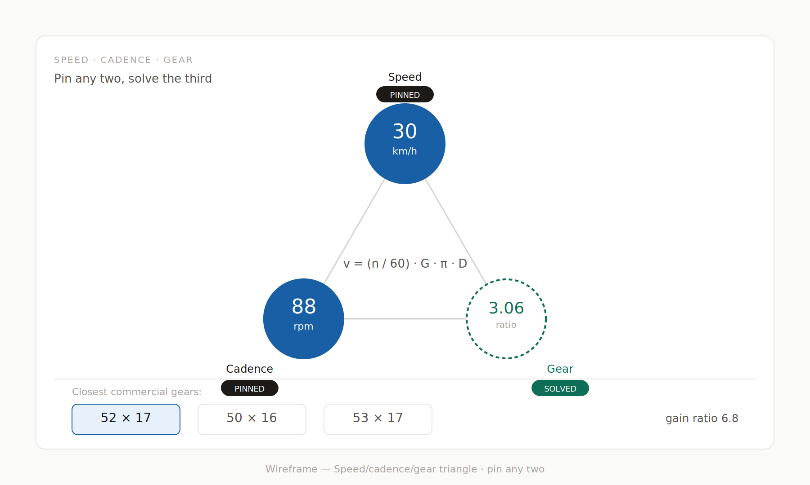
The triangle widget. Speed and cadence pinned (filled blue circles, PINNED badge); gear solved (dashed green outline, SOLVED badge). The closest commercial gears appear below.

8.1 Interaction
- Default state — Speed and cadence pinned; gear solved. The user enters the speed they want and the cadence they prefer; the system finds the gear.
- Click a pinned node — It unpins. The most recently changed of the other two becomes the solved variable. (Always exactly one solved node.)
- Click the solved node — No-op. To change which node is solved, unpin a different one.
- Drag a pinned node — A small thumb appears next to the circle, allowing direct edit of that value. The solved value updates live.
The pedagogical value
Most cyclists never think about the speed-cadence-gear triangle as a constraint. They pick a gear by feel. The triangle widget makes the math viscerally clear: if you want to go faster while staying at the same cadence, you must change gears. Surfacing this is the kind of “oh, of course” moment that earns trust in the rest of the tool.

9. Render layers and z-order
The simulator canvas has seven layers, drawn back-to-front each frame. Some layers are mode-dependent. The order is fixed.
z | Layer | Anatomical | Realistic | Diagnostic
1 | Background grid | visible | visible | visible
2 | Pedal arc and reach envelope | visible | pedal arc only | visible
3 | Bike frame stub (seat tube, BB) | visible | visible | visible
4 | Dead-zone markers (TDC/BDC red circles) | hidden | hidden | visible
5 | Anatomical layer (both legs) | outline + joint dots | filled silhouette | outline + joint dots
6 | Torso, helmet, arm | hidden | visible | hidden
7 | Force vectors and resultant line | hidden | hidden | visible
7 | Joint angle labels | visible | hidden | visible
7 | Motion blur trail | hidden | visible | hidden

9.1 Why this order matters
- Grid behind everything — The grid is reference — it should never interfere with reading the rider. Drawing it first and at low contrast keeps it visible without competing.
- Dead zones behind the legs — When the right leg is passing through TDC or BDC, the leg should be drawn on top of the red dead-zone marker, not behind it. The visual reads as "the leg is in the dead zone" rather than "there’s a sticker over the leg".
- Force vectors on top of everything — These are the most important diagnostic information in Diagnostic mode — they must always be readable, even when they overlap a limb.

10. Companion charts
Three charts appear below the simulator in Anatomical mode. They share visual conventions: 252 px tall, light card background, monospace axis labels in #a8a29e, current-position dot in danger red, optimum marker in success green.

10.1 Knee flexion vs crank angle
Line chart. X-axis: crank angle from 0° (TDC) to 360° (back to TDC). Y-axis: knee flexion in degrees, 0° at top (straight leg) to 130° at bottom (fully bent). Holmes target range (25–45° at BDC) shaded as a green band. The user’s current crank position appears as a red dot that animates along the curve. Hover/click to scrub.

10.2 Crank torque vs crank angle
Three overlaid lines. Right leg in #185FA5 (blue). Left leg in #D85A30 (coral). Total in #A32D2D (red), dashed. The right and left curves each show a single hump peaking around 90° past their TDC; the total curve shows the alternating double-hump that characterizes bilateral pedaling. The legend includes color swatches and the labels R, L, sum.

10.3 Efficiency vs cadence
Single line, color #0F6E56 (success green). X-axis: cadence from 50 to 130 rpm. Y-axis: predicted gross efficiency. The user’s current cadence appears as a red dot with a dashed vertical line; the predicted optimum as a green dot with a label. As the user changes other inputs (saddle height, crank length, fiber composition), the curve re-renders.
Charts are alive
Every chart on every screen updates in real time as the user adjusts inputs. The optimum marker moves. The current-position dot moves. The curves themselves redraw. This is essential: if charts only update on demand, users miss the cause-and-effect that makes the tool valuable.

11. Motion and animation
Default motion philosophy: animation reveals causal relationships and confirms state changes. It never decorates. Every animation has a purpose; if you can’t articulate the purpose, remove it.

11.1 Timing
Movement | Duration | Easing
Pedal stroke (the rider animating) | Driven by cadence (e.g. 90 rpm = 666 ms per revolution) | Linear (the crank rotates at constant angular velocity)
Slider change → rider redraw | < 16 ms (one frame) | No easing — immediate
View mode toggle | 200 ms | ease-out
Ghost overlay cross-fade | 1000 ms | ease-out
Annotation callout fade-in (after ghost) | 300 ms with 500 ms delay | ease-out
Number updates in HUD | 160 ms | ease-out, with digit roll-up on the changing digit only
Optimizer loading skeleton | — | Pulsing opacity 0.4 ↔ 0.7 over 1200 ms, ease-in-out
Hover state on cards | 120 ms | ease-out
Slow-motion mode (½×, ¼×) | Scales the pedal stroke duration | Linear

11.2 What animates and what doesn’t
- Animate — Pedal stroke (continuous). Number changes when a value updates. View mode transitions. Ghost cross-fades. Loading skeletons.
- Do not animate — Slider value display — it updates synchronously with the drag. Chart re-renders on parameter changes — they should be instant. Card layouts — they don’t move. Text content changes that are not numeric.

11.3 Reduced motion
Respect the OS-level prefers-reduced-motion setting. When enabled: disable the cross-fade (replace with instant swap), disable motion-blur trail, freeze the pedal stroke at the current angle until the user clicks the play button. Numerical updates remain because they are essential to the tool, but use a 1 ms transition instead of 160 ms.

12. Component library
A small inventory of primitives. Build everything from these. Each is a real React component spec, not a Figma symbol.

12.1 SliderRow
<SliderRow
label="Saddle height"
value={73.5}
unit="cm"
min={55}
max={95}
step={0.5}
onChange={setSaddle}
recommended={73.0} // optional, draws a faint marker on the track
outOfRange={false} // when true, value text turns danger red
/>
Visuals: 11 px monospace label on the left, 11 px monospace right-aligned value with unit on the right, then a 4-px-tall track below with an 18 px circular accent thumb. The recommended marker (when present) is a 1.5-px vertical line in #185FA5 at 60% opacity.

12.2 StatCard
<StatCard
label="Knee at BDC"
value="34°"
note="in Holmes range"
status="success" // success | warn | danger | neutral
/>
Visuals: 60 px tall, #F6F4EE background, 10 px monospace label in #a8a29e, 18–24 px monospace value, 10 px italic note in #a8a29e. The status prop adds a 2-px left border in the corresponding semantic color. When status is danger, the value text also turns danger red.

12.3 Badge
<Badge tone="success">Active</Badge>
<Badge tone="warn">Out of range</Badge>
<Badge tone="info">Trained</Badge>
Visuals: 4 px corner radius, semantic background (50-stop of the ramp) and text color (800-stop). Padding 4 px / 8 px. Min width determined by content.

12.4 ButtonPrimary, ButtonSecondary, ButtonGhost
Three button variants. Primary uses the accent color fill, white text, 6 px corner. Secondary uses surface fill, accent border, accent text. Ghost has no border, just text with hover background. All three sizes: 32 px (sm), 38 px (default), 44 px (lg).

12.5 ViewModeToggle
Three-segment toggle, 32 px tall. Active segment has a white background and a subtle shadow inside a #F6F4EE container; inactive segments are transparent with muted text. Click animates the selection slider with a 200 ms ease-out transition.

12.6 SectionLabel
The 10 px monospace UPPERCASE label that introduces a section inside a card. Letter-spacing 0.12 em, color #a8a29e. Bottom margin 8 px before the section content.

13. Responsive behavior
Pedalwise is a desktop-first tool. The optimization and visualization workflow is genuinely better with 1280+ px of horizontal space. We support down to 768 px but with deliberate compromises.
Breakpoint | Layout | Compromises
≥ 1280 px (target) | Three columns: controls (280) + sim (720) + recommendation (variable) | None — this is the canonical layout
1024–1280 px | Same three columns, right panel narrows to 240 px | Recommendation values use smaller typography; sensitivity bars shrink
768–1024 px | Controls collapse to a left drawer with toggle button; sim + recommendation stack | Some companion charts (efficiency vs cadence) move into a tab strip below the sim
< 768 px (mobile) | Single column: sim at the top, controls in a bottom sheet, recommendation in a separate screen | Diagnostic mode is unavailable; force vectors are unreadable at this width
Mobile is read-only on v1
Mobile users see the simulator and the recommendation but cannot adjust most parameters. They get a "view this on desktop to optimize" CTA. This is intentional: the bike-fit workflow is not phone-shaped, and a half-built mobile experience is worse than honest scope.

14. Accessibility
Pedalwise targets WCAG 2.1 AA compliance. The simulator is a visual tool, but the data behind it must be operable by everyone.

14.1 Keyboard
- Tab — Move between focusable elements (sliders, buttons, view mode toggle, mode segments)
- Arrow keys on slider — ± 1 step (e.g. 0.5 cm). Shift+arrow = ± 10 steps for big jumps
- Space or Enter on button — Activate
- Esc — Dismiss the ghost overlay; cancel a modal
- ? (anywhere) — Open the keyboard shortcuts cheat sheet

14.2 Color and contrast
- All text on background.app meets 7:1 contrast (#1c1917 on #fafaf9 = 14.8:1).
- Status colors meet 4.5:1 on their associated backgrounds (success on success.bg, etc.).
- Sliders are operable without color: the thumb position changes alone is sufficient state indication.
- Charts use both color and shape to distinguish series (solid vs dashed lines, dot markers in different shapes).

14.3 Screen reader
The simulator canvas has an aria-label that updates with the live state: “Pedaling simulation. Right leg at 142 degrees crank angle, knee flexion 47 degrees, generating 232 watts.” Updates throttled to once per second to avoid flooding the screen reader buffer. All charts have descriptive labels with the current data point announced when scrubbed.

15. Empty, error, and loading states

15.1 First visit (no profile)
Show a brief welcome card overlay with three calls to action: "Start with my measurements", "Use a preset", or "Show me an example". The simulator runs in the background with the 5’9” preset so there’s already something to look at.

15.2 Geometry impossible
When the user sets inputs that produce an unreachable pose (e.g. saddle 95 cm with 35 cm femur), freeze the simulation and overlay a red full-card error: "Geometry impossible. Need 95.4 cm of reach but leg can extend only 90 cm. Lower the saddle, lengthen leg segments, or shorten the crank." Do not silently clamp values.

15.3 Optimizer running
The right panel transitions to a skeleton state: three pulsing gray bars where the recommendation values will be. The button shows a spinner and the text "Solving…". The simulator continues to animate at the user’s current configuration. After 250 ms (typical) or up to 1000 ms (worst case), the recommendation arrives.

15.4 Optimizer found no improvement
If the user’s current configuration is already within 0.5% of the optimum, return a different recommendation panel: "You’re already at the optimum (within 0.5%). Marginal gains available by changing X, but the configuration you have is excellent." This is a win state, not a failure.

15.5 Optimizer didn’t converge
Rare but possible. The recommendation panel shows the best-found result with a yellow badge: "Best of 8 starts — marginal convergence". Include a Try again button. Internally we log this with the input set so we can debug pathological geometries.

16. Design-to-code handoff

16.1 Source of truth
This document and the PRD together are the source of truth. Figma files (if produced) are exploratory; if Figma and this doc disagree, this doc wins. Color and spacing tokens live in tokens.css (CSS custom properties) and tokens.ts (TypeScript constants); both are generated from one JSON file (single source).

16.2 Naming conventions
- CSS variables — --color-{role}, --space-{n}, --radius-{size}, e.g. --color-accent-primary, --space-16, --radius-md
- Component files — PascalCase TSX, one component per file, co-located styles, e.g. SliderRow.tsx + SliderRow.module.css
- Test IDs — data-testid="kebab-case" on every interactive element for Playwright tests
- Storybook stories — One story file per component, default story shows all variants in a row

16.3 What to build first
Suggested implementation order, optimized for early visible progress and unblocking the optimizer team:
- Week 1 — Token system (CSS variables, TS constants). SliderRow, Button, StatCard, Badge, SectionLabel primitives. Storybook setup.
- Week 2 — Anatomical-mode simulator on a canvas. Forward kinematics integration. Slider → rider redraw at 60 fps. HUD strip with live numbers.
- Week 3 — Companion charts (knee trace, torque, efficiency-cadence). Three view modes — implement Realistic and Diagnostic.
- Week 4 — Optimizer integration via Web Worker. Ghost overlay. Recommendation panel. Diff readout. Gear candidates.
- Week 5 — Speed/cadence/gear triangle. Sensitivity bars. PDF export. Polish pass.
- Week 6 — Accessibility audit, keyboard nav, screen reader testing, reduced-motion testing, performance budget verification.

End of document. Pedalwise Design v1.0.

