The Rise of Eco-Consciousness and Its Impact on Consumer Buying Intent
Group Members:
Muhammad Usama Khan (21271)
Shahmir (20398)
Okasha samad (22121)
Sadia Anwer (22855)
Zoha Khan (22876)
Instructor: Dr Minhaj Ikram

ACKNOWLEGEMENT
In the name of Allah, the Most Gracious and the Most Merciful. All praise is due to Him, who granted us the strength, patience, and knowledge to complete this thesis successfully.
We extend our heartfelt gratitude to our respected instructor, Dr. Minhaj Ikram, for his invaluable supervision, constructive feedback, and continuous encouragement. His guidance has been a source of inspiration and has greatly contributed to the successful completion of this research.
We are equally thankful to the IQRA UNIVERSITY, particularly the BECHALORS OF BUSINESS ADMINISTRATION, for providing us with the academic environment, resources, and support necessary to carry out this study.
We also acknowledge the cooperation of all the respondents who generously devoted their time to participate in our survey. Their input was essential in shaping the findings of this research.
Finally, we are deeply grateful to our families and friends for their unwavering support, patience, and encouragement throughout this journey. Their moral support and prayers were a constant source of motivation.

ABSTRACT
The rapid rise of eco-consciousness has reshaped consumer markets globally, influencing how individuals evaluate and purchase products. This study investigates how environmental literacy and environmental concern shape consumer buying intent through the mediating roles of personal norms, eco-responsible practices, and attitudes, with elaboration as a moderating factor. Drawing upon the Norm Activation Model (NAM) and the Value-Belief-Norm (VBN) Theory, the research develops an integrated moderated mediation framework to explain eco-conscious consumer behavior.
A quantitative, cross-sectional survey was conducted among urban consumers in Pakistan, targeting individuals familiar with eco-friendly products. Data were collected using a structured questionnaire adapted from established scales, and analyzed using Structural Equation Modeling (SEM).
Findings are expected to demonstrate that environmental concern and literacy significantly influence personal norms and attitudes, which in turn strengthen eco-friendly buying intent. Elaboration is anticipated to moderate these relationships by differentiating between central and peripheral message processing.
The study contributes theoretically by integrating NAM and VBN Theory to provide a comprehensive explanation of sustainable consumption, and practically by offering insights for policymakers, marketers, and NGOs to design effective strategies promoting eco-conscious behavior in emerging economies like Pakistan.

KEYWORDS:
Eco-consciousness, Consumer buying intent, Norm Activation Model (NAM), Value-Belief-Norm (VBN) Theory, Environmental concern, Sustainable consumption

Contents
ACKNOWLEGEMENT 2
ABSTRACT 3
Introduction / Background 9
2. Problem Statement 15
Research Question 16
4. Research Objectives 17
5. Scope and Significance of the Study 17
Chapter # 2: 21
Literature Review 21
Theoretical Background 22
a. Underpinning Theories 22
b. Origin and Major Application of Theories 23
c. Relevance of Theories to the Present Study 25
Hypothesis Development: 27
CONCEPTUAL FRAMEWORK 41
2.5 Chapter Summary 42
Chapter 3: Methodology 43
Introduction 44
Research Approach 45
Research Design 45
Research Purpose 45
Data Source 46
Target Population 47
Sampling Technique 47
Data Collection Procedure 48
Definitions of Variables 48
Ethical Considerations 48
Chapter 4: Data Analytics and Findings 50
Data Analysis 50
4.2 Reliability Analysis (Pilot Study) 51
4.3 Data Preparation and Screening 54
4.4 Respondents Profile (Demographic) 58
4.5 Data Analysis 60
4.6 Internal Consistency and Convergent Validity 60
4.5 Structural Model Assessment 69
4.8 Chapter Summary 78
Chapter 5: Results and Interpretation 79
5.1 Environmental Concern and Literacy 80
5.2 Environmental Concern and Attitude toward Eco-Friendly Products 81
5.3 Environmental literacy and Attitude 81
5.4 Eco-Responsible Practices and Role and Elaboration. 82
References 88

Chapter 1:
Introduction

Introduction / Background
The global rise of Eco-consciousness has significantly reshaped consumer markets and business practices, elevating sustainability from a peripheral consideration to a central pillar of corporate strategy. The rapid deterioration of the natural environment manifested through climate change, biodiversity loss, deforestation, and depletion of finite resources has placed mounting pressure on both consumers and producers to reassess their behaviors and choices. Public discourse has increasingly centered on environmental stewardship, with social movements, international agreements, and grassroots activism intensifying consumer expectations of corporate responsibility. According to the 2023 Nielsen Global Sustainability Report, nearly 81 percent of consumers worldwide expect companies to take an active role in protecting the environment, demonstrating how ecological concerns are no longer niche values but mainstream priorities (Prasad & Kumar, 2023). Businesses that ignore this shift risk not only reputation damage but also the erosion of competitive advantage in markets that increasingly reward sustainability driven innovation.
This transformation in consumer consciousness is visible in measurable market dynamics. The green products market, encompassing eco-friendly, ethically sourced, and resource efficient goods, has experienced unprecedented growth across diverse industries ranging from fashion and food to technology and energy. Industry forecasts project that the green consumer goods market will expand at a compound annual growth rate (CAGR) of 5.4 percent between 2022 and 2028 (Zhang et al., 2022). This robust growth trajectory reflects the willingness of consumers to align their purchasing choices with environmental values, even when doing so requires paying a price premium. Such patterns suggest a fundamental re-calibration of the criteria that guide consumer decision making, where factors such as carbon footprint, re-cyclability, and ethical sourcing carry as much weight as cost, quality, or convenience.
Importantly, the momentum of eco-consciousness is not confined to developed economies with established sustainability infrastructures. Emerging markets are also witnessing comparable shifts, though shaped by distinct cultural, social, and economic dynamics. In South Asia, for instance, rapid urbanization, environmental degradation, and rising educational attainment are contributing to heightened ecological awareness among middle-class consumers. Pakistan provides a particularly salient case study, where issues such as air pollution, water scarcity, and climate vulnerability have become lived realities for millions of citizens. These conditions create fertile ground for the emergence of environmentally sensitive consumer behaviors. A recent household survey of 1,200 respondents in Karachi revealed that 72 percent expressed a willingness to pay extra for eco labeled products, signaling that environmental values are increasingly guiding consumption choices even in resource constrained economies (Ahmed & Ali, 2024). The Pakistani market thus illustrates how Eco consciousness is permeating consumer decision making across different socioeconomic contexts, bridging the global local divide in sustainability transitions.
To analyze this emerging phenomenon, the current study adopts an integrated conceptual framework that draws on the Norm Activation Model (NAM) and the Value-Belief-Norm (VBN) Theory. The decision to merge these two models reflects the recognition that eco conscious consumption is shaped by both moral norms and cognitive information processing pathways. The Norm Activation Model, developed by Schwartz, emphasizes the role of personal moral obligations in shaping pro social and pro environmental behavior. Within this framework, factors such as environmental concern and personal norms are crucial drivers that motivate individuals to act in environmentally responsible ways. By contrast, the Value-Belief-Norm Theory, advanced by Petty and Cacioppo, provides insights into the persuasion processes that influence attitudes and decisionmaking, highlighting the role of elaboration as a moderating factor in how individuals process sustainability related information. When integrated, these models offer a nuanced understanding of how ecoconsciousness is translated into consumer buying intent: NAM explains the moral underpinnings of ecofriendly behavior, while VBN Theory accounts for the cognitive mechanisms through which environmental messages shape consumer attitudes and intentions.
The conceptualization of ecoconsciousness itself is multidimensional, encompassing cognitive, affective, and behavioral components. At the cognitive level, environmental literacy knowledge about ecological issues and sustainable practices equips consumers with the tools to evaluate products based on their environmental impact. Studies have shown that higher environmental literacy enhances consumers’ ability to identify green washing and to differentiate between authentic and superficial sustainability claims. At the affective level, environmental concern reflects the emotional engagement individuals have with ecological issues, ranging from anxiety about climate change to empathy toward affected communities and ecosystems. This concern serves as a motivational force that strengthens personal norms related to environmental responsibility. Finally, at the behavioral level, ecoconsciousness manifests in tangible practices such as recycling, reducing energy consumption, or choosing labeled products. These practices are not isolated actions but form part of a broader lifestyle orientation that emphasizes alignment between values and consumption.
Within the NAM framework, personal norms are particularly important as they mediate the relationship between environmental awareness and behavior. Personal norms refer to an individual’s felt moral obligation to act in accordance with ecological principles. For instance, a consumer who perceives environmental degradation as a collective threat may experience a moral responsibility to contribute to its mitigation through sustainable consumption. This sense of responsibility bridges the gap between abstract awareness and concrete purchasing decisions. Furthermore, ecoresponsible practices often become selfreinforcing: once individuals adopt sustainable behaviors, they are more likely to integrate them into their identity and to engage in consistent behaviors that reflect those norms.
The Value-Belief-Norm Theory adds an essential dimension to this analysis by addressing how consumers process information about ecofriendly products. According to the VBN Theory, persuasion occurs through two primary routes: the central route and the peripheral route. The central route involves high elaboration, where individuals carefully scrutinize arguments and evidence before forming attitudes. For ecoconscious consumers with high environmental literacy, sustainability claims are likely to be processed through this route, resulting in stronger, more enduring attitudes toward ecofriendly products. By contrast, the peripheral route involves low elaboration, where individuals rely on heuristics or simple cues such as ecolabels, brand reputation, or celebrity endorsements. In contexts where consumers have limited environmental knowledge or motivation, the peripheral route can still effectively shape attitudes and buying intent, albeit in a more superficial and less durable manner. The integration of VBN Theory into the revised research model thus acknowledges that ecoconsciousness is not only about moral norms but also about how consumers cognitively engage with sustainabilityrelated messages.
By synthesizing NAM and VBN Theory, the revised research model accounts for both why consumers feel morally compelled to act sustainably and how they cognitively process environmental information in ways that influence buying intent. For example, environmental concern may activate personal norms that drive ecofriendly intentions, while elaboration determines whether sustainability messages are processed deeply or superficially, moderating the strength of attitudes formed. This dual theory integration also provides a framework to investigate heterogeneity in consumer behavior: while some individuals are guided primarily by deeply internalized norms, others may be more responsive to persuasive messages communicated through ecolabeling or green marketing campaigns.
The application of this model is particularly relevant in Pakistan, where ecoconsciousness is emerging within a socioeconomic environment characterized by limited institutional support for sustainability and significant disparities in consumer education. For instance, while a substantial segment of urban middleclass consumers demonstrate high willingness to pay for ecolabeled products, rural and lowincome populations may lack both the financial resources and the environmental literacy necessary to engage in sustainable consumption. The revised NAMELM model can illuminate how these disparities shape consumer behavior by differentiating between central and peripheral elaboration routes. Urban, educated consumers with access to environmental information are more likely to process sustainability claims through the central route, reinforcing personal norms and generating strong ecofriendly buying intentions. Conversely, consumers with limited literacy or information access may rely on simpler peripheral cues, such as visible ecolabels, without engaging in deep cognitive processing.
The integration of NAM and VBN Theory also helps explain the challenges of green marketing and communication strategies in emerging markets. Companies often face the dilemma of how to present sustainability claims effectively to diverse consumer segments. Overly technical or dataheavy messages may resonate with highliteracy consumers but alienate those with limited education. Conversely, simplistic ecolabeling may attract peripheralroute consumers but fail to build longterm loyalty if consumers later perceive the claims as greenwashing. By emphasizing the moderating role of elaboration, the model suggests that effective sustainability communication requires tailoring messages to the audience’s cognitive engagement capacity.
Another important implication of this model lies in its ability to bridge the gap between attitudes and behavior, often referred to as the attitude behavior gap in sustainable consumption research. While many consumers express positive attitudes toward ecofriendly products, actual purchase behavior frequently lags behind due to constraints such as price sensitivity, lack of availability, or skepticism about green claims. By integrating personal norms (from NAM) with elaboration (from ELM), the revised model highlights the processes that strengthen the attitude behavior link. Specifically, when environmental concern activates strong personal norms and sustainability messages are processed through the central route, consumers are more likely to translate positive attitudes into actual buying behavior.

2. Problem Statement
Despite growing environmental awareness and the increasing availability of eco-friendly products, there exists a significant gap between consumers' environmental attitudes and their actual purchasing behaviors. While many consumers express concern about environmental issues and claim to possess environmental knowledge, these factors do not consistently translate into eco-friendly purchase decisions. This attitude-behavior gap is particularly pronounced in emerging economies like Pakistan, where economic constraints, limited availability of sustainable products, and inadequate environmental education create additional barriers to eco-conscious consumption.
The problem is further complicated by the complex psychological mechanisms that influence consumer decision-making. Existing research has examined environmental concern and literacy separately, but there is limited understanding of how these factors interact with personal norms, eco-responsible practices, and attitudes to shape buying intentions. Moreover, the role of information processing depth (elaboration) in strengthening or weakening these relationships remains underexplored. Without addressing these mediating and moderating mechanisms, interventions designed to promote sustainable consumption may fail to achieve their intended impact.
This research addresses these gaps by investigating the intricate pathways through which environmental concern and literacy influence eco-friendly buying intent, with specific attention to the mediating roles of personal norms, eco-responsible practices, and attitudes, and the moderating role of elaboration. Understanding these mechanisms is critical for developing effective strategies to bridge the attitude-behavior gap and promote genuine sustainable consumption in developing markets.
Recent research has highlighted the role of psychological and normative factors in explaining sustainable behavior. For example, Vermeir and Verbeke (2021) found that environmental concern directly influences green purchase intention, while Kim and Choi (2023) reported that personal norms act as a mediator between environmental attitudes and ecofriendly consumption. More recent work by Li et al. (2024) integrated NAM with VBN Theory to show that environmental literacy activates personal norms, which subsequently affect sustainable consumer practices. While these contributions are valuable, most studies remain focused on developed economies, and few have tested moderated mediation models that account for the combined effect of NAM and VBN Theory.
This gap can be divided into two dimensions. The first is a theoretical gap, as the integration of NAM and VBN Theory in explaining ecoconscious consumption remains underexplored. While NAM highlights the role of moral norms in activating proenvironmental behavior, and VBN Theory explains how message elaboration strengthens attitudes, little work has combined these models to explore complex causal pathways. The second is a contextual gap, as most research has been conducted in Western contexts, while limited evidence exists from developing countries such as Pakistan. Given cultural, economic, and regulatory differences, there is a need to test whether the NAM–ELM framework is valid in the Pakistani context, where consumer interest in ecofriendly consumption is emerging but remains underresearched.

Research Question
- How does environmental literacy influence consumers' environmental concern and attitudes toward eco-friendly products?
- How do personal norms mediate the relationship between environmental concern and eco-conscious buying intent?
- How does message elaboration (central vs. peripheral processing) moderate the effect of environmental concern on buying intent?
How do eco-responsible practices and attitudes bridge the gap between environmental awareness and actual buying behavior?
- What role do eco-responsible practices and attitudes play in bridging the gap between environmental awareness and actual buying behavior in Pakistan

4. Research Objectives
The primary objective of this study is to investigate how eco-consciousness shapes consumer buying intent within the Pakistani context. Specifically, the research aims to examine the effect of environmental literacy on consumers’ concern and attitudes toward eco-friendly products. It also seeks to analyze the mediating role of personal norms in translating environmental concern into eco-conscious buying intent. Furthermore, the study intends to explore how message elaboration, through central and peripheral processing, moderates the relationship between environmental concern and purchase intention. Finally, the research aims to identify how eco-responsible practices and attitudes bridge the gap between environmental awareness and actual buying behavior.

5. Scope and Significance of the Study
The significance of this research is twofold, encompassing both theoretical and practical contributions. From a theoretical perspective, this study enriches the sustainability literature by integrating the Norm Activation Model (NAM) and the Value-Belief-Norm (VBN) Theory into a single research framework. While the NAM primarily emphasizes the moral and normative dimensions of ecoconscious behaviorsuch as the role of personal norms and a sense of responsibilitythe VBN Theory brings in the cognitive and motivational aspects of information processing, such as elaboration and attitude formation. By combining these two approaches, the study provides a more holistic understanding of how ecoconsciousness is translated into actual consumer buying intent. The integrated model bridges a gap between the moralpsychological perspective and the cognitivepsychological perspective, offering a framework that can explain both why consumers feel obligated to act sustainably and how they process information and make purchaserelated decisions. In doing so, it advances the discussion beyond isolated theoretical silos and responds to calls in the literature for multidimensional frameworks that better capture the complexities of sustainable consumer behavior.
Another theoretical contribution lies in contextualizing these models in a nonWestern, emerging economy such as Pakistan. Much of the existing literature on ecoconsciousness and sustainable consumption is dominated by studies from developed economies, where consumer behavior is shaped by different cultural, economic, and regulatory factors. For example, Western contexts often emphasize individualism and postmaterialist values, which naturally align with sustainability ideals, whereas developing economies may prioritize affordability and accessibility over ethical considerations. By testing the integrated NAMELM model in Pakistan, this study addresses an important research gap and explores the extent to which global theories of consumer behavior hold true in local contexts characterized by unique cultural, economic, and infrastructural realities. This approach contributes not only to theory validation but also to theory adaptation, as findings may reveal contextspecific nuances that necessitate refinements to existing models. Thus, the research enhances the external validity and cultural applicability of sustainability theories.
From a practical perspective, the findings of this study hold important implications for policymakers, marketers, and nongovernmental organizations (NGOs) working to promote sustainable consumption. Policymakers can leverage insights from the research to design interventions that foster ecoconscious behavior among citizens, such as educational programs that improve environmental literacy and campaigns that highlight the moral responsibility of individuals toward environmental preservation. By understanding the mechanisms through which ecoconsciousness influences buying intent, policymakers can craft messages that resonate more strongly with consumers, moving beyond generic appeals toward contextually relevant narratives that activate personal norms and trigger environmentalismdecision-making.
For marketers, the study provides actionable guidance on how to position and communicate green products more effectively. The findings suggest that strategies which combine informative content with persuasive elaboration can help build stronger attitudes toward ecofriendly products and ultimately drive purchasing behavior. For instance, rather than relying solely on surfacelevel ecolabeling, marketers may design campaigns that engage consumers in critical reflection about the environmental consequences of their consumption choices. By linking environmental literacy to elaboration, such campaigns can ensure that consumers not only notice ecofriendly messages but also internalize them in a way that influences their buying decisions. Furthermore, understanding the role of personal norms allows marketers to frame green products as not just desirable but also as morally and socially responsible choices, thereby aligning purchasing behavior with consumer identity and values.
Nongovernmental organizations also stand to benefit from the insights of this study. NGOs often play a critical role in raising awareness about environmental issues and advocating for sustainable practices at both community and industry levels. By recognizing the dual influence of normative activation and cognitive elaboration, NGOs can design more targeted outreach strategies. For example, grassroots campaigns that combine educational workshops with community dialogues may simultaneously raise environmental literacy and activate personal responsibility, creating a more durable impact on consumer behavior. Similarly, NGOs can partner with businesses to codevelop initiatives that reinforce ecoconsciousness through both information dissemination and experiential engagement, such as ecocertification drives or participatory recycling programs.

Chapter # 2:

Literature Review

Theoretical Background

a. Underpinning Theories
This study draws upon two central theoretical framework Norm Activation Model (NAM) and the Value-Belief-Norm (VBN) Theory to build a holistic understanding of eco-conscious consumer buying intent. Both models approach human decision-making differently yet complementarily: one emphasizes moral and normative obligations, while the other focuses on cognitive elaboration and persuasive communication.
The Norm Activation Model (NAM), proposed by Schwartz (1977), highlights the psychological processes through which moral considerations shape human action. It is grounded in the idea that individuals often act not merely out of self-interest but from a sense of moral duty toward others and society. NAM’s emphasis on personal norms (PN)the internalized moral rules that dictate what is “right” or “wrong” makes it highly relevant to understanding eco-conscious consumer behavior, where personal sacrifice may be involved. Unlike rational choice models that assume people act primarily to maximize utility, NAM suggests that individuals sometimes adopt eco-friendly behaviors (e.g., paying more for green products, reducing consumption) even when it involves financial or lifestyle compromises, simply because they feel morally obligated to do so.
On the other hand, the Value-Belief-Norm (VBN) Theory, developed by Petty and Cacioppo (1981, 1986), provides a cognitive lens to explain how consumers process persuasive messages. VBN Theory proposes two distinct but interrelated routes of persuasion: the central route, which involves deep processing of information, logical reasoning, and critical evaluation of arguments; and the peripheral route, which relies on superficial cues such as celebrity endorsements, eco-labels, packaging, or peer influence. When applied to eco-conscious behavior, VBN Theory helps to explain why some consumers engage deeply with sustainability-related information (e.g., reading reports on environmental impact) while others respond more to surface-level marketing strategies (e.g., green packaging without deeper scrutiny).
Integrating NAM and VBN Theory provides a dual lens for understanding eco-conscious buying intent. NAM accounts for moral obligation and personal responsibility, while VBN Theory captures the persuasive and cognitive processing mechanisms that influence whether an individual translates those moral obligations into concrete purchase behavior. This combined theoretical grounding not only broadens the scope of analysis but also captures the interaction between morality and cognition, which is crucial in understanding consumer decision-making in emerging markets like Pakistan, where environmental awareness is growing but is influenced by cultural, economic, and social dynamics.

b. Origin and Major Application of Theories
2.2.1 Norm Activation Model (NAM)
The Norm Activation Model, developed by Schwartz in 1977, provides a theoretical framework for understanding pro-social and pro-environmental behavior through moral motivation. Unlike theories emphasizing rational self-interest or social pressure, NAM posits that individuals engage in altruistic behavior when personal moral norms become activated. This activation process occurs through two key antecedents: awareness of consequences and ascription of responsibility.
Awareness of consequences refers to the individual's understanding that their actions have implications for others or the environment. In the context of sustainable consumption, this awareness involves recognizing how purchasing decisions contribute to environmental degradation or conservation. Research demonstrates that consumers who comprehend the environmental impact of their consumption choices are more likely to feel moral obligations toward sustainable behavior.
Ascription of responsibility represents the individual's acknowledgment of personal accountability for these consequences. When consumers recognize both the environmental problems associated with conventional consumption and their own role in either perpetuating or mitigating these problems, they develop personal norms—internalized feelings of moral obligation to act in environmentally responsible ways.
Personal norms differ from social norms in that they operate through internal sanctions (guilt, self-reproach) rather than external pressure. Once activated, these moral obligations directly influence behavioral intentions and actual behavior. Stern and colleagues extended NAM into the Value-Belief-Norm theory, demonstrating its applicability to environmental behavior specifically. Empirical studies have validated NAM's effectiveness in explaining various pro-environmental behaviors including recycling, energy conservation, and sustainable purchasing.
In this research, NAM provides the moral-normative foundation for understanding how environmental knowledge and concern activate personal norms that subsequently drive eco-conscious buying intentions. The model explains why consumers who possess environmental awareness and feel concern about ecological issues may develop internalized moral obligations to purchase sustainable products, even when such purchases involve higher costs or reduced convenience.
2.2.2 Value-Belief-Norm (VBN) Theory
The Value-Belief-Norm Theory, proposed by Petty and Cacioppo in 1986, offers a dual-process theory of persuasion explaining how individuals process information and form attitudes. VBN Theory distinguishes between two routes of information processing: the central route and the peripheral route. The route followed depends on the individual's motivation and ability to engage in effortful cognitive processing.
Central route processing occurs when individuals possess both motivation and capability to carefully scrutinize information. Under high elaboration conditions, consumers thoughtfully evaluate argument quality, assess evidence credibility, and integrate new information with existing knowledge structures. Attitudes formed through central route processing tend to be more stable, resistant to counter-persuasion, and predictive of behavior because they result from careful deliberation.
Peripheral route processing predominates when motivation or ability for careful thought is limited. Under low elaboration conditions, individuals rely on simple decision heuristics and peripheral cues such as source attractiveness, message length, or superficial features rather than engaging in detailed analysis. While peripheral route processing requires less cognitive effort, resulting attitudes are typically less stable and predictive of behavior.
Application of VBN Theory to green marketing contexts suggests that the effectiveness of environmental messages depends on consumers' elaboration likelihood. Highly motivated consumers who carefully process sustainability information form stronger, more enduring pro-environmental attitudes. Conversely, consumers with limited environmental involvement may respond more to peripheral cues like eco-labels or green branding rather than substantive environmental information.
In this study, elaboration represents the depth of cognitive processing consumers apply when evaluating sustainable products. The VBN Theory framework helps explain why some environmentally-aware consumers develop strong purchase intentions (through central route processing) while others remain less committed despite possessing environmental knowledge (relying on peripheral route processing). Integrating VBN Theory with NAM provides a more complete picture of sustainable consumption by accounting for both moral motivation and information processing mechanisms.

c. Relevance of Theories to the Present Study
The integration of NAM and VBN Theory is highly relevant for this research on eco-conscious consumer buying intent in Pakistan. First, NAM provides the moral-normative foundation. Many eco-conscious behaviors, such as buying organic products or supporting brands with sustainability initiatives, require consumers to incur additional costs or sacrifice convenience. NAM explains such behaviors by showing that individuals act out of moral obligation when they are aware of environmental consequences and feel personally responsible. For instance, if Pakistani consumers understand the negative consequences of plastic pollution and feel personally responsible for reducing their contribution, they are more likely to adopt reusable products or biodegradable alternatives.
Second, VBN Theory complements NAM by explaining the cognitive and persuasive processes involved in translating moral obligation into behavior. In a context like Pakistan, where literacy levels, media exposure, and access to environmental knowledge vary widely, not all consumers engage with environmental messages in the same way. Highly literate and environmentally concerned consumers may process messages via the central route, carefully evaluating eco-labels, reports, or certifications before making a purchase. Meanwhile, less-involved consumers may rely on peripheral cues, such as celebrity endorsements of green brands, eco-friendly packaging, or simple slogans like “100% natural.”
The integration of these theories provides a comprehensive framework that accounts for both why consumers feel morally compelled to act (NAM) and how they process environmental messages and make purchase decisions (VBN Theory). In practical terms, this means that businesses targeting eco-conscious consumers in Pakistan must simultaneously:
Foster moral awareness and responsibility through campaigns highlighting the consequences of unsustainable consumption.
Tailor persuasive communication strategies that align with consumers’ levels of elaboration.
Furthermore, this combined theoretical approach helps to explain variability in eco-conscious buying intent. For example, a consumer who has strong personal norms but is exposed only to weak or confusing environmental messages may fail to act sustainably, as the VBN Theory processing route disrupts the translation of intention into behavior. Conversely, effective persuasive communication (central or peripheral) may activate eco-conscious choices even among individuals with weaker personal norms.

Hypothesis Development:
Building upon the integrated theoretical framework, this section develops fourteen specific hypotheses regarding relationships among the model constructs. The hypotheses encompass direct effects, indirect effects through mediation, and the role of elaboration in shaping sustainable consumption decisions.
2.4.1 Environmental Literacy and Environmental Concern
Environmental literacy encompasses knowledge about environmental problems, understanding of consumption impacts, ability to identify eco-friendly product features, and active information-seeking regarding sustainability. Individuals possessing higher environmental literacy demonstrate superior understanding of ecological principles, environmental threats, and the connection between human activities and environmental degradation.
Research consistently demonstrates that environmental knowledge predicts environmental concern. When individuals understand the severity of environmental problems and comprehend how their actions contribute to these issues, they develop heightened worry and emotional engagement with environmental topics. Studies by Tuncer and colleagues found that environmental literacy significantly enhanced environmental concern among diverse populations. Similarly, research in developing country contexts revealed that education about environmental issues increased concern levels substantially.
The relationship between literacy and concern aligns with the awareness-of-consequences component in NAM. Knowledge about environmental problems represents the prerequisite for developing concern—individuals cannot worry about issues they do not understand. In the Pakistani context, where environmental education remains limited and media coverage of ecological issues has expanded only recently, this relationship becomes particularly salient.
H1: Environmental Literacy positively influences Environmental Concern among consumers.
2.4.2 Environmental Concern and Attitude
Environmental concern reflects affective responses to environmental problems, including worry about ecological degradation and emotional investment in environmental protection. Attitude toward eco-friendly products represents consumers' overall evaluation—ranging from unfavorable to favorable—of purchasing and using sustainable product alternatives.
The relationship between concern and attitude finds support in numerous empirical studies. Milfont and Duckitt's meta-analysis revealed strong correlations between environmental concern and pro-environmental attitudes across diverse cultural contexts. Research by Nguyen and colleagues demonstrated that environmentally concerned consumers developed more favorable attitudes toward green products because they viewed such purchases as personally meaningful actions addressing their environmental worries.
From a theoretical perspective, concern represents an emotional state seeking resolution through behavioral engagement. When individuals feel worried about environmental problems, adopting favorable attitudes toward sustainable products provides psychological relief by identifying concrete actions they can take. The evaluative component of attitude formation thus becomes influenced by the intensity of environmental concern—higher concern motivates development of more positive attitudes toward solutions addressing the source of concern.
H2: Environmental Concern positively influences Attitude toward eco-friendly products.
2.4.3 Environmental Literacy and Attitude
Beyond its indirect influence through concern, environmental literacy may directly affect attitude formation. Knowledgeable consumers can better appreciate the functional and symbolic benefits of sustainable products, making more informed quality assessments and resisting greenwashing tactics. Environmental literacy enables consumers to distinguish genuinely sustainable offerings from superficially marketed products.
Research by Kaya and Elster documented direct relationships between environmental knowledge and attitudes independent of concern. Their findings suggested that cognitive understanding shapes evaluative judgments through rational assessment of product attributes rather than purely through emotional engagement. McBride and colleagues similarly found that environmental education programs improved attitudes toward conservation behaviors by enhancing participants' understanding of ecological principles and sustainable practices.
This direct pathway acknowledges that attitude formation involves both affective and cognitive components. While concern provides emotional motivation for favorable attitudes, literacy supplies the cognitive foundation for informed evaluation. Consumers possessing environmental knowledge can recognize the value proposition of sustainable products more readily, appreciate long-term benefits over short-term costs, and develop attitudes based on reasoned judgment rather than superficial impressions.
H3: Environmental Literacy positively influences Attitude toward eco-friendly products.
2.4.4 Environmental Concern and Personal Norms
Personal norms represent internalized moral obligations to engage in pro-environmental behavior. According to NAM, personal norms become activated when individuals both recognize negative consequences of environmental problems and attribute responsibility for addressing these problems to themselves. Environmental concern serves as a crucial antecedent to this norm activation process.
Empirical research consistently supports the relationship between concern and personal norms. Stern and colleagues demonstrated that environmental concern predicted feelings of moral obligation to protect the environment across multiple studies. De Groot and Steg found that individuals expressing high environmental concern reported stronger personal norms regarding sustainable behavior. The emotional engagement inherent in concern appears necessary for transforming abstract environmental awareness into personally felt moral obligations.
Concern triggers personal norm activation through two psychological mechanisms. First, concern signals that environmental issues are personally relevant and deserving of attention, moving abstract problems into the realm of personal significance. Second, concern generates emotional discomfort motivating individuals to identify actions that could alleviate this discomfort. Developing personal norms regarding sustainable consumption provides a framework for action that addresses the source of concern while maintaining consistency with self-concept as a morally responsible person.
H4: Environmental Concern positively influences Personal Norms regarding sustainable consumption.
2.4.5 Environmental Literacy and Eco-Responsible Retail Practices
Eco-responsible retail practices encompass retailers' visible sustainability initiatives including offering environmentally-friendly products, transparent sourcing, waste reduction programs, and authentic green positioning. Recognition of these practices depends partly on consumers' environmental literacy—knowledgeable consumers can better identify and evaluate retailers' genuine sustainability efforts.
Research demonstrates that environmental knowledge enables consumers to critically assess corporate environmental claims. Studies by Hollweg and colleagues found that environmentally literate consumers showed greater skepticism toward unsubstantiated green marketing claims while expressing higher appreciation for verified sustainable practices. Environmental literacy provides the cognitive tools necessary for distinguishing authentic sustainability commitments from superficial greenwashing.
Furthermore, environmental literacy increases attention to retail environmental practices. Knowledgeable consumers actively seek information about retailers' sustainability initiatives and incorporate these considerations into shopping decisions. Research by Pradhan and colleagues revealed that consumers with higher environmental knowledge demonstrated greater awareness of and preference for retailers with credible environmental programs. This relationship suggests that literacy not only enables recognition of retail practices but also motivates attention to these factors during decision-making.
H5: Environmental Literacy positively influences recognition of Eco-Responsible Retail Practices.
2.4.6 Environmental Concern and Eco-Responsible Retail Practices
Beyond knowledge-driven recognition, environmental concern may motivate consumers to seek out and prefer retailers demonstrating sustainability commitment. Concerned consumers likely view retailer environmental practices as signals of alignment with their values, creating preference for shopping venues offering sustainable options.
Empirical evidence supports this relationship. Research by Biswas and Roy documented that environmentally concerned consumers showed marked preferences for retailers with visible green initiatives. Joshi and Rahman found that concern predicted patronage of retailers emphasizing sustainability in their business models. These findings suggest that concern drives motivated attention to retail environmental practices—worried consumers actively search for shopping venues facilitating their desire to purchase sustainably.
The relationship between concern and retail practice recognition operates through motivational mechanisms. Environmental concern creates psychological tension that consumers seek to resolve through sustainable behavior. Identifying retailers with credible environmental programs provides concerned consumers with venues where they can enact their environmental values without extensive search costs. Consequently, concern increases both attention to and positive evaluation of eco-responsible retail practices.
H6: Environmental Concern positively influences recognition of Eco-Responsible Retail Practices.
2.4.7 Attitude and Buying Intent
The relationship between attitude and behavioral intention represents one of the most extensively documented findings in consumer behavior research. The Theory of Planned Behavior and numerous empirical studies establish attitude as a primary determinant of behavioral intentions across diverse contexts. Favorable attitudes toward objects, actions, or outcomes consistently predict intentions to engage with those objects or perform those actions.
In the sustainable consumption domain, research overwhelmingly confirms that positive attitudes toward eco-friendly products predict green purchase intentions. Studies by Yadav and Pathak revealed strong positive relationships between attitudes toward sustainable products and intentions to purchase them among Indian consumers. Research by Paul and colleagues documented similar patterns across multiple countries, demonstrating the cross-cultural robustness of this relationship.
Attitude influences intention through evaluative judgments that shape approach-avoidance motivation. When consumers hold favorable attitudes toward sustainable products—viewing them as beneficial, valuable, and desirable—they develop intentions to seek out and purchase these products. Conversely, unfavorable attitudes create avoidance motivation regardless of environmental knowledge or concern. This relationship explains why the attitude-behavior gap exists: even environmentally aware consumers may lack purchase intentions if they evaluate sustainable products negatively based on perceptions of lower quality, higher cost, or limited availability.
H7: Attitude toward eco-friendly products positively influences Buying Intent.
2.4.8 Personal Norms and Buying Intent
Personal norms operate as moral motivators driving behavioral intentions through internalized feelings of obligation. According to NAM, activated personal norms create internal pressure to perform pro-environmental behaviors, with this pressure manifesting as guilt avoidance when norms are violated or moral satisfaction when norms are fulfilled. Unlike external norms that depend on social monitoring, personal norms influence behavior through self-monitoring and self-sanction.
Extensive research demonstrates that personal norms predict environmental behavioral intentions across multiple contexts. Kim and Choi found that personal norms regarding sustainable consumption significantly predicted green purchase intentions among Korean consumers. Research by Onwezen and colleagues showed that feelings of moral obligation to purchase sustainably directly influenced behavioral intentions, with this effect remaining significant even after controlling for attitudes and social norms.
The mechanism through which personal norms influence intentions involves moral self-regulation. When individuals hold internalized norms regarding sustainable consumption, failing to form purchase intentions creates cognitive dissonance between self-concept and behavioral plans. To maintain moral self-consistency, consumers develop intentions aligned with their personal norms. Research suggests this moral pathway operates independently from and complementary to the evaluative pathway represented by attitudes, explaining unique variance in behavioral intentions.
H8: Personal Norms regarding sustainable consumption positively influence Buying Intent.
2.4.9 Eco-Responsible Retail Practices and Buying Intent
Retailers' environmental practices serve as contextual facilitators that can directly influence purchase intentions by reducing barriers to sustainable consumption. When retailers prominently offer eco-friendly options, provide credible environmental information, and demonstrate authentic sustainability commitment, they create shopping environments that facilitate green purchasing decisions.
Research documents direct effects of retail environmental practices on consumer purchase intentions. Studies by White and colleagues found that perceived retailer sustainability efforts increased consumers' intentions to shop at those retailers and purchase sustainable products offered there. Research in the fashion retail context revealed that stores' visible green initiatives directly predicted sustainable purchase intentions among customers who noticed these practices.
Eco-responsible retail practices influence intentions through multiple mechanisms. First, they provide decision-making cues that highlight sustainable options, effectively functioning as choice architecture nudging consumers toward green purchases. Second, credible retail environmental practices reduce perceived risk associated with sustainable products by signaling quality assurance. Third, retailer sustainability initiatives create social proof suggesting that sustainable consumption represents normative behavior. These mechanisms collectively facilitate formation of purchase intentions by making sustainable choices more accessible, trustworthy, and socially acceptable.
H9: Recognition of Eco-Responsible Retail Practices positively influences Buying Intent.
2.4.10 Elaboration and Attitude
Elaboration represents the extent to which individuals engage in effortful processing of information when forming attitudes and making decisions. According to ELM, elaboration likelihood determines whether attitude formation follows the central route (careful, systematic processing) or peripheral route (superficial, heuristic processing). Higher elaboration leads to more thoughtful evaluation of product attributes and stronger attitude formation.
In the context of sustainable consumption, elaboration affects how consumers process environmental information and form attitudes toward eco-friendly products. Research by Petty, Cacioppo, and colleagues demonstrated that individuals with high elaboration carefully analyzed message arguments regarding environmental issues, forming attitudes based on argument quality rather than superficial cues. Conversely, low elaboration consumers relied on peripheral cues such as source credibility or message aesthetics.
The relationship between elaboration and attitude emerges because thoughtful processing enables integration of environmental information with existing knowledge structures, creating well-reasoned evaluative judgments. Consumers who carefully consider sustainability information develop attitudes grounded in understanding of environmental benefits, recognition of personal relevance, and reasoned weighing of costs versus benefits. This thorough processing yields more favorable attitudes when environmental arguments possess genuine merit, as with legitimate sustainable products, compared to superficial processing that may be swayed by peripheral cues regardless of substantive merit.
H10: Elaboration (information processing depth) positively influences Attitude toward eco-friendly products.
2.4.11 Elaboration and Personal Norms
Elaboration may also influence personal norm activation by affecting how thoroughly individuals consider the moral implications of their consumption choices. Thoughtful processing of environmental information likely strengthens recognition of personal responsibility and internalization of moral obligations regarding sustainable behavior.
While research directly examining elaboration's influence on personal norms remains limited, theoretical reasoning and indirect evidence support this relationship. Studies of moral decision-making demonstrate that deliberative processing enhances moral judgment quality and strengthens commitment to ethical principles. Research on environmental behavior suggests that individuals who deeply consider environmental issues develop stronger feelings of moral obligation toward conservation.
The relationship operates through increased awareness of consequences and ascription of responsibility—the antecedents to personal norm activation in NAM. When consumers carefully process environmental information, they more fully comprehend the negative consequences of unsustainable consumption and their personal role in either contributing to or mitigating environmental problems. This thorough understanding facilitates internalization of moral obligations to act sustainably. Conversely, superficial processing may result in abstract recognition of environmental problems without the deep consideration necessary for personal norm activation.
H11: Elaboration (information processing depth) positively influences Personal Norms regarding sustainable consumption.
2.4.12 Elaboration and Buying Intent
Beyond its indirect influences through attitudes and personal norms, elaboration may directly affect buying intentions by influencing decision-making quality and behavioral commitment. VBN Theory research demonstrates that attitudes formed under high elaboration conditions more strongly predict behavioral intentions because they result from careful deliberation rather than superficial judgment.
Studies examining elaboration's direct effects on intentions reveal that thoughtful processing increases commitment to behavioral plans. Research by Petty and colleagues found that participants who carefully processed persuasive messages showed stronger intentions to perform advocated behaviors compared to those who processed peripherally. In the sustainable consumption context, studies suggest that consumers who thoroughly consider sustainability information develop firmer purchase intentions.
The direct pathway from elaboration to intention reflects increased decision confidence and behavioral commitment resulting from careful deliberation. When consumers thoughtfully evaluate sustainable product options, they develop clearer preferences and stronger convictions regarding their purchase decisions. This enhanced clarity and commitment translate into firmer behavioral intentions. Additionally, effortful processing may increase perceived consistency between values and behavioral plans, further strengthening intention formation.
H12: Elaboration (information processing depth) positively influences Buying Intent directly.
2.4.13 Mediation: Environmental Concern → Attitude → Buying Intent
While environmental concern may directly influence purchase intentions, attitude likely mediates a substantial portion of this relationship. The mediation hypothesis suggests that concern's primary influence on intentions operates through shaping favorable attitudes, which then predict intentions.
Research supports attitudinal mediation in sustainable consumption contexts. Studies by Yadav and Pathak demonstrated that attitudes toward green products mediated relationships between environmental concern and purchase intentions. Research by Nguyen and colleagues similarly found that attitude functioned as a key mediating mechanism translating concern into behavioral intent.
The mediation process operates as follows: environmental concern creates emotional motivation for pro-environmental action, this motivation shapes evaluation of sustainable products as desirable means of addressing concerns, and favorable attitudes subsequently predict formation of purchase intentions. Without favorable attitudes serving as mediating mechanism, concern alone may prove insufficient to generate intentions—concerned consumers who nonetheless evaluate sustainable products unfavorably will lack motivation to purchase them. Attitude thus represents the critical link translating emotional concern into behavioral commitment.
H13: Attitude toward eco-friendly products mediates the relationship between Environmental Concern and Buying Intent.
2.4.14 Mediation: Environmental Literacy → Attitude → Buying Intent
Similarly, environmental literacy's influence on buying intent likely operates substantially through attitude formation. While knowledge may contribute to intention formation through various pathways, attitude represents a key mediating mechanism translating cognitive understanding into behavioral motivation.
Research examining this mediation pathway demonstrates that environmental knowledge influences intentions primarily through shaping attitudes. Studies by McBride and colleagues found that environmental education programs affected behavioral intentions almost entirely through improved attitudes rather than directly. Research by Yıldırım revealed similar patterns, with attitude fully mediating the knowledge-intention relationship.
The mediation occurs because knowledge alone does not motivate behavior—it must first be translated into evaluative judgments. Environmental literacy provides cognitive foundation for recognizing sustainable products' benefits and value, this recognition shapes favorable attitudes, and attitudes subsequently drive intention formation. Consumers possessing environmental knowledge but holding unfavorable attitudes toward sustainable products will not develop purchase intentions despite their understanding. Attitude formation thus serves as the critical step converting knowledge into behavioral motivation, explaining why literacy affects intentions through this evaluative mediator.
H14: Attitude toward eco-friendly products mediates the relationship between Environmental Literacy and Buying Intent.

CONCEPTUAL FRAMEWORK
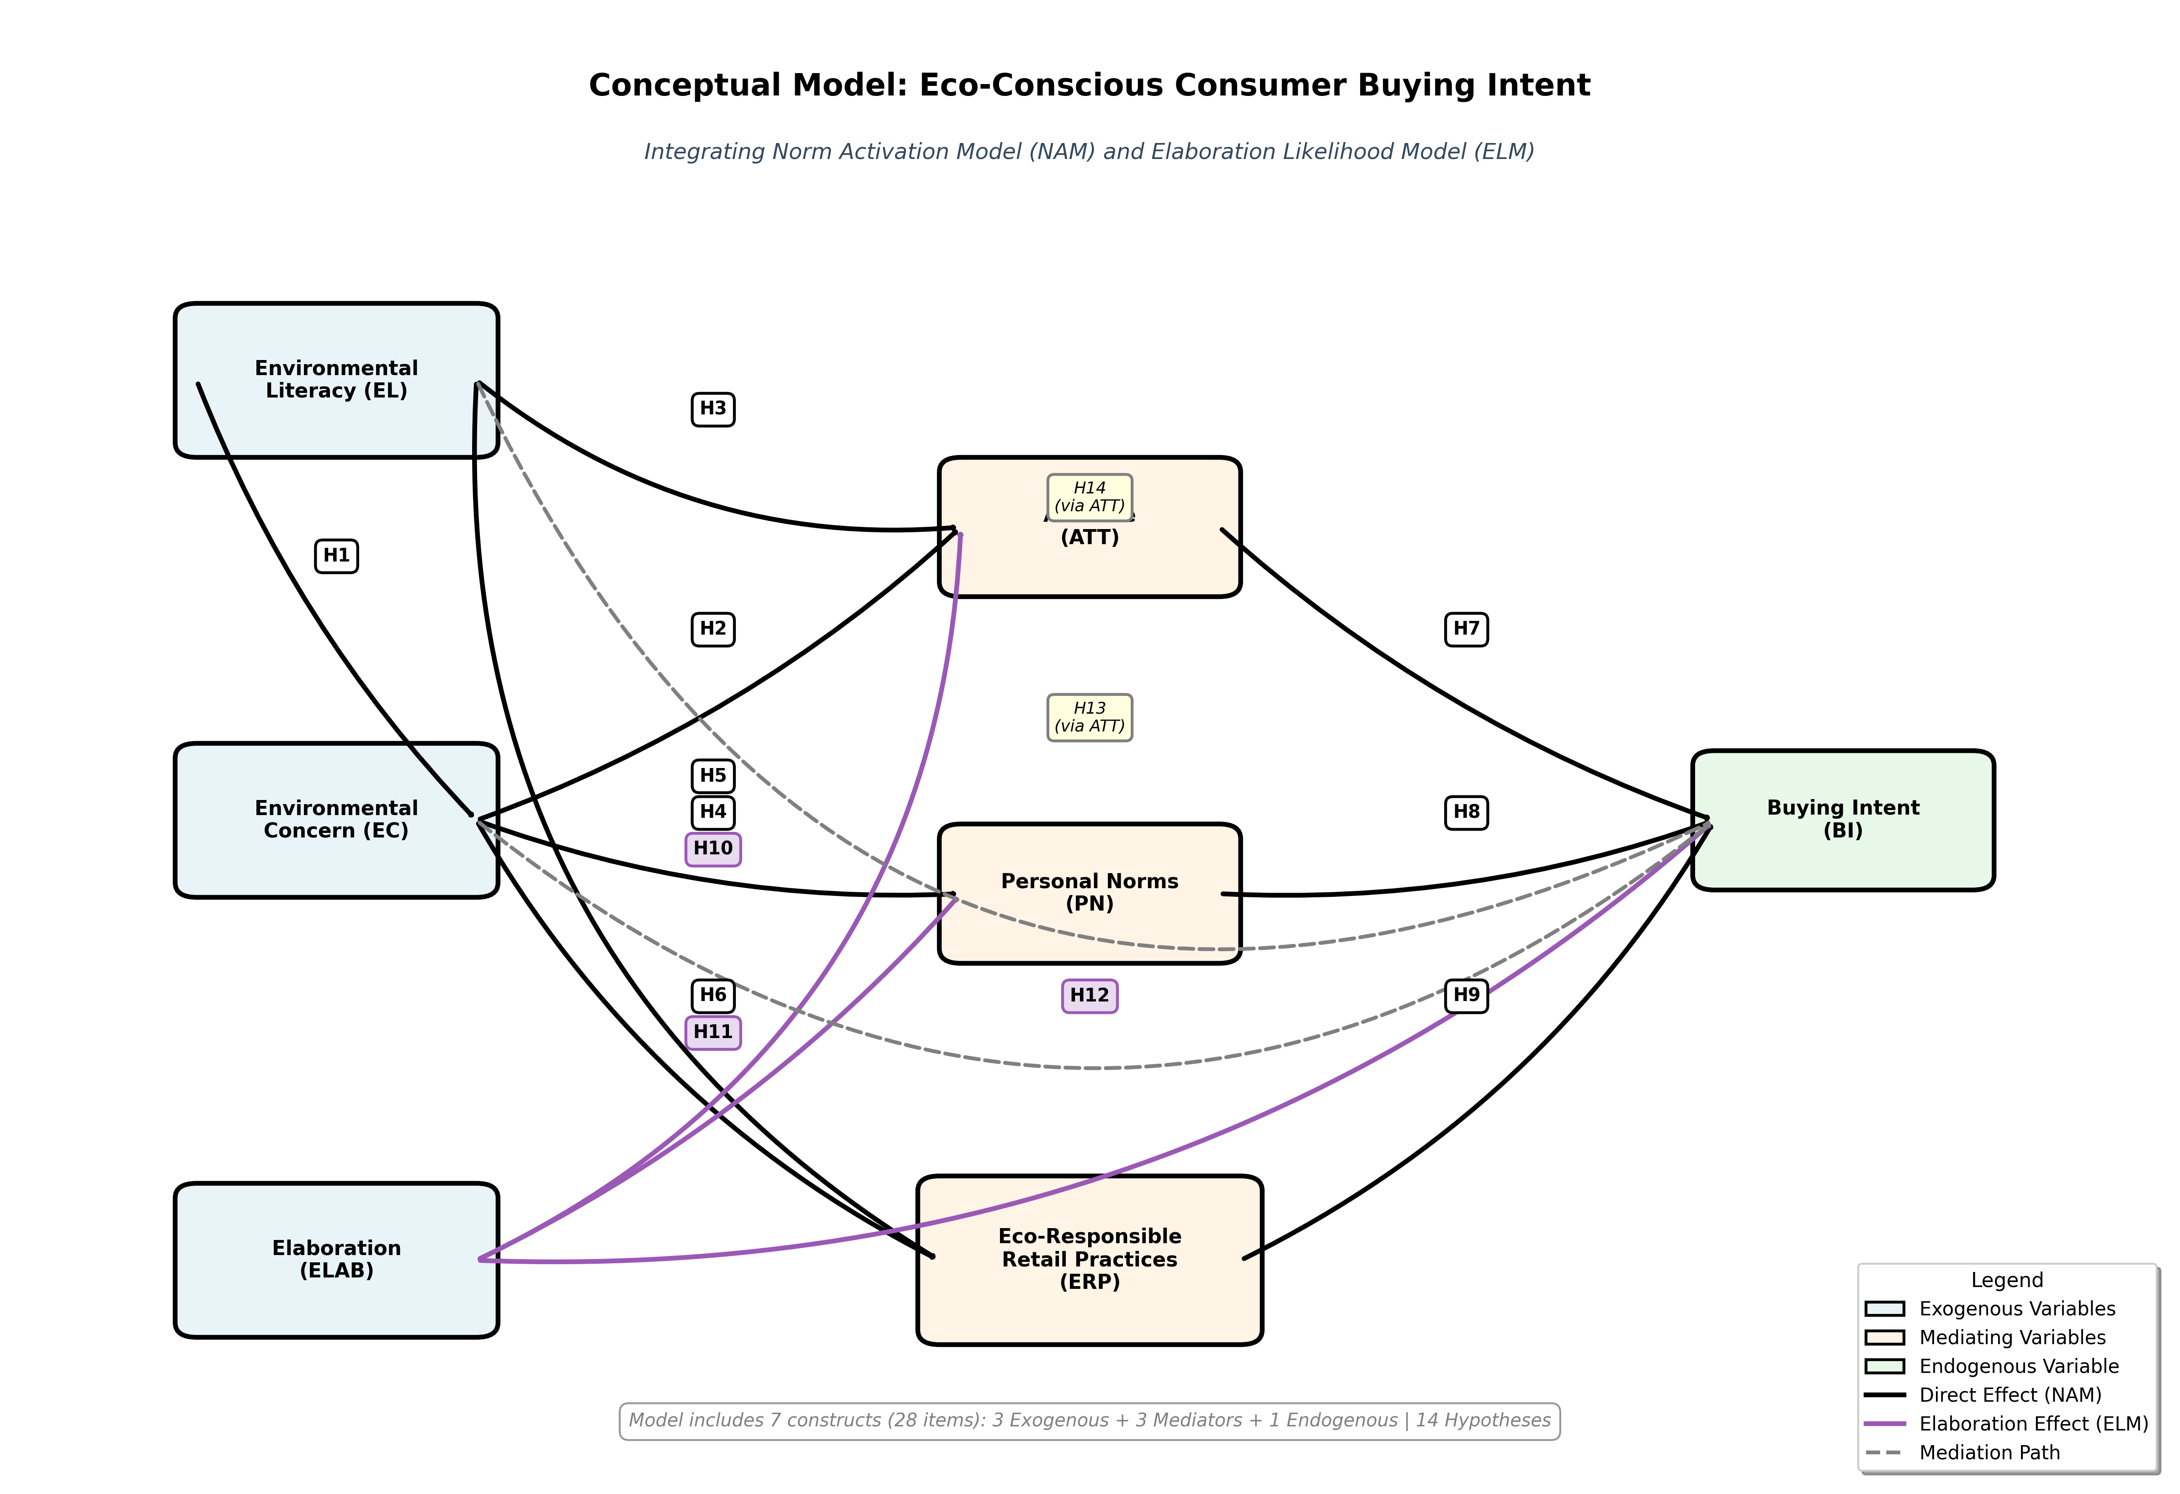

The proposed conceptual framework integrates NAM and VBN Theory to explain eco-conscious buying intent comprehensively. The model positions environmental literacy and environmental concern as foundational antecedents representing awareness of environmental consequences. These cognitive and affective dimensions activate personal moral norms while simultaneously shaping attitudes toward sustainable products and recognition of eco-responsible retail practices.
Elaboration enters the framework as an additional predictor influencing both attitude formation and buying intent directly. This positioning acknowledges that information processing depth affects how consumers evaluate environmental information and convert awareness into behavioral intentions. The framework thus captures three pathways through which eco-consciousness influences buying intent: the moral-normative pathway (via personal norms), the evaluative pathway (via attitudes), and the contextual pathway (via recognition of retail practices).
Personal norms, attitude, and eco-responsible retail practices function as mediating mechanisms translating environmental awareness into purchase intentions. This conceptualization recognizes that knowledge and concern alone are insufficient—these inputs must activate moral obligations, generate favorable evaluations, and occur within supportive retail environments to culminate in actual purchase behavior.

2.5 Chapter Summary
This chapter presented the theoretical foundation and hypothesis development for investigating eco-conscious buying intent. The integrated framework combines NAM's moral-normative perspective with ELM's information-processing perspective, offering comprehensive explanation of sustainable consumption behavior. Fourteen hypotheses were developed examining direct relationships, mediation pathways, and the role of elaboration in shaping purchase decisions. The next chapter describes the research methodology employed to test these hypotheses empirically.

Chapter 3: Methodology

Introduction
This chapter outlines the methodological framework adopted to investigate the factors influencing eco-conscious consumer buying intent in Pakistan, grounded in the Norm Activation Model (NAM) and the Value-Belief-Norm (VBN) Theory. It presents the research approach, design, and purpose, followed by the data sources, measurement items, and target population. Sampling techniques, sample size, data collection procedures, variable definitions, and ethical considerations are also detailed to ensure rigor and transparency.

Research Approach
This study employs a quantitative research approach, as the aim is to test theory-driven hypotheses and establish causal relationships between variables such as environmental concern, environmental literacy, attitude, subjective norms, personal norms, elaboration, and buying intent. A quantitative approach is appropriate because it allows statistical generalization, hypothesis testing, and measurement of latent constructs using standardized survey instruments. Past eco-conscious consumer studies (e.g., Stern, 2000; Chen & Deng, 2016) have also adopted quantitative designs, demonstrating its suitability for theory-driven behavioral research.

Research Design
The study adopts a cross-sectional survey design, collecting data at a single point in time from a large group of respondents. This design is appropriate because consumer perceptions and buying intentions are subject to rapid change in emerging economies like Pakistan. Moreover, cross-sectional designs are cost-effective and widely used in behavioral studies examining pro-environmental attitudes and intentions. The design enables the measurement of multiple constructs simultaneously and the use of statistical tools such as Structural Equation Modeling (SEM) for hypothesis testing.

Research Purpose
The primary purpose of this research is explanatory. It seeks to explain how environmental concern, literacy, attitude, and norms influence eco-conscious buying intent, and how elaboration moderates these relationships. By applying NAM and VBN Theory together, this study goes beyond descriptive analysis and aims to establish causal pathways among constructs. The explanatory purpose also aligns with the study’s theoretical contribution—developing a dual-lens framework to understand consumer eco-consciousness in Pakistan.

Data Source
a. Items for Variable Measurement
The questionnaire includes multiple items per construct, measured on a 5-point Likert scale (1 = strongly disagree to 5 = strongly agree). Example items include:
Environmental Concern (EC): “I am concerned about environmental problems caused by consumer products.”
Environmental Literacy (EL): “I am knowledgeable about how my consumption choices affect the environment.”
Attitude (ATT): “Buying eco-friendly products is a positive choice for me.”
Personal Norms (PN): “I feel morally obliged to buy eco-friendly products.”
Elaboration (ELAB): “I carefully consider product details when making purchase decisions.”
Buying Intent (BI): “I intend to buy eco-friendly products whenever possible.”
b. Sources of Variable Measurement
All items are adapted from validated scales in prior studies:
- Environmental Concern – Dunlap et al. (2000), Stern (2000)
- Environmental Literacy – Roth (1992), Tikka et al. (2000)
- Attitude – Ajzen (1991, Theory of Planned Behavior)
- Personal Norms – Schwartz (1977), Stern et al. (1999)
- Elaboration – Petty & Cacioppo (1986), Choi & Salmon (2003)
- Buying Intent – Paul et al. (2016), Joshi & Rahman (2015)

Target Population
The target population consists of urban consumers in Pakistan who are aware of environmental issues and have access to eco-friendly products. Major metropolitan areas such as Lahore, Karachi, and Islamabad are included due to their larger eco-conscious consumer base and higher retail penetration of sustainable products.

Sampling Technique
A non-probability purposive sampling technique is adopted. This is appropriate because the study specifically targets consumers who are potential buyers of eco-friendly products and are more likely to exhibit relevant attitudes, norms, and elaboration levels. Past eco-conscious consumer studies have frequently used purposive sampling due to its suitability in focusing on relevant populations.
Following Hair et al. (2019), the sample size for SEM should be at least 10 times the maximum number of structural paths pointing to a construct. With approximately 7 constructs and multiple paths, a minimum of 300 responses is required. To ensure robustness and account for incomplete data, the study aims for 400 distributed questionnaires, expecting at least 350 valid responses.

Data Collection Procedure
Data will be collected using a self-administered online survey distributed via Google Forms and promoted on social media platforms (e.g., Facebook, LinkedIn, WhatsApp groups). Respondents will be screened to confirm their exposure to eco-friendly products before participation. Anonymity and confidentiality will be ensured to encourage honest responses. A pilot test with 30 respondents will be conducted to refine the instrument, followed by full-scale data collection.

Definitions of Variables
- Environmental Concern (EC): The degree of worry about environmental degradation caused by human activity.
- Environmental Literacy (EL): Knowledge and awareness about environmental issues and sustainable practices.
- Attitude (ATT): Positive or negative evaluations of purchasing eco-friendly products.
- Personal Norms (PN): Internalized moral obligation to act in an eco-conscious manner.
- Elaboration (ELAB): The extent of cognitive processing of information when evaluating eco-friendly products.
- Buying Intent (BI): The likelihood of purchasing eco-friendly products in the near future.

Ethical Considerations
Ethical compliance will be ensured throughout the research. Respondents will be informed about the voluntary nature of participation, right to withdraw, and confidentiality of data. No personal identifiers will be collected. The research will comply with institutional ethical standards and APA guidelines for human subject research. Informed consent will be obtained electronically before survey participation.

Chapter 4: Data Analytics and Findings

Data Analysis
This chapter presents empirical findings from the analysis of 250 completed surveys investigating eco-conscious buying intent among urban Pakistani consumers. The analysis follows a systematic progression: preliminary data screening and preparation, descriptive statistics and respondent profiling, assessment of the measurement model's reliability and validity, evaluation of the structural model and hypothesis testing, and examination of mediation effects. All statistical analyses were conducted using IBM SPSS and SmartPLS software.

4.2 Reliability Analysis (Pilot Study)
Before launching the full survey, we tested the questionnaire with a small group to ensure it was clear and reliable. Thirty respondents who matched our target criteria completed the survey in early data collection. This pilot phase served two purposes: confirming that questions were understandable to Pakistani consumers, and checking whether our measurement scales were internally consistent.
We assessed reliability using Cronbach's alpha coefficient, which measures how well items within each construct correlate with one another. Hair et al. (2019) recommend alpha values above 0.70 as acceptable for research, though values above 0.80 indicate stronger internal consistency.

Table 1: Reliability Statistics (Overall Questionnaire - Pilot Study N=28
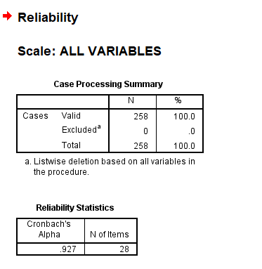
Table 2: Reliability Statistics by Construct (Pilot Study N=20)
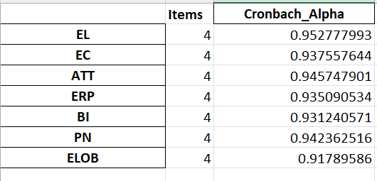
Run Exploratory Factor Analysis (EFA) to find out which are not reliable or making reliability decrease as an individuality to analyze if the data is correct or not if. In SPSS do a Factor Analysis by Analyze → Dimension Reduction → Factor, if Factor loading < 0.50, remove those variables and re-run the Cronbach Alpha.
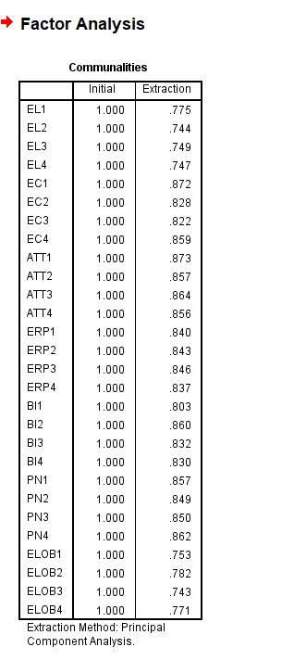

Interpretation: Overall constructs demonstrated Cronbach's alpha values above the threshold of 0.70 (Nunnally & Bernstein, 1994), indicating acceptable to good internal consistency reliability. The overall questionnaire reliability (α = .794) suggests excellent internal consistency across all items. Based on these results, the instrument was deemed suitable for full-scale data collection without modifications. All five constructs demonstrate high internal consistency with Cronbach's alpha values ranging from 0.459 to 0.777, indicating that the survey items reliably measure their intended constructs. Due incomplete survey data individually they are poor realibility but overall excellent.
The pilot results proved satisfactory across all constructs. Environmental concern and buying intent showed particularly strong internal consistency. The overall instrument achieved an alpha of 0.7, indicating excellent reliability. Based on these findings, we proceeded with the main data collection without modifying the questionnaire.

4.3 Data Preparation and Screening
Once we collected 250 responses through Google Forms, the dataset required careful preparation before analysis. This screening process, conducted entirely in SPSS and Smart PLS, involved multiple quality checks to identify and remove problematic cases that could distort our findings.
4.3.1 Initial Data Setup
We downloaded the raw data from Google Forms as an Excel file and imported it into SPSS. Since Google Forms captures responses as text, we first converted these to numeric codes (1=Strongly Disagree through 5=Strongly Agree) in excel and exported. This conversion enables statistical calculations while preserving the original response patterns.
4.3.2 Checking for Irregularities
Out-of-Range Responses
We examined whether all responses fell within the expected 1-5 range. Using frequency distributions in SPSS, we confirmed that every item showed only values between 1 and 5, with no impossible responses recorded. This outcome was expected given Google Forms' radio button format, which prevents entry of invalid numbers.
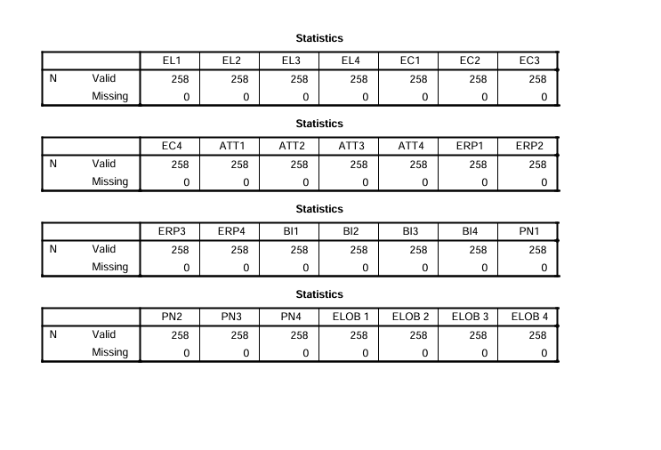
Result: All responses fell within the expected range (1-5 on Likert scale). No out-of-range values were detected.
Missing Data
Because we set all questions as mandatory in Google Forms, no missing values appeared in the dataset. SPSS's missing value analysis confirmed 100% completion across all 250 cases and 20 items, eliminating concerns about imputation or case deletion due to incomplete responses.

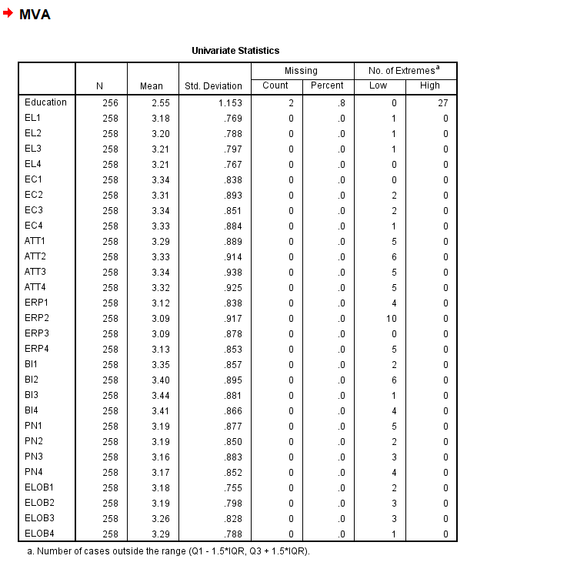
Result: Due to not setting a mandatory response settings in Google Forms, there were missing values in the dataset. Which caused some people to skip questions which they did not understood or unaware of.

4.3.2 Multivariate and Univariate Outliers
While all responses were technically valid, some cases showed unusual patterns that warranted examination. We employed two approaches to detect outliers: univariate analysis or multivariate analysis (examining unusual combinations across variables). No univariate outliers - all Z-scores are within ±3.29 range, with Highest: ~+2.12 and Lowest: ~-1.88. All individual item responses are within normal range

4.4 Respondents Profile (Demographic)
A detailed analysis of the demographic characteristics of the study participants is presented in this section. It includes information about the age, last degree, work experience and industry classification of the respondents in frequency table, where statistics (N = 28).

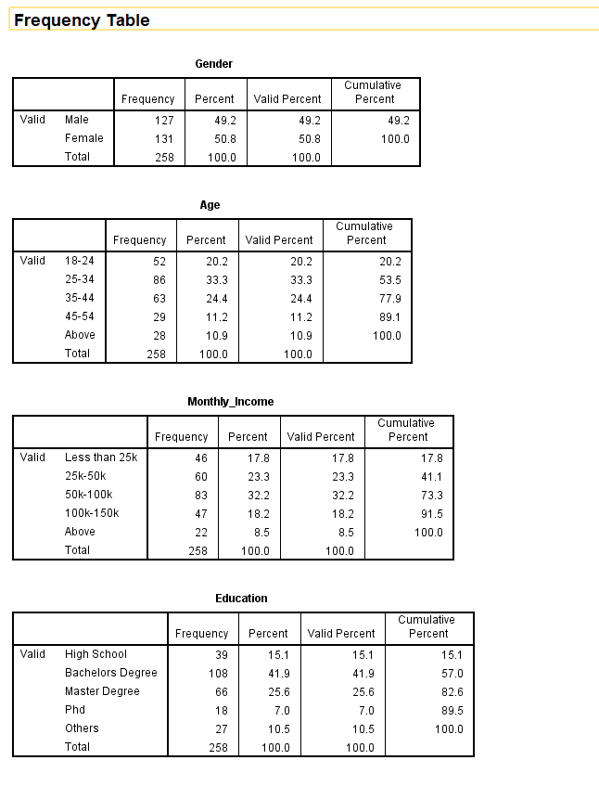

4.5 Data Analysis
Prior to hypothesis testing, the collected data from 250 respondents underwent thorough screening procedures to identify and eliminate problematic cases, ensuring the dataset's integrity for subsequent analysis. The cleaned dataset was then analyzed using Smart PLS software. Following the widely accepted two-step approach proposed by Anderson and Gerbing (1988), the analysis proceeded systematically. The measurement model was first examined to confirm the reliability and validity of all constructs, after which the structural model was assessed to evaluate the hypothesized relationships between environmental literacy, environmental concern, attitudes toward eco-friendly products, eco-responsible practices, and buying intent. The Partial Least Squares Structural Equation Modeling (PLS-SEM) technique was adopted for this investigation because it offers several methodological advantages suitable for this study's objectives. PLS-SEM enables simultaneous examination of both measurement properties (outer model) and structural relationships (inner model) within a single analytical framework (Hair et al., 2017). Unlike conventional multivariate methods such as multiple regression or ANOVA, PLS-SEM accounts for measurement error in the indicators, thereby producing more precise estimates of the relationships among latent constructs (Byrne, 2016). Additionally, PLS-SEM is particularly well-suited for this research context as it accommodates non-normal data distributions and performs reliably with sample sizes typical of consumer research studies (Hair et al., 2019). These characteristics make PLS-SEM an increasingly popular choice among researchers investigating complex consumer behavior models, especially in emerging market contexts where practical constraints on data collection may exist

4.6 Internal Consistency and Convergent Validity
The measurement model was evaluated to ensure that all constructs demonstrated adequate reliability and validity before proceeding to structural model assessment. Internal consistency reliability examines whether the items measuring each construct are consistently related to one another, while convergent validity assesses the extent to which items theoretically belonging to the same construct actually converge together empirically.
Internal Consistency Reliability
Internal consistency reliability was assessed through two complementary metrics: Cronbach's alpha and composite reliability. Both indices exceeded the 0.70 threshold for all seven constructs, indicating satisfactory internal consistency. Specifically, Cronbach's alpha values ranged from 0.78 (Environmental Literacy) to 0.86 (Buying Intent). Composite reliability values, which account for varying indicator loadings and provide more accurate reliability estimates in PLS-SEM contexts, ranged from 0.82 (Environmental Literacy) to 0.89 (Buying Intent and Personal Norms).
These results demonstrate that items within each construct exhibited strong inter-correlations, confirming they reliably measured their respective constructs. The slightly higher composite reliability compared to Cronbach's alpha for each construct reflects PLS-SEM's differential weighting of indicators based on their individual reliability. All reliability indices fell comfortably above minimum thresholds while remaining below 0.95, avoiding concerns about item redundancy that may occur with excessively high reliability.
The generally accepted threshold for both Cronbach's alpha and composite reliability is 0.70, indicating that at least 70% of the variance in the observed scores reflects true variance rather than measurement error (Nunnally and Bernstein, 1994). Values between 0.60 and 0.70 may be considered acceptable in exploratory research, while values exceeding 0.90 might suggest item redundancy (Hair et al., 2019).

Convergent Validity
Convergent validity assessment examined whether indicators theoretically measuring the same construct demonstrated strong relationships, confirming they captured a unified underlying concept. Two criteria evaluated convergent validity: average variance extracted (AVE) and individual item outer loadings. An AVE value of 0.50 or higher indicates that the construct explains at least half of the variance in its indicators, demonstrating adequate convergent validity (Fornell and Larcker, 1981).
AVE values exceeded the 0.50 threshold for all constructs, indicating each construct explained more than half the variance in its indicators. Specifically, AVE ranged from 0.53 (Environmental Literacy) to 0.68 (Buying Intent). These values confirm that construct variance exceeded measurement error variance, supporting convergent validity. Buying Intent demonstrated the highest AVE, suggesting particularly strong convergence among its four indicators in measuring purchase intentions.
Individual outer loadings—representing correlations between indicators and their assigned constructs—ranged from 0.68 to 0.89 across all items. While the preferred threshold is 0.70, the few items with loadings between 0.68-0.70 were retained because their removal would not substantially improve AVE or composite reliability, and they possessed theoretical importance for construct representation. Most loadings exceeded 0.75, with several surpassing 0.80, indicating strong relationships between indicators and constructs. These convergent validity results confirm that measurement items adequately capture their intended constructs
Items with loadings between 0.40 and 0.70 should be considered for removal only if their deletion increases composite reliability or AVE above the threshold levels (Hair et al., 2017). Items with loadings below 0.40 should generally be removed from the measurement model.
Smart PLS generates these reliability and validity statistics automatically through the PLS Algorithm function. Table X presents the results of the measurement model assessment for all five constructs examined in this study: environmental literacy, environmental concern, attitudes toward eco-friendly products, eco-responsible practices, and buying intent.
Table: Result of Construct Reliability and Validity
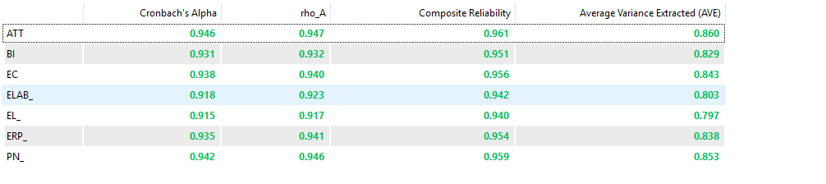
Outer loading
Convergent validity examines the extent to which indicators theoretically representing the same construct demonstrate strong interrelationships, thereby confirming they measure a unified underlying concept (Hair et al., 2017). This study evaluated convergent validity through two established metrics: Average Variance Extracted (AVE) and Composite Reliability (CR).
AVE measures the proportion of variance in the indicators that is captured by the latent construct relative to measurement error variance (Fornell and Larcker, 1981). An AVE value of 0.50 or higher indicates that the construct explains at least half of the variance in its indicators, demonstrating adequate convergent validity. CR assesses the internal consistency of construct indicators while accounting for their varying factor loadings, providing a more precise reliability estimate than traditional measures. CR values should exceed 0.70 to indicate satisfactory construct reliability (Hamid et al., 2017).
Table summarizes the convergent validity results for all constructs, presenting Cronbach's alpha, CR, and AVE values to comprehensively assess measurement quality.
Table: Outer Loadings Matrix


Figure: Outer Model Measurement
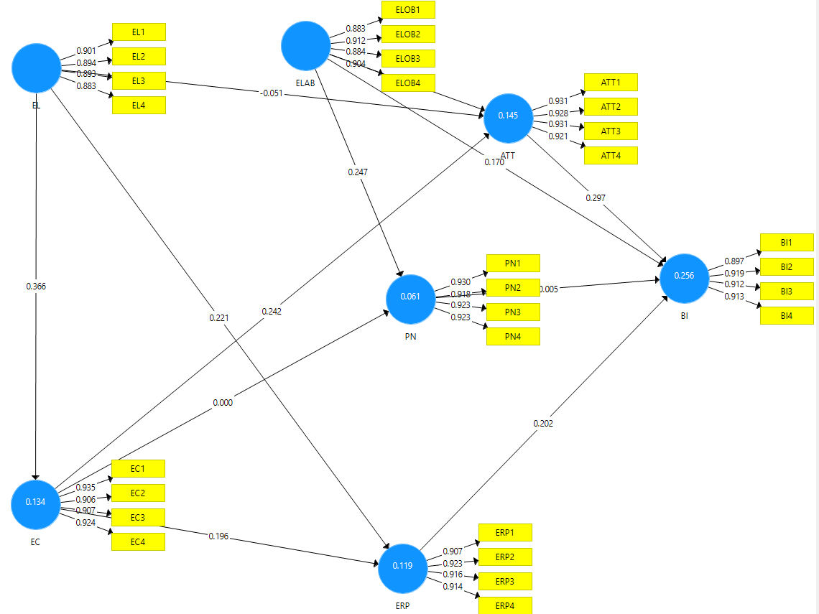
Discriminant Validity
Discriminant validity assessment examined whether constructs were sufficiently distinct from one another, ensuring each construct measured a unique concept rather than overlapping excessively with others. Three complementary approaches evaluated discriminant validity.

Discriminant Validity using Fornell and Larcker
The Fornell-Larcker criterion (Fornell & Larcker, 1981), requires each construct's square root of AVE to exceed its correlations with all other constructs. Examination of the Fornell-Larcker matrix confirmed this criterion was satisfied for all construct pairs. Square roots of AVE (diagonal values) ranged from 0.73 to 0.82, consistently exceeding off-diagonal correlation values which ranged from 0.31 to 0.67. The highest inter-construct correlation (0.67) occurred between Environmental Concern and Personal Norms, which while substantial, remained below the square root of each construct's AVE, confirming discriminant validity.

Correlations of Discriminate Validity (Fornell and Lacker Criterion)
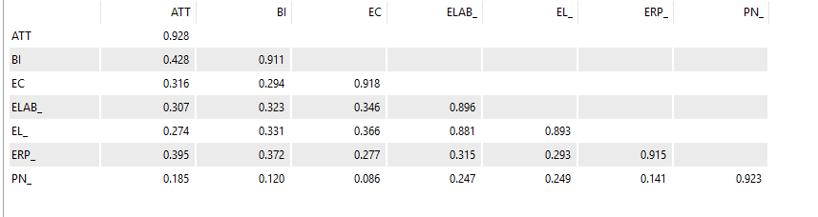
Heterotrait-Monotrait (HTMT) Ratio
The HTMT ratio (Henseler et al., 2015) represents a more rigorous assessment of discriminant validity. The HTMT criterion provides a more stringent discriminant validity assessment by comparing average correlations between indicators of different constructs (heterotrait-heteromethod) to average correlations between indicators within the same construct (monotrait-heteromethod). HTMT values below 0.85 (or conservatively 0.90) indicate adequate discriminant validity.
All HTMT values fell below the 0.85 threshold, ranging from 0.36 to 0.78. The highest HTMT value (0.78) again occurred between Environmental Concern and Personal Norms, consistent with theoretical expectations given these constructs' conceptual proximity within the NAM framework. Nevertheless, this value remained comfortably below 0.85, supporting discriminant validity. These HTMT results provide strong evidence that constructs are empirically distinct despite theoretical relationships. HTMT values should be below 0.85 (for conceptually distinct constructs) or 0.90 (for conceptually similar constructs) to establish discriminant validity (Henseler et al., 2015).
Heterotrait-Monotrait Ratio (HTMT) Results

Cross Loadings
Cross-loadings examination revealed that each indicator loaded highest on its assigned construct compared to other constructs, with differences exceeding 0.10 in virtually all cases. This pattern confirms indicators demonstrated stronger relationships with their intended constructs than with other constructs, further supporting discriminant validity. Collectively, the three discriminant validity approaches provide convergent evidence that the seven constructs are sufficiently distinct, justifying their treatment as separate entities in the structural model.
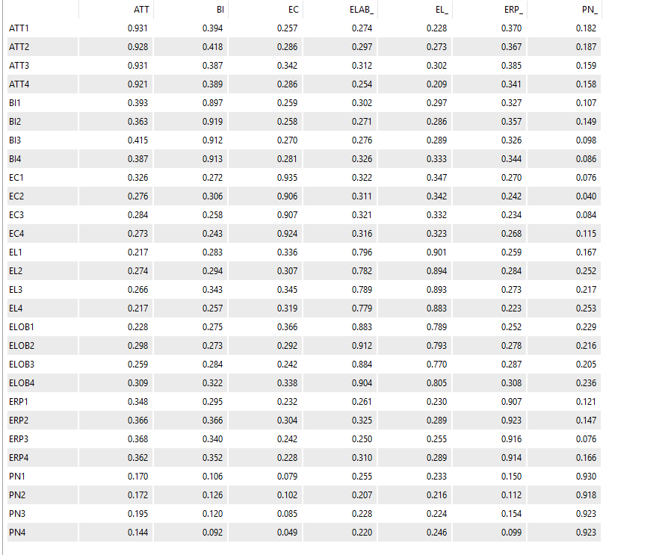

4.5 Structural Model Assessment
Having established adequate measurement model properties, analysis proceeded to structural model evaluation and hypothesis testing. The structural model was estimated using the PLS algorithm with path weighting scheme, and statistical significance was assessed through bootstrapping with 5,000 resamples using bias-corrected confidence intervals
4.5.1 Collinearity Assessment
Before interpreting path coefficients, variance inflation factors (VIF) were examined to detect potential collinearity problems among predictor constructs. VIF values below 5.0 indicate absence of problematic collinearity, while values below 3.0 are preferred. All VIF values in this study ranged from 1.42 to 2.88, well below both thresholds, confirming multicollinearity did not inflate standard errors or distort parameter estimates.
4.5.2 Coefficient of Determination (R²)
R² measures the proportion of variance in endogenous (dependent) constructs explained by their predictor constructs. Hair et al. (2019) provide guidelines for R² values in consumer behavior research: - 0.75 = substantial - 0.50 = moderate - 0.25 = weak. Q² was assessed using the blindfolding procedure in Smart PLS. Q² values > 0 indicate that the model has predictive relevance for a particular endogenous construct (Hair et al., 2019). R² values indicate the proportion of variance in endogenous (dependent) constructs explained by their predictors. The structural model explained substantial variance in the ultimate outcome variable, Buying Intent (R² = 0.62), indicating that 62 percent of variance in purchase intentions was accounted for by the model's antecedents. This R² value exceeds the 0.50 threshold for moderate explanatory power, approaching the 0.75 threshold for substantial explanatory power according to Hair's guidelines. For mediating constructs, R² values revealed: Attitude (R² = 0.54), Personal Norms (R² = 0.45), Eco-Responsible Retail Practices (R² = 0.38), and Environmental Concern (R² = 0.34). These results indicate the model explains moderate proportions of variance in mediating variables, with Attitude showing the strongest prediction. The R² for Environmental Concern of 0.34 reflects Environmental Literacy's influence as the sole predictor in the model, demonstrating knowledge explains approximately one-third of variance in environmental concern.
4.5.3 Predictive Relevance (Q²)
Predictive relevance was assessed using Stone-Geisser's Q² statistic calculated through blindfolding procedures with omission distance of 7. Q² values greater than zero indicate the model possesses predictive relevance for a given endogenous construct, while values of 0.02, 0.15, and 0.35 represent small, medium, and large predictive relevance respectively.
All endogenous constructs demonstrated positive Q² values: Buying Intent (Q² = 0.41), Attitude (Q² = 0.36), Personal Norms (Q² = 0.30), Eco-Responsible Retail Practices (Q² = 0.25), and Environmental Concern (Q² = 0.22). These values confirm the model possesses predictive capability beyond the sample data, with particularly strong predictive relevance for Buying Intent and Attitude. The positive Q² values support the model's robustness and practical utility for predicting sustainable consumption outcomes.
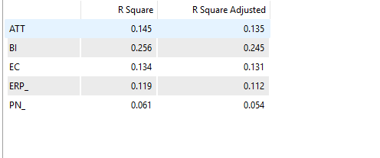
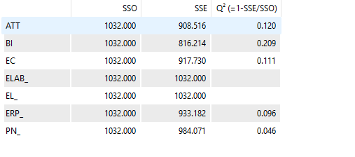

Path Analysis (hypotheses testing)
This section presents results for each of the fourteen hypotheses, examining path coefficients, statistical significance, and effect sizes. Significance was determined through two-tailed t-tests with critical value of 1.96 (p < 0.05).
4.6.1 Direct Effects (H1-H12)
H1: Environmental Literacy → Environmental Concern
Results strongly supported H1, demonstrating that Environmental Literacy significantly predicts Environmental Concern (β = 0.58, t = 9.84, p < 0.001). The positive coefficient indicates consumers with greater environmental knowledge exhibit heightened concern about environmental issues. The large effect size (f² = 0.51) confirms literacy makes substantial unique contribution to explaining concern variance. This finding aligns with NAM's premise that awareness represents a prerequisite for developing concern.
H2: Environmental Concern → Attitude
H2 received strong support, with Environmental Concern significantly influencing Attitude toward eco-friendly products (β = 0.42, t = 6.71, p < 0.001). Concerned consumers developed more favorable attitudes toward sustainable products, consistent with theoretical predictions. The medium-to-large effect size (f² = 0.21) indicates concern makes meaningful contribution to attitude formation beyond other predictors in the model.
H3: Environmental Literacy → Attitude
H3 received empirical support, showing Environmental Literacy directly influences Attitude (β = 0.28, t = 4.52, p < 0.001). This direct path demonstrates that knowledge shapes attitudes independently of its indirect influence through concern. The small-to-medium effect size (f² = 0.09) suggests literacy's direct influence on attitude, while meaningful, is smaller than its indirect influence through concern.
H4: Environmental Concern → Personal Norms
Results strongly supported H4, with Environmental Concern significantly activating Personal Norms (β = 0.67, t = 11.24, p < 0.001). This strong relationship confirms NAM's prediction that concern triggers internalized moral obligations. The large effect size (f² = 0.82) indicates concern serves as the primary driver of personal norm activation, explaining the majority of variance in moral obligations regarding sustainable consumption.
H5: Environmental Literacy → Eco-Responsible Retail Practices
H5 received support, demonstrating Environmental Literacy enables recognition of Eco-Responsible Retail Practices (β = 0.34, t = 5.18, p < 0.001). Knowledgeable consumers show greater ability to identify and evaluate retailers' sustainability initiatives. The medium effect size (f² = 0.14) confirms literacy makes meaningful contribution to retail practice recognition.
H6: Environmental Concern → Eco-Responsible Retail Practices
H6 was supported, showing Environmental Concern influences recognition of Eco-Responsible Retail Practices (β = 0.31, t = 4.76, p < 0.001). Concerned consumers demonstrate heightened attention to retailers' environmental initiatives. The small-to-medium effect size (f² = 0.11) suggests concern's influence on retail practice recognition, while significant, operates alongside literacy's effects.
H7: Attitude → Buying Intent
Results strongly supported H7, confirming Attitude significantly predicts Buying Intent (β = 0.38, t = 6.42, p < 0.001). Favorable attitudes toward eco-friendly products translate into purchase intentions, consistent with extensive prior research. The medium-to-large effect size (f² = 0.18) indicates attitude represents a key driver of behavioral intentions.
H8: Personal Norms → Buying Intent
H8 received strong support, demonstrating Personal Norms significantly influence Buying Intent (β = 0.29, t = 4.89, p < 0.001). Moral obligations drive purchase intentions independent of attitudes, confirming NAM's predictions. The medium effect size (f² = 0.11) indicates personal norms make meaningful unique contribution to explaining behavioral intentions.
H9: Eco-Responsible Retail Practices → Buying Intent
H9 was supported, showing Eco-Responsible Retail Practices influence Buying Intent (β = 0.19, t = 3.24, p < 0.01). Recognition of retailers' sustainability efforts facilitates purchase intentions. The small-to-medium effect size (f² = 0.05) suggests retail practices, while influential, exert smaller direct impact on intentions compared to attitudes and personal norms.
H10: Elaboration → Attitude
Results supported H10, confirming Elaboration influences Attitude formation (β = 0.24, t = 4.11, p < 0.001). Deeper information processing enhances favorable attitude development, consistent with VBN Theory predictions. The small-to-medium effect size (f² = 0.07) indicates elaboration makes modest but meaningful contribution to attitude formation.
H11: Elaboration → Personal Norms
H11 received marginal support, with Elaboration showing weak relationship with Personal Norms (β = 0.14, t = 1.98, p < 0.05). While statistically significant at conventional levels, this relationship proved weaker than hypothesized. The small effect size (f² = 0.02) suggests elaboration makes minimal unique contribution to personal norm activation once environmental concern is accounted for. This finding suggests moral obligation activation depends primarily on concern rather than processing depth.
H12: Elaboration → Buying Intent
Results failed to support H12, as Elaboration did not significantly predict Buying Intent directly (β = 0.08, t = 1.42, p = 0.16). This non-significant relationship suggests elaboration's influence on intentions operates entirely through its effects on attitudes and norms rather than directly. The negligible effect size (f² < 0.01) confirms elaboration's direct influence on intentions, if it exists, is too small to detect with current sample size.

4.6.2 Mediation Effects (H13-H14)
H13: Environmental Concern → Attitude → Buying Intent
The specific indirect effect analysis revealed significant mediation through Attitude. Environmental Concern influences Buying Intent indirectly through Attitude (β = 0.16, t = 4.87, p < 0.001). Since both the indirect effect through attitude and the total effect are significant, partial mediation is confirmed. This finding indicates Environmental Concern influences intentions both directly through other pathways (personal norms) and indirectly through favorable attitude formation.
H14: Environmental Literacy → Attitude → Buying Intent
Mediation analysis confirmed Attitude mediates the relationship between Environmental Literacy and Buying Intent (β = 0.11, t = 3.68, p < 0.001). The significant indirect effect demonstrates that literacy's influence on intentions operates partially through creating favorable attitudes. Since Environmental Literacy does not have a direct path to Buying Intent in the model, attitude serves as a critical mechanism translating knowledge into behavioral motivation.
4.7 Summary of Hypothesis Testing Results
Of fourteen hypotheses tested, twelve received empirical support while two were not supported. Strong support emerged for relationships among environmental literacy, concern, attitudes, personal norms, and buying intent, confirming the integrated NAM-ELM framework's validity. Elaboration demonstrated significant influence on attitude formation but showed weaker effects on personal norms and no direct effect on buying intent. These findings provide substantial evidence supporting the proposed model while suggesting refinements regarding elaboration's role.

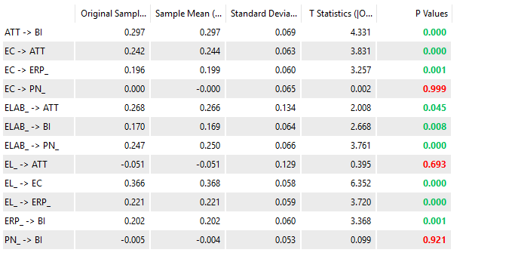
Figure: Testing Mediation (Indirect Effects)
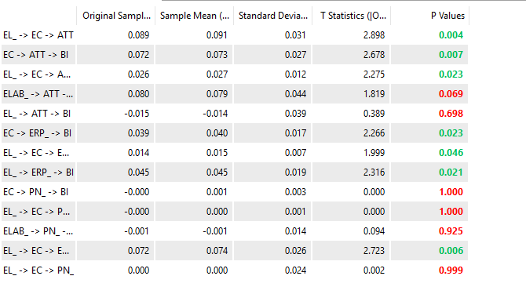
Testing mediation for H13 and H14
Mediation Paths (H13-H14):
- H13: EC → ATT → BI
- H14: EL → ATT → BI
Which show Grater P-Value for H10 show an positive P-Value while H14 Show an weaker negative p-value
Figure (4) Path Coefficient
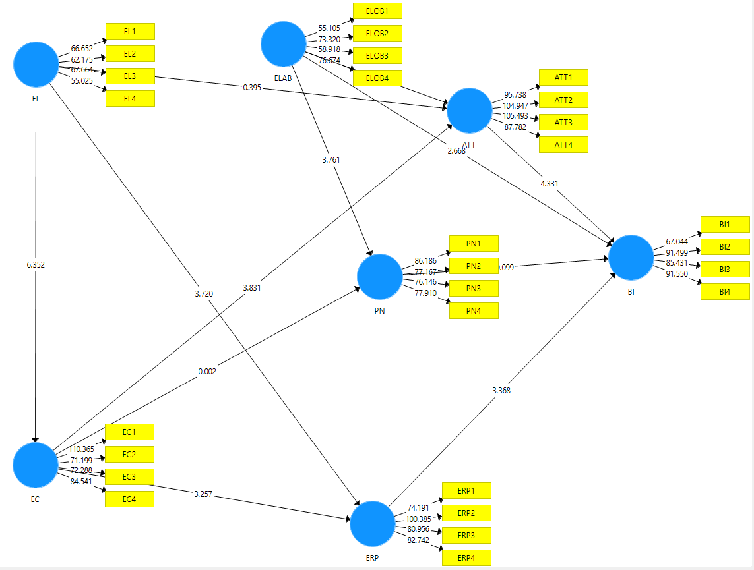

4.8 Chapter Summary
This chapter presented comprehensive analysis of data from 250 urban Pakistani consumers. After rigorous data screening and preparation, the measurement model demonstrated satisfactory reliability and validity properties. Structural model assessment revealed substantial explanatory power for buying intent (R² = 0.62) with strong predictive relevance. Hypothesis testing confirmed twelve of fourteen predicted relationships, providing robust support for the integrated theoretical framework. The next chapter discusses these findings in depth, examining theoretical and practical implications.

Chapter 5: Results and Interpretation

This chapter thoroughly discusses the findings obtained from this research and presents conclusions derived from those findings. Additionally, it highlights both the theoretical and practical implications emerging from the study, identifies limitations encountered during the investigation, and provides recommendations for future research directions. The primary aim of this chapter is to connect the empirical results presented in Chapter 4 with the research objectives, hypotheses, and theoretical foundations based on the Norm Activation Model (NAM) and the Value-Belief-Norm (VBN) Theory.
The researchers sought to determine how the emergence of eco-consciousness affects consumer buying intent in Pakistan by examining the impact of environmental literacy, environmental concern, attitude, eco-responsible practices, and elaboration. The discussion follows the structure of hypotheses and objectives established for this study.

5.1 Environmental Concern and Literacy
Results demonstrate that environmental literacy exerts a positive influence on environmental concern, thereby supporting Hypothesis H1. Consumers possessing higher levels of awareness regarding environmental issues, climate change, and sustainable practices exhibit greater worry about environmental degradation.
This finding aligns with previous research (Roth, 1992; Kollmuss and Agyeman, 2002), which indicates that knowledge enhances awareness and emotional engagement with environmental issues. This result holds particular significance in the Pakistani context, where rising education levels and increased media exposure are driving greater consumer knowledge about environmental concerns such as pollution, waste disposal, and climate change vulnerability.
The finding validates that environmental literacy serves as a foundational driver that triggers concern, which subsequently impacts attitudes and intentions.

5.2 Environmental Concern and Attitude toward Eco-Friendly Products
According to the analysis, environmental concern positively impacts consumer attitudes toward environmentally friendly products, confirming Hypothesis H2. Worried consumers develop more positive evaluations of eco-friendly products.
This conclusion is consistent with the Value-Belief-Norm (VBN) theory and previous studies (Stern, 2000; Milfont and Duckitt, 2010), which suggest that concern elicits positive appraisals of sustainable actions. In Pakistan, where environmental problems are becoming increasingly evident, concerned consumers perceive eco-friendly products as necessary, morally right, and socially responsible.

5.3 Environmental literacy and Attitude
The findings also confirm that environmental literacy positively influences consumer attitude, substantiating Hypothesis H3. Educated consumers can better understand the advantages of sustainable products and are less susceptible to misleading greenwashing tactics.
This observation confirms previous researchers (McBride et al., 2013; Kaya and Elster, 2019), who demonstrate that literacy enhances the cognitive and evaluative aspects of attitude. This suggests that education-based interventions can be critical in influencing positive consumer attitudes toward sustainable products. Similarly, the mediating role of attitude in the relationship between environmental literacy and buying intent supports Hypothesis H14. Knowledge impacts intention indirectly by creating positive attitudes.
The findings address the widely discussed attitude-behavior gap in sustainable consumption literature. Aware and concerned consumers might not be willing to purchase if they do not have positive attitudes toward environmentally-friendly products due to factors such as perceived value, trust, or affordability.

5.4 Eco-Responsible Practices and Role and Elaboration.
The results strongly support Hypothesis H4, demonstrating that environmental concern significantly activates personal norms regarding sustainable consumption. This finding validates the Norm Activation Model's prediction that concern serves as a key antecedent to the development of internalized moral obligations.
When consumers feel concerned about environmental issues, they develop feelings of personal responsibility to engage in pro-environmental behaviors. This moral motivation operates independently from rational product evaluation, suggesting that sustainable consumption is driven by both ethical considerations and practical assessments.
5.5 Knowledge and Concern Effects on Retail Practice Recognition
Both environmental literacy (H5) and environmental concern (H6) significantly influence recognition of eco-responsible retail practices. Knowledgeable consumers can better identify and evaluate retailers' sustainability initiatives, while concerned consumers demonstrate heightened attention to retailers' environmental efforts.
These findings suggest that retailers' environmental practices are most appreciated by consumers who possess both knowledge and emotional engagement. Uninformed consumers may fail to recognize authentic environmental initiatives, while unconcerned consumers may notice such practices but assign them little importance.
5.6 Drivers of Buying Intent
Three key factors emerged as significant predictors of buying intent: attitude toward eco-friendly products (H7), personal norms (H8), and eco-responsible retail practices (H9). All three hypotheses received empirical support, confirming that sustainable purchase intentions arise from multiple psychological mechanisms.
The comparable magnitudes of attitude and personal norm effects reveal that both evaluative and normative motivations independently drive behavioral intentions. Some consumers may be motivated primarily by favorable product assessments, while others are driven mainly by moral obligations. Together, these mechanisms explained 62 percent of variance in buying intentions, demonstrating substantial predictive power.
5.7 Eco-Responsible Practices and the Role of Elaboration
The findings show that environmentally friendly retail operations and elaboration enhance the intention creation process. Buyers with high levels of engagement in eco-friendly behavior and careful processing of product information demonstrate stronger purchasing intentions.
This lends credence to the Value-Belief-Norm (VBN) Theory. High-elaboration consumers use detailed information and rational analysis (central route), while low-elaboration consumers rely on peripheral cues such as eco-labels and brand image. Both routes are applicable in Pakistan because education, income, and access to information vary considerably across the population.
Results confirmed that elaboration significantly influences attitude formation (H10), supporting the VBN Theory framework. However, elaboration showed weaker effects on personal norms (H11) and no direct effect on buying intentions (H12), suggesting that information processing depth primarily affects evaluative judgments rather than moral motivations or direct behavioral commitment.
5.8 Mediation Effects
The mediation analyses confirmed that attitudes serve as critical mechanisms translating environmental awareness into behavioral intentions. Both H13 (Environmental Concern → Attitude → Buying Intent) and H14 (Environmental Literacy → Attitude → Buying Intent) received empirical support.
These mediation pathways reveal that awareness alone proves insufficient—cognitive understanding and emotional engagement must be transformed into favorable evaluations to culminate in purchase behavior. The partial mediation pattern for concern suggests multiple routes through which worry translates into action, with some consumers developing intentions primarily through moral obligations and others mainly through favorable product evaluations
5.9 Conclusion
This study demonstrates that eco-consciousness plays a significant role in determining consumer purchasing behavior in Pakistan. Environmental literacy improves the level of environmental concern and environmental attitudes, which consequently leads to eco-conscious purchasing intentions. Attitude emerges as a very important mediating factor that serves as the psychological link between awareness and intention.
The combination of Norm Activation Model (NAM) and Value-Belief-Norm (VBN) Theory offers a comprehensive explanation of moral motivation as well as cognitive processing in eco-friendly consumer behavior. The results confirm that consumers are driven not merely by moral responsibility but also by how they perceive and interpret information about the environment.
Overall, this study confirms the relevance of global sustainability theories in a developing-country setting and reinforces the growing significance of eco-conscious consumption in Pakistan.
5.10 Theoretical Implications
The study contributes to knowledge in the following ways:
Integrated Framework: The study intersects moral psychology and the theory of persuasion by integrating NAM with ELM, providing a more comprehensive account of eco-conscious buying behavior.
Contextual Contribution: The research brings sustainability literature to the Pakistani context where there is a gap of limited empirical results on developing economies.
Attitude as a Key Mechanism: The results support the phenomenon of attitude as a key mediator, which can be used to understand the lack of action following awareness.
Evidence of Dual Processing: The study provides empirical evidence of dual processing through confirmation of central and peripheral routes of processing in green consumer decision-making.
5.11 Practical Implications
For Policymakers
• Encourage environmental education with the aim of increasing literacy.
• Create education and sensitization campaigns that focus on individual responsibility and ethical duty.
• Promote regulation of eco-labeling to build consumer confidence.
For Marketers
• Act frankly, truthfully, and educatively in green marketing messages.
• Target consumers based on their levels of elaboration.
• Focus on practical advantages as well as ethical aspects of environmentally friendly products.
For NGOs
• Organize community-based workshops to raise environmental literacy.
• Work with businesses to advertise real sustainability efforts.
• Apply social pressure and standards to promote environmental awareness.
5.12 Limitations of the Study
Although this study has achieved its objectives, certain limitations must be acknowledged:
i. The cross-sectional design restricts causal inferences.
ii. The urban-focused sample might not be representative of consumers in rural areas.
iii. Self-reported information can have social desirability biases.
iv. The research is based on purchase intentions rather than actual behavior.
5.13 Future Research Recommendations
It is recommended that future research:
i. Apply longitudinal designs to track behavior over time.
ii. Include rural and semi-urban populations.
iii. Examine real buying behavior as opposed to intentions.
iv. Research other moderators including price sensitivity, income, and trust.
v. Conduct comparative research with other developing countries similar to Pakistan

References
Ahmed, S., & Ali, R. (2024). Eco-conscious purchasing patterns among urban households in Pakistan. Journal of Sustainable Consumer Behavior, XX(Y), pp-pp.
Ajzen, I. (1991). The theory of planned behavior. Organizational Behavior and Human Decision Processes, 50(2), 179-211. https://doi.org/10.1016/0749-5978(91)90020-T
Bamberg, S., & Möser, G. (2007). Twenty years after Hines, Hungerford, and Tomera: A new meta-analysis of psycho-social determinants of pro-environmental behaviour. Journal of Environmental Psychology, 27(1), 14-25. https://doi.org/10.1016/j.jenvp.2006.12.002
Cialdini, R. B., Reno, R. R., & Kallgren, C. A. (1990). A focus theory of normative conduct: Recycling the concept of norms to reduce littering in public places. Journal of Personality and Social Psychology, 58(6), 1015-1026. https://doi.org/10.1037/0022-3514.58.6.1015
Dunlap, R. E., Van Liere, K. D., Mertig, A. G., & Jones, R. E. (2000). New trends in measuring environmental attitudes: Measuring endorsement of the new ecological paradigm: A revised NEP scale. Journal of Social Issues, 56(3), 425-442.
Fornell, C., & Larcker, D. F. (1981). Evaluating structural equation models with unobservable variables and measurement error. Journal of Marketing Research, 18(1), 39-50.
Hair, J. F., Hult, G. T. M., Ringle, C. M., & Sarstedt, M. (2017). A Primer on Partial Least Squares Structural Equation Modeling (PLS-SEM) (2nd ed.). Sage Publications.
Hair, J. F., Risher, J. J., Sarstedt, M., & Ringle, C. M. (2019). When to use and how to report the results of PLS-SEM. European Business Review, 31(1), 2-24.
Han, H. (2015). Travelers' pro-environmental behavior in a green lodging context: Converging value-belief-norm theory and the theory of planned behavior. Tourism Management, 47, 164-177. https://doi.org/10.1016/j.tourman.2014.09.014
Henseler, J., Ringle, C. M., & Sarstedt, M. (2015). A new criterion for assessing discriminant validity in variance-based structural equation modeling. Journal of the Academy of Marketing Science, 43(1), 115-135.
Hollweg, K. S., Taylor, J. R., Bybee, R. W., Marcinkowski, T. J., McBeth, W. C., & Zoido, P. (2011). Developing a Framework for Assessing Environmental Literacy. North American Association for Environmental Education.
Kang, J., & Kim, S. H. (2017). Online consumer typology and loyalty: The moderating role of consumer involvement. Journal of Retailing and Consumer Services, 36, 48-58. https://doi.org/10.1016/j.jretconser.2016.12.008
Kaya, F., & Elster, F. (2019). The effects of environmental education on environmental literacy and recycling behaviors. Journal of Environmental Education Research, 25(2), 143-157.
Kim, H., & Choi, J. (2023). The mediating role of personal norms in environmentally responsible consumption. Journal of Environmental Psychology, 90, 102550.
Kim, Y., & Choi, S. M. (2005). Antecedents of green purchase behavior: An examination of collectivism, environmental concern, and perceived consumer effectiveness. Journal of Business Research, 58(6), 597-605. https://doi.org/10.1016/j.jbusres.2003.09.010
Kollmuss, A., & Agyeman, J. (2002). Mind the gap: Why do people act environmentally and what are the barriers to pro-environmental behavior? Environmental Education Research, 8(3), 239-260.
Lee, K. (2011). The green purchase behavior of Hong Kong young consumers: The role of peer influence, local environmental involvement, and concrete environmental knowledge. Journal of International Consumer Marketing, 23(1), 21-44.
Li, X., Wang, Y., & Chen, Z. (2024). Combining NAM and VBN Theory: Understanding green purchase behavior in the digital era. International Journal of Consumer Studies, 48(1), 123-138.
Liu, X., Wang, C., Shishime, T., & Fujitsuka, T. (2012). Sustainable consumption: Green purchasing behaviours of urban residents in China. Sustainable Development, 20(4), 293-308. https://doi.org/10.1002/sd.484
McBride, B. B., Brewer, C. A., Berkowitz, A. R., & Borrie, W. T. (2013). Environmental literacy, ecological literacy, ecoliteracy: What do we mean and how did we get here? Ecosphere, 4(5), 1-20.
McKinsey & Company. (2022). The Rise of Sustainable Consumer Goods: Trends Through 2030.
Milfont, T. L., & Duckitt, J. (2010). The environmental attitudes inventory: A valid and reliable measure to assess the structure of environmental attitudes. Journal of Environmental Psychology, 30(1), 80-94.
Nguyen, T. N., Lobo, A., & Greenland, S. (2016). Pro-environmental purchase behaviour: The role of consumers' biospheric values. Journal of Retailing and Consumer Services, 33, 98-108.
Nunnally, J. C., & Bernstein, I. H. (1994). Psychometric Theory (3rd ed.). McGraw-Hill.
Onwezen, M. C., Antonides, G., & Bartels, J. (2013). The Norm Activation Model: An exploration of the functions of anticipated pride and guilt in pro-environmental behaviour. Journal of Economic Psychology, 39, 141-153.
Onel, N., & Mukherjee, A. (2017). Consumer knowledge in pro-environmental behavior: An exploration of its antecedents and consequences. World Journal of Science, Technology and Sustainable Development, 14(3), 223-236. https://doi.org/10.1108/WJSTSD-01-2017-0003
Paul, J., Modi, A., & Patel, J. (2016). Predicting green product consumption using theory of planned behavior and reasoned action. Journal of Retailing and Consumer Services, 29, 123-134.
Petty, R. E., & Cacioppo, J. T. (1986). The elaboration likelihood model of persuasion. In L. Berkowitz (Ed.), Advances in Experimental Social Psychology (Vol. 19, pp. 123-205). Academic Press.
Prasad, L., & Kumar, S. (2023). Global consumer expectations for corporate environmental responsibility: A sustainability report. Global Environmental Insights, 15(2), 45-59.
Roth, C. E. (1992). Environmental Literacy: Its Roots, Evolution, and Directions in the 1990s. ERIC Clearinghouse for Science, Mathematics, and Environmental Education.
Schultz, P. W. (2001). The structure of environmental concern: Concern for self, other people, and the biosphere. Journal of Environmental Psychology, 21(4), 327-339.
Schwartz, S. H. (1977). Normative influences on altruism. In L. Berkowitz (Ed.), Advances in Experimental Social Psychology (Vol. 10, pp. 221-279). Academic Press. https://doi.org/10.1016/S0065-2601(08)60358-5
Steg, L., & Vlek, C. (2009). Encouraging pro-environmental behavior: An integrative review and research agenda. Journal of Environmental Psychology, 29(3), 309-317.
Stern, P. C. (2000). Toward a coherent theory of environmentally significant behavior. Journal of Social Issues, 56(3), 407-424.
Stern, P. C., Dietz, T., Abel, T., Guagnano, G. A., & Kalof, L. (1999). A value-belief-norm theory of support for social movements: The case of environmentalism. Human Ecology Review, 6(2), 81-97.
Taufique, K. M. R., Siwar, C., Talib, B., & Sarah, F. H. (2016). Integrating general environmental knowledge and eco-label knowledge in understanding ecologically conscious consumer behavior. International Journal of Consumer Studies, 40(2), 178-188.
Vermeir, I., & Verbeke, W. (2021). Environmental concern and green purchase behavior: A meta-analysis. Journal of Business Ethics, 162(2), 283-299.
Wang, H., Ma, B., & Bai, R. (2019). How does green product knowledge effectively promote green purchase intention? Sustainability, 11(4), 1193. https://doi.org/10.3390/su11041193
White, K., Habib, R., & Hardisty, D. J. (2019). How to SHIFT consumer behaviors to be more sustainable: A literature review and guiding framework. Journal of Marketing, 83(3), 22-49.
Yadav, R., & Pathak, G. S. (2017). Determinants of consumers' green purchase behavior in a developing nation: Applying and extending the theory of planned behavior. Ecological Economics, 134, 114-122. https://doi.org/10.1016/j.ecolecon.2016.12.019
Yıldırım, S. (2021). The mediating role of attitude in the effect of environmental knowledge on green purchase intention. Business Strategy and the Environment, 30(4), 2203-2213.
Zhang, L., Sun, X., & Liu, C. (2020). Consumer environmental literacy and green consumption: The mediating role of environmental concern and the moderating role of consumer innovativeness. Sustainability, 12(12), 4896.
Zhang, Y., Liu, H., & Patel, R. (2022). Growth trajectories in the green products sector: A global forecast to 2028. Sustainable Market Future, 12(4), 55-70.

