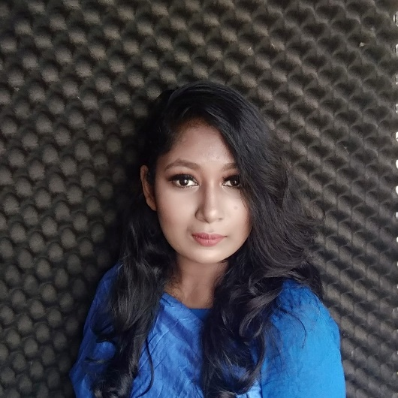

**ABOUT ME**

I'm a recent graduate from Khulna University of Engineering and Technology, equipped with a strong foundation in Computer Science and Engineering and a passion for innovation. Eager to apply my skills and make a meaningful impact in the professional world.

**⌂ Address**

House no-05,Road no-07,Block-D

Mirpur,Dhaka

**☏ Phone**

+88001825954952

**✉ Mail**

tasfiatasnim387@gmail.com

**CONTACT**

**Tasfia Tasnim**

**EDUCATION**

**2024** **B.SC in Computer Science and Engineering**

Khulna University of Engineering and Technology

Major: CSE

Result: CGPA 3.5 on 4.0 Scale

**2019 Higher Secondary Certificate**

Hermann Gmeiner College

Result: GPA 5.0 on 5.0 Scale

**2017 Secondary School Certificate**

Hermann Gmeiner College

Result: GPA 5.0 on 5.0 Scale

2013

**PERSONAL DETAILS**

**PROJECTS**

**Shopping Guide Application**

An android application that will guide your shopping.This app will suggest you the shopping mall name which is near to your house.You can check offering sale provided by different brand and can also check facilities available in this shopping mall.

**Hospital Management System**

Developed a user-friendly Hospital Management System using SQL, ensuring smooth management of patient records and appointment schedules. The system effectively organizes patient information and medical staff data, ensuring seamless hospital operations. management.

2013

**Date of Birth**

20th September 2002

**Nationality**

Bangladeshi

**Religion**

Islam (Sunni)

**Skills**

**Web Development**

* HTML
* CSS
* JS
* PHP

**Blind Stick**

Designed and prototyped a smart blind stick using Arduino, featuring obstacle detection, water sensing for road conditions, and a light sensor for night-time pedestrian safety. This project showcases my hardware prototyping skills and problem-solving abilities in addressing real-world challenges.

**Shopping Buddy**

Developed a dynamic shopping website using HTML, CSS, PHP, and Laravel, enabling users to browse and purchase products effortlessly. This project highlights my proficiency in web development and creating user-friendly interfaces.

**Blood Donation Application**

Developed a life-saving iOS application using Swift that facilitates blood donations, connecting donors and recipients seamlessly. This project underscores my ability to develop impactful applications that address vital societal needs.

**Chittopot**

An android application that will suggest content according to your mood.

2013

**PROJECTS**

**Mobile Development**

* Java
* Swift

**Database Management**

* SQL

**Programming Languages**

* C
* C++
* Python

**INTERESTS**

* Machine Learning
* AI
* Video Games
* Teamwork
* Problem Solving

**STRENGHTS**

**Dr. Humayan Kabir from Khulna University of Engineering and Technology**

[Humayan123@gmail.com](mailto:Humayan123@gmail.com) | 0193564653

**Dr. Hossain Kabir from ABC University**

[hossain1969@gmail.com](mailto:hossain1969@gmail.com) | 0178564653

2013

**References**