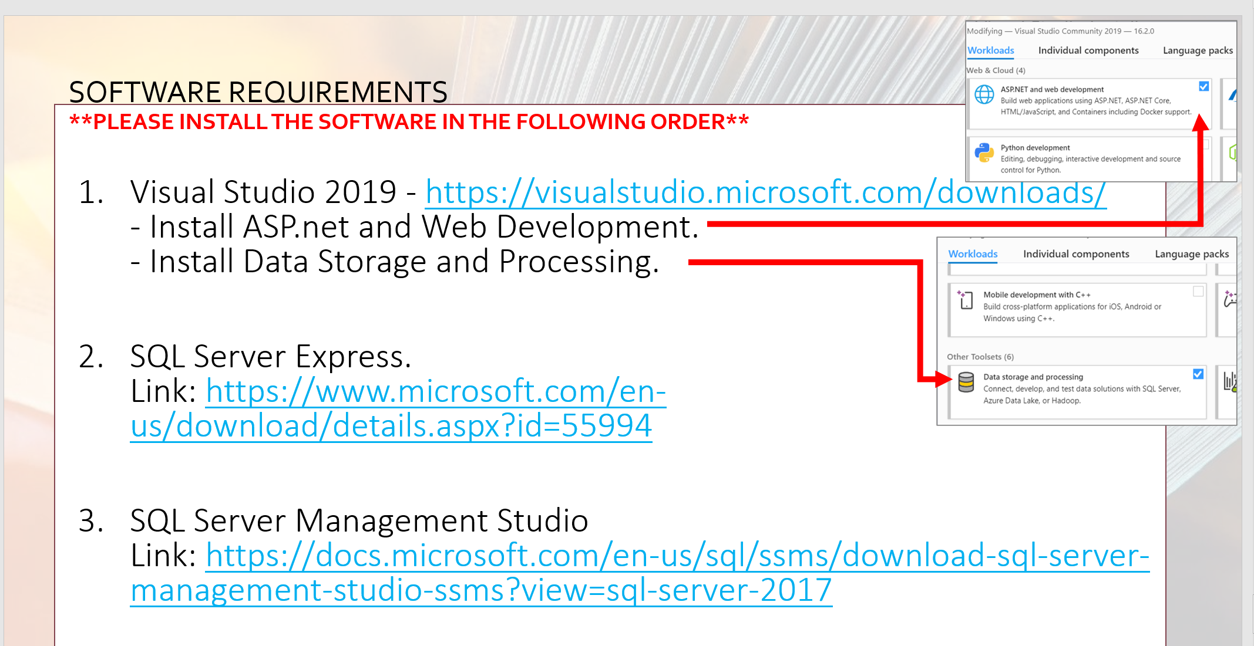

Do step by step, don’t do 1 and jump to 3. It doesn’t run later, reinstall all things

Download the zip file I send to u guys

Open it with visual studio

Double click the 334script.sql I sent to u guys, it will open in the sql server management studio

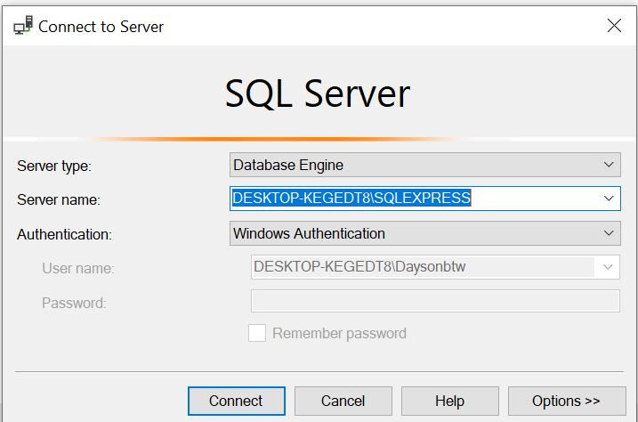

The server name: please check your computer name

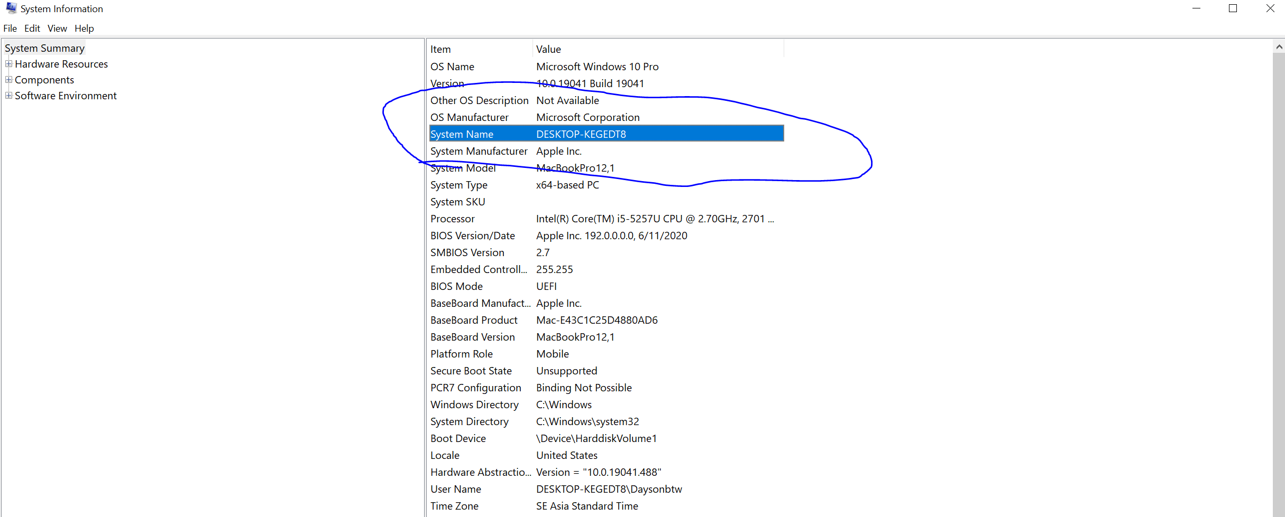

Add the /SQLEXPRESS and click connect

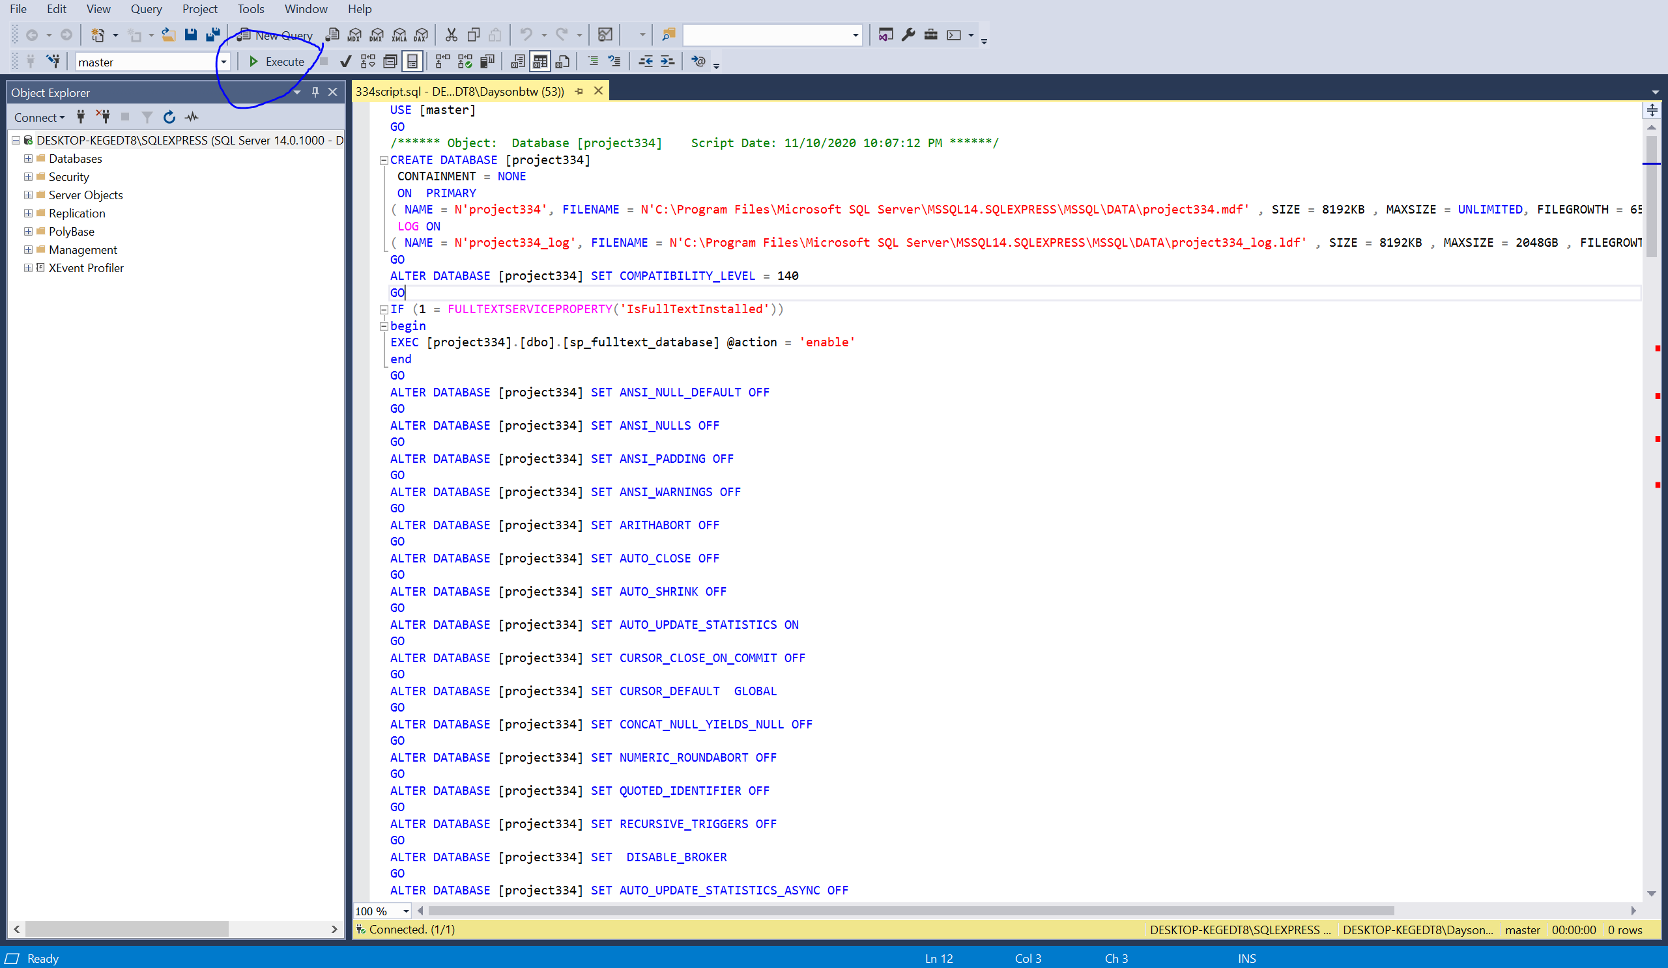

Click execute

Then u will have a database like this with the data added also

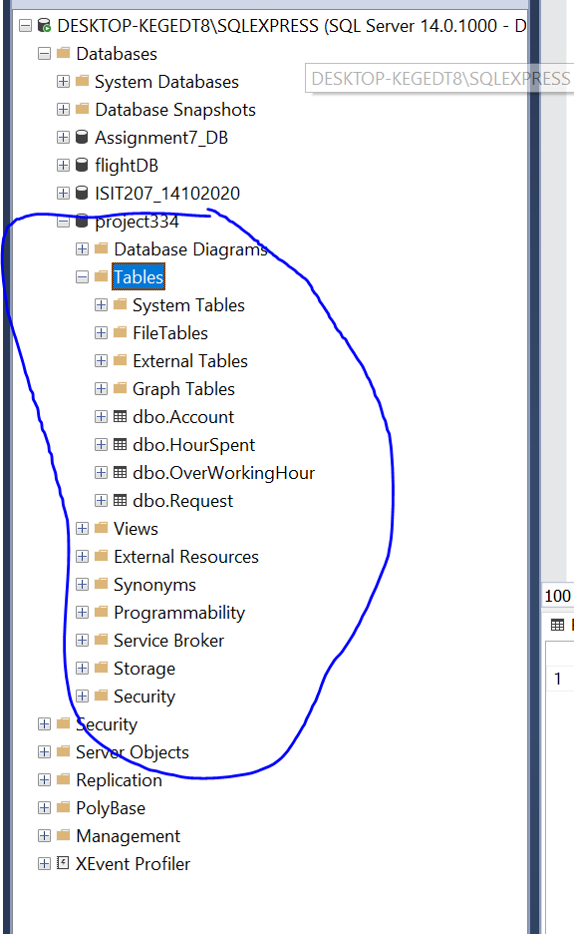

Right click to the table to have more options, can view the design the content, can edit content of the table

Go to tools > options > designers : untick the prevent saving changes

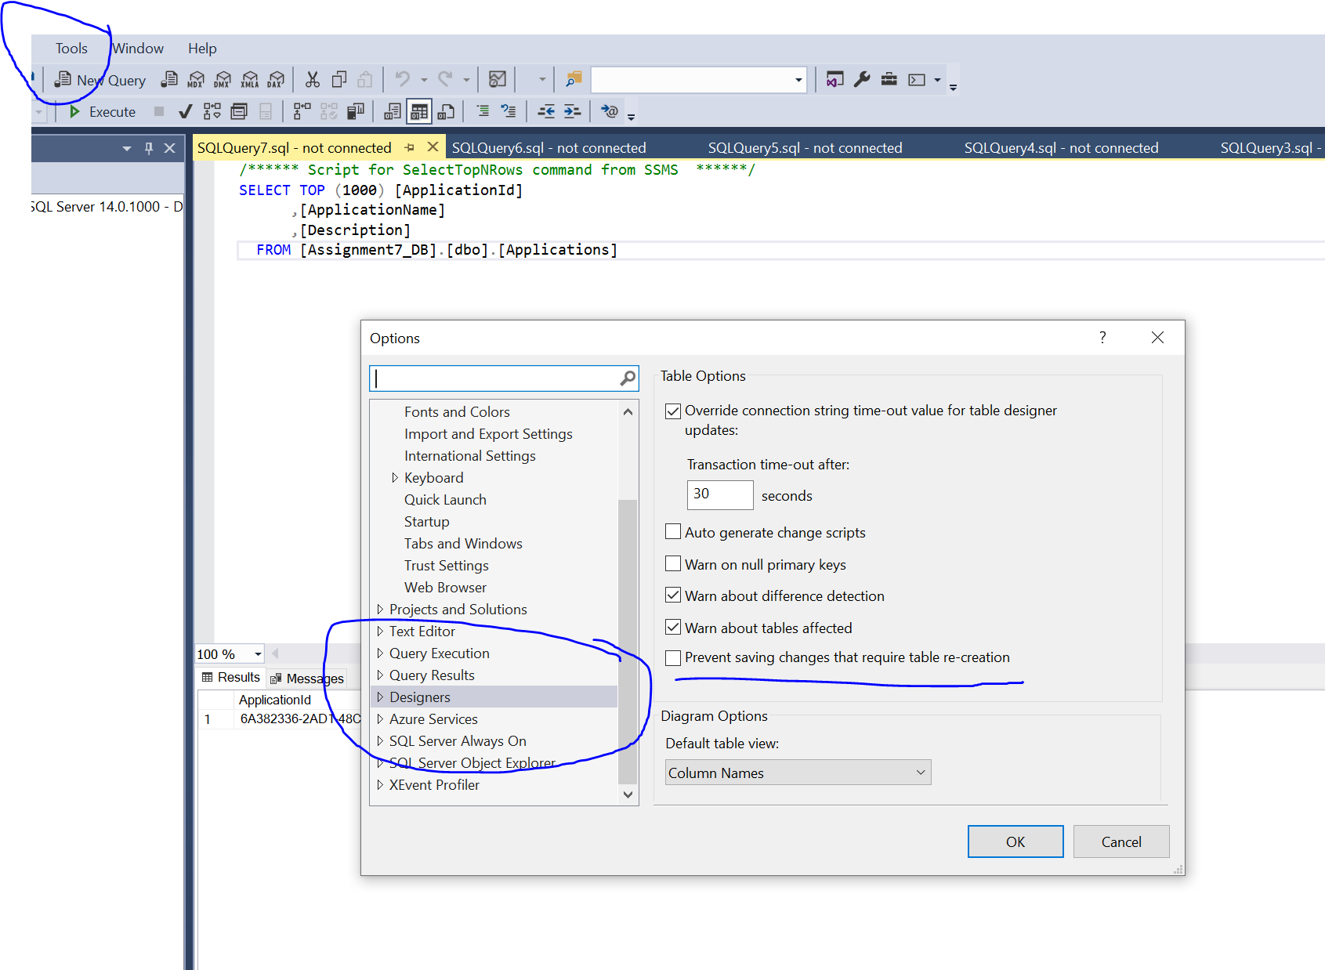

Go back to visual studio

Click server explorer, if cant see server explorer try to go to view setting and select it

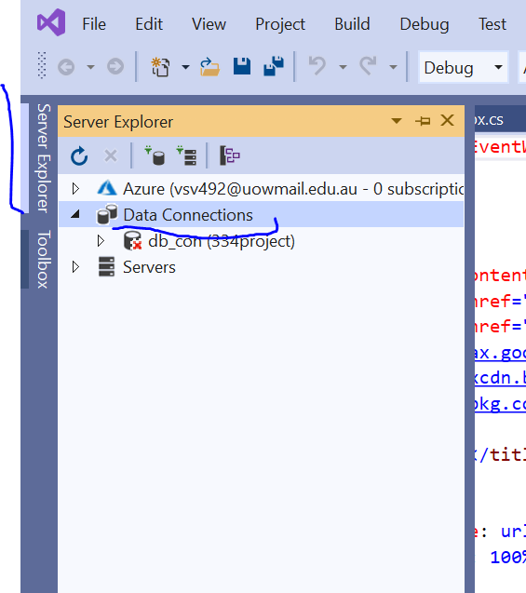

Right click to data connections, choose add new connection

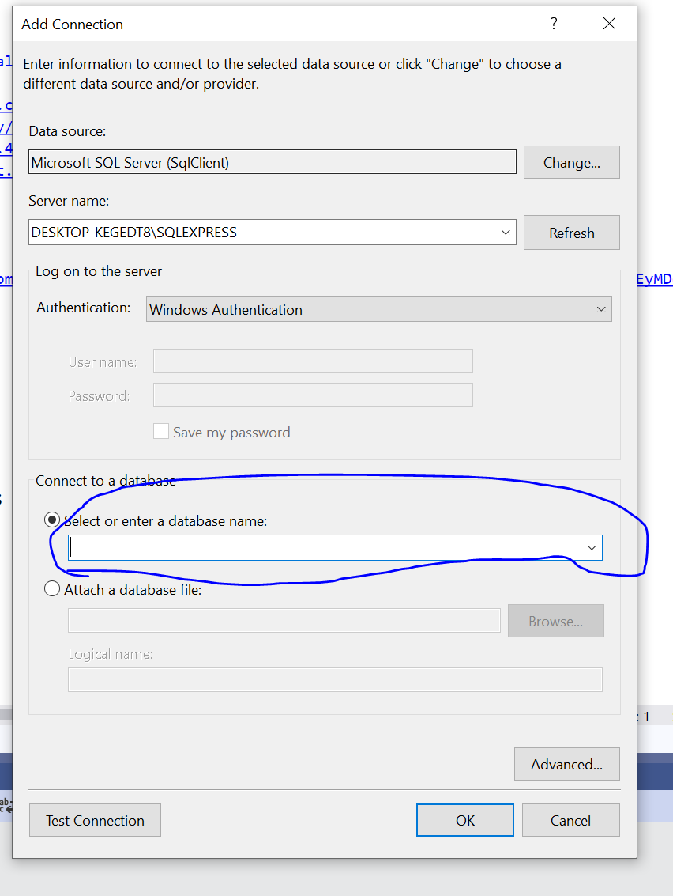

The server name is the one from the sql server management, just copy paste it

Then go to the connect to a database

A dropdownlist, choose a database name

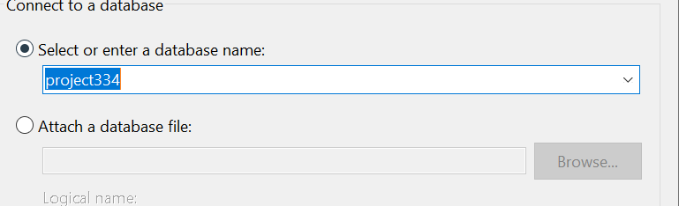

If u got this one it means ok

Click ok

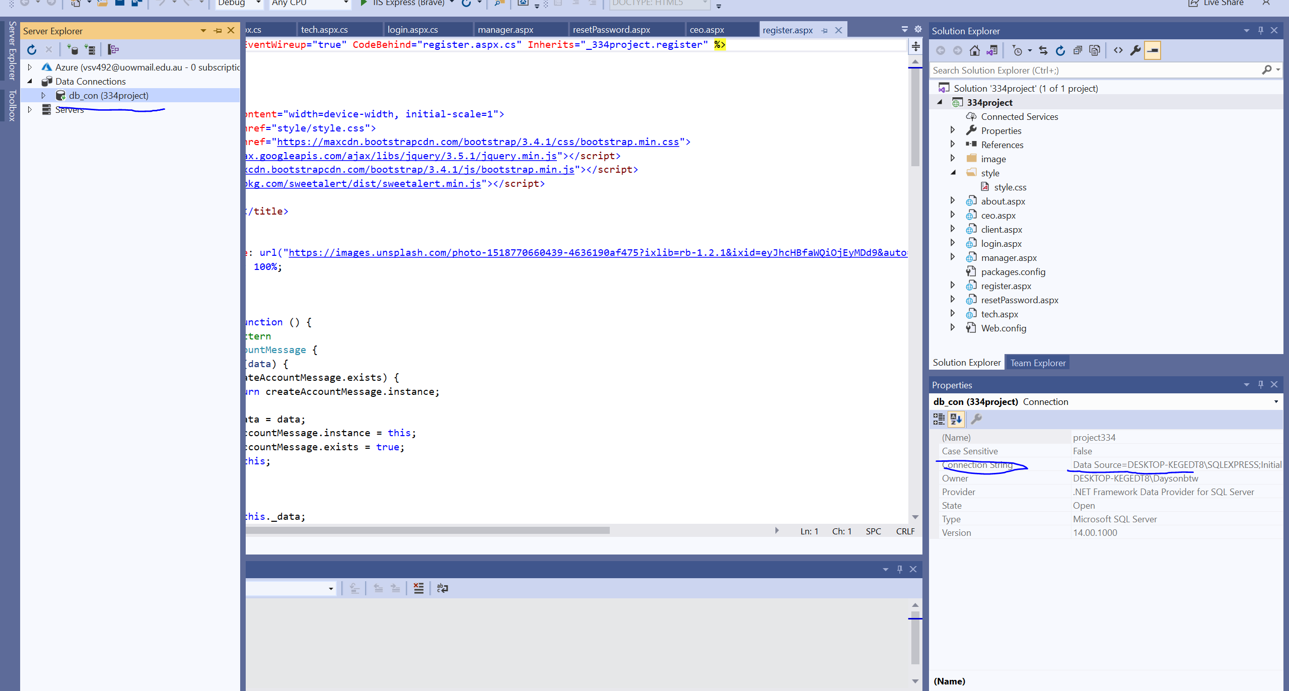

Click the db_con

Then see the property on the right hand side, see the connection string, copy the content which is data source= blablabla; copy all

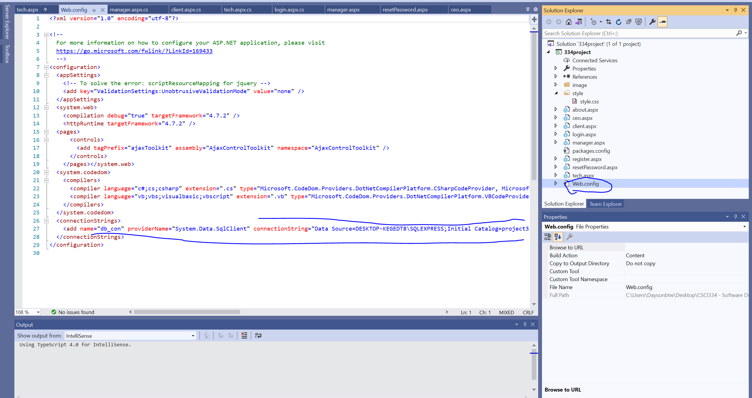

Choose web.config

Then find the connectrionString

Find the connectionString and replace it with the one u copied just now, every pc got different connection string . that’s why u need to copy and replace the new one for it to work

Then u go to the login.aspx or any page, click run

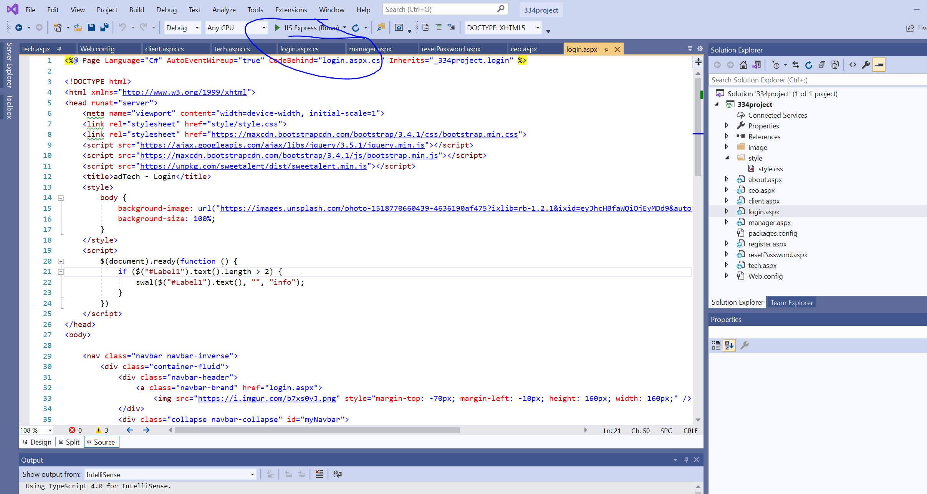

Ok test it