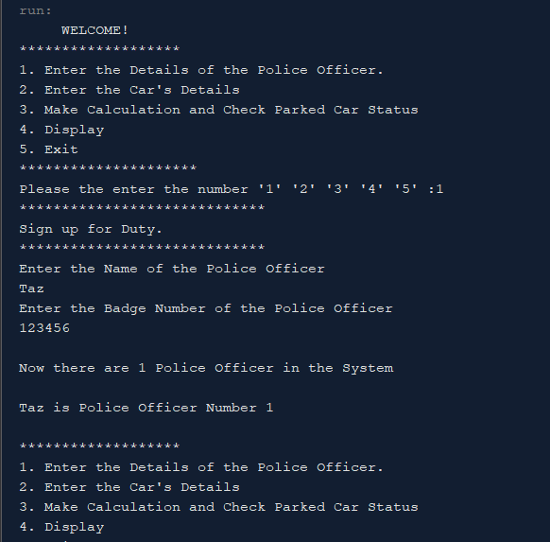

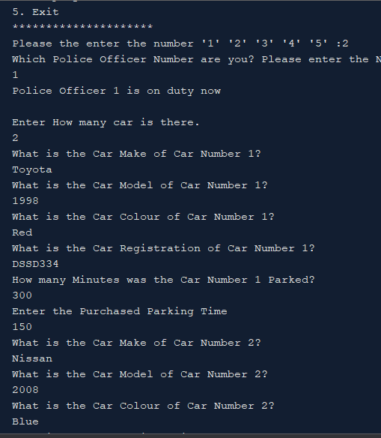

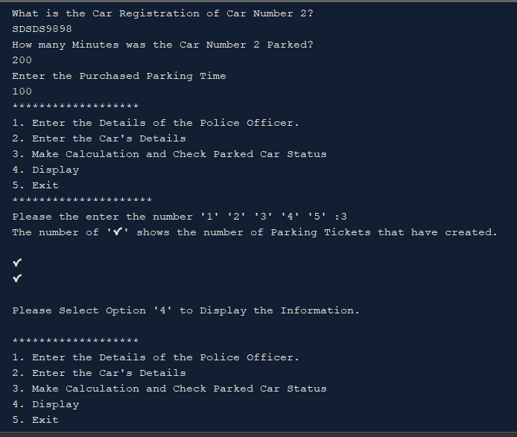

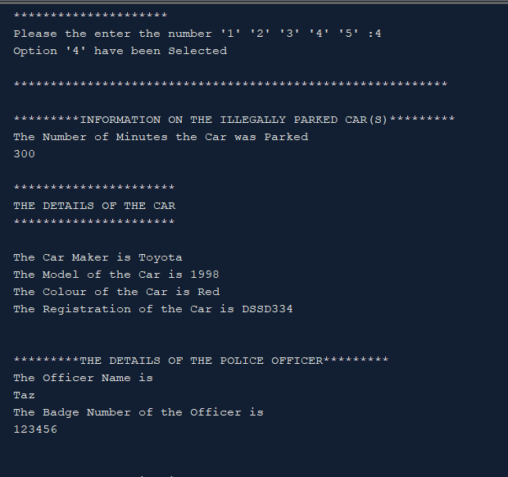

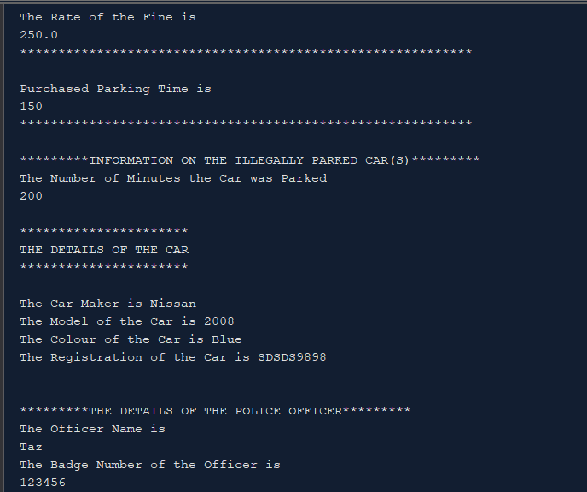

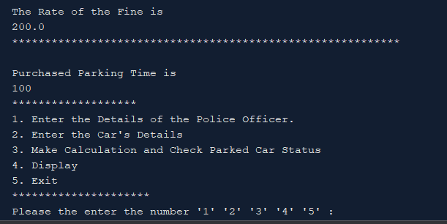

//Student's Full Name- Tasfique Enam

//Student's ID- J16020825/5886429

//Modification Date 16/04/2019

//Purpose of this file- Main Class

package assignment1;

import java.util.ArrayList;

import java.util.Iterator;

import java.util.Scanner;

public class Main {

public static void main(String[] args) {

Scanner read = new Scanner(System.in); //scanner for reading input from the user.

int PoliceSelector= 1;

int option;

int carNumbers;

// PoliceOfficer policeObj = new PoliceOfficer(); //policeofficer object

//ParkedCar parkedCarObj = new ParkedCar();

//

ParkingMeter [] AryObjParkingMeter = null; // (it was at down) this is an array object to store purchased parking ticket.

ParkedCar [] AryObjParkingLot = null; //an array object to store the car's information like car name, registration, color etc...

ArrayList<PoliceOfficer> policeList = new ArrayList<>(); //police officer array list

ArrayList<ParkingTicket> parkingTicketList = new ArrayList<>(); //parking ticket array list.

ArrayList<ParkingMeter> parkingMeterList = new ArrayList<>();

//entering name of the police officer and their badge number.

System.out.println(" WELCOME!");

do{

System.out.print("*******************\n" + //display menu

"1. Enter the Details of the Police Officer.\n" +

"2. Enter the Car's Details\n" +

"3. Make Calculation and Check Parked Car Status\n"+

"4. Display\n"+

"5. Exit\n"+

"*********************\n" +

"Please the enter the number '1' '2' '3' '4' '5' :");

option = read.nextInt();

switch(option) { //using switch case for selection

case 1:

{

System.out.print("*****************************\n");

System.out.println("Sign up for Duty.");

System.out.print("*****************************\n");

System.out.println("Enter the Name of the Police Officer");

String name = read.next();

System.out.println("Enter the Badge Number of the Police Officer");

String badgeNumber = read.next();

PoliceOfficer policeObj = new PoliceOfficer(); //policeofficer object

//putting the input into the object.

policeObj.setOfficerName(name);

policeObj.setBadgeNumber(badgeNumber);

policeList.add(policeObj); //adding the police object into array list.

System.out.print("\nNow there are "+policeList.size()+" Police Officer in the System\n ");//keep track of how many police officer in the system

System.out.println("\n"+name+" is Police Officer Number "+policeList.size()+"\n");

break;

}

case 2:

{

System.out.println("Which Police Officer Number are you? Please enter the Number (Only One Police Officer can work at a time!)");

PoliceSelector = read.nextInt();

if(policeList.size() !=0 && PoliceSelector<= policeList.size() && PoliceSelector >0) { //doing validation of wrong user input.

policeList.get(PoliceSelector-1); // selecting from the array list of police objects, to let users select which police they want to work with, as only one police officer can work at a time.

System.out.println("Police Officer "+PoliceSelector+" is on duty now\n");

System.out.println("Enter How many car is there.");

carNumbers = read.nextInt();

AryObjParkingLot = new ParkedCar [carNumbers]; //inputting the user input into the parkingLot array

//parked car array of object

AryObjParkingMeter = new ParkingMeter [carNumbers]; //inputting the user input into meters array, as the Parking Car Objects needs to be stored into a specific array index that matches the parkingLot[] and meters[]

//parking meter array of object

for(int c=0; c<carNumbers; c++) { //using a for loop for the number of cars there are, that the user inputted.

System.out.println("What is the Car Make of Car Number "+(c+1)+"? "); //asking for user input.

String carMake = read.next();

System.out.println("What is the Car Model of Car Number "+(c+1)+"? ");

String carModel = read.next();

System.out.println("What is the Car Colour of Car Number "+(c+1)+"? ");

String carColor = read.next();

System.out.println("What is the Car Registration of Car Number "+(c+1)+"? ");

String carReg = read.next();

System.out.println("How many Minutes was the Car Number "+(c+1)+" Parked?");

int minuteParkedTime = read.nextInt();

AryObjParkingLot[c] = new ParkedCar(carMake, carModel, carColor, carReg, minuteParkedTime);

//inputting the user's input into the ParkedCar objects and they r put into Array with a for loop.

//parkingLot.(parkedCarObj);

System.out.println("Enter the Purchased Parking Time ");

int purchasedParkingTime = read.nextInt();

AryObjParkingMeter[c] = new ParkingMeter(); //meter[c] is assigned to new ParkingMeter();

AryObjParkingMeter[c].setPurchaseParkingTime(purchasedParkingTime); //it is used like this because it is a setter.

//inputting the user's input into array as ParkingMeter number needs to be the same as ParkedCar Array

}

}else{

System.out.println("\n What you have selected doesn't exist in the System \n");

}

break;

}

case 3:

{

if(policeList.size() !=0 && AryObjParkingLot != null){ //this is a validation if the user inputs directly 3 in the system in the selection menu

System.out.println("The number of '✔' shows the number of Parking Tickets that have created. \n");

for(int index=0; index < AryObjParkingLot.length; index++) //using a for loop as there r more than one number of cars.

{

if(AryObjParkingLot[index].getMinuteParked() >

AryObjParkingMeter[index].getPurchaseParkingTime()) //using if statement to make a comparison to see if minute parked is greater than purchased parking time

{

ParkingTicket parkingTicketObj = new ParkingTicket(); //create a new object

ParkingMeter parkingMeterObj = new ParkingMeter();

parkingTicketObj.setPoliceOfficer(policeList.get(PoliceSelector-1)); //in the parkingTicketObj of the ParkingTicket class, setting the setPoliceOfficer method. policeObj contains police officer details.

parkingTicketObj.Calculation(AryObjParkingLot[index].getMinuteParked() - AryObjParkingMeter[index].getPurchaseParkingTime()); //accessing calculation method from the parkingTicketObj

parkingTicketObj.setParkedCarObj(AryObjParkingLot[index]); //accessing setParkedCarObj method to

parkingMeterObj.setPurchaseParkingTime(AryObjParkingMeter[index].getPurchaseParkingTime());

parkingTicketList.add(parkingTicketObj); //putting parkingTicketObj inside the Parking ticket array list.

parkingMeterList.add(parkingMeterObj);

System.out.println("✔");

}else{

System.out.println("\nThere are some Legally Parked Cars, and they have been Ommited from Display. \n");

}

}

}else{

System.out.println("\nPolice Officer or Car have not been entered into the System \n");

System.out.println("You must Sign in as a Police Officer and Enter the Car information for Option 3 to Process.\n");

}

System.out.println("\nPlease Select Option '4' to Display the Information.\n");

break;

}

case 4:

{

System.out.println("Option '4' have been Selected\n");

Iterator <ParkingTicket> itr = parkingTicketList.iterator(); //using itr to display all the elements

Iterator <ParkingMeter> itr2 = parkingMeterList.iterator();

while(itr.hasNext()) {

ParkingTicket element = itr.next();

ParkingMeter element2 = itr2.next();

System.out.println("*********************************************************** \n"+element);

System.out.println("*********************************************************** \n"+element2);

}

/*Iterator <ParkingMeter> itr2 = parkingMeterList.iterator();

while(itr2.hasNext()) {

ParkingMeter element2 = itr2.next();

System.out.println("*********************************************************** \n"+element2);

}*/

break;

}

case 5:

{

option =0;

break;

}

default:

{

System.out.println("You have selected the wrong number "); // if the user have inputted the wrong number, in the selection menu.

break;

}

}

}while (option!=0);

}

}

//Student's Full Name- Tasfique Enam

//Student's ID- J16020825/5886429

//Modification Date 16/04/2019

//Purpose of this file- Parking Ticket Class

package assignment1;

public class ParkingTicket {

private ParkedCar parkedCarObj = new ParkedCar ();

private double fine;

PoliceOfficer officerObj = new PoliceOfficer ();

public static double FIRST_HOUR_FINE_RATE = 150.00;

public static double ADDITIONAL_HOUR_FINE_RATE = 50.00;

public static double MAXIMUM_FINE_RATE = 300.00;

public ParkingTicket() { //default constructor

parkedCarObj = null;

fine = 0.0;

officerObj = null;

}

public ParkingTicket(ParkedCar parkedCarObj, double fine, PoliceOfficer officerObj) { //non default constructor

this.parkedCarObj = parkedCarObj;

this.fine = fine;

this.officerObj = officerObj;

}

public void setParkedCarObj (ParkedCar parkedCarObj) { //setter methods.

this.parkedCarObj = parkedCarObj;

}

public void setFine (double fine) {

this.fine = fine;

}

public void setPoliceOfficer (PoliceOfficer officerObj) {

this.officerObj = officerObj;

}

public ParkedCar getParkedCarObj () { //getter methods.

return parkedCarObj;

}

public double getFine () {

return fine;

}

public PoliceOfficer getPoliceOfficerObj () {

return officerObj;

}

public void Calculation (int minute) { // the calculation method

if(minute<61) {

fine = FIRST_HOUR_FINE_RATE;

}

else if (minute>60 && minute<121){

fine = FIRST_HOUR_FINE_RATE + ADDITIONAL_HOUR_FINE_RATE;

}

else if (minute>120 && minute<181){

fine = FIRST_HOUR_FINE_RATE + 2*ADDITIONAL_HOUR_FINE_RATE;

}

else if (minute>180) {

fine = FIRST_HOUR_FINE_RATE + 3*ADDITIONAL_HOUR_FINE_RATE;

}

if(fine > MAXIMUM_FINE_RATE) {

fine = MAXIMUM_FINE_RATE;

}

//return fine;

// else if (minute>240) {

// fine = FIRST_HOUR_FINE_RATE + 3*ADDITIONAL_HOUR_FINE_RATE;

// }

}

@Override

public String toString () { //toString method to display

String str;

str = "\n*********INFORMATION ON THE ILLEGALLY PARKED CAR(S)*********"+getParkedCarObj().toString()+"\n"

+"\n*********THE DETAILS OF THE POLICE OFFICER*********"+getPoliceOfficerObj()+"\n"

+"\nThe Rate of the Fine is \n"+getFine();

return str;

}

}

//Student's Full Name- Tasfique Enam

//Student's ID- J16020825/5886429

//Modification Date 16/04/2019

//Purpose of this file- Parking Meter Class

package assignment1;

public class ParkingMeter { //declaring attributes

private int PurchasedParkingTime;

public ParkingMeter (){ //default constructor.

PurchasedParkingTime = 0;

}

public void setPurchaseParkingTime (int PurchasedParkingTime) { //setter

this.PurchasedParkingTime = PurchasedParkingTime;

}

public int getPurchaseParkingTime () { //getter

return PurchasedParkingTime;

}

@Override

public String toString(){ //toString to display

String str;

str = "\nPurchased Parking Time is \n"+getPurchaseParkingTime();

return str;

}

}

//Student's Full Name- Tasfique Enam

//Student's ID- J16020825/5886429

//Modification Date 16/04/2019

//Purpose of this file- PoliceOfficer Class

package assignment1;

public class PoliceOfficer {

private String officerName;

private String badgeNumber;

public PoliceOfficer () {

officerName = null;

badgeNumber = null;

}

public void setOfficerName(String officerName) { //setter

this.officerName = officerName;

}

public void setBadgeNumber(String badgeNumber) {

this.badgeNumber = badgeNumber;

}

public String getOfficerName() { //getter

return officerName;

}

public String getBadgeNumber() {

return badgeNumber;

}

@Override

public String toString(){ //toString to display

String str;

str = "\nThe Officer Name is \n"+getOfficerName()

+"\nThe Badge Number of the Officer is \n"+getBadgeNumber()+"\n";

return str;

}

}

//Student's Full Name- Tasfique Enam

//Student's ID- J16020825/5886429

//Modification Date 16/04/2019

//Purpose of this file- Parked Car Class

package assignment1;

public class ParkedCar { //declaring attributes.

private String CarMake;

private String CarModel;

private String CarColor;

private String CarReg;

private int MinuteParked;

public ParkedCar (){ //constructor with the minuteparked initialised to 0 this is the default constructor

CarMake = "";

CarModel = "";

CarColor = "";

CarReg = "";

MinuteParked = 0;

}

public ParkedCar (String CarMake, String CarModel, String CarColor, String CarReg, int MinuteParked){ //non default constructor

this.CarMake = CarMake;

this.CarModel = CarModel;

this.CarColor = CarColor;

this.CarReg = CarReg;

this.MinuteParked = MinuteParked;

}

public void setMinuteParked (int MinuteParked) { //setter method for minute parked.

this.MinuteParked = MinuteParked;

}

public int getMinuteParked (){ //getter for minute parked.

return MinuteParked;

}

@Override

public String toString(){ //toString to Display

String str;

str = "\nThe Number of Minutes the Car was Parked \n"+getMinuteParked()+"\n"

+"\n**********************"+

"\nTHE DETAILS OF THE CAR \n"+

"**********************\n"+

"\nThe Car Maker is "+CarMake+

"\nThe Model of the Car is "+CarModel+

"\nThe Colour of the Car is "+CarColor+

"\nThe Registration of the Car is "+CarReg+"\n";

return str;

}

}