**CSIT 128 – ASSIGNMENT 5 (5%)**

**REMINDER:**

**1. Students must attend the lab session and demonstrate the assignment.**

**2. Plagiarism will not be tolerated. Student will receive 0 marks.**

During demonstration, 1 marks will be awarded to the student if the student able to clearly demonstrate, modify and answer question(s) given from the instructor.

**Task 1 (1 mark):**

1. Prepare HTML page as shown below (Figure 1). Use JavaScript and HTML DOM to complete the following task.
   1. Inside the HTML page, include THREE (3) images. (you can include your own image)
   2. When the user moves the mouse over an image (e.g: Strawberry), that particular image will be duplicate on the other two images (see figure 2 and 3 below). When the use moves the mouse out from the image, the image will restore as in initial page. (see figure 1 below)
   3. To complete this task, your code must use HTML DOM to access the child nodes. Link: <https://www.w3schools.com/jsref/dom_obj_all.asp>

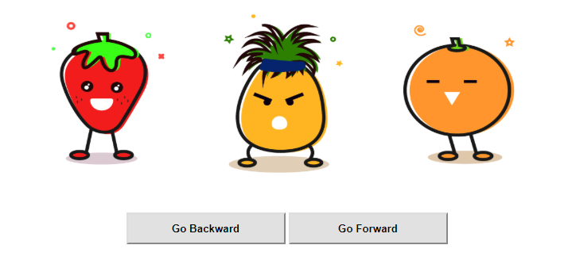

Figure : Initial page (default page)

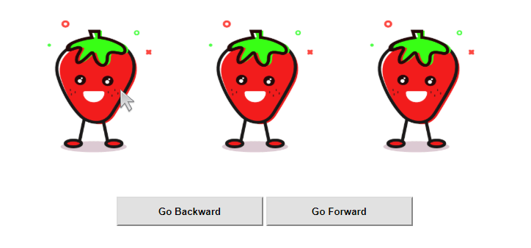

Figure : When the user mouse over the first image, the other two will display the same image

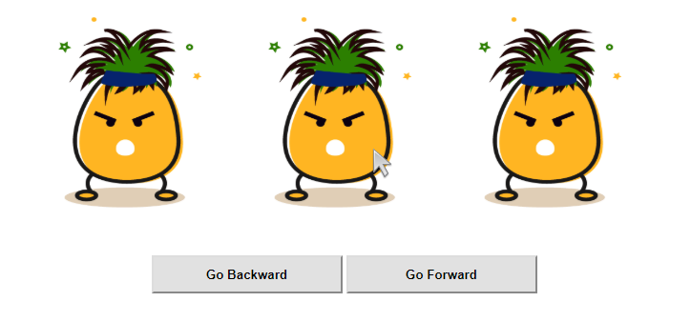

Figure : When the user mouse over the second image, the other two will display the same image

**Task 2 (1 mark):**

1. Prepare HTML page as shown below (Figure 4). Use JavaScript and HTML DOM to complete the following task.
   1. Inside the HTML page, include TWO (2) buttons: forward and backward.
   2. When the user clicks on “forward” button, the image will move forward. When the user clicks on “backward” button, it will move the opposite way.
   3. To complete this task, your code must use HTML DOM to access the child nodes, and replace the child node.

Link: <https://www.w3schools.com/jsref/dom_obj_all.asp>



Figure : Initial page (default page)

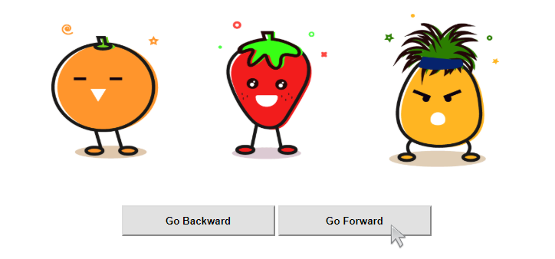

Figure : The user press the "forward" button, then the image will move one position to the right   
(see initial position of the strawberry)

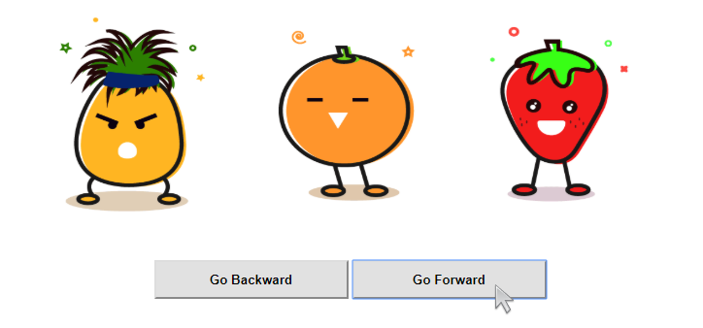

Figure 6: The user press the "forward" button, then the image will move one position to the right   
(see initial position of the strawberry)

**Task 3 (1 mark):**

1. Prepare a HTML page to display random dice value. Save the HTML page as “game.html”.
   1. In this page, create an array to store images/value of the rolling dice. This page should also have ONE (1) button. When the user clicked the button, the page will generate TWO (2) random dice value from 1 to 6. Display back the value by using the dice image, and calculate the total random number.
   2. The user can only play this game once. The button will disappear after displaying the output. If the user wanted to play again, they should refresh the webpage.
   3. W3schools JS Array Reference:
      1. <https://www.w3schools.com/js/js_arrays.asp>
      2. <https://www.w3schools.com/js/js_array_methods.asp>   
           
         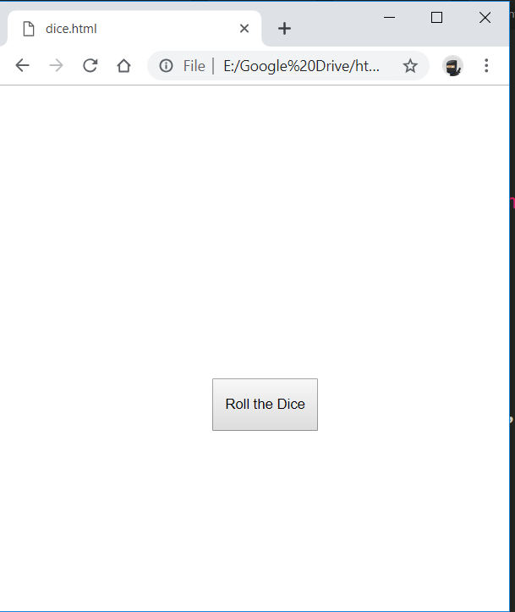 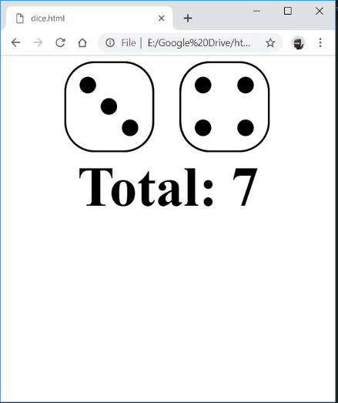

**Task 4 (1 mark):**

1. Use the same structure from Task 3. Save the HTML page as “game2.html”.
   1. Modify your previous code. When the dice rolls the same number, the user can play the game again. The user will continue to play the game until the dice displays two different numbers.
   2. For example, the first roll ends with same number (number 2 and 2). Your code should calculate the total, and allow the user to continue for the second time. On the second roll, the dice display two different number (number 3 and 4). Since it’s a different number, the game will stop. Your code will calculate the total (for round 1 and 2), and display it back on the web browser.

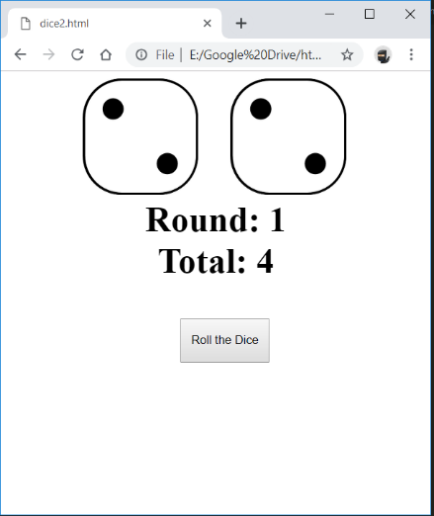 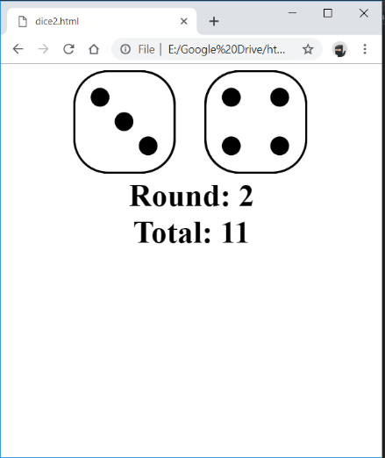

**Submission:**

1. During demonstration, your attendance is required. **If the student didn’t demonstrate the work, 0 marks will be given.**
2. The marks will be awarded according to tasks completion and ability to explain the code.
3. Paste all HTML code into a text file (**save it as Assignment5.txt**). You must include the following:
   1. Student declaration. (refer page 4)

(**If student didn’t submit this section, the instructor has the right to NOT MARK the student’s work**).

* 1. Student’s Assignment (code) separated by file name. (refer page 4)

**Example of Student’s declaration**

--------------------------------------  
STUDENT DECLARATION  
--------------------------------------  
**I have read the policy for plagiarism at University of Wollongong.  
I declare that this assignment is entirely my work.  
If found to be plagiarized, I will receive 0 marks.**

--------------------------------------  
STUDENT DETAILS  
--------------------------------------  
STUDENT ID NUMBER: <put your UOW/INTI ID here>  
STUDENT NAME: <put your name here>  
STUDENT FAMILY NAME: <put your family name here>  
UOW EMAIL: <put your UOW email address here>

**Example of Student’s Code**

--------------------------------------  
Filename: index.html  
--------------------------------------  
<!DOCTYPE html>  
<html>  
<head>  
 <title>Index</title>

</head>  
<body>  
This is index page

<a href="about.html">About Me</a>  
<a href="media.html">Media</a>  
<a href="contact.html">Contact Me</a>

</body>  
</html>