**CSIT 128 – ASSIGNMENT 7 (5%)**

**MARKING CRITERIA:**

Correctly prepare function to call/load XML document **– 0.5 mark**

Correctly create array of objects to parse data from XML document **– 1 mark**

Correctly display the data from XML into HTML table (as in requirement) **– 2.5 marks**

Student clearly explain the code and able to modify the code during demonstration **– 1 mark**

**REMINDER:   
1. Students must attend the lab session and demonstrate their assignment.**

**2. Plagiarism will not be tolerated. Student will be given 0 marks.**

During demonstration, 1 mark will be awarded to the student, if the student able to demonstrate, modify and answer question(s) given from the instructor.

**Task 1**

1. Open your Moodle, and download the XML file. (credit_card.xml). Prepare HTML page with JavaScript to read data from XML document. In your HTML webpage, include a button that will trigger the process to read data from XML file. You must use **AJAX** to complete this task. **Use JavaScript, NOT jQuery code**.

Once you have prepared the AJAX script, display the data in HTML table. See sample output below.

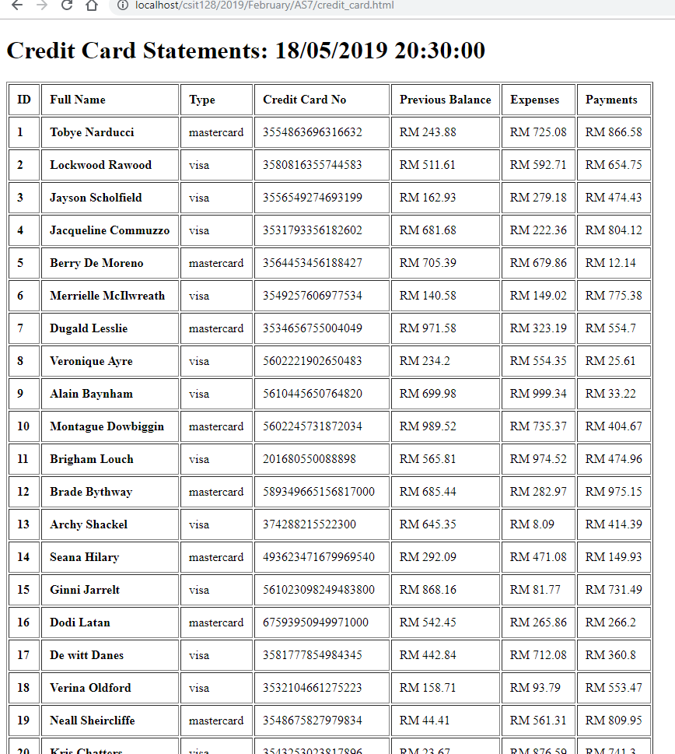

Figure 1: Sample output after reading XML document

1. From your previous output in Task 1a, modify your code to include the additional criteria. You may refer to sample image below as reference.
   * Include currency unit for previous balance, expenses and payment.
   * Find the average value for expenses.
   * Find the maximum value for expenses. (hint: use Math max for array)
   * Find the minimum value for expenses. (hint: use Math min for array)
   * Include a proper decision logic (in JavaScript) to display new balance and status.
     1. new balance = previous balance + expenses – payments.
     2. Each card has a credit limit of RM 1000. If the new balance is more than credit limit, then display the status.
     3. Use ‘red font’ for value beyond the credit limit and ‘green font’ for under the limit.

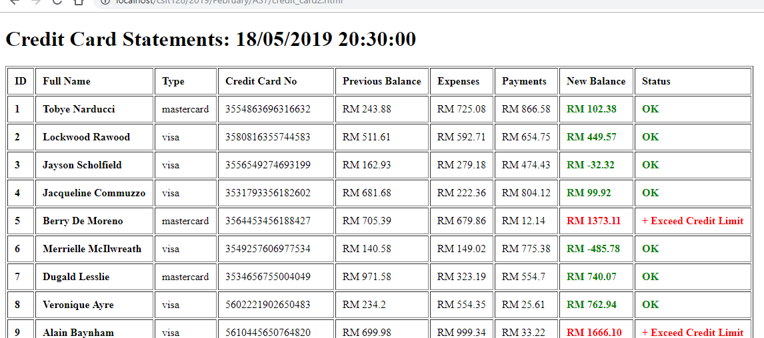

Figure 2: Sample output after including logical decision using JavaScript

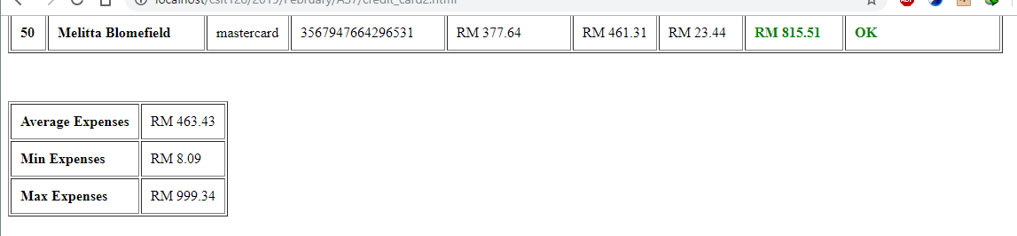

Figure 3: Sample output for average, minimum and maximum expenses

**Submission:**

1. During demonstration, your attendance is required. **If student didn’t demonstrate the work, 0 marks will be given.**
2. The marks will be awarded according to tasks completion.
3. Paste all HTML code into a text file (**save it as Assignment7.txt**). You must include the following:
   1. Student declaration. (refer page 3)

(**If student didn’t submit this section, the instructor has the right to NOT MARK the student’s work**).

* 1. Student’s Assignment (code) separated by file name. (refer page 3)
  2. **Make sure that you have checked the content before submitting the document. Any missing or incomplete task will be assume as work not done.**

**Example of Student’s declaration**

--------------------------------------  
STUDENT DECLARATION  
--------------------------------------  
**I have read the policy for plagiarism at University of Wollongong.  
I declare that this assignment is entirely my work.  
If found to be plagiarized, I will receive 0 marks.**

--------------------------------------  
STUDENT DETAILS  
--------------------------------------  
STUDENT ID NUMBER: <put your UOW/INTI ID here>  
STUDENT NAME: <put your name here>  
STUDENT FAMILY NAME: <put your family name here>  
UOW EMAIL: <put your UOW email address here>

**Example of Student’s Code**

--------------------------------------  
Filename: index.html  
--------------------------------------  
<!DOCTYPE html>  
<html>  
<head>  
 <title>Index</title>

</head>  
<body>  
This is index page

<a href="about.html">About Me</a>  
<a href="media.html">Media</a>  
<a href="contact.html">Contact Me</a>

</body>  
</html>