AOF projection – Production Team handover

How the live projection number gets updated during the show, without touching code! I’ve now set up the code so you can do one PNG exported from Canva and upload it to make it live within a minute without needing me (Tash). There is no code to edit.

You need a GitHub account
You’ll need to get free GitHub account to make this all happen. GitHub is a code sharing platform and I’m using it to make this code live for you (you can see it in the URL: https://tash-atkins.github.io/aof-projection/)
Sign up here: https://github.com/signup
Once you have an account, I need to add you as a collaborator on GitHub before you can upload anything. Once that’s done follow the instructions below.

How to get the Canva design uploaded done!
- Update the number/design in Canva and export the design as a PNG named exactly toll-image.png. If it is not named this it will not work as the code pulls this name EXACTLY. Export settings: PNG, 2400–3200px if you can!
- Go to the GitHub repo: github.com/tash-atkins/aof-projection.
- Click “add file”. Drag in the new design named exactly “toll-image.png”.
- Scroll down, type a short commit message (e.g. "update toll image – 53"), and click the green Commit changes button. Make sure “commit directly to main branch” is selected. The page should look like this:
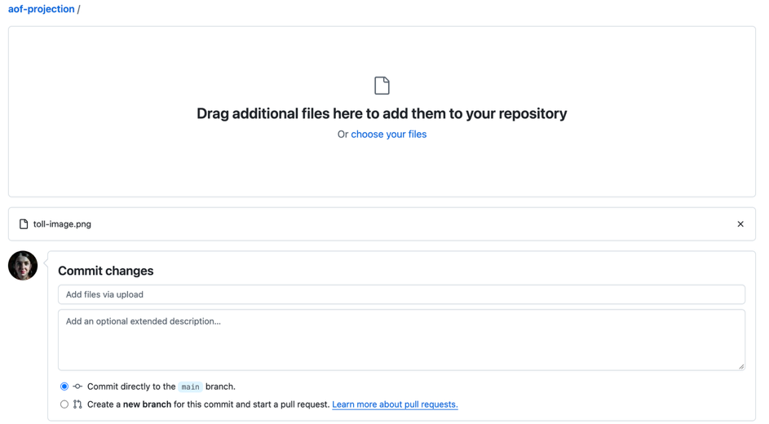
- Wait ~60 seconds, then hard refresh (Cmd+Shift+R on keyboard). Open the live projection URL and it will be there.
- If anything breaks, please email Tash, but it shouldn’t if you use the name “toll-image.png” and don’t delete anything, just replace.

And that’s it!

