# Report

## Q1

1. **The highlighted rules have been added to parse sentence S1 to S3:**

S -> NP VP | VP

NP -> N | Det Nom | PropN | NP PP

Nom -> Adj Nom | N

VP -> V NP | V S | VP PP

PP -> P NP

PropN -> 'Bill' | 'Bob'

Det -> 'the' | 'a' | 'an' | 'An' | 'The' | 'A' | 'on' | 'some'

N -> 'bear' | 'squirrel' | 'park' | 'block' | 'table' | 'river' | 'dog' | 'dogs'

Adj -> 'angry' | 'frightened' | 'furry'

V -> 'chased' | 'saw' | 'put' | 'eats' | 'eat' | 'chase' | 'have'

P -> 'on' | 'in' | 'along'

1. **The derivations for each sentence are as follows:**

S1: Got 2 derivations

S2: Got 5 derivations

S3: Got 1 derivation

Output:

S1

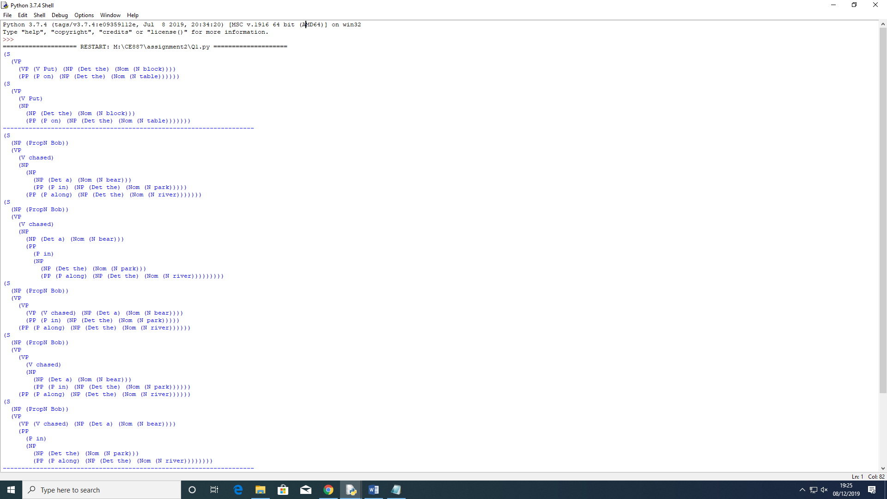

S1 first derivation starts with a sentence and then a branch for VP which has 2 other branches VP and PP. In VP, we have a verb ‘Put’ and a Noun Phrase ‘the block’. The noun phrase is broken down into a Det – ‘the’ and Nom noun – ‘block’. The second derivation is similar. But inside the VP and inside the NP theres two branches - NP ‘the block’ and PP – ‘on the table’ where ‘on’ is a preposition and the is a det and table is a noun.

S2



For S2, the first derivation has two branches, NP and VP where NP branch has a proper noun BOB and VP branch breaks down the rest of the sentence accordingly. The other 4 derivation work the same way to produce different derivation.

S3

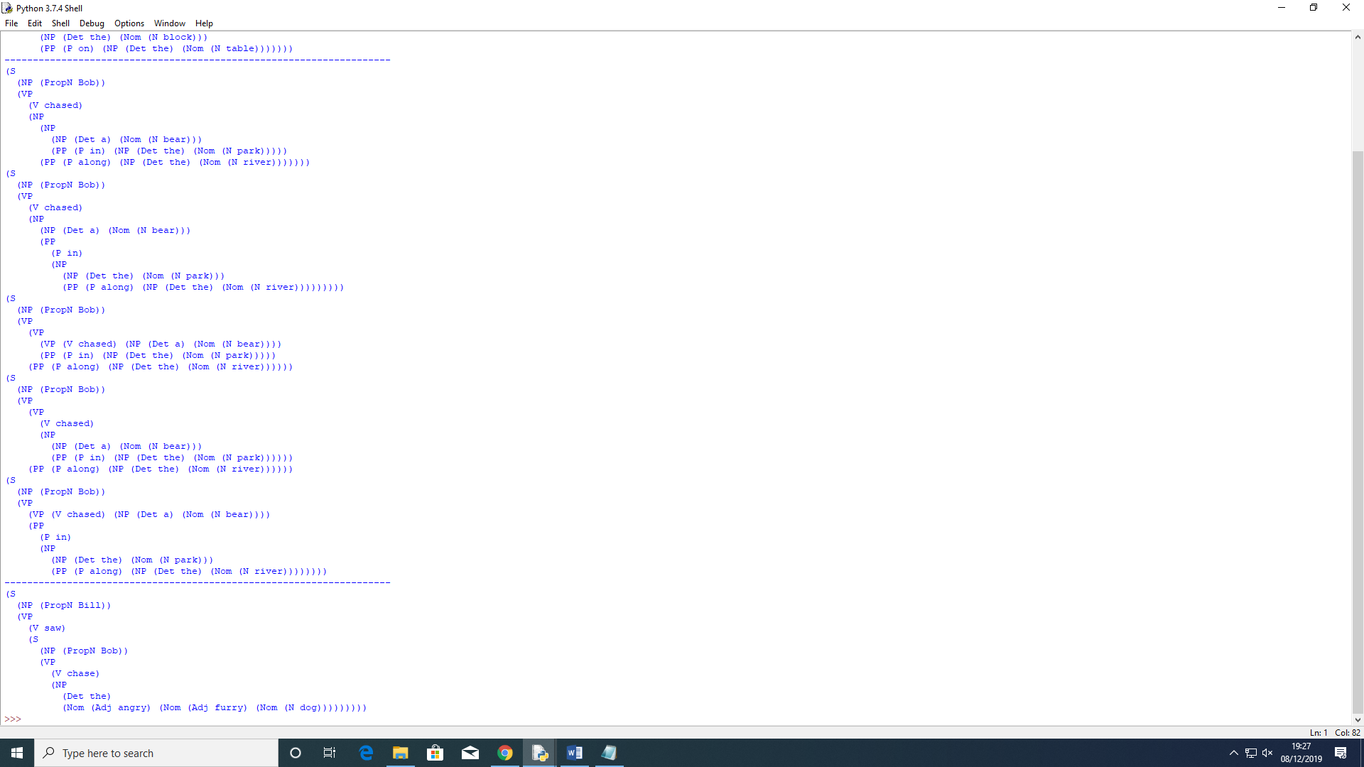

For s3, theres only one derivation. It has two branches, NP and VP where NP has a Proper Noun Bill. VP branch has a verb – ‘saw’ and another Sentence is detected inside the sentence where theres another proper noun ‘Bob’ and in the verb phrase, theres a verb ‘chase’ and then the noun phrase has a det ‘the and Nom adjective ‘angry’, ‘furry’ and a noun ‘dog’.

## Q2

**S4. An bear eat an squirrel**

**S5. The dogs eats**

1. **The sentences S4 and S5 are incorrect.**

S4 is not correct because in English there are three articles ‘a’, ‘an’ and ‘the’. Articles are used before nouns or noun equivalent and are a type of adjective. The indefinite article is ‘a’ and ‘an’ and is used before a noun that is general or unknown to the reader. So we would use the article ‘a’ or ‘an’ to indicate any non-specific member of a group. For example – “We are looking for a house” or “I think an animal is in the forest”. Usually, the article ‘a ‘ is used before a consonant sound and use ‘an’ before a vowel sound. E.g. a boy, an apple. In S4, since bear and squirrel are consonants, they should grammatically be ‘a’ and not ‘an’. So the sentence should be “A bear eats a squirrel”. The verb “eat” becomes plural.

S5 is incorrect because, in English, subjects and verbs must agree with one another in number (singular or plural). Thus, if a subject is singular, its verb must be singular. If a subject is plural then its verb must also be plural. This is called a subject-verb agreement. However, in the present tense, nouns and verbs must be opposites. Nouns add an s to the singular form and verbs remove the s from the singular form. So the sentence should be “The dog eats” or “The dogs eat”. Another reason could be that the grammar does not contain specific POS tags, for instance, dog is a proper noun singular and is POS tagging, that is a NN. As a result, it is not recognising it.

1. **The two parsers from NLTK used were the chart Parser and Shift Reduce Parser. The output when the two sentences were parsed are as follows:**

**“An bear eat an squirrel”**

Chart Parser

(S

(NP (Det An) (Nom (N bear)))

(VP (V eat) (NP (Det an) (Nom (N squirrel)))))

Shift Reduce Parser

(S

(NP (Det An) (Nom (N bear)))

(VP (V eat) (NP (Det an) (Nom (N squirrel)))))

**“The dogs eats”**

Chart Parser

No output

Shift Reduce Parser

No output

**“A bear eats a squirrel”**

Chart Parser

(S

(NP (Det A) (Nom (N bear)))

(VP (V eats) (NP (Det a) (Nom (N squirrel)))))

Shift Reduce Parser

(S

(NP (Det A) (Nom (N bear)))

(VP (V eats) (NP (Det a) (Nom (N squirrel)))))

**“The dog eats” or “The dogs eat”**

Chart Parser

No output

Shift Reduce Parser

No output

A parser processes the sentences according to the rules of the grammar. It searches through the space of trees licensed by a grammar to find one that has the required sentence along its fringe. So some of the words in S4 and S5 were added to grammar for it to work. The output for both parsers are the same. However, there is no output for “The dogs eat” or for the corrected “The dogs eat”. The structure for S5 is S -> Det N V. This structure does not exist in the grammar rule and that’s is why parser did not print anything. For it to produce an output, we would need to add V to NP in the grammar.

1. **The 2 other correct and 2 other incorrect sentences with the same grammar are as follows:**

Correct sentences

“Bill eats an angry furry dog”

“Bob chased a squirrel”

Incorrect sentences

“Dog saw an table”

“The bear frightened an squirrel”

The 2 correct sentences with the same grammar parse perfectly and give output. However, the first incorrect sentence “Dog saw an table” gives an error. This is because, although the word ‘dog’ is in the grammar, since it is at the start of sentence and is a capital ‘D’, its unable to parse it giving an error and indication to add ‘Dog’ to the grammar. The second incorrect sentence “The bear frightened “an squirrel” is incorrect and should be ‘a squirrel’ instead of ‘an’.

To prevent the sentences from parsing one would need to remove the word from the grammar.

## Q3

1. **S6 interpretations are as follows:**

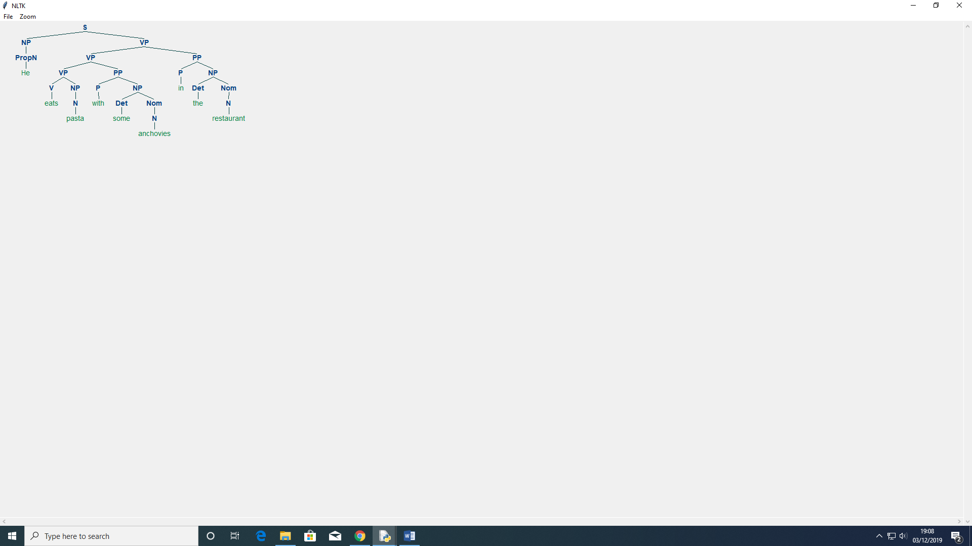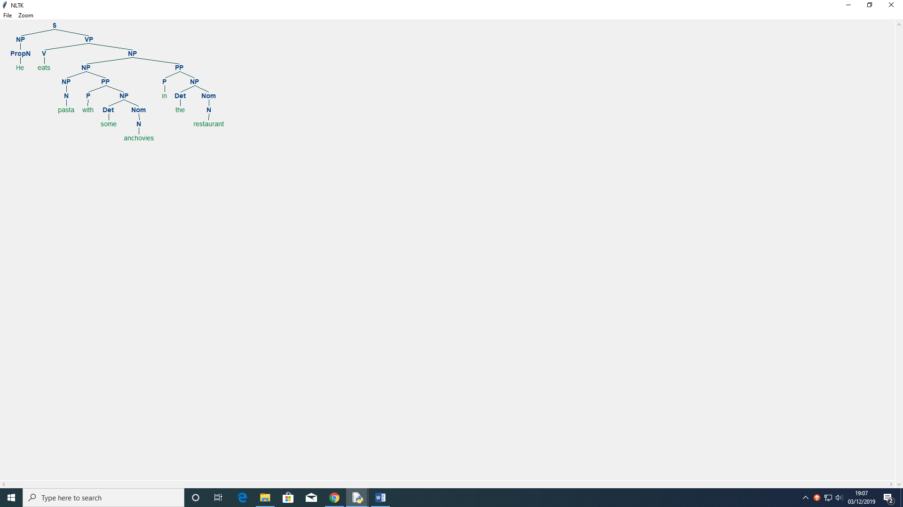

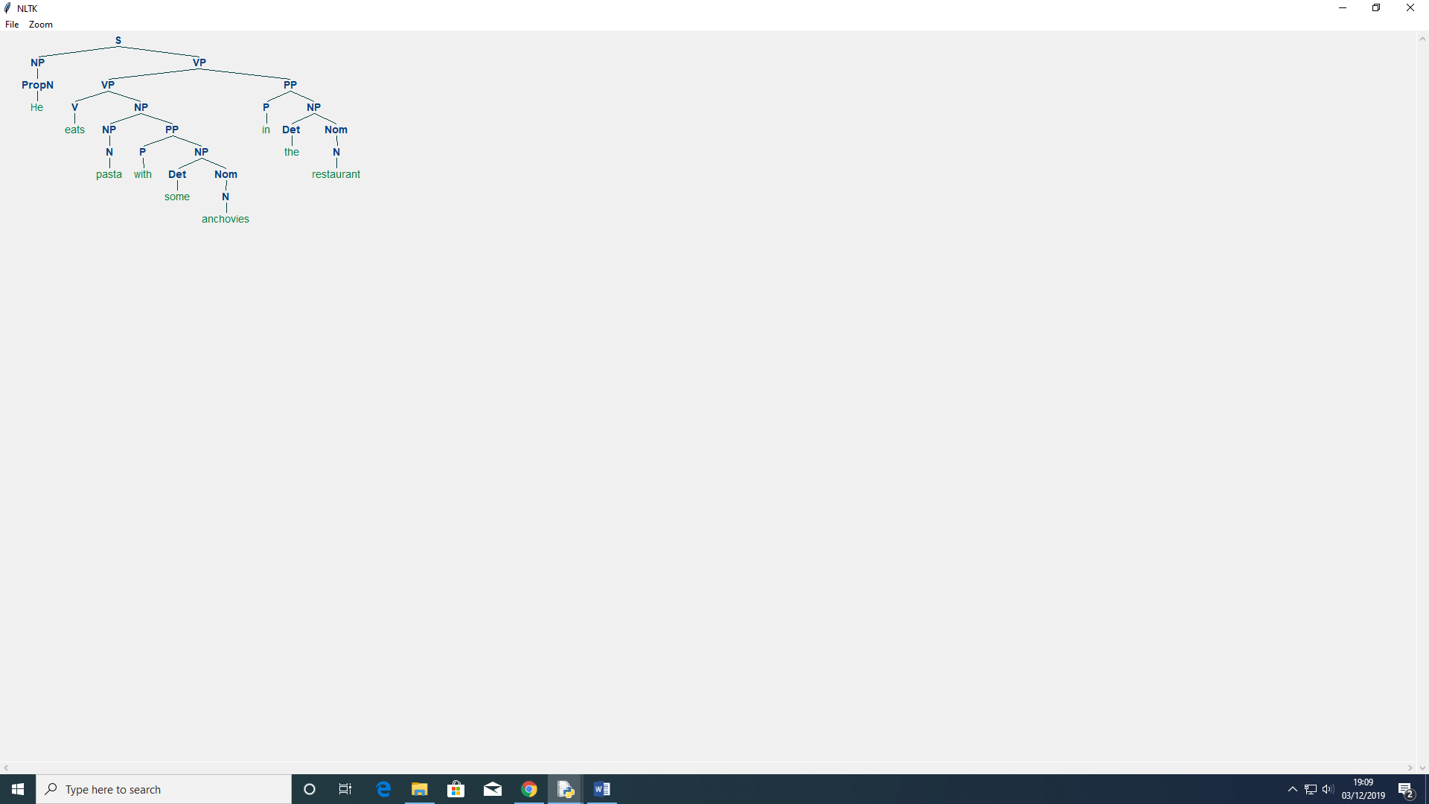

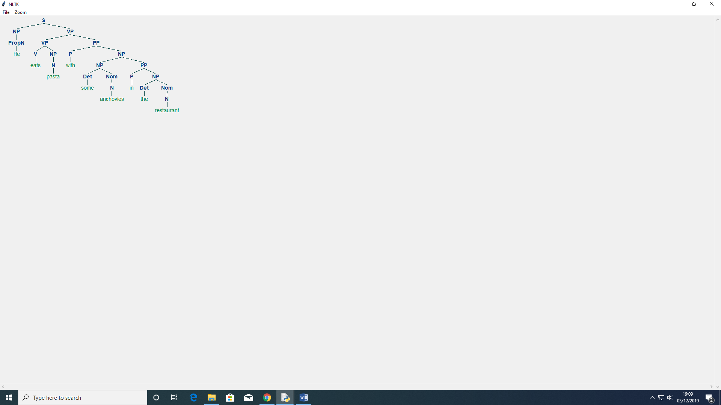

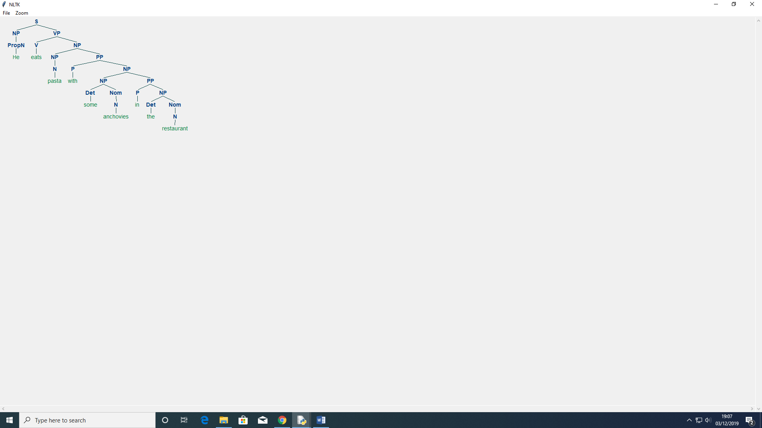

**S7 interpretations are as follows:**

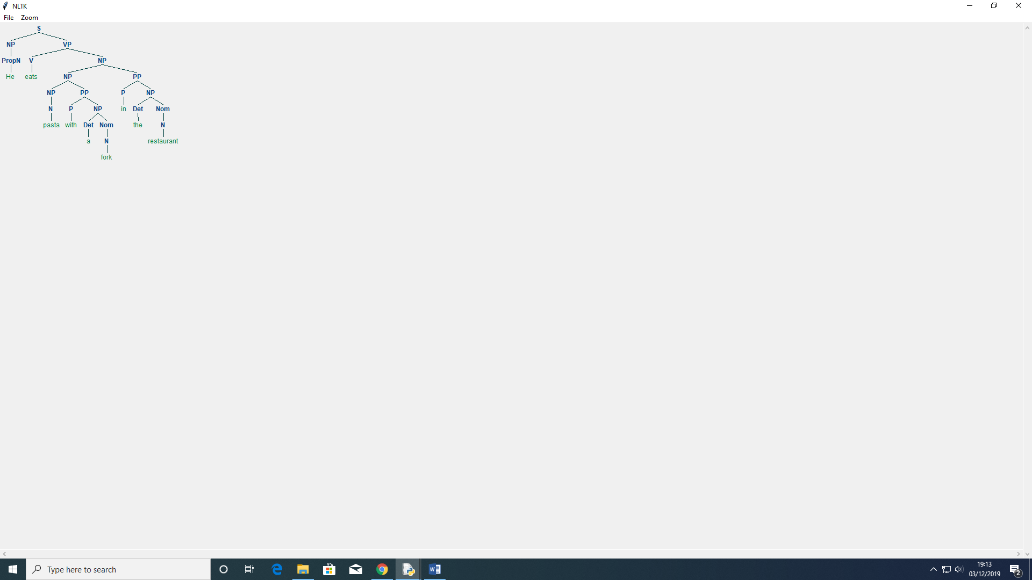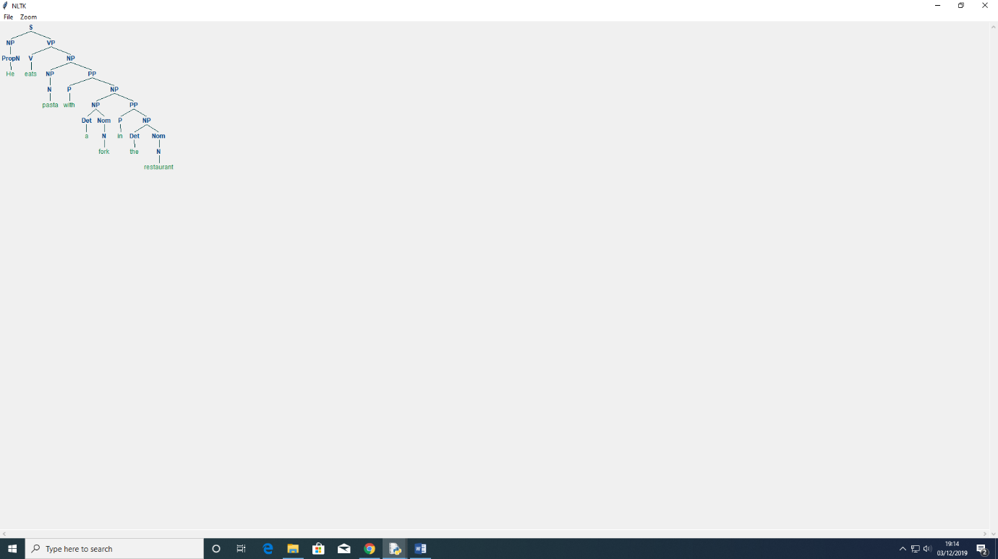

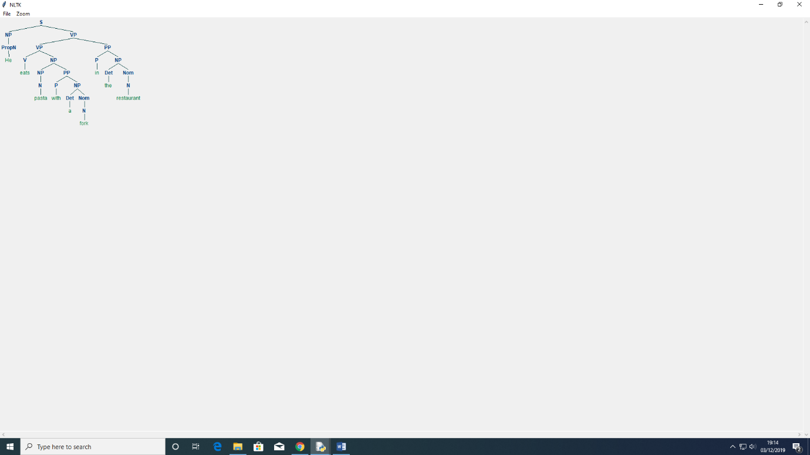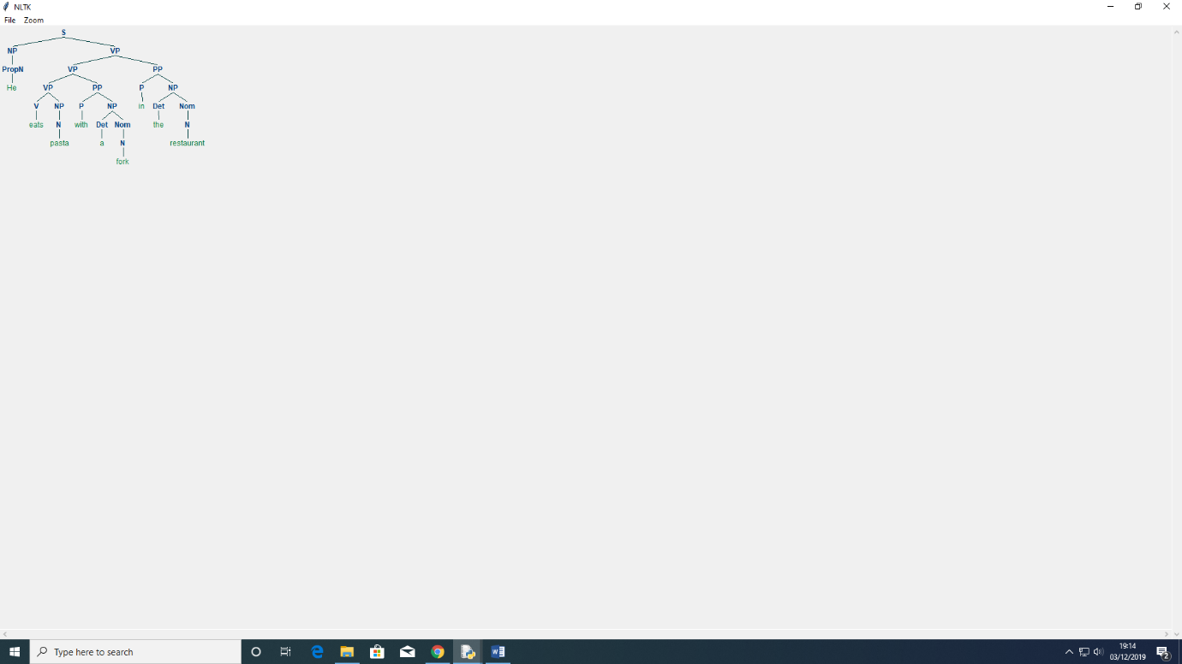

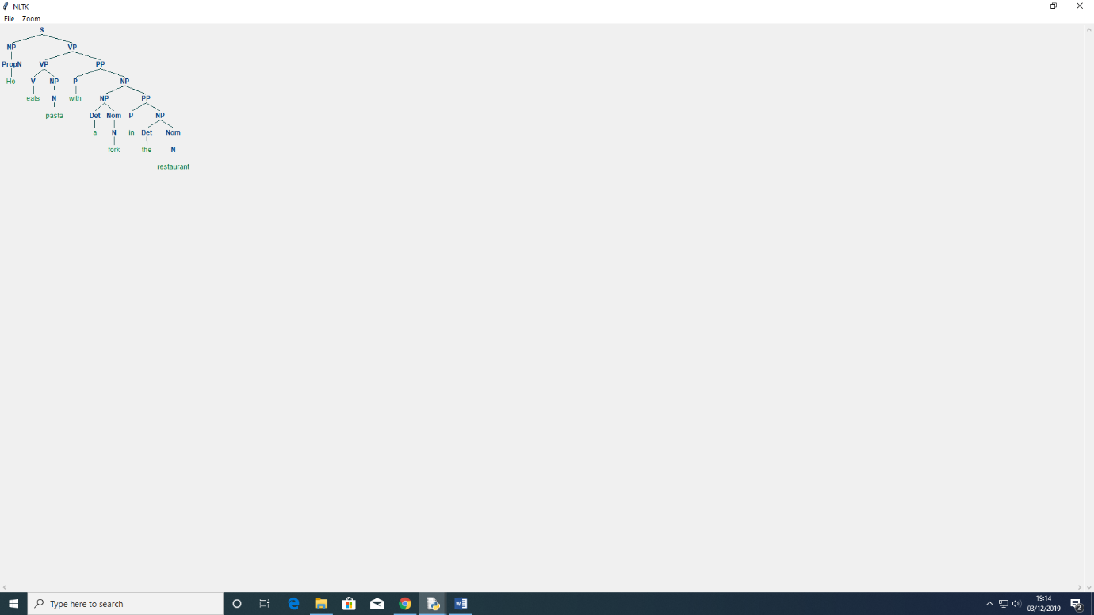

Both produce 5 derivation. Both have two branches, NP and VP where NP has a Proper Noun ‘he’. VP branch is either followed by a VP or NP or PP. The sentence is said to be structurally ambiguous. The ambiguity is called a prepositional phrase. It is an ambiguity about attachment since the PP ‘in the restaurant’ needs to be attached to one of two places in the tree – either as a child VP or child NP. Hence, when the PP is attached to attach to a VP then interpretation is that the event happened in the restaurant. However, if the PP is attached to NP then it is seen as the fork in S7, is considered to being ‘in the restaurant’.

1. **The output for Shift Reduce Parser and Earley Chart Parser are as follows:**

Shift Reduce Parser for S6:

No output.

Earley Chart Parser for S6:

(S

(NP (PropN He))

(VP

(V eats)

(NP

(NP

(NP (Det) (Nom (N pasta)))

(PP (P with) (NP (Det a) (Nom (N fork)))))

(PP (P in) (NP (Det the) (Nom (N restaurant)))))))

(S

(NP (PropN He))

(VP

(V eats)

(NP

(NP

(Det )

(Nom (N pasta))

(PP (P with) (NP (Det a) (Nom (N fork)))))

(PP (P in) (NP (Det the) (Nom (N restaurant)))))))

(S

(NP (PropN He))

(VP

(V eats)

(NP

(NP (Det ) (Nom (N pasta)))

(PP

(P with)

(NP

(NP (Det a) (Nom (N fork)))

(PP (P in) (NP (Det the) (Nom (N restaurant)))))))))

(S

(NP (PropN He))

(VP

(V eats)

(NP

(NP (Det ) (Nom (N pasta)))

(PP

(P with)

(NP

(Det a)

(Nom (N fork))

(PP (P in) (NP (Det the) (Nom (N restaurant)))))))))

(S

(NP (PropN He))

(VP

(V eats)

(NP

(Det )

(Nom (N pasta))

(PP

(P with)

(NP

(NP (Det a) (Nom (N fork)))

(PP (P in) (NP (Det the) (Nom (N restaurant)))))))))

(S

(NP (PropN He))

(VP

(V eats)

(NP

(Det )

(Nom (N pasta))

(PP

(P with)

(NP

(Det a)

(Nom (N fork))

(PP (P in) (NP (Det the) (Nom (N restaurant)))))))))

Shift Reduce Parser for S7:

No output.

Earley Chart Parser for S7:

(S

(NP (PropN He))

(VP

(V eats)

(NP

(NP

(NP (Det ) (Nom (N pasta)))

(PP (P with) (NP (Det a) (Nom (N fork)))))

(PP (P in) (NP (Det the) (Nom (N restaurant)))))))

(S

(NP (PropN He))

(VP

(V eats)

(NP

(NP

(Det )

(Nom (N pasta))

(PP (P with) (NP (Det a) (Nom (N fork)))))

(PP (P in) (NP (Det the) (Nom (N restaurant)))))))

(S

(NP (PropN He))

(VP

(V eats)

(NP

(NP (Det ) (Nom (N pasta)))

(PP

(P with)

(NP

(NP (Det a) (Nom (N fork)))

(PP (P in) (NP (Det the) (Nom (N restaurant)))))))))

(S

(NP (PropN He))

(VP

(V eats)

(NP

(NP (Det ) (Nom (N pasta)))

(PP

(P with)

(NP

(Det a)

(Nom (N fork))

(PP (P in) (NP (Det the) (Nom (N restaurant)))))))))

(S

(NP (PropN He))

(VP

(V eats)

(NP

(Det )

(Nom (N pasta))

(PP

(P with)

(NP

(NP (Det a) (Nom (N fork)))

(PP (P in) (NP (Det the) (Nom (N restaurant)))))))))

(S

(NP (PropN He))

(VP

(V eats)

(NP

(Det )

(Nom (N pasta))

(PP

(P with)

(NP

(Det a)

(Nom (N fork))

(PP (P in) (NP (Det the) (Nom (N restaurant)))))))))

Shift reduce parser gives no output. From this we can say that this parser does not detect ambiguity. On the other hand, Earley chart parser gives us different derivations for both sentences and so from that we can say that it does detect ambiguity.

**References:**

[1] Shoebottom, P. (2019). English Grammar Explanations - Articles. [online] Esl.fis.edu. Available at: http://esl.fis.edu/grammar/rules/article.htm [Accessed 30 Nov. 2019].

[2] Webapps.towson.edu. (2019). Subject - Verb Agreement. [online] Available at: https://webapps.towson.edu/ows/modulesvagr.htm [Accessed 30 Nov. 2019].

[3] Nltk.org. (2019). [online] Available at: http://www.nltk.org/book_1ed/ch08.html [Accessed 30 Nov. 2019].