**CODING PART A**

import math

# Prime number sum calculator

def my_prime(x):

    if x<= 1:

        return False

    for i in range(2,int(x**0.5)+1):

        if x %i== 0:

            return False

    return True

def total_sum (start,end):

    total = 0

    for x in range (start , end + 1):

        if my_prime(x):

            total += x

    return total

# Length unit converter

def LengthConvert(value, direction):

    mt_to_ft = 3.28084

    ft_to_mt= 0.3048

    if direction == 'M':

        converted_value = value * mt_to_ft

    elif direction == 'F':

        converted_value = value * ft_to_mt

    else:

        return ("Invalid direction! Use 'M' for meters to feet or 'F' for feet to meters.")

    return round(converted_value, 1)

# Consonant counter

def ConsonantCount(text):

    vowels = "aeiouAEIOU"

    ConsonantCount = 0

    for char in text:

        if char.isalpha() and char not in vowels:

            ConsonantCount += 1

    return ConsonantCount

# Min-Max number Finder

def MinMaxFinder(num):

    smallest = min(num)

    largest = max(num)

    return f"Smallest: {smallest}, Largest: {largest}"

# Palindrome checker

def palindrome(text):

    CleanText = ''.join(text.split()).lower()

    return CleanText == CleanText[::-1]

# Word counter

import requests

def word_count(text_file_url):

    response = requests.get(text_file_url)

    text = response.text.lower()

    wlist = ['the', 'was', 'and']

    word= {word: text.count(word) for word in wlist}

    return word

# Menu and main program flow

def main():

    while True:

        print("\nMenu:")

        print("1. Prime number sum calculator")

        print("2. Length unit converter")

        print("3. Consonant counter")

        print("4. Min-Max number finder")

        print("5. Palindrome checker")

        print("6. Word counter")

        print("7. Exit")

        choice = input("choose a function by entering a number (1-7): ").strip()

        if choice == '1':

            # Prime number sum calculator

            try:

                start  = int (input("enter the start range"))

                end = int (input("enter the end range"))

                result = total_sum (start , end)

                print(f"the prime sum of the  range given :{result}")

            except ValueError:

                print("Invalid input. Please enter integers.")

        elif choice == '2':

            # Length unit converter

            try:

                value = float(input("Enter the numeric value: "))

                direction = input("Enter the direction to convert ('M' for meters to feet, 'F' for feet to meters): ")

                result = LengthConvert(value, direction)

                print(f"Converted length value: {result}")

            except ValueError as e:

                print(f"Error: {e}")

        elif choice == '3':

            # Consonant counter

            text = input("Enter a text string: ")

            result = ConsonantCount(text)

            print(f"Number of consonants: {result}")

        elif choice == '4':

            #Min - Max

            n = int(input("How many numbers do you want to enter? "))

            num1 = []

            for i in range(n):

                num2 = float(input(f"Enter number {i+1}: "))

                num1.append(num2)

            print(MinMaxFinder(num1))

        elif choice == '5':

            # Palindrome checker

            text = input("Enter a text string: ")

            result = palindrome(text)

            print(f"Is the string a palindrome? {result}")

        elif choice == '6':

            # Word counter

            file_url = input("Enter the URL of the text file: ").strip()

            try:

                result = word_count(file_url)

                print(f"Word counts: {result}")

            except requests.exceptions.RequestException as e:

                print(f"Error fetching the file: {e}")

        elif choice == '7':

            print("EXIT DONE  Thank you!")

            break

        else:

            print("Invalid.")

        # Ask user if they want to perform another calculation

        choice = input("Do you want to continue? (yes/no): ").strip().lower()

        if choice != 'yes':

            print("Exiting the program. Goodbye!")

            break

# Run the main function

if __name__ == "__main__":

    main()

OUTPUT :

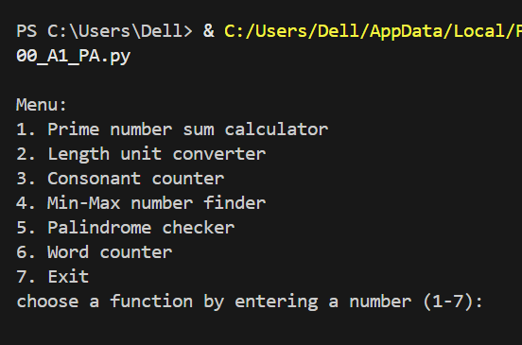

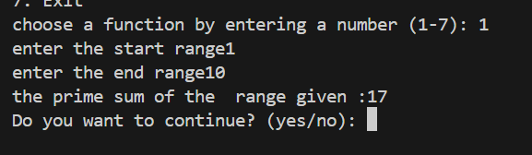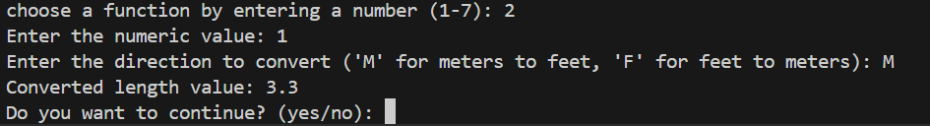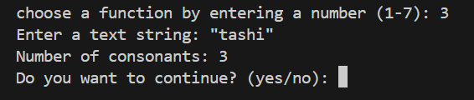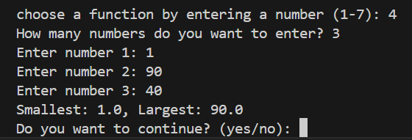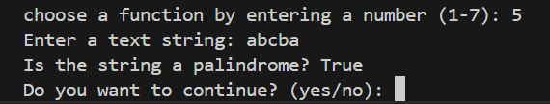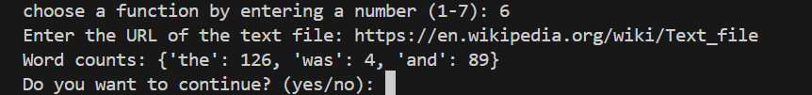

**CODING PART B**

import random

def guess_number():

    print("GUESS NUMBER GAME !")

    lower = 1

    upper = 100

    HiddenNumber  = random.randint(lower , upper)

    print (f"select number range from {lower} to {upper}")

    attempts =0

    while True:

        attempts += 1

        guess = int(input("Guess a Number : "))

        if guess < HiddenNumber:

            print("Your Guess is  Low! ")

        elif guess > HiddenNumber:

            print("Your Guess is High! ")

        elif guess == HiddenNumber:

            print("You Won!")

            break

        else :

            print("YOU WON!!!!!!")

    print(f' ATTEMPTED : {attempts} times . ')

def rock_paper_scissors():

    choices = ["rock", "paper", "scissors"]

    print("Welcome to Rock, Paper, Scissors!")

    print("Please choose 'rock', 'paper', or 'scissors'.")

    wins = {"rock":"scissors","scissors":"paper","paper":"rock"}

    rounds = int(input("ENTER THE ROUNDS OF GAME YOU WANT TO PLAY ! : "))

    user_score = 0

    computer_score = 0

    TIE = 0

    for i in range (rounds):

        while True:

            user_choice = input("Enter your choice (rock, paper, scissors): ").lower()

            if user_choice not in choices:

                print("Invalid choice. Please choose 'rock', 'paper', or 'scissors'.")

            else:

                break

        computer_choice = random.choice(choices)

        print(f"Computer chooses: {computer_choice}")

        if user_choice == computer_choice:

            print("It's a tie!")

            TIE += 1

        elif user_choice == wins[computer_choice]:

            print("You LOSE")

            computer_score +=1

        else:

            print("You win")

            user_score += 1

        print(f"Your Score : {user_score}  VS  computer_score : {computer_score}     TIE : {TIE}")

    final = (f"FINAL : You : {user_score}  Computer : {computer_score}    TIE : {TIE}")

    if user_score > computer_score:

        print("You WON")

    elif user_score == computer_score :

        print("TIE")

    else :

        print("You LOST")

    print(final)

def main ():

    while True:

        print("1 . Guess Number Game !! ")

        print("2 . Rock ,Paper and Scissors Game !! ")

        print("3 . EXIT !! ")

        choose = input("Choose a Number for Gaming (1 to 3) : ")

        if choose  == '1':

            guess_number()

        elif choose == '2':

            rock_paper_scissors()

        elif choose == '3':

            print("EXITING THE PROGRAM !! ")

            break

        else:

            print("invalid")

            return

        choose = input ("do yuo want to continue with game (yes/no) : ")

        if choose != 'yes':

            print("Exiting the program. Goodbye!")

            break

if __name__ == "__main__":

    main()

**OUTPUTS:**

