Student Time Table Management System

Since cell phones are prevalent with understudies and can be utilized as a part of all kinds of different backgrounds, we have endeavored to make an application that the understudies can without much of a stretch access through their cell phones. Despite the fact that there are numerous portable stages accessible in the market nowadays, Android OS is the most user-friendly and developer neighborly stage. Android is an Operating System supporting an extensive number of uses in advanced mobile phones. These applications make life more agreeable and progressed for the clients. One such application that we are discussing here in the paper is the Academic Scheduler. This application, for the most part, means to limit the challenges that the understudies look in overseeing and arranging their scholarly life. The client of this application will be simply the understudy and ought to have the application introduced on the cell phone/android gadget. In our task “Time Table Management” is utilized access the timetable of every understudy in a foundation. The Admin module gives the timetables of Student and educators from the administrator side and the staff and understudy can get to their timetable separately. This class timetable for Android has been produced. This application will assume a fundamental part for organizations or universities who need to advise their instructors of a unique time. Utilizing this application, educators will likewise ready to make their class timetable according to their benefit and roll out improvements according to their availability and need. It’s the class timetable application by which educators can get their class data by utilizing their fingers. To make this table more enlightening, all the data’s has been spoken to in a justifiable way. Utilizing this android application, educators and employees will ready to know their showing time at whatever point they are in require.

Idea Description
As we as a whole know, how the customary class time has been utilized and even in the present specialized period, this convention is going on. In any case, at some point, instructors may overlook their routine and remain sitting at staff room by which understudies must be the sufferer. Once in a while because of a misprint on paper chip away at in class timetable enroll, there happen clashes between educators for their opportunity plan which isn’t useful for instructing condition. Speedy updation work can’t be conceivable, due to having recorded at another area and it’s additionally not having conceivable to check their document instantly when required or when required.
Plafrom
The most critical and best component of this android application is that it can be gotten to from anyplace utilizing their shrewd or android based telephones. Utilizing this class timetable android application, educators will ready to get their accessible clumps and their planning subtle elements. Educators if the availability has been given through administrator, will ready to include new clumps the accessible existing time. Updation, cancellation, alteration of accessible groups can be made through administrator board, however in the event that any instructors have to get this office, will ready to make operations, along these lines ready to give dynamic workplace to the presently occupied timetable. At the point when the framework will include in updation work, there will be a legitimate message of holding up will be shown to the specific client. In any case, to make a responsive framework, it will deal with class time and enable educators to roll out improvements to their normal errand, before their beginning time.
The task included dissecting the plan of a couple of utilization in order to make the application more clients cordial. To do as such, it was truly critical to keep the routes from one screen to the next very much requested and in the meantime decreasing the measure of writing the client needs to do. Keeping in mind the end goal to make the application more open, the Android variant must be picked so it is good with a large portion of the Android gadgets.
Software Requirements:
1. Android Development Tools
2. Android Studio 3.4 or Higher(Recent Version)
3. Android SDK and Plug-ins for Android.
Working Systems bolstered
1. Windows 10 64bit
Advances and Languages used to Develop
1. Android
2. Java
3. XML
Debugger and Emulator
1. Android Gradle Debug Monitor
2. Android Emulator(Android Virtual Device)
For running the application the accompanying is the Software Requirements:
Operating System: Android 4.1 or higher adaptations♣
Hardware Requirements
For building up the application the accompanying is the Hardware Requirements:
Processor: Pentium IV or higher♣
RAM: 4 GB♣
Space on Hard Disk: least 22 GB♣
For running the application:
Device: Android rendition 4.1 and higher♣
Minimum space to execute: 10MB♣

Testing Category:
Unit Test
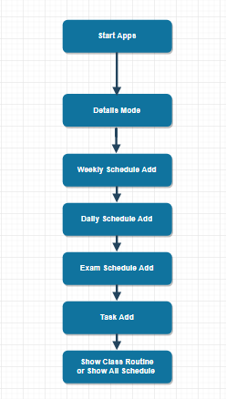

Class Diagram
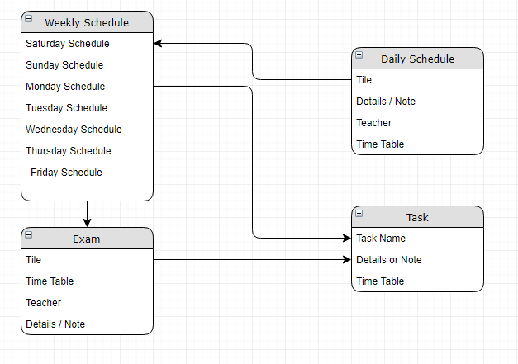

User Case Diagram
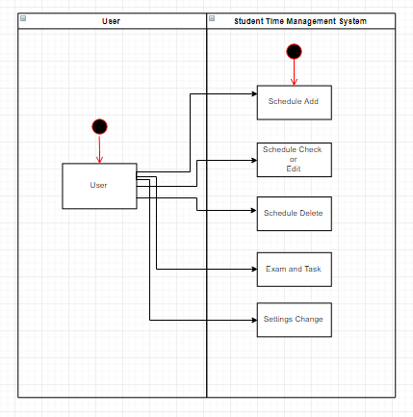

E-R Diagram
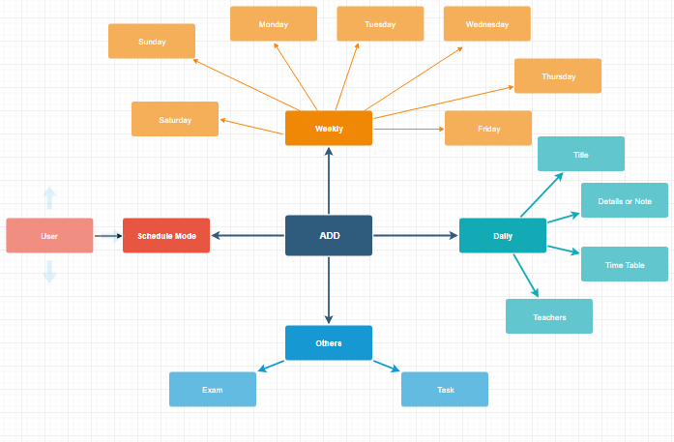

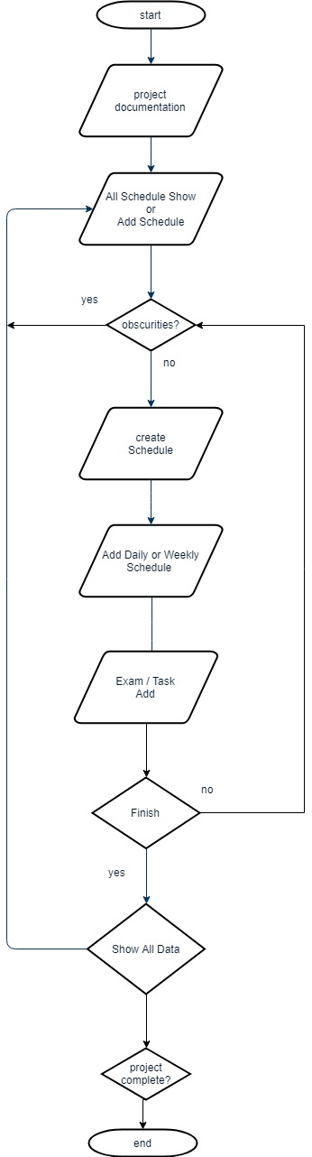
Activity Diagram

