The relay is an eminently significant device in power system protection schemes. In electrical engineering, a protective relay is a relay device designed to trip a circuit breaker when a fault is detected.

The first protective relays were electromagnetic devices, relying on coils operating on moving parts to provide detection of abnormal operating conditions such as over-current, over-voltage, reverse power flow, over-frequency, and under-frequency.

A SLD is made on ETAP for obtaining fault values and normal condition current and voltage values. These values were then tested in arduino to check if it is working perfectly.

Single Line Diagram.

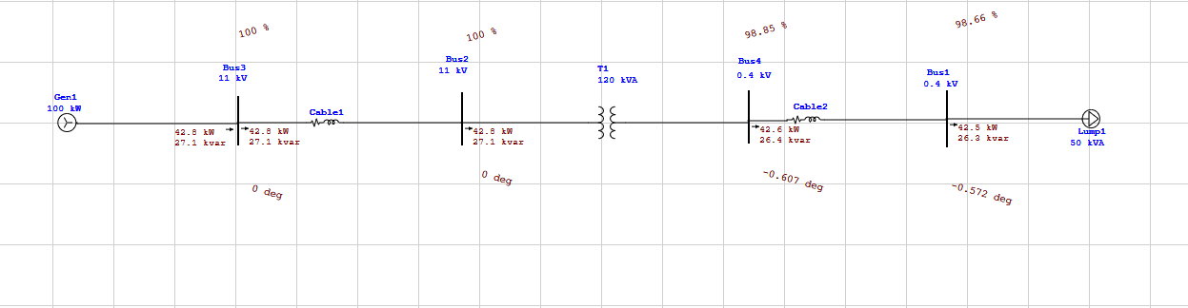

Normal Load Condition.

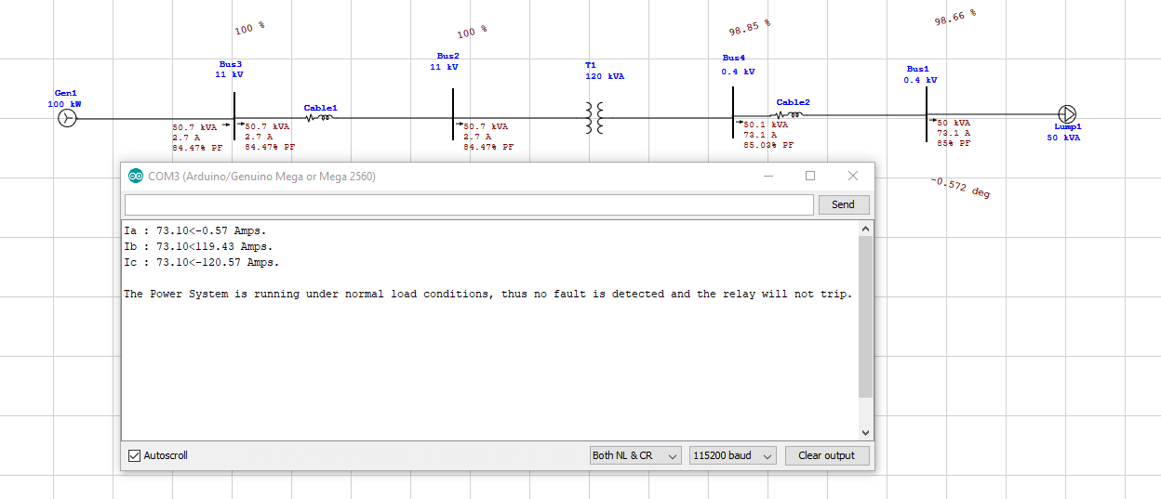

L-G Fault Detection.

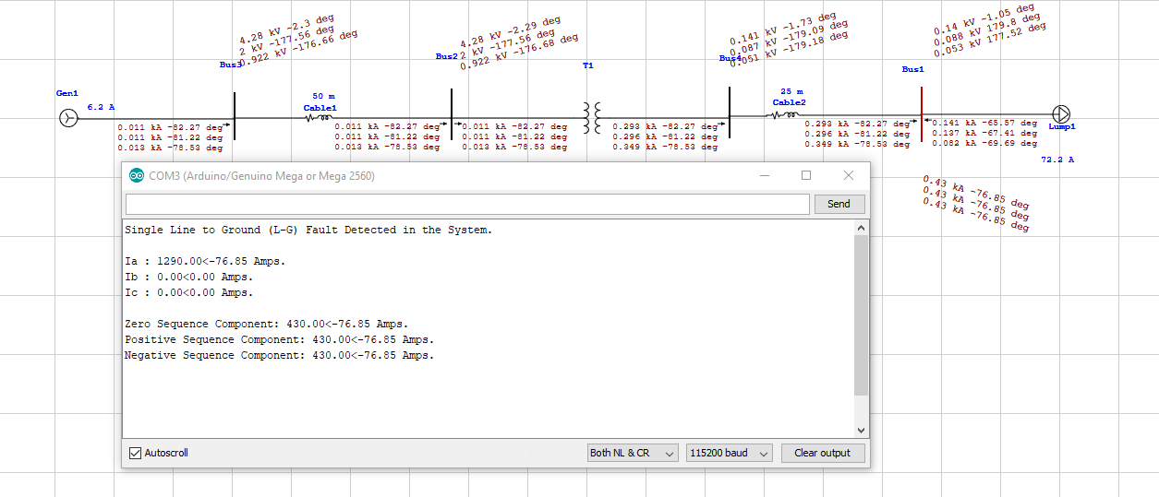

L-L-G Fault Detection.

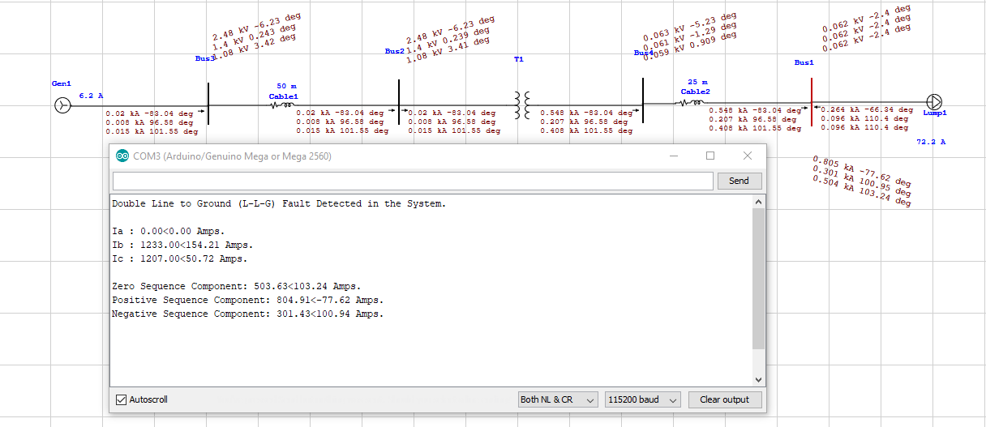

L-L Fault Detection.

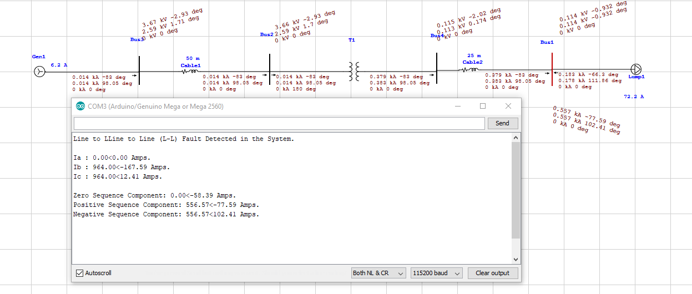

L-L-L Fault Detection.

