

Assignment 2

RELATIONAL SCHEMAS/EER



Tashfeen Abbasi

DS-C/D

**PART-1**

**Relational Schemas/ Mapping**

**Schemas Derived from Strong Entities**

* **Airlines** (A-code, A_name, A_address)
* **Flight** (f_id, origin, destination, arrival_time, departure, stops)
* **Travel_agencies** (t_code, t_address, contact_person)
* **Milage_Program** (p_code, description, Start_date)
* **Passengers** (p_number, address, gender, age)
* **Menu** (v_code, LF_code, v_protein, v_calorie, v_description, LF_protein, LF_calories, LF_description)

**Schemas Derived from Weak Entities**

* **Kohser_community** (v_code, LF_code)
* **Booking_information** (f_id, seat_no, pilot_name, crew_member, flight_date)

**Schemas Derived from Multi-Valued Entities**

* **days_of_week** (f_id, day)
* **phone_no** (t_code, num)
* **passenger_name** (p_number, n_id)

**Schemas Derived from Relationship Set**

* **Sign_up_to** (p_code, p_number)
* **Approval (**v_code, Lf_code, kohser_meals)
* **provides (**A-code, F_id)
* **booked_by (**f_id, t_code)
* **Offers (**A_code, p_code)
* **Offered (**p_number, v_code, LF_code, f_id)

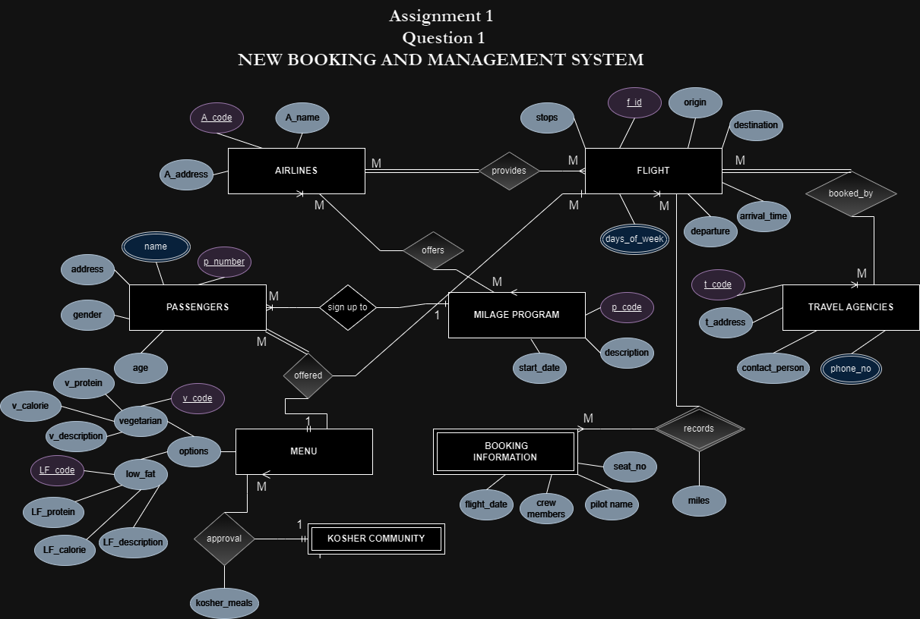

**Description of all tables**

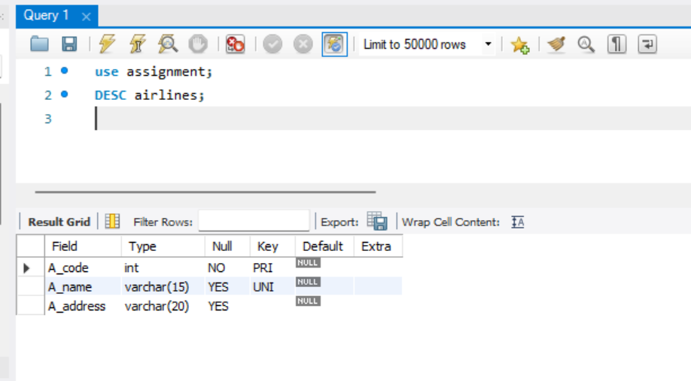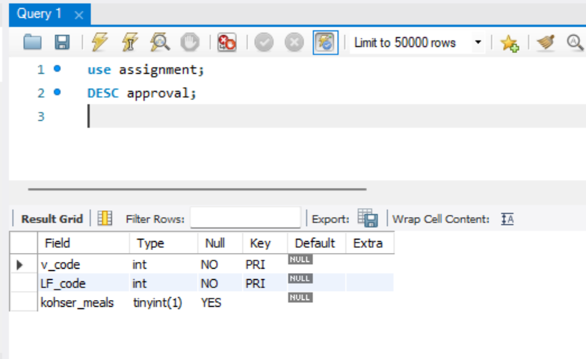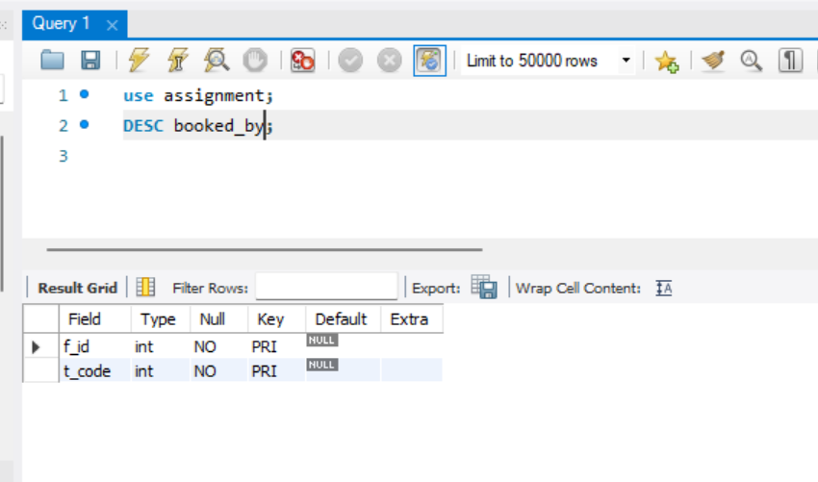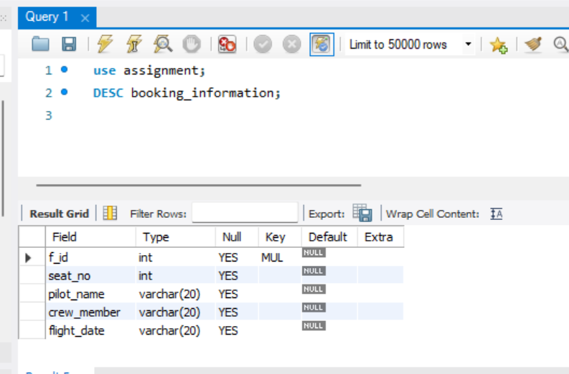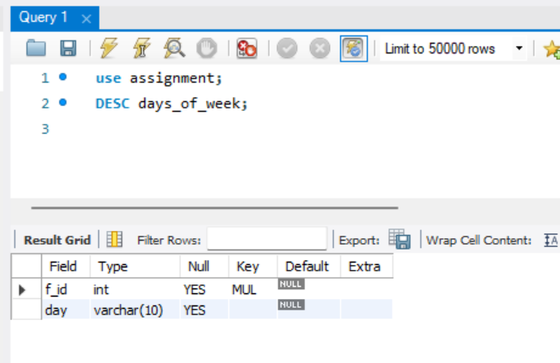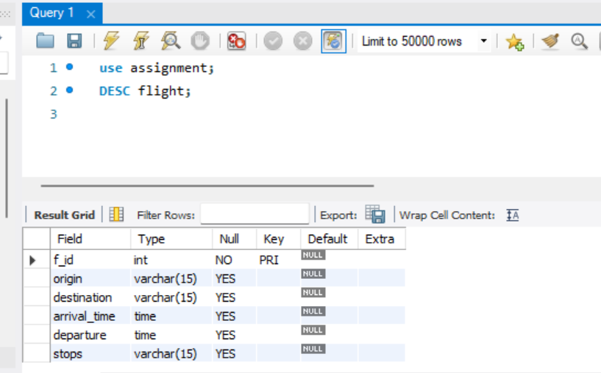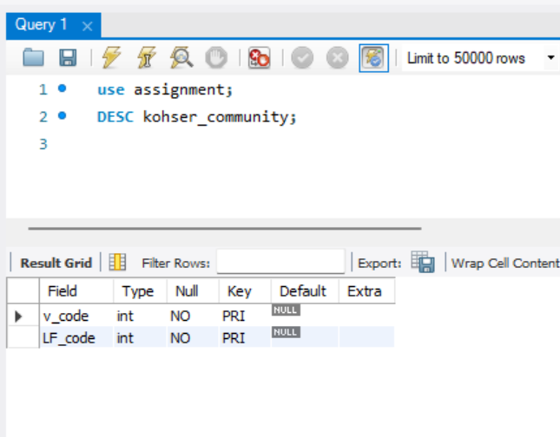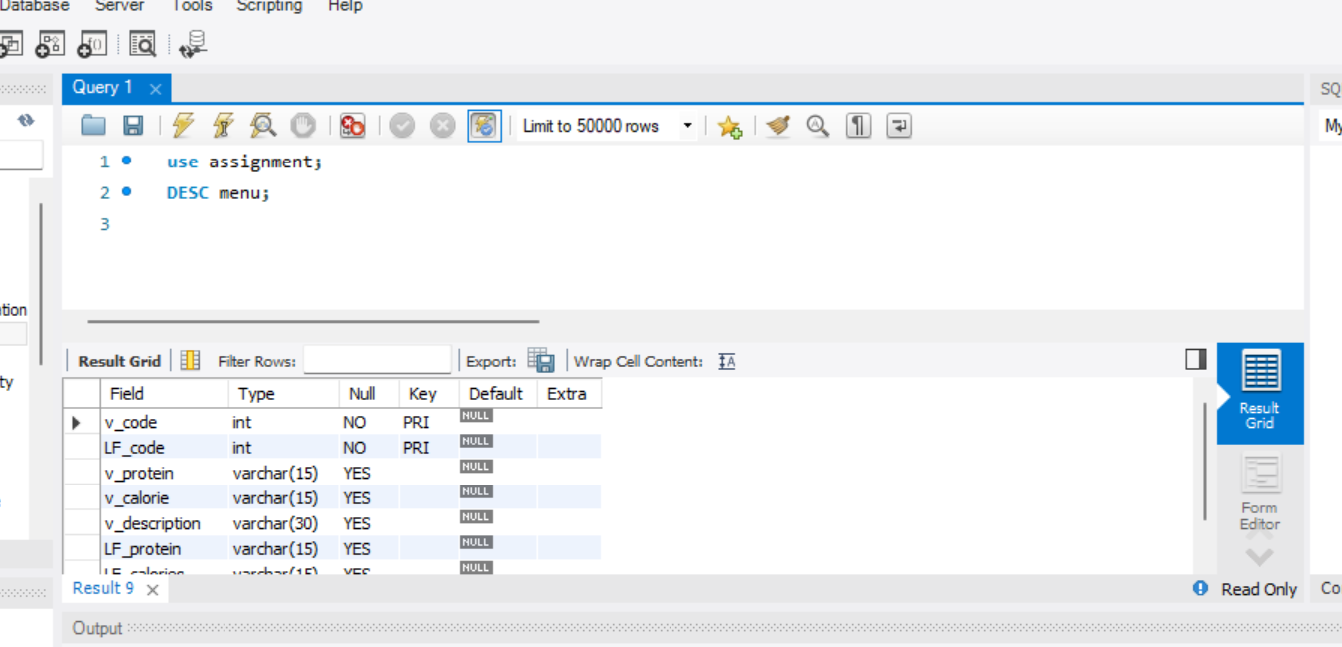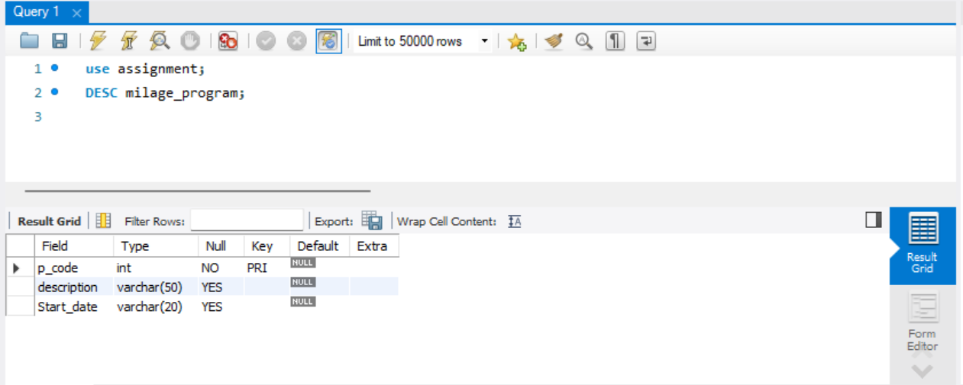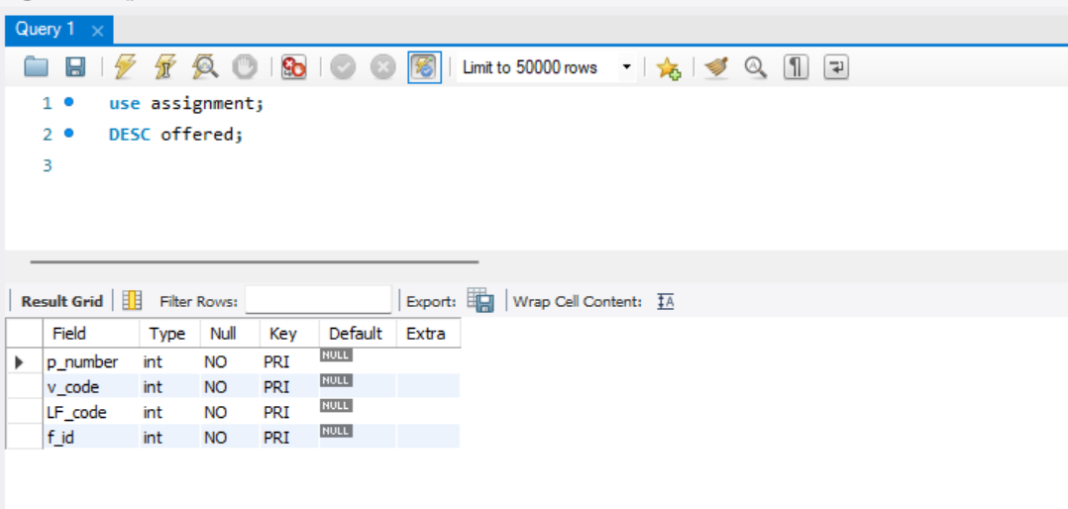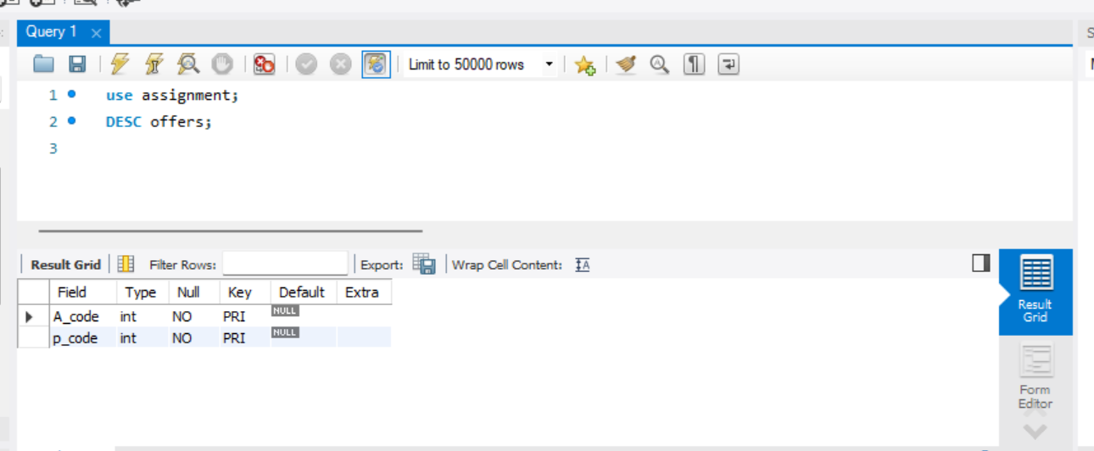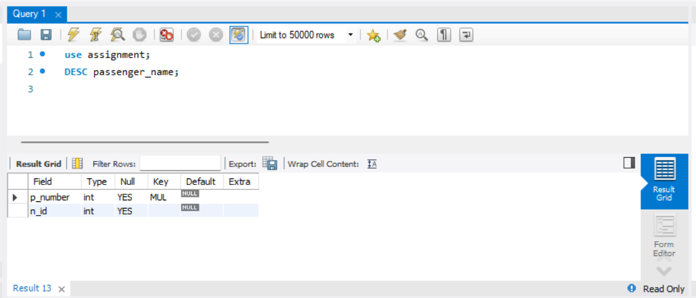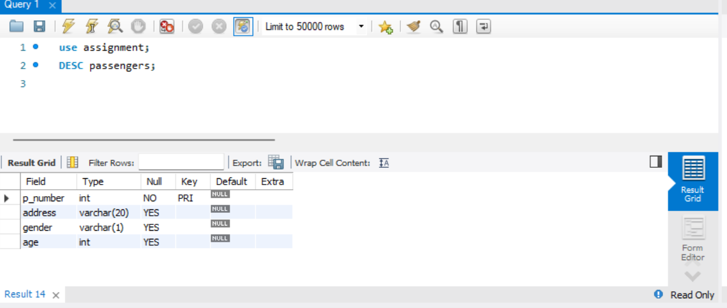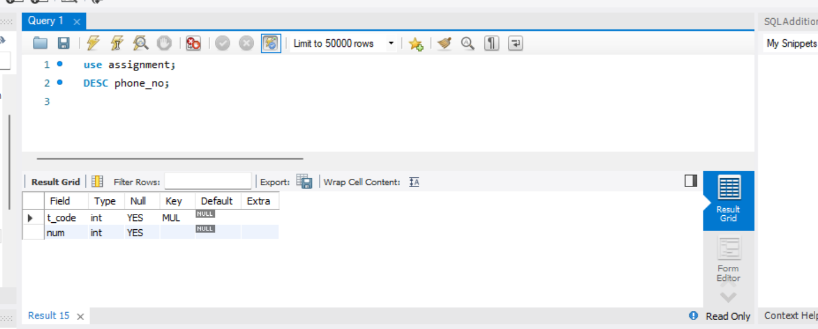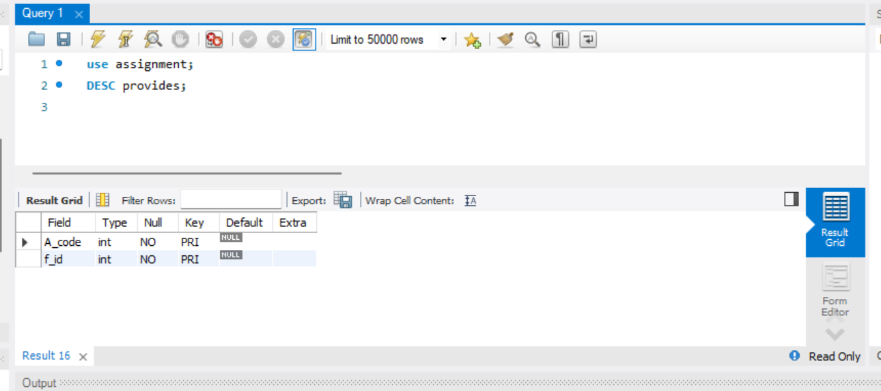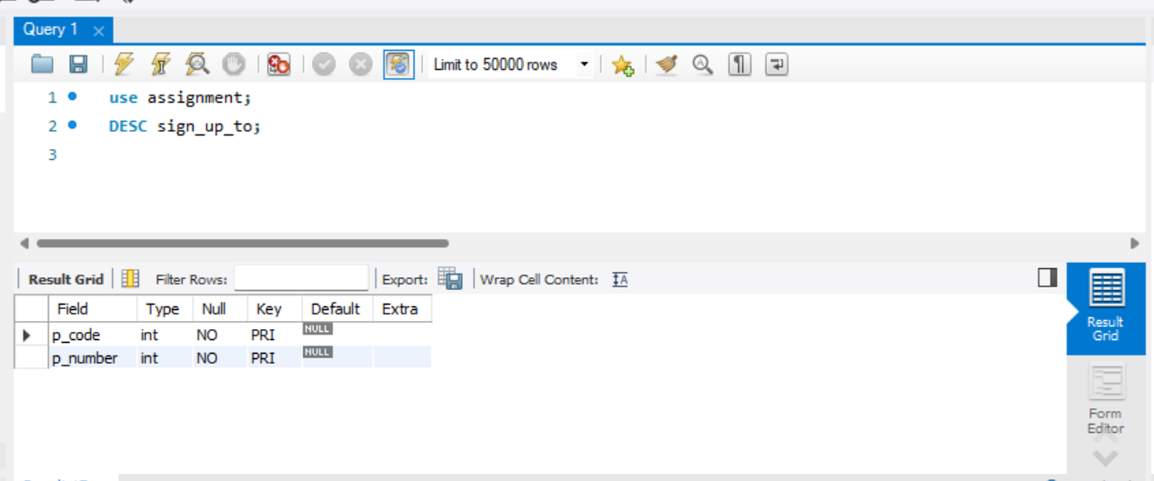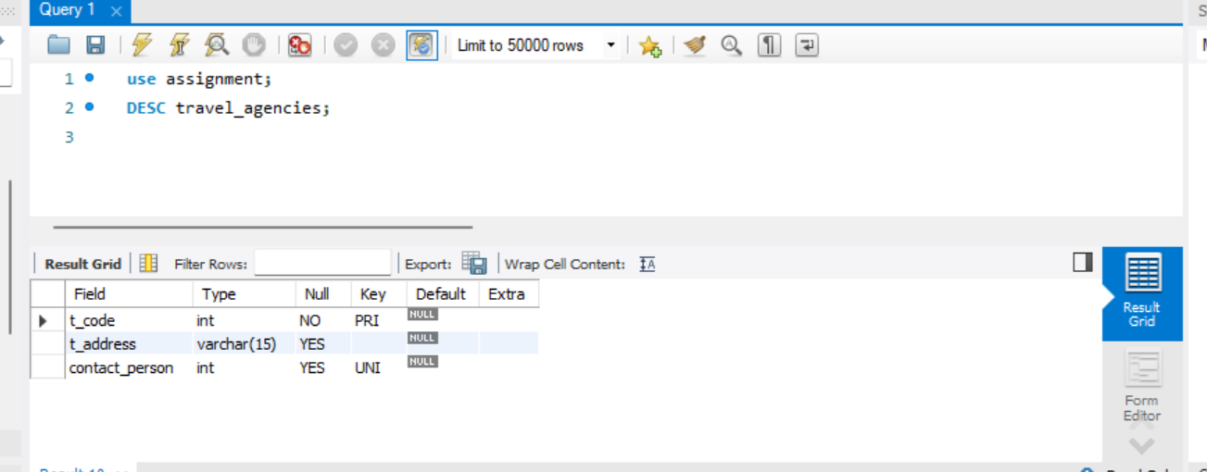

**Dataset**

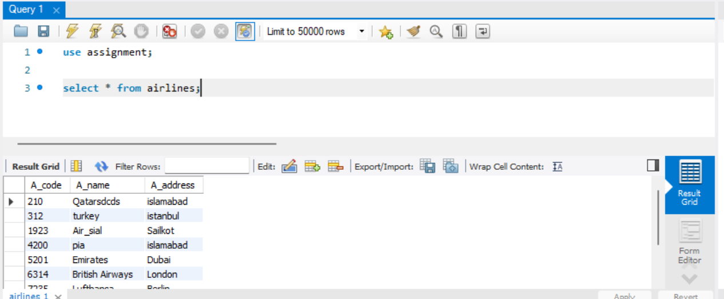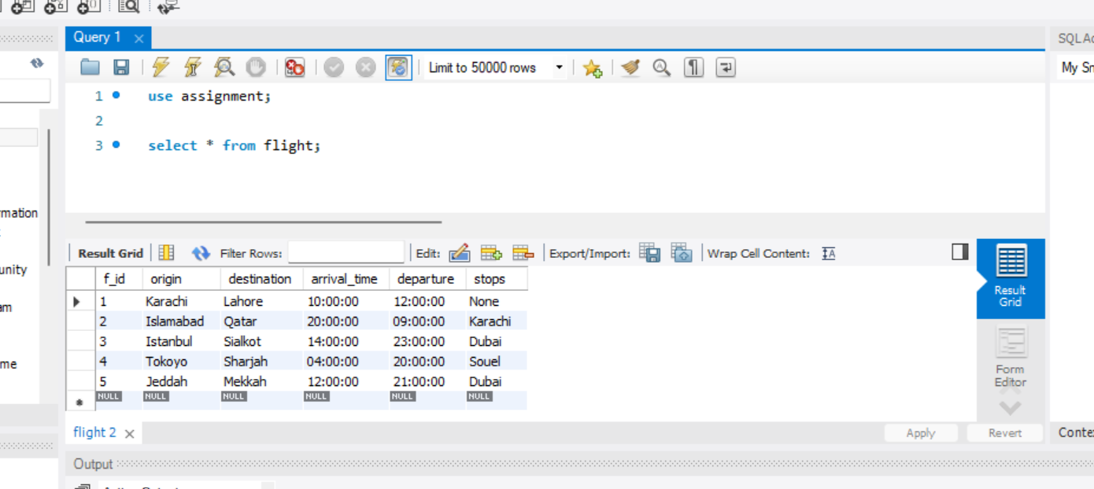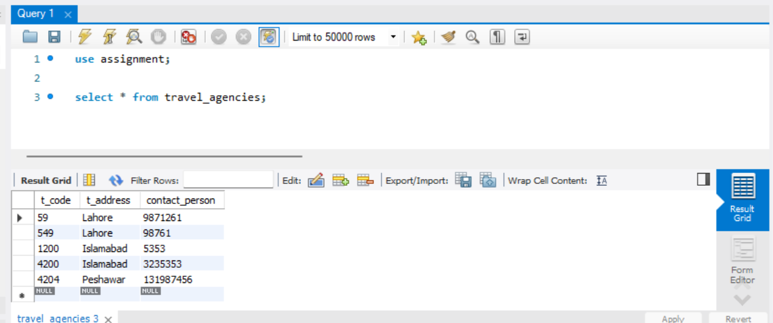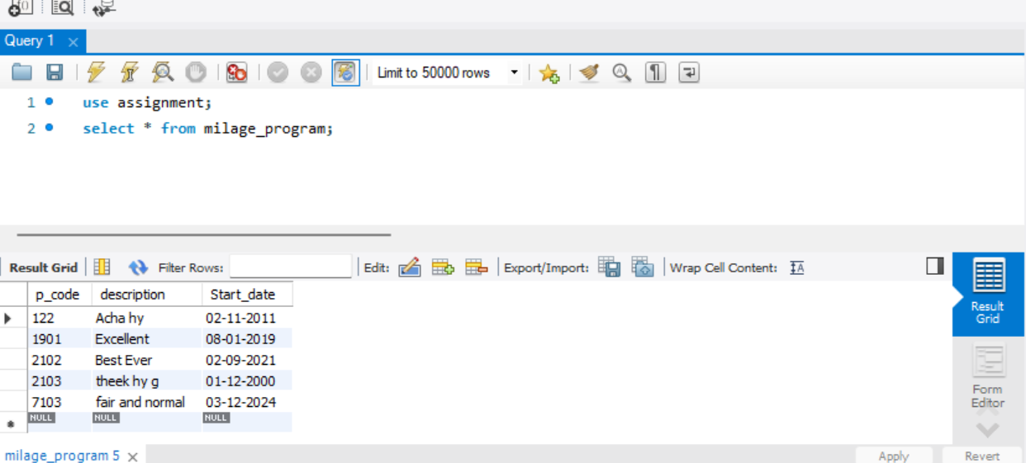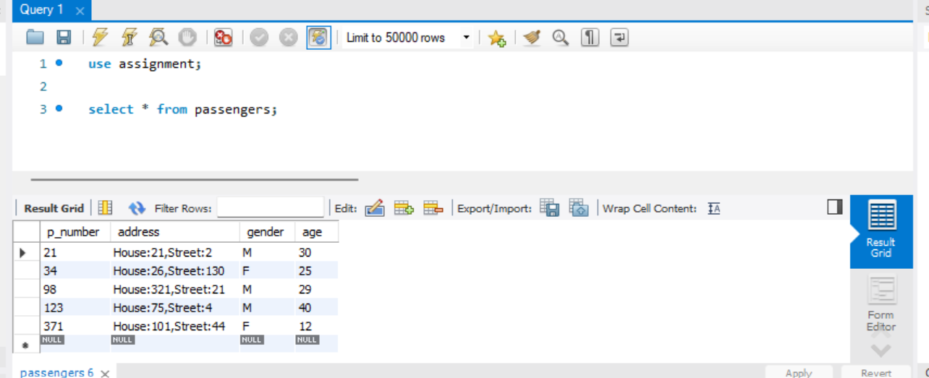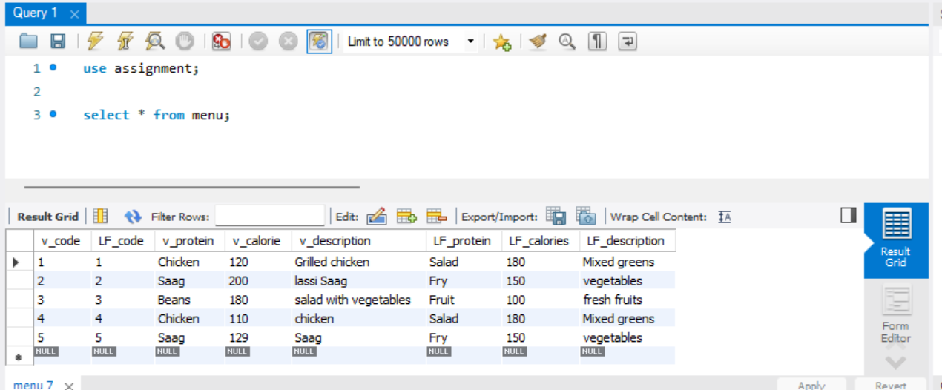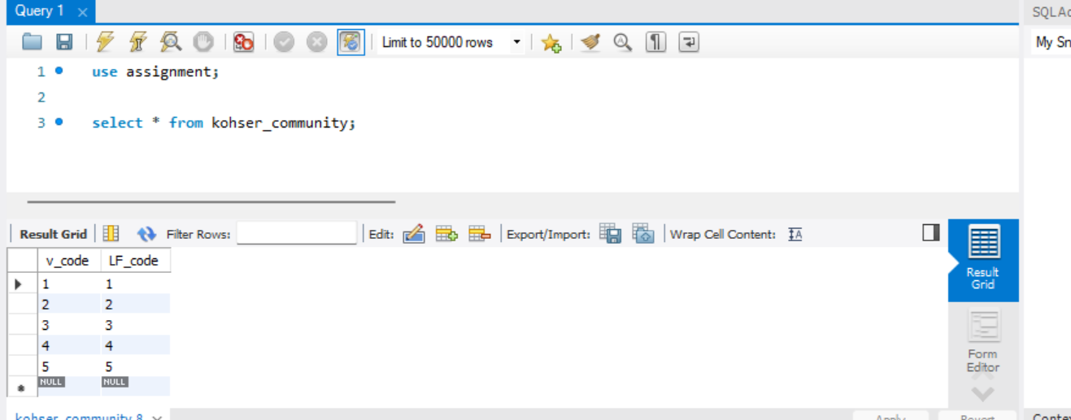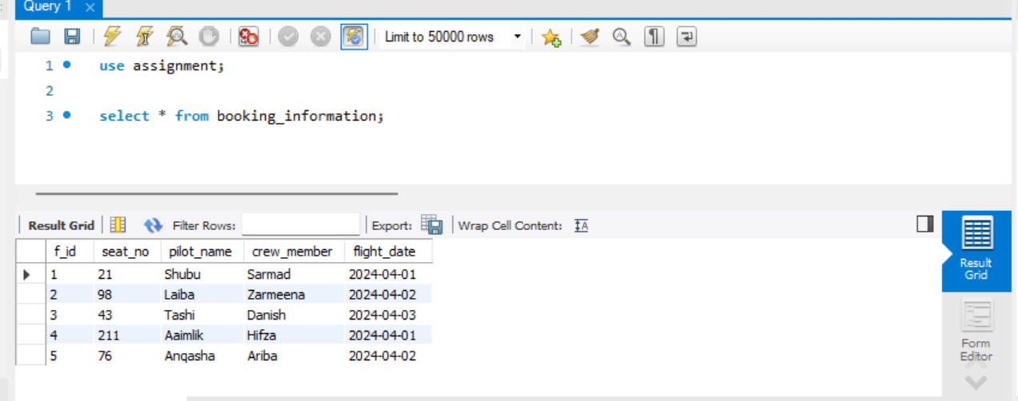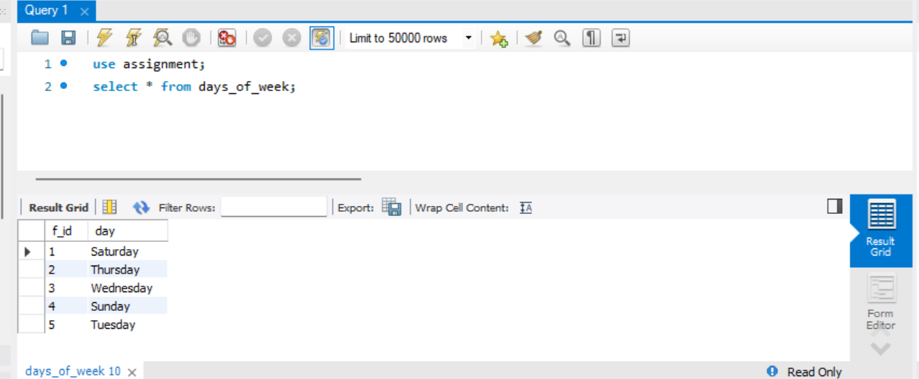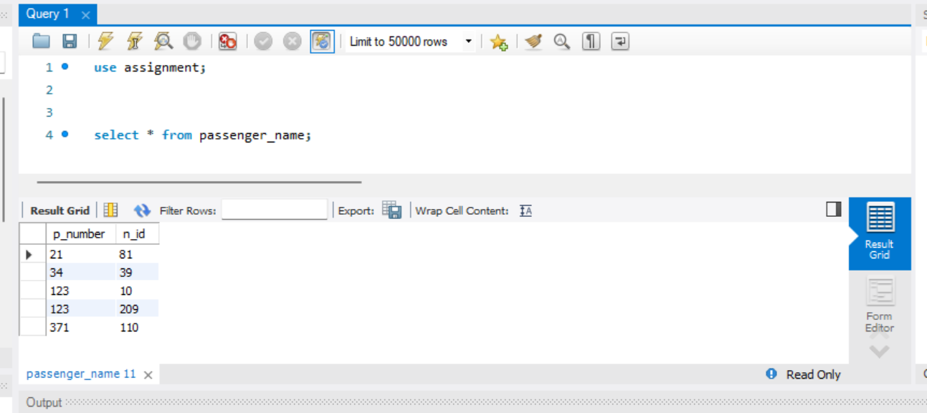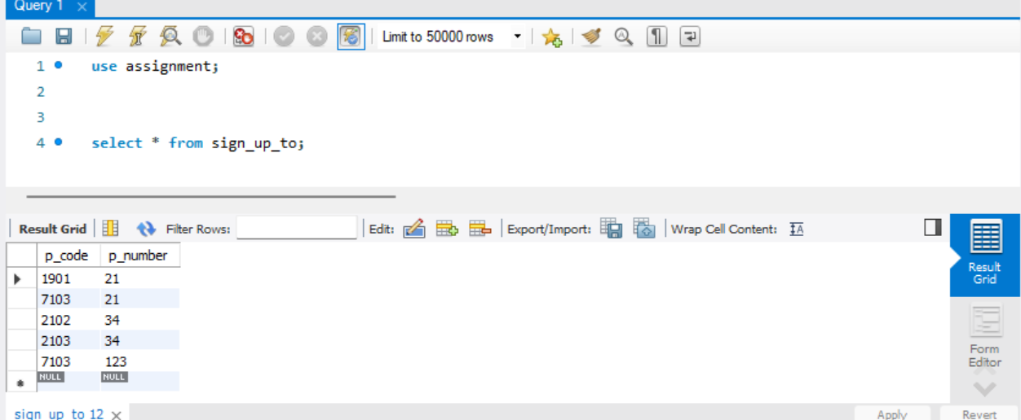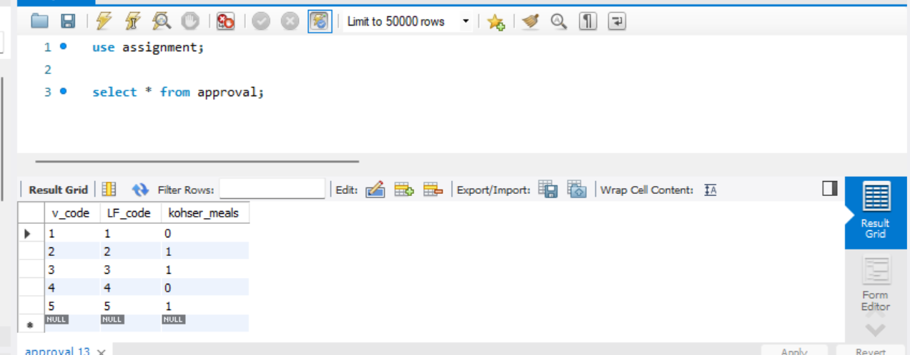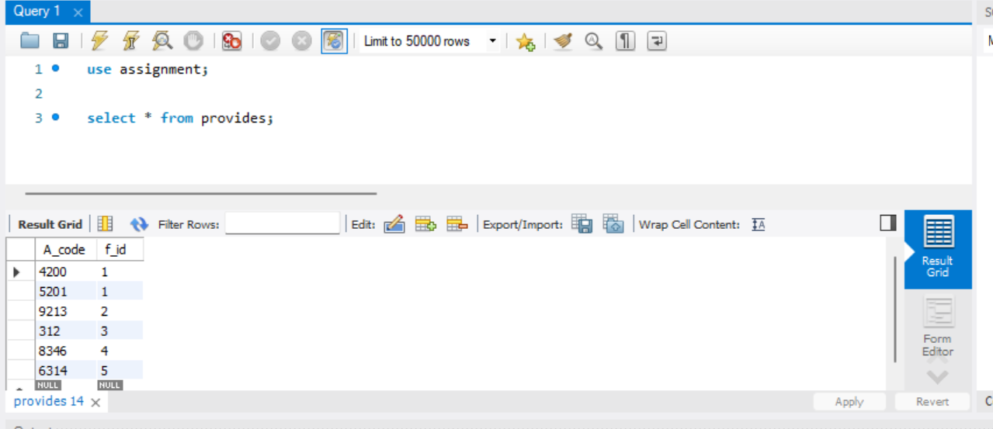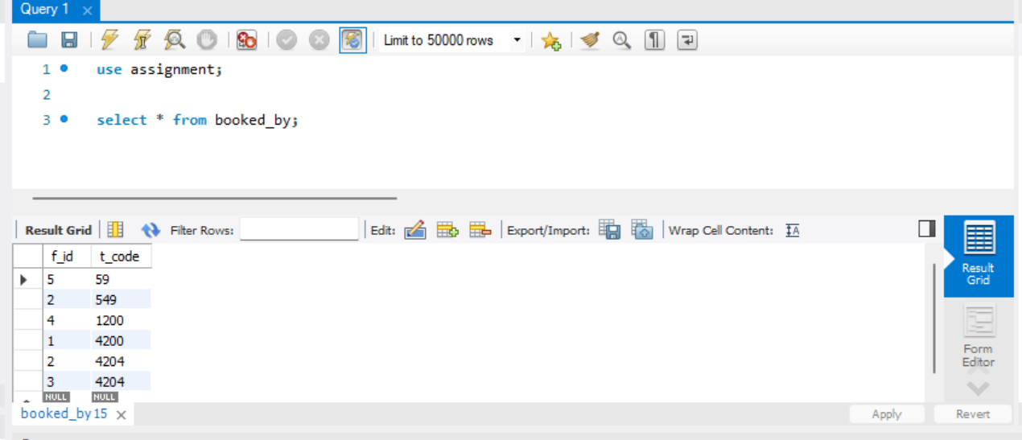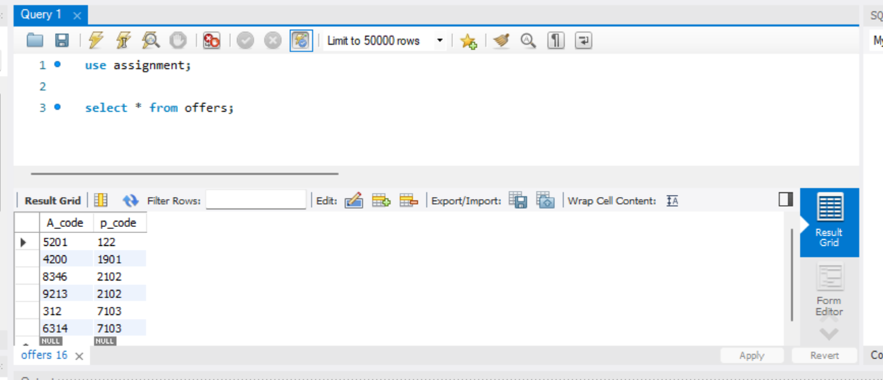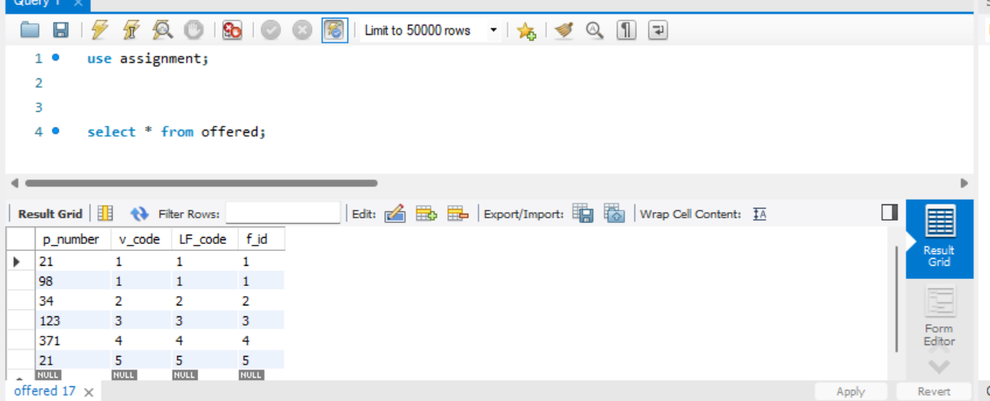

**PART-2**

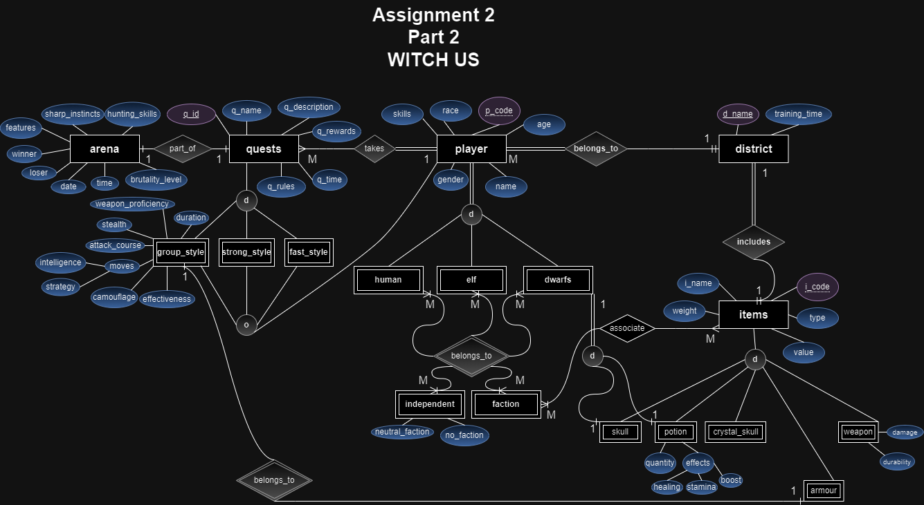

**THE END**