GarageMonkey – Design

System Architecture

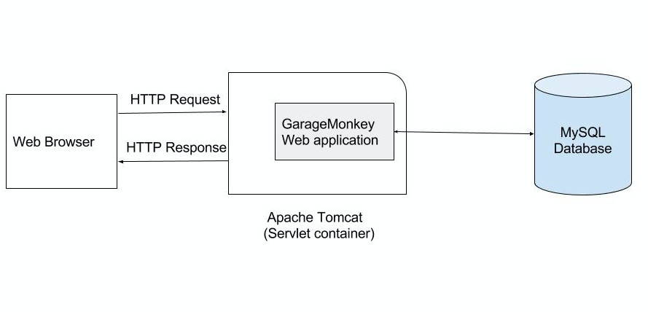

The web application is developed using Apache Tomcat web server and MySQL database. Tomcat acts as a web container for the Java application and handles HTTP requests.

System design

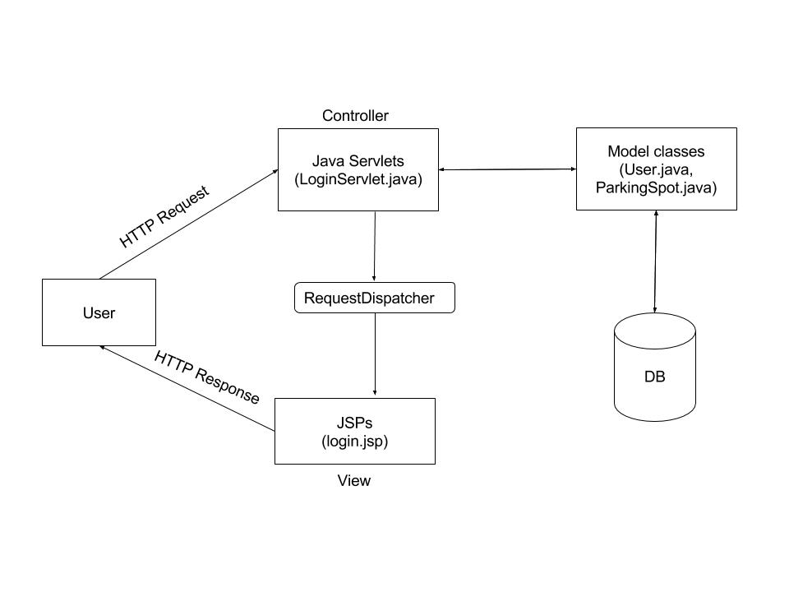

The Java application follows MVC (Model-View-Controller) design pattern. All the HTTP requests originating from user, are handled by appropriate Controllers (Java Servlets). For example, requests going to context /login are handled by LoginController servlet. Controller uses Model classes to process the request.

Model classes represent the business logic of the application and acts as an intermediately between controller and view. In the GarageMonkey web application there are server model classes to represent a User, a parking Spot and also include the logic to register a parking spot.

View is what is shown to the user. Views are implemented using JSPs and contain both the HTML as well as data generated by Model classes.

Database design

GarageMonkey database has following tables to permanently store user details, parking spot details and reservation details.

***user_details***

|  |  |  |  |  |  |  |  |
| --- | --- | --- | --- | --- | --- | --- | --- |
| Email | Password | F_name | L_name | Phone | UserType | Active | Date_created |
|  |  |  |  |  |  |  |  |
|  |  |  |  |  |  |  |  |

***parking_spots***

|  |  |  |  |  |  |  |
| --- | --- | --- | --- | --- | --- | --- |
| Spot_id | Level | Row | Spot_number | Size | Hourly_rate | Date_created |
|  |  |  |  |  |  |  |
|  |  |  |  |  |  |  |

***reservations***

|  |  |  |  |  |  |  |  |  |
| --- | --- | --- | --- | --- | --- | --- | --- | --- |
| Id | Vehicle_id | Spot_id | User_id | Start_time | End_Time | Reserved_by | Reserved_on | comments |
|  |  |  |  |  |  |  |  |  |
|  |  |  |  |  |  |  |  |  |

***reservations_history***

|  |  |  |  |  |  |  |  |  |
| --- | --- | --- | --- | --- | --- | --- | --- | --- |
| Id | Vehicle_id | Spot_id | User_id | Start_time | End_Time | Reserved_by | Reserved_on | comments |
|  |  |  |  |  |  |  |  |  |
|  |  |  |  |  |  |  |  |  |