Multiple-Choice Test

Chapter 05.04

Lagrange Method of Interpolation

- A unique polynomial of degree ______________ passes through 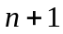 data points.
- or less
- or less

- Given the two points 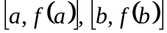, the linear Lagrange polynomial 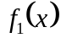 that passes through these two points is given by
- 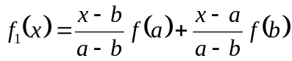
- 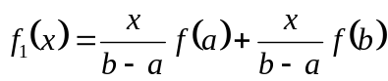
- 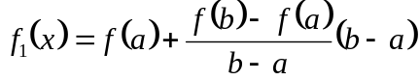
- 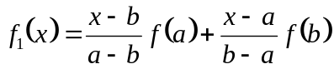

- The Lagrange polynomial that passes through the 3 data points is given by

 | 15 | 18 | 22
 | 24 | 37 | 25

The value of 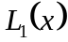 at 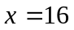 is most nearly
- –0.071430
- 0.50000
- 0.57143
- 4.3333

- The following data of the velocity of a body is given as a function of time.

Time () | 10 | 15 | 18 | 22 | 24
Velocity (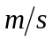) | 22 | 24 | 37 | 25 | 123

A quadratic Lagrange interpolant is found using three data points, 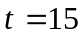, 18 and 22. From this information, at what of the times given in seconds is the velocity of the body 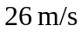 during the time interval of to 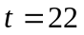 seconds.
- 20.173
- 21.858
- 21.667
- 22.020

- The path that a robot is following on a 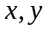 plane is found by interpolating four data points as

 | 2 | 4.5 | 5.5 | 7
 | 7.5 | 7.5 | 6 | 5

The length of the path from 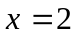 to 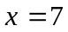 is
- 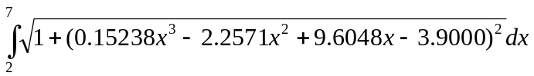
- 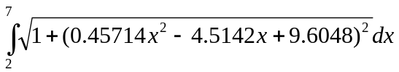
- 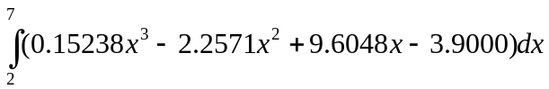
- The following data of the velocity of a body is given as a function of time.
Time (s) | 0 | 15 | 18 | 22 | 24
Velocity (m/s) | 22 | 24 | 37 | 25 | 123
If you were going to use quadratic interpolation to find the value of the velocity at 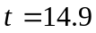 seconds, what three data points of time would you choose for interpolation?
- 0, 15, 18
- 15, 18, 22
- 0, 15, 22
- 0, 18, 24

For a complete solution, refer to the links at the end of the book.

