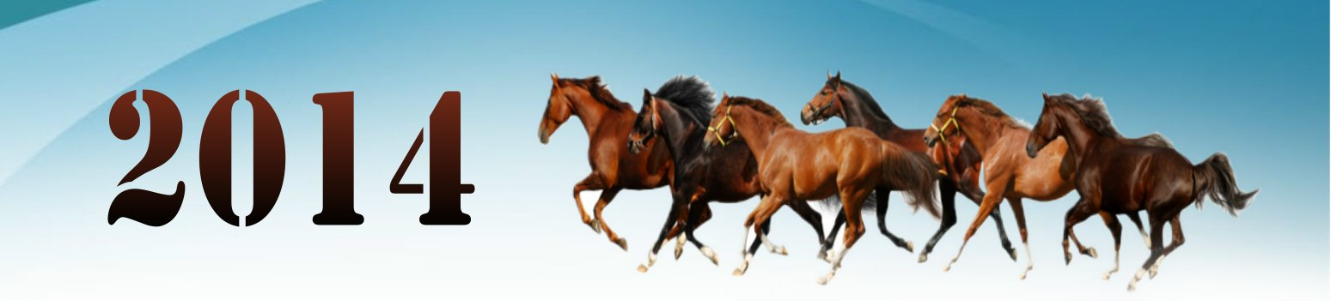

|  |  |  |  |  |  |  |  |  |  |  |  |  |  |  |  |  |  |  |  |  |  |  |  |  |  |  |  |  |  |  |  |  |  |  |  |  |  |  |  |  |  |  |  |  |  |  |  |  |  |  |  |  |  |  |  |  |  |  |  |  |  |  |  |  |  |  |  |  |  |  |  |  |  |  |  |  |  |  |  |  |  |  |  |  |  |  |  |  |  |  |  |  |  |  |  |  |  |  |  |
| --- | --- | --- | --- | --- | --- | --- | --- | --- | --- | --- | --- | --- | --- | --- | --- | --- | --- | --- | --- | --- | --- | --- | --- | --- | --- | --- | --- | --- | --- | --- | --- | --- | --- | --- | --- | --- | --- | --- | --- | --- | --- | --- | --- | --- | --- | --- | --- | --- | --- | --- | --- | --- | --- | --- | --- | --- | --- | --- | --- | --- | --- | --- | --- | --- | --- | --- | --- | --- | --- | --- | --- | --- | --- | --- | --- | --- | --- | --- | --- | --- | --- | --- | --- | --- | --- | --- | --- | --- | --- | --- | --- | --- | --- | --- | --- | --- | --- | --- | --- |
| | 七月 | | | | | | | | --- | --- | --- | --- | --- | --- | --- | | M | T | W | T | F | S | S | |  |  |  |  |  |  |  | |  |  |  |  |  |  |  | |  |  |  |  |  |  |  | |  |  |  |  |  |  |  | |  |  |  |  |  |  |  | | | 八月 | | | | | | | | --- | --- | --- | --- | --- | --- | --- | | M | T | W | T | F | S | S | |  |  |  |  |  |  |  | |  |  |  |  |  |  |  | |  |  |  |  |  |  |  | |  |  |  |  |  |  |  | |  |  |  |  |  |  |  | |
| | 九月 | | | | | | | | --- | --- | --- | --- | --- | --- | --- | | M | T | W | T | F | S | S | |  |  |  |  |  |  |  | |  |  |  |  |  |  |  | |  |  |  |  |  |  |  | |  |  |  |  |  |  |  | |  |  |  |  |  |  |  | | | 十月 | | | | | | | | --- | --- | --- | --- | --- | --- | --- | | M | T | W | T | F | S | S | |  |  |  |  |  |  |  | |  |  |  |  |  |  |  | |  |  |  |  |  |  |  | |  |  |  |  |  |  |  | |  |  |  |  |  |  |  | |
| | 十一月 | | | | | | | | --- | --- | --- | --- | --- | --- | --- | | M | T | W | T | F | S | S | |  |  |  |  |  |  |  | |  |  |  |  |  |  |  | |  |  |  |  |  |  |  | |  |  |  |  |  |  |  | |  |  |  |  |  |  |  | | | 十二月 | | | | | | | | --- | --- | --- | --- | --- | --- | --- | | M | T | W | T | F | S | S | |  |  |  |  |  |  |  | |  |  |  |  |  |  |  | |  |  |  |  |  |  |  | |  |  |  |  |  |  |  | |  |  |  |  |  |  |  | |

